ECON 313 Class notes APRIL 4

I asked a question related to the “costs” of having children and the teacher clarified that we look at the opportunity cost of raising children, which is interpreted as the lost income of the mother.

CH 7 Urbanization

- assumption that the more developed, the more urbanized
*but often developing countries are excessively urbanized or too-rapidly urbanization

-the combination suggests the migration and urbanization dilemma

Figure (fig) 7.1 changes in urban rural between 2011-2050

Urban Rural
Africa increase no decrease

Asia increase decrease

Europe increase large decrease

Latin America increase little decrease

North America increase no change

Fig 7.2 relation urbanization/per capita GDP
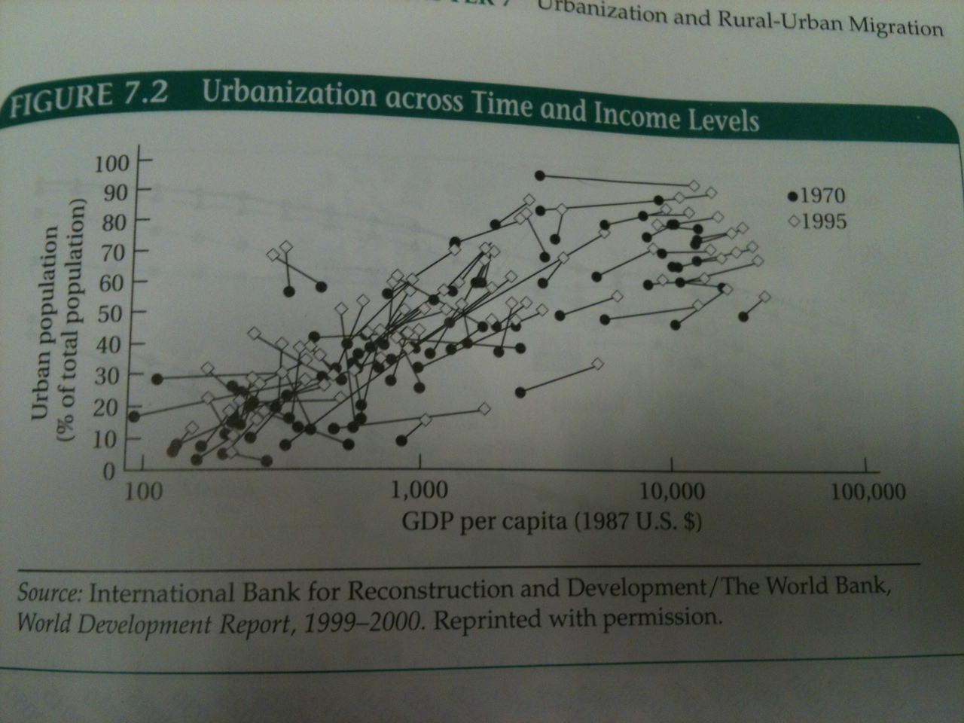
Fig 7.3 1970-1995 increase in urban population, in most cases, increase in per capita GDP
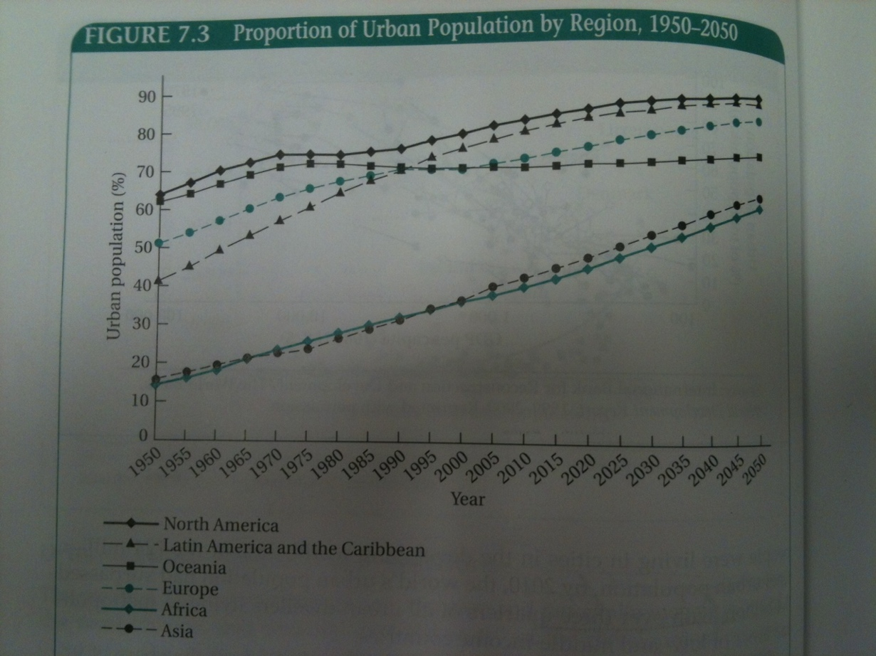
Fig 7.4 Megacities
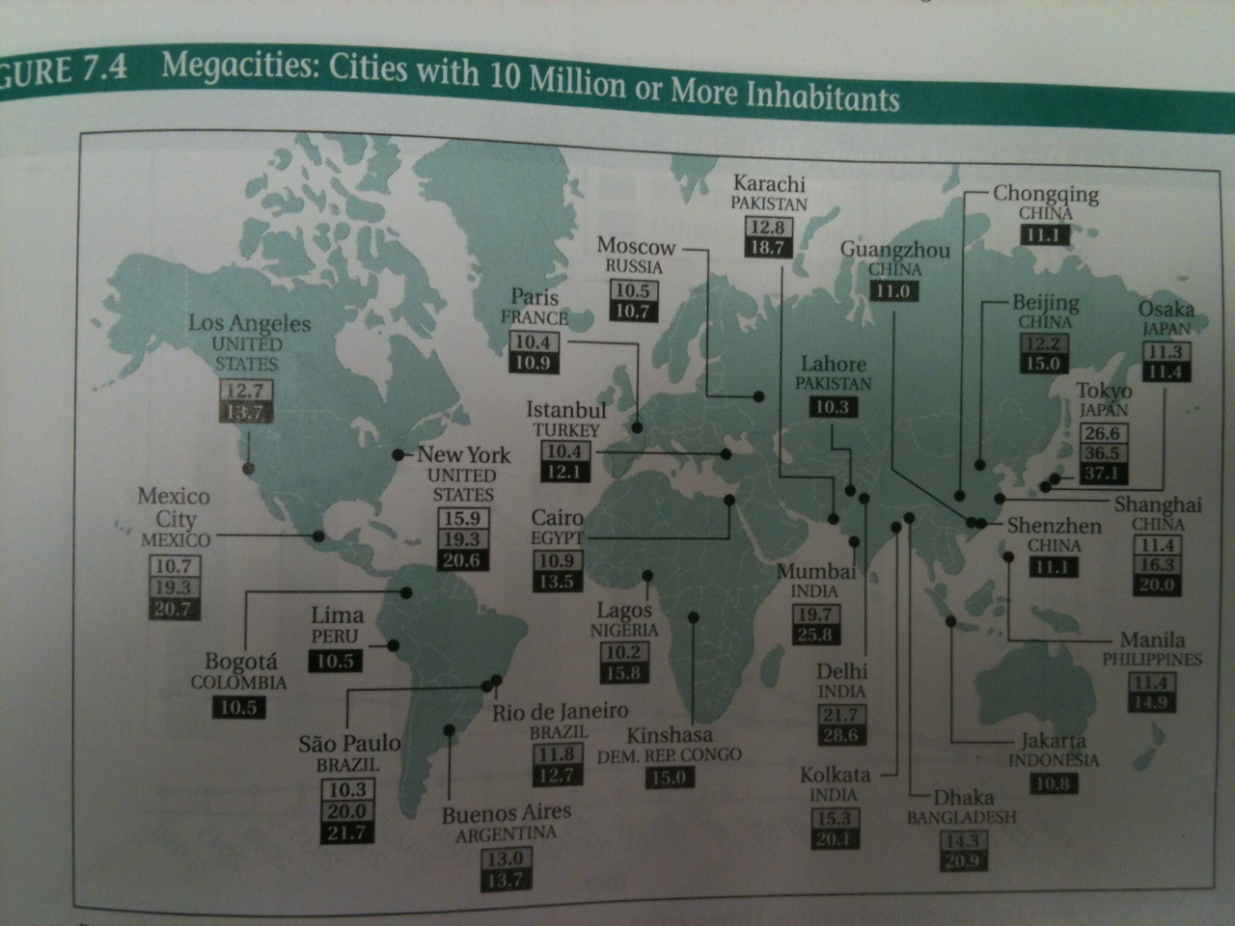
Fig 7.5 Growth of cities that have over 10 million pop will have the fastest growth (creation of new 10 million+, or current megacities migration)

Fig 7.6 Rapid urbanization in Less Developed Countries

Fig 7.7 High slum pop growth

The role of cities

-Agglomeration economies: urbanization (general) economies, localization (industry or sector) economies

-Saving on firm-to-firm, firm-to-consumer transportation

-Firms locating near workers with skills they need

-Workers locating near firms that need their skills

-Firms benefit from (perhaps specialized) infrastructure

-Firms benefit from knowledge spillovers in their and related industries

-Quality of clusters, or industrial districts is a key to sectorial efficiency

Unfortunately, a majority of developing countries have made only limited progress

China: a country that has made huge strides in generating industrial districts over the last decade

Cities also entail “congestion costs”

Economically efficient urban scale (form point of view of productive efficiency) found where average costs for industries are lowest

(high cost of living may discourage firms from settling in)

generally, differing efficient scales for different industrial specializations imply different city sizes

More extensive (expensive) capital, infrastructure required in urban areas.

Smaller cities may be expected in labour-intensive developing countries

General urban bias
-cities are capital intensive, so may expect that large cities are commonly located in developed countries
-unexpected rapid urbanization in developing countries
-huge informal sector in shantytowns and favelas
-large fraction of workers outside formal sector
-much urban growth in mid-size cities, but strong urban bias in developing countries
Giantism problem

-first-city bias (biggest cities assumption that they have more economic opportunity)
-causes: import substitution industrialization: less trade, incentive to concentrate in a single city largely to avoid transportation costs
-“Bread and Circuses”: big cities provide more services to prevent unrest (evidence: stable democracies vs unstable dictatorship)
-“hub and spoke” transportation system (rather than web) makes transport costs high for small cities
-compounding effect of locating the national capital in the largest city

Why promote the urban informal sector?
-generates surplus despite hostile environment
-creating jobs die to low capital intensity
-access to (informal) training, and apprenticeships
-creates demand for less- or un-skilled workers
-uses appropriate technologies, local resources
-recycling of waste materials (bottles, newspapers)
-more benefits for the poor, especially women who are concentrated in the informal sector

Fig 7.10 Youth unemployment rates
*caution while reading unemployment rates because they do not provide context or living conditions of people unemployed

Rural-urban migration viewed positively until recently because migration is bigger than cities’ ability to –create jobs and –provide social services

Todaro model:
Assumptions:
-migration is a rational decision
-the decision depends on expected rather than actual wage differentials
-the probability of obtaining a city job is inversely related to the urban unemployment rate
-high rates of migration are outcomes of rural urban imbalances
as more people move to urban areas expected income falls until urban wages = rural wages and migration then stops

The diagram part of the model will be shown next class

“To be yourself in a world that is constantly trying to make you something else is the greatest accomplishment.”
― Ralph Waldo Emerson

