ANP 1106 Midterm 2
Topic 4: The joints

Knee joint
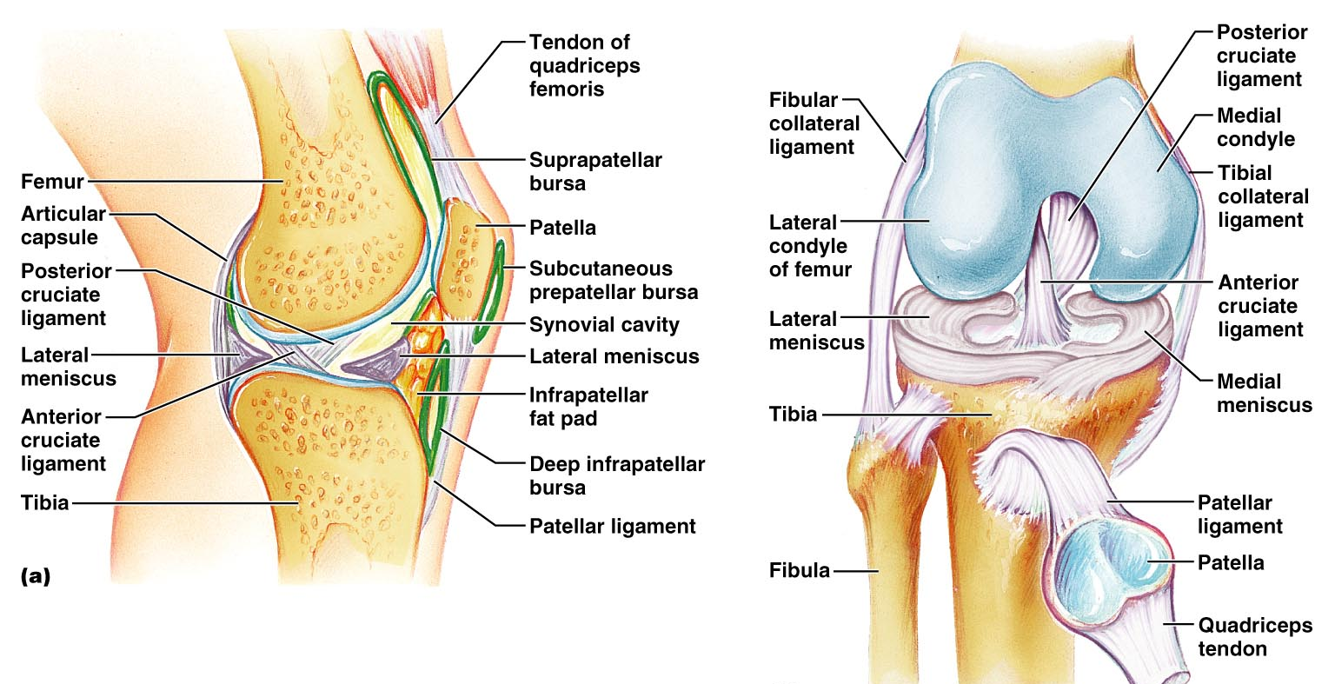
- Knee joint- flexion extension and slight rotation
- Three joints- femoropatellar, lateral tibiofemoral and medial tibiofemoral
- Anteriorly, joint capsule is replaced by 3 broad ligaments that are continuous with the quadriceps tendon (patellar ligament plus medial and lateral patellar retinacula).
- There are two intracapsular ligaments (anterior and posterior cruciate), 2 menisci (medial and lateral, attached at the fibrous capsule) and 2 extracapsular ligaments (fibular collateral and tibia collateral). Note the subcutaneous prepatellar bursa
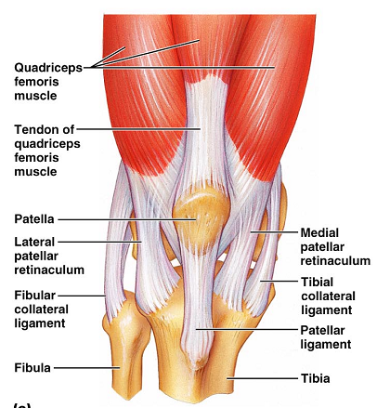
Tearing of tibial collateral and anterior cruciate ligaments and medial meniscus
Note that the cruciate ligaments are covered by synovial membrane and therefore are outside the synovial cavity.

Elbow joint
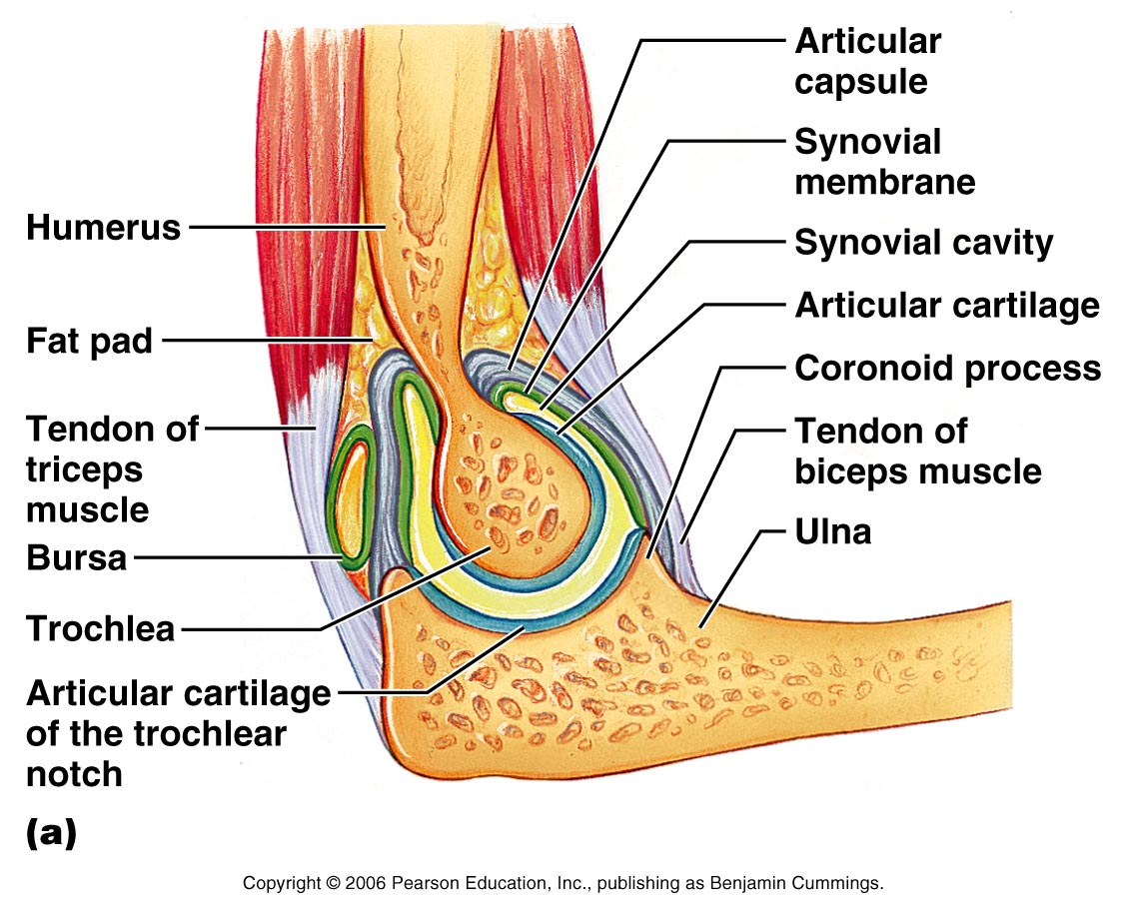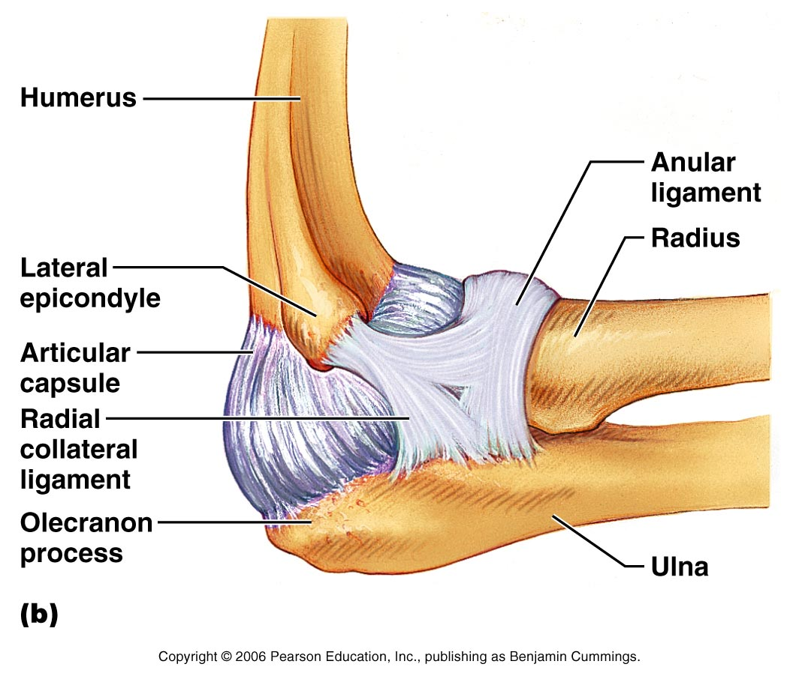

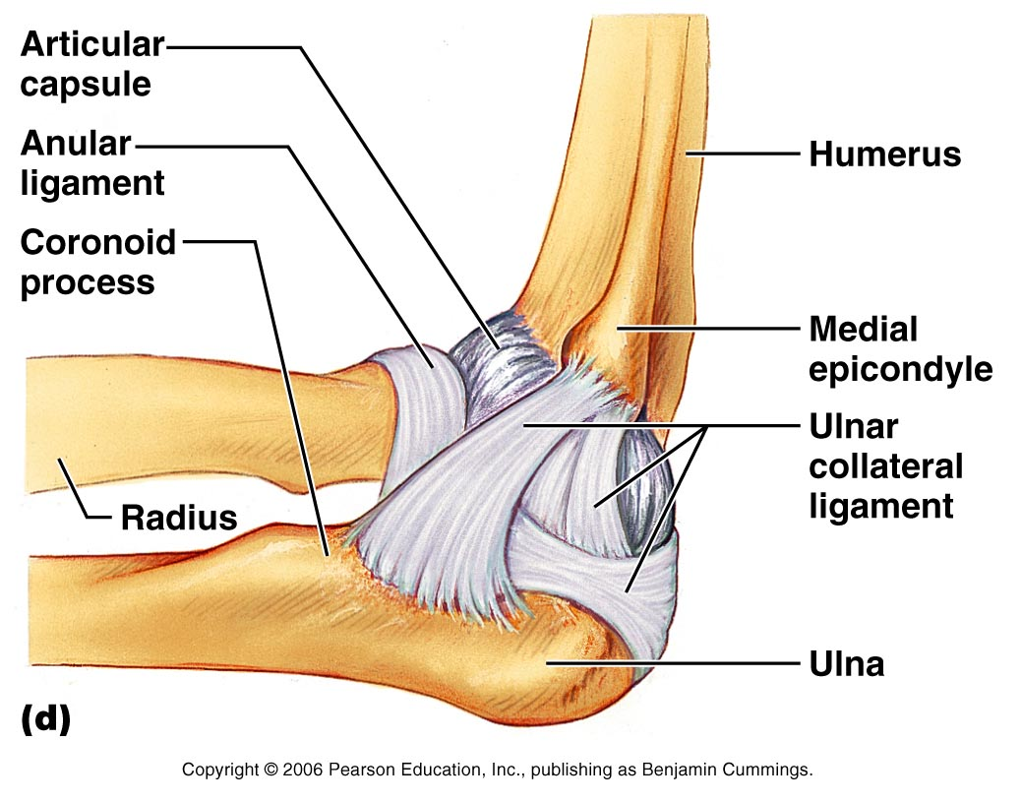

Hinge joint- largely through the articulation of the trochlea of the humerus with the trochlear notch on the ulna. The joint is stabilized by collateral ligaments and of note is the radius during pronation and supination.

Shoulder joint
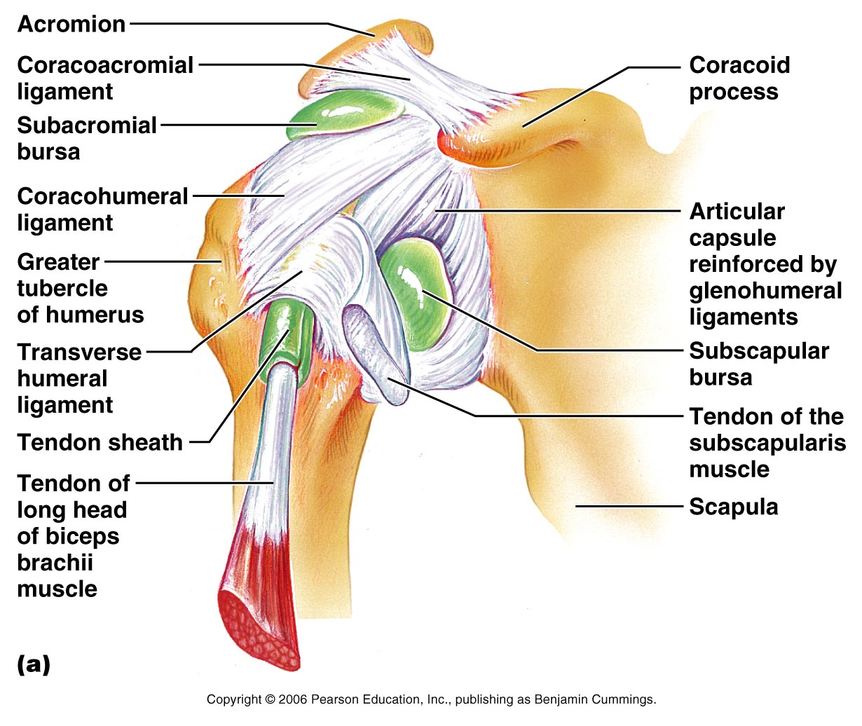
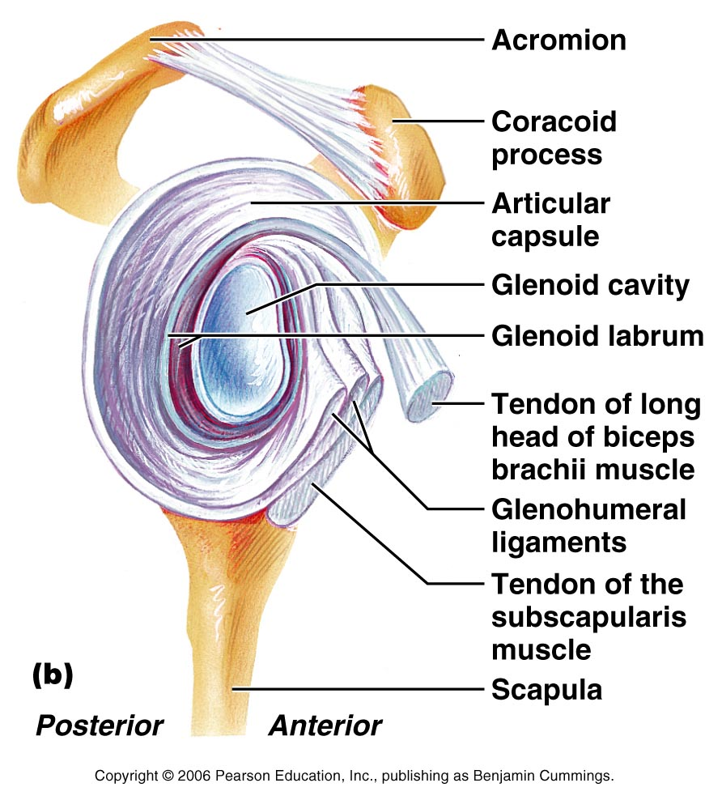

Glenohumoral joint- the glenoid cavity is broadened slightly by the glenoid labrum (fibrocartilaginous rim) but is still only 1/3rd the size of the head of the humerus. The only ligament of note is the coracohumeral. It is largely the tendons of the rotator cuff muscles that stabilize this joint.

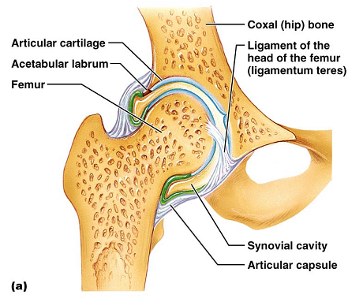
Hip joint
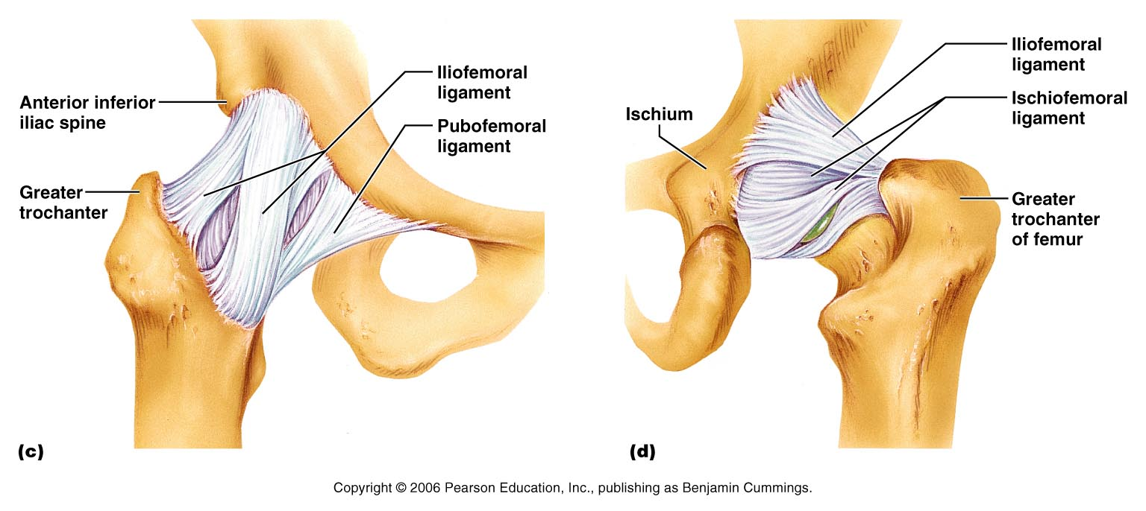

Deep ball and socket joint. There is an intracapsular ligament (ligament of the head of the femur- ligamentum teres) but its function in humans is unclear. Damage to its artery may lead to arthritis of the hip joint.
Extracapsular ligaments to note are the iliofemoral, pubofemoral, and ischiofemoral.

Temporomandibular joint
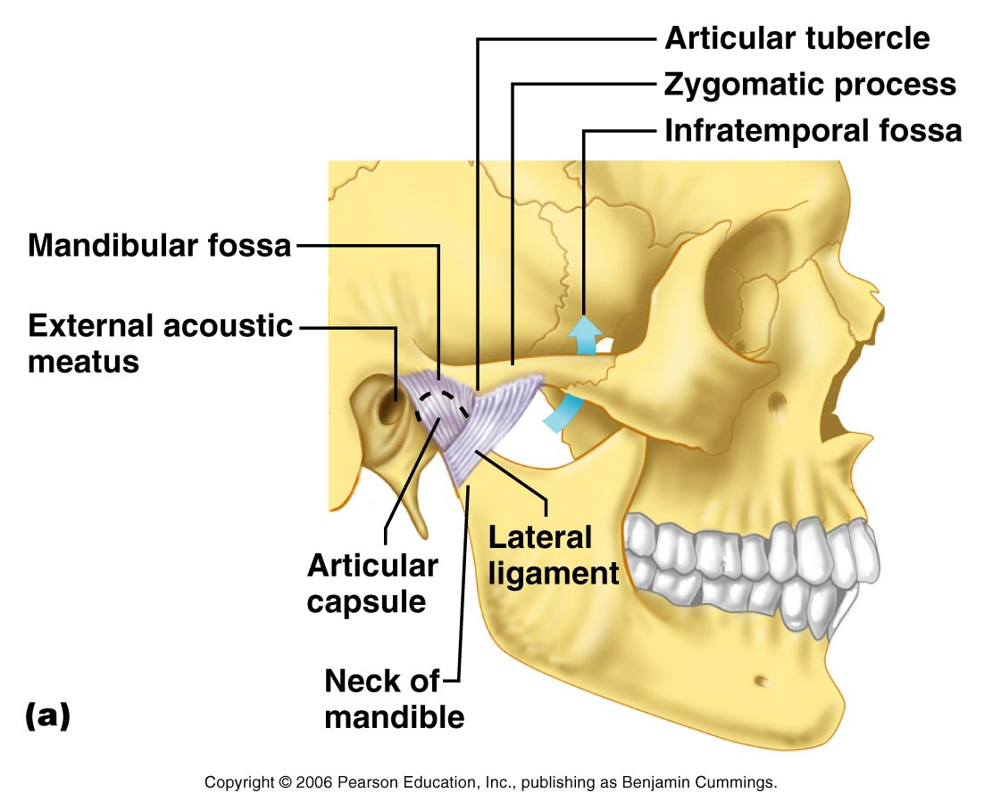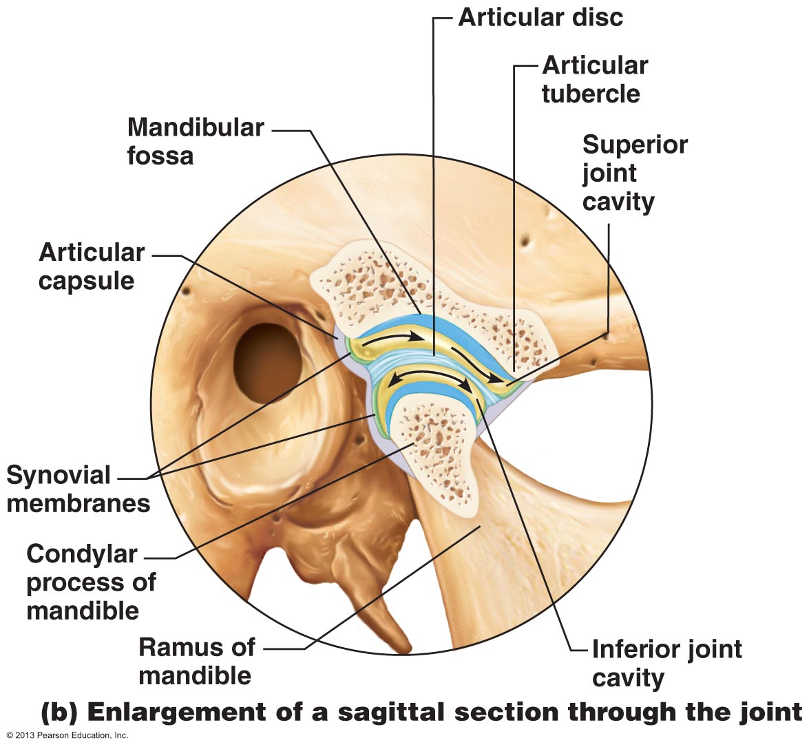

Articulation of the mandibular condyle with the mandibular fossa and the articular tubercle of the temporal bone. Stabilized by a lateral ligament. There is an articular disk that divides the synovial cavity into superior and inferior compartments.
Initial jaw opening is hinged (mandibular condyle within the temporal fossa). There is gliding when the condyle articulates with the articular tubercle.

Topic 5: Anatomy of the muscular system- Part 1
(chapter 10)
- Recall that muscle fiber is the name of a single muscle tissue cell
- Several different levels of CT wrapping:
- endomysium: fine layer of CT that surround each muscle fiber (cell)
- perimysium: sheath around a fascicle
- epimysium: dense, fibrous CT that surrounds and holds together a group of fascicles= outside layer of a single mucosa
- deep fascia: still coarser layer of dense CT that binds muscles into functional groups >> egg: hamstrings vs quadriceps
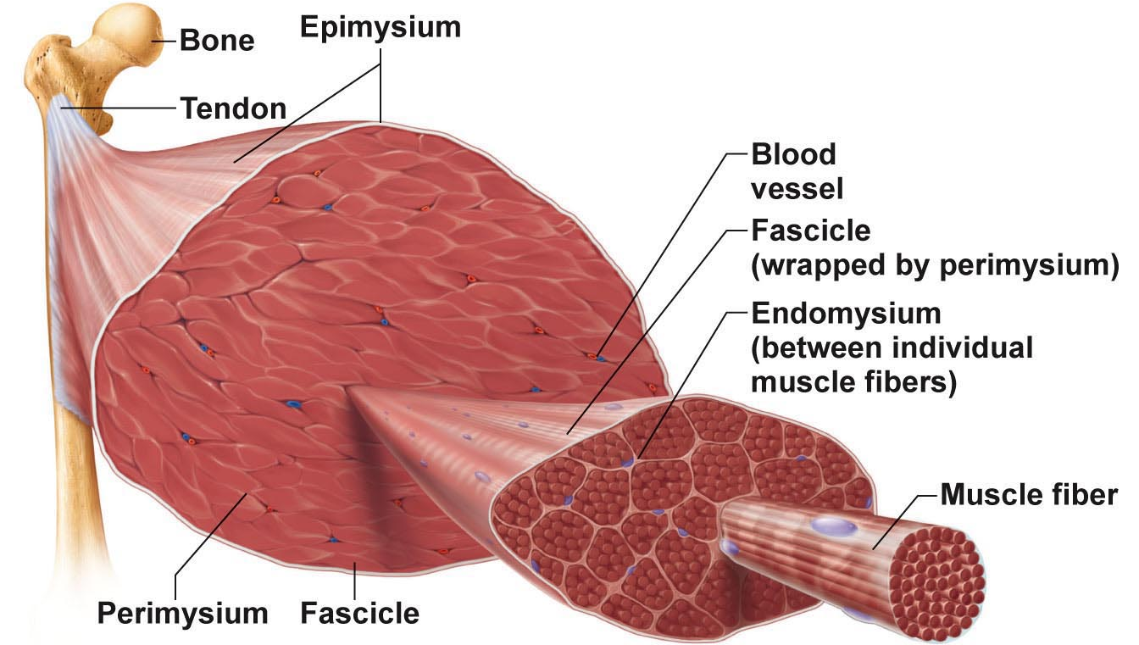

Muscle Attachments
- most muscles span joints
- most muscles are attached to bones in at least 2 places
- origin: anchored/ originates in this bone
- insertion: bone that moves
- aponeurosis: flat sheet of tissue connecting two muscles (ex: top of head)
- Most attachments are indirect attachments involving either a tendon or an aponeurosis.
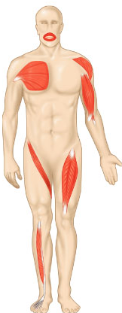
Arrangement of fascicles
- All skeletal muscles have fascicles
- 4 basic patterns:
- parallel:
- can be strap like (Sartorius) or fusiform (biceps brachii)
- pennate: (feather like)
- unipennate (e.g.: extensor digitorum longus) (1/2 feather)
- bipennate (e.g.: rectus femoris) (1 feather)
- multipennate (e.g.: deltoid) (many feathers)
- convergent:
- muscle is triangular or fan-shaped (e.g.: pectoralis major)
- ex: temporalis in head
- circular:
- concentric rings surround ext openings and contract to close opening (e.g.: orbicularis oris, allows you to pucker your lips)
- also associated with eyes

interactions of skeletal muscles
- muscles can work together or in opposition
- 4 functional groups: prime movers, antagonistsm synergists and fixators
- Prime mover:
- Allows movement to happen (there can be more than 1)
- e.g.: biceps brachii and elbow flexion
- Antagonist
- Acting against the movement (muscle tone)
- controls movement
- can provide resistance to prevent overshoot or control rate of movement
- a single muscle can be a prime mover for one action and an antagonist for another action – e.g.: biceps brachii and triceps brachii
- Synergists:
- Less important but still helping
- Muscles that help the prime mover by:
- Promoting the same movement
- Reducing undesirable movements (e.g.: finger flexor muscles cross both wrist and phalangeal joints) (allowing you to only flex what you want to)
- Fixators:
- Immobilize a bone- e.g.: muscles involved in posture
- Hold a certain pose

Naming skeletal muscles
- Location of muscle: bone or body region – temporalis, intercostal
- Shape of muscle: e.g.: deltoid (triangular), right and left trapezius muscles form trapezoid
- Relative size of muscle: maximus, minimus, longus, brevis – e.g.; gluteus maximus and gluteus minimus
- Direction of muscle fibers; e.g.: rectus= straight, parallel to midline (rectus femoris); also transversus abdominis, oblique
- Number origins: biceps, triceps, quadriceps- e.g.: biceps brachii
- Location of muscle’s origin and/or insertion: if both indicated, origin always indicated first- e.g.: sternocleidomastoid (neck region- dual origin on sternum and clavicle and insertion on mastoid process of temporal bone)
- Action of the muscle: flexor, extensor, adductor- e.g.: adductor longus for thigh adduction and suppinator muscle in forearm
What can we say about the extensor carpi radialis longus? Extensor carpi

Muscles of the head- facial expression
- Insert into skin or other muscles, not bones; innervated by the facial nerve
- Epicranius= muscle of scalp- consists of
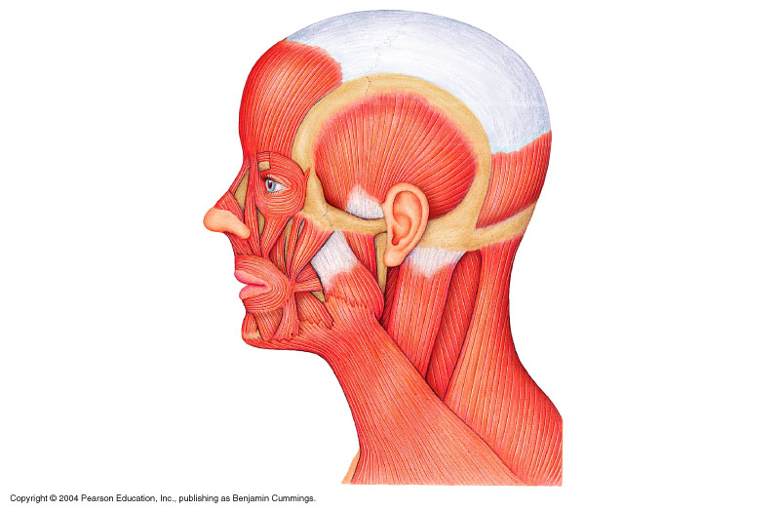
- Frontalis: raises eyebrows, wrinkles forehead (frontal belly)
epicranius
aponeurosis
- Occipitalis: pulls scalp posteriorly (occipital belly) (aponeurosis of epicranius)
- Orbicularis oculi; surrounds rim of orbit; protects eyes from light/ injury- blinking, squinting, also draws eyebrows down (squint when sunny)
- Zygomaticus (cheek to corner of mouth):
  - Smiling muscle
  - Orbicularis oris
    - Lips; multi-layered; closes, purses, protrudes lips
  - Mentalis (mandible to chin):
    - V-shaped pair- protrudes lower lip; wrinkles chin
- buccinators (mandible/maxilla to orb. oris):
  - Deep to masseter- whistling, sucking; hold food in place when chewing; especially in nursing infants (push food under teeth)
- Platysma (fascia of chests to mandible):
  - Helps depress mandible; tenses skin of neck
  - Helps open mouth

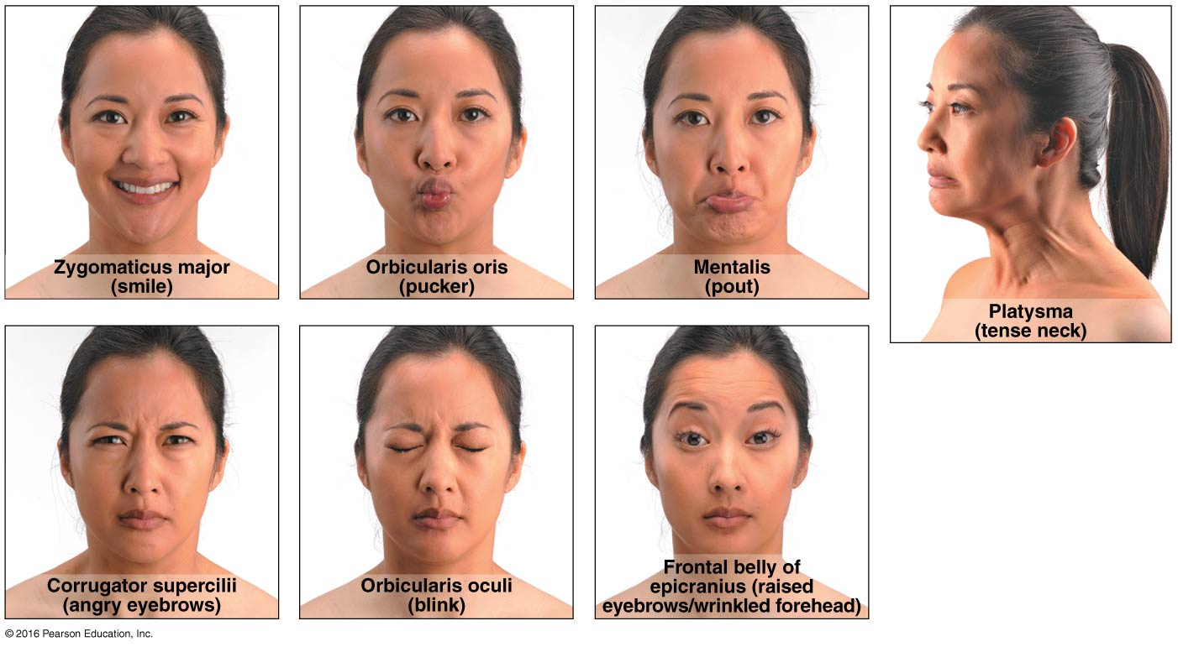

Muscles that move the tongue
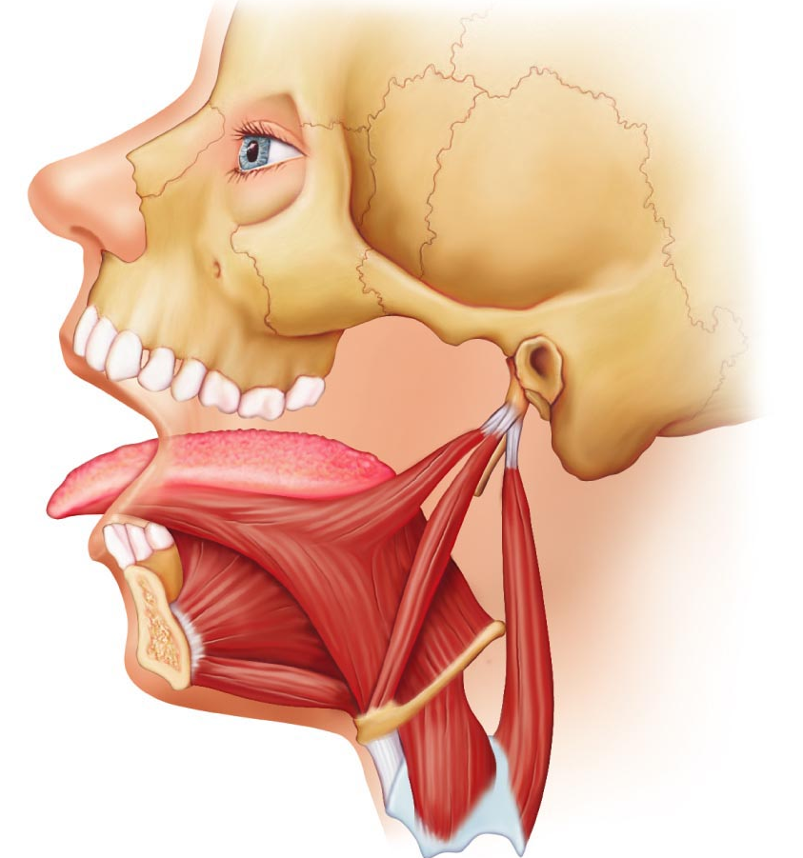
- Genioglossus (mandible to inferior tongue and hyoid bone): prime mover of tongue protrusion; anchors tongue to prevent obstruction of respiration (holds tongue down while sleeping so airway doesn’t get blocked)
- Hypoglossus (hyoid bone to inferolateral tongue): depresses tongue, especially lateral margins (flattens tongue)
- Styloglossus (styloid process of temporal none to inferolateral tongue): retracts and elevates tongue

Muscles of the head: mastication, etc.
- 4 pairs involved in chewing; all innervated by mandibular division of cranial nerve V
- masseter (zygomatic to mandible): prime mover of jaw closure (powerfully)
- temporalis (temporal to mandible): elevates and retracts mandible (closes jaw); maintains closed jaw at rest (originates on temporalis bone)
- Medial and lateral pterygoid (sphenoid to mandible): both both two headed; additional jaw movements (e.g.: side to side grinding movements) (originates on pterygoid process)
- Buccinators (mandible/ maxilla to orbicularis oris): helps keep food between grinding surfaces of teeth during chewing
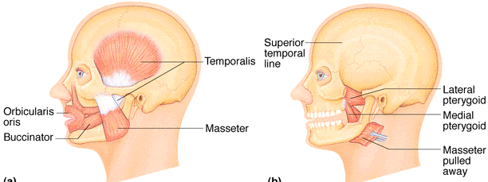

Muscles of neck and vertebral column: Head and trunk movements
- Head moved by muscles originating from axial skeleton
- Sternocleidomastoid (manubrium/ clavicle to mastoid process of temporal): 2-headed; deep to platysma; prime mover (both muscles) of head flexion; individual muscle action for head rotation to side, head tilts
- Scalenes (cervical vertebrae to 1st 2 ribs): more laterally and deep to platysma and sternocleidomastoid- elevates first 2 ribs, role in coughing, flex and rotate neck
- splenius (vertebrae to mastoid process of temporal): superficial; “bandage muscle”; head extension (both sides) or rotation, tilts (large muscles in back, can have multiple region)
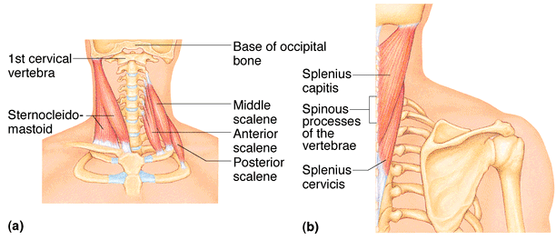

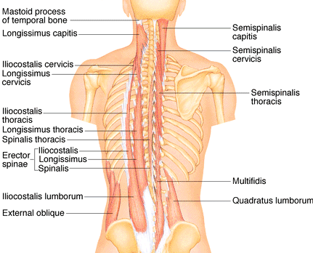
- erector spinae: prime mover of back extension; consists of 3 columns of muscles (iliocostalis, longissimus, spinalis); resistance to bending forward and extensors for return to erect position
- semispinalis: deeper, composite muscle from thoracic region to head; extends vertebral column and head, rotation of head, synergistic with sternocleidomastoid muscles
- Quadratus lumborum (iliac crest to lumbar vertebrae): individual muscles flex vertebral column laterally; jointly to extend lumbar spine and fix 12th rib; maintain upright posture

Muscles of respiration
- external intercostals: 11 pairs between ribs; oblique; pull ribs together to elevate rib cage (inspiration; 1st ribs fixed by scalene muscles), inspiration
- Internal intercostals: 11 pairs, between ribs; external intercostals; draw ribs together to depress rib cage (expiration; 12th ribs fixed by quadratus lumborum), expiration
- Diaphragm: dome-shaped when relaxed; prime mover of inspiration
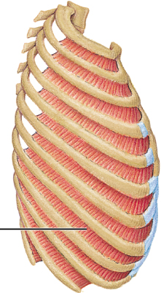
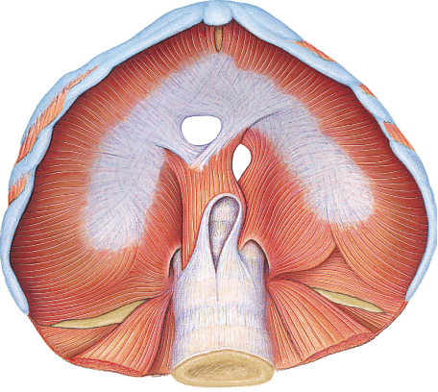
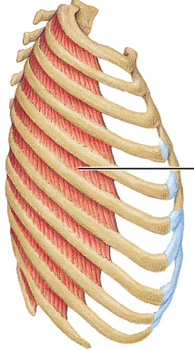
External Internal

Muscles of abdominal wall
- rectus abdominis- medial superficial; pubis to rib cage; lumbar rotation, fix depress ribs, stabilize pelvis during walking
- External oblique- largest and most superficial lateral muscle; together increase abdominal pressure, flex vertebral column(bend forward); individual rotation
- Internal oblique- deeper, but same actions as ext. obliques
- transversus abdominis- deepest; compresses abdominal contents

Muscles of the pelvic floor and perineum
- Levator ani (pubis to inner coccyx): supports pelvic viscera and forms supportive sling at anorectal junction and vagina; resists increase in intra-abdominal pressure
- Coccygeus (spine of ischium to sacrum and coccyx): supports pelvic viscera and coccyx
- Urogenital diaphragm: supports pelvic viscera and constricts urethra (support for urethra, vagina and anus)
- Levator ani and coccygeus = pelvic diaphragm
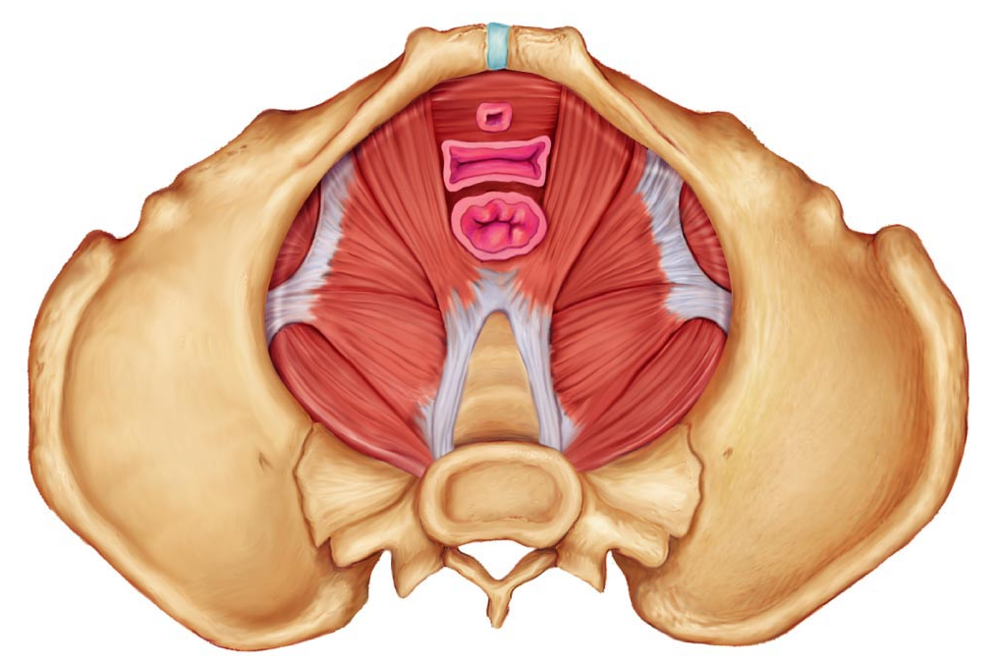

Anatomy of the muscular system- part 2

Superficial muscles of thorax: arm movements
- Pectoralis major (sternum/rib cartilages to humerus): prime mover of arm flexion; rotates arm medially; adducts arm; climbing, throwing, pushing
- Latissimus dorsi (vertebrae to humerus): broad, flat back muscle; prime mover of arm extension, arm adductor, rotates arm at shoulder, rowing, swimming
- Deltoid (clavicle/ scapula to humerus): thick, rounded, site of IM injection, prime mover of arm abduction (all fibers); also lateral and medial rotations, flexion or extensions if only some fibers used; swinging arm when walking

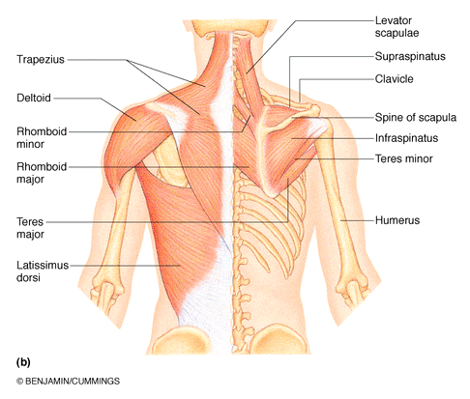
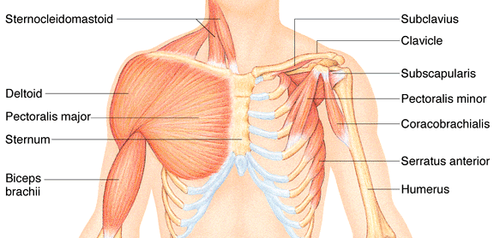

- trapezius (occipital and vertebrae to scapula): superficial, stabilizes, raises, retracts, rotates scapula
- Rhomboids (vertebrae to scapula): deep to trapezius; aid in scapula movements (e.g.: squaring shoulders, rotation when lowering arm)
- + subscapularis = rotator cuff muscles

Muscles crossing the shoulder and elbow joints
- triceps brachii (scapula/humerus to ulna): only muscle of posterior compartment of arm; powerful forearm extensor, may help stabilize shoulder joint
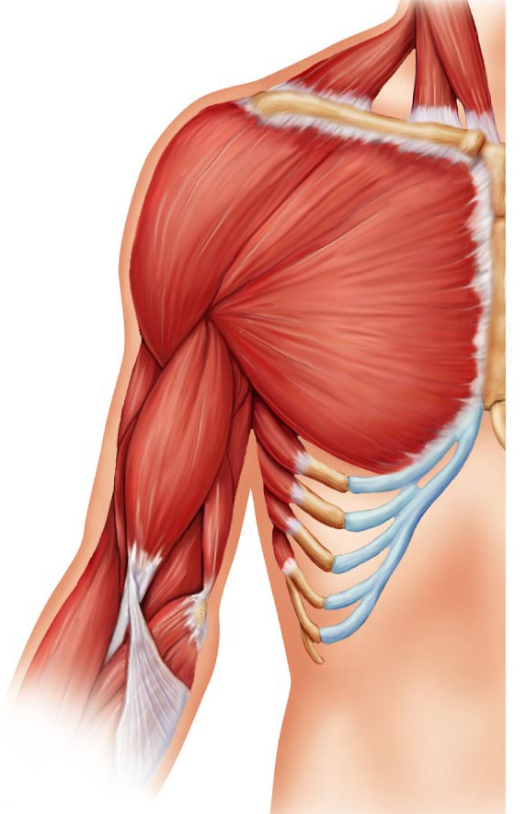
- biceps brachii (shoulder to radius): anterior, flexes elbow joint & supinates forearm; weak flexor of arm at shoulder
- brachialis (humerus to ulna): immediately deep to biceps brachii; major forearm flexor (strong) – lifts ulna as biceps lifts radius
- brachioradialis (humerus to radius): superficial; from distal humerus to distal forearm; synergist in forearm flexion

Muscles of the forearm: movements of the wrist, hand, and fingers
2 functional groups allow for movements of (i) the wrist and of (ii) the fingers and thumb
- pronator teres (humerus/ulna to lateral radius): pronates forearm, weak flexor of elbow
- flexor carpi radialis (humerus to metacarpals): diagonally across forearm, powerful flexor of wrist; abducts hand
- flexor carpi ulnaris (humerus/ulna to metacarpals): powerful flexor of wrist; also adducts hand in concert with extensor carpi ulnaris; stabilizes wrist during finger extension
- flexor digitorum superficialis (humerus/ulna to phalanges): 2-headed, deeper; flexes wrist & middle phalanges of fingers 2-5
- extensor carpi radialis longus/brevis (humerus to metacarpals): extends & abducts wrist
- extensor digitorum (humerus to phalanges): prime mover of finger extension; extends wrist, can abduct fingers
- supinator (humerus to radius): deep; assists biceps brachii to supinate forearm

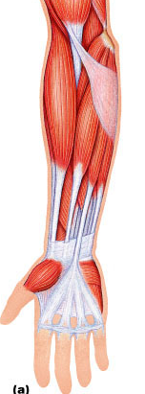
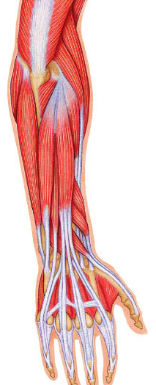

Muscles of hip, thigh and leg
- iliopsoas (iliac crest & lumbar vertebrae to femur): composite of 2 muscles; prime mover of hip flexion
- sartorius (iliac spine to medial tibia): strap-like; longest muscle; flexes & laterally rotates thigh; weak knee flexor
- adductors (magnus, longus, brevis) (pubis to femur): all adduct, flex, medially rotate thigh – e.g.: riding a horse, walking, fixing hip when knee flexed
- pectineus (pubis to femur): adducts, flexes & medially rotates thigh
- gracilis (pubis to medial tibia): adducts thigh, medially rotates leg (walking)
- rectus femoris (iliac spine to patella & tibia): extends knee; flexes thigh at hip
- vastus (lateralis, medialis, intermedius): all extend the knee
- tibialis anterior (tibia to tarsals): prime mover of dorsiflexion; inverts foot
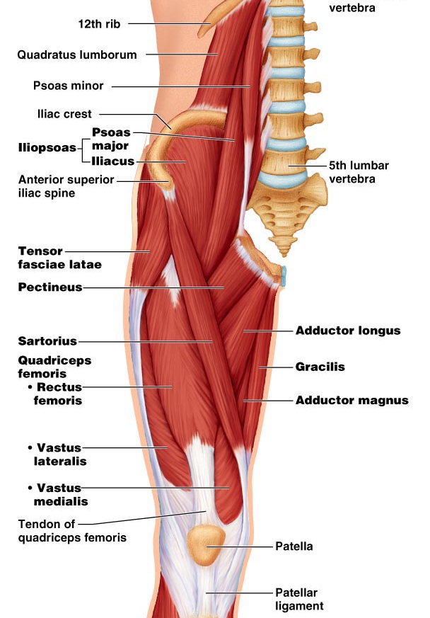
- extensor digitorum longus (tibia to phalanges): dorsiflexes foot; prime mover of toe extension
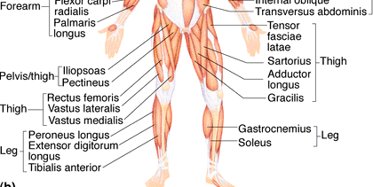

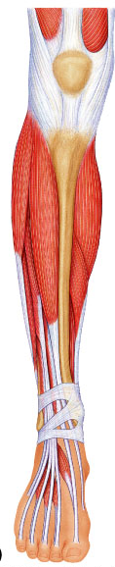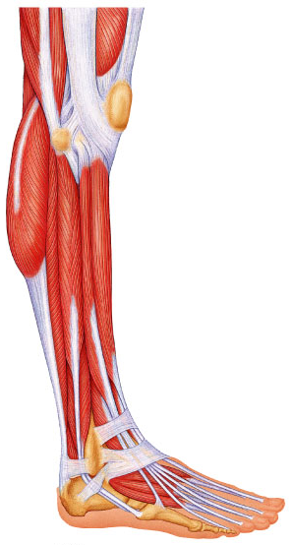

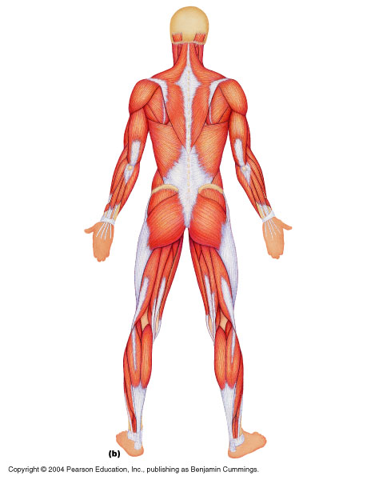
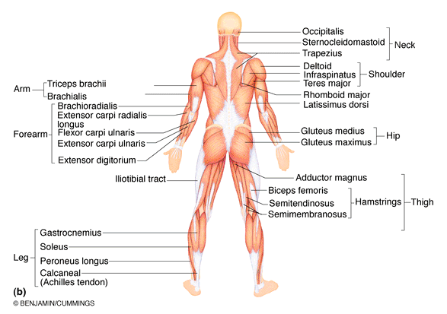
- gluteus maximus (ilium/sacrum to femur): largest & most superficial buttock muscle; major thigh extensor - climbing stairs, running (intramuscular injection)
- gluteus medius (ilium to femur): abducts & medially rotates thigh; esp. during walking (Intramuscular injections)
- hamstrings (ischial tuberosity to tibia/fibula): 3 muscles; all extend thigh & flex knee
** Know names of all three hamstring muscles, but only label biceps femoris

- gastrocnemius (femur to calcaneal tendon): plantar flexes foot when knee extended; flex knee if foot dorsiflexed
- soleus (proximal tibia/fibula to calcaneus): deeper, plantar flexes ankle: walking, running, dancing
- fibularis (peroneus) longus (fibula under foot to 1st metatarsal): plantar flexes & everts foot; helps keep foot flat on ground
- calcaneal (Achilles tendon): largest tendon in body (G & S)
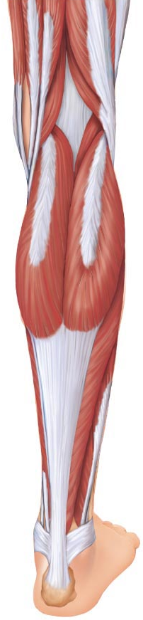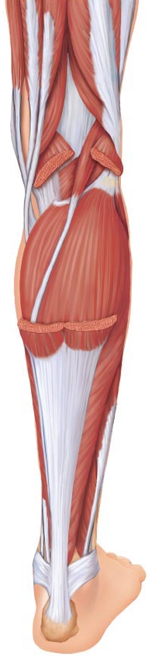

Topic 6: Anatomy of the nervous system part A

CNS (chp. 11: pg. 389-397, chp. 12: pg. 432-455)
- connected as a single unit, but anatomically divided into 2 parts:
    - Central Nervous System: brain + spinal cord; integrating & command center
    - Peripheral Nervous System: cranial & spinal nerves; communication between CNS & all parts of body
- Sensory division: somatic & visceral fibers; from receptors to CNS
- Motor division: motor nerve fibers from CNS to effectors
  - Somatic ns: voluntary; from CNS to skeletal muscle
  - Autonomic ns: involuntary; (visceral motor); from CNS to cardiac muscle, smooth muscle, glands
    - Sympathetic division: “fight or flight”
    - Parasympathetic division: conserve energy at rest
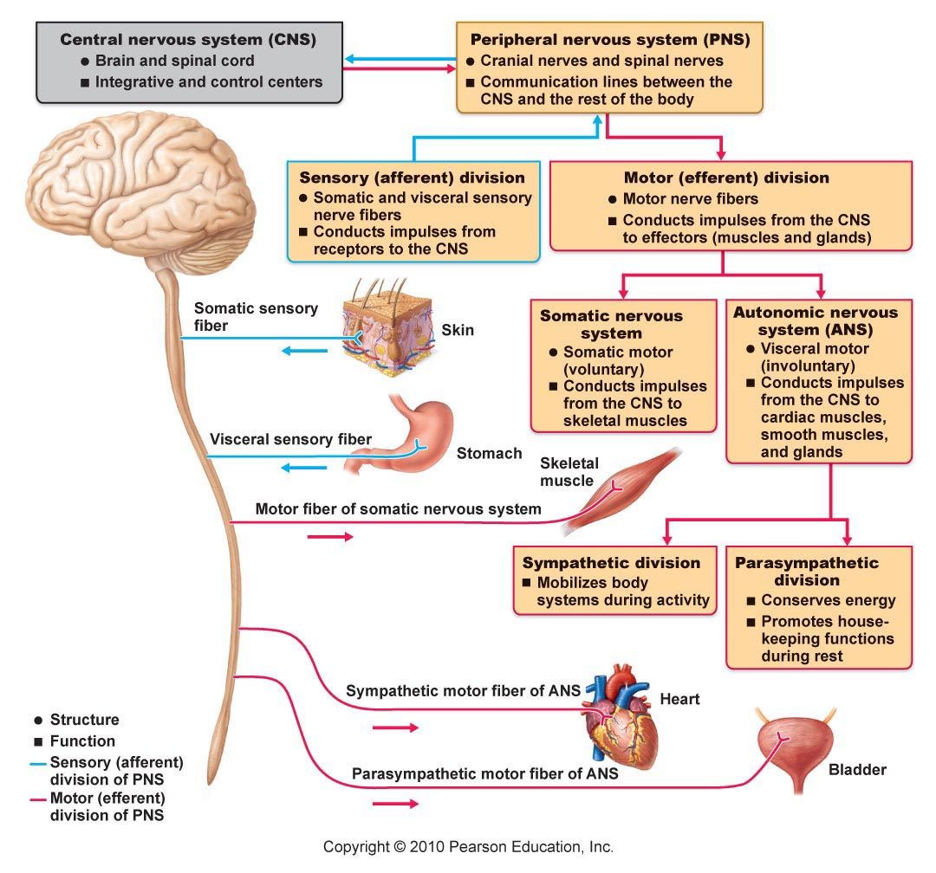

Histology of Nervous Tissue
• very cellular; minimal extracellular matrix
• 2 principal types of cells:
- neurons
- supporting cells (6 types):

CNS: (4 types – neuroglia)
- Astrocytes: star-shaped, most abundant; anchor neurons close to capillaries
• roles in nutrient exchange, antigen presentation, control of environment
- Microglia: protective; touch neurons to monitor well-being; can transform into macrophages
- Ependymal cells: line cavities of brain & spinal cord as barrier between CSF & fluid bathing cells of CNS; cilia circulate CSF
- Oligodendrocytes: “few branches”; provide myelin sheaths to CNS neurons

PNS:
- Satellite cells: surround neuron cell bodies in ganglia – influence chemical environment of these neurons (still being studied)
- Schwann cells: form myelin sheaths around larger neurons in PNS; vital to peripheral nerve cell regeneration

Neurons (won’t ask about neuron structure)
  - extreme longevity, amitotic, high MR
  - know: cell body, dendrites, axon, axon hillock, myelin sheath, node of Ranvier, terminal branches, axonal terminals

Structural classification of neurons

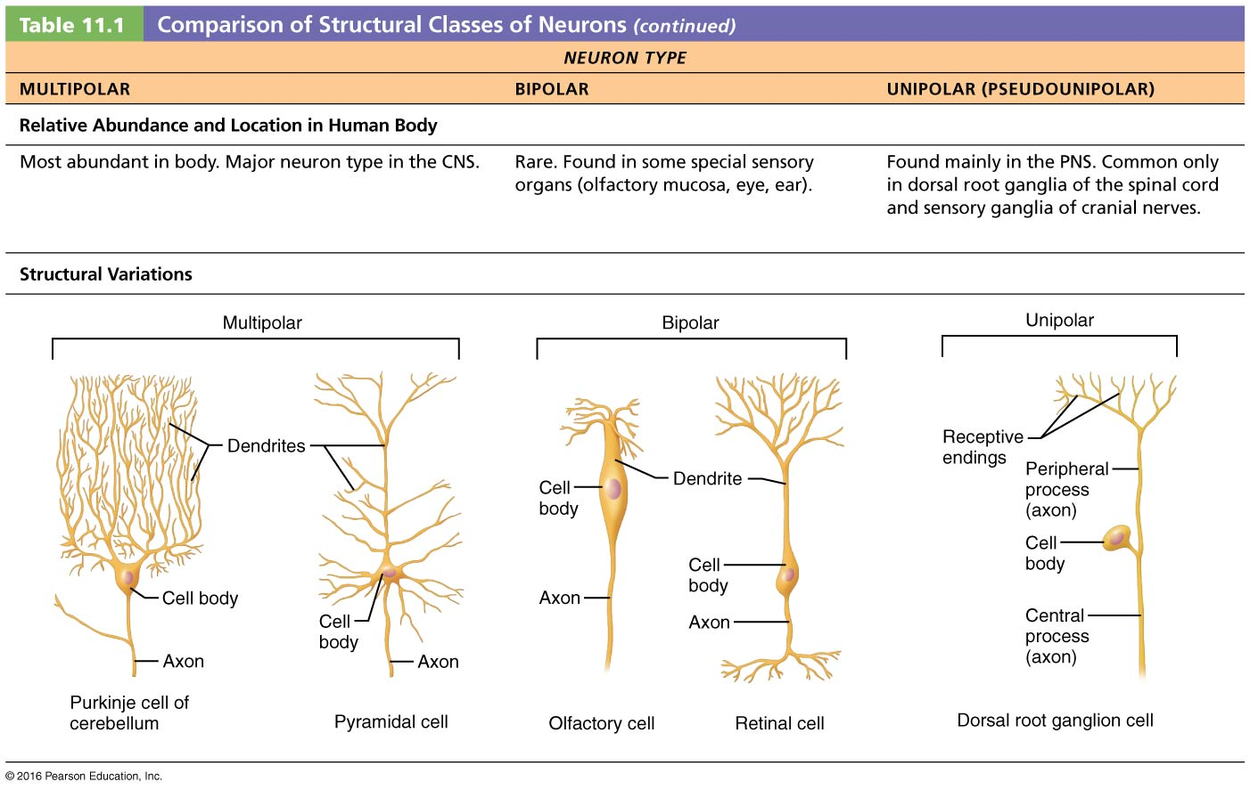

Functional Classification of Neurons
  - according to direction nerve impulse travels wrt CNS
  - sensory, motor & association neurons
- sensory: toward CNS; primary, secondary, tertiary
- except bipolar neurons in some special sense organs, virtually all primary sensory neurons are unipolar & cell bodies located in ganglia outside CNS
- higher order sensory neurons all multipolar & reside entirely within CNS – conduction to higher brain centers for interpretation
- motor: away from CNS to effector organs like muscle & glands; multipolar; most cell bodies reside in CNS
- association (interneurons): between sensory & motor neurons – integration of info; multipolar; most entirely within CNS; 99% of neurons of the body
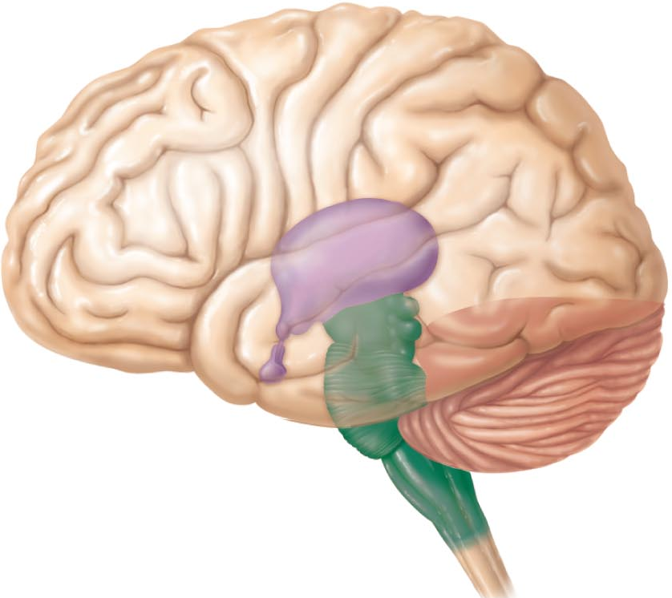
The Brain (jump to chapter 12 here)
• complexity of wiring rather than size is what matters
subdivisions:
cerebral hemispheres
diencephalon (thalamus, hypothalamus, epithalamus)
brain stem (midbrain, pons, medulla)
cerebellum

Arrangement of gray & white matter:
Spinal cord has central cavity surrounded by gray matter (…………………….) & white matter (………………………………)
Brain has same design, but with additional regions of gray matter;
cerebral hemispheres & cerebellum have outer “bark” of gray matter
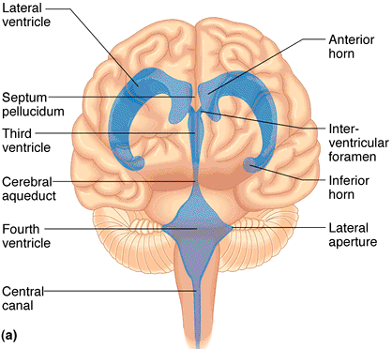
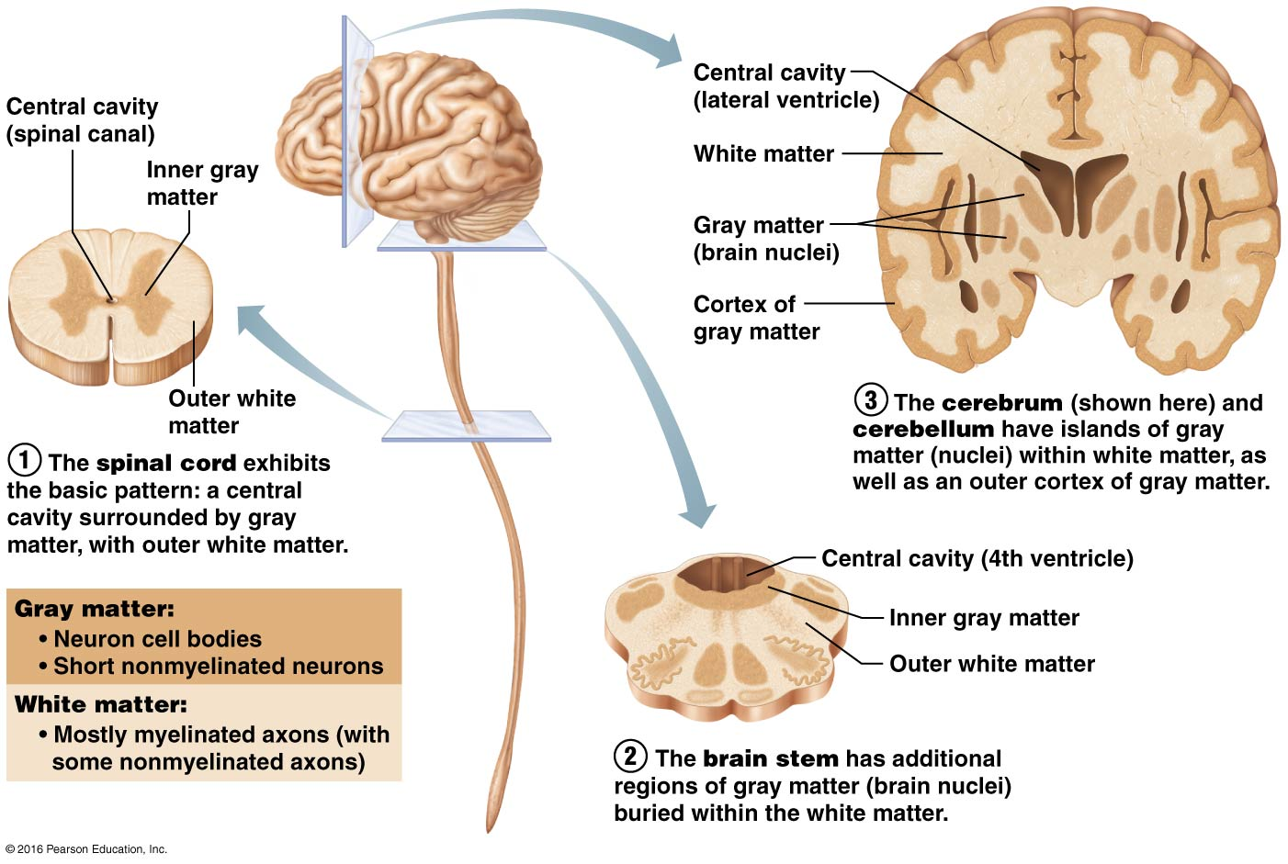

Ventricles of Brain:
continuous with one another and with central cavity of spinal cord; filled with CSF & lined by ependymal cells
- Paired lateral ventricles separated by narrow septum pellucidum
- Each communicates with narrow 3rd ventricle in diencephalon via interventricular foramen
- 3rd ventricle to 4th ventricle (dorsal to pons) via cerebral aqueduct
- 4th ventricle continuous with central canal
- 3 apertures (paired lateral apertures & median aperture) connect ventricles to subarachnoid space (surrounds brain)

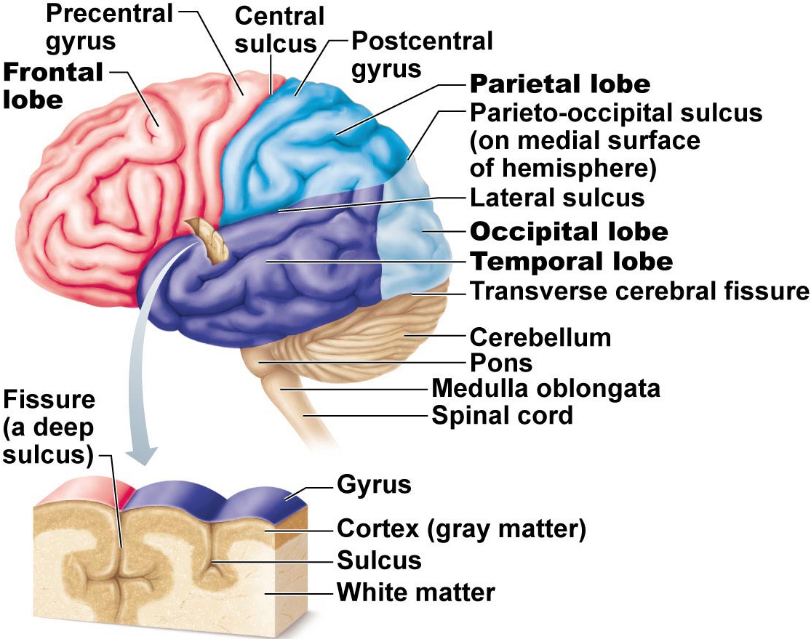
The Cerebral Hemispheres
- superior; ~83% of brain mass
- gyri separated by sulci; anatomical landmarks
- longitudinal fissure; transverse cerebral fissure
- Lobes: frontal, parietal, occipital, temporal, insular
- central sulcus: precentral/postcentral gyrus
- parieto-occipital sulcus, lateral sulcus

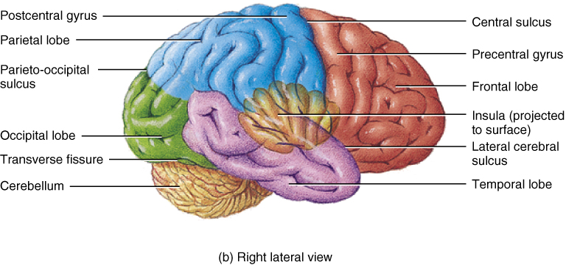

Cerebral cortex:
- allows us to perceive, communicate, remember, understand, appreciate, initiate voluntary movements -- conscious behavior
- cell bodies, dendrites & unmyelinated axons; only 2-4 mm thick, but many convolutions triple surface area
- Brodmann areas: numbered according to subtle differences in thickness, structure of contained neurons; some areas link with particular functions; other functions (memory & language) have overlapping domains; more diffusely organized
- 3 functional areas: motor, sensory & association
- each hemisphere handles sensory & motor functions of opposite side of body
- largely symmetrical, but not 100% equal in function (lateralization)
- no functional area of cortex acts alone; all conscious behavior involves entire cortex in some way

Motor Areas:
- posterior part of frontal lobes: primary motor cortex, premotor cortex, Broca’s area & frontal eye field
- 1) Primary motor cortex: - precentral gyrus of frontal lobe of each hemisphere; pyramidal cells allow control of skeletal muscles; axons project to spinal cord as pyramidal/corticospinal tracts
- entire body represented spatially in primary motor cortex of each hemisphere – somatotopy
- which areas require most precise motor control?
- motor innervation is contralateral

