Human Resource Management: Recruitment Labour Relation

Most Important Asset for A Company: Human Resources
Human Resource Management: Function of attracting, developing, and retaining employees who can perform activities needed for organizational objectives

3 Main Objectives for HR:
- Providing qualified, well trained employees
- Maximizing employee effectiveness
- Satisfying individual employee needs (monetary compensation, benefits, opportunities to advance, and job satisfaction)

Goals of HR:
- Locate – people best suited for the job
- Develop – train and provide employees w/ necessary knowledge & assets to do job efficiently & effectively
- Retain – continually motivate employees to better the company

- RECRUITMENT & SELECTION

-Recruiting techniques continue to evolve as technology advances
-Internet recruiting is quick, efficient, and inexpensive

Selecting and Hiring Employees:
- Identify job requirements
- Choose sources of candidates
- Review applications and resumes
- Interview the candidate
- Conduct employment tests and check references
- Conduct follow-up interviews
- Select a candidate and negotiate an offer

- TRAINING & PERFORMANCE EVALUATION

Performance Appraisals:
Performance Appraisals: evaluation of and feedback on employees’ job performance

Tasks of Performance Assessment (Cycle): Define expectations, measure and evaluate, provide feedback, record performance

- COMPENSATION & BENEFITS

Compensation:
Compensation: Amount employees are paid in money and benefits
Wage: Pay based on hourly rate or amount of work accomplished
Salary: Pay calculated on periodic basis (weekly, monthly)

Compensation is based on five factors:
- What competition is paying
- Government regulations
- Cost of living
- Company profits
- Employee’s productivity

Incentive Compensation:
- Profit sharing – bonus based on company profits
- Gain sharing – bonus based on productivity gains, cost savings, or quality improvements
- Lump-Sum bonus – one time cash payment or option to buy shares of company stocks
- Pay for knowledge – salary increase based on learning new job tasks

Employee Benefits:
Employee Benefits: additional compensation paid for by company
-By law, Canadian pension plan, unemployment insurance, and worker’s compensation programs are a mandatory benefit
-Benefits can be flexible based on the company offering them and their expense budget

Flexible Work:
-Allows for employees to adjust work conditions to accommodate personal needs

Flextime: employees can set their own work hours within constraints specified by the firm

Compressed Workweek: employees work regular number of weekly hours in fewer days than normal

Job Sharing Program: 2or more employees to divide the tasks of one job

Home-Based Work Program: employees or telecommuters to perform jobs from home

- SEPERATION

Employee Separation:
Voluntary Turnover: employees may leave firms to start their own business, take jobs w/ other firms, or retire
Involuntary Turnover: employers terminate employees because of poor job performance, unethical behaviour, or for downsizing

Downsizing/Outsourcing:
Downsizing: process of reducing # of employees

Outsourcing: using outside vendors to produce good and services and functions that used to be handled by company itself or establishments within the country
-Outsourcing is done to save expenses, & remain flexible

- PLANNING STAFFING NEEDS

Planning: Must align staff support needs to an appropriate space

MOTIVATING AND ENGAGING EMPLOYEES

Motivating Employees:
-Good employee morale (mental attitude)
-High morale occurs where workers feel valued, heard, and empowered
-Poor morale shows through absenteeism, voluntary turnover, and lack of motivation
-Need produces motivation which leads to goal directed behaviour resulting in satisfaction of that need
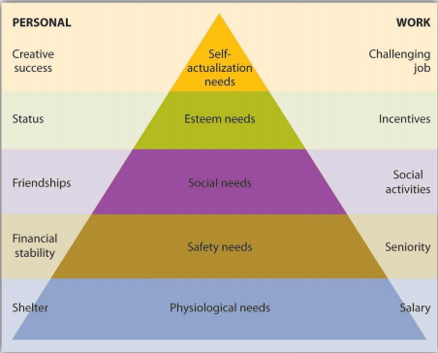
Maslow’s Hierarchy of Needs:
-Unsatisfied needs influence behaviour
-5 Levels of Needs:
- Physiological needs
- Safety needs
- Social (belongingness) needs
- Esteem needs
- Self-actualization needs

Herzberg’s Two-Factor Model:
Hygiene Factors: result in satisfaction
Ex. salary, job security, status, tech supervision, etc.

Motivator Factors: produce high levels of motivation if present
Ex. job responsibilities, achievement, recognition, growth opportunities, etc.

Expectancy Theory:
Expectancy Theory: process people use to evaluate the likelihood that their efforts will lead to the results they want
-Effort, performance, reward
Equity Theory:
Equity Theory: individual’s perception of fair and equitable treatment

Goal-Setting Theory:
Goal: target, objective, or result that someone tries to accomplish

Goal Setting Theory: idea that people will be motivated by accepting challenging goals and receiving feedback that shows progress toward goal achievement
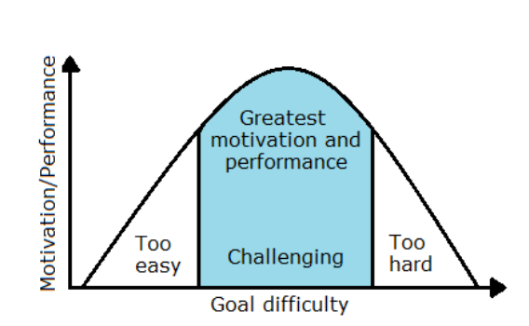

A goal should be S.M.A.R.T. –

Specific
Measurable
Assignable
Realistic
Time-based

APPROACHES TO MANAGING EMPLOYEE BEHAVIOUR IN FIRMS

Management by Objectives (MBO):
-Structured approach that helps managers to focus on goals and achieve best results based on organization’s resources
-MBO helps motivate individuals by aligning their objectives w/ goals of organization

Key Elements of MBO:
- Goal specificity
- Participative decision making
- Explicit performance period
- Performance feedback

Job Design & Motivation:
Job Enlargement: expands an employee’s responsibilities by increasing tasks assigned

Job Enrichment: expands employee’s job duties to empower employee to make decisions and learn new skills leads to career growth

Job Rotation: involves systematically moving employees one job to another, increasing range of activities

Theory X, Y, & Z:
X: assumes that employees dislike work and try to avoid. Managers must coerce.
-Money and job security are motivators

Y: assumes employee likes work and seek/accept greater responsibility
-Self-control and self-direction are motivators

Z: worker involvement is viewed as being key to increased productivity for company and improved quality of life for workers

