HSS1101 FINAL EXAM
150-160 MCQ

Ch. 9 – Recognizing Use, Misuse, Abuse and Addiction to Drugs and Behaviours (pg. 261-281), 15 Q

2 – Drug Use, Misuse and Abuse (pg. 262-263)
Drug use – taking drug, as intended
- E.g. taking over-the-counter pain reliever when you have a headache
Drug misuse – taking drug, not prescribe; using a way it was not intended
- E.g. using someone else’s prescription for the same malady or the effect of drug
- Not prescribed to you, even if using it for intended sickness – misuse
- Not taking prescription or OTC drugs according to directions and not completing full dose of prescription
Drug abuse – excessive use of drug, where excessive use is individually determined (difficult to quantify, according to body size, sex, previous use, etc.)
- According to your motivation for taking drug, e.g. taking a higher than prescribed dose of a prescribed medication for the euphoric effect
Drug profile – identifies that active ingredients, receptor sites affected, main effects, side effects, potential interactions w other drugs you use, and any potential adverse rxns
Individual Response: Set and Setting
- Response to drug involve more than amount or behaviour involved
- Main effect – intended rxn(s) to a drug; reason for which drug was taken, general purpose
- Side effect – unintended rxn(s) to drug; other effects, not often desired
Response to drugs is influenced by:
- Set – internal environment or mindset, at the time you take the drug or engage in a behaviour
  - Expectations of what drug will or will not be
  - Believing a drug can make you better – placebo effect
  - Related to mood – mood to party more likely to feel effects of alc faster
  - Elderly more susceptible to set – often experience more placebo and side effects w their prescription and OTC drug
- Setting – total external environment or mindset, at time you take drug or engage in a behaviour; encompasses physical and social aspects of environment
  - Loud place, w friends – more likely drug will produce greater effect

3 – Defining Addiction (pg. 263-265)
Addiction – persistent, compulsive dependence on behaviour, substance
- Addicted to substance or behaviour – academic performance or work suffers, relationships deteriorate, economic hardships develop, -ive effects on physical, emotional and social health
Aspect of addition include (exhibit at least 3):
- Excessive use of a substance, behaviour – use greater quantity or persist over longer period of time than intended
- Persistent desire or makes unsuccessful efforts to reduce or control use
- Spends great deal of time getting or using substance or engaging in behaviour or recovering from its effects and after-effects
- Frequent incapacitation or intoxicated due to use – by after-effects of drug or behaviour to fulfill major obligations
- Gives up regular activities – to use or engage
- Continues to use or participate despite having problems w it
- Develops physical tolerance – needs to engage or use more to get same effect
- Exhibits withdrawal when not using or engaging
- Substance, behaviour: to avoid withdrawal symptoms
- Psychological dynamics play important role in addiction
  - Explains addictive behaviours not related to use of chemicals (e.g. gambling)
- Every psychological state, there is a corresponding physiological state
Chems and drugs responsible for most profound addictions
- Produce dramatic mood changes
- Cause cellular changes that body adapts to that it eventually requires the chem in order to function normally
Particular behaviour to b addictive – must have potential to create positive mood
- Results in chem change in body such that engaging in behaviour is needed to feel normal
All forms of addiction likely reflect a dysfunction of certain biochemical systems in brain
4 – The Physiology of Addiction
Neurotransmitters influence receptor cites (nerve cells)
- Drug use and chronic stress can alter receptor sites and cause the production and breakdown of neurotransmitters
- Mood-altering chems fill up receptor sites for body’s natural “feel-goof” neurotransmitters (endorphins)
- Nerve cells fooled into thinking they have enough and shut down production temporarily
- Drug use stops – receptor sites become emptied, results in uncomfortable feelings that won’t stop until neurotransmitter production resumes or more drug consumed
May be “wired” to seek substances that increase pleasure or reduce discomfort
- Some ppl’s body’s always produce insufficient quantities of neurotransmitters
- Naturally seek chems (e.g. alc) as subs or pursue behaviours like vigorous PA/exercise or thrill-seeking activities– produce natural production
Tolerance: larger dose, to obtain desired effects
Withdrawal: drug causes an effect the body creates by itself
- Experience directly opposite to effects experienced when engaging (chem)
  - E.g. cocaine – “crash” (depression and lethargy)
- Addictive behaviours – usually less dramatic, still profound experience
- Severest form of withdrawal – delirium tremens (DTs)
  - Occurs in approx. 5% of ppl withdrawing from alc
  - Hallucinations, disorientation, tachycardia, hypertension, fever, agitation
  - Ppl addicted to alc for more than 10 yrs or ppl when they stop after period of several months of heavy drinking
5 – The Addictive Process
Nurturing through avoidance – maladaptive way of taking care of emotional needs; repeatedly seeking the illusion of relief from drug or behaviour to avoid unpleasant feelings or situations
- Behaviours or drug no longer pleasurable, still preferable to unhappy realities and withdrawal symptoms

Signs of Addiction
Four commonalities:
(1) Compulsion – obsession or excessive preoccupation; overwhelming need for it
(2) Loss of control – inability to predict reliably whether any isolated involvement will be healthy or damaging
(3) Negative consequences – physical damage, legal trouble, financial problems, academic failure, relationship difficulties, and family dissolution as a result of continued engagement
(4) Denial – inability to perceive that there is a problem resulting from engagement, that it is self-destructive
Relapse – tendency to return to addiction after period of abstinence

6-7 – Addictive Behaviours (pg. 265-267)
Gambling
- Video lottery terminals: role in gambling problems
- Use gambling to escape problems, lie to family members to conceal gambling
- Ppl addicted gamble for excitement, not money making possibility
  - Place increasingly higher bets to achieve desired level of excitement or euphoric feeling – similar to what person who uses drugs seeks
- More men than women; increasing among students
- Unable to control urge to gamble – even when faced w devastating consequences
Shopping and Borrowing
- Excessive spending on purchases
- Easy credit (companies target students) – “buy now, pay for it later”
- Some ppl spend money to meet emotional needs not fulfilled elsewhere
  - Anxiety, self-doubt, and anger can lead to spending as a way of coping w daily stressors
- Gambling, shopping can lead to compulsive borrowing
  - Irresponsible investments and purchases lead to debts that the individual who is addicted tries to repay by borrowing more
Exercise Addiction
- Exercise, a powerful mood enhancer (addictive)
- Lots of ppl w eating disorders – use exercise to purge instead of, or in addition to, self-induced vomiting
- Ppl who are addicted do so compulsively to treat to meet their needs for nurturance, intimacy, self-esteem, -competency – that an object or activity can’t truly meet
Warning signs
- Working out alone, following same rigid workout pattern, exercising for 2+ hours daily repeatedly, fixation on weight loss or calories burned, exercising when sick or injured, exercising to point of pain and beyond and skipping work, class or social plans for workouts
Consequences
- Alienation from friends and fam, injuries from overdoing, and craving for more
Technology Addictions
- Risk of overexposure has grown
  - Phones, video games, social media
- 1/8 internet users will experience internet addiction
  - Younger ppl more likely to be addicted than middle-aged
Symptoms
- Disregard for health, sleep deprivation, neglecting fam and friends, lack of PA, euphoria when online, lower grades in school, poor job performance
- Moody or uncomfortable when not online
- Use to compensate for feelings of loneliness, martial or work probs, poor social life, or financial probs

8 – Managing an Addiction (pg. 267-268)
Intervention – planned process of confrontation
- By significant others; break denial compassionately
- Individuals see destructive nature of addiction
- Once accomplished: treatment and recovery can begin
Treatment and Recovery
- Begins w abstinence – refraining from addictive behaviour or substance
  - Does little to change personality and psychological dynamics or biological and environmental influences behind addictive behaviours
- Recovery also involves learning new ways of looking at oneself, others and world
  - Replace addictive behaviours w less harmful or addictive ones
  - Exploration of traumatic past so psychological wounds can heal
Forms of therapy:
- Individual, group, family
- 12-step, alternatives to 12-step

9 - Drug Dynamics (pg. 268-269)
- Drugs work bc they physically resemble the chems produced naturally within body
- Drugs attach to receptor sites in the body
  - Receptor sites: specialized proteins found in all body cells
- Cells and tissue have different receptors
  - Different drugs, different effects
10 – Figure 9.1 How the Body Metabolizes Drugs (pg. 269)
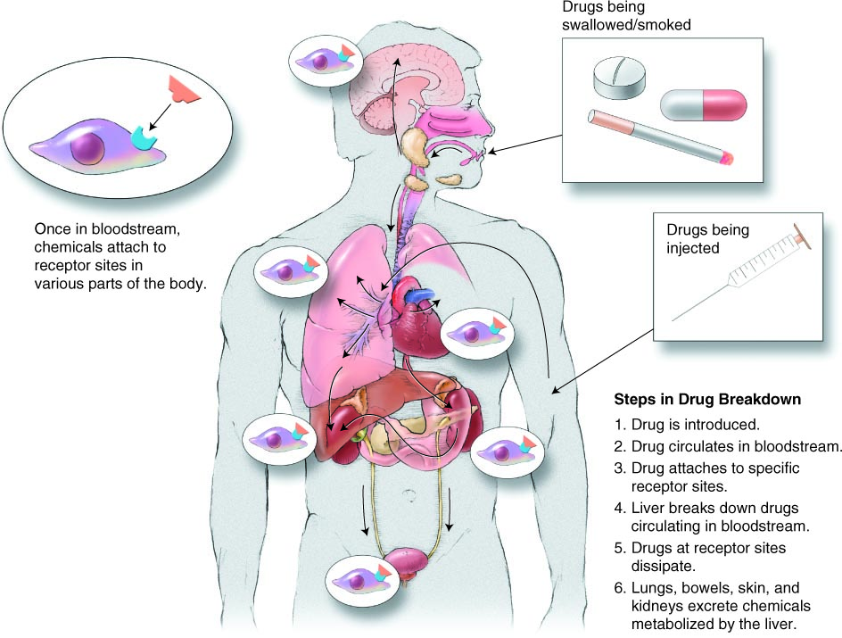

11-12 – Types of Drugs (pg. 269-271)
Psychoactive drug – alter moods or behaviours
Six categories of drugs:
(1) Prescription drugs – can only be obtained with a written prescription from physician
- E.g. Tylenol w Codeine for pain relief, Lipitor for reducing cholesterol, Pariet for stomach discomfort often related to anxiety
(2) Recreational drugs – used to relax or socialize during recreational time
- E.g. alcohol, tobacco, caffeine – are legal even though they are psychoactive
- Some may place illegal drugs such as marijuana in this category too
(3) Over-the-counter (OTC) drugs – purchased w/o prescription from physician
- Grocery or drug store
- E.g. Pain relievers such as Tylenol, Advil and Aspirin
  - Another large section includes various remedies aimed at relieving symptoms due to coughs and colds
(4) Herbal preparations – substances of plant origin believed to have medicinal properties
- At least 750 substances including herbal teas and other products of botanical origin
- Uses whole plants (most often unpurified extract) or a combo of herbs, and diagnostic principles based on treating the “underlying causes” of health issue
(5) Illicit drugs – whose use, possession, cultivation, manufacture and/or sale are illegal
- Psychoactive
- E.g. marijuana, cocaine, heroin, and many others
(6) Commercial preparations – commonly used chemical substances w drug action
- Most universally used yet least commonly recognized as products w a drug action
- E.g. perfumes, cosmetics, household cleansers, paints, glue, inks, dyes, gardening chems, pesticides and industrial by-products
13 – Routes of Administration of Drugs
Def. – manner in which a drug is taken into body
(1) Oral ingestion – intake of drugs through mouth
- Most common method for taking drugs and includes tablets, capsules and liquids
- Relatively slow absorption – drug must pass through stomach where it is acted on by digestive juices, then moves to small intestine before entering bloodstream
  - Alc is exception – majority absorbed into bloodstream w/o digestion
- Many that may irritate stomach are coated to keep them from being dissolved in stomach acids before they reach intestine – protect stomach lining from irritation
- Food in stomach – drug absorption is slower compared to empty
(2) Injection – introduction of drugs into body via hypodermic needle
- Rapid absorption, speed depends on type
- Intravenous – injection directly into vein, most concentrated form directly into bloodstream; feel effects within 3 mins
- Illicit drugs injected – high risk of overdose bc user may not b able to effectively control the dose, and once injected effects can’t be slowed
- Diseases can be transmitted through needle use (hepatitis, HIV)
- Intramuscular – injection directly into muscle; slower absorption
- Buttocks or triceps on back of upper arm
- Slow and consistent dispersion of drug into body’s tissues (flu shot)
- Subcutaneous – injection into layer of fat directly beneath skin
- Local anaesthetics and insulin replacement therapy
- Slowest, takes longer to b absorbed into bloodstream
(3) Inhalation – introduction of drugs through nostrils
- Rapid transfer into bloodstream through alveoli (air sacs) in lungs
- Effects felt immediately, don’t last long bc only small amounts can b absorbed and metabolized in lungs
- Risk – amount of drug consumed is not known, overdose chances are high
- E.g. nasal sprays, and inhalation of aerosol sprays, gases or fumes from solvents
(4) Innunction – introduction of drugs through skin (epidermal)
- E.g. adhesive patches used to alleviate motion sickness or nicotine patches
- Slowly release their chems for a consistent dispersal of drug so that drug’s effects are long lasting
(5) Suppositories – mixtures of drugs and a waxy medium where the drug is slowly released when the wax melts in the vascular regions of anus or vagina
- Many blood vessels, effects felt within 15 mins

14 – Drugs Interactions (pg. 271-272)
Synergism: interaction 2+ drugs; effects of individual drugs are magnified beyond what is expected of their individual contribution
- Most likely to occur when CNS depressants (alc, opiates, antihistamines, sedative hypnotics, minor tranquilizers and barbiturates) are combined
- Worst – alc and barbiturates; combo leads to slowdown of brain centres that normally control vital functions
  - Respiration, HR and BP can drop to point of coma or death
Antagonism: one drug blocks action of another at the receptor site
Inhibition: one drug eliminates effects of another drug
Intolerance: 2+ drugs, together produce uncomfortable reactions
Cross-tolerance: tolerance to one drug that carries over to another similar drug

15 – Prescription Drugs (pg. 273-275)
Types of Prescription Drugs
- Antibiotics – fight bacterial infection; intramuscular injection or tablet or capsule
- Sedatives – CNS depressants that induce sleep or relieve anxiety; high potential for addiction
- Tranquilizers – taken to relax body and relieve anxiety; CNS depressant;
- Antidepressants (SSRIs) – used to treat clinically diagnosed depression; inhibit release of certain neurotransmitters in brain, thereby moderating user’s mood
- Amphetamines – suppress appetite and increase breathing rate, BP and HR; stimulants, prescribed less commonly now; tolerance develops quickly
  - User trying to cut down or quit may experience rebound effects – severe withdrawal effects, including depression, nausea and violent behaviours
- Analgesics – pain relievers; available as prescription and OTC;
16 – Use of Generic Drugs
Generic Drugs – sold under chemical name rather than a brand name
- Contain same active ingredients
- Controversy surrounding effectiveness
- Lower costs

17-18 – Over-the-Counter (OTC) Drugs (pg. 275-276)
Types of OTC Drugs
Analgesics – pain relievers; work at receptor sites by interrupting pain signals
- Some nonsteroidal anti-inflammatory drugs (NSAIDS), also called prostaglandin inhibitors – inhibit production and release of prostaglandins where prostaglandins are released by body in response to pain
Cold, Cough, Allergy and Asthma Relievers
Designed to alleviate or reduce some or all of discomforting symptoms associated, no drug exists that cures; provide temp relief until sufferer’s immune system prevails
- Expectorants – formulated to loosen phlegm, allowing user to cough and clear congested respiratory passages
- Antitussives – calm or curtail cough reflex, most effective when cough is “dry” (doesn’t produce phlegm)
- Antihistamines – CNS depressants that dry runny noses, clear postnasal drip and sinus congestion and reduce tears
- Decongestants – designed to reduce nasal stiffness due to colds (clears sinus, more intense)
- Anticholinergics – often added to cold preparations to reduce nasal secretions and tears (prevent cramping and spasms)
Stimulants – active ingredient in most is caffeine
- Caffeine heightens wakefulness, increases alertness and relieves fatigue
- Also increased nervousness, irritability, anxiety and involuntary muscle twitches
- Energy drinks – contain caffeine + other drugs, used to provide energy when needed
Sleeping Aids and Relaxants – induce drowsy feelings that precede sleep
- Principal ingredient – antihistamine called pyrilamine maleate
Dieting Aids - laxatives or diuretics used to achieve weight loss; “water pills”
- Laxative – soften stool and relieve constipation; deplete body of needed fluids, salts and minerals
- Diuretics – increase excretion of urine from body
Inhalants – sniffed or inhaled in order to produce highs, chemicals that produce vapours
- E.g. petroleum products – rubber cement, model glue, paint thinner, lighter fluid, varnish, wax, spot removers, and gasoline

Ch. 2 – Promoting and Preserving Your Psychosocial Health (pg. 26-52), 19 Q

2 – Defining Psychosocial Health (pg. 27-33)
Def. – the intellectual, emotional, social and spiritual dimensions of health
3-4 – People who are Psychosocially Healthy
- Feel good about themselves
- Feel comfortable with other people
- Control tension and anxiety
- Meet the demands of life
- Curb hate and guilt
- Choose a positive outlook
- Enrich the lives of others
- Cherish things that make them smile
- Value diversity
- Appreciate and respect nature
6 – Intellectual Health: The Thinking You
Def. – “thinking” part of psychosocial health – includes values, attitudes and beliefs
Rational parts of psychosocial health, the ability to:
- Perceive things realistically
- Use reasoning in problem solving
- Interpret what is happening accurately
- Evaluate situations and react appropriately
- Take responsibility for actions
Person’s intellectual health deteriorates:
- May experience sharp declines in rational thinking and increasingly distorted perceptions
- Cynical and distrusting – mood swings, isolation
- Sharp declines may indicate poor mental health
7 – Emotional Health: The Feeling You
Def. – the “feeling” part of psychosocial health; the “feeling” reactions to life
- Subjective side of psychosocial health
Emotions – intensified feelings or complex patterns of feelings we experience; described as interplay of 4 components:
- (1) Arousal, (2) feelings, (3) cognition and (4) behaviours
  - Respond appropriately to upsetting or uplifting events
  - Not let one’s feelings overpower one’s self
- Learning to acknowledge that it’s okay to feel sad, unhappy, etc. and getting help (counseling, friends) – health process of adapting and coping
Poor emotional health = poor social health
- Social isolation – one of many potentially –ive consequences of unstable emotional responses
- Poor emotional health may be impact on academic performance
  - Emotional turmoil seriously affects ability to think clearly, reason or act in a rational way
8 – Social Health: Interactions with Others
Two factors in particular important to social health:
(1) Presence of Strong Social Bonds – degree or nature of interpersonal contacts, provide 6 major functions
- Intimacy
- Feelings of belonging to or integration w a group
- Opportunities for giving or receiving nurturance
- Reassurance of one’s worth
- Assistance and guidance
- Advice
- More connected to others – manage stress more effectively
(2) Presence of key Social Supports – structural and expressive aspects of social interactions; relationships that bring +ive benefits
- Can be expressive (emotional support, encouragement) or structural (housing, money)
Ability to: interact with others individually or in groups, use and provide social support and adapt to a variety of social situations
- Promotes physical and mental health
- Lack of social health may result in prejudice, bias
9-11 – Spiritual Health: An Inner Quest for Well-Being
Def. – search for meaning, connectedness, energy and transcendence, rather than simply a connection to a particular religion
- Source of strength and hope
- Source of a sense of purpose
Discover that material world cannot bring sense of happiness or self worth
- Recognition of uniqueness, place in the universe
- Connected to other dimensions of health
- Enhancing spiritual health: time, effort
10 – 4 major themes (in image)
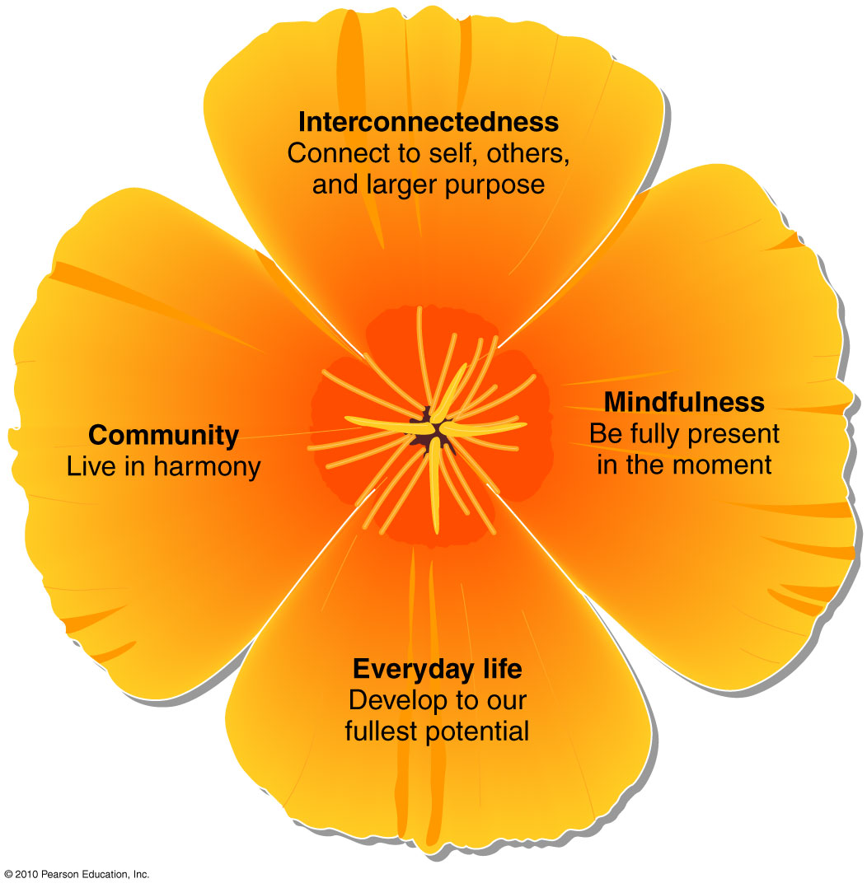

11 – Spirituality: A Key to Better Health
- More spiritually orientated students had better health, higher grades, more involvement in charitable organizations or volunteering and more interest in helping others
A Spiritual Resurgence
- Increase in spiritual awareness doesn’t necessarily mean an increase in belief in a god or supreme being of some kind
- May find fulfillment in music, poetry, art, nature or intimate relationships
Putting Spirituality into Practice
- Give yourself time to pause and reflect on life
Strategies for Finding Your Spiritual Side
- Volunteer
- Take time to reflect
- Get involved in service learning

12 – Factors Influencing Psychosocial Health (pg. 33-36)
- Most of psychosocial health reactions to life are a direct outcome of your experiences, along w social and cultural expectations
External Influences
Def. – factors that you don’t control
Influences of the Family
- Healthy (more likely to become well-adjusted, productive adults) vs. dysfunctional (have harder time adapting to life)
- Not all ppl raised in dysfunctional fam become psychosocially unhealthy and vice versa
Influences of the Wider Environment
- Childhood environments – raised in bad environments, increased risk of psychosocial issues
- Protective factors – such as having one or more +ive role models in midst of chaos, or high level of self-esteem – may help kids from bad environments grow up healthy and well-adjusted
- Access to services and programs
13-14 – Internal Influences
Self-Efficacy and Self-Esteem
- Self-efficacy: belief in your ability to perform a task successfully
  - High self-efficacy, more likely to feel that you have personal control over situations or believe your internal resources to allow you to control events
- Self-esteem: sense of self-respect and worth
Learned Helplessness vs. Learned Optimism
- Learned helplessness – an attitude of giving up and not trying bc of past failures
  - Victimology – laying blame for own problems on others or on circumstances rather than accepting responsibility for actions or lack of actions
- Countering hopelessness, learned optimism – pattern of responding that focuses on the +ive, choose to view each sitch +ively and w a sense of hope
Personality – psychologically healthy traits
Possess following traits, likely to be psychologically healthy:
- Extroversion – ability to adapt to social sitch and demonstrate assertiveness as well as power or interpersonal involvement
- Agreeableness – ability to conform, be likeable, and demonstrate friendly compliance as well as love
- Openness to experience – willingness to demonstrate curiosity and independence (inquiring intellect)
- Emotional stability – ability to maintain control of feelings
- Conscientiousness – qualities of being dependable and demonstrating self-control, discipline and need to achieve
15 – Resiliency and Developmental Assets
- Resiliency: traits that protect from threat or harm (protective factors)
- Assets: positive forces that contribute to resiliency; financial, emotional, spiritual, physical, intellectual or social

16 – Enhancing Psychosocial Health (pg. 36-40)
- Attaining self-fulfillment is lifelong, conscious process
Developing and Maintaining Self-Esteem and Self-Efficacy
Developing a Support Group
- Old ties are often strongest – friends and fam from past can provide foundation of unconditional love
Being a Support for Others
- Feel better about yourself by helping others to feel good about themselves
Completing Required Tasks
- On time – not likely to succeed in studies if you leave them to night before due
Forming Realistic Expectations
- Assess current resources and direction you are heading – set small, incremental goals that are possible to meet
Making and Taking Time for You
- Viewing new activities (sport, volunteer, auditioning for a play) as something to look forward to and an opportunity to grow is important part of keeping excitement in life
Maintaining Physical Health
- Contributes to self-esteem and overall psychosocial health
- Regular PA, nourishing meals, adequate sleep
Eat More Veggies and Fruit
Examining Problems and Seeking Help
- Don’t need to deal w things alone
Getting Adequate Sleep
- Needed for physical and psychosocial (mental) functioning
- 6-9 hours of sleep a night recommended
- Sleep inertia – cognitive impairment, disorientation and grogginess you experience when you first get up in morning
- Wake up effectively and well rested – go to bed and wake up at same time
17 – Sleep debt – every night you don’t get 8 hours of sleep creates it; average college student gets 5 hours of sleep a night; 1 sem = sleep debt of 14 days
18 – Understanding The Mind-Body Connection
- Think about being in a good mood or feeling +ive about things, also tend to feel physically better
Happiness and Physical Health (positive benefits)
Happiness – feeling of contentment created when expectations and physical, psychological and spiritual needs are met and life is enjoyed
- Believed to reduce the risk or limit severity of CV disease, pulmonary disease, type 2 diabetes, hypertension, colds and other infections
- Laughter – increases H and respiration rates and reduces stress hormones in same way as PA; promoted as possible risk reducer for hypertension and other CV diseases
Subjective well-being (SWB) – an uplifting feeling of inner peace and/or an overall feel-good state; defined by 3 central components
- Satisfaction with present life
- Relative presence of positive emotions
- Relative absence of negative emotions
- May be biologically predisposed to happiness – may be related to actual differences in brain physiology
  - Neurotransmitters may function more efficiently when you’re happy
19 – Does Laughter Enhance Psychosocial Health?
Studies show:
- Stressed people + sense of humour = less depressed and anxious
- Students using humour as coping mechanism report positive mood
- Telling jokes: sense of belonging, social cohesion
Psychosocial Health and Well-being
- Although lots of evidence pointing to an association b/w physical and mental health, still much to learn
- Maintaining optimistic mindset continues to b sound advice – relates to improved quality of life, regardless of whether or not it increases quantity

20 – When Things Go Wrong (pg. 40-44)
Mental Illnesses – conditions that result in abnormal thinking, feeling, moods and behaviours and cause impaired functioning in daily life
- 1 in 5 Canadians will experience mental illness
21 – Depression
- Most common emotional disorder in Canada
- Generally b/w 15-30, females have a greater risk of depression
Two acknowledged forms of depression:
- Endogenous: biochemical origin/basis; neurotransmitters in brain responsible for mood elevation become unbalanced for unknown reasons
  - Not treated, can become chronic
- Exogenous: caused by an external event (death of loved one, martial break-up); slide into chronic if unable to work through grieving
Similar symptoms – lingering sadness, inability to find joy in pleasure-giving activities, loss of interest in work and reduced concentration, diminished or increased appetite, unexplainable fatigue, sleep disorders, loos of sex drive, withdrawal from friends and family, feelings of hopelessness and worthlessness, and desire to die
22 – Facts about Depression
- Not a natural reaction to crisis, loss
- People will not “snap out” with willpower
- Frequent crying is not a hallmark
- Depression is not “all in the mind”
- No “single” psychotherapy method for all cases
23 – Treating Depression
- Lifestyle modification (engaging in PA, eating well, managing stress, adequate sleep, developing strong social support system, etc.)
- Psychotherapeutic therapies:
  - Cognitive – aims to help person look at life rationally and address habitually pessimistic thought patterns; 6-8 months of weekly sessions comprising reasoning and behavioural exercises
  - Interpersonal – sometimes combined w cognitive; primary goal is to manage chronic issues w human relationships
- Attending a support group
- Taking medication (antidepressants)
24 – Seasonal Affective Disorder (SAD)
Def. – type of depression that occurs in winter months, when sunlight levels are low
- 2-3% of Canadians suffer from SAD
- 25% of Canadians report mild winter blues
  - Researchers believe caused by lack of light exposure
- People between 20-40 are most vulnerable
- SAD causes irritability and apathy (carb craving, weight gain, increases in sleep time and general sadness)
- Treatments: light therapy, diet, physical activity, stress management
  - 80% if ppl experience relief from symptoms after light therapy
- Not considered clinical, not as intense
25-26 – Anxiety Disorders
Def. – characterized by persistent feelings of threat and anxiety in coping w everyday problems
- Most common mental health problem
- Affects behaviour, thoughts, emotions, physical health
- Intense prolonged feelings of fright, distress
- Combo of genetics and personal circumstances
- Treatments: medications, cognitive-behavioural therapy
Obsessive-Compulsive Disorders: obsessive thoughts or habitual behaviours
- Obsessions (intrusive and illogical) are constant ideas, thoughts, impulses and images
- Common – contamination (wash hands many times before eating), doubts (not being sure whether lights were turned off), and disturbing sexual or religious thoughts
- More harmful behaviours – pulling out hair, eyebrows or eyelashes
Phobias: deep and persistent fear of a specific object, activity or sitch that results in a compelling desire to avoid the source of fear
Panic Disorders: sudden, rapid onset of disabling terror
- Can happen at any time, suddenly and unexpectedly
- Face turns red, cannot catch breath, nauseated, perspire, feel like you’re going to pass out or having heart attack
Post-Traumatic Stress Disorder: terrifying flashbacks, detachment and anxiety following a severe traumatic event (serious after-effects of an event)
- Common in soldiers – never relaxed
- Rape, abuse, assault, war, natural disasters, airplane or car crashes
27 – Schizophrenia
Def. – irrational behaviors, sever alterations of sense (hallucinations) and often, inability to function in society
- 1% of Canadians suffer from schizophrenia
- Alterations of the senses:
  - Hallucinations, inability to sort incoming stimuli
  - Altered sense of self, radical behaviour changes
- Brain damage involved occurs v early in life – possibly in fetal development
  - Most commonly has onset in late adolescence
- Treatable but not curable
- Slurred speech, poor hygiene

Sex Issues in Psychosocial Health (pg. 44)
28 – Depression and Sex
- Women twice as likely as men to develop depression
- Biologically – hormonally related sex differences – women’s hormone level changes observed during menstrual cycle, pregnancy, miscarriage, postpartum period, pre-menopause and menopause
- Multiple roles of women
- Men often mask depression by alc or drug use or by socially acceptable habit of working excessively long hours
- Different mechanisms for coping, women more at risk for developing
  - Men tend to distract themselves from depressed mood, women tend to focus on it
PMS: Physical or Mental Disorder?
- Characterized by depression, irritability
- Increased stress, prior to menstruation (day or two)
- Somewhat disruptive and uncomfortable – doesn’t interfere w daily function
Premenstrual Dysphoric Disorder (PMDD) – woman must have at least 5 symptoms of PMS for 7-10 days, at least 1 that is severe enough to interfere w ability to function at work or home

29 – Suicide: Giving Up on Life (pg. 44-47)
- 3,613 suicides reported in Canada in 2004
- 3 times higher in males than females
  - More women attempt
- 2nd leading cause of death, 15-24 year olds
- Rates: First Nations peoples, 3-8 higher than others
30 – Warning Signals of Suicide
- Making a plan or increased risk taking
- Talking, writing, or drawing about suicide
- Preoccupation with death
- Inability to let go of grief
- Withdrawal from friends and family
- Increased use of alcohol or drugs
31 – Taking Action to Prevent Suicide
- Monitor the warning signals
- Take any threat seriously
- Do not belittle the person’s feelings
- Let the person know you care
- Listen
- Ask directly, “Are you thinking of hurting yourself?”
- Help think of alternatives
- Tell the person’s friends, family, or counselor

32 – Seeking Professional Help (pg. 47-49)
Should consider if under following circumstances:
- Think you need help
- Experience wild mood swings
- Problem is interfering with daily life
- Fears or guilt is distracting
- Withdraw from others
- Feel inadequate or worthless
33 – Types of Mental Health Professionals
- Psychiatrist – licensed physician who specializes in treating mental and emotional disorders
- Psychoanalyst – psychiatrist or psychologist w special training in psychoanalysis (therapy where person is helped to remember early traumas that block personal growth)
- Psychologist – person w a PhD and training in clinical or counseling psychology
- Clinical/Certified/Psychiatric Social Worker – person with a master’s degree and at least 2 years of clinical training
- Counsellor – person w a variety of academic and experiential training who deals w the treatment of emotional probs
- Psychiatric Nurse Specialist – nurses that have chosen to continue their education and specialize in psychiatric practice
34 – What to Expect When You Being Therapy
- Explain your needs
- Provide a personal history
- Be honest and trust your therapist
- Not to expect therapist to give answers
- Set own goals and timetables
- Change therapist, if not good fit

Ch. 7 – Committing To Relationships and Sexual Health (pg. 190-221), 14 Q

2 – Communicating: A Key to Establishing Relationships (pg. 190-192)
Communicating How You Feel
- Ppl differ in comfort when expressing
- Assertive – directly and honestly communicate needs
Improving Communication Skills
Learning Appropriate Self-Disclosure
Def. – sharing personal info with others
- Revealing how you are reacting to the present sitch and giving info about the past relevant to the other person’s understanding of your current rxns
Becoming a Better Listener
Listen best when
- Believe that the msg is important and relevant to you
- Speaker holds your attention through humour, dramatic effect, use of media or other techniques
- In the mood to listen (free of distractions and worries)
- Ppl gravitate towards ppl who seem to understand and agree w them and have they have fun and interesting reactions
- Tuned-out behaviour – lack of sleep, stress, preoccupation, drunkenness, or being under influence of drugs
Skills to become a better listener: be present in the moment, use +ive body language and voice tone, express empathy not necessarily sympathy, ask for clarification, control desire to interrupt, avoid snap judgments based on what ppl look like or what they say, resist from “setting ppl straight”, try to focus on speaker and be tenacious

3 – Characteristics of Intimate Relationships (pg. 192-193)
Def. – close relationships w other ppl in which you offer, and are offered validation, understanding and a sense of being valued intellectually, emotionally and physically
- Define intimate relationships in terms of 3 characteristics – behavioural interdependence, needs fulfillment and emotional attachment
Needs, which may often be met only through relationships w others, are:
- Need of approval and sense of purpose
- Intimacy
- Social integration
- Nurturing others and being nurtured
- Reassurance of self-worth
Emotional availability – ability to give to and receive from other ppl emotionally w/o being inhibited by fears of being hurt

4 – Forming Intimate Relationships (pg. 193-197)
Families: The Ties That Bind
- Modern family – different from previous generations
- Families – care, protect, love and socialize
Today’s Family Unit
- Family of origin – includes ppl present in the household during child’s first years of life (usually parents and siblings)
  - Impacts child’s psychological, social, spiritual development
5 – Establishing Friendships
Includes:
- Enjoyment and acceptance
- Trust and respect
- Mutual assistance
- Confiding and understanding
- Spontaneity
6 – Significant Others, Partners, Couples
Typical include characteristics of friendship as well as the following related to passion and caring:
- Fascination
- Exclusiveness
- Sexual desire
- Giving the utmost
- Being a champion/advocate
Both friendships and relationships share: common bonds of nurturance, enhancement of personal well-being, and a genuine sense of mutual regard, trust and security
7 – This Thing Called Love
Companionate love – secure, trusting attachment, reciprocal liking, respect; friends and family members
Passionate love – high arousal (ecstasy of being loved or agony of being rejected)
- 3 conditions: culture of love (concept is idealized), suitable person and physiological arousal
8 – “Triangular Theory of Love”

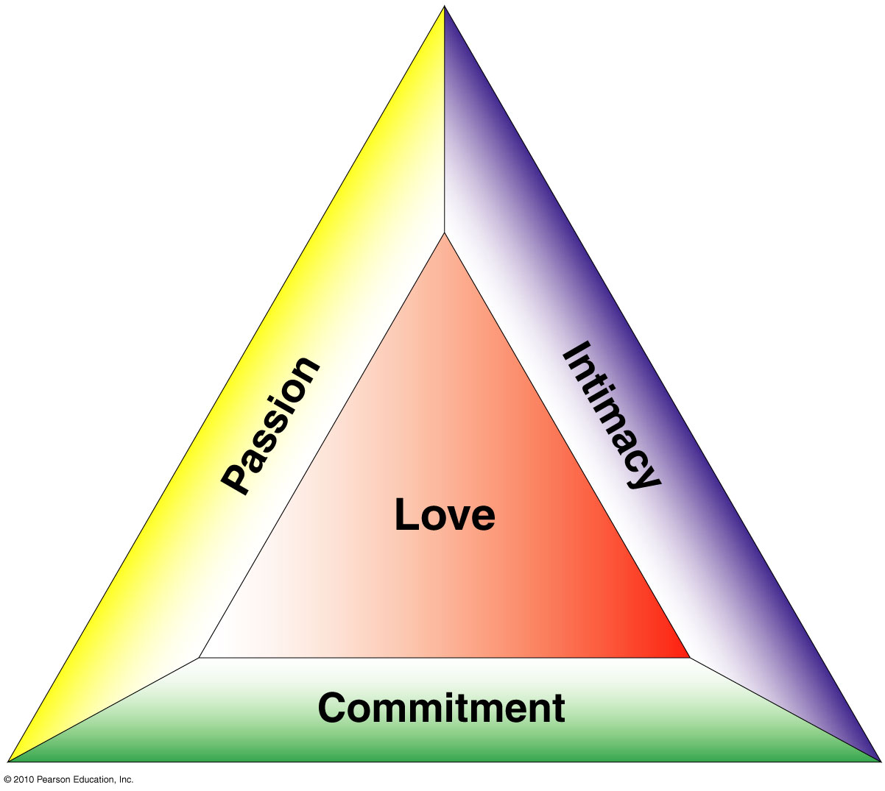

Another theory – based on brain circuitry and chemistry, follows pattern based on:
- Imprinting
- Attraction, neurochemicals produce feelings of euphoria and elation
- Attachment, endorphins (natural opiates) cause lovers to feel peaceful, secure and calm
- “Cuddle chemical” (oxytocin), stimulate sensations during sex and eliciting feelings of satisfaction and attachment
9 – Gender Issues (pg. 197-198)
Why The Differences?
- Different development patterns for boys and girls
  - Boys get separated from mothers whereas girls don’t
  - Men, intimacy may consist of physical proximity rather than verbal sharing
- Different attraction criteria
- Emotions generate sexual feelings in females, sexual feelings generate emotion in men
Picking Partners: Similarities and Differences b/w Genders
- Proximity – the more you see a person, more likely for an interaction to occur
- Similarities – attitudes, values, intellect, experiences, interests
- Attraction (physical) – men, youth and physical attractiveness; females, greater emphasis on partners who are older, good financial prospects, dependable and industrious

10 – Barriers to Intimacy (pg. 198-199)
Lack of personal identity, emotional immaturity, poorly developed sense of responsibility
Dysfunctional Families
Def. – a family in which the interaction b/w members inhibit rather than enhance psychological growth
- Ability to sustain genuine intimacy is largely developed in family of origin
- Refers to settings where negative interactions are the norm
- Children of alcoholics, survivors of abuse – sometimes likely to struggle
11 – Jealousy in Relationships
Def. – an aversive rxn evoked by a real or imagined relationship involving a person’s partner and another person
- Sign of underlying problems that are a significant barrier to a intimate relationship
- Overdependence on the relationship
- High value placed on sexual exclusivity
- Severity of the threat
- Low self-esteem
- Fear of losing control

12 – Committed Relationships (pg. 199-201)
Commitment in relationships – refers to an intent to act over time in a way that perpetuates the well-being of the other person, you, and the relationship
- Committed vs. not – willingness of partners to dedicate themselves to acquiring and using the skills that will ensure a lasting relationship
Marriage
- Enter into a legal agreement, includes finances, property and responsibility for raising children
- Monogamy – exclusive sexual involvement w one partner
- Serial monogamy – monogamous sexual relationship w one partner before moving on to another
- Open relationship – partners agree that there can be sexual involvement outside the relationship
- Good marriage: provides support and stability
Cohabitation
Def. – living together w/o being married
- Unmarried couple: intimate connection, living together
- Common-law marriage – cohabitation lasting at least 6 months

13 – Success in Committed Relationships (pg. 201-202)
- Success measured by couple staying together over the yrs
Partnering Scripts
- Children raised with what is expected of them as adults
- Script: sex, age, social class, personality
- Different backgrounds: tension, lack of social reinforcement
14 – The Importance of Self-Nurturance
Two concepts important to knowing yourself and maintaining a good relationship are:
- Accountability – accepting responsibility for decisions, choices, actions
- Self-nurturance – taking care of oneself as needed
  - Sleeping, eating, exercising, working, relaxing, socializing
15 – Elements of Good Relationships
- Trust: degree of confidence in a relationship
  - Includes 3 fundamental elements: predictability, dependability and faith
- Trust and intimacy: foundation of healthy relationships

16 – Staying Single (pg. 202)
- 39.5% of the population is single, more male
- Many services support single lifestyle
  - Singles clubs, social outings
- Overall health of single vs. married people, contradictory
  - Social isolation, influencing factor of health

17 – Having Children (pg. 202-203)
- Couple’s relationship changes: stresses accentuated
- Does not fix “bad” relationship – may compound probs that already exist
- Factors that influence family well-being: consistency, communication, affection and mutual respect
- Children born into homes with conflict
  - Feel loved and respected, if treated fairly
  - Parents take responsibility for any of their own conflicts, make it clear to children that they are not the reason for conflict

18 – Ending a Relationship (pg. 203-205)
Warning Signs
- Usually a change in communication
- Continually spending time apart or in company of others
- Students afar: vulnerable to unhealthy relationships
Seeking Help: Where to Look
- Trusted friend – can offer needed support, few have training and detachment necessary to help you resolve problems
- Health or counseling centres
19 – Trial Separations
- Reassess self and commitment to relationship
- May, may not improve the relationship
Why Relationships End
- Divorce rates: lowest in first year, highest in fourth year
- Lack of communication during stressful times
- Unmet expectations
- Differences in sexual needs
- Couples don’t grow together, they often grow apart
20 – Deciding to End Your Relationship
- Usually a difficult decision
- Married and cohabiting couples (many issues)
- Many feel anger, guilt, rejection, unworthiness
Coping w Loneliness
Unfulfilled desire to engage in a close personal relationship, difficult emotion to experience
- Reflection on relationship can help prevent same mistakes
- Remember lovable aspects of self, former partner

21 – Your Sexual Identity (pg. 205-206)
Gender Identity and Roles
- Gender: sense of masculinity or femininity (defined by society)
- Gender identity: personal sense of being male or female
- Gender roles: expression of maleness, femaleness
- Gender role stereotypes: socialized generalizations concerning how males and females should be and express themselves
  - Men – independent, aggressive, better in math and science, logical and in control of their emotions
  - Women – passive, nurturing, intuitive, sensitive and emotional
- Androgyny: masculine and feminine traits together in a person

22 – Expressing Your Sexuality (pg. 211-215)
Sexual Orientation
Def. – attraction to and interest in members of the opposite, same or both sex(es) in emotional, social and sexual situations
- Heterosexual (opposite sex)
- Homosexual (same sex)
- Bisexual (both sexes)
- Best understood by incorporating biological, psychological, and socioenvironmental factors
- Homophobia: irrational hatred, fear of homosexuals or homosexuality
23 – Developing Sexual Relationships
- Development takes time, patience, and practice
- Influences include family, friends, the media
- Limerence: the quality of sexual attraction
  - Based on: chemistry and gratification of sexual desire
  - What makes us feel “turned on”
- Limerence thought to last 2 yrs max, relationships based upon love that has taken time to mature are much more likely to last
24 – Sexual Expression: What Are Your Options?
- Knowing and accepting yourself as a sexual person w individual desires and preferences is the first step in accepting sexual satisfaction
- Celibacy: not engaging in sexual activity
- Autoerotic Behaviours: sexual fantasy and masturbation
- Kissing and Erotic Touching: erogenous zones
  - Areas, when touched, lead to sexual arousal

25 – Difficulties That Can Hinder Sexual Functioning (pg. 215-217)
Sexual dysfunction – problems associated with achieving sexual satisfaction
Sexual Desire Disorders
- Inhibited sexual desire (ISD) – lack of sexual appetite or simply a lack of interest and pleasure in sexual activity
- Sexual aversion disorder – sexual phobias (unreasonable fears) and anxiety about sexual contact
Sexual Arousal Disorders
- Erectile dysfunction (impotence): difficulty achieving or maintaining erection
Orgasm Disorders
- Premature ejaculation (prior to or almost immediately following) or retarded ejaculation (inability to ejaculate once penis is erect)
- Preorgasmic: never having experienced an orgasm (women)
26 – Drugs and Sex
- Alcohol reduces inhibitions, inhibits sexual response
- Tendency: blame drug for irresponsible behaviours
- Good sex, not dependent on chemical substances

Ch. 3 – Understanding and Coping with Life’s Stressors (pg. 53-75), 19 Q

2-3 – What is Stress? (pg. 54-56)
Stress: mental and physical responses to demands placed on us
- External stressor – teacher assigns 10-pg paper, most is actually self-imposed
- Stress is neither positive or negative
- Response to stress is positive or negative
Stressor: physical, social or mental event or condition that forces us to adjust
- Adjustment: attempt to cope with a situation
- Strain: wear and tear body and mind endures during adjustment or resisting a stressor
Stress: provide opportunities for personal growth and satisfaction
- Eustress: positive stress
  - E.g., getting married, starting a career
- Distress: negative stress
  - E.g., financial problems, illness, academic difficulties
4 – The Mind-Body Connection: Physical Responses
- Psychoneuroimmunology (PNI): focuses on relationship between mind and body and its relationship to health (immune system)
- Stress: negative long-term effects
Stress and Impaired Immunity
- Stress linked to depressed immune functioning
- Decreases ability to fight off diseases
- More research is needed

5 – The General Adaptation Syndrome (pg. 57-59)
Def. – pattern followed in our physiological and psychological responses to stress, consisting of the alarm, resistance and exhaustion phases
Figure 3.1 (pg. 57)
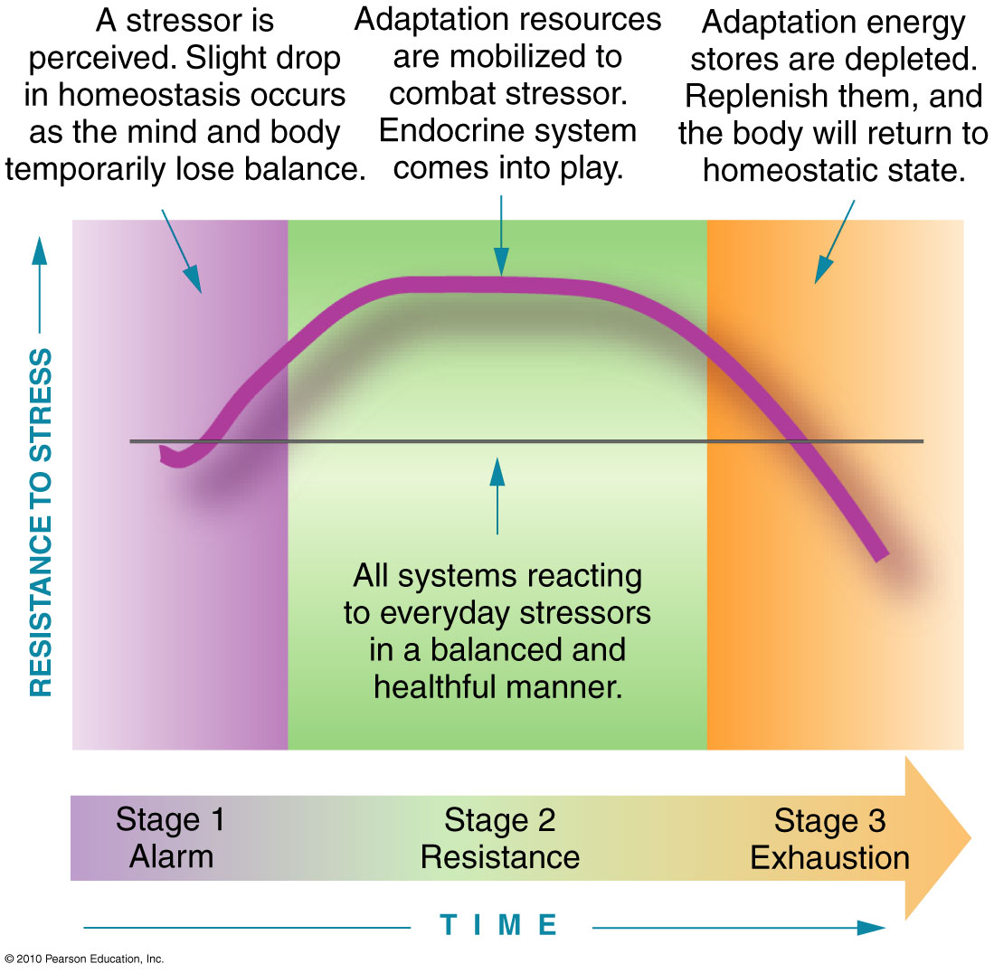
6 – Alarm Phase
- Stressor perceived that disturbs homeostasis
- ANS prepares body for fight or flight
- SNS energizes the body; PNS slows the body
Resistance Phase
- Begins immediately after alarm phase
- Body regains physical and mental homeostasis
Exhaustion Phase
- Physiological and psychological energy depleted
- Chronic stress response = burnout or serious illness

7-8 – Sources of Stress (pg. 59-63)
Psychosocial Sources of Stress
- Change: more change = more adjustments, greater your stress response may be
- Pressure: feel like you have to change to meet a higher standard of performance
- Inconsistent goals and behaviours: might find –ive stress effects are magnified when goals and behaviours are not the same
- Conflict: simultaneous existence of incompatible demands, needs, goals
- Overload: feel pressured by constant and overwhelming demands made upon us; experience excessive time pressure, responsibility, expectations
- Burnout: physical and mental exhaustion resulting from continuous overload
9 – Other Forms of Psychosocial Stress
- E.g., problems adapting, frustration, discrimination, socioeconomic events

Environmental Stress
Def. – events occurring in physical environment, examples:
- One time events: natural, industrial disasters
- Background distressors: noise, pollution, extreme weather; may not be aware
10 – Self-Imposed Stress
Self-Concept and Stress
- Cognitive stress system – psychological system that governs emotional response to stress; recognizes, evaluates, and decides for coping
- Self-esteem and expressing anger constructively
11 – Personality Types and Hardiness
- Type A – hard-driving, competitive, anxious, time-driven, impatient, angry and perfectionistic vs. Type B – relaxed, noncompetitive
- Psychological hardiness: accepting self-responsibility; personality characteristic characterized by control, commitment, challenge, choices, connectedness and courage (sometimes called Type C personality)
Self-Efficacy and Control
Def. – belief in one’s skills and abilities
- Learned helplessness: lack confidence in coping
- Internal locus of control – belief that you are in control of your life vs. External – belief that an outside power (fate or destiny) controls your life

12-13 – Stress and the Post-Secondary Student (pg. 63-64)
Symptoms of Stress Overload
- Difficulty with school
- Relationship problems: family, friends, intimate partners
- Frequent mood changes
- Sleeping difficulties
- Lack of interest in social activities
- Drugs or alcohol to avoid stress
- Intolerance to differences in opinions
- Diminished sex drive
- Tendency to overeat
- Stuttering: difficulty finding right words
- Lack of awareness
- Accident-prone

14 – Stress Management (pg. 64-72)
Dealing with Stress
Assessing your stressors
- After recognizing stressor, need to assess
- Can you alter circumstances or your behaviour or reactions?
Recognizing and Changing your Responses
- Requires self-reflection, practice, and emotional control
- First response that comes to mind isn’t always best, how will the response affect you in the long run
Learning to Cope
- Conscious efforts to deal w stress are important – alc, drugs, PA, etc.
Downshifting
- Taking a step back and simplifying life
- Involves a fundamental alteration in values and honest introspection about what is important in life
Taming Technostress
Def. – personal stress generated by reliance on tech devices, a panicky feeling when they fail and a state of near-constant stimulation, or being perpetually ‘plugged in’
- Many ppl feel frustrated and distressed in their struggle to adapt to increasingly complex technology
- Technosis – syndrome in which ppl get so immersed in tech that they risk losing their own identity
15 – Managing Emotional Responses
- Stress management requires that you examine your emotional responses, including self-talk and explanatory style
Learning to Laugh and Cry
- Good to let your emotions flow!!!
Managing Social Interactions
- Less important to have wide circle of acquaintances than it is to have few really good friends
- Focusing on others can help you get your problems into perspective and control
Making the Most of Support Groups
- Provide you with emotional and physical support
16-17 – Taking Mental Action
Changing the Way You Think
- Worry constructively
- Regard life as fluid
- Consider alternatives
- Focus on the positive
- Break large tasks into smaller pieces
- Have moderate expectations
- Keep things in perspective
- Do not rush into action
- See stumbling blocks as challenges
- Reframe
18 – Taking Physical Action
Physical Activity
- Releases hormones (endorphins) that enhance mood
- Reduces the stress response
- Walking and talking – effective way to manage stress, physically and mentally
Relaxation
- Helps refocus energies
- Diaphragmatic or deep breathing – maximally expanding chest by including lower abdomen, commonly used in yoga
- Progressive muscle relaxation – involves systematically contracting and relaxing each of several muscle groups; breathing deeply and concentrating on the muscles being contracted and relaxed part of process
  - As you concentrate on inhaling, also contract particular muscle group (e.g. hand and fingers)
19 – Meditation
20 – Eating well
- Balanced, healthy dietary intake – provides stamina, may stress-proof you
- Poor eating creates distress in the body
21-22 – Learning Time Management
- Clean off your desk
- Never handle papers more than once
- Prioritize your tasks
- Avoid interruptions
- Do not be afraid to say no
- Reward yourself for being efficient
- Use time to your advantage
- Become aware of your own time patterns
- Remember that time is precious
23 – Using Alternative Stress Management Techniques
Massage Therapy
- Varies from gentle-aggressive treatments, assists with relaxation
Meditation
- Deep breathing and may involve visualization
- Allows tension to leave body w each exhalation

25 – Focus On: Spiritual Health (pg. 76-84), 4 Q

26 – What is Spirituality? (pg. 76-79)
Def. – individual's sense of peace, purpose and connection to others and beliefs about the meaning of life
- Quest for answers to ultimate questions
- Relationship with the sacred or transcendent
27 – Religion and Spirituality: Distinct Concepts
Religion: system of beliefs, practices, rituals and symbols designed to facilitate closeness to the sacred or transcendent
- Not same as spirituality, may consider spirituality important in your life, but not necessarily in the form of religion
Spirituality Integrates Three Facets
3 Facets believed to constitute the core of human spirituality:
- Healthy relationships: contemplate who you chose as a life partner or how to mend a quarrel w a friend, foster inner wisdom; treat yourself and others w respect, honesty, integrity, and love, manifest spiritual health
- Values: principles that influence your thoughts and emotions and guide the choices you make in life; attempt to clarify values and live according to them, you engage in spiritual work
- Meaningful Purpose in Life – spiritually healthy, able to articulate your purpose and make choices that reflect it
28 – Spiritual Intelligence is an Inner Wisdom
Def. – ability to access higher meanings, values, abiding purposes and unconscious aspects of self, characteristic that helps to find a moral and ethical path to guide you through life
- Qualities: humility, different thinking, beyond ego

29 – How is it Beneficial to Focus on your Spiritual Health? (pg. 79-80)
Spiritual Health Contributes to Physical Health
- Decreasing anxiety, depression, anger, feelings of isolation
- Decreasing drug and alcohol use
- Decreasing blood pressure, risk of heart disease
- Increasing hope and optimism
30 – Contributes to Psychological Health
- May decrease anxiety and depression.
- Yoga, deep meditation, and prayer – +ively affect brain chem
  - Effects similar to antidepressant medications
Spiritual Health Contributes to Reduced Stress
- Improved health and longevity
- Better ability to cope with illness
- More effective stress management

31 – What You Can Do to Focus on Spiritual Health (pg. 80-83)
Train Your Body
- Yoga: physical and mental process involving controlled breathing, physical postures (asanas), meditation and other practices believed to cultivate unity with Absolute
- Energize body, sharpen focus: jogging, biking, aerobics
Expand Your Mind
- Psychological counseling: first step toward spiritual health; let go hurts of past, accept limitations, manage stress and anger, deduce anxiety and depression and take control of life
- Studying major religions and spiritual practices
- Exploring different spiritual practices on campus
32 – Tune in to Yourself and Your Surroundings
4 ancient practices that will help you “tune in”:
- Contemplation: concentrating mind on spiritual or ethical question; journaling can be form
- Mindfulness: practice of focused, nonjudgmental observation, fully present in moment, engaged w all senses
- Meditation: practice of emptying mind of thought, cultivating stillness
- May help increase forgiveness, empathy, understanding
- Prayer: communicating with transcendent Presence
33 – Reach Out to Others
- Altruism: the giving of oneself, serving others; volunteering, donating money
- Environmental stewardship: personal responsibility toward our environment; reducing and recycling, turning off lights, etc.

Ch. 13 – Controlling Risk for Infectious and Noninfectious Conditions (pg. 369-408), 20 Q

- Pathogen: disease-causing agent; found in air you breath, food you eat, etc.
- Epidemic: disease outbreak in a community, affects many ppl at same time
- Pandemic: global epidemic
- Virulent – strong enough to overcome host resistance and cause disease

2 – Infectious Disease Risk Factors (pg. 370-371)
- Most diseases are multifactorial (caused by interactions of several factors, inside and outside person)
- Conditions required for disease to occur: susceptible host (immune system weakened), transmitting agent present and hospitable environment for pathogen (temp, light, moisture, etc.)
3 – Risk Factors You Can’t Control
Heredity
- Ppl born into families in which diseases (heart, cancer, diabetes) are prevalent increases their risk
- Sickle cell anemia – genetic disease resulting from chromosomal abnormalities commonly found among ppl of African descent
Aging
- After age of 40, become more vulnerable to chronic diseases
- Immune system responds less efficiently
- Very young – compromised immune system
Environmental Conditions
- Immunological competence – ability of immune system to defend body from pathogens
Risk Factors You Can Control
- Stress and poor nutrition
- Physical inactivity and lack of sleep
- Poor personal hygiene
- High risk behaviours (ex. sex, drugs)

4 – The Pathogens: Routes of Invasion (pg. 371-376)
Transmission
- Direct (sexual activity, touching) and indirect contact
  - Hands greatest source of transmission
- Autoinoculation – transmission of pathogen from one part of body to another
- Airborne contact – inhaling droplet spray from sneeze, breathing air that carries particular pathogen
- Food-borne infection (eat something contaminated by microorganisms), animal-borne pathogens (spread diseases through bites, feces, carrying infected insects)
- Water-borne diseases – transmitted directly from drinking water and indirectly from foods washed or sprayed w water, also if you swim in contaminated streams, lakes, rivers, etc.
5 – Bacteria
Def. – single-celled organisms that may cause diseases in humans
- Bacteria don’t cause diseases, toxins do (poisonous substances produced by certain microorganisms that cause various diseases)
Staphylococcal infections – found normally on skin, only cause infection when there is break in skin
- E.g. acne, boils, styes (infections of eyelids), toxic shock syndrome
Streptococcal infections – bacteria that can cause strep throat or scarlet fever
Pneumonia – disease of lungs, usually caused by bacteria
Tuberculosis – disease caused by bacterial infiltration of respiratory system
- Transmitted by breathing infected air from infected person’s coughing or sneezing
- Ppl fighting other diseases (HIV-related) may be a t increased risk
Periodontal diseases – diseases of the tissue around teeth
Viruses
Def. – minute parasitic microbes that cause disease
- Exists only in parasitic relationship w cell it invades
- Incubation period – time b/w exposure to disease and appearance of symptoms
- Slow-acting viruses – long incubation periods, causing slowly progressive symptoms
- Interferon – protein substance produced by body that aids the immune system by protecting healthy cells
The Common Cold – caused by any number of viruses
- Endemic – continued prevalence of a specific infection or disease in a specific population or area
Influenza – common viral disease of respiratory tract (flu)
Infectious Mononucleosis – “kissing disease”
Hepatitis – virally caused disease in which liver becomes inflamed, resulting in fever, headache, and jaundice
Mumps – minor symptoms, virus in glands of neck, swelling of salivary glands
Chicken Pox – skin eruptions that blister, itch and produce clear fluid
Measles – viral disease that produces symptoms including itchy rash and high fever
- Most contagious disease
- Rubella (German measles) – milder form, causes rash and mild fever in children and may cause damage to a fetus or newborn baby

6 – Your Body’s Defenses: Keeping You Well (pg. 377-378)
Physical and Chemical Defenses
- Skin (allows few pathogens to enter)
- Enzymes – organic substances that cause bodily changes and destruction of microorganisms (produce inhospitable pH)
- Slight elevations in body temperature – creates inhospitable environment
- Linings of the body (mucous membranes) – trap and engulf invading organisms
- Secretions at body entrances (tears, nasal secretions, ear wax) – contain enzymes designed to destroy or neutralize invading pathogen
- Immune system
7 – The Immune System: Your Body Fights Back
- Antigens (capable of triggering immune response), antibodies (produced to destroy or weaken specific antigens, belong to mass of large molecules, immunoglobulins)
  - Group of 9 chemically distinct protein substances, plays role in neutralizing, setting up for destruction or destroying antigens
- Humoral immunity – body’s major defense against bacteria and bacterial toxins
- Cell-mediated immunity – formation of population of lymphocytes that can attack and destroy foreign invaders
Autoimmune Diseases
- Immune system mistakenly targets own tissues:
8 – Fever
Def. – rise in body temp above norm of 37
- Destroys some disease-causing organisms
- Stimulates more white blood cell production
Pain
- Response to injury: stops action; prevent further injury
- Direct or referred pain; often accompanied by inflammation
9 – Vaccines: Bolstering Your Immunity
Def. – inoculation with killed, weakened pathogens in order to prevent, lessen effects of some disease
- Vaccinations contribute to acquired immunity

10 – Acquired Immune Deficiency Syndrome (AIDS) (pg. 391-394)
AIDS – extremely virulent STI that renders the immune system inoperative
- HIV: human immunodeficiency virus, slow-acting virus that causes AIDS
- Global health problem
  - 21+ million have died of AIDS
  - 57 million infected with HIV
- Canada: black, Aboriginal Canadians, higher rates
11 – How HIV is Transmitted
Engaging in High-Risk Behaviours – increase risk for disease
- Promiscuous sex (unprotected sex), having sex w ppl who have shared needles
Exchange of Body Fluids (HIV-infected) – greatest risk factor
- Blood, semen, and vaginal, cervical and anal secretions
Receiving a Blood Transfusion Prior to 1986 – since then stringent testing program for donated blood has been implemented
Injecting Drugs – sharing or using HIV-contaminated needles
Mother-to-Infant Transmission (Perinatal) – in womb, passing vaginal tract
12 – Symptoms
- Incubation time varies greatly
- Infants and newborns: at high risk
  - Immune system, not fully developed
- HIV+ adults: AIDS develops in 8-10 years
  - With no treatment

13 – Noninfectious Diseases (pg. 394-395)
- Chronic diseases: pain, suffering, and disability
  - Normally do not result in death
- Not transmitted by pathogen, personal contact
- Develops over long period of time
- Lifestyle and personal health, major factors
- Prevention and control could minimize effects

14 – Respiratory Disorders (pg. 395-397)
Allergy-Induced Problems
Def. – hypersensitive rxn to a specific antigen or allergen in environment in which body produces excessive antibodies
- Body defends: specific antigen, allergen
- Body overreacts: production of antibodies
- Antibodies trigger the release of histamines
  - Chemicals: dilates vessels, increases mucous secretions, produce other allergy-like symptoms
15 – Hay Fever
Def. – chronic respiratory disorder most prevalent when ragweed and flowers bloom
- Sneezing; itchy, watery eyes and nose
- Genetic component – change in lifestyle have little-no impact
Asthma
Def. – characterized by wheezing, shortness of breath, and coughing spasms
- Majority: children under 10 years (mainly boys)
- Dust, pollen, animal dander, stress, exercise
16 – Emphysema
Def. – alveoli become distended or ruptured and no longer functional
- Gradual destruction of alveoli (air sacs)
- Difficulty exhaling; struggles taking in air
- Cause is uncertain; effects irreversible
- Associated with long-term cigarette smoking
  - Also exposure to air pollution
17 – Chronic Bronchitis
Def. – bronchial tubes become inflamed and swollen such that respiratory function is compromised
- Called “smoker’s cough”
- Symptoms: productive cough, shortness of breath; persist for several weeks
- Cigarette smoking, the major risk factor

18 – Neurological Disorders (pg. 397-399)
Headaches
- Tension – caused by muscle contractions or tension in neck or head; due to overuse, static positions held for long time, or tension triggered by stress
- Migraine – localized headaches that result from alternating dilation and constriction of vessels; excruciating painful and recurring headaches
- Secondary – arise as a result of some other underlying condition
- Psychological – stem from anxiety, depression and other emotional factors; result from stress of emotional disturbances
Seizure Disorders
Epilepsy – neurological disorder caused by abnormal electrical brain activity; often accompanied by altered consciousness or convulsions (seizure)
- Grand mal – major motor seizure, often preceded by shrill cry or seizure aura
- Petit mal – minor seizure, no convulsions, minor loss of consciousness that may go unnoticed
- Psychomotor – mental processes and muscular activity, mental confusion and listless state (lip smacking, chewing and repetitive movements)
- Jacksonian – progressive, begins in one part of body, moves to other parts; usually only one side of body affected

19 – Sex-Related Disorders (pg. 399-400)
Fibrocystic Breast Disease
Def. – common, non-cancerous problem in women whose breasts contain fibrous or fluid-filled cysts
- Small lump to large masses (tissue)
- Progressively worse with age; causes, unknown
Premenstrual Syndrome (PMS)
Def. – series of physical and emotional symptoms that may occur in women prior to their menstrual periods
- Symptoms: depression, irritability, headaches, cramps
- Plausible cause: hormonal imbalance

20-21 – Digestion-Related Disorders (pg. 400-402)
Colitis and Irritable Bowel Syndrome (IBS)
Ulcerative colitis: inflammation of mucous membranes of large intestine (colon)
- Symptoms: bloody diarrhea, stomach cramps, weight loss, nausea, sweating, fever
- Cause unknown; linked to stress, food
- Treatment: focuses on relieving symptoms
Irritable bowel syndrome (IBS): nausea, pain, gas, or diarrhea caused by certain foods or stress
- Symptoms vary from week to week, fade for long periods of time then return
- Stress management, healthy habits control IBS
22 – Diverticulosis
Def. - bulges in walls of the intestine, results in irritation and infection of intestine
- Bulges may fill with feces – can become irritated, infected; causing pain
- Bleeding and chronic obstruction can occur – can be life threatening
23 – Peptic Ulcers
Def. - damage to stomach or intestinal lining, usually caused by digestive juices
- Common cause: bacterial infection
  - Treatment: antibiotics
- More prevalent in those highly stressed
  - Especially high fat foods, excessive alcohol
24 – Gallbladder Disease
Def. – gallbladder repeatedly irritated by chemicals, infection or overuse; reducing ability to release bile for digesting of fats
- Pain: upper right portion of abdomen (after eating fatty foods)
- Treatments: medication, altering diet, surgical removal

25 – Musculoskeletal Diseases (pg. 402-403)
Arthritis
Def. – painful inflammatory disease of joints
Osteoarthritis (OA): progressive deterioration of bone and joints associated w “wear and tear” of aging
- Treatments: anti-inflammatory drugs, joint replacement
Rheumatoid arthritis – serious inflammatory joint disease (autoimmune disorder)
- Destruction of bony ends of joints
- More prevalent in women; cause, unknown
26 – Fibromyalgia
Def. – chronic, painful rheumatological-like disorder
- Array of symptoms
  - Widespread pain, stiffness, tender points, depression
  - Swelling, coldness, numbness, tingling, headaches
- Cause is unknown
  - Sleep and stress are possible links
27 – Low Back Pain (LBP)
Risk Factors for Low Back Pain
- Age, body type, poor posture
- Psychological (changes in mood, effect ways in which you position yourself) and occupational factors
Preventing Back Pain and Injury
- Good posture, mattress, and shoes
- Ergonomics, physical activity

28 – Other Maladies (pg. 403-404)
Chronic Fatigue Syndrome (CFS)
- Symptoms: chronic tiredness, headaches, sore throat
- Possible psychological roots
Job-Related Disorders
- Computers: eye strain; discomfort in low back, neck, shoulder
Carpal tunnel syndrome – common, median nerve in wrist becomes irritated, causing numbness, tingling and pain in fingers and hands

Ch. 17 –Preparing for Aging, Dying and Death (pg. 478-499), 19 Q

2 – Redefining Aging (pg. 479)
Ageism – discrimination based on age
Gerontology – study of individual and collective aging processes
Age-related characteristics:
- Biological age – relative age or condition of person’s organs and body systems
- Psychological age – person’s adaptive capacities, coping abilities and intelligence
- Social age – habits and roles relative to society’s expectations; how do you interact within your environment
- Legal or chronological age – number days, months, years you have been alive; nothing to do w bio and functional
- Functional age – ways in which ppl compare to others of similar age; heredity, lifestyle; how you maneuver; physical capacity

3 – What is Normal Aging? (pg. 479-480)
Def. of “old” (used for research)
- 60 to 69 years = young-old
- 70 to 79 years = middle-old
- 80 to 89 years = old-old
- 90+ years = oldest-old
Older ppl: product of lifelong experiences
- Molded over years of happiness, heartbreak, day-to-day existence

4 – Who Are the Elderly? (pg. 480)
Table 16.2 – don’t need to memorize

5 – Theories on Aging (pg. 480-482)
Biologic Theories
- Wear-and-tear theory – human body wears out, more you don’t treat body well, faster it will wear out (physical activity is good for health, is there validity?)
- Cellular – at birth we have only certain number of usable cells, these cells are genetically programed to divide or reproduce only limited number of times (certain point where mitosis starts to stop)
- Autoimmune – decline of body’s immunological system (experience mortality at point where body starts to attack self)
- Genetic mutation – # of cells exhibiting unusual characteristics increases w age

Psychosocial Theories
- Developmental model – ppl must progress through 8 critical stages in lifetime
  - Middle to old age: stressful period
- Develop coping methods early (maladjustments later on)
- Successful aging: emotional, physical well-being
Never will get firm grasp in what is right

6 – Changes in the Body and Mind (pg. 482-487)
Physical Changes
The Skin – becomes thinner and loses elasticity, lines, age spots
Bones and Joints – deterioration, fragile and brittle, increased risk of fracture, osteoporosis
The Head – features enlarge and become more noticeable
The Urinary Tract – urinary incontinence (inability to control urination)
The Heart and Lungs – SV diminishes, muscles deteriorate, vital capacity declines
Eyesight – hardens, lens yellow and lose transparency, pupil shrinks, depth perception declines, farsightedness
- Cataracts (clouding of lens), glaucoma (elevation of pressure within eye), macular degeneration (breakdown of light-sensitive part of retina)
Hearing – hear high-frequency consonants declines, inability to distinguish extreme ranges of sound from normal conversation tones
Taste – declines, add excessive salt, sugar to food
Smell and Touch – diminishes
Mobility – incidence and severity of disability typically increases w age
Sexual Changes – noticeable changes in sexual function
Body Comfort – loss of body fat, thinning of epithelium, diminished glandular activity – difficulty regulating body temp; poor nutrition
7 – Mental Changes
Intelligence – what old ppl lack in speed of learning, make up for in practical knowledge
- “Wisdom of experience”
Memory – short-term memory may fluctuate on daily basis, long-term remains unchanged Adaptability – differences in how elderly confront many changes brought on by aging
Depression – may be most common psychological prob as we age
Dementia – mental deterioration, loss of memory, and judgment and orientation problems
Alzheimer’s Disease – common form of dementia, chronic condition involving changes in nerve fibres of brain, results in mental deterioration

8 – Health Challenges of Older Canadians (pg. 487-489)
Alcohol Use and Abuse
- Abuse: 5x more in men than women
- Prone to alcoholism in younger and middle yrs – more likely to continue drinking during later yrs
Prescription Drug Use
- Addiction: prescription and OTC drugs
Over-the-Counter Remedies
- Common: ASA and laxatives
9 – Physical Activity
- Sarcopenia: age-related declines in quantity and quality of muscle tissue
- 150 min, moderate-intense activity each week
Dietary Concerns
Nutrients especially important to healthy aging:
- Ca, Vit D, Protein
Gender Issues: Caring for Older Canadians
- Women: live longer, more often alone
  - Comorbidity: presence of more than one disease at a time poverty and health problems
10 – Graphs

11 – The Process of Dying (pg. 491-494)
Coping Emotionally w Death: 5 Psychological Stages
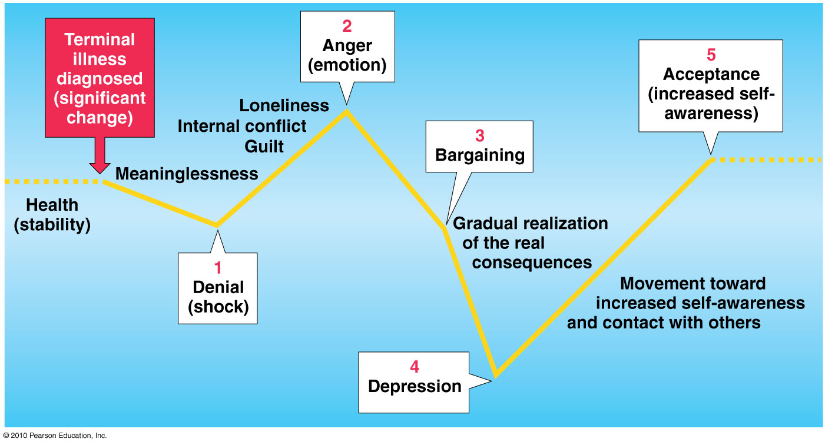

12 – Social Death
Def. – irreversible sitch in which a person is not treated as an active member of society
- Loss of value, appreciation by others
- No longer same types of relationships
- Not treated as member of society:
  - Avoided, isolated, and excluded
- Dying person is referred to as if already dead, dying person excluded from conversations, moved to terminal wards and given min care, etc.
Near-Death Experiences
- Three phases: resistance (aware of danger, struggles to escape), life review (feeling of being outside one’s body and beyond danger, life experiences seem to pass by in rapid review), transcendence (feelings of euphoria, contentment, even ecstasy)
13 – Coping w Loss
- Bereavement – loss of deprivation experienced when a loved one dies
- Disenfranchised grief – grief concerning a loss that cannot be openly acknowledged, publically mourned or socially supported
  - Divorce spouse, secret lover, gay lover
- Grief – mental state of distress that occurs in rxn to significant loss
- Mourning – culturally prescribed behaviour patterns for expression of grief
14 – What is “Normal” Grief?
Responses vary widely, and may include:
- Distress, tightness in throat
- Choking, shortness of breath
- Frequent need to sigh; feeling emptiness
- Muscular weakness
- Intense anxiety that is painful
15 – Coping with Grief
- Grief work: process of accepting the reality of a person’s death and coping with memories of deceased; integrating new reality to life
Worden’s Model of Grieving Tasks
4 developmental tasks to complete grief work process:
- Accept the reality of the loss – acknowledging and realizing person is dead; funeral
- Work through the pain of grief – acknowledge and work through pain of loss
- Adjust to environment (which deceased missing)
- Emotionally relocate deceased (move on)
16 – When an Infant or Child Dies
- Bereaved siblings have difficulty (coping skills)
- Children not comfortable discussing death
  - Difficulty understanding death
- Potentially less social support
  - Feeling emotionally abandoned

17 – Quasi-Death Experiences (pg. 494)
Def. – losses or experiences that resemble death in that they involve separation, termination, significant loss, change of personal identity and grief
- Child abduction
- Divorce, loss of romance (intimate partner)
- Job termination or retirement
- Ending an athletic career

18 – Life-and-Death Decision Making (pg. 494-496)
Palliative Care
- Pain, symptom management (facility, in-home)
- Social, psychological, and spiritual support
- Dyathanasia: passive form of “mercy killing”
  - Treatments withheld, allowing person to die naturally
- Euthanasia: active form of “mercy killing”
  - Death of terminal person, hastened knowingly
  - Direct administration of lethal drug overdose

Ch. 14 – Choosing Healthy Living for the Environment (pg. 417-456), 14 Q

2-3 – Overpopulation (pg. 419-420)
- Effective environment management needed
  - Avoid 25% of preventable diseases, worldwide
  - Prevent 13 million deaths, annually
- Unsafe water and air pollution
  - 4 million deaths, annually (children under 5)
- Safer water storage and cleaner fuels:
  - Reduces disease and death
- World population predicted 9.2 billion (2050)
  - Majority of growth in developing world
- Estimates for population growth
  - Fertility rates and life expectancy
  - Population increases = competition for resources
- North Americans consume most energy
  - Most raw materials per person (worldwide)
4 – Figure 14.1 Major Pathways of Human Exposure to Environmental Contaminants (pg. 418)
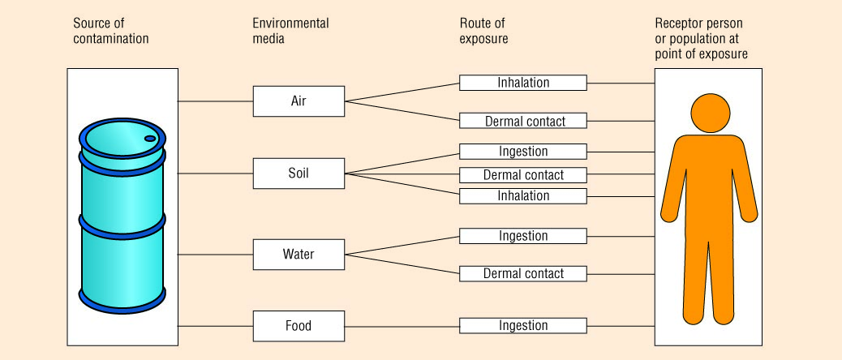

5 – Air Pollution (pg. 420-426)
Sources of Air Pollution
- Sulphur Dioxide – colourless gas and main ingredient of acid rain, smells like burnt matches
- Particulates – tiny solid particles or liquid droplets suspended in air; cigarette smoke, by-products of some industrial processes
- Carbon Monoxide – odourless, colourless, tasteless gas that is poisonous at [high]; burning fossil fuels in vehicles
- Nitrogen Oxides – reddish brown gas w foul smell; burning fossil fuels; can be fatal
- Ozone – form of oxygen produced when nitrogen dioxide reacts w hydrogen chloride which is altered by sunlight; irritates mucous membranes
- Lead – metal pollutant found in exhaust of motor vehicles; -ively affects circulatory, reproductive and nervous symptoms; particularly bad for kids and fetuses, increased risk of absorption
- Hydrocarbons – chemical components that contain C and H; combined w sunlight and other pollutants can form poisons which are respiratory irritants; play major part in formation of smog
6 – Smog
Def. – brown, hazy mix of particulates and gases from combo of hydrocarbons and nitrogen oxides
- Temperature inversion: weather conditions occurring when cool air is trapped under warm air; preventing air circulation
- Results: difficulty breathing, burning eyes, headaches, nausea
- Long term problems: vulnerable population
  - Children, elderly, pregnant women
7 – Acid Rain
Def. – precipitation contaminated with acidic pollutants
- Sources: burning fossil fuels
Effects of Acid Rain
- Environmental damage
- Respiratory problems
- Leaching (dissolve and filter) of metals out of the soil
- Damage to crops, monuments, structures
8 – Indoor Air Pollution
- Wood Stove Smoke – emit significant levels of particulates and CO and SO2
- Furnaces – inadequate cleaning and maintenance can lead to buildup of CO
- Asbestos – substance that separates into stringy fibres and lodges in lungs, where it cannot be expelled
  - Mineral commonly used in insulating materials in buildings prior 1970
- Passive Smoke – secondhand or sidestream cigarette smoke, -ive health effects
- Formaldehyde – colourless, strong-smelling gas released from products through outgassing; carpets, furniture, plywood, etc.; respiratory probs
- Household Chemicals
9 – Ozone Layer Depletion
- When oxygen interacts with sunlight
- Protective membrane-like layer in earth’s stratosphere
- Depletion of the ozone layer:
  - Chlorofluorocarbons (CFCs)
  - Production and importation, banned in Canada
10 – Global Warming
- Greenhouse gases: by burning fossil fuels; contribute to global warming by trapping heat near earth’s surface
  - CO2, CFCs, ground-level ozone, NO, methane
- Average global temperatures: higher than ever
- Most economically costly change of society
11 – Reducing Air Pollution
- Practices needing change: energy, industry, transportation
- Renewable resources: solar, wind, water power
- Shift away from gas-powered automobiles

12 – Water Pollution (pg. 427-429)
Water Contamination
- Point source pollutants: pollutants that enter waterways at a specific entry point
  - Sewage treatment plants, industrial facilities
- Non-point-source pollutants: seep into waterways from broad areas of land; runoff or sedimentation
  - Fertilizers on agricultural land, pesticides & contaminants in rain, snow, etc.
- Septic Systems – bacteria from human waste can leach into water supply from improperly installed septic systems
- Landfills – generate liquid leachate, can trickle through layers of garbage and eventually into water supply
- Gasoline and Petroleum Products – test for benzene (highly toxic, associated w cancer development)
- Dioxins – highly toxic chlorinated hydrocarbons contained in herbicides and produced during certain industrial processes
13 – Chemical Contaminants
- Polychlorinated biphenyls (PCBs): toxic chemicals once used as insulating materials for electrical equipment
  - Body doesn’t excrete them, stores them in fatty tissues and liver
  - Birth defects known to cause cancer
- Pesticides: chemicals designed to kills insects, rodents, plants, fungi that interfere w growth of a particular product (e.g. grass)
- Trihalomethanes (THMs): synthetic chemicals
  - By-product of water treatment (chlorine)
- Lead: mineral that can damage health

14 – Noise Pollution (pg. 429-430)
- Loud noises: source of physical, mental distress
- Short-term exposure reduces:
  - Productivity, concentration, attention span
- Symptoms of noise distress:
  - Sleep disturbance, headaches, negative health
- Prevent hearing loss:
  - Music, reasonable levels; earplugs, physical barriers

15 – Land Pollution (pg. 430)
Solid Waste
Def. – durable and nondurable goods, containers, and packaging, and food, yard, and miscellaneous wastes from residential, commercial, institutional and industrial sources
- Reduce, reuse, recycle (90% of garbage reused or recycled)
Hazardous Waste
Def. – solid waste that poses hazard to humans or environment
- The Canadian Environmental Protection Agency
  - Deals with hazardous wastes (elimination, reduction)

16 – Radiation (pg. 430-433)
Ionizing Radiation
Def. – radiation produced by photons w enough energy to ionize atoms
- Exposure, inescapable (nature, X-rays, TV)
- Can damage genetic material
- Most people: within “safe” dosage
Nonionizing Radiation
Def. – radiation produced by photons associated w lower-energy portions
- Sources: household appliances, electric power lines
- Little known about the biologic effects
17 – Nuclear Power Plants
- Less than 1% of total radiation exposure
- Proponents: safe and efficient way to generate electricity
- Concerns:
  - Disposal of nuclear waste
  - Chances of a meltdown – accident that results when temp in core of nuclear reactor increases sufficiently to melt nuclear fuel and its containment vessel

18 – Food Quality (pg. 433)
- Food: 80-95% of most persistent toxic contaminants
- Air contributes 10-15%; drinking water, very little
- Canada’s food: safest in the world
- Concerns: microbial, environmental contamination in food
  - Chemicals in food production and bioaccumulation

Ch. 16 – Becoming a Wise Consumer of Health Services (pg. 458-477), 11 Q

2 – Making Informed Health-Care Choices
Financing Health Care
- Predominantly publicly funded in Canada
- Medicare: provincial, territorial insurance plans
  - Universal, comprehensive coverage
  - Hospital, inpatient & outpatient physician services
- All principles linked at Federal level
3 – Accepting Responsibility for your Health Care
- Disparities in access to uninsured services (dental care, vision care, counseling)
- Learn: how, where, when to enter system
  - To obtain needed care
- Know about self-care, its limits
4 – Why Some False Claims May Seem True
- Spontaneous Remission – disappearance of symptoms w/o any treatment
  - Ppl experiencing spontaneous remissions can easily attribute their “cure” to a treatment, drug or provider that had no real effect on disease or condition
- Placebo effect – apparent cure or improved state of health brought by a substance or product w no medicinal value
5-6 – Evaluating Online Medical Resources
- Who runs the site?
- Who pays for the site?
- The purpose of the site?
- Where does the information come from?
- The basis of the information?
- How is the information selected?
- How current is the information?
- How does site choose other sites?
- What information does site collect, why?
- How does site interact with visitors?

7 – Self-Help or Self-Care
Self-care – composite of individual identity and specific attitudes and behaviours associated w looking after “self”
- Knowing your body, recognizing its signals, and taking appropriate action to stop progression of illness or injury to improve overall health
When to Seek Help
- Effective self-care – understanding when to seek professional attention
  - Serious accident or injury
  - Sudden or severe chest pains
  - Sudden high fever
  - Persistent, recurrent diarrhea or vomiting
8-9 – Being Proactive in your Health Care
- Know your medical history (your condition)
- Bring friend, relative to medical appointments
- Ask providers to explain clearly
- Ask about medications, lab test results
- Seek a second opinion
Afterwards:
- Write an account of what happened
- Shop around for the best price
- Ask pharmacist: side effects, drug interactions
- Have clear instructions written on label
10 – Assessing Health Professionals
- Training, license, certification
- Affiliations with accredited institutions
- Clear timeline for treatment
- Diagnoses, treatments: consistent with scientific theory; peer review
- Listen, respect you; allow for questions

11 – Choices of Medical Care (pg. 465-469)
Traditional (Allopathic) Medicine
Def. – traditional, Western medical practice; based on scientifically validated methods and procedures
- Primary care practitioner – medical practitioner who treats routine ailments, advises on preventive care, gives general medical advice, and refers
  - E.g. family practitioner
Allied Professionals
Nurses – health practitioner who provides many services and may work in variety of settings
- Registered nurses and nurse practitioners (professional nurses w advanced training obtained through either a master’s degree program or specialized nurse practitioner program)
12-13 – Non-Allopathic Medicine
Def. – medical alternatives to traditional, allopathic medicine
- Chiropractic Treatment – form of medical treatment that emphasizes manipulation of the spinal column
- Massage Therapy – working towards soft tissue (skeletal muscles, ligaments, tendons, facial), expert on feeling and breaking tension in feeling and breaking tension in skeletal muscle, less invasive
- Acupuncture (ancient Chinese art of inserting needles at points on skin that fall along 14 major meridians, or pathways of energy that flow through body) and acupressure (similar but doesn’t use needles, apply pressure to points critical to balancing yin and yang)
- Herbalists (practice herbal medicine, based on medicinal qualities of plants and herbs) and homeopaths (use herbal medicine, minerals and chemicals; at root of practice is theory that extremely diluted doses of potent natural agents the produce disease symptoms will cure disease in sick) – non invasive, botanical elixirs
- Herbal remedies and other supplements
- Naturopathy – blends modern scientific knowledge w traditional and natural forms of medicine; believe illness results from violations of natural principles of life
- Other alternative therapies – reflexology, iridology, aromatherapy, auramassage

Focus on: Financial Health (pg. 500-503), 4 Q

16 – Financial Wellness (pg. 500-503)
Def. – state of wealth achievable by individuals or families, irrespective of income levels
- Be prepared for fluctuations: income, spending
- Spending, saving, and living better within your financial reality
- Can be achieved by ppl of all levels of income
17-18 – Students and Their Financial Wellness
- Higher education $ = significant financial burden
  - Economic downturn (less jobs, more competition)
- Personal debt can lead to stress
  - Headaches, insomnia, depression, drugs, violence
- Advice: be realistic, recognize, do not hide
Suggestions to help improve financial health:
- Develop a realistic budget
- Pay bills immediately, consider electronic banking
- Educate yourself how to manage money
- Avoid tempting credit card offers
- Do not get into debt
19-20 – Personality and Financial Health – Is there a Connection?
3 personality characteristics that may influence your spending habits:
A Loss of Perspective
- Manic individuals often overspend – inability to recognize consequences of it
- Daily spend: (income - living expenses), divide 30 (assuming you’re paid once a month)
  - Amount you can spend each day w/o going into debt
An Addictive Personality
- Question: Do I really need this? (alternatives – pack lunch and snacks, bring coffee from home)
- Keep track of spending – including what, when and how much it costs
A Loss of Control:
Use a Likert-type scale of rarely, sometimes, often, always:
- How much time is spent buying?
- Feel guilt, depression, or shame?
- Discretionary purchases impair basic necessities

Ch. 1 - Discovering Your Personal Rhythm for Healthy Living (Part 2) (pg. 9-25), 12 Q

2 – Improving Your Health (pg. 7-16)
Factors Influencing Behaviour Change
Predisposing factors – hard to change, fixated, not necessarily limiting factor
- Life experiences, knowledge, cultural and ethnic inheritance, current beliefs and values
- Predispose you to certain attitudes and behaviours include your sex, race, income, family education
Enabling factors – things you can acquire
- Skills, abilities, physical, emotional, mental capabilities
- +ive enablers – encourage you to carry through on your intentions
- -ive enablers – work against your intentions to change
Reinforcing factors – things around you in environment
- Support and encouragement from significant others
- Can make or break you, how someone sees health, views body, etc.
3 – Understanding When to Change vs. What to Change
- Changing established attitudes, not easy task
- Much of what we do is influenced by number of variables
  - Our history, reward systems, values and culture
Stages of Change, Transtheortical Model:
- Precontemplation – may not think what you’re doing it bad for your health; usually ppl know; no intention of changing, not aware of need of a change
- Contemplation – see more ppl at, chronically inhibited bc of overthinking; know what you’re doing isn’t good; recognize they need to change
- Preparation – how do you get into action of doing better; make a plan
- Action – changing behaviour, actually doing things to change behaviour, 6 months, can still slip in and out
- Maintenance – after 6 months, becomes more difficult to revert back to old behaviours; long-term commitment
- Termination – when ppl have fully terminated, e.g. smoke free for 10 yrs; behaviour becomes ingrained and is “new” habit; part of daily living
- Relapse – something drastic happens, may relapse;
- Levels of awareness, goes all the way down to conditioned behaviour
4 – Do Beliefs and Attitudes Influence Behaviour?
Health Belief Model (HBM): model for explaining how beliefs about health may or may not influence behaviours and attitudes regarded health and wellness
- Oldest model
Factors that support belief that change is needed:
- Perceived seriousness of the health problem
- Perceived susceptibility to the health problem
- Cues to action – life equator, something that is drastic in life
5 – Your Intentions to Change
Theory of Reasoned Action: model for explaining the importance of our intentions in regard to our behaviours
- Behaviours result from intentions to perform actions
- The more consistent and powerful your attitudes about an action, and more you are influenced by others to take that action, greater your intention to do so will grow
6 – Self-Determination Theory
Intrinsic and extrinsic rewards continuum:
- “Low” end – amotivation
- “Middle” end – extrinsic motivation
- “High” end – intrinsic motivation
Satisfy 3 psychological needs: all facilitate intrinsic motivation
- Autonomy – self-initiation in regulation of personal behaviour
- Competence – ability to interact effectively in one’s environment
- Relatedness – feeling connected to other ppl
7 – Significant Others as Change Agents
- Your family – parents influenced your behaviours by giving strong cues about which actions were socially acceptable and which were not
The Influence of Others
- Understanding the subtle and not-so-subtle ways in which other ppl influence your actions may be another important step in process of changing your behaviours
Theory of Planned Behaviour – outlines 3 reasons for how you choose to act
- Attitudes toward the behaviour – what you think about +ive or –ive effects of your actions and importance of each
- Level of perceived behavioural control – how much control you think you have over the particular behaviour you want to change
- Your subjective norms – if you think your actions will b approved by ppl important to you

8 – Behaviour Change Techniques (pg. 16-18)
Shaping: Developing New Behaviours in Small Steps
- Start slowly
- Keep steps small and achievable
- Be flexible/adaptive
- Refuse to skip steps
- Reward yourself for short, long-term goals
- Changing small behaviours, at certain amount of time can see big change
- Not getting overloaded w change, building towards stages, prevents system from being shocked
- Some ppl respond better to shocking, not little steps
9 – Visualizing: The Imagined Rehearsal
Imagined rehearsal – practicing a skill or behaviour through mental imagery
- Visualizing planned action ahead of time
- Likely to be more proficient at behaviour
- E.g. sports, visualize certain movements and enforce it
Modeling
Def. – learning specific behaviours by watching others perform them
- Careful observation of others
- Watching someone perform
- Another way to pick up cues and reinforce behaviour
“Controlling” the Situation
- Situational inducement – attempts to influence behaviour by using situations and occasions structured to exert control over that behaviour; putting yourself in better sitch
- Only certain amount of control
- Within the moment, how do you put yourself in situation where you will not do behaviours that will deteriorate health
- Ppl you’re surrounding yourself w, etc.
- External environments you can control
Reinforcement
Positive reinforcement – presenting sometime +ive following a behaviour being reinforced
- Positive (reward behaviour)
- Long term – reward systems don’t hold up
10 – Changing Self-Talk
Rational-Emotive Therapy
- Connection: what you say = how you feel
- Taught to identify, challenge and replace self-defeating thoughts and beliefs into more +ive and healthier thoughts
Meichenbaum’s Self-Instructional Methods:
- Self instructions and positive affirmations
- Start thinking more positive
Blocking or Thought Stopping
- Purposely stopping negative thoughts before they happen, think about something more pleasant
- Have to know what it is in order for you to avoid it, doesn’t always set up well
- Something comes in, try to minimize effect

11 – Making Behaviour Change (pg. 18-19)
Self-Assessment: Antecedents and Consequences
Antecedents – the setting events for behaviour; cue/stimulate a person to act in certain ways
Consequences – results of behaviours, affect whether a person will repeat a behaviour
- Both include physical events, thoughts, emotions and actions of other ppl
Analyzing the Behaviours You Want to Change
- Frequency – how often?
- Duration – time?
- Seriousness – trying to hurt ppl, consequences?
- Basis for the problem behaviour – trying to make yourself look better?
- Antecedents – what kind of situations trigger?

Etches et al. (2006): Measuring Population Health – A Review of Indicators, 3 Q

2-4 – Research Terms
Census – pop estimate
- Denominator for prevalence/incidence calculations
Surveys – given to sub-sample that represents an entire pop
- Collect more specific info than census
Mapping data – visual representation of geographic areas
- E.g. flu outbreak: trends in incidence rates
- Different colours depending on legend, coordinated levels
Qualitative data – interviews, open-ended questions
- Responses vary; no categories, scales
- Inquiring, why ppl do certain things
Multilevel analysis – relationships b/w risk factor and health outcome (e.g. smoking and lung cancer)
- Predict future events; establish patterns in disease/health outcomes
Rick adjustments – trade off b/w risks and rewards
- E.g. mass immunization risks (adverse rxns, high cost of vaccine); rewards (less burden on health care)
Attributable risk – difference in rate of a condition in an exposed pop vs. an unexposed pop
Vital stats – records of births and deaths; in conjunction w census, headcount
Civil registries – similar to census, smaller scale (municipal, provincial)
- Birth and marriage certificates
International classification systems – e.g. International Classification of Diseases codes: disease rates (WHO)

5 – Etches Model, 2006
- Incorporates life continuum (life stage changes)
- Ppl have different timeline to how they evolve, what is important to them

6 – Etches et al. Population Health Model Summary
- Health” is holistic.
- Population health = social determinants, interconnected
- Etches et al.: synthesis of the broad determinants
- Inequalities in distribution of resources, and other societal and environmental determinants of health.
- What makes a population healthy: develop, recede, and re-emerge in the future.
- Authors: health measured in multiple ways; non-medical factors influence health. Health indicators cannot only be medical.
  - Integrated, not just something purely physiological

