Accounting Midterm Review

Chapter 1&2
External Users
- Shareholders/owners/investors
- Potential investors
- Creditors
- Competitors
Internal Users
- Board of Directors
- Management

Manufacturing-Sector Companies provide tangible products that have been converted to a different for from that of the products purchased from suppliers

Service-Sector Companies provide services or intangible products to their customers

Merchandising-Sector companies provide tangible products they have previously purchased in the same basic form from suppliers

Performance is generally measured as Revenues – Expenses

Statement of Shareholder’s Equity presents a reconciliation of each account in shareholders’ equity from the beginning of year balance to the end of year balance. It includes…
Capital Stock / Share Capital / Common Shares:
- The investment made by shareholders in the company
- Increases when new shares are issued by the company
Retained Earnings:
- Accumulated earnings of a corporation not distributed to its shareholders since its inception

Statement of Financial Position / Income Statement provides a snapshot of a company’s financial position at a particular point in time. It includes assets, liabilities and shareholder’s equity
FUNDAMENTAL ACCOUNTING EQUATION:
Assets = Liabilities + Owner’s Equity

Current Assets are used, sold or turned into cash within one year
- Cash
- Short-term Investment
- Accounts Receivable
- Inventory
- Prepaid Expenses
Non-Current Assets are used, sold or turned into cash over a period longer than one year.
- Property, Plant & Equipment
- Intangible Assets (patents, trademarks, copyright)
- Long-term investments
Current Liabilities come due or have to be settled within one year
- Accounts Payable
- Taxes Payable
- Salaries Payable
- Dividends Payable
- Unearned Revenue
Non-Current Liabilities come due or have to be settled beyond one year
- Bonds Payable
- Long-term Notes Payable
Shareholder’s Equity
Capital Stock: Any amounts invested in the company by shareholders
Retained Earnings: The cumulative total of the net income earned by a company by not distributed to shareholders since its inception

Evaluate the firm’s financial strength…
Liquidity: nearness to cash, ability of the firm to pay current debt
Solvency: ability of the firm to pay both current and long-term debt

Liquidity Analysis… Is the company able to satisfy its short-term obligations?

$$Working Capital=Current Assets-Current Liabilities$$

$$Current Ratio=\frac{Current Assets}{Current Liabilites}$$

$$Quick Ratio \left(Acid Test Ratio\right)= \frac{Cash+Short-Term Investments+Accounts Receivables}{Current Liabilites}$$

Chapter 3

The Accounting Cycle
Start of New Period
- Beginning account balance of this period = ending balance of the last period
During the Period
- Analyze transactions
- Record journal entries in the general journal
- Post amount to the general ledger
At the End of the Period
- Prepare an unadjusted trial balance to determine is debits equal credits
- Adjust revenues and expenses and related statement of financial of financial position accounts (record in journal and post to ledger)
- Prepare an adjusted trial balance to determine if debits equal credits
- Prepare a complete set of financial statements and disseminate it to users
- Close revenues, gains, expenses and losses to Retained Earnings (record in journal and post to ledger)

An Account is a standardized record used by companies to accumulate the dollar effects of transactions
Each company create a list of accounts to record its transactions, called a chart of accounts

Transaction Effects of T-Accounts

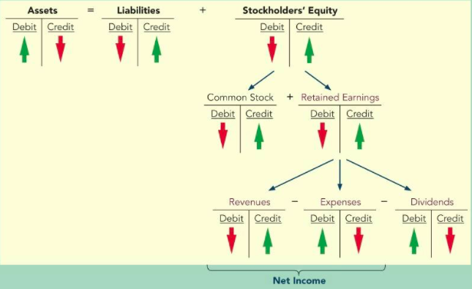

General Ledger: is a formal account that records increases and decreases in a specific asset, liability or shareholders’ equity items and shows their balances

Chapter 4 – Accrual Accounting Concepts

Accrual Basis: Revenues are recognized when earned; Expenses are recognized with incurred; regardless of when the cash is received or paid
Two Fundamental Principles of Accrual Accounting…
- Revenue Recognition: When are revenues earned?
  - Occurs when 3 conditions are met:
- The sales or performance effort is substantially complete
- The revenue amount is determinable (measurable)
- The collection of the revenue is reasonably assured.

- Matching: When are expenses incurred?
  - Expenses should be recorded in the same period as the revenues to which they relate, regardless of when cash is paid
  - Expenses are incurred when resources are committed or consumer to earn revenues for a given accounting period
    - Cost of goods sold
    - Utility expense
    - Salary expense

Adjusting Entries are required at the end of each fiscal period to get the revenues and expenses into the “right” period
Types of Adjustments:
Prepayment: cash has been paid out or received when adjusting entries are made
- Prepaid expenses: expenses paid in cash and recorded as assets before they are used
- Unearned Revenues: cash received and recorded as a liability before revenue is earned
  - Ex) gift certificates sold, rent collected in advance, subscriptions collected in advance
Accrual: cash has not been paid or received when adjusting entries are made
  - Accrued Expenses: Expenses incurred but not yet paid in cash
    - Ex) salaries, interest, utilities
  - Accrued Revenues: revenues earned but not yet received in cash
    - Ex) interest receivable, rent receivable

Closing the Books
    - Assets, Liabilities and Shareholder’s Equity are PERMANENT accounts and are never closed. Their balances are carried forward from one period to the next.
    - Revenues and expenses are TEMPORARY accounts are closed at the end of the period (reset to zero). Net income or net loss get recorded to retained earnings.

Closing the Books
- Closing entries at the end of a fiscal period
- Transfer profit or loss to Retained Earnings
- Establish a zero balance is each of the temporary accounts to start the next accounts period

Steps:
- Close revenues to Income Summary
All Revenue Accounts
Income Summary

- Close expenses to Income Summary
Income Summary
All Expense Accounts

- Close Profit to Retained Earnings
Income Summary
Retained Earnings

- Close Dividends to Retained Earnings
Retained Earnings
Dividends

$Gross Margin Percentage=\frac{Gross Profit}{Net Sales}$

$$Return on Sales=\frac{Net Income}{Net Sales}$$

Chapter 5: Merchandising Operations

- Journal entries for sales returns, sales allowances, and sales discounts
- Two Inventory Systems
  - Perpetual Inventory System
  - Periodic Inventory System
- Ration Calculation: Inventory turnover

2/10, n/30
First Number – Represents the discount… 2%
Second Number – Represents the discount period… 10 days
The letter n – Stands for the word net… to total sales minus any returns
Last Number – Represetns the maximum days in the credit period… 30 Days
- “Can get a 2% discount if payed within 10 days, otherwise the amount is due within 30 days”

Sales Discounts: early payment discounts are offered to customers
Sales Returns: customers return merchandise for refund
Sales Allowances: when sold merchandise is slightly defective, a credit is granted to the customer who keeps the merchandise
*These situations are recorded in a separate account

Sales & Sales Contra Accounts
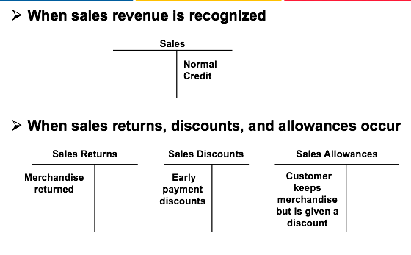

Inventory System: is to determine Cost of Goods Sold (COGS) and ending inventory (asset)
Two Types:
- Perpetual (real time)
- Periodic

Inventory System: Critical Formula
Beginning Inventory + Purchases
= Goods Available for Sale – Ending Inventory
= Cost of Goods Sold

Periodic & Perpetual Inventory: Purchases
All costs incurred to bring the inventory to saleable condition
- Invoice price
- Costs of inspection, loading, unpacking, and preparing
- Shipping costs
  - FOB Destination Point: the buyer does not pay the skipping costs; therefore the skipping costs are not included in inventory purchases
  - FOB Shipping Point: the buyer pays the shipping costs; therefore shipping costs are included in inventory purchases
Cost of Inventory = All inventory costs incurred – Purchase returns & allowances – Purchase discounts

Inventory is tracked constantly on a real-time basis in the inventory account
Inventory is updated after each purchase and each sale.

Control: inventory is counted at least once a year (control purposes only)

Periodic Inventory System – During the Accounting Period
Inventory purchases are tracked in a temporarily account called “Purchases”

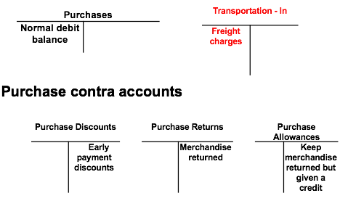

Periodic Inventory System – At the End of the Accounting Period
- Purchases, Transportation-In and all contra-accounts are closed to zero
  - The balances (purchases + transportation-in – all contra accounts) are transferred to the Inventory account
- Ending balance of inventory is determined by the physical count
- Calculate COGS and make an adjusting entry for COGS
  - COGS = beginning inventory + purchases – ending inventory

Ratios

Inventory Turnover: the number of times inventory is sold during the year
$$\frac{Cost of Goods Sold}{Average Inventory}$$

Days in Inventory: The number of days it takes to sell inventory
$$\frac{365 Days}{Inventory Turnover}$$

Chapter 6 – Reporting & Analyzing Inventory

Track the actual physical flow of the goods
- Applicable when expensive items are in stock and each item tends to differ from the other items
- For example, aircraft, yachts, fine art objects, buildings, luxury cars etc.…

Inventory valuation methods (costing methods)
- Specific item valuation
- Cost Flow Assumptions
  - FIFO
  - Weighted Average

- When items in stock are identical and in large quantity, it is impractical or too expensive to track which items are being sold
- For the purpose of inventory costing, we assume the physical flow of goods on and off the shelves.
  - FIFO: the first that arrived is the first inventory that was sold
  - Weighted – Average Method: All batches in stock are mixed together, and the inventory sold proportionally consists of all bathes in stock

First-In, First-Out (FIFO)
- Assume that the earliest goods purchased (the first ones in) are the first units sold (the first ones out)
No differences in ending inventory cost and COGS for FIFO under the periodic and perpetual methods

Weighted-Average Method
- All batches in stock are mixed together, and the inventory sold proportionally consists of all batches in stock
- The weighted average unit cost is calculated and is used to determine the cost of goods sold and ending inventory
- Two Versions:
  - Annual weighted average for periodic systems
    - Unit cost is calculated at the end of the period
Unit Cost = Cost of goods available for sale/units available for sale

  - Moving weighted average for perpetual systems
    - Unit cost is recalculated every time a purchase is made
Unit Cost = Cost of all goods on hand/the number of units on hand

Specific Identification Method
Ending Inventory = Ending Units x The unit cost of corresponding units

FIFO, Periodic & Perpetual
Ending Inventory = Ending Units x The unit cost of most recent purchases

Weighted Average, Periodic & Perpetual
Ending Inventory = Ending Units x The unit weighted average cost

The Lower of Cost and Net Realizable Value Rule (LCNRV)
At the end of each accounting period, the cost of inventory is compared with the market value of the inventory.
The market value (aka the net realizable value) = The selling price of the inventory item – any costs incurred to sell it
- If NRV < the cost on the book…
  - Inventory must be written down to the market value

Dr. COGS
Cr. Inventory

- The written-down amount of inventory can be reversed if the market value of the inventory increases next accounting period

Dr. Inventory
Cr. COGS

- If NRV > or = the cost on the book, no journal entry to adjust the value of ending inventory

Chapter 8: Reporting & Analyzing Receivable

- Accounts Receivables are created when companies have sales to customers on open accounts

Accounting for Bad Debts: Allowance Method
- At the end of each accounting period, uncollectible accounts receivable are estimated and matched against sales in the same accounting period in which the sales are incurred
Adjusting Journal Entry:
Dr. Bad Debt Expense
Cr. Allowance for Doubtful Accounts

Calculating of Estimating the Allowance – Balance Sheet Approach
- First, estimate the desired ending balance
  - Aging of the accounts receivable listing

- Second, record the adjusting entry to recognize bad debt expense
  - Bad Debt Expense = End. Balance +/- Unadjusted Balance

Aging of Accounts Receivable Listing:
- Group all outstanding receivables based on how long they have been outstanding
- Based on past experience, estimate the percentage of the accounts receivables in each group that will not be collected
- Add up the estimated uncollectable amounts in all groups

Anytime during the year when an account receivable is deemed uncollectable (the company gives up on collecting it)… it should be written off: completely removed from the company’s accounts

Dr. Allowance for Doubtful Accounts
Cr. Accounts Receivable

When a previously written-off account gets recovered:
- Reverse the entry made to write the account off
Dr. Accounts Receivable
Cr. Allowance for Doubtful Accounts

- The Record the collection of the account
Dr. Cash
Cr. Accounts Receivable

Valuation of Account Receivables – Allowance Method
- Allowance for Doubtful Accounts (AFDA) is a Contra-account of Accounts Receivable

The Allowance Method
- Net amount expected to be collected in cash
- Keeps receivables from being overstated on the balance sheet
- How to estimate uncollectible accounts? How to record them?

Summary: The Allowance Method
- Record estimated uncollectible accounts
  - Any increase to the allowance is recorded as bad debts expense
- Recording the write-off of an uncollectible account
  - Actual accounts are written off when they are determined to be uncollectible
  - This write-off reduces the allowance
- Recording the recovery of an uncollectible account
  - If a written-off account is later collected, the write-off is reversed and the collection recorded

Ratios… Asset Management Analysis (how well the firm’s assets are managed)
Day sales in Accounts Receivable (average collection period)
= Average Accounts Receivable / (Net Credit Sales/365)

This tells us how many days it takes, on average, to collect accounts receivable

Notes Receivable are written promises from customers to pay with specified terms
- Formal contract to repay (promissory note)
- Often accepted from new customers or repeated customer who need to extend payment of an account receivable
- Requires payment of interest

Has 3 Entries…

- Dr. Notes Receivable (face value)
Cr. A/R or Sales

- Dr. Interest Receivable
Cr. Interest Revenue
(Note: Interest accrued with earned)

- Dr. Cash
Cr. Notes Receivable

