Experiment 4

By: Claudia Nathalie Prieto, 8721546

Partner: Victoria Suwalska, 8135074

CHM1311C

Lab day: Friday Afternoon
Lab week: 7

Demonstrator:
Tom Burns

11/11th 2016

University of Ottawa

INTRODUCTION:

The base of this laboratory are kinetics. Kinetics is defined as the study and discussion of chemical reaction rates. This includes the analysis of variations in respect to the effect of various variables such as temperature, concentration, catalysis, formation of intermediates, etc. These divers factors determine the usefulness of a reaction as it depends on its rate. In this case, the factor being observed is the concentration of the reactants, or more specifically, the order of the reaction. Thus, in order to determine the order of the reaction used in this experiment implicates the measurement of the appearance of a coloured species as a function of time. In another words, the method being applied involves the measurement of the change in rate of the reaction as a matter of time. Furthermore, for this to be possible, it is necessary to make use of a spectrophotometer. A Spectrophotometer is an apparatus used for measuring the intensity of light in a part of the spectrum as transmitted by a particular substance, which in this case would be chromium (III) salt mixed with an excess of EDTA (ethylene tetraacetate) at a concentration of 0.1mol/L. For this reaction to be successful and the results to be reliable, the pH must be maintained at a range of 3.5 to 5.5 and at room temperature. Likewise, as spectrophotometry is used, % transmittance and absorbance must be calculated by using T = %T/ 100 and A = -log T, subsequently. At the end of the reaction, it is also necessary to determine the amount of unreacted Cr(III) using the equation ACr (III) = A∝ - At. Finally, in order to determine the rate of the reaction, the equation: Log Rate = a log [Cr(III)] + log k must be used and as the value have been previously calculated, it is only necessary to sub them in.
COLLECTED DATA:
Wavelength: 577.3 nm
 | Trial 1 | Trial 2 | Trial 3
Volume | 10 mL | 10 mL | 10 mL
PH (EDTA) | 4.0 | 4.5 | 5.0
% transmittance unheated | 70.564 | 46.877 | 72.099
 | 3.252 | 1.180 | 1.299

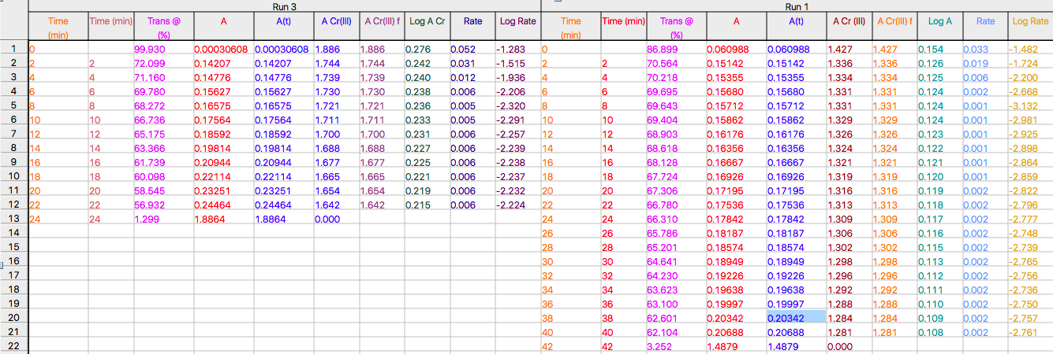
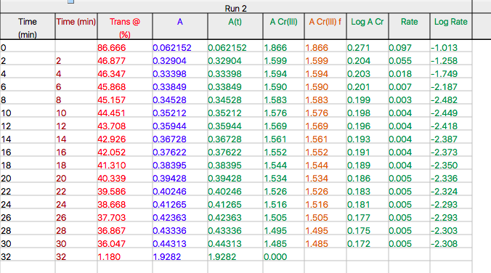

OBSERVATIONS:
The observations of the laboratory can be seen as general due to the fact that besides the concentration of PH and the time, the steps and the heat used were the same. For the initial solution, when the EDTA of diverse PH (4.0,4.5 and 5.0 subsequently) is mixed with two drops of Chromium(III) the colour of the solution went from being fully transparent and odorless, to having a slight purple tint. Likewise, for all three trials, after putting an initial amount of solution in the cuvette, the remaining amount was heated up in boiling water. At this point, it was possibly to observe the change in colour once again. In this case, initially a darker purple was seen as it slightly took over the whole solution making in very dark. For the first trial, this final change occurred in about 2 min, for the second trial it occurred in about 30 seconds, and for the third trial it occurred in 40 seconds. Finally, it was also seen that as soon as the final dark colour was achieved, the solution remained this colour even when cooled down in cold water.

Trial 1: table
Time (min) | Time (min) f | Trans @ (%) | A | A(t) | A Cr(III) | A Cr(III) f | Log A Cr | Rate | Log Rate
0.000 |  | 86.899 | 0.061 | 0.061 | 1.427 | 1.427 | 0.154 | 0.0330 | -1.482
2.000 | 2.000 | 70.564 | 0.151 | 0.151 | 1.336 | 1.336 | 0.126 | 0.0189 | -1.724
4.000 | 4.000 | 70.218 | 0.154 | 0.154 | 1.334 | 1.334 | 0.125 | 0.0063 | -2.200
6.000 | 6.000 | 69.695 | 0.157 | 0.157 | 1.331 | 1.331 | 0.124 | 0.0021 | -2.668
8.000 | 8.000 | 69.643 | 0.157 | 0.157 | 1.331 | 1.331 | 0.124 | 0.0007 | -3.132
10.000 | 10.000 | 69.404 | 0.159 | 0.159 | 1.329 | 1.329 | 0.124 | 0.0010 | -2.981
12.000 | 12.000 | 68.903 | 0.162 | 0.162 | 1.326 | 1.326 | 0.123 | 0.0012 | -2.925
14.000 | 14.000 | 68.618 | 0.164 | 0.164 | 1.324 | 1.324 | 0.122 | 0.0013 | -2.898
16.000 | 16.000 | 68.128 | 0.167 | 0.167 | 1.321 | 1.321 | 0.121 | 0.0014 | -2.864
18.000 | 18.000 | 67.724 | 0.169 | 0.169 | 1.319 | 1.319 | 0.120 | 0.0014 | -2.859
20.000 | 20.000 | 67.306 | 0.172 | 0.172 | 1.316 | 1.316 | 0.119 | 0.0015 | -2.822
22.000 | 22.000 | 66.780 | 0.175 | 0.175 | 1.313 | 1.313 | 0.118 | 0.0016 | -2.796
24.000 | 24.000 | 66.310 | 0.178 | 0.178 | 1.309 | 1.309 | 0.117 | 0.0017 | -2.777
26.000 | 26.000 | 65.786 | 0.182 | 0.182 | 1.306 | 1.306 | 0.116 | 0.0018 | -2.748
28.000 | 28.000 | 65.201 | 0.186 | 0.186 | 1.302 | 1.302 | 0.115 | 0.0018 | -2.739
30.000 | 30.000 | 64.641 | 0.189 | 0.189 | 1.298 | 1.298 | 0.113 | 0.0017 | -2.765
32.000 | 32.000 | 64.230 | 0.192 | 0.192 | 1.296 | 1.296 | 0.112 | 0.0018 | -2.756
34.000 | 34.000 | 63.623 | 0.196 | 0.196 | 1.292 | 1.292 | 0.111 | 0.0018 | -2.736
36.000 | 36.000 | 63.100 | 0.200 | 0.200 | 1.288 | 1.288 | 0.110 | 0.0018 | -2.750
38.000 | 38.000 | 62.601 | 0.203 | 0.203 | 1.284 | 1.284 | 0.109 | 0.0018 | -2.757
40.000 | 40.000 | 62.104 | 0.207 | 0.207 | 1.281 | 1.281 | 0.108 | 0.0017 | -2.761
42.000 | 42.000 | 3.252 | 1.488 | 1.488 | 0.000

Trial 1: A Cr(III) final vs. Time final
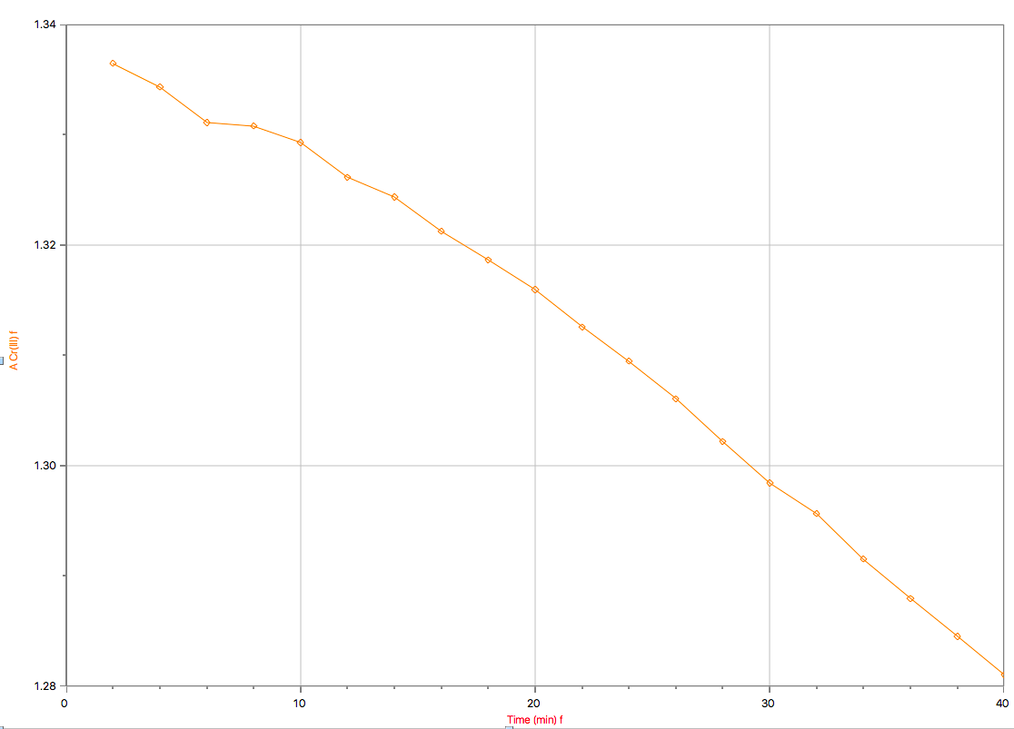

Trial 1: log ACr (III) vs. time final
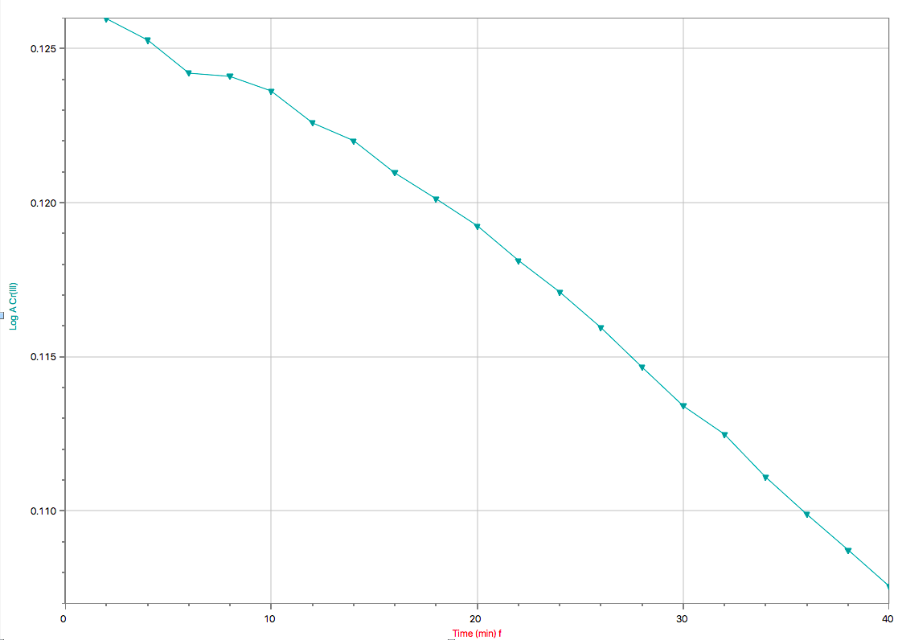
Trial1: log rate vs. log ACr(III)
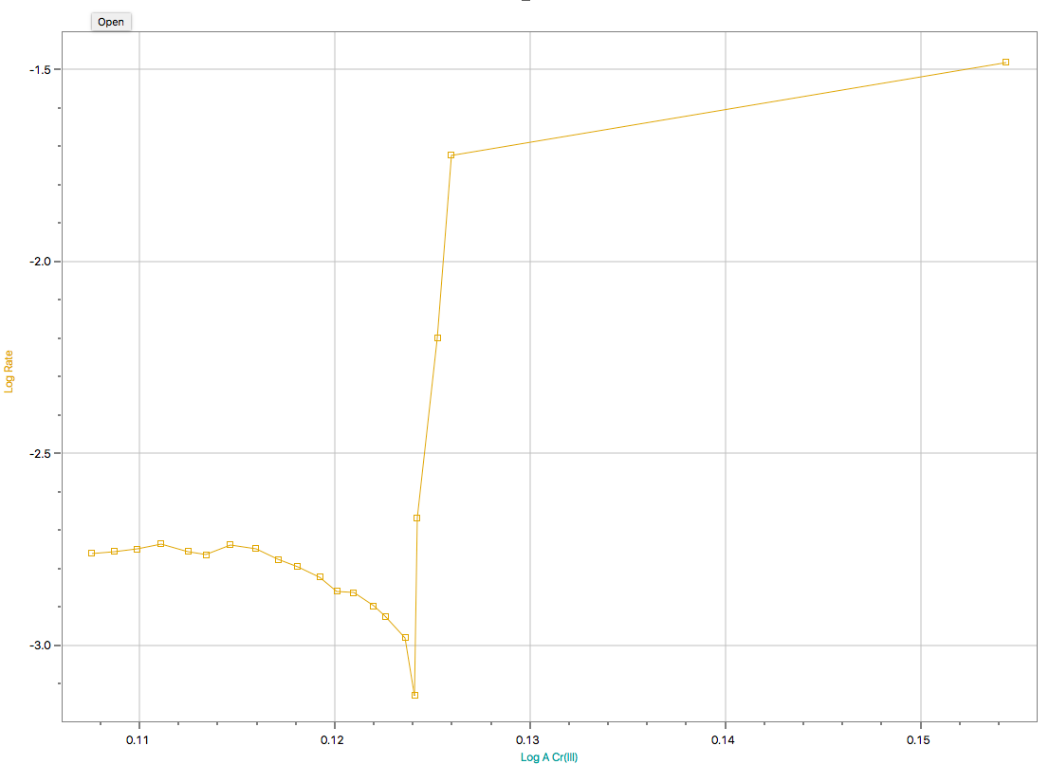

Trial 2 table
Time (min) | Time (min)f | Trans @ (%) | A | A(t) | A Cr(III) | A Cr(III)f | Log ACr(III) | Rate | Log Rate
0.000 |  | 86.666 | 0.062 | 0.062 | 1.866 | 1.866 | 0.271 | 0.0971 | -1.013
2.000 | 2.000 | 46.877 | 0.329 | 0.329 | 1.599 | 1.599 | 0.204 | 0.0552 | -1.258
4.000 | 4.000 | 46.347 | 0.334 | 0.334 | 1.594 | 1.594 | 0.203 | 0.0178 | -1.749
6.000 | 6.000 | 45.868 | 0.338 | 0.338 | 1.590 | 1.590 | 0.201 | 0.0065 | -2.187
8.000 | 8.000 | 45.157 | 0.345 | 0.345 | 1.583 | 1.583 | 0.199 | 0.0033 | -2.482
10.000 | 10.000 | 44.451 | 0.352 | 0.352 | 1.576 | 1.576 | 0.198 | 0.0036 | -2.449
12.000 | 12.000 | 43.708 | 0.359 | 0.359 | 1.569 | 1.569 | 0.196 | 0.0038 | -2.418
14.000 | 14.000 | 42.926 | 0.367 | 0.367 | 1.561 | 1.561 | 0.193 | 0.0041 | -2.387
16.000 | 16.000 | 42.052 | 0.376 | 0.376 | 1.552 | 1.552 | 0.191 | 0.0042 | -2.373
18.000 | 18.000 | 41.310 | 0.384 | 0.384 | 1.544 | 1.544 | 0.189 | 0.0045 | -2.350
20.000 | 20.000 | 40.339 | 0.394 | 0.394 | 1.534 | 1.534 | 0.186 | 0.0046 | -2.336
22.000 | 22.000 | 39.586 | 0.402 | 0.402 | 1.526 | 1.526 | 0.183 | 0.0047 | -2.324
24.000 | 24.000 | 38.668 | 0.413 | 0.413 | 1.516 | 1.516 | 0.181 | 0.0051 | -2.293
26.000 | 26.000 | 37.703 | 0.424 | 0.424 | 1.505 | 1.505 | 0.177 | 0.0051 | -2.293
28.000 | 28.000 | 36.867 | 0.433 | 0.433 | 1.495 | 1.495 | 0.175 | 0.00498 | -2.303
30.000 | 30.000 | 36.047 | 0.443 | 0.443 | 1.485 | 1.485 | 0.172 | 0.00492 | -2.308
32.000 | 32.000 | 1.180 | 1.928 | 1.928 | 0.000
Trail 2: ACr (III) final vs. time final
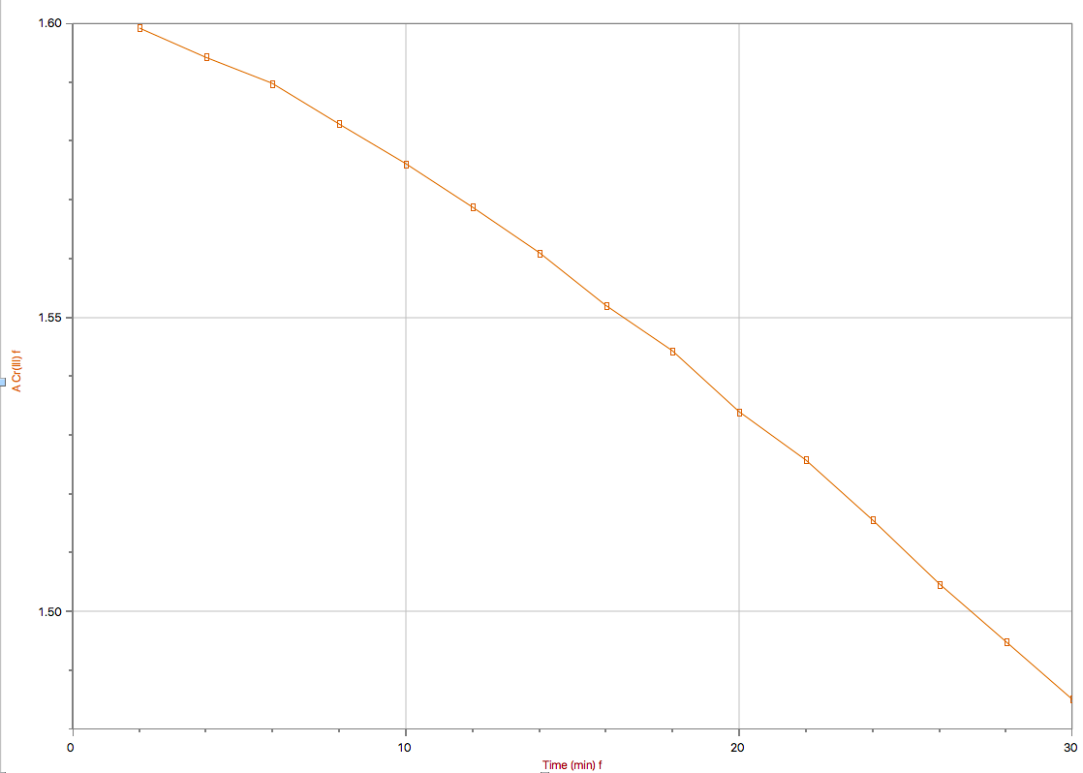
Trial 2: log ACr(III) vs. time final
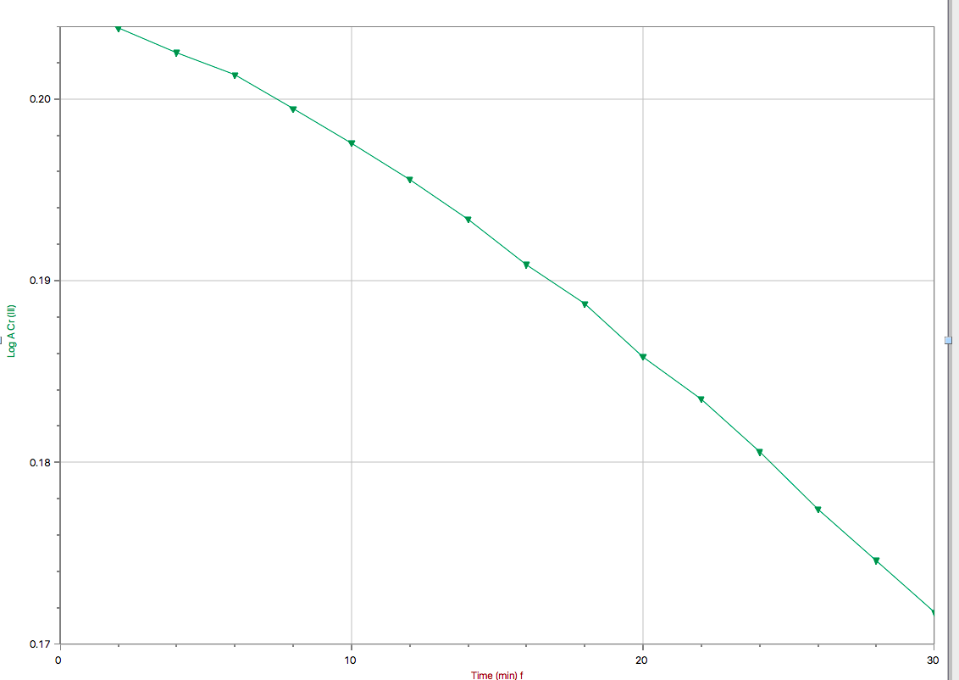
Trial 2: log rate vs. log ACr(III) 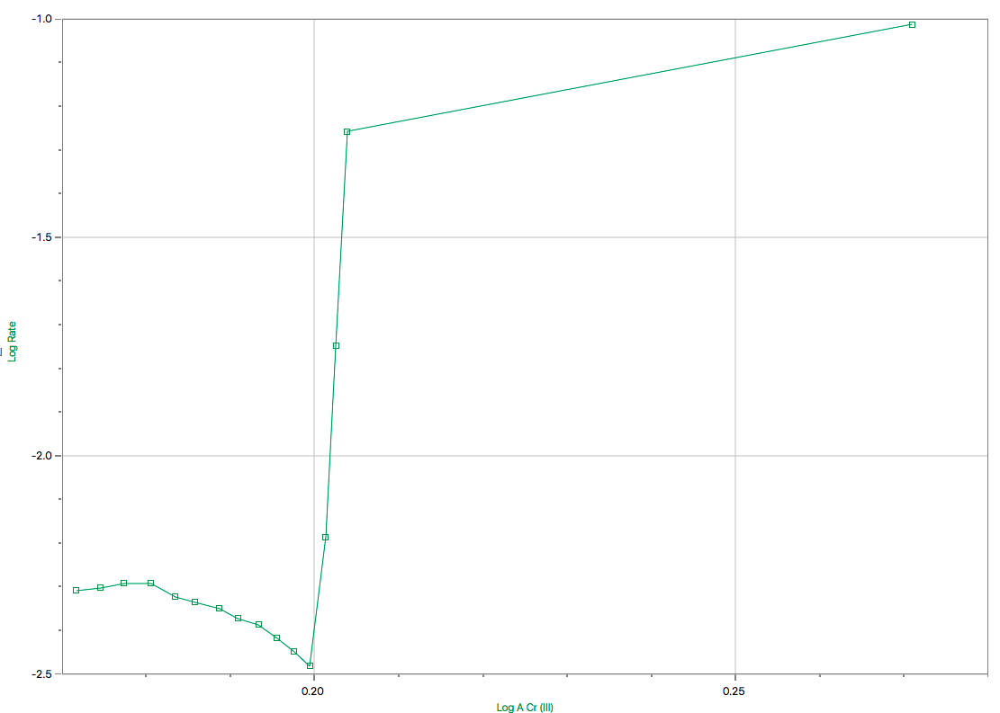
Time (min) | Time (min)f | Trans @ (%) | A | A(t) | A Cr(III) | A Cr(III)f | Log A Cr | Rate | Log Rate
0.000 |  | 99.930 | 0.000 | 0.000 | 1.886 | 1.886 | 0.276 | 0.0521 | -1.283
2.000 | 2.000 | 72.099 | 0.142 | 0.142 | 1.744 | 1.744 | 0.242 | 0.0305 | -1.515
4.000 | 4.000 | 71.160 | 0.148 | 0.148 | 1.739 | 1.739 | 0.240 | 0.0116 | -1.936
6.000 | 6.000 | 69.780 | 0.156 | 0.156 | 1.730 | 1.730 | 0.238 | 0.0062 | -2.206
8.000 | 8.000 | 68.272 | 0.166 | 0.166 | 1.721 | 1.721 | 0.236 | 0.0048 | -2.320
10.000 | 10.000 | 66.736 | 0.176 | 0.176 | 1.711 | 1.711 | 0.233 | 0.0051 | -2.291
12.000 | 12.000 | 65.175 | 0.186 | 0.186 | 1.700 | 1.700 | 0.231 | 0.0055 | -2.257
14.000 | 14.000 | 63.366 | 0.198 | 0.198 | 1.688 | 1.688 | 0.227 | 0.0058 | -2.239
16.000 | 16.000 | 61.739 | 0.209 | 0.209 | 1.677 | 1.677 | 0.225 | 0.0058 | -2.238
18.000 | 18.000 | 60.098 | 0.221 | 0.221 | 1.665 | 1.665 | 0.221 | 0.0058 | -2.237
20.000 | 20.000 | 58.545 | 0.233 | 0.233 | 1.654 | 1.654 | 0.219 | 0.0059 | -2.232
22.000 | 22.000 | 56.932 | 0.245 | 0.245 | 1.642 | 1.642 | 0.215 | 0.0060 | -2.224
24.000 | 24.000 | 1.299 | 1.886 | 1.886 | 0.000
Trial 3 : table

Trail 3: ACr (III) final vs. time final

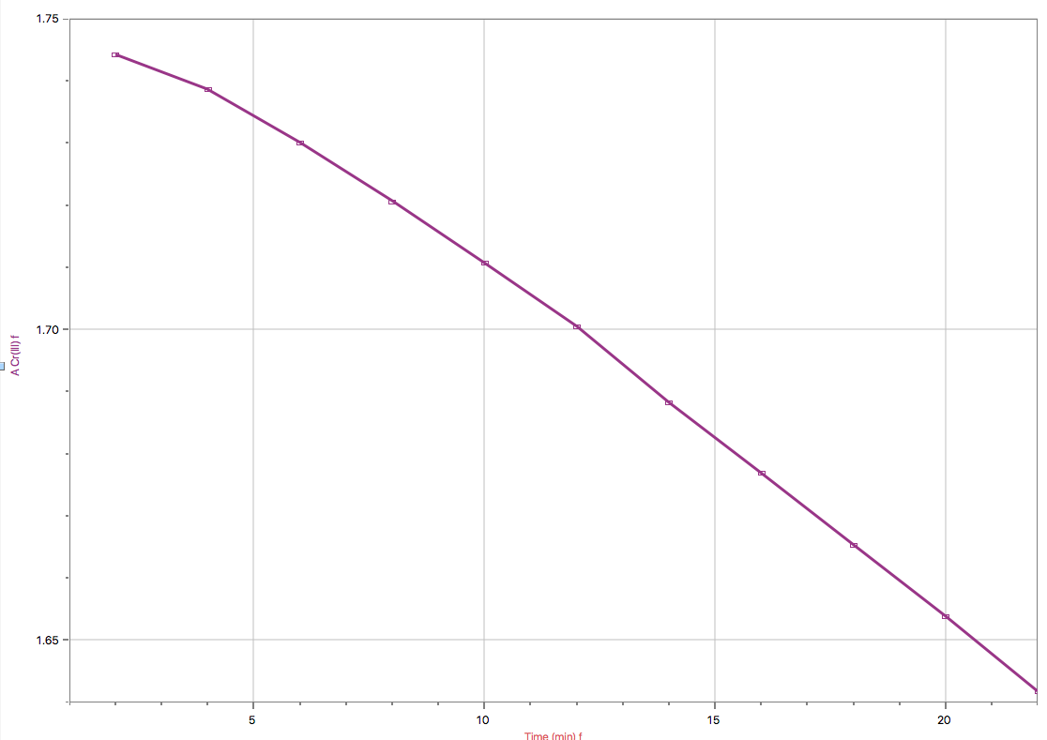
Trial 3: log ACr(III) vs. time final
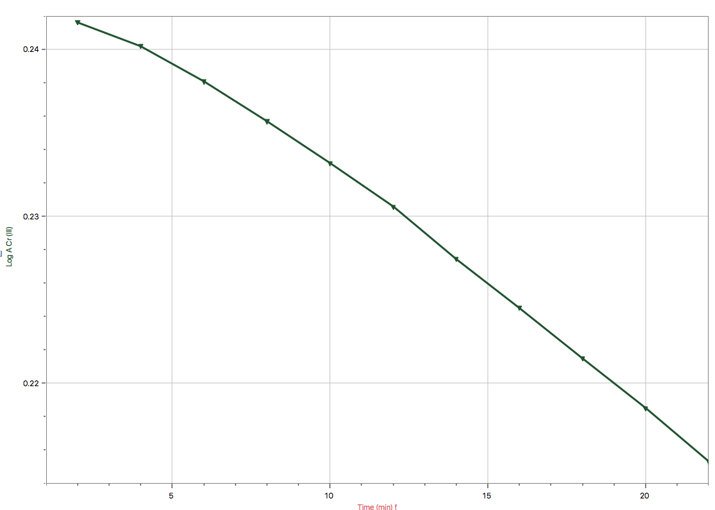
Trial 3: log rate vs. log ACr(III)
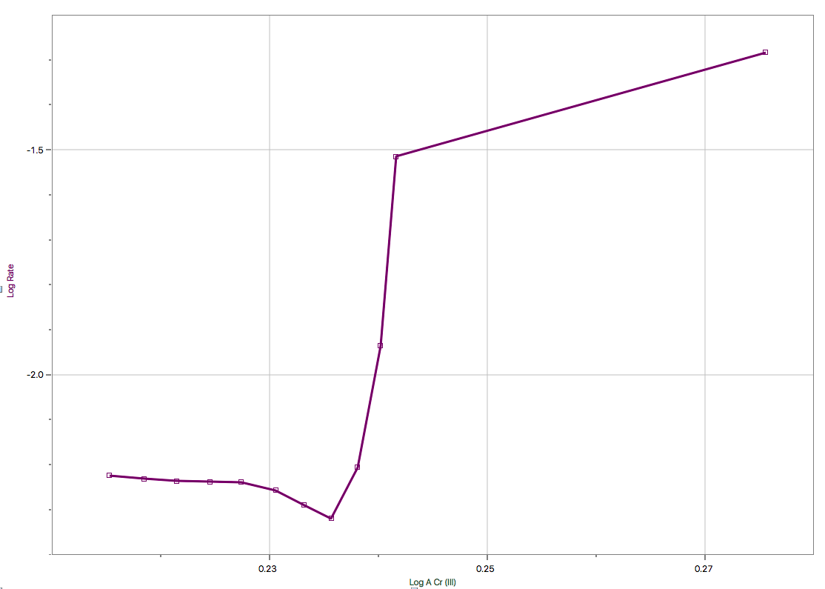 CALCULATIONS (data from trial 1 used) :
- % Transmittance absorbance
%T = 70.564%
T = 70.564/100
= 0.70564

A = - log T
= - log (0.72099)
= 0.15142

- Absorbance Absorbance of chromium ion
At = 0.15142 ; A∝ = 1.488

A Cr (III) = A∝ - At
= 1.488 – 0.15142
= 1.3366

- Absorbance of chromium ion log of absorbance of chromium
Log A Cr (III) = log (1.3366)
= 0.12600

- Rate log of rate
Log rate = -1.724

- Slope
m = ($∆y/∆x$)
= (( -1.724) – (0)) / ((-2.761) – (-0.108)
= 0.65 ≈ 1

DISCUSSION:
After effectuating this laboratory, diverse factors affecting the rate of the reaction have successfully been seen. The most important and noticeable ones were volume, concentration, and temperature. Through the results it is possible to justify the effects of this factors. More specifically, when talking about volume, it was visible that the volume of chromium(III) added, which in this case was 2 drops, determined % transmittance of the solution. This is to say that when the reactant volume was increased, Le Chatelier principle comes into play, thus the equilibrium will shift right and more chromium(III)-EDTA complex will be formed and the solution will be darker. As a result, % transmittance will decrease which means that the amount of light going through the particles will be less. When it comes to temperature, it was seen that when the solution was heated up to 100°C for about 10 min. the solution rapidly came to completion as the colour became darker in a matter of seconds. Thus, it is deductible that the temperature increase causes the number of high energy collisions to be greater which then causes the reaction to form the final complex faster.
When analyzing all the data, it could be inferred that the data could be approximately reproducible if the lab is effectuated under the same conditions. This is to say, that the reactants are used at the same temperature and PH levels, and the steps are followed as before, very similar results can possibly be obtained. However, divers types of errors causing slightly different results can be seen. Some of these errors could include wiping the cuvette to take off the remains of water and fingerprints that will influence the final results given by the spectrophotometer, adding an extra drop of Chromium(III), use the wrong EDTA solution, among others. When talking about the graph of log A Cr(III) vs. t, it is visible that it was historically plotted as a descending straight line approaching zero as time passes by. The slope of this graph is 1, which is also the rate of the reaction. Likewise, this graph is related and proofs the results of the rate equation: Log Rate = a log [Cr(III)] + log K. The general calculations of the instantaneous rate on the graph were not all the exact same, however they are extremely similar. Generally, it Is not important to calculate the instantaneous rate of reaction due to the fact that it is the same as the slope of a line tangent to the concentration versus time curve. Being a pseudo first-order reaction, and based on the rate law for a first order equation, the rate is fully proportional to the concentration of the reactant. Therefore, as the PH of the solution increases. Likewise, when speaking of the partial order with respect to the hydrogen ions, it is possible to make the assumption that as the number of hydrogen ions decreased the rate of reaction increased as there is a inversely proportional relationship between the two.

CONCLUSION:
After analyzing the results of the laboratory, and observing the graphs, it was possible to determine that the partial order was 1 in co-ordinance to Cr(III). Likewise, as the concentration of Cr(III) ion decreased continuously as the time passed by. Through these result, it is possible to assume that the amount of H⁺ ions and the rate of the reaction have a inversely proportional relationship. Lastly, it is necessary to keep in mind that this results are true for this experiment but they are not fully accurate to the mechanisms as we only observed a small period of time of a whole reaction.

REFERENCES:

Principles of Chemical Kinetics2nd Edition. Academic House, E. James. 2007. Press. Burlington, Massachusetts

General Chemistry: Principles and Modern Applications, 10th Edition. Toronto, Ontario. Pearson.

Experiment 3: Chemical Kinetics Laboratory Manual Ventateswaran, Rashmi. 2012.Ottawa, Ontario. University of Ottawa.



