Experiment 3: AC Circuit Analysis, Pre-lab
Amir Ali, 610144

Series AC Circuit:

- 500 Hz and 600 Hz
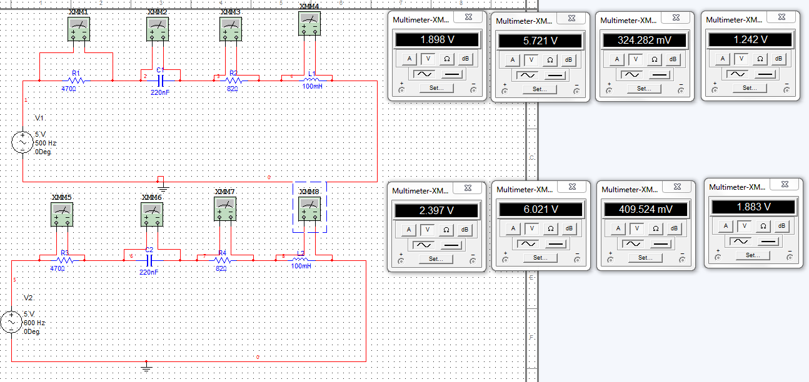
- 700 Hz and 800 Hz
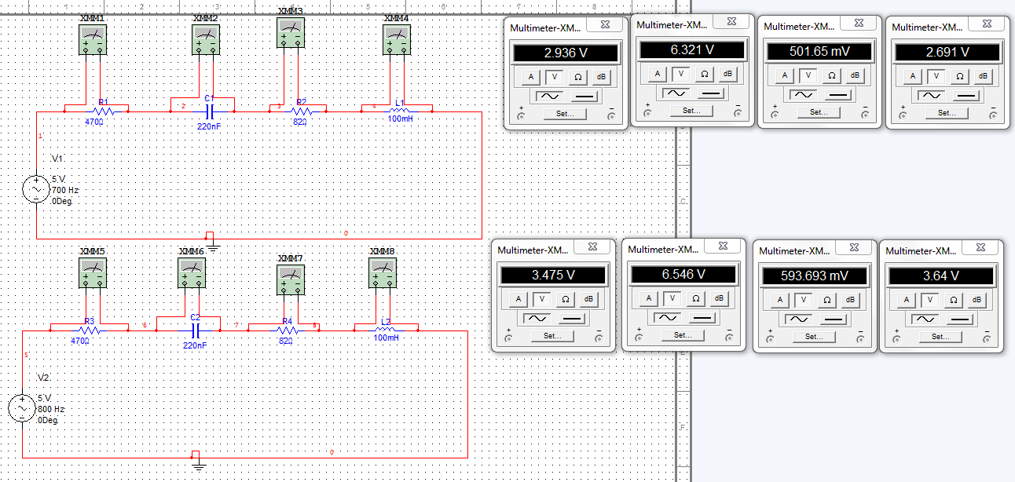
- 900 Hz and 1000 Hz
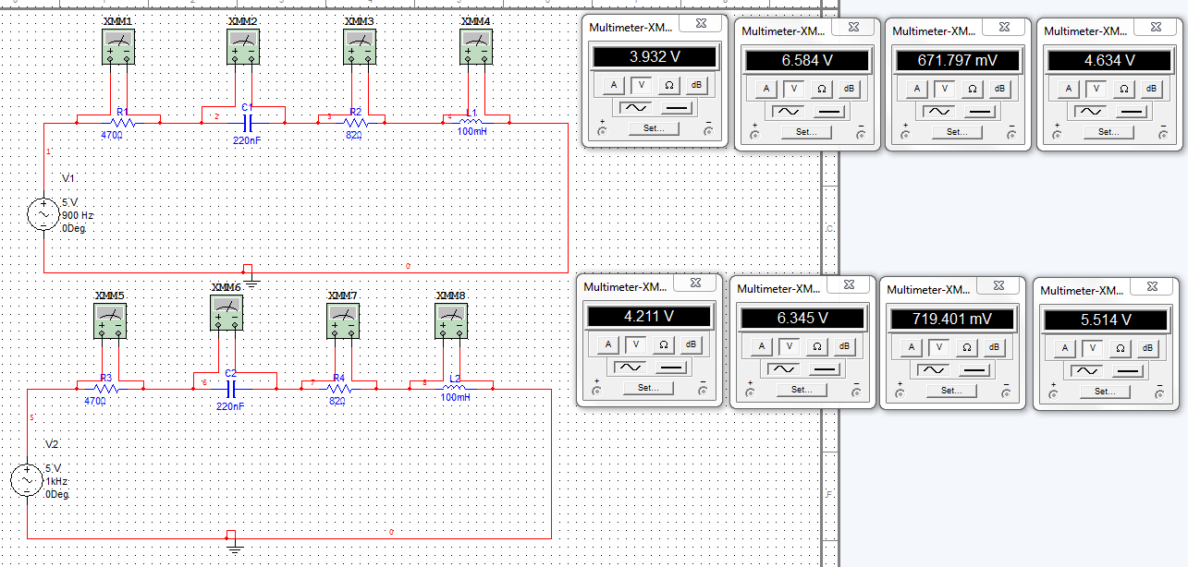
Parallel RLC Circuit:



