Biology notes
By: Danielle palmer



Introduction to cell biology (1st lecture)

What is a cell?
- Robert Hooke was the first to observe looking at a cell using a microscope at the molecular level in the mid 1600s

Cell theory
- All organisms are composed of one or more cells
- The cell is the basic structural and functional unit of all living organisms
- Cell arise only from division of pre-existing cells

Cell features
- Diversity:
- Wide range of sizes (nm to m)
- Simple or complex shapes; related to function
- General or very specialized role
- Common characteristics:
- Components
- Basic chemistry
- Metabolism (ATP)
- DNA
- Examples of cells: bacterium, Achaean, protest, algae, animal cells, plant cells, fungal cells

Cell size and scale
- Typical cell sizes:
- Prokaryote: 1-5um
- Eukaryotes: 10-100 um

Why are cells small?
- Because of surface area, the greater the surface area of the cell the harder it will be for the cell to reach equilibrium. If it is small then the cell can easier maintain itself ex: it needs fewer nutrients and produce far less waste

2 main types of cells
- Prokaryotes: unicellular, bacteria
- Eukaryotes: unicellular (protists)
- Multicellular: plants, fungi

Prokaryotes
- Very small
- Simple
- Highly adaptable
- Small genomes

Eukaryotes
- Larger
- Elaborate membrane allow compartments to organize cellular function
- Transport systems
- Larger genomes, linear, associated with proteins
- Ribosomes are somewhat an organelle because they do not have a membrane, but they do have a functional job of the cell

Organelles of the eukaryotic cell

Lysosomes
- They are acidic organelle that contain a battery of degradative enzyme
- They form closed compartments in which the composition of the lumen
- In animal cells: they are bounded by a single membrane and are responsible for degrading components that have become old for the cell
- Lysosomes perform endocytosis which is the process by which extracellular materials are taken up by invagination of a segment of the plasma membrane to form a small membrane-bounded vesicle (endosome)
- They contain a group of enzymes that degrade polymers into their monomeric subunits
- TaySachs disease is caused by a defect in one enzyme catalyzing a step in the lysosomal breakdown of certain glycolipids called gangliosides, which are abundant in nerve cells. Most people diagnosed die before the age of 2
- Enzymes work efficiently at acid ph values: A hydrogen ion pump and a Cl channel protein in the lysosomal membrane maintain the pH of the interior at ≈4.8
- Acid helps denature proteins
- If a lysosome release some of it contents into the cytosol (ph 7.0-7.3) little degradation of cytosolic components takes place
- Primary lysosomes are roughly spherical and do not contain obvious debris
- Second lysosomes are large, irregular shape, they contain particles in the process of being digested
- Autophagy: refers to the process in which a lysosome begins to age and degrade “eat oneself”

Vacuoles
- Vacuole takes up majority of plant cell space
- Stores water, ions, nutrients like sucrose and amino acids
- They can hold waste products & excess salt
- They have an acidic pH maintained by proton pumps, contains a battery of degradative enzymes
- Permeable to water by osmosis but not to small molecules
- Growth of plant cell depends heavily on the pressure that the vacuole exerts of the membrane of the plants cell wall

Peroxisomes
- Small organelles
- Bounded by a single membrane
- Contain oxidases (enzyme that sues oxygen to oxidize organic substances to form hydrogen peroxide)
- The energy released during peroxisomal oxidation is converted to heat, and the acetyl groups are transported into the cytosol, where they are used in the synthesis of cholesterol and other metabolites

Mitochondria
- Main site of ATP production during aerobic metabolism (power plant)
- Largest organelle
- Has 2 membranes
- Outer membrane: half lipid & protein renders the membrane permeable to molecules
- Inner membrane: least permeable, has a number of folds called cristae
- In nonphotosynthetic cells the Principle fuels for ATP synthesis is fatty acids and glucose
- 34 ATP molecules per mitochondria

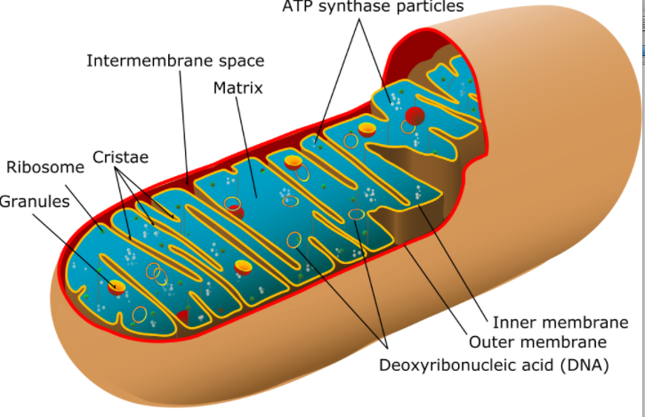
Chloroplast
- Largest in plants other then vacuole
- Has an inner and outer layer
- Contain an extensive internal system of interconnected membrane limited sacs called thylakoids, which are flattened to form disks; These often are grouped in stacks called grana and embedded in a matrix, the stroma
- Thylakoid membrane contains chlorophylls and enzymes that absorb light and generate ATP (photosynthesis)
- ATP used to produce sugars

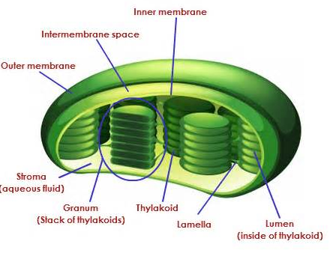

The smooth Endoplasmic reticulum
- Lacks ribosomes
- Synthesis of fatty acids and phospholipids occur here
- Enzymes detoxify hydrophobic chemicals such as pesticides and carcinogens by converting them into more water soluble products

Rough endoplasmic reticulum
- Ribosomes are bound to the RER
- Secretory proteins and membrane proteins are synthesized on the rough endoplasmic reticulum, a network of interconnected membrane vesicles studded with ribosomes.

Golgi vesicles
- Small membrane bounded vesicle
- They carry proteins to the luminal cavity of another membrane limited organelle, the Golgi complex
- Golgi complex: enzymes/ proteins are modified here
- After secretory proteins are modified in the Golgi sacs, they are transported out of the complex by a second set of transport vesicles, which seem to bud off the trans side of the Golgi complex

Double-membrane nucleus
- Largest organelle in eukaryote cells
- 2 membranes made of phospholipid bilayers
- Outer membrane is surrounded by the rough endoplasmic reticulum
- Has nuclear pores which are fused nuclear membranes which regulate the movement of material between the nucleus and the cytosol
- Produces DNA and RNA
- Easily recognizable under light microscope
- RNA is synthesized her

Cytosol
- Protein rich
- Contains soluble enzymes and 3 major protein types: actin microfilaments, microtubules and intermediate filaments
- Filaments form complex network, the cytoskeleton that gives the cell structural stability and contributes to cell movements

Nucleolus
- Houses genetic information
- Where DNA and RNA are
- Controls the cell

Ribosomes

The architecture of cells

Impermeable membrane
- Used to prevent interior contents from leaking out into the surrounding environment
- Chemical process of cellular life take place in watery solution
- Cells in order to maintain integrity need to be surrounded by an environment through which water cannot flow
- Membrane contains fatty molecules so that water cannot flow into and out whenever
- Phospholipid bilayer (polar and non polar)
- The membrane is given rigidity by cholesterol
- The linking of cells together through proteins helps maintain the integrity of tissues as well as gives the cell strength and protection

Other roles of the membrane
- Energy storage: it takes energy to move molecules across the membrane
- Proteins embedded throughout the membrane help transport molecules
- It is also embedded with receptors that signal molecules that allow individual activities of them any cells in the body to be coordinated this is called signal-transduction proteins

Prokaryotes and single membranes
- Prokaryotes consist of a single closed compartment containing the cytosol and bounded by the plasma membrane
- Many members of the archaeal lineage grow in unusual, often extreme, environments.
- the halophiles require high concentrations of salt to survive, and the thermoacidophiles grow in hot (80°C) sulfur springs, where a pH of less than 2 is common. Other archaeans, called methanogens, live in oxygen free milieus
- Some bacteria also have an invagination of the cell membrane, called a mesosome, which is associated with synthesis of DNA and secretion of proteins. Thus bacterial cells are not completely devoid of internal organization
- The cell wall is composed of layers of peptidoglycan, a complex of proteins and oligosaccharides; it helps protect the cell and maintain its shape
- Ecoli has a thin cell wall and an unusual outer membrane separated from the cell wall by the periplasmic space

Eukaryotes & organelles & complex cytoskeleton
- Eukaryotes: plants, animals, fungi, protozoans
- Unlike prokaryotic eukaryote contain extensive internal membranes that enclose specific compartments, the organelles, and separate them from the rest of the cytoplasm, the region of the cell lying outside the nucleus
- Most organelles are surrounded by a single phospholipid membrane except for the nucleus
- The membrane controls the organelles internal composition
- Nucleus= largest organelle and houses DNA
- Cytoskeleton: gives the cell strength and rigidity therefore helping maintain shape also it controls movements of structures within the cell, it is composed of cellulose and other polymers

Cellular DNA/ chromosomes
- The DNA is 1 to 50 long linear chromosomes
- Each chromosome comprises a single DNA molecule associated with numerous proteins, and the total DNA in the chromosomes of an organism is referred to as its genome
- Chromosomes are visible in light microscope during cell division
- In prokaryotic cells: genetic info resides in a single circular DNA molecule
- The arrangement of DNA heavily differs between eukaryotic and prokaryotic

The universal features of cells on earth

Introduction
- Heredity is a central part of life that helps distinguishes life from other processes
- Living organism must consume free energy to create and maintain it’s organization
- Everything created must be generated by cell division from a single cell (the single cell is the information that defines a species)

DNA where cells store their hereditary information
- Living cells have been diversifying for over 3.5 billion years
- It was assumed that lone time ago all cells stored their information in the same form
- All living cells no earth store their hereditary information in the form of double-stranded molecules of DNA: long unbranched paired polymer chains, formed always of the same four types of monomers (A, T, C, G)
- The linear sequence of ATCG encodes genetic information

Templated polymerization
- Each monomer in a single DNA strand that is, each nucleotide—consists of two parts: a sugar (deoxyribose) with a phosphate group attached to it, and a base, which may be either adenine (A), guanine (G), cytosine (C) or thymine (T)
- Each sugar is linked via phosphate group creating a polymer this creates a sugar phosphate backbone
- DNA is synthesised by a pre-existing DNA strand
- The complementary structures of the bases: A binds to T, and C binds to G
- The complementary strands twist together and form a double helix
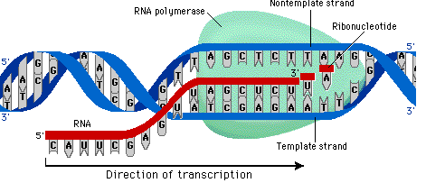

RNA
- The process begins with a templated polymerization called transcription, in which segments of the DNA sequence are used as templates to guide the synthesis of shorter molecules of the closely related polymer ribonucleic acid, or RNA.
- In RNA the backbone is formed from ribose and one of the four bases is U= uracil instead of T= thymine in ATGC
- During transcription, RNA monomers are lined up and selected for polymerization on a template strand of DNA
- RNA molecule that specifies the amino acid sequence of a protein. Produced by RNA splicing (in eukaryotes) from a larger RNA molecule made by RNA polymerase as a complementary copy of DNA. It is translated into protein in a process catalyzed by ribosomes.
- RNA Being single-stranded, their backbone is flexible, so that the polymer chain can bend back on itself to allow one part of the molecule to form weak bonds with another part of the same molecule

How cells use proteins as catalysts
- in a protein molecule the polymer chain folds up to into a specific shape defined by its amino acid sequence. A groove in the surface of this particular folded molecule, the enzyme lysozyme, forms a catalytic site. (B) A polysaccharide molecule (red)—a polymer chain of sugar monomers—binds to the catalytic site of lysozyme and is broken apart, as a result of a covalent bond-breaking reaction catalyzed by the amino acids lining the groove.
- Proteins, above all, are the molecules that put the cell's genetic information into action

Cell translate RNA into protein
- The information in the sequence of a messenger RNA molecule is read out in groups of three nucleotides at a time: each triplet of nucleotides, or codon, specifies (codes for) a single amino acid in a corresponding protein.
- Several codons can correspond to the same amino acid.
- The code is read out by a special class of small RNA molecules, the transfer RNAs (tRNAs)
- Each type of tRNA becomes attached at one end to a specific amino acid, and displays at its other end a specific sequence of three nucleotides—an anticodon—that enables it to recognize, through base-pairing, a particular codon or subset of codons in mRNA
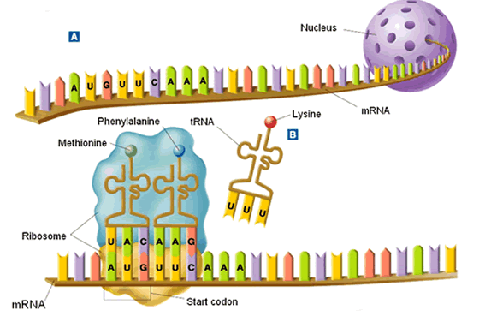
- the whole process of translation is carried out in a ribosome as the large and small subunit work together

Genetic information
- gene; a segment of DNA sequence corresponding to a single protein
- the cell adjusts the rate of transcription and translation of different genes independently, according to need. The noncoding regions of DNA determine the rate

Free energy
- when a cell dies a great deal of energy is released to the environment as heat
- For the cell to make a new cell in its own image, it must take in free energy from the environment, as well as raw materials, to drive the necessary synthetic reactions
- Free energy is required for the propagation of information
- The newly recruited nucleotides have been joined together to form a new DNA strand, a fresh input of free energy is required to force the matched nucleotides apart once again
- Free energy helps replicate the dead cells genetic information faithfully

Proteins (lecture #4)
Proteins
- Polymers of amino acids
- 20 amino acids
- Basic structure
- Units are Dalton
- 1 amino acid is- 110 Da
- In a cell, pH is typically 7.2; most aa will be in their ionized form
- Peptide bond (oriented)
- Backbones are the same but the radicals are different

Levels of proteins structure
- Primary: no folds, just a linkage of amino acids
- Secondary structure: consists of alpha helix and beta pleated sheets
- Tertiary structure: stable, can come together to from quaternary structure
- Quaternary structure: More then one subunit attached to each other

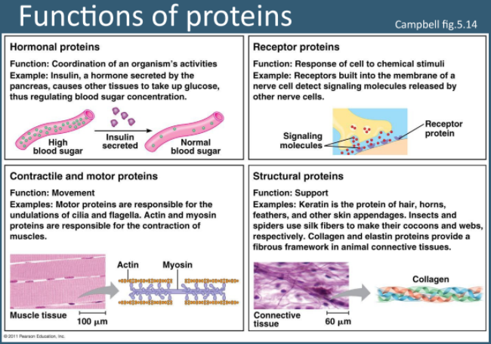
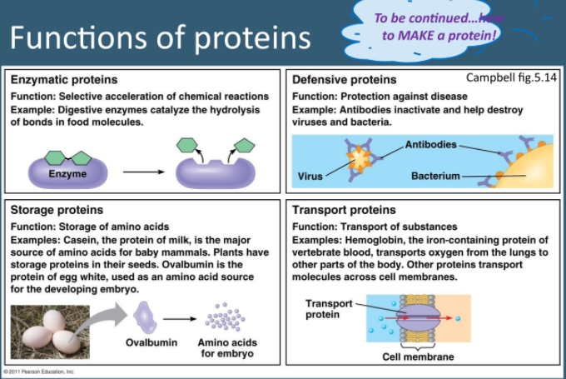

MEMBRANES

Why it is important to have membranes
- Boundary; selective permeability
- Organize and scaffold
- Regulate solute transport
- Receive signals
- Communication

Plasma membrane- fluid mosaic model
- Fluid lipid molecules with embedded, free- floating or anchored proteins. Arranged in sheets, non-covalently bound
- Two facing sheets/fluid lipid layers- provide structure
- Mosaic of different proteins- allow various functions (specificity)
Fluidity
- Within each layer the lipids continuously change places for ex: lateral diffusion occurs very quickly
- Rarely a change from 1 layer to the other occurs
- The membrane is asymmetric (both layers are different)

Composition of the lipid layers
- Phospholipids are the most abundant lipids in the membrane bilayer
- 1 polar head, 2 hydrocarbon tails
- amphipathic
- presence of unsaturated double bond produces “kink” and influences fluidity of the membrane
- glycolipids: are 1 or 2 fatty acid chains with single or multiple sugar groups attached via glycerol or sphingosine
- 4 main phospholipids:
phosphatidylethanolamine
- phosphatidylserine (-)
- phosphatidylcholine
- sphingomyelin
- important for cellular recognition, antigens (ex: blood groups)
- as temperature rises so does fluidity as well
- Sterold:
- are 4 ring hydrocarbons
- present only in eukaryotes
- play an important role in fluidity; both in terms of arrangement and in relation to temperature (buffers)

properties of lipid bilayer
- 1. Membrane asymmetry ( both layers are different)
- 2. Membrane fluidity:
- length and saturation of fatty acid chains
- polar head groups (variable polarity)
- sterols (buffering effect)
- temperature

Membrane asymmetry
- translocation from 1 later to the other is rare and require energy (ATP)
- this is necessary to maintain the asymmetry of the bilayer

Membrane fluidity
- Temperature
- chain length and degree of saturation
- Polarity

Membrane is also dynamic
- Homeoviscous adaptation:
- The ability to change the membranes lipid composition in response to the environment in order to maintain membrane fluidity
- A desaturase is an enzyme that introduces a doubled bond
why are there proteins in the plasma membrane
- Their function:
- Transport
- Enzymes (catalytic activity)
- Sugnal transduction
- Attachment/recognition

3 types of membrane proteins
- integral proteins: ion channels, transporters, receptors
- peripheral proteins: spectrin, ankyrin
- lipid- anchored proteins: GPI (glycosyl phosphatidyl inositol), prenyl, or fatty acid-anchored

Endosymbiosis: lessons in conflict resolution (lecture #5)

Introduction
- Symbiosis: interdependent relationship between 2 species
- Endosymbiosis: specific type of symbiosis in which one typically microbial partner lives within its host and represents the most intimate contact between interacting organisms
- Mitochondria and chloroplasts for example result from endosymbiotic events
- Insects form diverse associations with bacteria that represent a wide spectrum of evolutionary strategies

Lifestyle extremes in insect endosymbionts
- Endosymbiosis provides essential nutrients and provides models for highly specialized
- These ‘primary’ endosymbionts are required for the survival and reproduction of the host, most of which feed on unbalanced diets such as plant sap, blood, or grain, and occur within specialized host cells called bacteriocytes
- Molecular phylogenetic demonstrates stability
- By allowing their hosts to exploit inadequate food sources and habitats the acquisition of these mutalists can be viewed as a key innovation in the evolution of the host

The theory of endosymbiosis
- Describes how a large host cells and ingested bacteria could easily become dependent on one another for survival, resulting in a permanent relationship
- They believe that the mito and chloro originated as bacterial cells that came to live inside larger cells
- Proof of how the mitochondria and the chloroplast could live outside of the cell:
- Mitochondria has it’s own DNA which is different from the DNA found in the nucleus of the cell
- Both organelles use their DNA to produce many proteins and enzymes required for their function
- Mitochondria huge size resembles that it could live on it’s own because it is the same size as bacteria

Cytoskeleton and extracellular matrix

The cytoskeleto
- Functions:
- Provides structure and support
- Intracellular transport
- Position organelles within the cell
- Generate force for cell movement
- Contributed to cell division

Assembly of cytoskeletal fibers
- No covalent bonds between subunits

Microtubules
- Units are tubulin dimers
- GTP binding site location confers polarity to MT: “+ end” and “-“ end
- Originate from a central point, the MTOC (microtubule organization center) at the centrosomes (near nucleus)
- Can originate in cytoplasm
- If microtubules were not anchored then the double links could begin to slide away and separate

Microtubule formation
- Tubulin heterodimers assemble as a single row (protofilament)
- These will stack to form sheets
- Their 3D structures assembly of 13 explains the tubules shape
- Hollow inside

Microfilaments
- Thin fibers (5-7nm)
- Made of 2 apparent strands of actin right hand helix
- ATP binding sites and polarity

Intermediate filaments
- Formed by proteins
- Made of helix proteins, which forms a coiled-coil
- Dimers then associate head to tail to form tetramers
- Tetramers stack together in a staggered manner forming rope structures
- No energy molecule involved (spontaneous assembly)
- No polarity

Motor proteins
- Mechanoenzymes: use ATP as fuel
- Allow to drive motion in cells:
- Along the polar cytoskeletal fiber
- Vesicles, organelles, pigments, membrane, motility and mobility
- Microtubules: kinesins and dyneins
- Microfilaments: myosin
- Intermediate filaments: ….

Centrosome/centrioles
- Every cell has one, made up of 2 centrioles
- Made up of 9 mincrotubule triplets, arranged in a ring structure
- Serve as anchor to cilia and flagellum
- Are the beginning of MTOC
- Mitotic spindle formation

Cilia and flagellum
- Use microtubules to exert different motion
- They have different structures: 9 + 2 of MTS

Cell to cell interactions – junctions
- Tight junctions: fusion of proteins on external plasma membranes, seals that area- even ions cannot pass
- Anchoring junctions: plaques of proteins interact and anchor cells together
- Gap junctions: channels formed by proteins bridging cells. Allows passage of ions and small molecules (cell communication)

The shape and structure of proteins

The shape and structure of a protein
- 20 types of amino acids in proteins
- a proteins is made from a long chain of amino acids liked to it’s neighbour through covalent peptide bonds
- Proteins= polypeptides
- Protein has a unique sequence of amino acids
- Repeating sequence of atoms along the core of a polypeptide chain is referred to as the polypeptide backbone
- The amino acid sequence of a protein is always presented in the N-to-C direction, reading from left to right.
- The folding of protein chain is constrained by different sets of weak noncovalent bonds that form between one part of the chain and another
- The weak bones include: hydrogen bonds, van der walls bonds, ionic bonds
- Chapter 2, hydrophobic molecules, including the nonpolar side chains of particular amino acids, tend to be forced together in an aqueous environment in order to minimize their disruptive effect on the hydrogen­bonded network of water molecules
- An important factor governing the folding of any protein is the distribution of its polar and nonpolar amino acids
- When polar amino acids are buried within the protein, they are usually hydrogen bonded to other polar amino acids or to the polypeptide backbone
- The polar amino acid side chains tend to gather on the outside of the protein, where they can interact with water; the nonpolar amino acid side chains are buried on the inside to form a tightly packed hydrophobic core of atoms that are hidden from water.
- The larger number of hydrogen bonds form between adjacent regions of the folded polypeptide chain and help stabilize it’s three dimensional shape

Proteins fold into a conformation of lowest energy
- Each type of protein has a particular three dimensional structure, which is determined by the order of the amino acids in its chain
- The final folded structure is generally 1 in which free energy is minimized
- a protein can be denatured by certain solvents which disrupts the noncovalent interaction holding the folded chain together which causes the protein to lose shape and thus lose it’s function
- protein folding in a cell is often assisted by a protein called the molecular chaperones: These proteins bind to partly folded polypeptide chains and help them progress along the most energetically favorable folding pathway.

The a helix and the b sheet are common folding patterns
- Both types of β sheet produce a very rigid structure, held together by hydrogen bonds that connect the peptide bonds in neighbouring chains
- An α helix is generated when a single polypeptide chain twists around on itself to form a rigid cylinder
- Short regions of a helix are especially abundant in proteins located in cell membranes such as transport proteins
- Proteins that cross the bilipid layer are usually apla helix: The polypeptide backbone, which is hydrophilic, is hydrogenbonded to itself in the α helix and shielded from the hydrophobic lipid environment of the membrane by its protruding nonpolar side chains
- Stable structure: when apla helicies wrap around one another known as coiled-coil: this can happen when 2 apla helices have most of their nonpolar side chains on one side so that they can twist around each other

The protein domain is a fundamental unit of organization
- 4 levels on folding of a protein:
- primary structure: sequence of amino acids
- secondary structure: stretches of polypeptide chain that form apha helicies and beta pleated sheets
- tertiary structure: full 3 dimensional structure, where the alpha and beta sheets fold on themselves
- Quaternanry structure: when a protein forms a complex of more than one polypeptide chain
Topic 4 (January 30th 2017)

3 types of membrane proteins:
- integral proteins: ion channels, transporters, receptors
- peripheral proteins: spectrin: maintenance of plasma membrane integrity and cytoskeletal structure, ankyrin
- Lipid-anchored proteins: GPI, prenyl, or fatty acid-anchored

Integral proteins
- Transmembrane proteins
- Span the membrane once or more (single pass, double pass or multiple pass)
- N or C terminus can face inside or outside cell

Peripheral proteins
- Can be on the insdie or the outside of the cell membrane
- Non-covalently bound to another element
- Can serve to provide structural support (elasticity) or mediate binding

Lipid anchored proteins
- Proteins can be anchored (covalently) on the outside or inside of the cell
- There are 2 types of anchors:
- Extracellular proteins: GPI anchors, useful for cell adhesion
- Intracellular proteins: fatty acid or prenyl groups, involved in mediating cell division and cell growth

How to study membranes
- Microscopy
- Freeze-fracture: useful to study inside the membrane
- Fluorescence recovery after photobleaching (FRAP): useful to study the ability of molecules to move within membrane

Movement across membranes

- General principles:
  - Relative permeability of molecules
  - Concentration gradient vs. electrochemical gradients
  - Gradients store potential energy
- Use the concentration gradient of another solute: secondary transport
- Antiport transportation: is a structure in a cell membrane that simultaneously transports different molecules or ions through the membrane in opposite direction, Na and Ca exchangers
- Symport transportation: is a type of integral protein that is involved in the transport of many different molecules across the cell membrane, molecules will travel in the same direction in relation to each other , moves glucose and sodium in the cell
- Using direct energy input, such as ATP: primary transport (ATP pumps):
- P-type (ion ATPases: Na/K/ATPase, Ca/ATPase)
- F or V type (H+ pumps- eg mitochondria
- ABC (ATP binding cassettes- large molecules eg: drugs, toxins)

Exocytosis, endocytosis, phagocytosis
- Exocytosis: vesicle joins plasma membrane and releases contents
- Endocytosis: also known as pinocytosis, vesicle imports water and other substances from outside the cell
- Phagocytosis: it is the ingestion of bacteria or other material by phagocytes and amoeboid protozoans

Microtubule motors and movement
Intro:
- Microtubules are responsible for a variety of
- cell movement including intracellular transport and positioning of membrane vesicles and organelles
- the separation of chromosomes at mitosis
- the beating of cilia and flagella
- Movement along microtubules is based on the action of motor proteins that utilize energy which comes from ATP hydrolysis to produce force and movement
- The kinesins and the dyneins are proteins which are responsible for powering the movement in which microtubules participate in

Microtubules motor proteins
- Kinesin and dynein, the prototypes of microtubule motor proteins, move along microtubules in opposite directions—kinesin toward the plus end and dynein toward the minus end
- Dynein: highly abundant protein in cilia
- It was difficult to find the other microtubule-based motors because they were not s abundant and occurred in low concentrations
- The development of motor proteins was based on the use of video enhanced microscopy, to study the movement of membrane vesicles and organelles along microtubules in squid axons
- a video camera is used to increase the contrast of images obtained with the light microscope, substantially improving the detection of small objects and allowing the movement of organelles to be followed in living cells
- Vesicles and organelles also had been observed to move back toward the cell body, implying that a different motor protein might be responsible for movement along microtubules in the opposite direction—toward the minus end
- In microtubule poor regions of the cell vesicles are transported along microfilaments powered by a myosin motor
Kinesin
- About 380 kd and consists of 2 heavy chains and 2 light chains
- They heavy chains have long alpha-helical regions that wind around each other in a coiled-coil structure
- The amino-terminal globular head domains of the heavy chain are the motor domains of the molecule
- They bind to both microtubules and ATP, the hydrolysis of which provides the energy required for movement
- Kinesin and myosin’s motors domains are structurally similar suggesting that kinesin and myosin evolved from a common ancestor
- The tail portion of the kinesin consists of light chains in associating with the carboxy-terminal domains of the heavy chain
- The tail portion is responsible for binding to other cell components (such as membrane vesicles and organelles) that get transported along the microtubule

Dynein
- Large molecule: 2000 kd
- Consists of 2-4 heavy chains which are responsible for movement along the microtubule by globular ATP-binding motor domains
- Light chains: bind to the organelles and the vesicles

Organelle transport and intracellular organization
- Ribosomes are only present in the cell body and dendrites of nerve cells therefore proteins, vesicles and organelles must be transported by the cell body to the axon
- Microtubules are usually oriented with their minus ends anchored in the centrosomes and their plus ends extending toward the periphery different members of kinesin family transport materials toward the center of the cell
- Conventional kinesin carry their cargo toward the periphery whereas dynein’s transport materials to the center of the cell
- Kinesin’s plays an important role of positioning lysosomes away from the center of the cell as well as the movement of the mitochondria
- Dynein is responsible for the movement of the Golgi apparatus
- Microtubules are not only responsible for vesicle transport but also establishing the positions of membrane enclosed organelles with the cytoplasm

Separation of mitotic chromosomes
- Microtubules reorganize at the beginning of mitosis to form the mitotic spindle which plays a central role in cell division by distributing the duplicated chromosomes to daughter nuclei
- The distribution of genetic material takes place during anaphase of mitosis, where sister chromatids separate and move to opposite poles of the spindle
- Anaphase A and anaphase B, which involve different types of spindle microtubules and associated motor proteins.
- Anaphase A
- Consists of the movement of chromosomes toward the spindle poles along the kinetochore microtubules, which shorten as chromosome movement proceeds
- This type of chromosome is driven by kinetochore associated motor proteins that translocate chromosomes along the spindle microtubules in the minus end direction toward the centrosome
- Anaphase B:
- Refers to the separation of spindle poles
- Spindle pole separation is accomplished by the elongation of the polar microtubules
- The overlapping of polar microtubules slide against one another pushing the spindle poles apart, this happens because the plus ends are overlapping and because they are the same charge they repel

Cilia and flagella
- They are microtubule based projections that are responsible for the movement of eukaryotic cells
- Bacteria flagella are protein filaments projecting from the cell surface rather than projections of the plasma membrane supported by microtubules
- Cilia and flagella are similar structures in diameter
- Cilia beat in a coordinated back and for the motion, which moves the cell through fluid or moves the fluid towards the cell or sweeping food towards the cell
- Flagella not as common, normally only 1 or 2 present on cell, have different locomotion’s of cilia as well as length
- Minus ends of microtubules of cilia and flagella are anchored in a basal body which is similar in structure to a centriole and contains 9 triplets of microtubules
- The movements of cilia and flagella result from the sliding of outer microtubule doublets relative to one another, powered by the motor activity of axonemal dynein (Figure 11.53). The dynein bases bind to the A tubules while the dynein head groups bind to the B tubules of adjacent doublets. Movement of the dynein head group in the minus end direction then causes the A tubule of one doublet to slide toward the basal end of the adjacent B tubule. Because the microtubule doublets in an axoneme are connected by nexin links, the sliding of one doublet along another causes them to bend, forming the basis of the beating movements of cilia and flagella

Cell junctions

Tight Junctions
- Cell junction can be classified into 3 functional groups:
- Occuluding junction seal cells together in an epithelium in a way thar prevent even small molecules from leaking from one side of the sheet to the other
- Anchoring juctions mechanically attach ( and their cytoskeleton) to their neighbors or to the extracellular matrix
- Communicating junctions mediate the passage of chemical or electrical signals from 1 interacting cell to it’s partner
- Tight junctions in epithelia serve as a barrier to solute diffusion, also to prevent back flow of molecules and to confine the transport proteins to their appropriate membrane domains by acting as a diffusion barrier within the lipid bilayer
- Tight junctions can be seen by freeze fracture electron microscopy ( they are composed of a branching network of sealing strands)
- The tight junction sealing strands are made out of adhesion proteins
- Tight junctions are occluding junctions that are crucial in maintaining the concentration differences of small hydrophilic molecules across epithelial cell sheets.
- Tight junctions seal the plasma membranes of adjacent cells together to create a continuous impermeable, or semipermeable, barrier to diffusion across the cell sheet. Second, they act as barriers in the lipid bilayer to restrict the diffusion of membrane transport proteins between the apical and the basolateral domains of the plasma membrane in each epithelial cell.

Anchoring junctions
- Main type of junction
- Ex: desmosomes, focal adhesions and hemidesmosomes
- Adherens junctions and desmosomes connect cells together and are formed by cadherins, while focal adhesions and hemidesmosomes connect cells to the extracellular matrix and are formed by integrins
- Adherens junctions and focal adhesions are connecting sites for bundles of actin filaments, whereas desmosomes and hemidesmosomes are connecting sites for intermediate filaments.

Gap junctions
- They are communicating junctions
- Composed of clusters of connections that allow small molecules to pass directly inside from one cell to the next
- Cells connected by gap junctions share many of their inorganic ions and other small molecules and are therefore chemically and electrically coupled.
- They are important for coordinating the activates of electrically active cells and have a coordinating role in other cells

The extracellular matrix of animals
Matrix
- Cells in connective tissues are embedded in an extracellular matrix that not only binds the cells together, but also influences their survival, development, shape, polarity and behavior
- Matrix contains various protein fibers that are covered in a hydrated gel composed of a network of GAGs chains (glycosaminoglycan= charged polysaccharide
- GAGs are a group of negatively charged polysaccharide chains that are covalently linked to proteins to form proteoglycan molecules
- GAGs form hydrated gels
- Proteoglycans are on the cells surface where they function as co-receptors to help cells respond to secreted signal proteins
- Fiber forming proteins strengthen the matrix and give it form as well They also provide surfaces for cells to adhere to.
- Elastin molecules form an extensive cross-linked network of fibers and sheets that can stretch and recoil, imparting elasticity to the matrix
- Fibronectin and laminin are examples of multidomain matrix glycoproteins. By means of their multiple binding domains, such proteins help organize the matrix and help cells adhere to it.
- Matrix proteins such as collagens, laminins, and fibronectin are assembled into fibrils or networks on the surface of the cells that produce them by a process that depends on the underlying actin cortex. The organization of the matrix can reciprocally influence the organization of the cell's cytoskeleton and can mechanically influence cell spreading.
- The matrix also influences cell behavior by binding to cell surface receptors that activate intracellular signaling pathways.

Cytoskeletal filaments
Cytoskeleton
- Cytoplasm is organized by a network of proteins filaments knows as the cytoskeleton
- Network contains 3 principal types of filaments:
- Microtubules
- Actin filaments
- Intermediate filaments
- All three types of filaments form as helical assemblies of subunits that self associate using a combination of end to end and side to side protein contacts
- Microtubules are strong, rigid hollow tubes.
- Actin filaments are the thinnest of the three and are hard to stretch but easy to break
- , all three types of cytoskeletal filaments undergo constant remodeling through the assembly and disassembly of their subunit
- Microtubules and actin filaments add and lose subunits only at their ends, with one end (the plus end) growing faster than the other.
- Tubulin and actin (the subunits of microtubules and actin filaments, respectively) bind and hydrolyze nucleoside triphosphates (tubulin binds GTP and actin binds ATP).
- Actin filaments in cells seem to predominantly undergo tread milling, where a filament assembles at one end while simultaneously disassembling at the other end
- Microtubules in cells predominantly display dynamic instability, where a microtubule end undergoes alternating bouts of growth and shrinkage.
- Whereas tubulin and actin have been strongly conserved in eukaryotic evolution. In all these cells, the primary job of intermediate filaments is to provide mechanical strength.

Intro
- Intermediate filaments: provide mechanical strength and resistance to shear stress
- Microtubules determine the positions of the membrane-enclosed organelles and direct intracellular transport
- Actin filaments determine the shape of the cells surface and are necessary for whole cell locomotion.
- Accessory proteins are essential for the controlled assembly of the cytoskeletal filaments in particular location and it includes the motor proteins that either move organelles along the filaments or move the filaments themselves

Structure of the plasma membrane

Phospholipid bilayer
- Plasma membrane of animal cells contains 4 major phospholipids:
- Phosphatidylcholine
- Phosphatidylethanolamine
- Phosphatidylserine
- Sphingomyelin
- Each phospholipid is asymmetrically distributed between the 2 halves of the of membrane
- Outside of the membrane has: phosphatidylcholine, sphingomyelin, glycolipids
- Inside of the membrane: has: phosphatidylethanolamine, phosphatidylserine
- Cholesterol is distributed on both sides of the membrane
- Phospholipid bilayer is important because it helps separate the extracellular and intracellular matrix
- Phospholipids have 1 or more double bonds which introduce kinks into the hydrocarbon chains and make them difficult to pack together
- The long hydrocarbon chains of the fatty acids therefore move freely in the interior of the membrane so the membrane itself is soft and flexible
- At high temperatures, cholesterol interferes with the movement of the phospholipid fatty acid chains, making the outer part of the membrane less fluid and reducing its permeability to small molecules
- At low temperatures, however, cholesterol has the opposite effect: By interfering with interactions between fatty acid chains, cholesterol prevents membranes from freezing and maintains membrane fluidity
- Sterols are the cholesterol that are found in animals in plants and preforms the same function

Membrane proteins
- Porins: a class of proteins that form channels in the outer membranes of some bacteira
- Oligosaccharides exposed on the cell surface helps provide a set of markers that help identify the distinct type of cell ( type of glycocalyx)

Midterm 2 info

Topic 5 lesson

The mitochondria
- Are essential for:
- Metabolism
- Response to stress
- Cell death
- Calcium storage

The objective of cellular respiration: power Fo up!
- In Fo each C subunit forms an ionic bond with a; rotation 1/10 per proton
- E and y are mobile and linked to F1 unit (where ATP synthesis occurs)

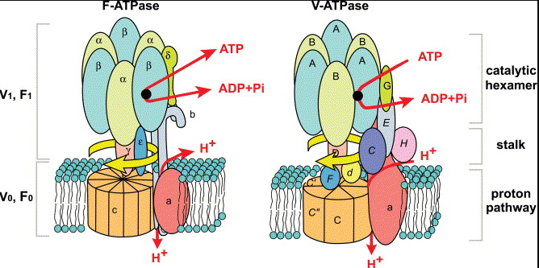

Metabolic function of mitochondria
- Fatty acid B-oxidation (ATP via phosOx)
- Krebs (TCA) cycle
- Heme biosynthesis (hemoglobin, cytochromes)
- Steroidogenesis (mevalonate can convert cholesterol)
- Fe/s complex assembly (complex 1 and II; metalloproteins, ferredoxins)
- Amino acid metabolism (urea cycle)
- Gluconeogenesis
- Ketogenesis

Question
- What is the purpose of carrying all those electrons from glycolysis pyruvate oxidation and krebs cycle: use those electrons to build a hydrogen gradient that powers the FOF1ATPase

Glycolysis
- Depends on the cell removing NADH and Hydrogen (end-products)
- End product: pyruvate
- Depends on the cell metabolic requirements and the availability of oxygen:
- Aerobic conditions
- Anaerobic conditions

Krebs cycle
- Describes the 8 enzymatic reactions the furnace uses to burn the combustible (pyruvate) and generate energy (ATP)
- End product: 6 NADH and H+ molecules, 2 FADH2 molecules, 2 ATP molecules

ATP
- Limitations on ATP generation in eukaryotes:
- Entry of e- from glycolysis into mitochondria
- Use of mitochondrial proton gradient from transport
- Oxidative phosphorylation is regulated by supply of ADP

Mitophagy
- Means to selectively remove damage or reduce the number of mitochondria by autophagy

Importance of calcium
- Response to stimuli (eg: vesicle secretion)
- Muscle contraction
- Signaling (second messenger)
- Enzymatic cofactor (coagulation)
- Bones
- Closing of stomata
- Metabolism
- Calcium is toxic to cells

Topic 5 lesson pt 2

Calcium regulation
- Concentration gradient: channels/transporters
- Binding proteins (calsequestrin, calbindin, parvabumine)
- Compartmentalization: ER/Mitochondria channels/ transporters
- Replenish: reserves

Why do cells die
- The size of an organ or organism depends on the total cell mass; the cell number must be controlled

What triggers the death of a cell
- Chemical messengers:
- Growth factors
- Mitogens (cell division)
- Survival factors
- Stress (toxicity, damage, dyshomeostasis)
- Cell cycle checkpoints

Question
- Which of the following does not occur in necrosis: blebbling

Necrosis vs. apoptosis
- Apoptosis does not occur only in response to negative stressor- it is essential part of development

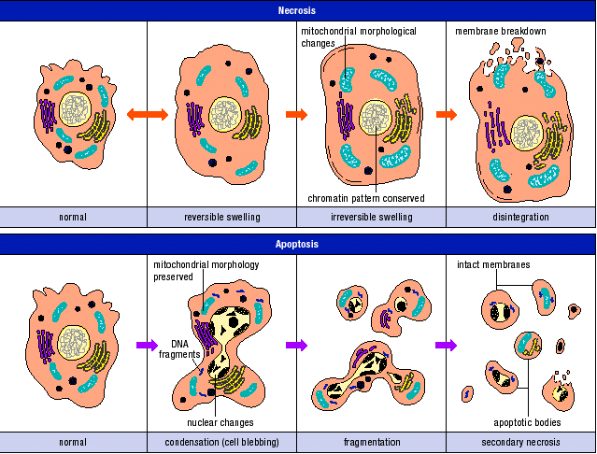

Necrosis: The calpain-cathepsin pathway
- Calpain is a calcium dependant protease it degrades the lysosome’s membrane
- Leads to proteases (cathespin) to be released. They digest all cellular content

Phagocytosis
- Asymmetric distribution of plasma membrane is lost
- Negatively charged phosphatidylserine then becomes exposed on the outside of the cell
- The cell is then marked for phagocytosis, carried out by a macrophage

Apoptosis-signaling pathways
- 2 main apoptotic signaling pathways :
- intrinsic pathway
- extrinsic pathway

Caspases
- caspases are a family of proteases (enzymes that cleave protein; cysteine aspartate proteases)
- they are split in 2 groups: initiator (CASP2,8,9,10) and executioner (CASP3,6,7) caspases

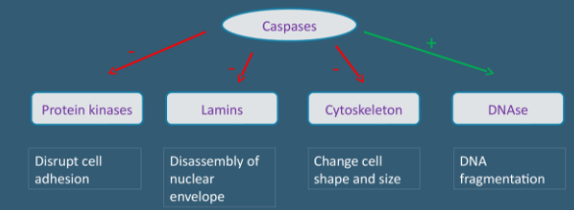

question
- what rearrangements within the mitochondria need to occur for cytochrome C to be released: the cristae are rearranged to facilitate release, then a permeability pore is made

Role of the mitochondria in apoptosis
- death triggers: activate bad
- Bcl2 and Bad/bax/bak: key players in balance between life and death (Bcl2 is anti-apoptotic; Bad is pro-apoptotic)
- Mitochondria play key roles in activating apoptosis in mammalian cells. Bcl-2 family members regulate the release of proteins from the space between the mitochondrial inner and outer membrane that, once in the cytosol, activate caspase proteases that dismantle cells and signal efficient phagocytosis of cell corpses.

Calcium and organelles
- Mitochondria and ER interact via Ca2+
- During stress, ER releases Ca2+ via IP3-gated channel
- Mitochondria absorb Ca2+ to protect cell from toxicity
- Excess Ca2+ in mitochondria leads to PTP (pore)
- Bcl2 can inhibit IP3(stops the release of Ca2+ from ER) while BAX/BAK activates Ca2+ release

Mitochondria in apoptosis
- No, toxins, hormones, cytokines (bad released)
- Inhibition of Bcl2 and activation of bax and bak (IP3)
- Increases in Ca2+ opening of ATP (permeability transition pore) release of CytoC
- Apoptosomes are formed (CytoC, apaf-1, cas9)
- Nuclear condensation DNA fragmentation cytoplasmic shrinkage apoptotic bodies phagocytosis

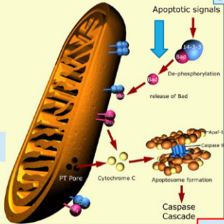

Topic 5 reading- programmed cell death (apoptosis)

Intro
- If cells are no longer needed they commit suicide by activating an intracellular death program known as apoptosis
- Sometimes healthy cells dies and the reason is because for example mouse paws are sculpted by cell death during the embryonic development: they start out as spadelike structures and the individual digits separate only as the cells between them die
- Aonther reason why healthy cells die: to regulate cell numbers: ex in the nervous system cell death adjusts the number of nerve cells to match the number of target cells that require innervation
- Cell death balances cell division if not tissues would grow or shrink

Apoptosis is mediated by intracellular proteolytic cascade
- Necrosis:
- cells die as a result of an injury swell and burst
- they spill their contents all over their neighbors
- this causes a damaging inflammatory response
- Apoptosis:
- Cells the undergo apoptosis die neatly without damaging it neighbors,
- the cell shrinks and condenses
- the cytoskeleton collapses and the nuclear envelope disassembles and the nuclear DNA breaks up into fragments
- cell surface is altered which displays that they cell is dying and is required to be phagocytosed by a cell or a macrophage
- this allows the organic components of the dead cell the be recycled
- caspases are synthesized in the cell as inactive precursors which are activated by the cleavage at aspartic acids
- Once activated caspases cleave and activated precaspases resulting in an amplifying proteolytic cascade
- Some of the activated caspases then cleave other key proteins in the cell. Some cleave the nuclear lamins, for example, causing the irreversible breakdown of the nuclear lamina; Another cleaves a protein that normally holds a DNA degrading enzyme (a DNAse) in an inactive form, freeing the DNAse to cut up the DNA in the cell nucleus. In this way, the cell dismantles itself quickly and neatly, and its corpse is rapidly taken up and digested by another cell.

Procaspases are activated by binding to adaptor proteins
- How precaspases are activated to initiate the caspase cascade:
- They are triggered by a adaptor protein that bring multiple copies of a specific precaspases known as initiator precaspases close together in a complex or aggregate
- Forcing initiator precaspases together in a complex cause them to cleave one another
- This causes a downstream precaspases to amplify the death signal and spread it throughout the cell
- Another way precaspases can be activated:
- can be triggered from outside the cell by the activation of death receptors on the cell surface
- killer lymphocytes can induce apoptosis by producing a protein called fas ligand which binds to the death receptor protein Fas in the surface of the target cell
- clustered fas proteins recruit adaptor proteins that bind and aggregate procaspase 8 molecules which cleave one another
- caspase 8 molecules activate downstream precaspases to induce apoptosis
- the mitochondria can help induce apoptosis by:
- releases cytochrome C in the cytosol where it binds and activates Apaf-1
- when it does this amplifies the caspade cascade
- DNA damage can trigger apoptosis in response to p53 which can activate the transcription of genes that encode proteins that promote the release of cytochrome C from the mitochondria

Bcl-2 family proteins: main intracellular regulators for apoptosis
- Bcl-2 are proteins that regulate the activation precaspases
- Bcl-2 inhibit apoptosis by blocking the release of cytochrome c from the mitochondria
- Bad which is a Bcl-2 protein functions by binding to and inactivating the death inhibiting members of the Bcl-2 family
- Whereas Bax/bak stimulate the release of cytochrome c, they are activated by Bid
- IAP (inhibitor of apoptosis) bind to some precaspases to prevent their activation or they bind to caspases to inhibit their activity
- When they mitochondria release cytochrome C it also releases a protein that blocks IAP therefore increasing apoptosis

Topic 6 lesson- signal transduction
Question
- Neural activity involves transmission of information via… in contrast, endocrine activity involves transmission of information via…: electrochemical events; hormone transport to target tissues

Question
- The target tissues for steroids do not have receptors for them on the membrane surface, because steroids: are soluble in the lipid bilayer

1. Chemical messengers-6 classes
- Their structure will determine:
- Their chemical properties (hydrophobic vs hydrophilic)
- The communication path taken to reach target cell
- Their mode of action/interaction with the cell and receptors
- 6 classes:
- steroids
- lipids
- peptides/proteins
- purines
- amines
- gases

Steroids
- derived from cholesterol
- lipophilic- cannot be stored in vesicles (endocrine path):
- will diffuse or be bound to transport protein (ex: albumin)
- membrane permeable- can reach intracellular receptors
- act as gene transcription factors
- 3 classes of steroids
- aldosterone
- cortisol
- testerone/estrogen

Eicosanoids
- derived from arachidonic
- lipophilic
- paracrine pathway
- 2 main pathways lead to 2 main classes:
- pain: prostaglandins
- inflammation: leukotrienes

peptide/protein
- hydrophilic
- packaged in secretory vesicles
- secreted by exocytosis (regulated secretion)
- most indirect paths

Amines
- have an amine NH2 group
- usually biosynthesized from amino acid
- most are hydrophilic
- many neurotransmitters are amines
- ex: epinephrine, histamine, GABA and thyroid hormones (hydrophobic)

Purines
- derived from nitrogenous bases adenine or guanine
- need a transporter or can use exocytosis
- mainly use paracrine and endocrine paths

Gases
- small molecules, short half-life
- passively diffuse
- direct and indirect paths
- ex: NO, O2, CO

2. Receiving the message
- the interaction with the receptor is the first level of discrimination (sets the path to the cell’s response)
- ligand (messenger) binding will induce a change in conformation of the receptor protein
- this acts as the trigger for the next phase: signal transduction

Question
- which od the following hormones enter cells and have the primary action to increase or decrease mRNA production: steroids and thyroid hormones

Receptors-4 classes
- 4 receptors: ligand-gated ion channel, receptor enzyme, G protein coupled receptor
- receptor activation leads to relying and amplifying the signal inside the cell
- maximum cellular response with minimal ligand

Question
- how can one cell alter gene expression of another cell: by sending a chemical messenger that will trigger a signal transduction cascade

Intracellular receptors
- can be found in the cytoplasm or in the nucleus
- lipophilic or very small ligands will diffuse and reach these receptors
- the ligand-receptor complex acts as a transcription factor:
- in the nucleus, bind to specific areas of DNA (the gene promoter sequence)
- activate or inhibit gene transcription

Glucocorticoids
- cortisol is secreted by adrenal glands; it is involved in stress response and metabolism
- caffeine increases cortisol levels
Question
- which of these types of proteins is not a potential candidate to act as a trans membrane receptor: porin

Transmembrane receptors
- integral proteins that span the membrane
- ligand binding domain outside the cell
- ligands are mostly hydrophilic
- ligand binding induce a change in conformation that relays the message inside the cell-second messengers
- the ligand itself never enters the cell
- 3 classes:
- ligand gated ion channels
- enzyme receptors (3 main classes)
- G-protein coupled receptors (GPCRs)

Lipid rafts
- Rafts can accommodate proteins with long transmembrane domains
- Organize and cluster proteins to function together (receptor mediated signaling)
Topic 6 lesson- part 2
Membrane potential
- The uneven distribution of ions creates potential energy: it can measure in mv (millivolts)
- When channels open/close, changing this ionic distribution, potential energy, and hence the membrane potential, changes
- Can lead to lead action potentials

Ligand gated ion channels
- Important to the nervous system
- Special channels for certain molecules
- Voltage-gated ion channels: similar; rely on change in voltage to open/close rather than ligand binding

Acetylcholine
- Important neurotransmitter
- Can be excitatory or inhibitory (depending on receptor/cascade)
- Can use 2 types of receptors (ionotropic or metabotropic):
- Ligand-gated ion channels (nitcotinic receptors)
- GPCRs (muscarinic receptors)

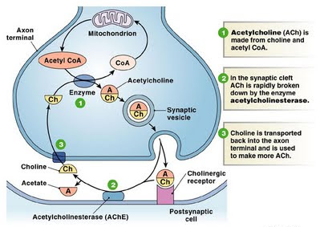

Ach ligand-gated ion channels
- When both binding sites are filled, conformation changes, pore opens and lets ions through; omstly Na+ and Ca2+ into the cell, some K+ goes out
- This changes the electrochemical gradient or membrane potential and can lead to action potential

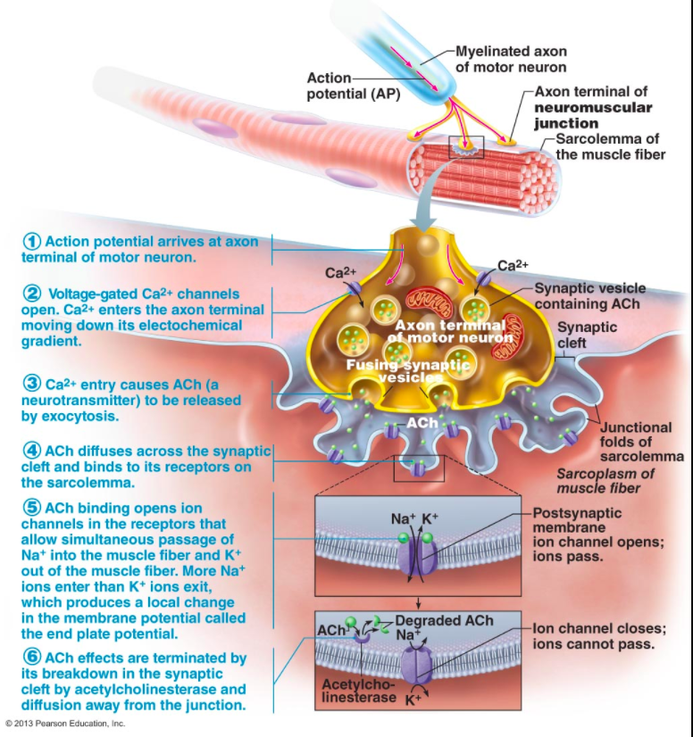

Receptor enzymes
- Intracellular catalytic domain acts as an enzyme
- Initiates a cascade of phosphorylation-dephospohroylation that amplifies the ligand’s impact on target cell
- 3 main classes: guanylate cyclase, tyrosine kinase, serine/theroine kinase

tyrosine kinase receptors
- largest family of enzyme receptors
- involved in pathways linked to survival, growth, proliferation and metabolism
- activation requires dimerization and autophosphorylation
- signaling is initiated via an area called an SH2 domain
- main second messengers: RAS (rat sarcoma protein) and phospholipids
- ligand examples:
- insulin
- growth factors

G-protein
- largest family of receptor
- multiple ligands- some bind to many different GPCRs:
- ACH can bind 5 different types of GPCR’S
- Adrenalin
- Mediate responses to a diverse range of ligands (photons of light, ordorants)
- Diversity of receptor for given ligand translates to multiple responses
- 2 main pathways:
- cAMP
- PIP (IP3)

Topic 6 reading
How cells communicate
- Information is transmitted between cells in the form of molecules
- A cell will send out a signal molecule to a target cell and the target cell will respond to the message in an appropriate manner
- Each signaling molecule is recognized by a specific receptor in a specific target cell. The receptor on the target cell then converts the extracellular signal into an intracellular signal
- Ex of responses: change in gene expression, apoptosis, growth etc

Modes of communication
- Endocrine: signal molecule that is secreted into the bloodstream. This affects the entire organism. It is called hormones
- Paracrine: when signal molecules are released into it’s local environment. The molecules diffuse to the nearby cells (only travels as far as diffusion can take it, it does not enter the blood stream)
- Autocrine: happens when sometime the paracrine signaling molecules affect the original molecule that signal them because they posses the specific signaling receptors
- Cell-cell communication: when cells communicate directly by the interaction between their membrane interaction proteins
- Neural signaling neurons can deliver messages over long distances to specific target cells. Once electrical signals reach the axon terminal it turns into chemical signals and neurotransmitters are released to the target cell

3 categories of receptors
- Ion channel coupled receptors:
- Regulate flow of ions
- Composed of multiple subunits that surround a central channel
- They possess transmembrane domains composed of multiple alpha helices
- Opening and closing is the channel is regulated by the binding of a specific signaling molecule
- The flow of ions is controlled by an electrochemical gradient
- GPCR’s:
- All look the same
- Composed of single polypeptide chain
- Has a extracellular ligand binding domain
- 7 alpha helices, has an intracellular heterotrimeric G protein binding domain
- where there is an extraceuular ligand binding: causes the GPCRs to activate heterotrimeric G protein which transmit the signal through a signaling downstream signaling cascade
- RTKs:
- 2 polypeptide chains
- possess an extracellular ligand binding domain
- single transmembrane alpha helix
- intracellular tyrosine kinase domain
- when a signal molecule binds to a monomer RTK this naturally brings 2 monomers together creating a dimer which brings the intra and extra cellular portions of the monomers together as well as it activates tyrosine kinase domain
- only has 1 membrane passing

Intracellular switches: ATP
- 2 types of switches those that use ATP through dephosphorylating or GTP
- Phosphorylation is the covalent attachment of a phosphate group from ATP to a specific residue on a target protein. The action is performed by kinase
- ATP enters the activate site on the kinase protein, kinase covalently attaches the phosphate to the target molecule after removing a P from ATP, then ADP dissociates from kinase
- The attachment of the phosphate on the target protein can alter the conformation of the protein, either leading to the activation or deactivation of the protein
- Phosphatases can then remove the phosphates from the target protein
General overview of GPCRs
- Represent the largest family of cell surface receptors
- GCPRs are involve in: sight, smell, taste, neural communication, endocrine activity, cardiovascular regulation etc…
- These proteins consists on a single polypeptide chain that crosses through the membrane 7 times
- Consists of a N terminal which is on the extracellular side, C terminal which is on the intracellular side, 3 extracellular loups involve with ligand bindings and 3 intracellular loups involved with heterotrimeric G protein
- When a signaling molecules binds to the extracellular portion this causes changes between the alpha helices to shift with respect to each other therefore changing the intracellular portion increasing the affinity of the hetermetric G protein to bind the GPCR’s

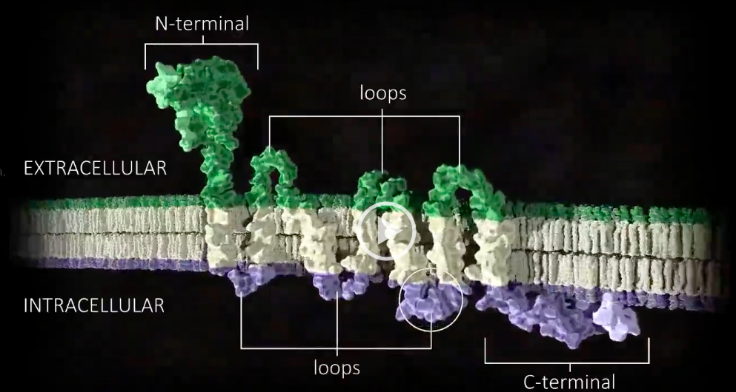

Heterotrimeric G proteins structure-function
- This protein posses GTP binding subunits referred to as alpha subunits
- Alpha and gamma subunits posses hydrophobic motif that inserts itself in the membrane therefore the G protein can remain attached to the membrane
- When a signaling molecules activates GCPRs hetero G protein with also the attachment of GDP binds to the 3rd intracellular loop of the GPCR
- After the attachment to the GPCR this causes the GDP molecule to dispatch itself and then GTP attaches to the molecule thus activating the protein
- This then causes the protein to leave the GPCR and causes the alpha subunits to disperse from the Gamma and beta subunits

Adenylate cyclase
- Enzyme composed of a single polypeptide chain
- 12 membrane helices, 2 intracellular catalytic domains (C1A and C2A) as well as linkers that connect the catalytic domains to the transmembrane domains
- C1A and C2A come together to form the catalytic core of the enzyme
- Ac is activated by the interaction on the Alpha subunit of the heterometric G protein. The interaction causes the catalytic domain to change ATP to cAMP
- The production of cAMP will cause floods in the cytosol quickly spreading the signal to a multitude of downstream targets. This will effect different cells
- One of the downstream target cells are PKA which has 2 regulatory subunits and 2 catalytic subunits
- When cAMP binds to the regulatory subunits this cases the catalytic subunits to de-attach and then these catalytic kinases phosphorylate serine and threoninesn downstream proteins

Topic 7- reading: gene expression is the transformation of DNA information into functional molecules

Summary:
- RNA is a linear polymer made of 4 different types of nucleotides subunits (uracil, cysteine, guanine adenine) linked together by phosphodiester bonds, it contains uracil instead of thymine
- Before a protein is created a mRNA molecule must be produced by transcription
- Before transcription can take place, the DNA double helix must unwind near the gene that is getting transcribed. The region of opened-up DNA is called a transcription bubble
- Transcription uses one of the two exposed DNA strands as a template; this strand is called the template strand. The RNA product is complementary to the template strand and is almost identical to the other DNA strand, called the nontemplate (or coding) strand
- mRNA is produced when the enzyme RNA polymerase initiates transcription at a promoter (which is a nucleotide sequence in DNA which RNA polymerase binds to, to begin transcription)
- in humans the promoter sequence is a TATA box
- As RNA polymerase initiates transcription it elongates the RNA chain and stops transcription at a terminator, after it releases both the DNA template and the completed mRNA molecule
- When RNA elongates it is elongated in the the 3’ to 5’ direction
- Eukaryotic mRNA is synthesized by RNA polymerase II
- During the elongation phase of transcription, the nascent RNA undergoes three types of processing events: a special nucleotide is added to its 5′ end (capping), intron sequences are removed from the middle of the RNA molecule (splicing which is done by a splicesosome), and the 3′ end of the RNA is generated (cleavage and polyadenylation)

Topic 7 lesson- transcription
Which strand
- The RNA strand produced is elongated in the 5’ to 3’ direction
- RNA polymerase II reads the 3’-5’ DNA strand (the template strand)

Question
- What is the role of the stigma o factor in transcription: is a protein needed only for initiation of RNA synthesis. It is a bacterial transcription initiation factor that enables specific binding of RNA polymerase to gene promoters.

How it starts
- 1st step: TBP (TATA box building protein) binds to the TATA sequence on DNA. This positions the helix for transcription
- 2nd step: additional protein come and complete transcription initiation complex (include transcription factors and regulatory elements)
- this provides stability and allows RNA pol II to come and start transcription
- activators: these proteins bind to genes at sites known as enhancers and speed the rate of transcription
- repressors: these proteins bind to selected sets of genes at sites known as silencers and thus slow transcription

initiation
- within the promoter, some proteins and transcription factors bind to specific sequences and form the transcription initiation complex

Elongation
- RNA pol III adds 20-60 nucleotides per second! Contrary to DNA polymerase, it does not proofread or make corrections
Eukaryotes termination
- Specific sequences that differ depending on which RNA polymerase
- Ex: for mRNA sequence AAUAAA to which proteins bind, this triggers end of transcription

Prokaryotes termination
- RHO dependant: ATP dependant unwinding enzyme at 3’ end
- RHO independent: GC rich sequences at end, hairpin loop which pulls RNA away from DNA

Eukaryote transcript
- Exons: coding sequence
- Introns: non-coding sequence and must be removed by splicing by spliceosomes

Splicing
- Small nuclear ribonuclear proteins
- They recognize the ends of introns and catalyze their cleavage
- The ends of exons after removal of introns will be joined together for a continuous coding sequence

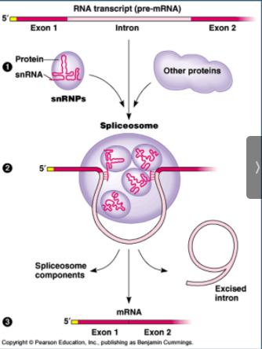

Alternative splicing
- is a regulated process during gene expression that results in a single gene coding for multiple proteins. In this process, particular exons of a gene may be included within or excluded from the final, processed messenger RNA (mRNA) produced from that gene.

Regulation of gene expression- eukaryotes
- in addition to the TIC; activators and repressors control which genes are expressed and the rate at which transcription occurs
- siRNA can bind mRNA and target to degradation (no translation)

miRNA
- micro RNAs (miRNAs) are important for regulation of gene expression (ex: time sensitive expression)
- they form miRISC (miRNA induced silencing complex)- this halts translation and or reduces available mRNA

Topic 7 reading- how genetic switches work
Summary:
- Eucaryotic activators and repressors act by a wide variety of mechanisms—generally causing the local modification of chromatin structure, the assembly of the general transcription factors at the promoter, and the recruitment of RNA polymerase.
- Whereas the transcription of a typical procaryotic gene is controlled by only one or two gene regulatory proteins, the regulation of higher eucaryotic genes is much more complex, commensurate with the larger genome size and the large variety of cell types that are formed
- when large amount of tryptophan are present and enters the cell the cell no longer needs these enzymes and shuts down the production
- The promoter and operator are arranged so that when the tryptophan repressor occupies the operator, it blocks access to the promoter by RNA polymerase, thereby preventing expression of the tryptophan producing enzymes
- When tryptophan is absent, the repressor protein does not bind to the operator and the genes are transcribed.

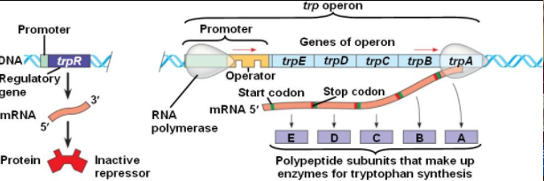

Topic 8 lecture- translation
Translation
- 3 base codons on the mRNA corresponding to specific amino acids direct the sequence of building a protein. These codons are recognized by tRNA’s (transfer RNA’s) carrying the appropriate amino acids. Ribosomes are the machinery for proteins synthesis

From mature mRNA… to amino acids
- the code is degenerate (or redundant); there are synonyms but no ambiguity (only one AA per codon but many codons per AA)
- the reading frame is determined by the start codon- AUG (met)
- reading ends with stop codons: UAA, UAG or UGA

Oscillation or wobble effect
- certain amino acids are associated with more than 1 codon- the difference lies in the 3rd nucleotide
- this is how the synonyms arise it gives flexibility in reading the sequence

Exons correspond to protein domains
- domains can carry out different abilities ex: ligand binding, transmembrane region, catalytic domain

Transfer RNA (tRNA)
- tRNA’s carry the amino acids at their 3’ end and recognize the mRNA sequence (codon) in their anticodon region
- thanks to the wobble effect (oscillation) humans only need 31 tRNA’s to accommodate the 61 codons

Aminoacylation: a specific pairing
- each amino acid can bind only to one specific tRNA and uses a specific enzyme (aminoacyl-tRNA synthetase) to do so

Topic 8- translation and protein sorting

Ribosomes
- formed by rRNA and 2 protein subunits
- assembled in the cytosol when binding to mRNA (small to RNA and large to complete ribosome)
- recruit tRNA, catalyse peptide-bond formation

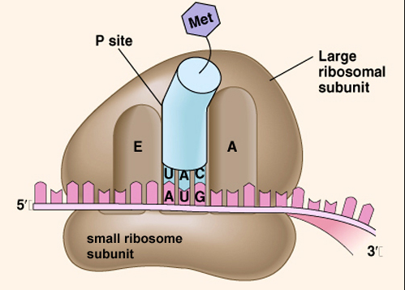

From mRNA to protein: ribosomes
- A site: aminoacyltRNA arrives with proper amino acid
- P site: peptide bond is formed
- E site: exit of empty tRNA

Initiation
- Met is the first AA and is the only one that goes straight to the P site
- mRNA is recruited and large subunit then completes the ribosome
- GTP binding proteins assist formation of ribosomal complex

Termination
- Stop codon reached; no tRNA with that anticodon
- Release factor (RF) protein occupies the A site, promoting last peptide bond formation and translocation
- Recycling of components

Polysomes (polyribosomes)
- An mRNA can be translated by more than one ribosome at a time giving rise to multiple polypeptides

Prokaryotes
- In the absence of a nuclear membrane, and since the mRNA is mature, transcription and translation occur simultaneously

Ribosomes
- Soluble protein (that will remain in the cytosol) will be translated using free cytosolic ribosomes
- What about proteins to be secreted or transmembrane protein?:

CO- translation: transmembrane proteins
- The signal sequence that direct translation to ER, there is a stop sequence that halts co-translational imports
- Translation is complete, but not import; resulting in a transmembrane protein

Vesicles and cytoskeleton
- Vesicles travel using motor proteins and the cytoskeleton
- Direction is important

Post-translational modifications
- Begin in ER, continue in Golgi
- Occur after translation is complete
- Important for folding, sorting, protection
- Final location:
- Glycosylation: add sugar to amino acid side chain (sorting in Golgi; functional)
- Acetylation: add acetyl group to N-term (increases stability)
- Disulfide bond: links s between residues
- Lipidation: add lipids ubiquitination: adds ubiquitin (targets for degradation)

Mutations
- Error durinf DNA replication or transcription
- Mutagenic agents (radiation, chemicals, UV)
- Viruses and microorganisms
- Can lead to different types of changes to genes or how they are expressed

Mutations Cont’
- Missense mutation: change in nucleotide sequence leads to change in amino acids
- This slight change in sequence has profound impact on structure and hence, protein function
- Others include deletion or insertion of a base pair- resulting in a frameshift

Chaperons
- Protect protein and facilitate the proper folding of nascent (newly formed) proteins

