MUSCLES
10.1 FOR ANY MOVEMENT, MUSCLES CAN ACT IN ONE OF THREE WAYS
- Prime mover (agonist): muscle that has the major responsibility for producing a specific movement
- Antagonists: when prime mover is active, the antagonist muscle may stretch or relax. Also help regulate the action of prime mover by providing resistance
- Synergist: help prime mover y adding a little extra force or by reducing undesirable movements
- Fixators: muscle that immobilizes one or more bones, allowing other muscles to act from a stable base
10.3 FASCICLE ARRANGEMENTS HELP DETERMINE MUSCLE SHAPE AND FORCE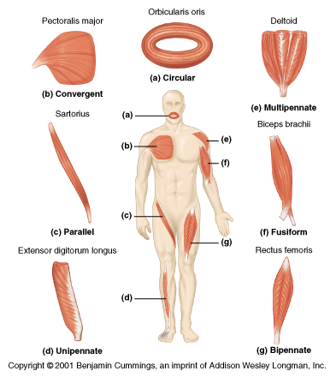
- Circular: fascicles are arranged in concentric rings, surrounds external body openings which they close by contracting
- Convergent: broad origin, and its fascicles converge toward a single tendon of insertion. Triangular or fan shaped
- Parallel: the length of the fascicles run parallel to the long axis of the muscle. Straplike or spindle shaped
  - Fusiform: spindle-shaped with an expanded belly. Ex biceps
- Pennate: fascicles are short and they attach obliquely to the central tendon that runs the length of the muscle
  - Unipennate: fascicles insert into only one side of the tendon
  - Bipennate: fascicles insert into the tendon from opposite sides
  - Multipennate: looks like many feathers side by side, with their quills inserted into one large tendon

THE MUSCLES OF THE HEAD
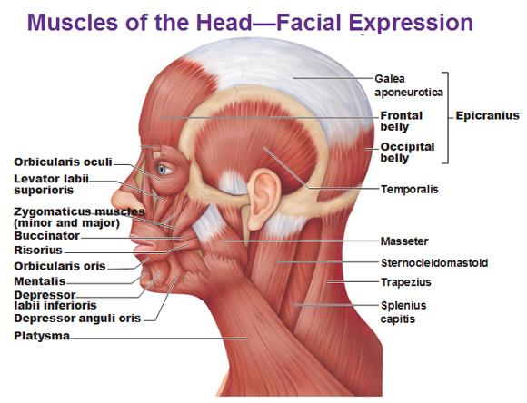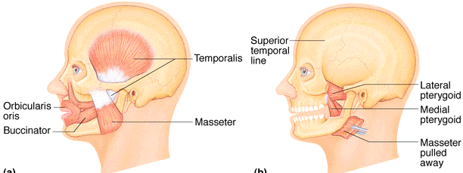
- Epicranius: main muscle of scalp, consists of;
  - Frontalis: raises eyebrows, wrinkles forehead
  - Occipitalis: pulls scalp posteriorly
- Orbicularis oculi: protects eye from light/injury. Blinking, squinting, draws eyebrows down
- Zygomaticus: smiling muscles
- Orbicularis oris: lips, multi-layered; closes, purses, protrudes lips
- Buccinator: deep to masseter – whistling, sucking, hold food in place when chewing
- Platysma: helps depress mandible; tenses skin of neck
- Masseter: prime mover of jaw closure
- Temporalis: elevates and retracts mandible(closes jaw); maintains closed jaw at rest
- Medial and lateral pterygoid: additional jaw movements, both two headed
MUSCLES THAT MOVE THE TONGUE

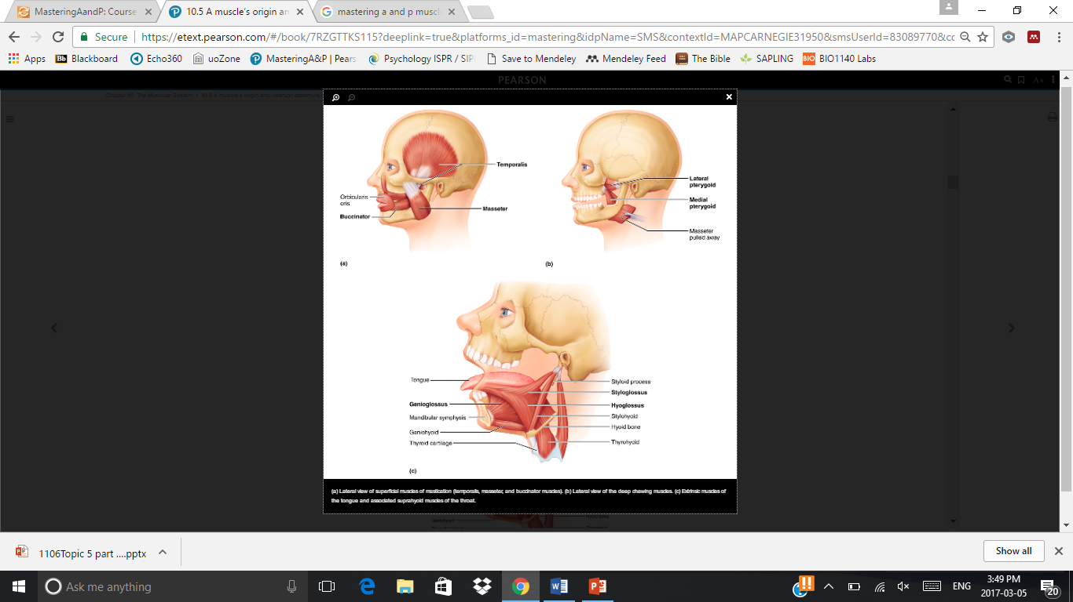
- Genioglossus: prime mover of tongue protrusion, anchors tongue to prevent obstruction of respiration
- Hyoglossus: depresses tongue, especially lateral margins
- Styloglossus: retracts and elevates tongue
MUSCLES OF THE NECK AND VERTEBRAL COLUMN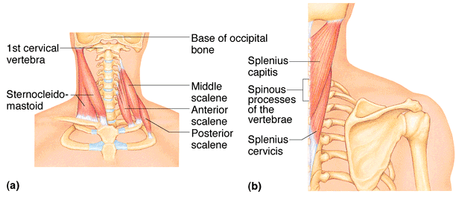
- Sternocleidomastoid: prime mover (both muscles)of head flexion; individual muscle action for head rotation to side, head tilts
- Scalenes: elevates first 2 ribs, role in coughing, flex and rotate neck
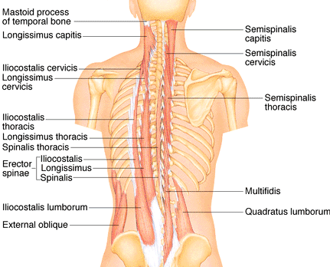
- Splenius: head extention(both sides) or rotation, tilts

- Erector spinae: prime mover of back extension; resistance to bending forward and extensors for return to erect position
- Semispinalis: extends vertebral column and head, rotation of head, synergistic with sternocleidomastoid muscles
- Quadratus lumborum: individual muscles flex vertebral column laterally; jointly to extend lumbar spine and fix 12th rib; maintain upright posture

MUSCLES OF RESPIRATION
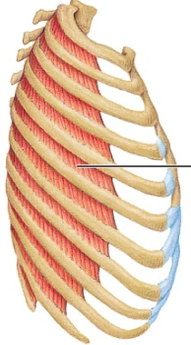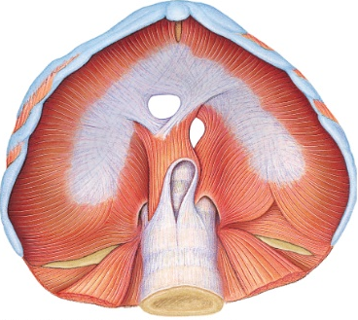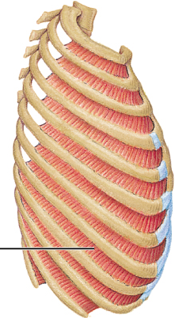
Eternal Internal
- External intercostals: 11 pairs between ribs; oblique; pull ribs together to elevate rib cage (inspiration; 1st ribs fixed by scalene muscles)
- Internal intercostals: 11 pairs, between ribs; perpendicular to external intercostals; draw ribs together to depress rib cage (expiration; 12th rib fixed by quadratus lumborum)
- Diaphragm: dome-shaped when relaxed; prime mover of inspiration

MUSCLES OF ABDOMINAL WALL
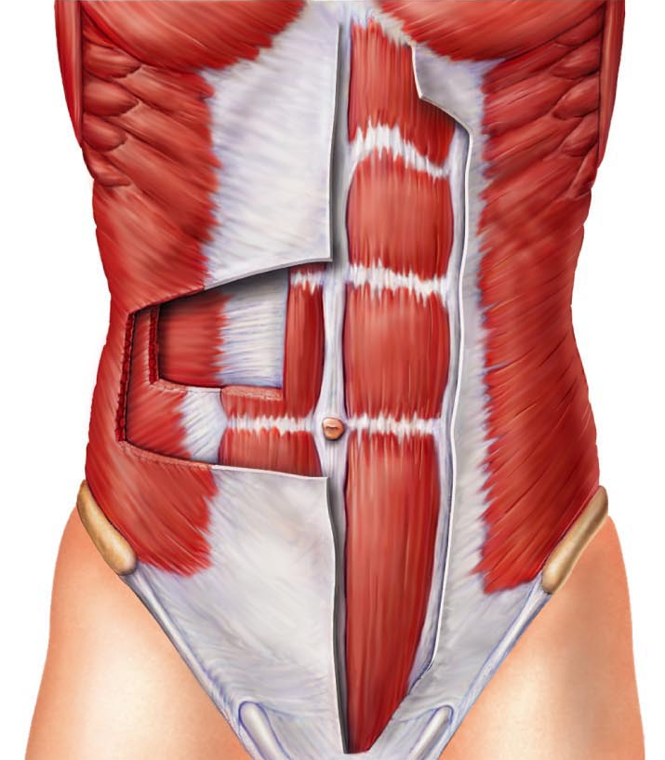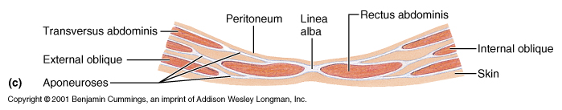
- Rectus abdominis: medial superficial; pubis to rib cage; lumbar rotation, fix and depress ribs, stabilize pelvis during walking
- External oblique: largest and most superficial lateral muscle; together increase ab pressure, flex vertebral column; individual rotation
- Internal oblique: deeper, but same actions as ext obliques
- Transversus abdominis: deepest; compresses abdominal content

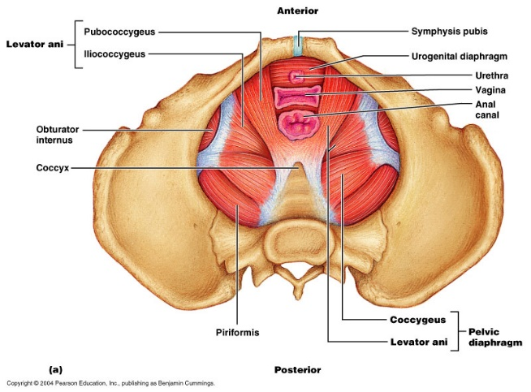
MUSCLES OF PELVIC FLOOR AND PERINEUM

- Levator ani: supports pelvic viscera and forms supportive sling at anorectal junction and vagina; resists increases in intraabdominal pressure
- Coccygeus: supports pelvic viscera and coccyx
- Urogenital diaphragm: supports pelvis viscera and constricts urethra

SUPERFICIAL MUSCLES OF THORAX: ARM MOVEMENTS
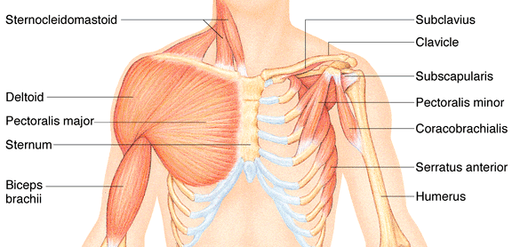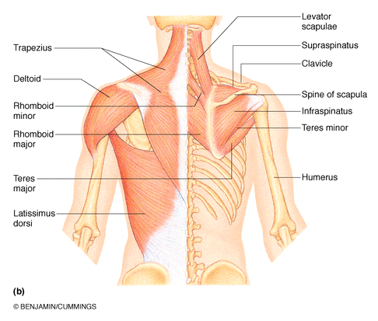
- Pectoralis major: prime mover of arm flexion; rotates arm medially; adducts arm
- Latissimus dorsi: broad, flat back muscle; prime mover of arm extension, arm adductor, rotates arm at shoulder
- Deltoid: prime mover of arm abduction; also lateral and medial rotations, flexions or extensions if only some fibers used
- Trapezius: superficial, stabilizes, raises, retracts, rotates scapula
- Rhomboids: deep to trapezius; aid in scapula movements
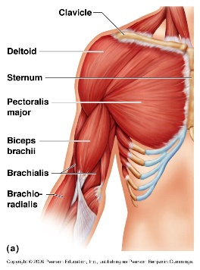
MUSCLES CROSSING THE SHOULDER AND ELBOW JOINTS
- Triceps brachii: powerful forearm extensor, may help stabilize shoulder joint
- Biceps brachii: flexes elbow joint and supinates forearm; weak flexor of arm at shoulder
- Brachialis: prime mover of forearm flexion- lifts ulna as biceps lifts radius
- Brachioradialis: synergist in forearm flexion

MUSCLES OF THE FOREARM: MOVEMENTS OF THE WRIST, HANDS AND FINGERS
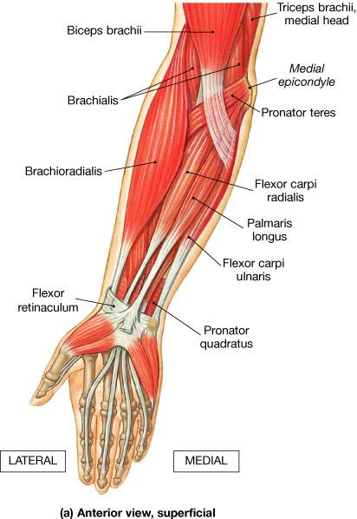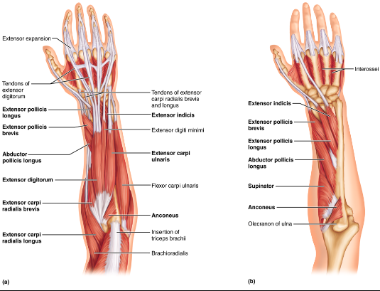
- Pronator teres: pronates forearm, weak flexor of elbow
- Flexor carpi radialis: powerful flexor of wrist; abducts hand
- Flexor carpi ulnaris: powerful flexor of wrist; also adducts hand in concert with extensor carpi ulnaris; stabilizes wrist during finger extension
- Flexor digitorum superficialis: flexes wrist and middle phalanges of fingers 2-5
- Extensor carpi radialis longus/brevis: extends and abducts wrist
- Extensor digitorum: prime mover of finger extention; extends wrist, can abduct fingers
- Supinator: assists biceps brachii to supinate forearm

MUSCLE OF HIP, THIGH AND LEG
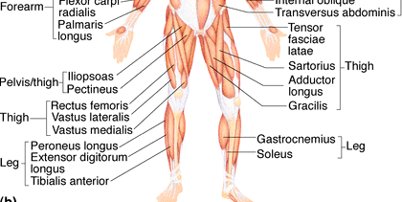
- Iliosoas: prime mover of hip flexion
- Sartorius: flexes and laterally rotates thigh; weak knee flexors
- Adductors: all adduct, flex, mediallu rotate thigh
- Pectineus: adducts, flexes and medially rotates thigh
- Gracilis: adducts thigh, medially rotates leg
- Rectus femoris: extends knee; flexes thigh at hip
- Vastus (latralis, medialis, intermedius): all extends knee
- Tibialis anterior: prime mover of dorsiflexion; inverts foot
- Extensor digitorum longus: dorsiflexes foot; prime mover of toe extention
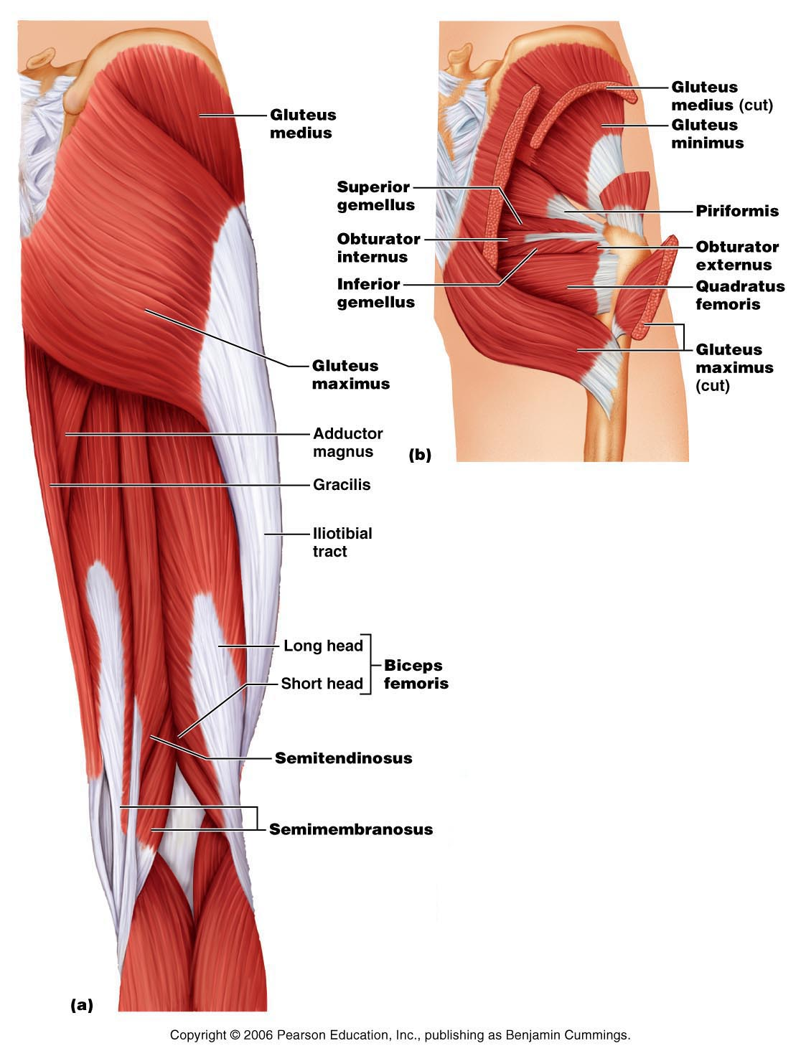
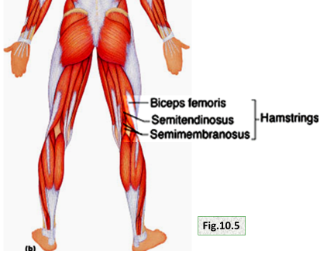

- Gluteus maximus: largest and most superficial butt muscles; major thigh extensor
- Gluteus medius: abducts and medially rotates thigh
- Hamstrings: 3 msucles; all extend thigh and flex knee
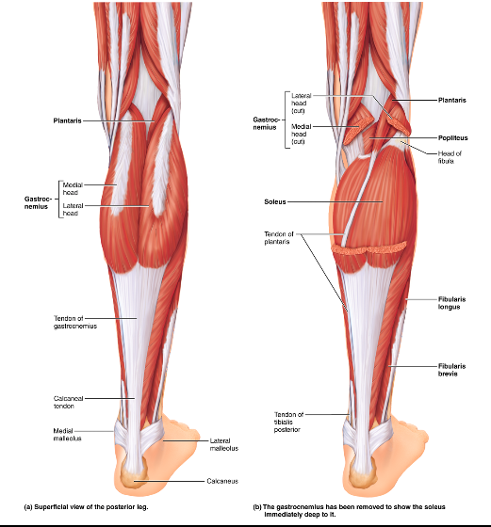

- Gastrocnemius: plantar flexes foot when knee extends; flex knee if foot dorsiflexes
- Soleus: deeper, plantar flexes ankle
- Fibularis longus: plantar flexes and everts foot; helps keep foot flat on ground
- Calcaneal: largest tendon in body

