Lecture 3
January 24th, 2017

Chapter 7- Production and Growth
Production and Growth
*Real Interest Rate = Normal interest rate – Inflation Rate*
- There is a large difference in the level of per person income (standard of living) across countries
- The average person in a rich country, such as Canada, the Unites States, or Germany, has an income more than ten times as high as the average person in a poor country
- These large differences in income are reflected in large differences in quality of life
  - Richer countries have more automobiles, more telephones, more televisions, better nutrition, safer housing, better health care, and long life expectancy
- Across countries cross sectional comparison
- Across time temporal comparison
- Even within a country, there are large changes in the standard of living over time (Due to growth)
  - In Canada over the past century, average income, as measured by real GDP per person, had grown by about 2% per year
  - This rate of growth implies that average income doubles every 35 years
  - Average income today is about eight times as high as average income a century ago
- Growth Rate g 70
G
Pn = Po (Hg)’n
Pn= amount at the end
Po= amount now
G= growth rate
N= # of years

- Growth rates differ substantially across countries
  - Average income in Singapore, South Korea and Taiwan has risen by about 7% per year in recent decades
  - At this rate, average income doubles every 10 years
  - Over the past three decades, China has attained even higher growth rate- about 12% per year
  - By contrast, in some countries, including in sub-Saharan Africa, average income has been stagnant for years
- Although imperfect, GDP is a good measure of economic prosperity and progress
- So in this chapter we focus on long term determinants of the level and growth of real GDP

- We proceed in 3 steps:
- What explains the diversity in living standards and growth rate around the world?
  - Look at the data in per person real income level and growth differences
- How can the rich countries ensure that they maintain their high standard of living?
  - Productivity and its determinants
- What policies should the poor countries pursue to promote more rapid growth in order to join the developed world?
  - Link between productivity and economic policies

Economic Growth Around the World
- Data on real GDP per person show that living standards vary widely from country to country
- Income per person in Canada is about (table 7.1):
  - 6 times higher than that of China
  - 12 times higher than that of India
  - and Indonesian in 2010 received less real income than a British in 1870
  - A Pakistani’s income in 2010 was about the same of a Canadian 140 years ago
  - Canada’s long term average annual income of 2% ignores short-run fluctuations around the long-run trend

Productivity: Its Role and Determinants
- Explaining the large variation in living standards around the world is, in one sense, very easy
A single word: PRODUCTIVITY
- Productivity: the quantity of goods and services produced from each hour of a worker’s time
- But seeing the link between living standards and productivity is only the first step
- Productivity is the key determinant of living standards
  - Like Crusoe, a nation can enjoy a high standard of living inly if it can produce a large quantity of goods and services, that is, having higher productivity
  - Canadians live better than Nigerians because Canadian works are more productive than Nigerian workers
- Growth in productivity is the key determinant of growth in living standards

How Productivity Is Determined
- Why are some economies so much netter at producing goods and services than others?
- What determines Productivity?
  - Physical capital per worker
  - Human capital per worker
  - Natural resources
  - Technological knowledge
Physical Capital: the stock of equipment and structures that are used to produce goods and services
Human Capital: the knowledge and skills that workers acquire through education, training, and experience
Natural Resources: the inputs into the production of goods and services that are produced by nature, such as land, rivers and mineral deposits
Technological Knowledge: society’s understanding of the best ways to produce goods and services

Economic Growth and Public Policy
- What can government policy do to raise productivity and living standards?
  - The importance of saving and investment
  - Diminishing returns and the catch-up effect
  - Investment from abroad
  - Education
  - Health and nutrition
  - Property rights and political stability
  - Free trade
  - Research and development
  - Population growth

The Importance of Saving, Investment, and Stable Financial Markets
- Because resources are scarce, devoting more resources to producing capital require devoting fewer resources to producing goods and services for current consumption
- Consequently, the accumulation of capital involves a tradeoff
- When government encourage saving and investment they also encourage growth and in the long run this raises the standard of living
- A well-functioning and carefully regulated financial market, one that quickly and efficiently brings savings and investment together with minimal risk and in a transparent way, is a critical ingredient in the recipe for economic growth

Diminishing Returns and the Cath-Up Effect
- Suppose government pursues policies to raise saving rate- the percentage of GDP devoted to saving rather than consumption
- With the nation saving more, fewer resources are needed to make consumption goods and more resources are now available to make capital goods
- The capital stock increases, which raises productivity thus leading to a higher rate of growth of GDP
- If saving rate remains at this high level, will GDP growth rate stay high indefinitely or only for a period of time?
- The benefits from additional capital becomes smaller over time, so growth slows down
- In the long run the higher saving rate leads to a higher level of productivity and income but not too higher growth in these variables. This phenomenon is known as diminishing returns
Diminishing Returns: the benefit from an extra unit of an input declines as the quantity of the input increases
The diminishing returns to capital has another important implication
- Other things equal, it is easier for a country to grow if it starts out relatively poor
- The effect of initial condition on subsequent growth is called catch-up effect—Countries that start off poor tend to grow more rapidly than countries that start off rich
  - In poor countries, workers lack even the most rudimentary tools and as a result, have low productivity and any small amount of capital would substantially raise their productivity
  - In rich countries, per worker capital is high and low is the return

Investment from Abroad
- Another way to acquire new capital
  - Foreign Direct Investment: a capital investment that is owned and operated by a foreign entity- Bombardier building a plant to assemble planes in Ireland
  - Foreign Indirect Investment: an investment that is financed with foreign money but operated by domestic residents, also called Foreign Portfolio Investment
  - A Canadian might buy stocks in an Irish company, which in turn an use the proceeds from the stock sale to build a new factory.
  - In both cases, Canadian savings is used to finance Irish investment
- Investment from abroad does not have the same effect on all measure of economic activity
- Foreign investment in Canada raises the income of Canadians (this is captured in GNP) b less than it raises production in Canada (this is captured by GDP)
  - GDP increases because the investment increases Canada’s capital stock
  - GNP increases by less because the profits generated from foreign investment return to the country of the investors
- Never-less, investment from abroad and help a country grow
- Besides increasing capital stock and productivity and wages, FDI also allows poor countries to learn state- of-the-art technologies developed and used in richer countries
- Accordingly, the World Bank tries to encourage the flow of capital to poor countries
- Economic distress often leads to political turmoil, international tensions, and military conflict
- The World Bank and the International Monetary Fund were created after World War 2 to promote economic prosperity around the world

Education
- Investment in human capital (education) is at least as important as investment in physical capital or long-run economic success
- It is well known that more education leads to higher wages and salaries
- One-way government policy can improve the standard of living is to provide good schools
- Human capital is also important for economic growth because it conveys positive externalities – the effect of one person’s actions on the well-being of a bystander
  - For example, an educated person might generate a new idea that enters society’s pool of knowledge and therefore society can benefit from it
  - The return to schooling for society is greater than for individual
- Some poor countries face a problem of brain drain
Brain Drain: the migration the most highly educated workers to rich countries for higher standard of living
- From Canada to the US

Health and Nutrition
- Other things equal, healthier workers are more productive
- The casual link between health and wealth runs in both directions:
- Poor countries are poor in part because the populations are not healthy; their populations are not healthy in part because they are poor
- It is a vicious cycle
- This fact opens the possibility of virtuous cycle, however
- Policies that lead to more rapid economic growth would naturally improve health outcomes
- In turn, this would further promote economic growth

Property Right and Political Stability
- In a free-market economy, it is the invisible hand that brings supply and demand into balance in the many thousands of markets
- For the price system to work, property rights must be respected
Property Rights: the ability of people to exercise authority over the resources they own
- Political instability is a threat to property rights
- When revolutions are common, doubt exists that property rights will be respected in the future
- There is less incentive to save by nationals, and foreigners have less incentive to invest
- Countries with an efficient court system, honest government officials, and a stable constitution will typically enjoy a higher standard of living

Free Trade
- Countries that eliminate trade restrictions often experience the same kind of economic growth that would occur after a major technological advance
- Trade volume is determined not only by government policy but also by geography
- There are more disadvantages for landlocked countries

Research and Development
- One of the major reasons why living standards are so much higher today than they were a century ago is because state-of-the-art technological knowledge has progressed so much
- Even if most R&D is conducted in the private sector, there is a public interest in promoting such efforts
- To a large extent, knowledge is a public good
- Governments have a vested interest in promoting R&D
- Over the years the Canadian government has:
  - Funded research in CANADU nuclear reactors
  - Offered research grand from NSERC and SSHRC
  - Offered tax breaks to firms that engage in R&D
  - Managed the patent system

Population Growth
- A large population means a larger total output of goods and services
- However, it need not mean a higher standard of living for a typical citizen
- Beyond theses obvious effect of population size, population growth interacts with the other factors of production in ways that are subtler and open to debate
- Thomas Robert Malthus (1766–1834) argued that an ever- increasing population would continually strain society’s ability to provide for it
- For him, mankind was doomed to forever live in poverty
- In a way he was arguing at the extrema about the stretching natural resources
  - A large population means a larger workforce
  - A large population means more consumer
  - Therefore, a large population do not mean a higher standard of living, but poorer one
- But Malthus was wrong: humankind’s ingenuity has offset the effects of larger population
- As Malthus was worried about was the effects of population growth on natural resources, some modern theories of economic growth emphasize its effects on capital stock
  - According to this theory, high population growth reduced GDP per worker because rapid growth in the number of workers forces the capital stock to be spread more thinly
  - With rapid population growth, each worker is equipped with less capital; a smaller quantity of capital per worker leads to lower productivity and lower GDP per worker
  - The most apparent problem is in human capital, providing good education to all
  - The population growth rates are high in developing countries and low in the developed ones
  - Even though population growth is not the main problem, some believe that reducing the population growth rate would help poor countries raise their standards of living:
    - Regulating the number of children (china)
    - Policies that foster equal treatment of women- incentive
- On the contrary some economists believe that population growth has been an engine of technological progress and economic prosperity
  - More scientist, more inventors and more engineers
Conclusion: The Importance of Long-Run Growth
- Economists differ in their view of the role of government in promoting economic growth
- At the very least, government can lend support to the invisible hand by maintaining property rights and political stability
- More controversial is whether government should target and subsidize industries that might be especially important for technological progress

Chapter 8- Saving, Investment and The Financial System
Saving, Investment and the Financial System
- For someone who requires financing for capital investment (start a business) there are various ways
  - Borrow the money, perhaps from a bank or from a friend or relative
  - Convince someone to provide the money for your business in exchange for a share of your future profits
Financial System: the group of institution in the economy that help to match one person’s savings with another person’s investment
- Saving and investment are key ingredients to long-run economic growth
  - When a country saves a large portion of its GDP, more resources are available for investment in capital, and higher capital raises a country’s productivity and living standard
- However, we did not discuss how the economy coordinates between saving and investment
- This is done by financial system

Financial Institutions in the Canadian Economy
- The financial system moves the economy’s scare resources from saver (who spend less than they earn) to borrowers (who spend more than they earn)
- Financial system is made up of various institutions that help coordinates savers and borrowers
- These institutions operate wholly at the private sector but government sets the rules and regulation that guide their operation
- Financial institution can be grouped into two categories:
  - Financial markets
  - Financial intermediaries
Financial Markets: financial institutions through which savers can directly provide funds to borrowers
- The two most important financial markets in our economy are the Bank market and the stock market

The Bond Market
- When a company wants to borrow it can do that by directly borrowing from the public by selling bonds
Bond: it is a certificate of indebtedness that specifies the obligation of the borrower to the holder of the bond
- Bond is the debt-finance
- Put simply, a bond is an IOU which identifies the time at which the loan will be repaid, called the date of maturity, and the rate of interest that will be paid periodically until the loan matures
- The buyer of a bond lends money for this promise of interest and eventually repayment of the principle
- The buyer can hold the bond until maturity or can sell at an earlier date to someone else
- Although these bonds differ in many ways, two characteristics of bonds are most important
- The bonds term: the length of time until the bond matures; some are of short term some are long (30 years)
- Some bonds, perpetuity, never matures but never pays principal
- The interest rate depends on term: long term bonds are riskier than the short terms and hence pays higher rate
- The bonds credit risk: the probability that the borrower will fail to pay

The Stock Market
Stock: represents ownership in a firm and is, therefore, a claim to its profits
- The sale of a stock to raise money is called equity finance
- Although corporations use both equity and debt finance to raise money, stocks and bonds are very different
- The owner of stock is a part-owner of company; the owner of bond is a creditor of the corporation
- If the company if profitable, the shareholders enjoy the benefits, whereas the bondholders get only the interest
- And if it runs into financial difficulty, the bondholders are paid before shareholders receive anything at all
- Compared to bonds, stocks offer both higher risk and return
- The prices at which Shared trade on stock exchanges are determined by the supply and demand for the stock
Stock Index: and average of a group of stock prices
- Dow Jones Industrial Average: based on the prices of the sticks of 30 major U.S companies, such as Boeing, general Electric, Microsoft, Coco-Cola, AT&T and IBM. It is computed regularly since 1896
- S&P/TS Composite Index: based on the prices of over 200 major firms listed on the TSX
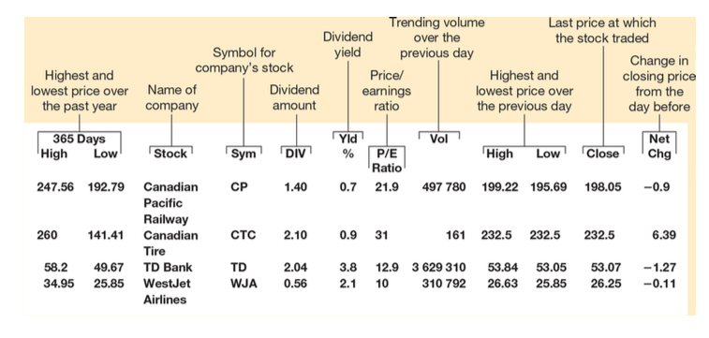
- Because stock process reflected expected profitability, stock indexes are watched closely as possible indicators of future economic conditions
Financial Intermediaries
Financial Intermediaries: are financial institutions through which savers can indirectly provide funds to borrowers
- The terms intermediary reflects the role of these institutions in standing between savers and borrowers
Banks
- The primary function of a bank is to take deposits from savers and use these deposits to make loans to people who want to borrow
- Banks pay depositors interest on their deposits and charge borrowers slightly higher interest on their loans
- The difference between these rates of interest covers the banks’ costs and returns some profit to the owners of the bank
- Banks pay a second important role in the economy: they facilitate purchases of goods and services by allowing people to write cheques against their deposits
- In other words, banks can help create a special asset that people can use as a medium of exchange
Mutual Funds
Mutual Fund: is an institution that sells share to the public and uses the proceeds to buy a portfolio of stocks and bonds
- The shareholder of the mutual fund accepts all the risk and return associated with the portfolio
- There are two advantages of mutual funds:
  - Allow diversification
  - Access to the skills of professional money managers

Saving the Investment in the National Income Accounts
- Financial Institutions coordinate the economy’s saving and investments, which are important determinants of long-run growth in GDP and living standard
Accounting: refers to how various numbers are defined and added up
- The national income accounting includes, in particular, GDP and many related statistics
- It includes several important identities, an equation that must be true because of the way the variables in the equation are defined
GDP (or Y) = C + I + G + NX
In a closed economy:
NX = 0
Y = C +I + G
Y – C – G = I
\ | /
S
S = I
National Saving(s): the total income in the economy that remains after paying for consumption and government purchases
- Let T denote the taxes collected by government minus transfer payments
- National saving ca then be expressed in either of two ways
S = Y – C – G or S = (Y – T – C) + (T – G)
Private Saving: the income that households have left after paying for taxes and consumption
Y – T – C
Public Saving: the tax revenue that the government has left after paying for its spending
T – G
Budget Surplus: T > G
Budget Deficit: T<G

The Meaning of Saving and Investment
- Although the accounting identity S=I show that saving and investment are equal for the economy as a whole. This does not have to be true for every individual household or firm
- Putting money in the bank or buying bond is a saving and investment refers to purchase of new capital

The Market for Loanable Funds
Market for Loanable Funds: the market in which those who want to save supply funds and those who want to borrow to invest demand funds
- The term loanable funds refer to all income that people have chosen to save and lend out
- In the market for loanable funds, there is one interest rate, which is both the return to saving and the cost of borrowing
- Saving (private plus public) is the source of supply and loanable funds
- Investment is the source of demand for loanable funds ( that comes from firms or households)
- The interest rate is the price of a loan

Policy #1: Saving Incentives
- Canadian families generally save a smaller fraction of their incomes than their counterparts
- Many policymakers view the relatively low level of savings in Canada as a major problem
- One principle is that a country’s standard of living depends on its ability to produce goods and services in which in turn depends on higher saving
- In response to this problem, economists favor changes to the tax system that encourage greater saving
- A higher saving rate could lead to a higher rate of growth of GDP
- As people respond to incentives, economists suggest that low saving rates in Canada is due to tax laws that discourages savings
- The important changes made in this directions are:
  - Consumption taxes like the GST
  - RRSPs
  - TISAs
  - RESPs

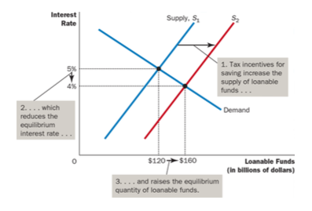

Policy #2: Investment Incentives
- An investment tax credit gives a tax advantage to any firm building a new factory or buying a new piece of equipment
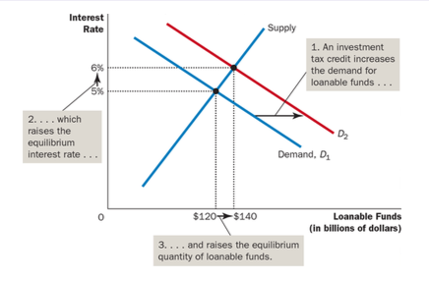

Policy #3: Government Budget Deficits and Surpluses
- When a government spends more than it receives in tax revenue, the shortfall is called the government’s budget deficit
- When a government spends less than it receives in tax revenue, the excess is called the government’s budget surplus
- When a government spends exactly what it receives in tax revenue it is said to have a balanced budget
Government Debt: the sum of past budget deficits and surplus
Crowding Out: a decrease in investment that results from government borrowing
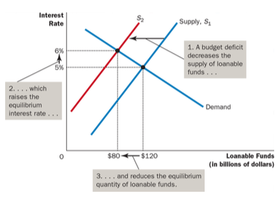

- It shifts the supply curve
- It shifts to the left
- Interest rate rises- crowding out
- Hence, budget deficits reduce country’s growth rate by reducing investment
- Why does increased borrowing from the government shift the supply curve, while increased borrowing by private investors shifts the demand curve?
- The model takes the term loanable funds to mean the flow of resources available to fund private investment; thus, a government budget deficit reduces the supply of loanable funds
- If we had meant it as flow of resources available from private saving, then the government budget deficit would increase demand rather than reduce supply
- But the bottom line would be the same: rise in interest rate and crowding out
- Budget deficit can cause vicious circle: lower economic growth, lower tax, higher spending on employment insurance and other income support programs, higher deficits and even lower growth
- Budget surplus can lead to lower interest rate and higher growth and virtuous circle
- However, both are requiring as policy tools depending on the economic situation of the country
- Canada’s debt rose from 1975-1997, almost like vicious circle. Since 1995, it ran budget surplus and hence the debt fell drastically till 2008, since when the budget is in deficit again.

