Lecture 2
January 17th, 2017

Chapter 5- Measuring A Nations Income
Measuring A Nations Income
Microeconomics: the study of how individuals and how firms make decisions and how they interact in markets
Macroeconomics: the study of economy-wide phenomena, including inflation, unemployment, and economic growth
Gross Domestic Profit (GDP): measures the total income of a nation
- Because it is thought to be the best single measure of a society’s economic well-being, it is the most closely watched economic statistic

The Economy’s Income and Expenditure
For and economy as a whole, income must equal expenditure
- GDP measure two things at once:
  - The total income of everyone in the economy
  - The total expenditure on the economy’s output of goods and services
- The reason why GDP can perform the trick of measuring both total income and total expenditure is that these two things are really the same
- For an economy as a whole, income must equal expenditure, because every transaction has two parties:
  - Buyer
  - Seller

The Measurement of GDP
GDP: the market value of all final good and services produced within a country in a given period of time

“GDP Is the Market value…”
- GDP adds together many different kinds of products into a single measure of the value of economic activity
“…Of All…”
- It includes all item produced in the economy and sold legally in markets
- GDP also includes the market value of the housing services provided by the economy’s stock of housing
- There are some products, however that GDP excludes because measuring them is so difficult
“…Final…”
- GDP includes only the value of final goods
- The reason is that the value of intermediate goods is already included in the prices of the final goods
- An important expectation to this principle arises when an intermediate good is produced and is added to a firm’s inventory of goods to be used or sold at a later date
“…Goods and Services…”
- GDP includes both tangible goods (food, clothing, cars) and intangible services (haircuts, housecleaning, dentist visits).
- GDP includes goods and services currently produced
“…Produced…”
- GDP includes goods and services currently produced
“…Within a Country…”
- GDP measures the value of production within the geographic confines of a country
“…In a Given Period of Time…”
- GDP measure the value of production that takes place within a specific interval of time
  - Usually that interval is a year or a quarter
- GDP measures the economy’s flow of income and expenditure during that interval

The Components of GDP
Y = C + I + G + NX
Y= GDP
C= Consumption
- Spending by households on goods and services, with the exception of purchases of new housing
I= Investment
- Spending on capital equipment, inventories, and structures, including household purchases of new housing
G= Government purchases
- Spending on good and services by local, territorial, provincial and federal government
NX= Net Exports (X – M)
- Exports minus imports
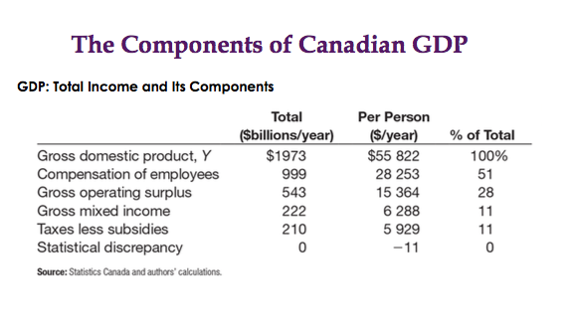
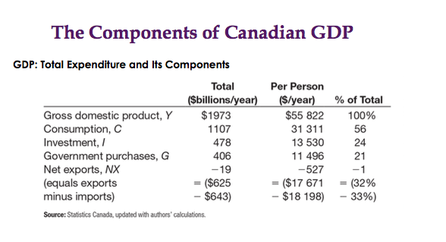
- The value of a nations exports minus the value of its imports; also called the trade balance
Other Measures of Income:
- Gross national product
- Net national product
- National income
- Personal income
- Disposable personal income

Real VS Nominal GDP
The GDP Deflator
GDP Deflator = Nominal GDP X 100
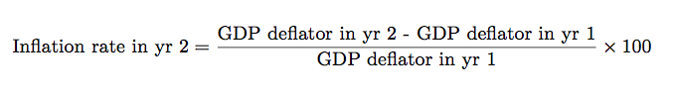
Real GDP
Chapter 6- Measuring the Cost of Living
Measuring the Cost of living
- The consumer price index (CPI) is used to monitor changes in the cost of living over time
- When the CPI rises, the typical family has to spend more dollars to maintain the same standard of living
- The term inflation to describe a situation in which the economy’s overall price level is rising
- The inflation rate is the percentage change in the price level from the previous period

The Consumer Price Index
The consumer price index (CPI): the overall measure of the cost of the good and services bought by a typical consumer
- Every month, statistic Canada computes and reports the CPI
- It uses data on the price of more than 600 different goods and services
- To see how these statistics are constructed, a simple economy with two goods is used: hot dogs and hamburgers

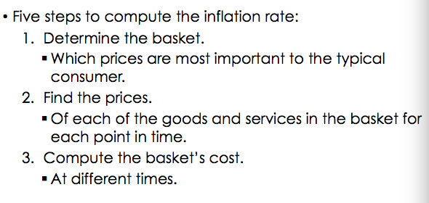
How the Consumer Price Index Is Calculated?

Problems in Measuring the Cost of Living
- The CPI is not a perfect measure of the cost of living
- Commodity substitution bias
- Introduction of new goods
- Unmeasured quality change
- Taken together, these sources of bias cause the CPI to overstate the cost of living by 0.5 percentage points per year according to the Bank of Canada

The GDP Deflator VS The Consumer Price Index
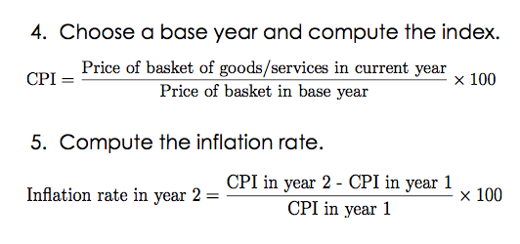
- Both the GDP deflator and the CPI gauge how prices are changing; usually, these two statistics tell a similar story
- Two important differences can cause them to diverge:
  - The GDP deflator reflects prices of goods and services produced domestically whereas CPI does that for consumption
  - The GDP deflator compares the price of currently produced goods and services with the price of the same goods and services produced during the base year

Correcting Economic Variables for the Effects of Inflation
- The purpose of measuring the overall level of prices in the economy is to permit comparison between dollar figures from different points in time
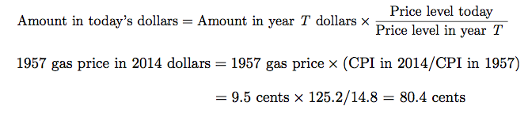
- To compare the 1957 price of gas with the 2014 price, we need to inflate the price of 9.5 cents per liter turn 1957 dollars into 2014 dollars
Indexation: The automatic correction of aa dollar amount for the effects of inflation by law or contract
- Long term labor contracts may include partial or complete indexation of the wage to the CPI, which is called cost-of-living allowance (COLA)
- A COLA automatically raises the wage when the CPI raises

Real and Nominal Interest Rates
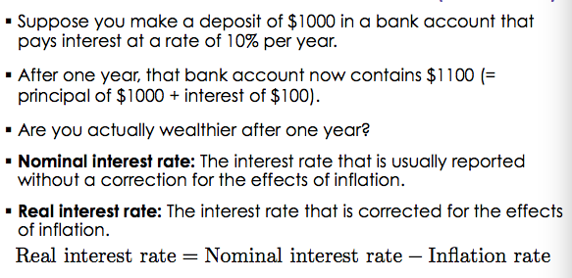
- Interest rates involve comparing amounts of money at different points in time

