- Every organism either consists of cells or is itself a single cell
CELL THEORY:
*basic structural and reproductive unit of life*
- All organisms consist of one or more cells (structure)
- The cell is the basic unit of structure for all organisms(structure)(Theodor Schwann)
- All Cell arise from pre-existing cells (reproduction)(Rudolf Virchow)
- Cells have diversity , in form and function and size
- Cells are small ( typical prokaryote 1-5 um, typical eukaryote 10-30 um)
- CELLS ARE SMALL B/C:
  - Surface area : volume ratio (can fold to increase ratio) volume of cell determines what needs (nutrients) and how much waste, SA allows this. Linear dimensions increase volume faster than SA not allowing proper nutrition and waste.
  - Rates of diffusion; movement of individual molecules, diffusion is slow, larger distance, slower diffusion. Eg. Oxygen moving to reach equilibrium; solution: transport systems within cells.
  - Synthetic capacity; ability of cell to synthesis molecules (proteins, lipids, etc) required to run cell, most bio chem. Reactions requires certain concentration of substrate, larger cell more substrates needed to reach concentration (all cells need to be same concentration all throughout. Solution: compartimentalize( only happens in certain areas- eg. Mitoch. ATP found in them have correct concentration.
*All cells use same amino acids, all use DNA, and use ATP
*Most cells oxidize sugars for ATP
PROKARYOTIC
- Smaller than eukaryotic
- Simple structure
- Cell wall, plasma membrane, cytoplasm that lacks organelles, ribosomes, nucleoid, flagellum
- No nucleus
EUKARYOTIC
- Protists (single-celled organisms), fungi, animals, plants (multicellular)
- Compartmentalization of cellular functions
- Nucleus
- Cytosol (instead of cytoplasm)
- Larger than prokaryotes
-Have internal trans. Systems and compartimentalise
-Membrane- bound organelles
-both pro and euk have plasma membrane cytoplasm contains cytosol and organelles
Non- Membrane bound organelles
Cytoskeleton
- Support/shape, internal organization, movement of cell, movement within cell.
Ribosomes
-Protein synthesis
Membrane bound organelles
- no protein in prokaryote chromosome
- proteins to be exported from cell or membran pr0teins synthesis in RER
- Detox of ethonal in liver cells smooth ER
Nucleus
    - Nuclear envelope
    - Nuclear pores (movement in/out of nucl. Eg. DNA, receptors)
    - Nucleaolus
    - DNA and protain organized into chromosomes (chromatin)

Endoplasmic reticulum
Tubular membranes and cisternae
Rough- ribosome, for membrane protein and secreted protein synthesis
Smooth- for lipid and steroid synthesis, detoxification
- Ribosome and cytoskeleton are non- membrane bound organelles
- Golgi complex: stack of flattened sicles, sorting modification and packaging of proteins, membrane sacs
- Vesicles: transports packaged protein among organelles and/or to plasma membrane
- Lysosomes, peroxisomes: contain hydrolases, catalases
- Vacuole: temporary storage, turgor pressure in plant cells, limp plants not watered, water creates turgor pressure
*contain different enzymes digestive (hyaralase).
*catalase= degradation of peroxide.
- Mitochondrion: double membrane( cristae), oxidative metabolism yielding ATP, Circular mitochondria DNA, reproduce by fission.
  - Have a system on which are located the enzymes and proteins required for oxidation meta
- Chloroplast: double membrane and thylakoids, conversion of light energy to chemical energy (complex carbohydrates), circular chloroplast DNA, reproduce by fission
* mitochondira and chloroplast used to be bacteria then incorporated into cytoplasm of larger cell
* thylakoids used to house chlorophyll to synthesize carbs, synthesis of carbs from light
*Mitochondria oxidative metabolism. (sugar ATP)
* own DNA found as singular both reproduce own ribosome to strengthen their own protein.
-Mitochondria have a system on which are located the enzymes and proteins required for oxidation metabolism ATP
-They are the power house in the cell were oxidative metabolism takes place.
Cristae are membranes that are the home of enzymes and stutural complexes that allow oxidative metabolism to occur
-Chloroplast are the sites in the cell where light energy is converted to chemical energy in the form of carbohydrates
-Found in plant cells and some protist
-Thylakoids house the enzymesand the chlorophyl involved in photosynthesis
- ENDONSYMBIONT THEORY
  - Mitochondria from incorporation of aerobic prokaryote
  - Chloroplast from incorporation of cyanobacterium
  - Support – size, circular DNA, ribosomes, fission
    - EX:Symbiotic animals containing green photobionts, Kleptoplasty ( marine animal steal chloroplast from the alloy that feeds on , solar – powered sea slugs)
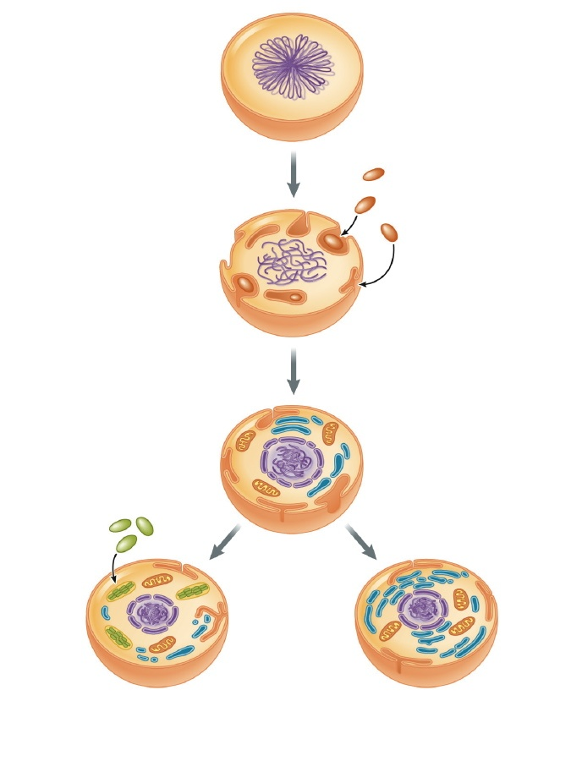
Fig. 2.21
Original
prokaryotic cell
Aerobic
bacteria...
... become
mitochondria
Photosynthetic
bacteria...
... become
chloroplasts
Eukaryotic cells
(plants, some protists)
Eukaryotic cells
(animals, fungi, some protists)

*Origins of eukaryotic cells and more specifically mitochondria and chloroplasts;
There was an original anaerobic prokaryotic cell that engulfed aerobic bacteria and instead of breaking them down the engulfed bacteria formed a stable symbiotic relationship. They stayed intact in the host cell and were able to keep their functions. A symbiotic relationship implies a mutual relationship. The host cell’s benefit is that it engulfed an aerobic cell The benefit for the cell engulfed because it has a safe place to grow and divide
*Host cells is able to generate its own food with light
LECTURE 2
-Cell chemistry is carbon chemistry
C forms the backbone of essentially all molecules of importance to the cell
Environment of the cell many reactions happening all at the same time , in an aqueous environment ( a water solvent) and are happening at relatively low temperature. The biochemistry of this cell is very complexe.
Carbon forms the backbone of most of the cell constituents, and its because it has a valence of four and a very small molecule.
A diversity of molecules is possible, (linear, branched or cyclic C chains)
-Elaborate structures, long carbon chains, and take the simple structures and build them into even more complex molecules. Oxygen, Phosphate, nitrogen and theses are other atoms that carbons form bonds with.
Chemical formula
-OH
-C=O
-SH
-COOH
-PO₃²⁻
-NH₂
Name
Hydroxyl group
Carbonyl group
Sulphhydryl group
Carboxyl group
Phosphate group
Amino group
Properties
Neutral, polar
Neutral, polar
Neutral, polar
-ve charge at cellular pH
-ve charge at cellular pH
+ve charge at cellular pH

Cell chemistry is water based
-H₂O typically composes 75-85% of cell by weight
Polarity and the formation of hydrogen bonds
-Bond energy = 1 – 4 kcal/mol
-Properties as solvent
-Hydrophilic
-Polar molecules
-Ions
-Hydrophobic interactions( non-polar(hydrophobic) disrupt H bonding, results in hydrophobic molecules to bunch,not because attracted to each other but pushed together.
*Water = the oxygen in water is – and the hydrogen Is +
This is true when its liquid and solid.
Hydrogen of one water molecules are attracted to the oxygen’s of a neighboring water molecules making a weak bond, but these bonds are important to let water act as a solvent.
I.e. salt, it consist of ions of sodium and chloride that are attracted because of opposite charge.
-Cell Chemistry is hierarchical: Inorganic precursors small organic molecules macromolecules supramolecular structures organelles cell
CARBOHYDRATES
- Plymers of monosaccharides (polysaccharides)
  - CnH2n0n ( n = 3to7)
  - Linear vs. ring configuration
  - Isomers
- Energy storage (starch[in plants])
- Stuctural (glycogen in animals)
- Ex. Starch, glyogen, cellulose, chitin
- Monosaccharides
  - CnH2nOn (n = 3 to 7 *3456 carbons)
  - Trioses, pentoses and hexoses most common
  - Linear vs. ring configuration
  - Isomers
*If at least 5 molecules can be linear or ring
*Ring is more stable/important
* isomers- where there are 4 different groups bound to carbon.
- Polysaccharides
  - Glycosidic bond
  - C1 to C4
  - a vs ß (a= simple bond because projecting below glucose ring .e.g starch can digest; b= complex, cond. Rxn between carb 1+4 above in one, below in another; mammals don’t have enzyme to break this bond beta glycocidic bonds.
NUCLEIC ACIDS
- Plymers of nucleotides
  - Informational
  - DNA( genetic material storage) vs. RNA ( scaffold upon which protein synthesis occurs; messenger between genetic material and protein synthesis(mrna); lines up amino acid in proper order (trna); DNA protein
- Nucleotides
*nucleotides have 2 roles in cell; building blocks of nucleic acid and important in energy transfer
*dehydration reaction between nucleotides to make nucleic acids.
*dGTP- deoxy (sugar) ganasine (base) triphosphate (3 phosphates attached)
-5 carbon sugar
ribose (or deoxyribose
- nitrogenous base
-purine: adenine, guanine (double ring)
-Pyrimidine: cytosine, thumine, uracil (single ring)
- Up to 3 phosphate groups
- Sugar + base = nucleoside
- Phosphodiester bond
- RNA single stranded
- DNA double-stranded
PROTEINS
- Polymers of amino acids
  - Informational
  - Wide array of functions:
      - Regulatory (e.g. transcription factors, hormones)
      - Receptors (e.g. ß-adrenoreceptors)
      - Defensive (e.g. antibodies)
      - Enzymes (e.g. carbonic anhydrase gas exchange)
      - Structural (e.g. keratin, collagen)
      - Motility (e.g. actin)
      - Transport (e.g. Na⁺-K⁺-ATPase)
* no two are the same, order of amino acid determines molecule
*R group determines functional property, structure determines function

-Amino Acids
Central carbon
  - carboxyl group
  - amino group
  - H atom
  - Side chain (R group = 20 main aiming R built in after; >20 in reality)

- R group
- Properties of amino acid determined by R group:
  - Nonpolar (hydrophobic)
  - Polar, uncharged(e.g. hydroxyl)
  - Polar acid (-ve charge)
  - Polar, basic (+ve charge)
  - Reactive functional groups
*be able to recognize cysteine
*2 cysteines form disulphide bridge through reaction of sulphidral groups form covelant bond
* Stabalize protein structure more resistant to detergents for .e.g. look for cysteines containing sulphydral groups.
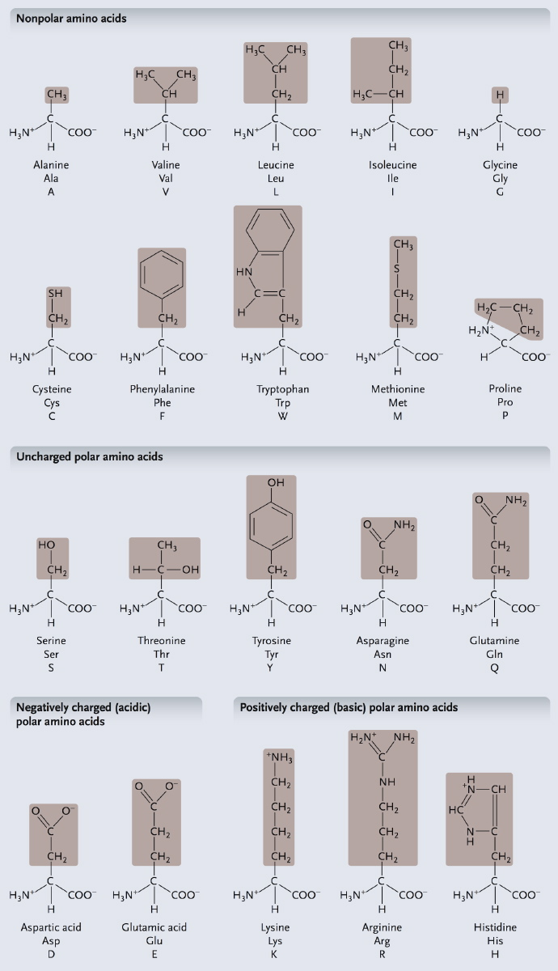
Nonpolar
Polar, uncharged
Polar, charged
Reactive functional groups
-Polypeptide:
- peptide bond
-N-terminus vs. C terminus ( N term (free amino gp @ one end) to C term( free carboxyl gp @ other end of molecule) in a.acid molecule C protein)
- Average 400-500 aa residue
- From polypeptide to protein…
- one or more polypeptides folded into native conformation( aquires functional p
monomeric (single polypeptide)
multimeric homomeric, heterometric
- conformation is dependent on covalent and non – covalent interactions in backbone and/or R groups
* String amino acids into poly pepetide, amino acid residues
*> 50 is polypeptide
* condensation reaction between carboxyl of one amino acid of other amino to get peptide bond
* chaperones prevent from folding the wrong way
*denatures – loses 3D structure , loses function but is still a polypeptide
*amino amcids- central C w/4 different groups attachedm therefore amino acids have different isomers
*L isomer used for making proteins
- Protein structure:
  - Primary structure: aa sequence, 20 n possibilities whenre n= #aa
  - Secondary Structure: hydrogen bonding in backbone of molecule, a helix and B pleated sheet, motifs ex. Hairpin loop, helix – turn- helix ( first step in folding into native confirmation.)

ß sheet
α helix
a helix- peptide backbone folded stabilized by its bond between an amino acid group and double bonded o in next amino acid give max H bonding = stable
hairpin loop = 2 beta helias linked by free loop of amino acids
helix- turn- helix = 2 alpha helias linked by free loop of amino acid ( a and b often build into other secondary structures (aka. Motifs, infer what function based on motif. E.g. Zn finger means may not factor protein binding to DNA.
- Tertiary structure
  - Overall shape or conformation
  - Interaction b/ween R groups
    - Disulphide bridge
    - Hydrogen bonds, ionic bonds, hydrophobic interactions( forced together by hydrophobic area of protein), van der Waals interactions
    - Relative contributions of 2 and 3 ?
    - Fibrous vs. globular proteins
    - Domains
*more folding of secondary
*R groups important because T structure due to interactions between them
*Vanderwaals = weak interactions due to uneven distributions off electrons, but if we/they et enough of them is can be significant
*Main determinant of overall shape
*extensive regions of secondary structure entire molecule is one giant alpha-helix wound together and multiplied to get fibrous in this case secondary more important than tertiary in terms of protein shape.
*Domains: folded into 2 regions each domain has specific function, fold independently of each other.

Quaternary structure
  - Interactions of subunits to form multimeric protein
*Interactions that hold together these chains is what forms quaternary structure **only applies to multimeric**
*polypeptides come together to form mature protein. Mature protein can be made from single polypeptide chain , aka. MONOMEr ; >1 chain = multimeric proteins
* if have repeats of same chain it is homomeric, different chains is heteromeric.
LIPIDS
-Macromolecules
- not polymers
- insolubles in water, soluable in nonpolar solvents
- energy storage, membrane structure, signaling
- Types
- 6 main classes:
- Fatty acids(building block found in other lipids, hydrocarbon chain and carboxyl
- Phospholipids
- Triglycerides
- Steroids
-Fatty Acids
-Hydrocarbon cahins with carboxyl group
14 -22 carbon fatty acids very common
amphiphathic(hydrophobic/+phallic in one molecule)
- Saturated vs. unsaturated
*Saturated: single bonds between carbons, straight
*Unsaturated; double bonds, bent

-Triglycerides
-Glycerol + 3 fatty acids( can be same or different)
- ester bonds
- Energy storage
-adipocytes(fat storing cells in animals)
-Fat(animal) vs. Oil(plants)
*oils liquid @ room temp. both function as e+ source.
- Phospholipids
- Structural component of membranes
- Phosphoclycerides
- Glycerol
-2 fatty acids (16-18C)
- Phosphate
- Hydrophilic R group = serine, ethanolamine, choline, inositol
- amphiphatic( one hydrophil, one end hydrophobic)
*phosphoglyceride named according to Rgroup (e.g. chlorine)
- Steroids
-Dericatives of 4 – ringed hydrocarbon skeleton
- Only in eukaryotic cells
- Sterols ( most common steroid in cells)
Cholesterol ( animals)
Phytoterols (plants)
* oils liquid @ room temp. fatty acids w/ double bonds, don’t pack as tightly as fats w/ saturated fats
LECTURE 3
- Fluid mosaic model:
    - Singer & Nicholson 1972
    - Fluid lipid molecules in which proteins are embedded and freely floating
*cell membrane can define compartment within cell, interior different from exterior.
*provide structure on which proteins can be organized

- Functions:
    - 1. Define boundaries; selectively permeable barrier
    - 2. Localisation and organization
      - Scaffoid for biochemical activities (enzmes)( group them together for a particular function)
      - Ex. Mitochondria(syntesis of ATO involves proteins organized together into a group on inner membrane so don’t have to chase around for the proper enzyme, its organized.
  - 3. Regulation of solute transport
    - In and out of cell and/or organelles( w/or against gradients in/out of cell/organelle
    - Uphill or downhill
    - Eg. Na +, K+ -ATPase
  - 4. Responses to external signals
    - Receptors and signal transduction
*1rst point of contact, contains structures that detect and respond, linked to internal structures that take signal from membrane and respond accordingly
    - E.g. B- adrenoreceptor (heat cells have receptors to increase activity)
  - 5. Cell to cell communication
    - Recognition, adhesion, exchange of materials (recognize and respond to other cells)
    - Gap junctions, plasmodesmata (adhesion at membrane, physical contact of membranes via gap (animal),plasmodesmata (plants).
- Plasma membrane of Schwann cell (myelin sheath)(18% protein/ 82% lipids)
- Inner mitochondrial membrane ( 76% protein/24% lipid)
* Structure linked to function
*membrane of mitochondria contains lots of protein to tailor to ATP synthesis
-MEMBRANE STRUCTURE
-Fluid mosaic model:
- Lipid= protein assembly in which components are held together in a thin sheet by non- covalent bonds(phsopholipic bilayer lipids clump together inside
-Two fluid lipid layers – structural bckbone, permeability barrier water soluable molecules but CANT PASS)
-Mosaic of proteins – unique complement responsible for specific functions lipids form backbone and permeability layer
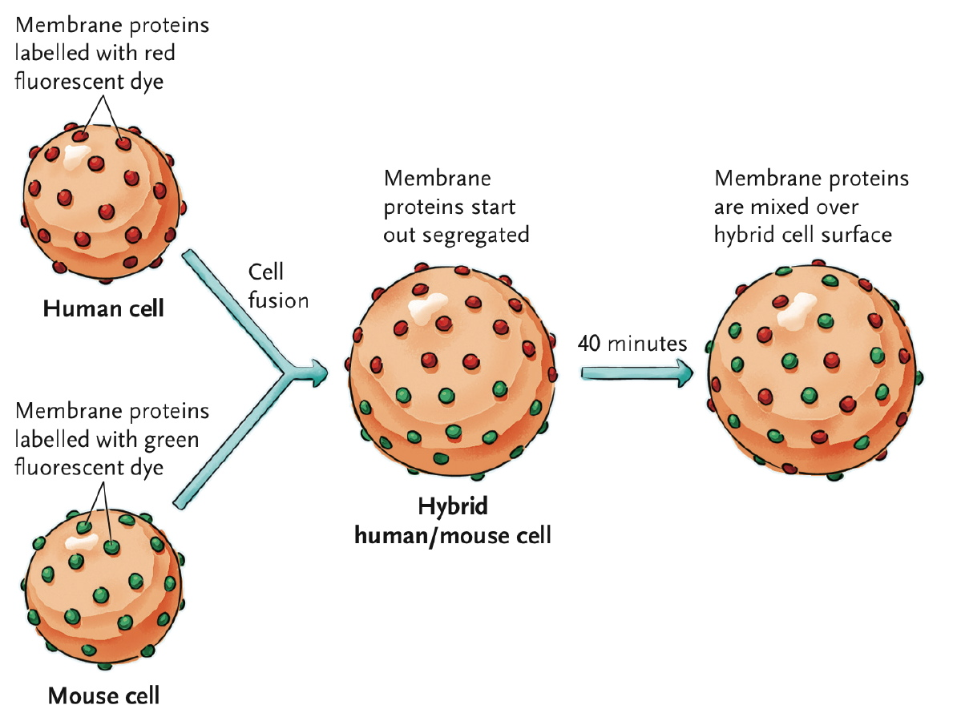
*human cells w/ one fluorescent dye, mouse cells (proteins) w/ other, exposed to virus that created mouse- human hybrid cell, if mem. Was not fluid, cell should stay red half (human)and green had BUT there was fluidity and they mixed.
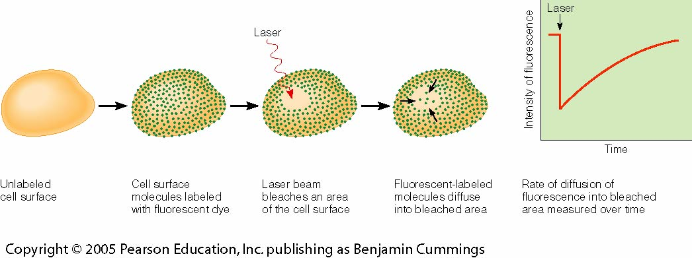
Fig. 7-11 Becker et al. 2009
Fluorescence
Recovery
After
Photobleaching
*^ laser bleaches area in cell, labeled molecules move into that area used to determine fluidity of membrane
-The unit membrane:
-Gorter &Grendel (proposed lipid bilyaer)
- Lipid billayer
- Key component of permeability barrier (amphip
-Composition
Phosphoglycerides (bulk of phospholipids ,2 hydrophobic fatty acid chains, 16-18 carbons polar head group)
    - serine, choline, ethanolamine, inositol
    - 16-18 C
    - Saturated & unsaturated
Glycolipids(linked to membrane)
- single sugars or oligosaccharides
- marker ( e.g. ABO blood groups)*external surface recognition; blood type determined by which glycolipids found on outer membrane.
Sterois(only in eukaryotic)
- Cholesterol(animal), phytosterols(plants)
- Absent from prokaryotes
* When insert sterols into fatty acid chain they disrupt movement because they disrupt movement because they are rigid, at normal temp. reduce fluidity
*Sterols buffer membrane fluidity against change in temp. increase fluidity at low, reduce fluidity at high.
-MEMBRANE ASYMMETRY
- Lipids distributed unequally between the two leaflets (half of bilayer)
-Established during membrane biogenesis (movement of phosphoglycerides from inner to outer or vice versa rare because if were to flip, hydrophilic would have to pass through hydraphob
-Flip – flops vs. rotation and lateral diffusion
*two halves differ in lipid comp. – inner half towards cell, outer towards env.

-MEMBRANE FLUIDITY
- Fluid nature of membrane essential for function
-As temperature decreases, fluidity decreases.
- C chain length and saturation(in fatty acid long chains pack together rigidly, shorter or mixed male more fluid when temp. decreases. Unsaturated have double bond bends, don’t pack, thid happenes when temp falls, increase unsaturated.
-Head group polarity
- Buffering effect of sterols( eukary- @ low temp. rigid shape prevents packing, making membrane more fluid, @ high temp fluid makes easier to pack causing rigidity.
*if not consistent, moving stuff across membrane difficult
*allows cells to change shape, efficiently fluid allows amoeboid movement, but if too fluid is disorganized does not function as a barrier property
- Homeoviscous adaption
-Alterations in lipid composition to maintain membrane fluidity at different environmental temperatures
- also occurs at an evolutionary level (through natural selection as habitat temp. falls , increases in % of unsaturated fatty acids within membrane phospholipids
-Semi – palmated sandpiper
- Migratory flight from summer habitat in Artic to winter habitat in SA includes 2- week stopover at Bay of Fundy prior to - day, 4500km trans- oceanice journey
-Birds feed on mudshrimp that is very high in PUFA
-Improves fatty acid mobilization for flight endurance
*Feed on Pufa rich shrimp, taylor muscle membrane to fatty acid update for flight
*Unsat. Bond in pectoral muscle, increases, allows fatty acids (increase fluidity) into membrane more, used to power flight.
- lipid rafts are characterized by lower fluidity and involved in cell signaling
*there are areas od membrane that are less fluid, longer chained fatty acids, cholesteral used for organizing proteins ( clustering) for cell signaling.
LECTURE 4
Membrane proteins
-The ‘ mosaic ‘ component of the fluid mosaic model
- Functions include:
- Transport -Signal transduction
-Enzymes - attachment/ recognition
- 3 types: integral, peripheral, lipid – anchored
*less fluid, some larger, some anchored
*structures in cell will prevent proteins from moving in cell
Integral membrane proteins
- Amphipathic with one or more hydrophobic regions
- Usually transmembrane ( single or multipass)
- Transmembrane regions typically a – helix of 20- 30 hydrophobic amino residue
- They are embedded within the membrane
*go right through membrane, have hydrophobic and phallic on ends; single pass have N and C terminus goes right through; Several transmembrane regions and protein weaves back and forth though membrane – hard to isolate.
Peripheral membrane proteins
- Membrane- associated through non- covalent interactions (on surface)*much easier to dislodge from membrane (e.g. change in pH. Change in concentration of solution;
- Dynamic relationship with membrane may be attracted (detached from membrane as signaling pathway)

Lipid- anchored membrane proteins
-Membrane- associated trough covalent
-Fatty- acid anchored (covalent & anchore to fatty acid chainds)
-Intracellular orientation
- GPI anchor( glycosylphosphatidylinostiol)
- Extracellular orientation
- can be cleaved with phopholipase C
- e.g. type IV carbonic anhydrase
- anchors the cytoskeleton to the membrane
MOVEMENT ACROSS THE MEMBRANE
- Anything that has a charge needs a special transporter … because of this charge they attract a sphere of water molecules which make them too large to move across the membrane
- Importance of size (decides movement method), polarity/charge, gradient
- How?
    - Active transport(against gradient with expenditure of e+
        - Primary
        - Secondary
    - Passive transport
        - Simple diffusion (w/ gradient for molecules that can readily cross the membrane)
        - Facilitated diffusion (w/ gradient w/ help of protein transport
*Small moves through more easily; bigger stuff doesn’t need specialized transport pathways
*Anything charged 9ions) doesn’t pass because attracts cloud of water which makes it large.

PASSIVE TRANSPORT
Diffusion
- Spontaneous; bases on random movements
- Driven by diffusion gradient (downhill)
    - For solutes without a charge concentration gradient
    - For gases partial pressure gradient
    - For ions electrochemical gradient
    - For water osmotic gradient
- Membrane permeability
    - Lipophilic molecules
    - Partition coefficient(predict rate based on this solubility) ratio of solubility in organic solvent to that in water
Facilitated diffusion
- Channel proteins
    - Ions, water (water channel= aquaporins)*have hydrophobic regions that anchor but hydrophilic channels down centre of protein
    - Highly selective
    - Leaks(open all the time) vs. gates (only open for certain signals which happens when membrane potential changes binding of particular chemical(ligand)( eg. Voltage – gated, ligand- gated)
- Carrier proteins
    - Ions, larger and/ or polar molecules
    - Highly selective
    - Types

*rate of rxn depends on # of transport proteins present
*protein has 2 stable confirmation switches between them, protein binds and causes change in carrier so its released on other side; ions, amino acids usually moved by carrier protein.
*symporters = co transporters; 2 solubles across membrane in same direction
*exchange/antiporters; 2 solutes in opposite directions
ACTIVE TRANSPORT
- Carrier – mediated movement against gradient (uphill) via couple input of energy (“pumps”)
  - Highly selective
  - Unidirectional
* expending e+ to pumpe against gradient
Primary active transport
  - ATP hydrolysis directly coupled to transport of solute (carrier itself involved)
  - Several types
    - P – types
        - Move cations (Na+, K+, Ca2+, H+)
        - Reversibly phosphorylated (when ATP hydralized, phosphate group temporarily attaches to pump, solute binds, pump undergoes charge to 2nd conformational figure. And allows solute to cross, phosphate re-attaches.
        - E.g. Nat+. K+ - ATPase
  - V-type – move H+ into organelles
*Vacuolar—on membrane of vacuoles to pump it into vac. can also occur on all mem. pump H+ out of cell.
Secondary active transport
- Simultaneous transport of two solutes. Downhill transport alon gradient established by 1 active transport allows uphill transport of second solute
  - Na+ gradient in animal cells
  - H+ gradient in plant cells
*movement of solute secondary to generation of gradient made for other solute
*can’t go simple diff., protons go into cell by expending e+ create proton gradient across cell 2nd transp. uses e+ stored in gradient, that exp. of against gradient

Transport in the mammalian kidney (type 1 diabetes have high blood glucose, kidney cant reabsorb, remains in urine.
*uphill – from low-high against diff. gradient
*downhill – high to low w/ different gradient
- Filtration followed by reabsorption
- Transport maximum for glucose and diabetes mellitus
- Structural specialization – mitochondra and microvilli(lots of mitochondrias in kidney, elaborate plasma.)
The Cytosceleton
Functions of the cytoskeleton;
-The provision of structure and support (shape)
- Intracellular transport
-The positioning of organelles within the cell
- The generation of force for cell movement
- Contributing to cell division
* muscle function nased on cytoskeletal , cilia, etc.
*Changes in membrane, exo/endo cytosis rely on cytoskeleton
*cytokenesis
- they play an imprtant role in support which is important within the animal cell becuase it does not have a cell wall
- it is a also a way for the cell to ship stuff through out the cell without using diffusion becuase this take so long and this allowed the eukaryote to grow larger and this is important in muscled fore exmpla s th emovement of micro filaments is what allows muscle contration.
-the movement of the cytoskelton allows for the cell movement wichiis important for embryoic developement and the healing of a wound
-- cell divsion is also nessescary

Intermediate Filaments
Structure
- Strong, rope-like fibres of 10-12 nm diameter
- Family of fibrous proteins
-e.g. keratin, neurofilament proteins, nuclear lamins
-Tissue specific
-a- helix domain flanked by variable globular domains
- Coiled-coil dimer
- Protofilament – tetramer
- Filament – 8 protofilaments
-intermediate in size and that’s how they were name they were found after the other two portion of the cytoskeleton
- Plants do not usually have intermediate filaments within the cell but they do have it within the nucleus
- The large regions of alpha helix -> the alpha helix is often though of as a motif it is very common and this is such a huge amount within the molecule and it is considered a domain... at the ends there is two globular domains that have folded independently of it at either end
- compare proteins to cities there is ottawa Toronto has own shape and then they have have very similar region like recognized structure and function which is a domain and then there recognizable structure within the univerity and they have recognizable function like the cafeteria and all the univeritires have this and then this would be considered to the the a motif
-this is important in the determining where the origin of cancer and the cancer cells will have the same intermediate filaments within the cells and these are retained as it moves through out the cell
- there are many different proteins but a cell will only use a few of them but they all have a similar shape
- the individuals twist together to form a dimer and then they move together to form a protofilaments ans then they move together to for a very strong filament
-there are eight protofilaments within the a filament
-- Keratine and Nuclear Lamins.... remember these- the rope like structure is what allows them to be very strong this increase the tensile strength that allows them
- answering the structure function question would have to include 2 to 3 lines in having what ths structure of that component is and then how it affects the function
-Dynamic character
- Relatively stable, but do turn over
- e.g. nuclear lamins
-Functions
- Mechanical strength in animal cells
- e.g. Keratin IFs
- Link to desmosomes and hemidesmosomes
- Epidermolysis bullosa simplex
- Only nuclear lamins in other eukaryotes
-they are very stable but this does not mean that they are static they
-example nuclear lamin and they break apart and come back together through cell division
-these are highly important in ells that need a lot of support esp. aniam and then even more so in nurons as they are so long ans fragile
- these are also common within epitheli
-these are used in desomosomes and they are imporant within the skin etc and they help to hold them together
- in babies with EBS the skin blisters and bursts with very the slightest touch because the skin cannot form together

Microfilaments
Structure
- Flexible, helical fibers of ~7 nm diameter
- G-actin:
  - Central cavity binds ATP or ADP
- F-actin:
- Polymer of G-actin monomers
- Helix
- Filament has polarity
much simpler in structure and they are formed through one type of pritient the globular form bindw ith atp and they then fitt tgether ans form a string of beed once it gets to a string it is call filamentous actin (f-actin)
-two strings are wound around eachother this is monomort held together through non covalent intereaction and they can move easily
-the + eod as the ATP exposed adn they grow at this end ans shrink at the – end
-the + end grows becuase of the exposure of ATP
-it is also able to hydrolyze atp at and become ADP and the beads come off ans then the beads come off and the (G - actin is added to the + end)
-if it don at the same rate treadmill like ic an buld in a similar direction or gain more faster the microfilanments will move out into the cytockeleton
-the can grow reall fast and ddisaapear quicky- they are slow to start building and this is called nucleation
- the growth is within a doublet

Dynamic character
- ATP-G-actin polymerizes more readily than ADP-G-actin
- Hydrolysis follows polymerization
- ADP-G-actin dissociates more readily than ATP-G-actin
- Actin-binding proteins regulate the rate and form of polymerization and network formation
- Cell signalling mechanisms regulate actin-binding proteins
-the cell needs to regulate throu having actin binding protein
-help to building... nucealting it is very difficult and this is assisted by proteins
-others that help polymerization and epolymerization
-some protents that will cap the + end of the microfiament to keep at the same length
-some will hep with fun
-actin binding protines help to move the the cell through cell signalling
-cytochalasin-> microfilaments tend to depolimerize, cell movement will be inhibited and the you can dtermin if polymerization was important for that movemt
- Phalloidin -> the will stabilize the filament and they do change therefore is extension etc. is important

Functions
- Shape/support and motility (of cell and within cell)
- All eukaryotic cells
- Shape/support
- Cell cortex : Networks
- Microvilli: Bundles
- Adherens junctions
-micro filaments go along the plasma membrane to support it and it needs to be flexible and is link through peripheral proteins
- the cell cortex is a network
-found within micro vili this helps them to saty the same shape.
-- this is important that the actin does not change shape and the actin binding proteins keep it the same length
- they work in adherens junction they make up the proteins that hold onto eacthother -> intermediate filaments are also involved
- Motility:
- Motor proteins = ATP-dependent “motors”
- Myosins
>Heavy chain = globular head + tail
>Move towards + end
- Motility based on muscle contraction:
- Thin filaments - microfilaments
- Thick filaments - myosin II
- Sarcomere
-cell motility
-- allows mechanic enegy
-- used motor protein
-- hydrolysing teh atp
-- they used other filaments to and each step of the mico filament of the micro tubules needs ATP
-- the particular head is called myosin which sits on the head of the actin
-- it can bind to actin and hydrolize
-- it is a specail domai
-- myosin pairs and then there is always one to hold on and the they are + end only move in that direction
-best example is skeletal muscles... contractile unit and there is a sarcomere the microfilaments are attached to the z lie and extend out and the thick filaments z sidc is made up of Titin

- Motility based on muscle contraction cont’d
- Sliding filament model
- Cross-bridge cycle
- Regulated by Ca²⁺
- The thick and think filament slie over one another and they use ATP and use the engergy needed to move along and garb onto the next part of the actin filament each individual actin head and the sacromere shortens
-the basis of this movement and the myosin head binds and the next moves along and the cycle occurs as long as there is ATP it can go and the crossbriges have been moved
-- muscle is known for its stabel array of the actin and myosus

- Contractile assemblies also occur in non-muscle cells
- Sliding filaments
- myosin II
e.g. cytokinesis
Myosin II is the contractile version and is not limited to the
the micro filaments etc. into the areas that its dividing
this is very transeint asn and the proteins will move to the that area and that is needed

- Cell crawling – motility by polymerization
- Amoeboid motion (pseudopodia)
- Cell migration and invasion (lamellipodia, filapodia)
- phagocytosis
the lamellipodi it will send out the a little projection and the cytoplasm will flow itnallows for embryonic develepent, cancer matsis etc.
will foam an array of micro filaments through the polymenrization in the direction that it wants it than anchors the rest in than pulled along using motor proteins to retract the trailing edge through tension

- Motility within the cell
- “unconventional” myosin; e.g. myosin I
this is this pulling aroung a vessicle through the
- the move along mirco tubules and eventually the microfilamentsthis is re important the the microtubules
MICROTUBULES
- Structure
- Building block is aß-tubulin
  - globular
  - GTP binding site
  - Only ß-tubulin hydrolyzes GTP
  - Protofilament – structural polarity
    - + end = ß-tubulin
    - -end = a-tubulin
    - Microtubule = 13 protofilaments
Tubumin forms into dimers and they are the building block an they you one of 2 and each are acapalbe of biding GTP bound to it and it s burried into the dimer and it isprotected from hydrolzation a single is a protfilement and then there are 13 protfilaments and has a 25nM diamter
-Dynamic character
-Polymerization when GTP bound to ß-tubulin of the aß-dimer (tubulin-GTP)
- Hydrolysis follows polymerization
-Dissociation more likely when GDP bound to ß-tubulin of the aß-dimer (tubulin-GDP)
-Dynamic instability model
- Rate of hydrolysis > rate of tubulin-GTP addition
-Microtubule-binding proteins regulate the rate of assembly and stability of microtubules
- MAPs (microtubule-associated proteins)

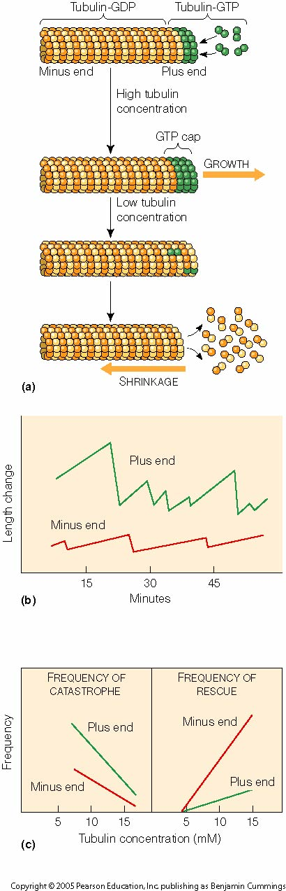

*at the end of the GP tublin at the veyr end it is the dissociation at the - end this allows for tread milling
*Dynamic instabilty and this reverse to the GTP is not fast enough
GTP not added quickly enough + end becomes unable and shirks; dissociation occurs at + end thus aren't of FTP added determines ability of growth
-Regulationg by drugs:: Conlchiche ( prevents monomers tubulin from adding on to microtubules resulting in dissociation)
-Taxo: durg used to treat cancer; stabilizes microtubules; functions depend of microtubuols will be inhabitted. Cells that are more stablle will be less affected; slow down cancer by inhibiting rapidily dividing cells ( like cancer cels) are affected by this drug another example would be hair cells ( therfore hair loss)l
-_____________________________
-after it is all it you do not add GTP sat enough the hyrdolysis if high and the + end become sustable and will shrink and it is atrisk of shinking and this is catastrophe... the + end can be unstable this si the difference between teh two
-Wether it grows at the + end or shrink is dependant upon the the availabilty of GDP

-there are drugs:
-- cholchicine - microtubules shrink becuase they are unable to grow it prevents the abilty to grow and then theis make unstable and they will shink
- - taxol- this is stablizing and itwill inhino
-- used to treat cancer cancer
-- it inhibits microtbulules and it prevents mitosis and patients are given just enough dose for it to ttack the cells that rapidly divide
- cells use protines to control the
-Microtubule – organizing centers (MTOC)
-Initiate assembly and anchor microtubules; establish orientation
-y-tubulin acts as template to initiate assembly
-e.g. centrosome = centrioles + pericentriolar material (animal cells)

Getting microtubules started is difficult, when started it is easy to keep it growing.
Microtubule organizing centres allows the cell to control where microtubules will start and in what directions they’ll grow.
- they provide a template for growth
- gamma tubulin; affinity for alpha thus polarity.
- array of microtubules in parallel fahsion
______________
-MTOC’s -> the difficult pat is getting the stated and it is a hard to initiate... one they begin to grow
-the get around the problem and give a template so that it can grow and it allows the cell to control to where the tubule will start and the direction
-the structure most known is the centrosomes and the this used gamma tubulin and the dimers and the alpha tubulin and it allows for the easy growth an it control how where it grows
- the case of the axon the - end is near the nucleus and the microtubules extend through the end and then the in the cilia
-Functions;
-Intracellular motility via motor proteins
-Kinesins
Globular head binds MTs and hydrolyzes ATP
Cargo attached to tail
Moves towards + end (outbound cargo)
-Cytoplasmic dynein
Globular head is motor domain
Cargo attached to base
Moves towards - end (inbound cargo)
Short branches involved in collecting information
Axon carries info away , can be up to a meter long.
Green paralell lines are the microtubules.
-Diffusion is too slow alon axon. Microtubles carry from body along axon (kinesins to and dyenins back)
-- Provides mechanism
-- efficient transport system that maintains stability while axons remains very thin
-____________
-- the cell body is the place of synthisized
-the extension of the body and there are smaller ones for collection of the information and then a long one is is a axon and the cell has a long cytoplasmic extension but there needs to be transport through the long projection to ensure enough of that materail gets there i.e. NT
-the parrallel lines through the micrograph are the microtunubules the centrosomes is near the nucleus this allows .
-- it moves very quickly the rate of movement can be the same and the is is dependant n how quickly atp is sent
-Example – chromatophore movement in fish, amphibians and reptiles
- Pigment in membrane-bound granules
- Under hormonal and neural control
-Pigment granules move along microtubules to change colour of frog; aggregation in center of…
- –neural ad movement mechanisms can control colour
-_______________

-chromatohoes and is a pigment withn a granule
-- the granule is able to move through out the cell and the pigent granules will move through out the cells and the animal will be darker colour
-- and then if it comes back in and background colout will move in and it will be spott
-y- when it moved out it is move through kineases and it will move back through the use of dyenins
-the hormone msh and the grandulues will move in and out
-Noradrenalin can causes aggregation of pigment
-the stressed animal would be spotty and paler.
Example – urea excretion in toadfish
Urea transporter insertion into the gill cell membrane
-Something must inhibit urea excreation mechanis,
--process completed by tubules
--vesicles containing urea moves to cell membranes and is excreted; thus tubules must be part of the transport
-- if urea excretion is prevent then the plasma increases in the cell
-_______
-the blood urea working through facilitated diffusion and the urea is release and then the machanicsm to release urea there needs to be tranpone to the outside and they believe that as the the transporteres are carried in transporters and then the toad fish will move the the vessielce with protien will move to the outside
-they testes this through treating with colchicine and then the tmicrotubules cannot grow. therefore the urea will releain high
Cellular motility
Cilia
Short (<10 µm), numerous, oar-like power stroke
Movement of fluid over cell
Flagella
Longer (<200 µm), one or two, undulating power stroke
Structure
-Enclosed in cell membrane; 0.25 µm diameter
-Axoneme – 9 + 2 arrangement of MTs
- A = 13, B = 10-11 protofilaments
- Radial spokes + nexin links
- Axonemal dynein
-Basal body anchors minus end of MTs
- centriole (9 triplet MTs)
-Axonemal dynein
- Associated with A tubule
- Moves along adjacent B tubule
(in minus direction)
- Results in sliding tubules
- Coordinated
Cilia and flagella are membrane bound structures.
-The axoneme looks like a cartwheel..
-9 + 2 shows there are 2 complete microtubles and surrounding thoses t, here are 9 pairs; on pair is complete called the a mictrotubles and the second one is the b microtubule.
-- AXONEMAL DYNEIN is a motor protein and is responsible to help move the cilia/flagella
-_________________________________
-they are different from teh bacteria through haveing a membrane unlike the bacteria an then the ciallia cut across and look inside and then there is the aximin 9 + 2 there is is two complete micros within the centres and then there is 9 doulets surrounding the two in the centre this is common arrgange . withint he doublet there is two microtunules and then they shar a w wall one is complete - A while incomple is V
-everythign is connected inbetween the spokes is nexin
- anchoring the cillua or flagella is the basal body and it is done through a tiplets it is the bottom of the linger diagram
-movement is do through dyenin and it is axonemal dyein
- the motor protien is attached to the A tubules and the heads are anchored on one edge and move along the other.
They cant slide freely past each other so when the microtubules try and slide past each other it ends up being in a bending motion. There is a fair degree of control over where the motor proteins are active.
______________________
the two drobluets are forms through sliding together and the doulets are link through nexin and the do not move freelly this cuases it to bend and the sliding causes the tying and they dont move thfreely therefore ben and then the motoro proten are activated on one side then again on the other side resulting in movement back and forth
Cell Division
-Mitotic Spindle
-Duplication of centrosome in animal cells
- Organized by chromosomes in plant cells
-Kinetochore- driven chromosome movement
-Seperation of poles by sliding polar MTs
Not allot of time on this
But the microtubules are an important component to mitosis.
__________________________
-chromosme have to separted and then cyoplams has to be moved and the mirco tubules..
-the kinetichoere moves along the microtubules and they are pullued toward ... they pulles themselves along the track and then tehe trakc is disolved
-mircortunules are used through polar mirotubules and the motor proitnes ar moved relaive to eachoht er and the push way from eachother
-mircro tubues re important for the sepration of the cell...
snaimsl and plant cell are differenand the used of look over min 51 what is important between teh animals and plants
-Plant cell do not have centrosomes they believ that teh chromosomes do it on they onethey do not have the mirofilemnt array to separate
EXTRACELLULAR INTERACTION
Plant cell walls and plasmodesmata;
-Provides rigidity and protection, regulates permeability
-Structure involves 3 classes of molecules
-Structural fibres – cellulose microfibrils
-Matrix – polysaccharides (e.g. hemicellulose, pectins)
-Adhesive molecules – pectins
-Parallels made between matrix and cell wall
- synthesized and secreted by cells they surround.
-- in plant cells matrxi is nade up of long branched poly sacrides.
-- pectins are important because they are in help thicken up the cell wall and form a gel like structure where the fibers can be embedded, ( also found in homemade jam)
Cellulose is not synthesize in the cell its synthesized on the cell
Primary vs secondary cell wall
Middle lamella (pectins)
Primary cell wall – loose network of cellulose fibrils
Secondary cell wall – cellulose fibrils highly organized
-Multi-layered
-Lignin
Plasmodesmata
-Lined with plasma membrane
-Desmotubule (smooth ER)
-Route for ions, small molecules

- Cytoplasmic links between plant cells
- Hole in cell, lined with plasma membrane, cytoplasm of adjacent cells are connected, things can move between them, (small proteins, hormones, water etc)
- Allows two cells to be in communication with each other
- Smooth ER in center of plasma, occupies space, reason not clear
- Still room to move around smooth ER
- Occur in early stages, while cell wall is being built
- Once cell wall is built, hard to make hole
- Establish cytoplasmic connection as cell wall is laid down
- Main type of cell-cell connection in plant cells
Cell –cell connections;
A variety of types;
- Adhesive (anchoring) junctions: adherens junction, desmosome
- Tight junctions
- Gap junctions
- Adhesive – adherence junctions and desmosomes
- Same basic structure
- Connection between plasma membrane proteins (cadherins)
- Transmembrane protein
- Extracellular side fairly large domain, consists of units that recognize and bond to other cadherins
- Repeated units with ability to connect to other proteins that are the same
- This connection is the cell to cell communication
- Cadherins on inside link to cytoskeleton to provide stability
- Cytoskeleton provides mechanical strength
- Adherence junction (picture), microfilaments
Flat layers of cells
•Adhesive (anchoring) junctions
•Adherens junctions
•Connect to MFs
•Small areas or continuous zones of attachment in epithelia
•Desmosomes
•Connect to IFs
•Protein plaque for strong adhesion (skin, cardiac muscle, cervix of uterus)
•Cadherins
•Transmembrane glycoprotein
•Repeats in extracellular domain “zip” together
•Cell-cell separation ~30 nm
•Intracellular linking proteins
- Desmosomes attach o intermediate filaments
- Dense clusters of filaments
- Strong plaques, strong adhesive junction
- Found in places where strength and flexibility are needed
- Point junctions
- Adherence – Velcro, desmosomes – buttons

Tight junctions
Permeability barrier in epithelia
-e.g. intestine, bladder, skin, gill
Barrier to lateral diffusion in plasma membrane
-Polarized cell
Structure
-Ridges formed of junctional proteins claudins, occludin
- Holds cells together
- Seal space between cells
- Dye cannot get past tight junction
- “sealing junctions”
- Important in tissues that form barrier between two compartments
- Ex. Intestine
- Prevents leakage from bladder, skin, etc
- Permeability layer
- Can only pass through cells themselves
- Prevent lateral pass of proteins and phospholipids, allow for polar cells
- Call have cell differences from one side to other
- Prevented from becoming homogenous by junction
- Transmembrane proteins form ridges
- Ridges match up with ridges of other cell
- Point junctions, layers of junctions, the more you have the tighter the seal
- Claudins and occuldin – globular proteins that line up in ridges, allow connections between cells
- Have enough “ridges” tight cell connection
- Anchored into membrane, do not extend much past membrane
Gap junctions
Cytoplasmic contact
-Electrical and chemical communication
Muscle and nerve tissue
-e.g. Coordination of heart beat
Structure
-Cell-cell separation 3 nm
-Connexin – integral membrane protein
-6 form linking structure
- Communicating junction in animal cells
- Cytoplasmic connection between two cells
- Transmembrane proteins (connexion)
- 6 connexin in each
- Recognize and attach to connexin in other cells
- Cells continuous with each other
- Not as large as plasmodesmata in plants
- Water and ions can move
- Larger molecules not able to pass through
- Cytoplasmic continuity
- Always present
- Animal tissues much more flexible, gap junctions can disappear, typically don’t
- Allows cell-to-cell communicaton
- Important in nerve and muscle cells
- Rapid communication from one cell to next
- Ex. Heart;
- Actin and myosin in heart cells
- Two plasma membranes close together, linked by protein connections
- Heart cells need desmosomes and gap junctions
- Allows heart beat to be spread across all cells
- Initiates in one section, spreads across heart
- Depolarization spreads from cell to cell without involvement of any nerves
- Big black are mitochondria
- Advantage: don’t require nerve cells
- Heart cells in peetree dish will contract
- Mesh covered in red heart cells will start beating
- Contractile protein
- Making patches to put on heart after heart damage
The extracellular matrix(ECM) of animal cells
-Organized network of extracellular materials
-Diversity of forms
-Bone
-Cartilage
-Connective tissue
-Basement membrane
-Cornea
-Secreted by cells it surrounds and organized locally
- Extracellular matrix – plant cell wall
- Diverse in structure
- Made up of macromolecules, synthesized and secreted by cells they surround
- Organized into cell matrix
- Diverse forms depending on tissue
- Bones – minerals added, connective – highly organized, cartilage – contains lots of water, acts as cushion to prevent bone on bone
-Structure involves 3 classes of molecules
-Structural proteins – collagens, elastins
-Matrix – proteoglycans (protein-polysaccharide complexes)
-Adhesive glycoproteins – e.g. fibronectin
- Matrix – not network of polysaccarides, network of proteoglycans
- A lot of negative charges, attract water
- Structural fibres imbedded in matrix
- Fibrous proteins in structure
- Collagen microfibrils provide strength ridigity
  - Secreted in cell
  - Can be built into larger microfibrils
  - Not stretchy, flexible, won’t break
- In lungs, need elastin
  - Fibrous proteins
  - Linked by covalent interactions
  - Stretch out into network, when pressure is released bounce back into tighter network
  - Strength – collagen, resiliency – elastin
- Elastin is stretchy because of covalent bonds
- Skin important example
  - With age, collagen linked closer together
  - Elastin disappear
  - Matrix gets thinner
  - Skin is no longer resilient etc
- Can have disorders where you lack collagen (Ehlers-Donlos syndrome)
- Adhesive glycoproteins, some way to attach extracellular matrix to cells
- Stick extracellular matrix together and to cells that secrete it
- Pectins in plants
- Fibronectin – most important, two proteins links by disulfide bonds
  - Fibrous protein
  - Capable of bonding to different parts of extracellular matrix
  - Domains that bind with proteins present within cellular membrane (integrin)
- Binds to membrane proteins
Can cross cell and hold things in place
Integrins
•Heterodimer (a and ß chains)
•Integrate ECM with cytoskeleton
•Extracellular binding site for adhesive glycoproteins
•Intracellular binding sites for linking proteins
•Focal adhesions and hemidesmosomes
- Firbonectins connect to
- Transmembrane domain
- Two different proteins make up integrin
- Extracellular side: areas that are recognized by fibronectin
- Inside: binding sites for linking proteins to cytoskeleton
- Skeleton links to integrins
- Equivalent to desmosomes, but within cellular membrane
- Focal adhesions/hemidesmosomes – between cell and cell matrix
  - Membrane proteins different
  - To extracellular matrix rather than another cell
  - Between actin microfilament and matrix
Organism | Extraceulluar structure | Structural fibre | Matrix | Adhesive molecules
Animal | Extracellular matrix | Collagen/elastin | Proteoglycans, proteins w carbo attached | Glycoproteins, fibronectin
Plant | Cell wall | Cellulose | Pectins, polysaccharides | Pectins
CELL TO CELL COMMUNICATION
Types of cell communication
Gap junctions and plasmodesmata
Contact
Chemical messengers
- Cells can not only respond to outside influences, but also intracellularly; Allow response of cell to be tailored to specific needs; Not only way cells have to communicate
- Are ways such as gap junctions allow cells to communicate directly
- Chemical messengers;Released by one cell;Used to change activities of another cell at a distance;Gives cell most capacity to respond
- Membrane receptor signaling systems
Signals are water-soluble chemicals;
- Signalling molecule does not enter cell
-Signal removal
e.g. environmental chemicals, neurotransmitters, hormones
Membrane receptors are integral membrane glycoproteins
- Ligand-gated channels
-Receptor tyrosine kinases
-G protein-coupled receptors
Charged or too large cant diffuse across the membrane.
Receptors are very specific and will only bind with the molecule they are designed to recognize. Once it binds it has a change in confirmation and initiates the cellular response.
Ligan gated channels
-Channel proteins. And there are two common types od gated channels ( votage and ligand gated)
-- It is not only an ion channel but is also a receptor
-- found in muscle and responds to a signaling chemicalr released by nerves (acetocholine) then it responds to the to activate the muscle cell
--very short pathway
Signalling cascades
-Role of phosphorylation: kinases vs phosphatases
-Amplification
-Termination
-Removal of ligand-receptor complex
-Inactivation of receptor
-Inactivation of signalling cascade
- Triggers sequence of events
- Phopsorelation cascades
  - Transfer phosphate group from ATP ADP
  - Phosphate group transferred to inactive protein, protein becomes activated
- Kinases – phosphorelate proteins
- Phosphatises – removes phosphate group
- Cascade: kinase activates protein, protein can act as kinase for another protein, each protein turns on another protein
- One protein turns on and that one turns on another one.
- The proteins are activated (phosphoralation) transferring a phosphate group into ATP
- Kinase (purple) takes an atp by phosphralation and transfers it to the blue one .
- Each protein acts as a kinase for the next protein in line
- The initial step is carried out by activation of the receptor.
- The cells contain phosphotases which go around savaging phosphate groups. They are always looking to remove phosphate and turn off.
- Several diff. ways this pathaway can be turned off.
- Amplification; one turns on 1 and that 1 turns on 3 more
Receptor tyrosine kinases
-Dimer formation
-Activation of cytoplasmic protein kinase domain
-Autophosphorylation (tyrosine residues)
-Phosphorylation of target proteins
-Typically regulate cell growth and proliferation
- Receptor acts as kinase
- Phosphorelates tyrosin residues
- Binds to receptor, activates receptor
- Two receptors dimerize, capable of phosphorelating each other
- Add phosphate groups to tyrosin residues in the receptor itself
- Two receptors activated by coming together
  - Auto-phosphorelation
- They usualy regulate growth factors.
- Final protien can enter neucleus and bind to dna, causing mitosis to occur.
- MAP = mitogen actived pathway)
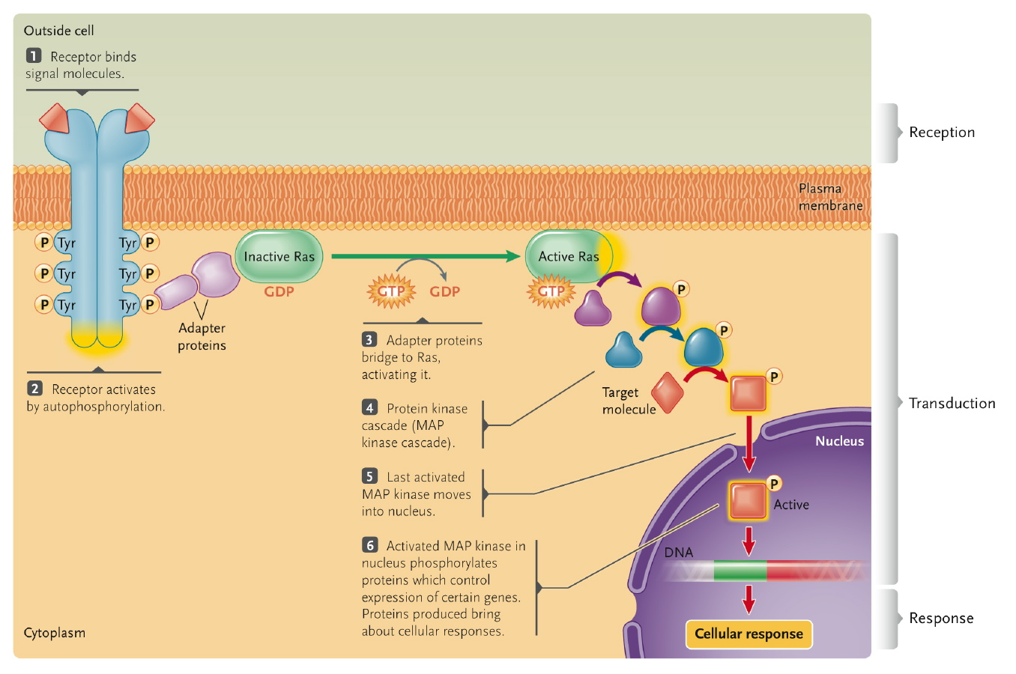
- Activates RAS, activates phophorelation cascade
  - Enters nucleus
  - Activates cells division and cell growth
- Transcription factors enters nucleus and tells what to do
- Many growth factors mitogens because they help with cell growth by gene expression

G protein-coupled receptors
-Activate guanine nucleotide-binding proteins (G protein)
-G protein activates enzyme to produce 2nd messenger
-l2nd messenger activates protein kinases

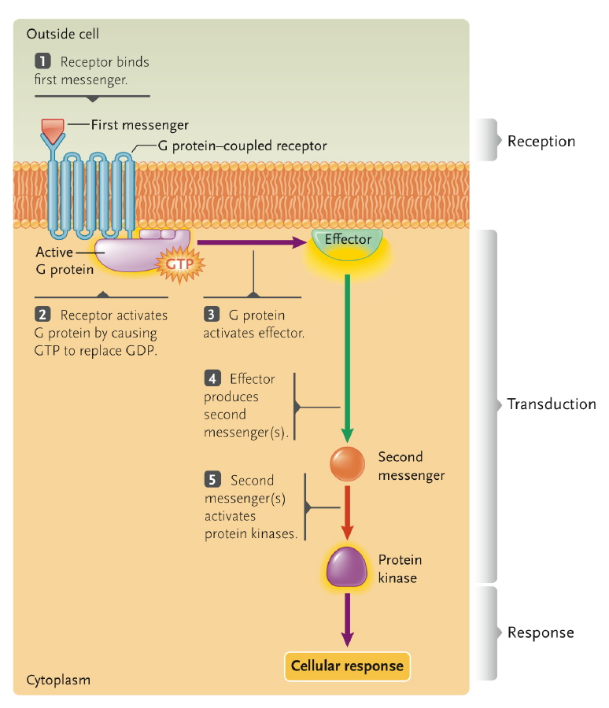
Ligand
binding
domain
7 transmembrane
domains
G protein
binding
site
- G protein coupled receptors is not able to phosphorilate protein.
- Involve second messenger, within cell
- Activate cellular responses on behalf of the primary messenger (does not enter cell)
- Signal transduction of primary messenger
- Intracellular side: links to and activates g-protein when it itself is activated
- Turns on phosphorelation cascade
G proteins are molecular switches
GTP bound = on
GDP bound = off
G proteins are heterotrimers
G_{a} binds GTP or GDP
G_{b} and G_{g} form a unit
G proteins are diverse
Adenylyl cyclase activation (Fig. 8.10)
Phospholipase C activation (Fig. 8.12)
Adenylyl cyclase inhibition
Lipid anchored protein. ( GPI externaly , fatty acid linked internaty ( G proteins))When gtp is bound to them butthey are aos able to hydrolise gtp when it is hydrolised to gdp then it is turned off
- Fatty acid linked protein
- Lipid anchored proteins (GPI external side, fatty acid linked on internal side)
- Bound to membrane by linking to fatty acid chains that are inserted into membrane
- Three subunits come together to make g protein
  - Bind GTP (active)
  - Hydrolyse GTP (GTPGDP)
  - GDP inactive
- Receptor deterimes whether or not it is hydrolyzed
- Allowing GDP to bind makes it inactive
- Active form splits in alpha unit and beta gamma unit
- Activated by getting rid of GDP and replacing with GTP, once it is hydrolyzed back to GDP, it becomes inactive once again
- Enzyme adenylyl cyclise and phospholipase C give rise to secondary messenger
- Catalyses conversion into cyclic AMP
- Phosphodiesterase always present in cell
- Receptors that turns on g protein, secondary messenger turns on different molecule depending on g protein, secondary messenger triggers cellular response
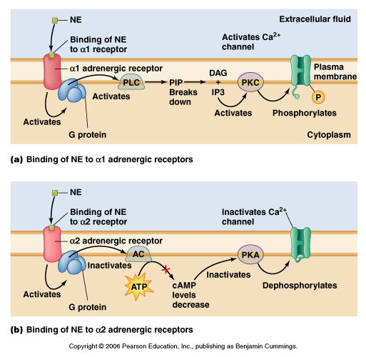
    - Example – vasoconstriction in cold hands
Ca²⁺ release from ER

cytosolic Ca²⁺
Smooth muscle contraction
Blood vessels constrict
Reduced blood flow

Fig. 4.31, Moyes & Schulte 2008

- G protein - activates phospholipase C
- Splits in two, secondary messenger
Lipid-soluble signals & intracellular receptors
Signals enter cells by diffusion
e.g. steroid hormones
Receptors are ligand-activated transcription factors
Ligand-binding domain
DNA-binding domain
Regulate gene expression
Response elements
Example
Testosterone and muscle
- Signalling molecule can enter cell
- Can only trigger genes with response element for that receptor
- Is possibility for amplification
- One gene can amplify a bunch of other genes

DOCTOR JONHSON
Unit 1 – DNA, RNA, Structure & Function
Basic Building Blocks for DNA & RNA
- Four nitrogenous bases
  - Adenine, cytosine, guanine, thymine
- A base is a purine or a pyridimine
- A base + a pentose sugar = nucleoside
  - If the sugar is deoxyribose it is a deoxyribonucleoside
- A nucleoside + phosphate = deoxynucleotide
- There are 5’-monophosphates, 5’-diphosphates, 5’-triphosphates
- The bases are hertocyclic, aromatic rings
- In RNA, uracil replaces thymine
  - Ribose replaces deoxyribose
Basic or Archetypal Structural Forms for DNA and RNA
- Bacterium – dsDNA, circular
  - Protein/DNA
  - Nucleotide
- Eukaryote – dsDNA, linear
  - Protein/DNA
  - Chromosome
- Mitochondria – dsDNA, linear
  - Protein/DNA
- Chloroplast – dsDNA, circular
  - Protein/DNA
- Virus – ss or ds DNA, circular or linear
  - ss or ds RNA, circular or linear
  - Protein/DNA
- Viroid – ssRNA, circular
  - None?
Griffith’s Experiment
- Four tests done to determine nature of genetic material
- Mice injected with live infective S cells
  - Mice die. Live, infective S cells in their blood shows that S cells are virulent
- Mice injected with live, noninfective R cells
  - Mice live. No live R cells in their blood, shows that R cells are nonvirulent
- Mice injected with heat-killed S cells
  - Mice live. No live S cells in their blood, shows live S cells are necessary to be virulent to mice
- Mice injected with heat-killed S cells plus live R cells
  - Mice die. Live S cells in their blood shows that living R cells can be converted to virulent S cells with some factor from dead S cells
- Conclusion: some molecules released when S cells were killed could change living R cells genetically to the virulent S form. He called the molecule the transforming principle and the process of genetic change transformation
Hershey Chase’s Experiment
- Infected E. coli growing in the presense of radioactive ³²P or ³⁵S with phage T2. The progeny phages were either labelled in their DNA with P or in their protein with S
- Fresh E. coli cells were infected with the radioactively labelled phages
- After infecting the bacteria, the cells were mixed in a blender to remove the phage coats from the cell surface. The components were analyzed for radioactivity
  - Result`: no radioactivity within cell, S in phage coat
- Progeny phages analyzed for radioactivity
  - No radioactivity in progeny phages
Other proofs that DNA is the genetic material
- Fibre diffraction experiment
  - Picture of DNA samples
  - Franklin`s DNA diffraction pattern
  - Only works is you have models and crystal structures for small dsDNA
  - Standard model – B-DNA
- DNA forms a right-handed helix
DNA Structure Always the Same?
- Different x-ray fibre patterns (A,B,C,D,Z) under different ionic conditions
- Z DNA is found in GC-rich DNA
- Z DNA has been associated with some binding proteins and transcription
- These in vitro results suggest that microheterogeneity can occur in DNA structure
Basic Structural Forms for RNA
- Highly organized
- Primary, secondary, tertiary much like proteins
DNA and RNA can be extensively modified in the cell
Modification | Possible function; organism
N6-methyladenine (N6-MeA) | Recognition and control; bacteria, Archea, protists, plants, animals
N4-methycytosine (N4-MeC) | Recognition and control; bacteria, Archea
5-methycytosine (5MeC) | Structure and regulation; eukaryotes
5-hydroxymethycytosine (5OHMeC) | Unknown; mammals
D-glucosyl-5-hydroxulmethyluracol (“J”) | Unknown; trypanosome brucei
7MeG in mRNA | Translational control; eukaryotes
Methylation of 2’-O-ribose | Structural role; eukaryotes and Archaea
Cytodine-to-uridine (C to U RNA editing) | Codon changes, splice site variants; eukaryotes
Adenosine to inosine (A to I RNA editing) | Codon changes & unknown; prevalent in brain cells of mammals
Pseudouridylation | Structural; urbacteria, archaea, eukaryotes
Methylation of 16S rRNA | Resistance to pactmycin or gentamicin
- Chemistry is important for structure and function
- Tertiary structure is important for correct binding of proteins
- Structures are dynamic
DNA Organization in Eukaryotes and Prokaryotes
- Histones pack eukaryotic DNA at successive levels of organization
- Many nonhistone proteins have key roles in the regulation of gene expression
- DNA is organized more simply in prokaryotes than in eukaryotes
- DNA-protein interaction follow the same basic principles
The Basic Principles
- DNA packaging involves specific proteins
- Packaging is achieved via the use of repeating subunits
- More compact structures are based upon simpler structures
- Subunit assembly must be dynamic
- Protein modifications can affect chromosome structure
- Viruses: basic proteins that may be part of the virus particle
- Bacteria: basic proteins such as HU, IHF, H-NS to form a series of loops called a nucleoid
- Eukaryotes: basic proteins called histones and a hierarchical organization
Bacterial Chromosome
- Closed, circular molecule of DNA packed into nucleoid
- Replication begins from a single origin, proceeds in both directions
- Plasmids replicate independently of the host chromosome
- Nucleod: DNA + basic proteins
  - 40 and 50 supercoiled loops of DNA/genome in E. coli
Eukaryotic Chromosomes
- Consist of DNA complexed with histone and nonhistone proteins, called chromatin
- Dna wraps around a nucleosome (two molecules each of histones H2A, H2B, H3, H4)
  - Linker DNA connects adjacent nucleosomes
  - Binding of histone H1 causes nucleosomes to package into a coiled structure (solenoid)
- Nonhistone proteins help control the expression of individual genes
Nucleosomes and Chromatin Fibre
- Nucleosomes form a left-handed helix
- Nucleosome structure is conserved
- Parameters: 2 of each 4 histones named H2A, H2B, H3 and H4
  - DA is wrapped around the outside
  - Adding histone H1 brings nucleosomes together to form the 10nm fibre
  - Sequences that are distant can now be closer together
Solenoid
- 6-8 nucleosomes per turn
- Structure not well defined
- Sequences that are more distant can now be closer together
Chromatin
- Distributed between
  - Euchromatin (loosely packed region, genes active in RNA transcription)
  - Heterochromatin (densely packed masses, genes are inactive)
- Folds and packs to form thick, rodlike chromosomes during nuclear division
- Eukaryotic DNA wraps around histones to form nucleosomes
  - Promoters inaccessible
- Chromatin remodelling makes gene promoters more accessible
  - Activators recruit remodelling complexes that displace nucelosomes
  - Activators recruit enzymes that acetylate and loosen histone association with DNA
  - Other modifications can include methylation of Lys, methylation of Arg and His, phosphorylation of Ser and His
- These modifications affect the “tails” (amino termini)
- The influence of these modifications on transcription is now as the Histone Code
The Histone Code
- This section of the course describes the effects at the level of chromatin where the change from one state to the other affects many genes in the region affected. This is a large scale effect. In some cases an entire chromosome can be silenced – called “genomic imprinting”. See text p334.
- Localized methlyation can also occur and effect (inactivate) only one (or a few) genes. In this case the chromatin structure is not changed!! This is discussed in the section of Regulation. See text p333-4.
- Euchromatin – higher histone acetylation
  - Lower histone methylation
  - Lower DNA methylation
  - Active genes
  - Dispersed
- Heterochromatin – lower histone acetylation
  - Higher histone methylation
  - Higher DNA methylation
  - Inactive genes
  - Highly condensed
  - 15% of genome
  - Constitutive or facultative
- Post-translational modifications of histones introduce meaningful variations into chromatin and provide a regulatory platform for controlling and/or fine-tuning many important DNA-templated processes, including gene transcription, the repair of DNA damage and DNA replication.
- Histone modifications, together with factors responsible for adding ('writing'), interpreting ('reading') and removing ('erasing') histone modifications, regulate specific and distinct functional outputs of our genomes, which constitute the basis of the 'histone code hypothesis'.
- As recent evidence starts to link the miswriting, misinterpretation and mis-erasing of histone modifications to oncogenesis, we further propose that misregulation of the histone code leads to deregulated gene expression and perturbation of cellular identity, and is therefore a major contributor to cancer initiation, progression and/or metastasis
Chromatic Structure
- Influences transcription, replication, repair and recombination
- Chromatin remodelling can convert accessible to inaccessible
- Remodelling is influenced by alterations of the cell physiology
- Remodelling influences the expression of many ganes, thus “transcriptome”
- The histone code hypothesis posits that the sum of modification to the “tails” of the histone mediates transcriptional changes
- Histone modification and histone variants can play a role in the regulation of gene expression
Useful Concepts
Name | Area | Comments
Genomics | DNA genome | The original, includes cloning and functional analysis
Epigenomics | DNA modifications | Inheritable changes in phenotype not caused by genotype
Transcriptomics | mRNA | Can vary between cells, time, condition, etc
Proteomics | Protein | May take into account modification

Unit 2 – Regulation
Gene Regulation
- Why is understanding regulation the key to understanding so much of life?
- Changes in environment or changes in nutrients
- In a multicellular organism, cellular differentiation
- Conseve energy
- Gene regulation refers to the regulation of activity and may occur at any level
- Main control is at the level of transcription
- Additional controls at posttranscriptional, translational and posttranslational levels
Regulation of Gene Expression in Prokaryotes
- Prokaryote gene expression reflects life history
- Rapid, reversible responses to environment are observed
- Typically RNA polymerase binds to DNA sequence 5’ to the gene called the promoter
  - Within promoter may be the consensus sequence 5’-TATAAT-3’ called a TATA box
- Repressor proteins binding to other regulatory DNA sequences may prevent the gene from being expressed
- Activator proteins binding to other regulatory DNA sequences may turn on expression of the gene
- How can you load RNA polymerase into the TATA box? What are the factors that interact with the DNA to either push that to happen or stop that from happening?
- Repression systems- block/demish transcription
- Repressor and activators may regulate the same gene
- Many genes organized into clusters (transcription untis) that are implicated in a single function
- Smaller scale – many genes organized in operons
  - One or more operons may be found within a transcriptional unit
- Operon itself can be considered as a unit of transcription with several genes controlled by a single promoter
- Operon is a cluster of genes and DNA sequences involved in their regulation
- RNA polymerase binds at the promoter and transcribes all the genes in the operon into one mRNA
  - Called polycistronic because it contains several cistrons – an older definition of a gene used in genetics
- Estimated 630 to 700 operons in E. coli.
  - Examples are the lac operon for lactose metabolism (3 genes)
  - trp operon genes for tryptophan biosynthesis (5 genes)
  - Lack operons consist of three genes, and trip operons 5 is another classic system. TOT 7
  - -The lack operon is an example of an operon which is a collection of genes and within this collection of genes there is a single spot for transcription to start, you get one message and that message is a polysystronique message because it contains 3 genes. Systron is an old name for genes. This is not meant to imply that the order of translation is 5 to 3. In a systron the secondary structure and the binding of proteinscan influence which genes is translated most.
  - - there are some opereons where 3 genes are found but it’s the second genes hat translated most and that’s because it has a good shine-dalgarno sequence because the secondary structure allows translation to enter
lac Operon for Lactose Metabolism
- Lactose metabolism in E. coli requires three genes lacZ, lacy and lacA
  - Lac operon contains all three genes and regulatory sequences
  - focusing more and Z which is controlled by a negative regulation which is a protein binding to a dna sequence called an operator.
- Lac operon operator sequence is between promoter and lacZ
  - Operator sequence is the site of repressor building
- Study of the lac operon allows us to understand the interaton of one metabolic pathway in the context of both positive and negative regulation
- Jacob and Monod won Nobel Prize in 1965 for its study
- E. coli has circuitry to respond to cues (glucose or lactose as a carbon source).
- Expression is controlled by a “repressor” (lacI) that binds to the operator (lacO) and prevents transcription.
- When the inducer (lactose, allolactose, IPTG) binds the repressor, the repressor-lactose complex does not bind to the operator so synthesis is achieved. Thus if lactose is around, you use it for a carbon source.
- When the level of lactose falls, the level of repressor-lactose falls and the binding of repressor to operator resumes. Synthesis is repressed. Thus if lactose is no longer around, you search for another carbon source.
- E. coli uses a general sensing system to positively regulate many possible genes or operons. Which one it uses depends on what the cell senses is available.
- In the presence of lactose and absence of glucose, cyclic AMP (cAMP) joins with a catabolite activator protein that binds to the lac promoter and facilitates the transcription of the lac operon. If glucose is high cAMP is low, so…
- E coli can break down DNA.
- E coli has a high cAMP, and it has choices.
- Lac repressor stops lac operon expression
  - Encoded by lacI, synthesized in active form
  - Binds operator, prevents transcription
- Allolactose made from lactose when it enters cell, lasts as long as lactose is available
  - Inducer of lac operon by binding to lac repressor
  - Inducible operon because inducer increases expression
- Experimentally mimic by adding IPTG, an analogue of lactose that is not metabolized, and use a substrate such as X-gal to measure enzyme activity (X it turns blue)
- Inducer reverses. By binding to the repressor and cause adduction or derepression
Positive Regulation of lac Operon
- Operates when lactose but not glucose is present
  - Glucose more efficient energy source than lactose
- Catabolite activator protein (CAP) is an activator that stimulates gene expression
  - CAP activate by cAMP
  - cAMP only abundant when glucose levels are low
- In E. coli many genes/operons have CAP regulation
- Cap stimulates transcription because it recognizes a signal ( cAMP) in the cell. When you have a lot of Glucose, you have very low cAMP, when you have low glucose you have + cAMP.
- In Ecoli there are many genes that have this sort of regulation
Regulation of Transcription in Eukaryotes
- In eukaryotes, regulation of gene expression occurs at several levels
  - Transcriptional regulation – determines which genes are translated
    - Chromatin remodelling to make genes accessible for transcription
    - Regulation of transcription initiation
  - Posttranscriptional regulation – determines types and availability of mRNAs to ribosomes
    - Variations in pre-mRNA processing
    - Removal of masking proteins
    - Variations in rate of mRNA breakdown
    - RNA interference
  - Translational regulation – determines rate at which proteins are made
    - Variations in rate of initiation of protein synthesis
  - Posttranslational regulation – determines availability of final product
    - Variations in rate of protein processing
    - Removal of masking segments
    - Variations in rate of protein breakdown
- Chromatin structure plays important role in whether a gene is active or inactive
- Regulation of transcription initiation involves the effects of proteins binding to a gene’s promoter and regulatory sites
- Methylation of DNA can control gene transcription
Organization of a “Eukaryotic Gene”
- Eukaryotic gene organization allows regulation
  - Promoter includes TATA box that binds transcription factors
  - Promoter proximal region upstream of promoter increases transcription
  - Enhancer further determine maximum transcription rate
  - Proximal region is the typical focus of regulation. That’s where the transacting proteins interact and the sysaque sequences -

Transcription Complex on the Promoter
- How do these factors assemble to initiate transcription
  - Bind to TATA box area and recruit RNA polymerase II
  - Transcriptional initation complex, low rate (“basal”)
  - Acitivators bind to promoter proximal elements and increase transcription rate
Transcription Initiation Regulation
- Coactivators bridge enhancer and promoter
  - Interactions between coactivator, proteins at promoter and RNA polymerase increase transcription
- Repressors oppose effect of activators
  - Transcription rate depends on activation and repression signals
  - In a mulitcelluar organism these signals may be external (heat, light) or internal (hormones)
  - May bind to sites on an activator or coactivator or increase association with histones
- Overall regulation is a balance of many factors
- Phosporilation is a very common mechanism of regulation in eukaryotic cells.
- Able to bind two activators/repressors at the same time but folding the DNA into a loop and bring the regions close together and influence transcriptions.
- s = bridge
- Ecoli has many states, you don't have to go from off to completely on . You can go from off to an intermediate level to maximal. This allows to control expression at a much finer level.
- Ex. Your going to be making RNA, RNA is going into the cytoplasm and what happens back there it might take the signal a while to get to the nucleus so you want much finer control to what off or on.
Combinatorial Gene Regulation
- A unique combination of activators control gene A
  - Gene A controlled by activators 2, 5, 7, and 8 binding to regulatory sequences in its enhancer
- A different combination of activators controls gene B
  - Gene B controlled by activators 1, 5, 8 and 11 binding to regulatory sequences in its enhancer
Can be used to explain the regulation of different cell types, regulation of the same cell under diff conditions, regulation in the same cell that’s undergoing differentiation from one form to another.
SLIDE 21 of 28
Imprinting and Methylation:
Methylation on a large scale = the formation of barb- body in females which is you have two x chromosomes that are highly mylenated and therfore no genes are expressed/ low level expression of some genes.
Barb –body is heterochronization brought to the extreme its even more condensed then a metaphase chromosome. ( why they are more condencsed)

Genomic imprinting; system in which you have a blocking/ diminishing of transcription and genes b/c of location on the chormosome. Imprinting is an inherited state in which the highly myth elated allele are silenced. Ths is methylation maintained by replication ( ____ methel C).

GC on one strand and GC on the other, both C’s are mentholated after replication.
_______*** PERTAINS TO FOLLOWING SLIDE***_______
1)What happens if the steroid( estrogen) is replace with a carbohydrate or another protein? Something that cannot enter the cell. How odes it affect the signal?
- The target cell might have a receptor , if so the carbohydrate could bind to the signal or a receptor that crosses the membrane.
2)What happened if it binds to the receptor but cannot enter?
-It could in to the receptor, and stay attached, but the receptor would begin to change.
- Inside the receptor itself, the receptor changes shape and leads to a phorsphorilation cascade which is simply ; phosphorilation of a targets and with each different target , the intensity increase. Once signal form the outside becomes many signals on the inside, you are essentially boosting the outside signal.
Ex. Transmitting a signal after binding to the outside, changes the inside confirmation and leads to a phosphorilation cascade.
3) Both green boxes share the same amino acid sequence, why is only one able to enter?
-binding the signal, changes the confirmation.
What is the actual molecular mechanism that results form changing the shape?
(not changing amino acid sequence, simply changing the shape)
- The nuclear hole complex, is a whole in the wall full of proteins. There is a complex/ receptor there. Therefore the green box interacts with the receptor, and will know if its in the right place.
-ANSWER: this change in confirmation exposes a signal that wasn’t there, phosphorilation could expose a signal or make a signal that wasn’t there before.
Methylation of DNA
- DNA methylation adds –CH₃ to cytosine
  - Gene silencing occurs when DNA methylation is located in promoters
  - Example: barr bodies
- Genomic imprinting
  - Permanent silencing of a maternal or paternal allele
  - Inherited methylated allele is silenced
  - Methylation maintained as DNA is replicated
SLIDE 26
- If you inherit a silence allele form one parent and a non functional from the other what happens? Well if you cant reverse you have lost both allele.
- -One of many types of regulation: In general, the cell has a nucleus and a cytoplasm and the receptor is a molecule/protein in the cytoplasm. Along comes a steroid hormone and because its hydrophilic it can go through the membrane and it can find the hormone receptor and bind to it. This complex can now migrate to the nucleus. The protein could be 1 of several.
- -The transacting factor = protein + signal , causes expression of hormone regulated genes. They will not all be expressed at the same level because of sacty sequencesthat respond to other signals. This causes a message which is processed in the ways we’ve described …
- -When you remove the hormone, you essentially remove the signal , then the gene can have no expression ,etc, and then eventually the protein will decay away. All thoses processfrom production of the protein to the decay are all possible sites of regulation.
- - Any one of the steroid hormones with a similar structure will follow the same program.
- -ESTROGEN: so you have a target cell and it has a receptor, incomes the steroid (estrogen) comes across the membrane diffuses the membrane, bind the estrogen receptor, this complex can now move into the nucleus it can bind the estrogen responsive element (ERE) the genes are expressed, transcription, translation, production of protein, estrogen decreases and this reverses. When you produce estrogen it doesn’t go to a particular cell, it circulates; it has to find the particular cell that has a target. Testosterone will have different target tissue.
Posttranscriptional, Translational, and Posttranslational Regulation
- Posttranscriptional regulation controls mRNA availability to ribosomes
  - Pre-mRNA processing changes which proteins are made
    - Alternative splicing of introns and exons
  - mRNA breakdown rate are variable
    - Mechanism: 5’ UTR or 3’ UTR nucleotide sequences
  - Masking proteins bind to mRNA to prevent translation
    - Signal for mRNA activation removes masking proteins during development
  - Micro-RNA (miRNA) regulates gene expression through RNA interference (RNAi)
    - miRNA binds to any complementary mRNA sequence and silences it
  - Small interfering RNA (siRNA) is form RNA encoded outside the cell’s genome
    - Often used by viruses
- For every gene regulated this was it must have at least one locus that produces an anti- sense. The locus can be different or the same as long as it produces and anti –sense.
- Anti – sense RNA, bound to proteins can be presented to a target, the target is complimentary therefore forms a double stranded region. Therefore the formation of double stranded RNA is the necessary intermediate in theses formation processes.
- What is the fate of double stranded RNA where the target is a message?
- - It’s presented as a protein RNA complex. It has two fates; 1. It could be divided which induces a cleavage system. The RNA gets cleaved and then the RNA can no longer be translated. This cleavage product can further be degraded down to small nucleotides and then recycled. 2. Rna isn't cleaved immediately , thus blocking translation. Translation starts somewhere and tries to get through but cant.
- Translational regulation controls the rate of protein synthesis
  - Increasing length of poly (A) tail increases translational of mRNA
- Posttranslational regulation controls the availability of functional proteins
  - Chemical modification alters activity of protein
  - Processes inactive precursors to active proteins
  - Rate of degradation, ubiquitin pathway
REPLICATION
DNA Replication in Eukaryotes
- The DNA structure is antiparallel
- DNA strands go from 5’ to 3’
- Two strands of parental DNA molecule unwind aided by helicase
- Helicases unwind DNA to expose template strands for DNA synthesis
- Each is a template for the synthesis of a complimentary copy
- Synthesis follows the base-pairing rules
- DNA replication is semi conservative
- One new DNA strand is synthesized continuously; the other, discontinuously
- Synthesis of DNA or RNA is always 5’ to 3’
- DNA polymerases are the primary enzymes of DNA replication
- Multiple enzymes coordinate their activities in DNA replication
- DNA replication begins at replication origins (ori, ars)
- RNA primers provide the starting point for DNA polymerase to begin synthesizing a new DNA chain
- Telomerase solve a specialized replication problem at the ends of linear DNA molecules
Enzymes of DNA Replication
- Helicase unwinds DNA
- Primase synthesizes RNA primer (starting point for nucleotide assembly by DNA polymerases)
- DNA polymerases assemble nucleotides into a chain, remove primers and fill resulting gaps
- DNA ligase closes remaining single-chain nicks
Basic Problem: DNA polymerase cannot start synthesis
- Requires a primer to initiate synthesis
- Primer can be a suitable DNA molecule, one that has a 3’OH, which can be extended
- In the absence of a primer, one must be provided de novo
- RNA polymerases are used to initiate replication
- Leads to other problems that relate to how the cell deals with these short RNAs
Assembling Antiparallel Strands
- Leading strand – continuous
- Lagging strand – discontinuous
- Replication fork – where the DNA that is unwound meets the DNA that is wound
- Leading strand heads towards replication fork
- As DNA helix unwinds, one template strand runs in a direction allowing new DNA strand to be made continuously in the direction of unwinding
- Other template strand is copied in short lengths that run in the direction opposite to unwinding
  - Discontinuous replication produces short lengths, then linked into a continuous strand
- Okazaki fragments – relatively short fragments of DNA created on lagging strand of DNA replication
- Steps:
  - Helicase unwinds the DNA and primases synthesize short RNA primers
  - RNA primers are used as starting points for the addition of DNA nucleotides by DNA polymerases
  - DNA unwinds further and leading strand synthesis proceeds continuously, while a new primer is synthesized on the lagging strand template and extended by DNA polymerase
  - Another type of DNA polymerase removes the RNA primer, replacing it with DNA, leaving a nick between the newly synthesize segments
  - Nick is closed by DNA ligase
  - DNA continues to unwind and the synthesis cycle repeats as before: continuous synthesis of leading strand and synthesis of a new segment to be added to the lagging strand
Major Enzymes of DNA Replication
- Helicase – unwinds DNA helix
- Single-stranded binding proteins – stabilize DNA in single-chain form
- Primase – assembles RNA primers
- DNA polymerase – assemble DNA chains on primers; replace primers while simultaneously replacing primer nucleotides with DNA nucleotides
- DNA ligase – seals nicks left after RNA primers replaced with DNA
- Topoisomerases – relieve over-twisting and strain of DNA ahead of replication fork (in circular DNA)
Telomeres
- Regions at end of chromosomes that protect against deterioration
- Short sequences repeated hundreds to thousands of times
- Repeats protect against chromosome shortening during replication
- Chromosomes shortening is prevented in some cell types which have a telomerase enzyme (adds telomere repeats to chromosome ends)
DNA Ends, the Problem
- 3’ end of DNA template unwound and ready for replication
- Primer added and new DNA assembled from end of primer
- Primer removed
DNA Ends, the Solution
- Adding telomere repeats
- Extra telomere repeats added by telomerase at 3’ end of template strand
- Primer added and gap filled
- Primer removed original length is restored
DNA Synthesis
- Begins at sites that act as replication origins
- Proceeds from the origins as two replication forks moving in opposite directions
- Control the number of replication origins
DNA Replication in Bacteria
- Genome circular in replication
- Replication initiates at a unique site, called the origin of replication and proceeds in a bidirectional manner until the terminus is reached
- Can be cloned and sequenced
Mechanisms that Correct Errors
- Errors inevitably occur, during replication or caused by DNA damage
- Proofreading depends on the ability of DNA polymerases to reverse and remove mismatched bases
- DNA repair corrects errors that escape proofreading or caused by DNA damaging agents
Proofreading by DNA Polymerase
- If a replication error causes a base to be mispaired, DNA polymerase reverses and removes the most recently added bases
- The enzyme then resumes DNA synthesis in the forward direction
DNA Repair Mechanisms
- DNA polymerase Enzymes
  - Recognize distorted regions caused by mispaired base pairs
  - Remove DNA section with mispaired base from the newly synthesized nucleotide chain
  - Resynthesize the section correctly, using original template chain as guide
- Repair enzymes recognize a mispaired base and break one chain of the DNA
- The enzymes remove several too many bases, including the mismatched base, leaving a gap in the DNA
- The gap is filled by a DNA polymerase using the intact template strand as a guide
- The nick left after gap filling is sealed by DNA ligase to complete the repair
- Crude estimates of the number of DNA-damage events in a single human cell range from 10⁴-10⁶ per day
DNA-repair systems effectively counteract this
TRANSLATION &TRANSDUCTION
Translation and Transduction Notes
Unit 2
Translation is mRNA-directed polypeptide synthesis
- tRNA are small RNAs of a highly distinctive structure that bring amino acids to the ribosome “adaptor hypothesis”
- Ribsomes are rRNA-protein complexes that work as automated protein assembly machines
- Translation initiation brings the ribosomal subunits, an mRNA, and the first aminoacyl-tRNA together
- Polpypeptide chains grow during the elongation stage of translation
- Termination releases a completed polypeptide from the ribosome
- Multiple ribosomes simultaneously translate a single mRNA
- Newly synthesized polypeptides are processed and folded into finished form
- Finished proteins contain sorting signals that direct them to cellular locations
- Base-pair mutations can affect protein structure and function
- Within the cell are multiple sites of protein synthesis; cytoplasm, membrane-bound and organelle
- Location and function are related
Translation
- Assembly of amino acids into polypeptide occurs on ribosomes
- P, A, and E sites on ribosome used for stepwise addition of amino acids to polypeptide as directed by mRNA
- All steps require protein factors (initiation factors = IF, elongation factors = EF, energy supplied by GTP)
- A site: the site where the charged aminoacyl tRNA enters the complex (except for the first aminoacyl tRNA, Met-tRNAMet or fMet-tRNAfMet, which enters at the P site).
- P site: the site of synthesis where the peptidyl tRNA is formed in the ribosome.
- E site: exit site where the now uncharged tRNA leaves after the amino acid has been added to the growing peptide chain.
- Some proteins were named before a standardized system such as EF-Tu or EF-G.
The Genetic Code
- DNA, three letter code: triplet
- RNA ,three letter code: codon
- A three letter code with 4 bases allows 64 combinations, more than enough for 20 amino acids, start and stop codons
- Conventions:
- The codon in DNA is written the same as the codon in RNA, except that T becomes U
- If the codon is 5’GAC3’ then the anticodon is 5’GUC3’ to maintain the H-bonding rules
- By convention 5’GAC3’ is simply GAC
Features of Genetic Code
- Start or initiator codon
  - First amino acid recognized during translation
  - Specifies amino acid “methionine”
  - Establishes the reading frame
- Sense codons
  - 61 codons specify amino acids
  - Most amino acids specified by several codons (degeneracy or redundancy)
- Stop codons or termination codons (nonsense)
  - End of a polypeptide-encoding mRNA sequence
  - UAA, UAG, UGA (ochre, amber, opal)
Genetic Code Universal
- The same codons specify the same amino acids in all living organism and viruses (with oly a few minor exceptions)
- Slight differences in mitochondrial and chloroplast mRNA which have their own transcription and protein synthesis system
- In some E. Cole genes, alternative start codons are used: 14% GUG, 3% UUG and one or two others. In some plant genes ACG is used
- In eubacteria AUG encodes fMet-tRNA, in Archaea and eukaryotes AUG encodes Met-tRNA
Conservative change
- Similar chemical properties, protein still functions
- Substitution of one basic for another basic
- Substitution acid for acid etc
- Substituting doesn’t always work, sometimes always need one specific amino acid
Main Players in Translation
- tRNA contains anticodon sequences that pairs with codon in mRNA
- Many tRNAs are encoded by multiple genes. In general if an organism uses an anticodon frequently it makes more of the cognate tRNA. This is called codon bias
- tRNAs are heavily modified after transcription
- 61 different sense codons do not require 61 different tRNAs
- Forst two nucleotides of anticodon and codon must match exactly
- Third nucleotide has more flexibility
- “Wobble Hypothesis”
- Example: tRNA carrying phenylalanine matches codon UUU & UUC
  - tRNA carrying leucine matches codons CUC & CUU
- Aminoacyl-tRNA synthesize charges the tRNA with the correct amino acid (adds amino acid to tRNA
- The eminoacyl-tRNA is the name for the amino acid linked to the tRNA
- Specificity of synthesis depends upon the anticodon and other bases
- There are ~20 such enzymes
Ribosome
- Made of ribosomal RNA (rRNA) and proteins
  - Two subunits: large and small
- Consist of RNA and protein
- Prokaryotes smaller 70S (50S+30S)
- Eukaryotes 80S (60S+40S)
- Subunits for prokaryote: large – 23S, small – 16S
- Subunits for eukaryotes: large – 28S, small – 18S
- Subunits not together, only come together for translation
- Large subunit only exists if signal is there
Stages in Translation
- Initiation
  - Ribosome assembled with mRNA molecule and initiator methionine-tRNA
  - Initiator tRNA bind to small subunit
  - Complex binds to 5’ cap of mRNA to find AUG start codon
  - Large ribosomal subunit binds to complete initiation
  - Assemble in this order once translation is started
  - GTP source of energy
  - ATP energy source to make molecules, but not for translation itself
- Elongation
  - Amino acids linked to tRNA added one at a time to growing polypeptide chain
  - Aminoacyl-tRNA matching the next codon enters A site
  - Peptidyl transferase catalyzes formation of the first pepride bond and cleaves tRNA in P site
  - Ribosome moves along mRNA to next codon
    - Empty tRNA moves from P site to E site, then released
    - Newly formed peptidy-tRNA moves from A site to P site
    - A site empty again
- Termination
  - New polypeptide released from ribosome
  - Ribosomal subunits separate from mRNA
  - Begins when A site reaches codon
  - Release factor (RF) or termination factor binds to site A
  - Polypeptide chain released from P site
  - Remaining parts of complex separated
Polysomes
- Multiple ribosomes can simultaneously translate a single mRNA
Simultaneous Transcription and Translation
- Can occur where no nuclear envelope; prokaryotes, organelles
- Can detect protein being made on the polysome
Polypeptide processing
- Processing reactions convert polypeptides into finished form
- Removal of one or more amino acids from the protein chains
- Addition of organic groups
- Folding guided by chaperones
- Alternative pathways to different mature polypeptides

Summary
- rRNAs are not specific, that is they can be used to synthesize many different proteins and hence can be reused many times over
- Individual mRNAs are specific for a given protein
- tRNAs are specific for a given AA but one can interact with several codons (Wobble)
- The genetic code is (almost) universal
- Translation is a complex process, the ribosomes is the scaffold
- Translation can occur in multiple locations
- Following translation the protein is released from the polysome and processed
TARGETING
Unit 3 – Targeting
- When proteins are released from the ribosome (or before), their fate is still uncertain
- Organize into two conceptual areas
  - Need to get to right place in order to function
  - Will undergo modification (>80% are covalently modified)
- Protein trafficking or sorting or targeting-what is it and why is it important
- Proteins do not function without context
  - Interact with other macromolecules and within the correct context (part of the cell)
- With the exceotion of proteins made in organelles, all proteins are translated in the cytoplasm
Protein Targeting: examples and mechanisms
- The endomembrane system (ER, Golgi & Vesicles)
  - Endoplasmic reticulum (ER)
  - Outside the cell (plants the apoplast)
  - Golgi and vesicles
  - Mitochondrian
  - Chloroplast
  - Nucleus
General Principles for Protein Targeting
- E. coli – newly synthesized protein must get to its proper location
- Simple compared to eukaryote where targeting is more complicated
- Eukaryote has complex internal structure – endomembrane system – organelles, and a nucleus
- More locations
- Internal structure is complex and there is constant movement within cell
- Solution is to use information in the protein as a signal for transport across the membrane using specific receptors
- Step one: translation
- Step two: interaction with receptor and unfolding
  - Signals on protein (signal “peptide”)
  - Proteins aid unfolding (chaperones)
- Translocation
- Refolding/processing
  - Proteases may remove signals
  - Proteins aid unfolding (chaperones)
- Transport across the membrane into the ER (the lumen) is the first step for targeting to many locations-ER, Golgi, several vesicles and outside of the cell
  - Signal peptide is required, as is a receptor
- In the absence of further information the protein is exported
  - Referred to as the “default pathway”
Signal Mechanism in ER: co-translational transport
- Signal peptide for ER transport is a length of 20-50 aa’s with a hydrophobic core
- Recognized by signal recognition particle and the complex binds to the SRP receptor
- When translation resumes the signal peptide is cleaved by the signal peptidase
- Refer to original protein as the preprotein
- Example: prelysozyme becomes lysozyme when SP is removed
- Find cleavage = can find signal, or source of signal
- Cloning, protein sequencing – predicted DNA sequence
- Mature sequence start with L
- Presence of hydrophobic amino acids bracketed by other amino acids is what allows for signalling
- The lumen of the ER
  - Proper folding of the protein with the aid of chaperones
  - Addition of complex sugars to the motif
  - Transport to Golgi via vesicles or can stay in the ER if you have a retention signal
  - H/KDEL at the carboxyl terminal
- Can have small cytoplasmic RNA (cRNA)
- Stop general term associated for cessation of translation
  - Damaged or stop codon
  - Docking protein
  - Mediates attachment
- Must have proper 3D structure
  - Need proteins to make this structure
Vesicle Traffic: form the ER to...
- Outside the cell
- Default pathway if no more information the protein is exported
- If no more information is available, it goes out
- Can go from stack to stack of proteins
Golgi and Vesicles
- The lysosome
- Vesicles are used to transport proteins from the ER through the stacks of the Golgi (cis-trans-cisternae) to the plasma membrane
- Alternative is to travel to organelles such as the lysosome in mammals or the vacuole in plants
- Same basic rules apply
- In the Golgi, a mannose-6-phosphate tag sends the protein to the lysosome via vesicles
Mitochondrian
- In multiple membrane systems, there may be multiple signals
- Enter matrix (M) via receptor and remove targeting signal with signal peptidase
  - E.g. DHFR
- Enter inter membrane space (IMS) via receptor and remove spacer sequence
  - E.g. cytochrome
Chloroplast
- May be multiple signals
Nucleus
- The “tag” for transport from the cytoplasm to nucleus is a “nuclear localization signal” or NLS
- Some proteins do not have NLA but still get in

Target Organelle | Usual Signal Location within Protein | Signal Removal | Nature of Signal  (Optional information)
Endoplasmic reticulum | N-terminal | (+) | “Core” of 6–12 mostly hydrophobic amino acids,  often preceded by one or more basic amino acids
Mitochondrion (into matrix) | N-terminal | (+) | 3 – 5 non-consecutive Arg or Lys residues, often  with Ser and Thr; no Glu or Asp residues
Chloroplast (into stroma) | N-terminal | (+) | No common sequence motifs; generally rich in Ser, Thr,  and small hydrophobic amino acid residues and  poor in Glu and Asp residues
Peroxisome | C-terminal | (−) | Usually Ser-Lys-Leu at extreme C-terminus
Nucleus | Internal | (−) | One cluster of 5 basic amino acids, or two smaller  clusters of basic residues separated by ≈10 amino acids
Vacuole | C-terminal | (+) | No common sequence motifs; generally rich in  hydrophobic amino acid residues

CELL CYCLE
Unit 4 – The Cell Cycle
Overview
- Increasing size, developmental complexity, and diversity of functioning of multicellular eukaryotic organisms require strict control of cell division
- Ultimately results in a mature body composed of different subpopulations of cells
- Cell cycle: a period of growth followed by nuclear division and cytokinesis
The Mitotic Cell Cycle: stages
- Interphase extends from the end of one mitosis to the beginning of the next mitosis
  - G1, S, G2
  - The two main subdivisons
  - Mitosis (M)
  - Interphase (G1, S, G2)
  - Following mitosis, the daughter cells may re-enter the G1 phase or enter a phase called "G0“( G zero),
  - Where growth and replication stop.
  - Later, some may leave G0 and enter G1.
- After interphase, mitosis proceeds in 5 phases
  - Prophase
  - Prometaphase
  - Metaphase
  - Anaphase
  - Telophase
- Cytokinesis completes cell division by dividing the cytoplasm between daughter cell

Interphase
- Cell grows at steady rate
- G0: a resting phase where cell has left the cycle and has stopped dividing
- G1: gap 1 the cell is metabolically active and continuously grows but does not replicate its DNA
- S: DNA replication takes place
- G2: cell growth continues and proteins are synthesized in preparation for mitosis
- Controlled: may or may not turn to next phase, depending on conditions
Regulation
- Cyclins and cyclin-dependent kinases are the internal controls that directly regulate cell division
- Maturation promoting factor (MPF) is a heterodimeric protein composed of cyclin B or cyclin A and cyclin-dependent kinase (CDK1, also known as Cdc2 or p34 kinase) that stimulates the mitotic and meiotic cell cycles
  - Names originate from studying specific systems (ex. yeast vs. animal)
- Internal checkpoints stop the cell cycle if stages are incomplete
  - Transition from one phase to the next
- External controls coordinate mitotic cell cycle of individual cells within the overall activities of the organism
Cell Cycle Control: general principles
- Complexes of cyclin and a cyclin-dependent protein kinase (CDK)
  - Directly control cell cycle
  - These complexes are themselves regulated by a variet of mechanisms that respong to the cell’s environment
- CDKs
  - Add phosphate groups to target proteins
  - Activiated when combined with a cyclin
- Different cyclin: CDK combinations regulated cell cycle transitions at different “checkpoints”
- Internal controls
  - Important internal controls create checkpoints
    - Ensure that reactions of one stage are complete before cycle proceeds to next stage
- External controls
  - Based on surface receptors that recognize and bind signals
    - Peptide hormones and growth factors
    - Cell-surface molecules
    - Molecules of the extracellular matrix
  - Binding triggers internal reactions that speed, slow, or stop cell division
- Only cell with no cell cycle don’t have this control (ex. blood cells)
Cell Cycle Control: Cyclin/CDK Control
- Entry into M is initiated by MPF (maturation-promoting factor) MPF has kinase and regulatory subunits
- The level of regulatory subunit (cyclin) determines MPF activity
- Cyclin activity increases during interphase
- There are many cyclins and cyclin-dependent kinases
- Different variants, in combination, regulate the transitions indicated in this figure
- If cyclins control the cell cycle, what controls cyclins?
- Cyclin concentration (transcription of genes, thus mRNA)
- CDK phosphorylatoin state ( the products of the two genes, the kinase Weel and the phosporylase cdc25 control phosphorylation)
- CDK inhibitors (the product of the gene Sic1 in yeast inhibits CDK)
- Controlled proteolysis (“ubiquitin-mediated proteolysis underlies the regulation of the cell cycle”)
- Subcellular localization
- There are multiple controls
  - Not all are used in each organism
- Textbook evidence: cyclin B1 in animals shuttles between nucleus and cytoplasm
  - When in the nucleus it could be phosphorylated, remain there and exert its function

