Mana 341
Chapter 1

- Organization theory is a way to see and analyze organizations more accurately and deeply than we otherwise could.

- Historical Perspectives:

  - Efficiency Is Everything: Pioneered by Frederick Winslow Taylor, scientific management postulates (suggest) that decision about organizations and job design should be based on precise, scientific study of individual situation.

  - How to Get Organized: Administrative principles look at the design and functioning of the organization as a whole. Henri Fayol proposed the 14 principles at the foundation of modern management practices. Administrative principles contributes to the development of bureaucratic organizations, which emphasized designing and managing organization on an impersonal, rational basis (defined authority and responsibility, formal record, uniforms...).

  - What about people? Hawthorne study’s interpretation concluded that positive treatment of employees improved their motivation and productivity.

  - What about the environment? Moving away from one kind of efficient organization to a contingency approach (the government, shareholder, supplier, social movements...)

- Current Challenges
  - Globalization: Markets, technologies and organizations are increasingly interconnected. Organizations have to feel “at home” anywhere in the world. Can locate different parts of the company in different places or contract some of their functions to other countries or partners to gain global advantage. Organizations have to learn to cross lines of times, cultures and geography to survive.

  - Ethics and Social Responsibility: Tremendous pressure form the government and the public to hold their organizations and employees to high ethical and professional standards since the image of corporate executive has be tarnished by a few crooked employees and CEO.

  - Speed of Responsiveness: A significant challenge for organizations is to respond quickly and decisively to environmental changes, organizations crises, or shifting customer expectations.

  - The Digital Workplace: Most of the work is performed with computers, e-business is booming. Disintermediation elimination the middleperson.

  - Diversity: Fact of life that cannot be ignored when organizations today have an international presence. Demographics are also changing in Canada, increase of visible minorities and aging population.

- What Is an Organization?
  - Organizations: 1. Social entities that are 2. Goal directed 3.designed and deliberately structured and coordinated activity systems, and 4. Linked to the external environment. Key element of organization is that they compromise people and their relationship with each other.

  - Type of organizations:

    - Manager in business direct their activities towards earning money for the company. Sale of products or service.
    - Managers in non-profits use business practices to direct their efforts towards generating some kind of social impact. Financing from government grants and individual / corporate donations. Social impact is more objective because they cannot measure their impact easily.
  - 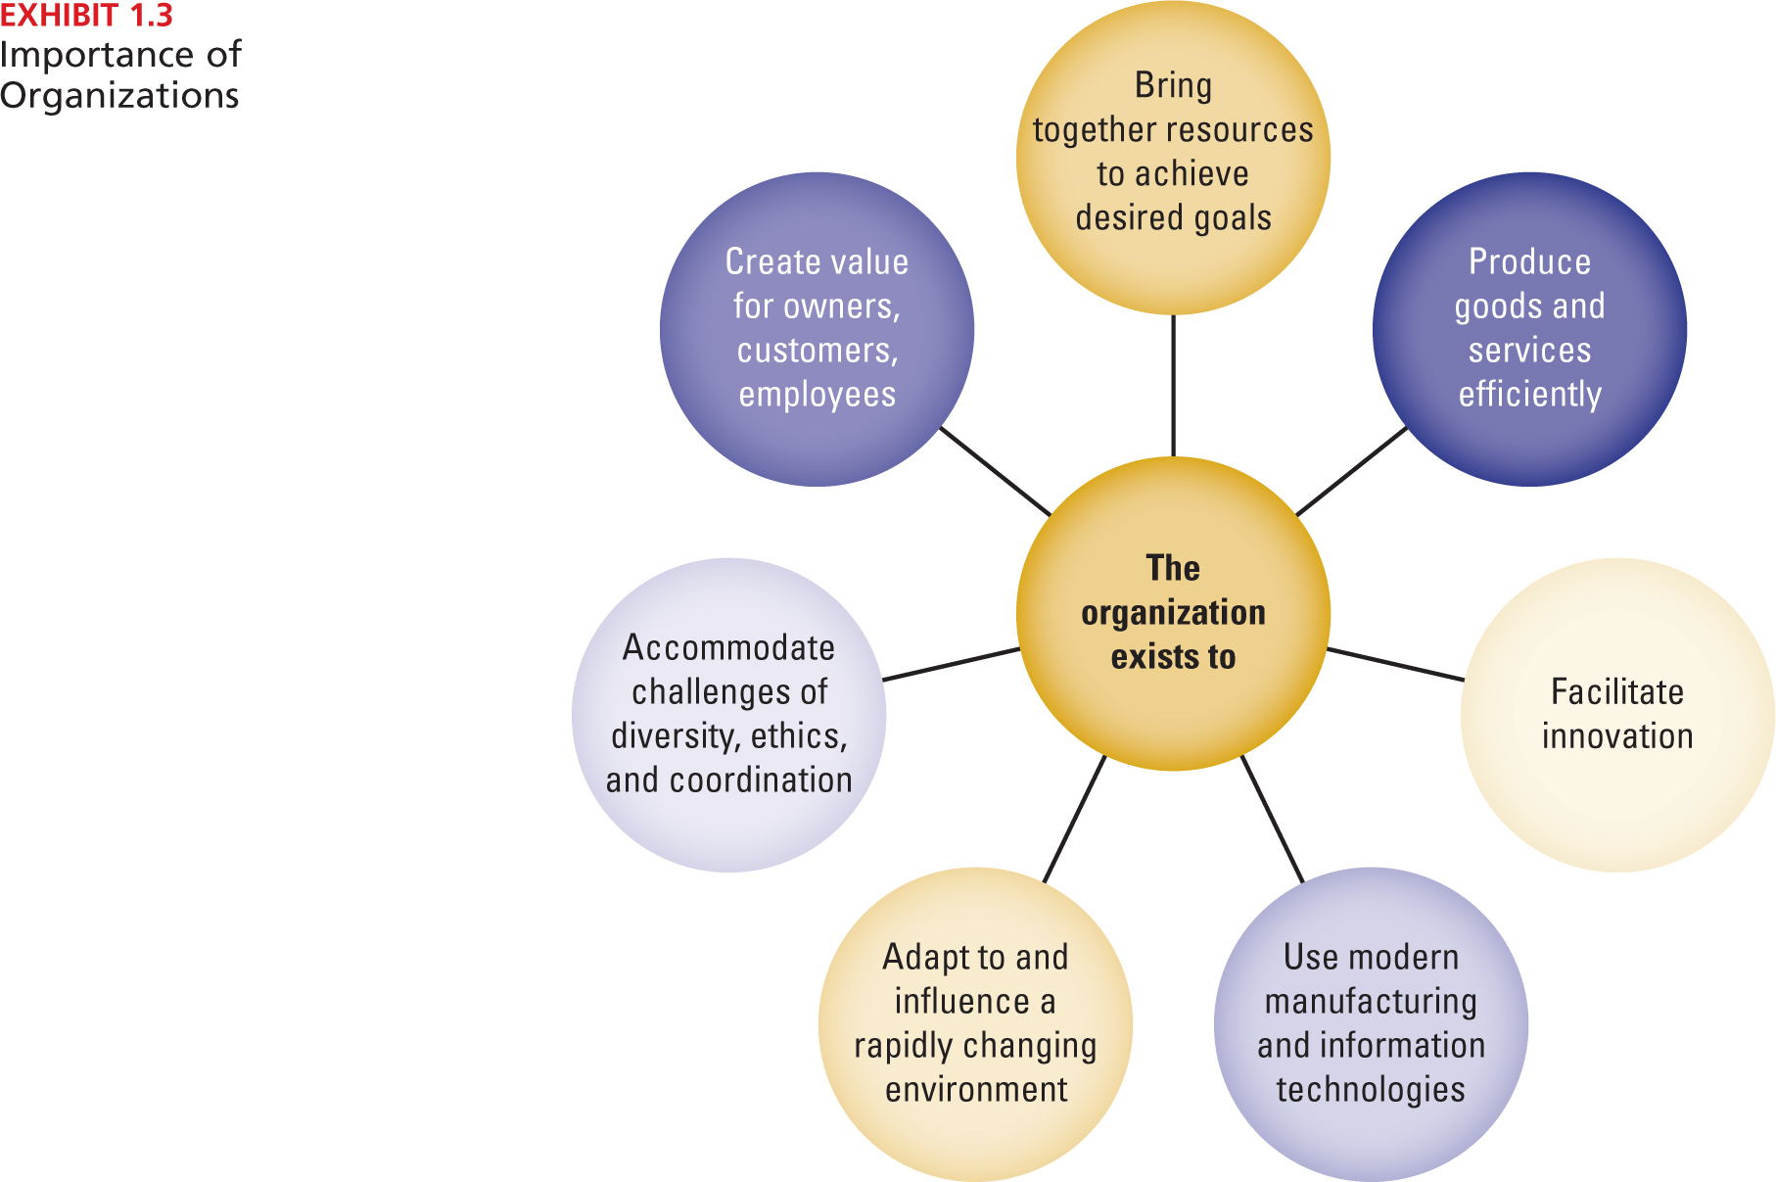
- Perspective on organizations:
  - Open system: Must interact with the environment to survive; it both consumes resources and exports resources to the environment to survive.
  - Closed system: Would not depends on it’s environment, would be autonomous, enclosed, and sealed off from outside worlds. Ex: Scientific management, leadership style and industrial engineering (Cannot exists)
  - System: A set of interacting elements that acquires inputs from the environment, transforms them and discharges outputs to the external environment.
    - Subsystems: Perform the specific functions required for the organizations survival.
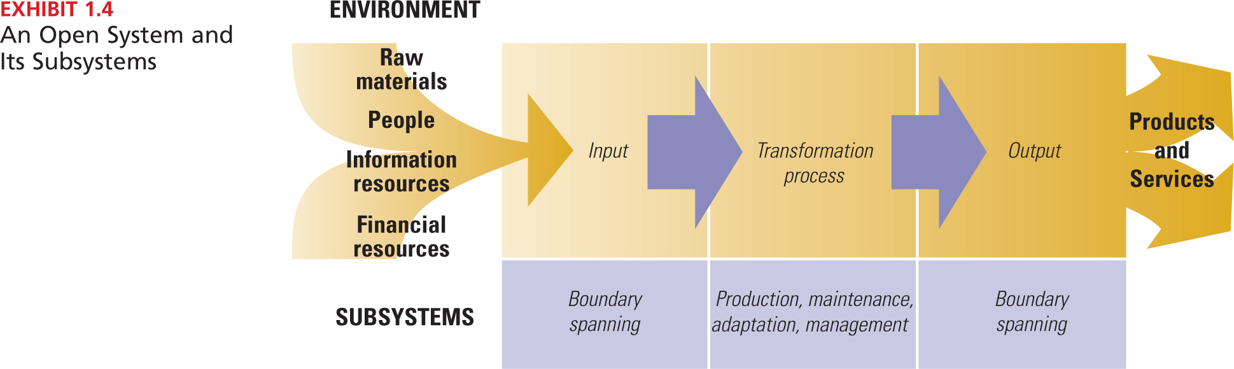

- Organizational configuration
  - Technical core: People who do the basic work of an organization. Perform the production subsystem and actually produces the product or service.
  - Management: Responsible for directing and coordinating other parts of the organization.
  - Technical support: Help the organization adapt to the environment. Researchers and engineers scan the environments for problems, opportunities and technological developments.
  - Administrative Support: Responsible for the smooth operation and upkeep of the organization including its physical and human element. (includes HR, recruiting and hiring )

- Dimensions of Organizational Design:
  - Organizational design: The administration and execution of a strategic plan

  - Structural dimensions: Provide labels to describe the internal characteristics of an organization. Basis for measuring and comparing organizations. Describes the internal characteristics.

    - 1. Formalization: refers to the amount of written documentation in the organization.
    - 2. Specialization: degree to which organizational tasks are subdivided into separate jobs. Extensive = employee perform narrow range of tasks. Low = wide range of tasks.
    - 3. Hierarchy of authority: describes who reports to whom and the span of control of each manager.
    - 4. Centralization: Hierarchical level that has authority to make decision. Decision-making is kept at the top level mean centralized.
    - 5. Professionalism: Formal education and training of employees. Considered high when employee have to follow long periods of training in order to work for the organization.
    - 6. Personnel ratios: Deployment of people to various functions and departments. Administrative ratio, clerical ratio, the professional staff ratio and ratio of direct and indirect labour employees.

  - Contextual dimensions: Characterize the whole organizations, including its size, technology, culture, environment, goals and strategy. Describe the organization setting that influences and shapes the structural dimensions.

    - 1.Organizations goals and strategy: Define the purpose and competitive techniques that set it apart from other organizations.
    - 2. The environment: includes all the elements outside the boundary of the organization. (Industry, government, customers, supplier and financial community)
    - 3. Size: number of people working in the organization
    - 4. Culture: Underlying set of key values, beliefs, understanding and norms shared by employees.
    - 5. Technology: refers to the tools, techniques and actions used to transform inputs into outputs.

- Performance and Effectiveness Outcomes:
  - Efficiency: Quantity of raw material, money, and employees necessary to produce a given level of output.
  - Effectiveness: Degree to which an organizations achieve its goals.
  - Stakeholder approach: integrates diverse organizational activities by looking at various organizational stakeholders and what they want from the organization.
  - Stakeholder: any group within or outside the organization that has a stake in the organization’s performance.
  - Contingency: one thing depends on other things.

- Contemporary Organizational Design
  - Chaos theory: relationships in complex, adaptive systems are nonlinear and made up of numerous interconnections and divergent choices that creates unintended effects and render the universe unpredictable.
  - Learning organization: promotes communication and collaborations that everyone is engaged so that everyone is engaged in identifying and solving problems, enabling the organization to continuously experiment, improve, and increase its capability.

- Efficient Performance versus the Learning Organization
  - From vertical to Horizontal Structure
  - From routine tasks to empowered roles
  - From formal control systems to shared information
  - From competitive to collaborative strategy
  - From rigid to adaptive culture

