Comm 215 notes

Chapter 1

- What is Business Statistics?
    - A collection of procedures and techniques used to convert data into meaningful information in a business environment
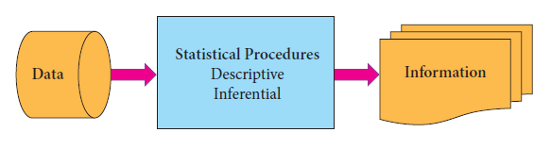
  - Statistical Procedures
- Descriptive Statistics
Procedures and techniques designed to describe data such as charts, graphs, and numerical measures
- Charts and graphs
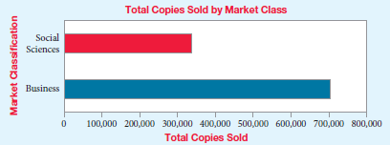
- Numerical measures
N = Number of data values
X_{i} = ith data value

- Inferential Statistics
Tools and techniques that help decision makers to draw inferences from a set of data ex. Estimation and hypothesis
  - Statistical Inference Procedures = procedures that allow a decision maker to reach a conclusion about a set of data based on a subset of that data

- Estimation: in situation when we would like to know about all the data in a large data set but it’s impractical to use all the data, decision maker can use techniques to estimate what the larger data set would look like.
e.g., Estimate the population
mean weight using the sample mean weight

- Hypothesis Testing: : Hypothesis testing uses statistical techniques to validate a claim. With hypothesis testing, sample data is used to make an inference about the larger population from which the sample was drawn. ex: the population mean weight is 120 pounds

- Procedures for Collecting Data

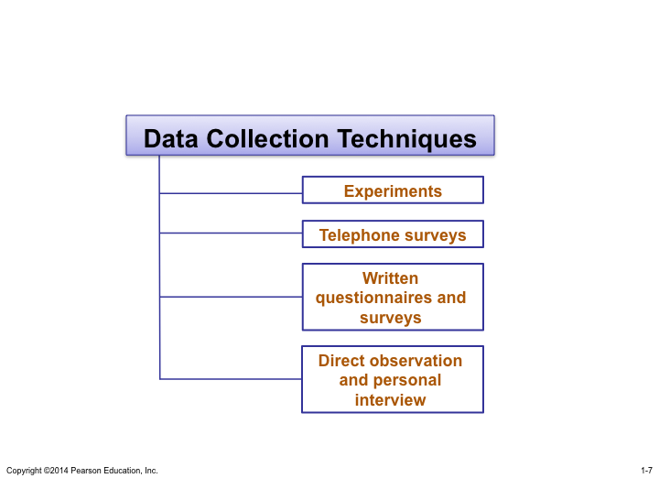

- Experiments
- Experiment
  - A process that produces a single outcome whose result cannot be predicted with certainty.
- Experimental design
  - A plan for performing an experiment in which the variable of interest is defined. One or more factors are identified to be manipulates, changed, or observed so that the impact( or influence) on the variable of interest can be measured or observed
- Telephone surveys
- Phone surveys must be very short generally composed of :
- Closed-end Questions: questions that require the respondent to select from a list of defined choices
- Demographic Questions: questions relating to the respondents’ characteristics, backgrounds, and attributes
- Written Questionnaires and Surveys
- most frequently used method to collect opinions and factual data from people however very low response (5% to 20%). Can contain closed-end and open-end questions
- Open-End Questions: questions that allow the respondents the freedom to respond with any value, words, or statements of their own choosing.
- Observation and interviews
- Direct Observations
- Data are being collected is physically observed and the data recorded based on what takes place in the process.
- Subjective and time-consuming
- Personal Interviews
  - Used to gather data from people they can be :
  - Structured: interviews in which questions are scripted
  - Unstructured: interviews that begin with one or more broadly stated questions, with further questions being based on the responses
- Data Collection Techniques
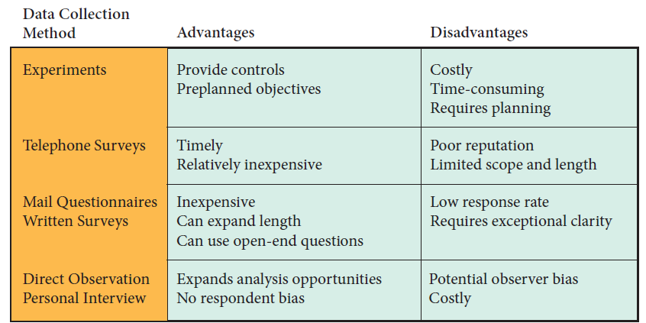

- Data Collection Issues
  - Data Accuracy: When you need data to make a decision, first see if the data has already been collected but before relying on that data make sure it’s sources to make sure it was collected properly and is reliable and accurate.
  - Interview Bias: potential bias in the data collection can be caused by anything ( the way questions are asked, the interviewer attitudes …)
    - Bias: an effect that alters a statistical result by systematically distorting it; different from a random error, which may distort on any one occasion but balances out on the average
  - Nonresponsive Bias: Those who respond may provide data that is different from those who refuse to respond. If you’re not careful responses may be heavily weighted to one side rather than the other.
  - Selection Bias: Bias can be interjected through the way subjects are selected for data collection. Ex: doing evening interviews you can miss the opinion of people working at night
  - Observer Bias: Data collection through personal observation is also subject to problems. People tend to view the same event or item differently.
  - Measurement Error: the measurement collected by different people of the same object is different
  - Internal Validity: a characteristic of an experiment in which data are collected in such a way as to eliminate the effects of variables within the experimental environment that are not of interest to the researcher
  - External Validity: A characteristic of an experiment whose results can be generalized beyond the test environment so that the outcomes can be replicated when the experiment is repeated.

- Populations, Samples, and Sampling Techniques

    - Population and Samples
- Population: The set of all objects or individuals of interest
or the measurements obtained from all objects or individuals of interest
- Sample: A subset of the population
- Census: An enumeration of the entire set of measurements taken from the whole population

Population vs. Sample
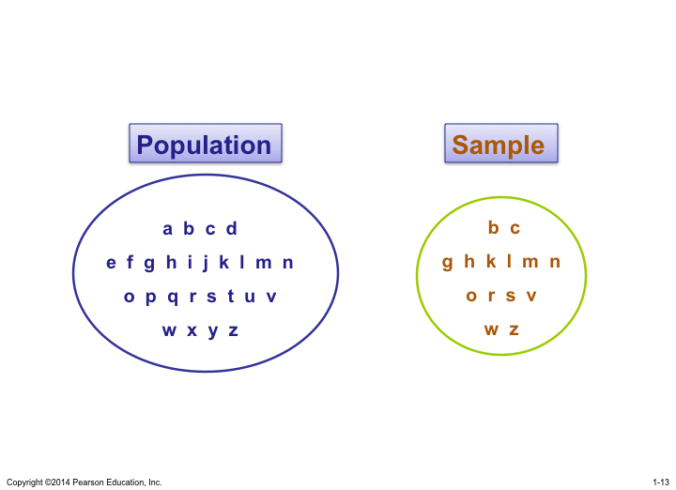
- Parameters and Statistics
  - Parameters: Descriptive numerical measures, such as an average or a proportion, that are computed from an entire population
  - Statistics: Corresponding measures computed for a sample

    - Sampling Techniques
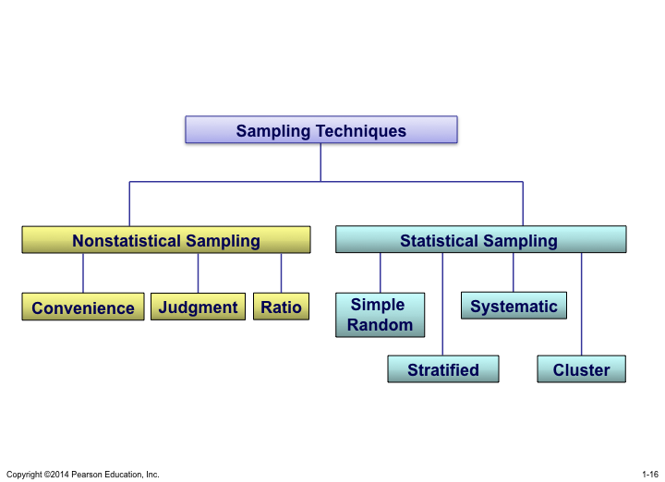
- Statistical (also called probability sampling) : Sampling methods that use selection techniques based on chance selection. Allows every item in the population to
have a known or calculable chance of being included in the sample

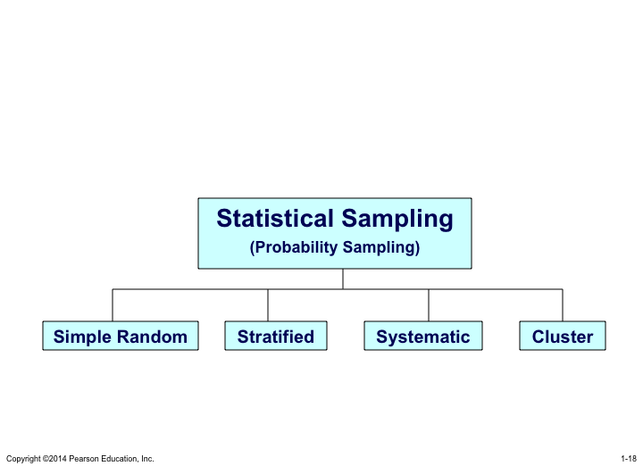
  - Simple Random Sampling:
    - Every possible sample of a given size has an equal chance of being selected
    - Selection may be with replacement or without replacement
    - The sample can be obtained using a table of random numbers or computer random number generator
  - Stratified Random Sampling:
    - Divide population into subgroups (called strata) according to some common characteristic ( characteristics of interest)
      - e.g., gender, income level
    - Select a simple random sample from each subgroup
    - the population is divided into homogeneous groups called strata. The idea is to make all items in a stratum as much alike as possible with respect to the variable of interest thereby reducing the number of items that will need to be sampled from each stratum.
    - Combine samples from subgroups into one
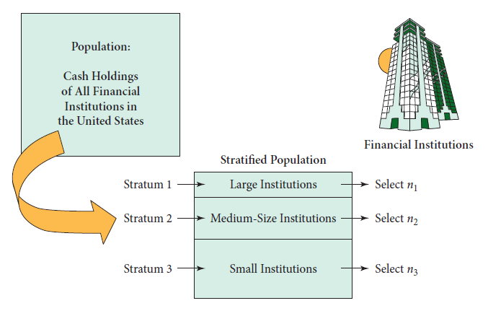
- Systematic Random Sampling:
- Decide on sample size: n
- Divide ordered (e.g., alphabetical) frame of N individuals into groups of k individuals: k = N / n
- Randomly select one individual from the 1st group
- Select every k^{th} individual thereafter
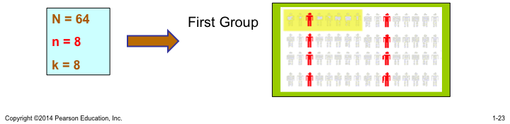
    - E.g.: choosing 500 students from 20,000, you chose every 40th student starting at the 25th si 25, 65,105, … until you reach 500.
- Cluster Sampling:
- Divide population into several “clusters,” each representative of the population (e.g., county)
- the idea is to break the population into heterogeneous groups called clusters (usually on a geographical basis) such that each cluster looks as much like the original population as possible.
- Select a simple random sample of clusters
- All items in the selected clusters can be used, or items can be chosen from a cluster using another probability sampling technique
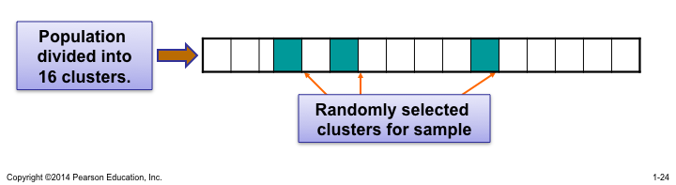

- Nonstatistical: Methods of selecting samples that use convenience, judgment, or other non-chance processes.
  - Convenience sampling: a sampling technique that selects the items from the population based on accessibility and ease of selection
  - Judgment: Based on judgments about who in the population would be most likely to provide the needed information
  - Ratio
- Data Types and Data Measurement Levels

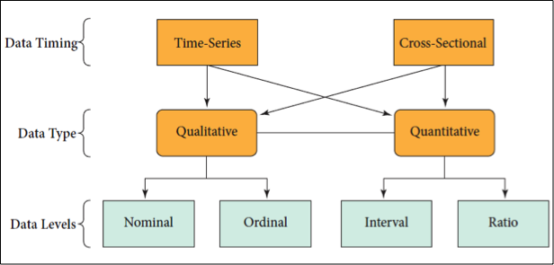
- Quantitative and Qualitative Data
  - Quantitative: measurements whose values are inherently numerical
    - discrete (e.g. number of children)
    - continuous (e.g. weight, volume)
  - Qualitative: data whose measurement scale is inherently categorical (e.g. marital status, political affiliation, eye color)
- Data Types
  - Time-Series: a set of consecutive data values observed at successive points in time, can also be observe at intervals over time (e.g. stock price on daily basis for a year or data collected by banks from each customer because it relates to a fixed point in time )
  - Cross-Sectional: A set of data values observed at a one point in time (e.g. bank data about its loan customers at January 1 2015)

    - Data Timing Example
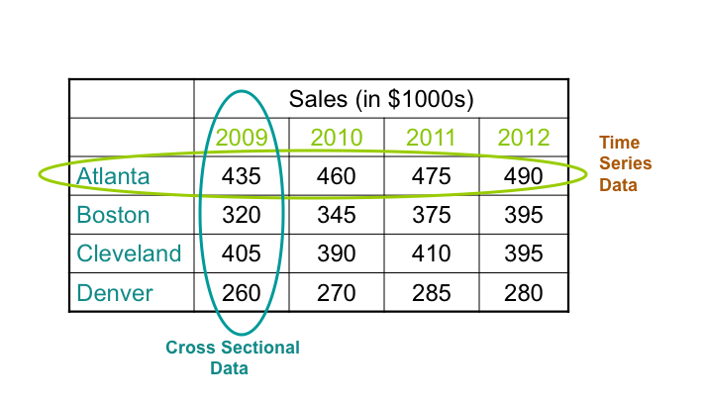

- Data Measurement Levels
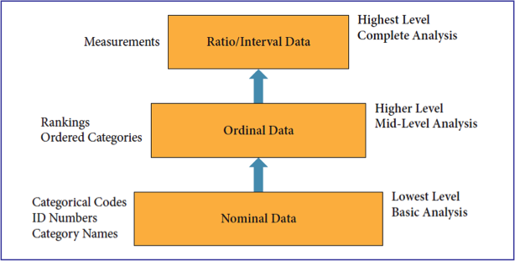

- Nominal data: lowest form of data, often have codes assigned to categories
- Eg: 1. Married 2. Single 3. Divorced 4. Other
- For each person a code is recorded
- Value of the code have no specific meaning because the order is arbitrary
- Nominal data give complete control over the codes used , all that matter is which code stands for which categories
- Can only have an equal relationship (=)

- Ordinal data( or rank data) : the data elements can be rank-ordered an the basis of some relationship among them with the assigned values indicating this order
- Allow to equate two or more observation or to rank-order the observations
- Can have an greater than (>) or less than(<) relationship
- Interval Data: when the distance between two data items can be measured on some scale and the data have ordinal properties(<,>,=)
- Eg: temperature 32 celsius > 30 celsius , 80 fahrenheit> 78 fahrenheit , interval between the two is the same 2 degrees
- Ratio data: data that have all the characteristics of interval data but also have a true zero point( at which zero means “none”), highest level of measurement
- Weight, money, distance, time are ration measures because it can have a value of 0
- Categorizing Data
  - Identify each factor in the data set
  - Determine whether the data are time- series or cross-sectional
  - Determine which factors are quantitative data and which are qualitative data
  - Determine the level of data measurement for each factor.


