Week 1
- What distinguishes a conference paper from a journal article?
- What does it mean that a source is “peer reviewed”, why is it important?
- Is the use of Google and/or Google Scholar sufficient to conduct research? CLASS 6
- What should I be reading to engage intelligently in conversations about my field?
Every field has its own encyclopedia(s)

Week 2
- What does it mean to be information literate?
- The set of abilities requiring individuals to "recognize when information is needed and have the ability to locate, evaluate, and use effectively the needed information” (American Library Association). 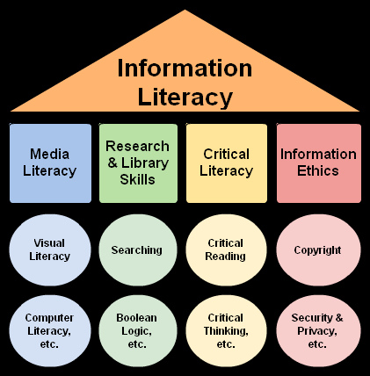 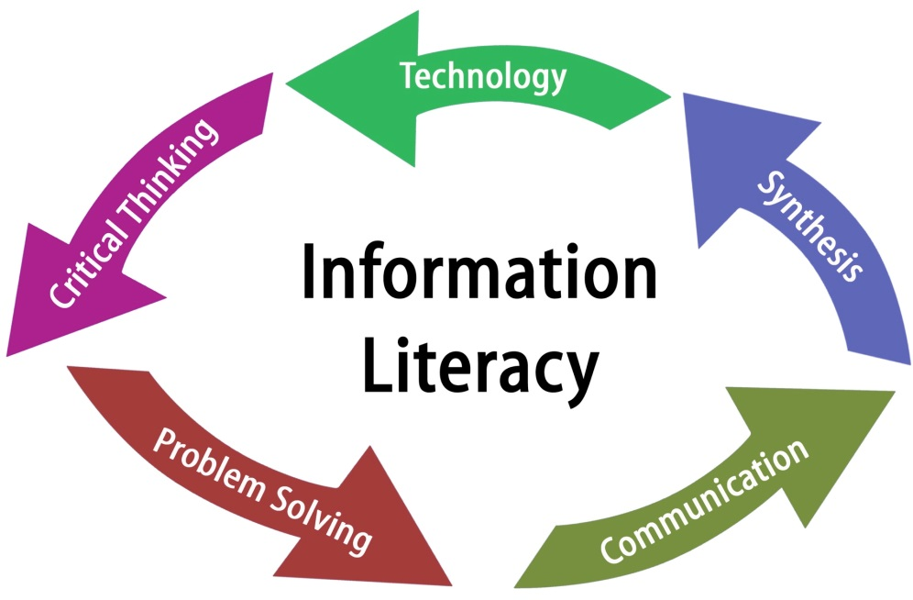 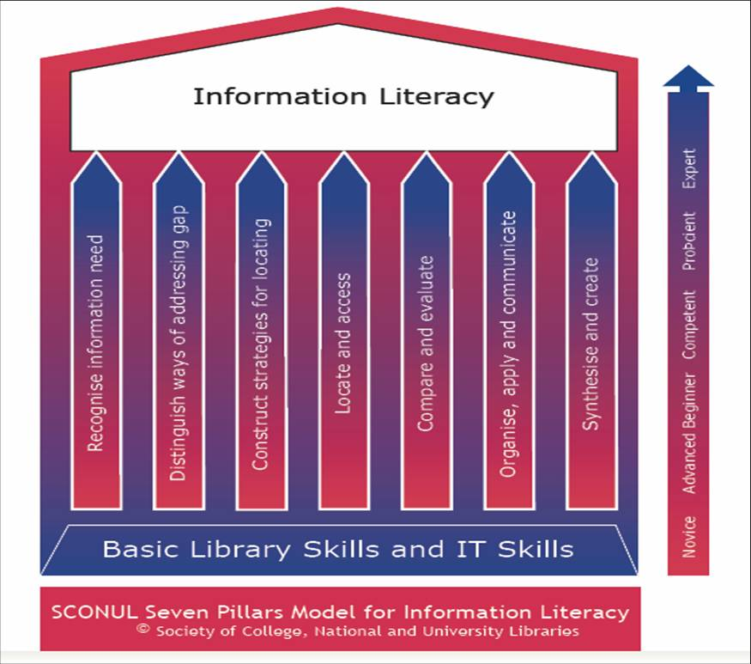

- What are some of the qualities that distinguish a good topic from a bad topic?
A topic is used to describe a limited examination of an idea, categorized by subject.
  - It must examine a specific issue
  - It must address a knowledgeable reader and carry that reader to another level of knowledge, and
  - It must have a serious purpose
A topic should have a built-in issue so that the researcher can interpret the issue and cite the opinions of outside sources.
Topics:
- Specific content
- Narrowed focus
- Directs the approach of inquiry
Examples: The impact of urban sprawl on the average
- What purpose does a Thesis Statement serve?
- Should use clear language; avoid vague and ambiguous language.
- The ideal is one clear sentence; two is allowable; but don’t confuse the thesis statement for the introduction.
- Should provide clear guidance to your line of inquiry; i.e. what literature you need to go out to find to support your central argument
- Should provide clear guidance to how you build your search strategy.

- What is the point of an undergraduate research paper?
Information Literacy
The set of abilities requiring individuals to "recognize when information is needed and have the ability to locate, evaluate, and use effectively the needed information” (American Library Association).

Week 3
- What type of publication should make up the majority of your sources in an undergraduate research paper?
JOURNAL ARTICLES
- What does it mean that something has undergone “peer review”?
A process by which a scholarly work (such as a paper or a research proposal) is checked by a group of experts in the same field to make sure it meets the necessary standards before it is published or accepted
- What is a dissertation?
PDF file. You go through a process before it gets published. It is more scholarly. You CAN source this.
- Published by graduate students in fulfillment of their degrees - Master’s degree: Thesis / Doctorate (PhD): Dissertation
- Dissertations are listed in many major databases (e.g. ERIC, PsycINFO)
- Dissertations are reviewed by a panel of faculty experts in the topic area (usually with representatives from other universities).
- Considered more rigorous than theses, and more appropriate for use as scholarly references
- Long; about the length of a book
- Detailed and comprehensive literature reviews may provide a launching point for a search strategy
- Not typically used as references in undergraduate papers.
- Can you cite a conference paper?
- Cite 1-2 conference papers maximum, try to make sure it is peer reviewed
- Only include if published in the last 2-3 years
- What about a blog post or website?
As a general rule, avoid citing them, but:
Can be cited if written by a noted expert or academic, but don’t count towards your references (if for example your prof has requested 10-12 references). In the intro or conclusion is most appropriate place for this type of reference.
Not considered scholarly

- What is an “Executive Summary”?
Often quite large; but an ‘Executive Summary’ will also be prepared to make the content more digestible.
It is a summary which indicates a research report. It is usually long. You CAN cite research reports.
Week 4
- How do Public libraries differ from Academic libraries?
- Public Libraries
Support the needs of a local community
- Academic Libraries
Support the research of faculty and students
- What is the name of the library on the Loyola campus?
Vanier Library
- What is the name of the library on the Sir George Williams Campus?
Webster Library
- What system organization (classification) does Concordia use?
- Academic (university, college) libraries have adopted the Library of Congress Classification system.

- What does ‘Controlled Vocabulary’ mean?
- Databases do NOT use Library of Congress Subject headings.
- Each database has its own internal controlled vocabulary system – subject labels that they assign to records to better describe their content.
- Sometimes these subject labels are called Subjects, Subject Headings, Descriptors, Index Terms
- The guide to these controlled vocabulary terms is called the database’s Thesaurus.

- Which of the following can be found in CLUES?: ALL
  - Books?
  - Encyclopedias?
  - Journal Articles? no
  - DVDs?
  - Music scores?
- What will you find in CLUES?
  - Books, Periodicals (i.e. Journals, Newspapers), Audio-Visual materials, Reserve Lists, Dissertations, Special Collections, and Database listings.
- What won’t you find in CLUES?
  - Articles (i.e. the contents of Journals, Newspapers)
  - Government documents

Sample Question 1
- The bolded part of the LC Call Number LB 1408 A76 is known as:
  - Main Division
  - Shelf Mark
  - Call Number
  - Dewey Number
  - There is no particular name for this part
Sample Question 2
- When conducting a literature search one should attempt to locate information that is ‘documented’. What is meant by this?
  - The information is factual
  - The book/article has been peer reviewed
  - The author has cited his/her sources
  - All of the above
  - None of the above
Sample Question 3
- Which of the following is a good example of a preliminary thesis statement:
  - My feelings on the Iraq and Afghanistan wars.
  - Violence in schools.
  - What are the discomforts of living in a modern city?
  - All of the above
  - None of the above

Sample Question 4
- According to the Publications Cycle for research, which of the following is true:
  - It can take up to three years or more for preliminary research results to be presented at conferences.
  - Research results are first published in reference books such as encyclopedias.
  - It can take up to three years or more for final research results to become popularized in magazines and newspapers.
  - The entire cycle takes 6 years.
  - All of the above
Sample Question 5
- When doing research, one might consult a bibliography because:
  - They provide detailed information about important people.
  - They provide a list of useful organizations, with contact information.
  - They provide an extensive list of material about a topic.
  - None of the above
  - All of the above

