Adm1300 – September 7, 2016 – Chapter 1
Management - getting the right things done through other people.
Organizations

Organization:
- A collection of people working together to achieve a common purpose.
- Organizations provide useful goods and/or services that return value to society and satisfy customer needs.

Organizations as open systems:
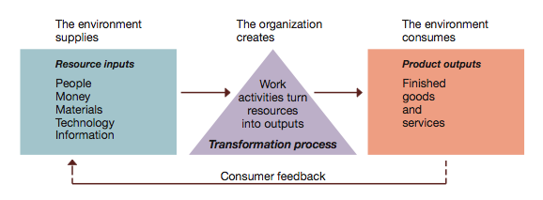

Productivity and the dimensions of organizational performance: (goal is top right corner):

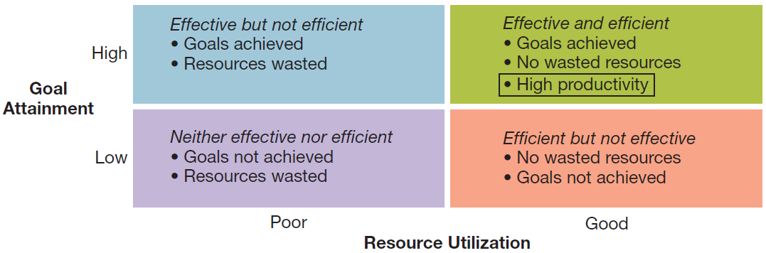

Organizational Environment

The general environment: all of the background conditions in the external environment of the organization including:
  - Economic – health of the economy
  - Legal-political – norms, customs, social values
  - Socio-cultural – philosophy/objectives of political party running the government
  - Technological – development and availability of technology
  - Natural environment – nature and conditions of environment

Organizational Environment: Sample general environment conditions faced by firms like Starbucks.

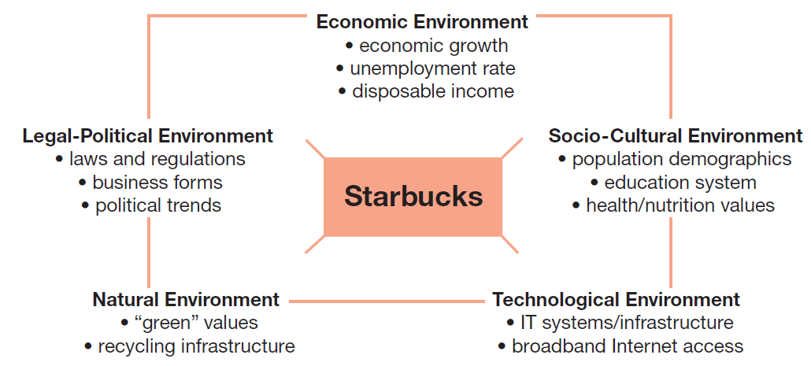

(example)
**Must be able to argue (say why) each of the organizational environment for different situations.
**Assume marker knows nothing. Define all terms, then explain, and say why.

The specific (task) environment: actual organizations, groups, and persons with whom an organization interacts and conducts business (the stakeholders) Includes important stakeholders such as:
  - Customers
  - Suppliers
  - Competitors
  - Regulators
  - Investors/owners
Value creation is creating value for and satisfying the needs of constituencies.
Key stakeholders: those with high interest and high power to influence the stakes of the organizations.

Multiple stakeholders in the specific or task environment of a typical business firm.

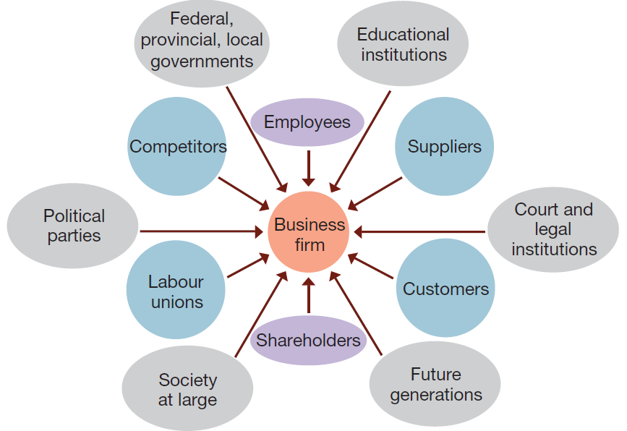

Environmental Uncertainty: a lack of complete information regarding what exists and what developments may occur in the external environment.
Two dimensions of environmental uncertainty:
- Degree of complexity
- Rate of change

Dimensions of uncertainty:
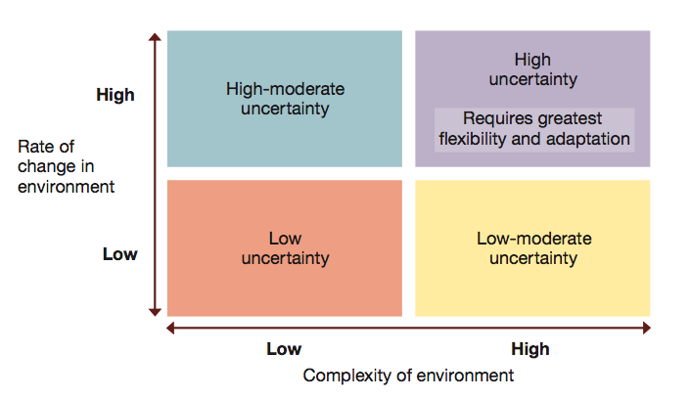

**Very few organizations are found in lower left quadrant.

Managers in the New Workplace:

Levels of Management:
- Top managers: responsible for performance of an organization as a whole or for one of its larger parts.
- Middle managers: in charge of relatively large departments or divisions.
- Team leaders or supervisors: in charge of a small work group of non-managerial workers.

Management levels in a typical business and non-profit organizations:
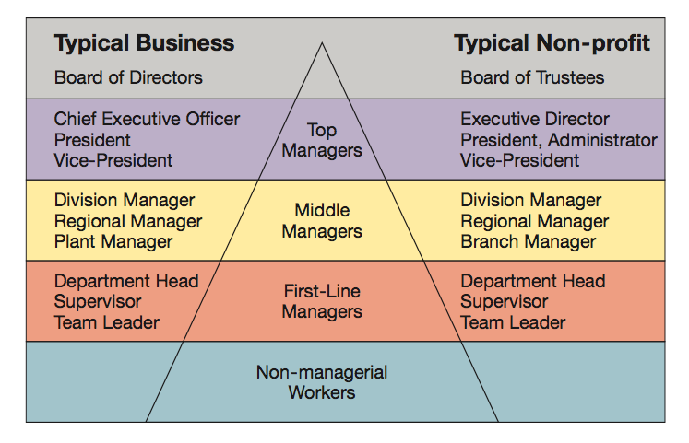
**Board of directors - they hire senior managers (are not actually above them).

The Management Process

Managers achieve high performance for their organizations by best utilizing its human and material resources.
Management is the process of planning, organizing, leading, and controlling the use of resources to accomplish performance goals. All managers are responsible for the four functions of Management:
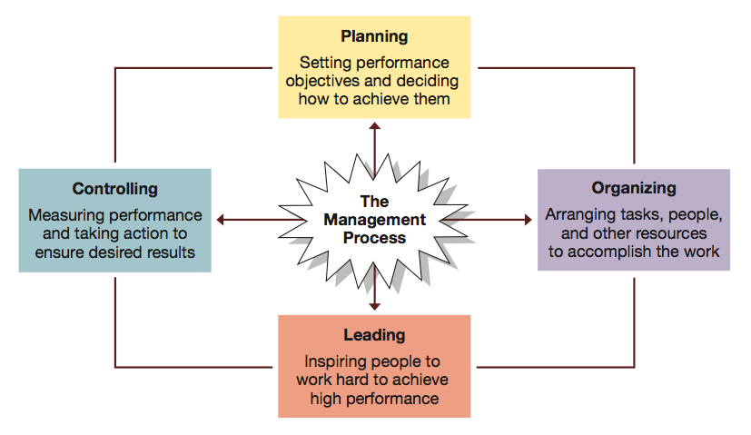
Control = making sure individuals adhere to the plan.

************* IMPORTANT FOR MIDTERM!!!!!!!!!
The Management Process:
Managerial activities and Roles (3 key roles any manager would play)
- Informational roles
Involve giving, receiving, and analyzing of information.
- Interpersonal roles
Involve interactions with persons inside and outside the work unit.
- Decisional roles
Involve using information to make decisions in order to solve problems or address opportunities.

Mintzberg’s 10 Managerial Roles:

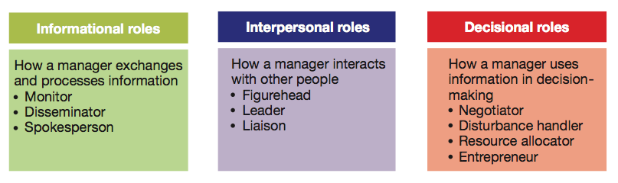

******midterm

Katz’s Essential Managerial Skills
- Skill — the ability to translate knowledge into action that results in desired performance.
- Technical skill — the ability to apply a special proficiency or expertise to perform particular tasks.
- Human or interpersonal skill — the ability to work well in cooperation with others.
Emotional intelligence is the ability to manage ourselves and relationships effectively (preserve professionalism, understand what employee might be going through.) Ex. bad argument, manager is in foul mood but knows to leave the anger outside and not take it out on employees. Ex. There is downsizing in a company you’re managing, you can not tell employees. Ex. Fire an employee that worked for you for 25 years, you have to relay the message to them. You have to make sure employee is okay, give them resources and help. Management requires resilliance, even if you feel too tired to do your job, you have to treat all employees the same.
- Conceptual skill — the ability to think critically and analytically to solve complex problems.

Katz’z Essential Managerial Skills Diagram:

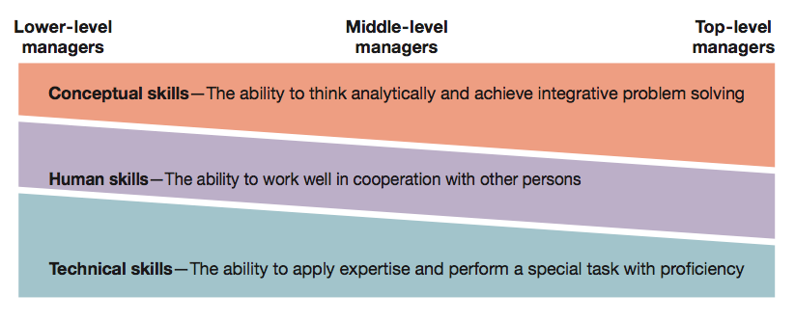

Adm1300- Textbook Notes- Chapter 1

Intellectual Capital: The collective brainpower or shared knowledge of a workforce that can be used to create value.
Knowledge Worker: someone whose mind is a critical asset to employers.
Conceptual age: people with “whole minds” whose competencies are both “High concept” – creative and good with ideas, and “High touch” – joyful and good with relationships. (Daniel Pink).
Creative economy: knowledge is becoming a commodity and the most important differentiator will be how fast you can create something new. (Gary Hamel).
Glass ceiling effect: is an invisible barrier limiting career advancement of women and minorities.
Globalization: is the worldwide interdependence of resource flows, product markets, and business competition that characterizes our new economy.
Ethics: a code of moral principles that sets standards of what is “good” and “right” as opposed to “bad” and “wrong” in the conduct of a person or group.
Portfolio Worker: someone who always has the up-to-date skills needed to readily shift jobs and even careers.
Organization: collection of people working together to achieve a common purpose.
Organizations are Open Systems: that interact with their environments in the continual process of obtaining resource inputs and then transforming them into outputs in the form of finished goods and services for their customers.
Productivity: is the quantity and quality of work performance, with resource utilization considered.
Performance effectiveness: is an output measure of task or goal accomplishment. Ex. If you are a software engineer for a video game company, performance effectiveness may mean that you meet a daily production target in terms of quantity and quality of lines of code.
Performance efficiency: is an input measure of resource cost associated with goal accomplishment. Ex. In the gaming example, the most efficient software production is accomplished a t a minimum cost in materials and labor. If you are producing fewer lines of code in a day than you are capable of, this amounts to inefficiency.
The General Environment: of organizations consists of all external conditions (economic, legal-political, technological, socio-cultural, and natural environment conditions) that set the context for managerial decision-making.
Sustainable Business: both meets the needs of customers and protects the well-being of our natural environment.
Sustainable innovation: creates new products and production methods that have reduced environmental impact.
Specific environment: (task environment) includes the people and groups with whom an organization interacts.
Top level decisions are often made with the assistance of stake-holder analysis focusing on value creation: (creation of value for an satisfying needs of stakeholders).
Competitive advantage: refers to something that an organization does extremely well, a core competency that clearly sets it apart from competitors and gives it an advantage over them in the marketplace.
Strategic positioning: occurs when an organization does different things or the same things in different ways from its major competitors.
Organizational effectiveness: is sustainable high performance in using resources to accomplish a mission.
Accountability: Is the requirement to show performance results to a supervisor.
Changing the nature of managerial work by the upside-down pyramid: in which the operating workers are at the top, serving customers, while managers are at the bottom, supporting them. This view shows the whole organization is devoted to serving the customer, and that the job of managers is to support the workers.
Networking: is the process of creating positive relationships with people who can help advance agendas.
Social capital: is a capacity to get things done with support and help of others.
Managerial competency: is a skill-based capability for high performance in a management job.

Example Question:
- A business operates in an organizational environment that consists of the general environment and the specific or task environment. Briefly describe the elements that comprise the general environment the task environment. In your view which element(s) has (have) been most affected by globalization.
General environment: All of the background conditions of the external environment
Economic – health of the economy
Legal-political – norms, customs, social values
Socio-cultural – philosophy/objectives of political party running the government
Technological – development and availability of technology
Natural environment – nature and conditions of environment

Task environment: actual organizations, groups, and persons with whom an organization interacts and conducts business (the stakeholders).
Ex. (of stakeholders)
Customers
Suppliers
Competitors
Regulators
Investors/owners

In my view, the elements that have been most effected by globalization is the effect on the Task environment. This is because the emergence of a single global economic system, run by a multitude complex and unique stakeholders. So when a company becomes globalized, more stakeholders come into play, (such as the international community, possibility of different suppliers). The General environment is also affected because, the legal political environment is affected. In different countries, the customs and social values of the people living there, are different than our own- and the laws protecting workers are different in these countries too.

- Productivity is defined by your textbook as the quantity of work performance with resource utilization considered. Productivity involves two common performance measures: effectiveness sand efficiency that are typically framed in terms of the degree of goal attainment and the use of resources. Describe each of the four dimensions of organizational performance.
Four dimensions of organizational performance:
- Effective but not efficient: goals achieved, resources wasted.
- Effective and efficient: goals achieved, no wasted resources. **High productivity.
- Neither effective nor efficient: goals not achieved, resources wasted.
- Efficient but not effective: No wasted resources, goals not achieved.

Adm1300– Chapter 2

Management Theory
“Clockwork” – Movie Notes:
- Humans need management, machines do not need management
- The most experiences skilled craftsman planned the job and how it would be done. Little coordination between departments. Lack of control over workers proved uneconomical.
- Lower paid and experienced workers could be hired, and controlled more easily when task were broken down.
- Machines could serve as a model for humans
- Fredrick Winslow Taylor born in 1856, earned engineering degree.
- Taylor conducted experiments, offered a 60% raise to a man, and controlled all of his actions. This control increased productivity by 400%. Anyone who could not work at this pace was moved, or fired.
- Workers feared and resisted Taylor’s system.
- Every job divided into b
- Using rates of fastest workers standards were devised according to the fastest worker.
- Forman made sure
- Taylor spent 26 years testing all possible forms
- Taylors new method: Scientific Management
- Gilbert took pictures and videos to study how the human body moved, and how tasks could be simplified.
- Lights were attached to workers hands and study their movements and see how they could make them simplified.
- Ww1 helped end worker resistance
- In 1921 Milwaukee factory, men were only needed to lift parts from one machine to the next. Machines did the rest.
- With the invention of computers, instructions could be given straight to the machines to do the work.
- Humans were only needed to do the simplest or most difficult tasks.
First time people began studying management during Taylorism.

Chapter 2: Management Leaning: Past to Present

Management = getting the right things done through other people

Classical vs Behavioral management below…

Evolution of Management Theory:
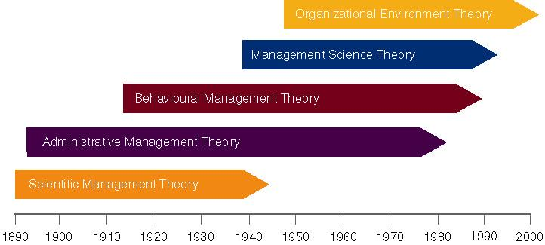

Classical Management Approaches:
*Assumption: People are rational

Classical approaches to management include:
- Scientific Management (Frederick Taylor)
- Administrative principles (Henri Fayol)
- Bureaucratic organization (Max Weber)

Scientific Management

Scientific Management: Frederick Taylor

- Scientific Management: The systematic study of the relationships between people and tasks to redesign the work for higher efficiency. This method emphasizes careful selection and training of workers and supervisory support.
- Taylor sought to reduce the time a worker spent on each task by optimizing the way the task was done. Redesigned tasks for higher efficiency. Optimized the way the task was done.

Taylor’s Principles

Principles to increase efficiency:
- For every job develop a science that includes:
    - Rules of motion: the science of reducing a task to its basic physical moments.
    - Standardized work implements
    - Proper working conditions
- Carefully select workers with the right abilities to perform the job
- Train workers to do the job and give them proper incentives to cooperate with the job science
- Support workers by carefully planning their work
Study & Codify –> Select & Train –> Reward

Problems of Scientific Management

Managers often implemented only the increased output side of Taylor’s plan.
  - They did not allow workers to share in increased output. (Wouldn’t be paid extra for doing more work)
  - Specialized jobs became very boring, dull.
  - Workers ended up distrusting Scientific Management.

Workers could purposely “under-perform”, because they knew they would not be rewarded for their increased efforts.
Management responded with increased use of machines.
“select the people to do the best job” – what Taylor did hiring the strongest, fastest.

Scientific Management – Frank and Lillian Gilbert
- Frank and Lillian Gilbreth refined Taylor’s methods.
  - Made many improvements to time and motion studies.
- Time and motion studies:
  - 1. Break down each action into components.
  - 2. Find better ways to perform it.
  - 3. Reorganize each action to be more efficient.
- Gilbreths also studied fatigue problems, lighting, heating and other worker issues.

Gilbreths vs Taylor
- Gilbreths’ studies were more focused on how a task was done, and how to best eliminate unneeded, fatiguing steps in any process
- Gilbreths’ form of scientific management had a more developed view of the worker and his/her interests vs. Taylor’s predominant view of the worker as driven solely by pay
- Gilbreths used photography as a means to study human motion in completing tasks (micro motion films)

Practical lessons from scientific management
- Make results-based compensation a performance incentive
- Carefully design jobs with efficient work methods
- Carefully select workers with the abilities to do these jobs
- Train workers to preform jobs to the best of their abilities
- Train supervisors to support workers so they can perform to the best of their abilities.

Administrative Management:

Henri Fayol:
From the executive down, thought that this way of working could be taught.
Postulated that all administrative activities could be divided into 6 groups.

Fayol’s Principles: (administrative principles)
- Fayol also developed a set of 14 principles:

1. Division of Labour: allows for job specialization.
- Fayol noted firms can have too much specialization leading to poor quality and worker involvement.

2. Authority and Responsibility: Fayol included both formal and informal authority resulting from special expertise.

3. Unity of Command: Employees should have only one boss.

4. Line of Authority: a clear chain from top to bottom of the firm.

5. Centralization: the degree to which authority rests at the very top.

6. Unity of Direction: One plan of action to guide the organization.

7. Equity: Treat all employees fairly in justice and respect.

8. Order: Each employee is put where they have the most value.

9. Initiative: Encourage innovation.

10. Discipline: obedient, applied, respectful employees needed.

11. Remuneration of Personnel: The payment system contributes to success.

12. Stability of Tenure: Long-term employment is important.

13. General interest over individual interest: The organization takes precedence over the individual.

14. Esprit de corps: Share enthusiasm or devotion to the organization.

Bureaucratic organization (Max Weber)

Bureaucracy
- An ideal, intentionally rational, and very efficient form of organization.
- Based on principles of logic, order, and legitimate authority.
Max Webber developed the concept of bureaucracy and the principles.

Bureaucratic Principles:

Authority is the power to hold people accountable for their actions.
Positions in the firm should be held based on performance not social contacts.
Position duties are clearly identified. People should know what is expected of them.
Lines of authority should be clearly identified. Workers know who reports to who.
Rules, Standard Operating Procedures (SOPs), & Norms used to determine how the firm operates. Sometimes, these lead to “red-tape” and other problems.

Program decisions- follow policy.
Non program- no precedent (guide/standard/policy), you just have to make the call.

Behavioral Management Approaches…
Behavioral Management - human resource approaches include:
  - Mary Parker Follett’s - organizations as communities
  - Elton Mayo’s - Hawthorne studies
  - Abraham Maslow’s - Theory of human needs
  - Douglas McGregor’s - Theory X and Theory Y
  - Chris Argyris’s - theory of adult personality (and organization)

Behavioral Management Theory: (Know Classical vs Behavioral)

Also known as “Human resource approaches”.
Assumption: People are social and self-actualizing

Mary Parker Follett:

- Suggested workers help in analyzing their jobs for improvements.
- The worker knows the best way to improve the job.
- If workers have the knowledge of the task, then they should control the task.

Set by input
Businesses were service organizations, but the question of who actual owns the business organization. Are they responsible to shareholders or society at large? Companies do not delve into this, that is the government’s responsibility. They exist through the laws, laws come from society. Profit has to take into account what’s best for society not just the shareholders.
Parker thought you should involve the worker.

Elton Mayo:
Driver of Hawthorn effect.

Hawthorne Studies:
- The aptitudes of individuals are imperfect predictors of job performance
- The informal organization affects productivity
- Work-group norms affect productivity
- The workplace is a social system

*****important ex.
six women were assembling relays together on assembly line.
When doing peace work output went up
Length of rest periods output went up
Early dismissal output went up
When put back to normal conditions with no breaks/meals/exc output went up to it’s highest.
They knew they were being observed so that’s why output went up.

“Would you preform differently if people were watching you?”
People preform differently when being observed.

Maslow’s hierarchy of human needs:
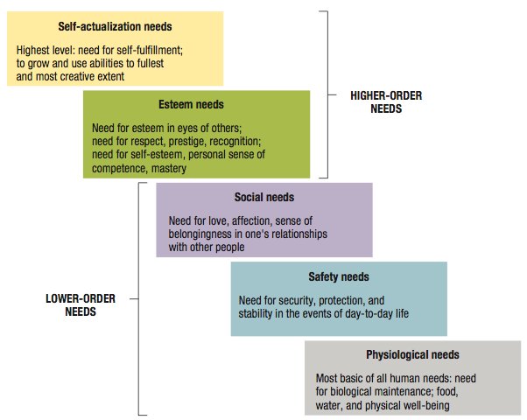

Maslow’s theory of human needs:
- Deficit principle: A satisfied need is not a motivator of behavior.
- Progression principle: A need becomes a motivator once the preceding lower-level need is satisfied.
- Both principles cease to operate at self-actualization level.
The minute you satisfy one need, now a new one is motivating you.
This is not always correct, people enter the hierarchy of diagram at different levels.
*consider picture of man lying next to a shopping cart in Nice. Physiological needs would be a motivator.
*consider picture of lumber jacks, two men observing, but one man is inside the tree. Maybe safety need aren’t met, but maybe they are not, so up to social needs and so on.
*consider pic of president of us whose esteem need are met

Douglas McGregor

Managers are only as good as those who work for them. At the end of the day somebody has to make the decisions, and sometimes it isn’t a popular one.
Douglas McGregor proposed the two different sets of worker assumptions.

Theory X: Assumes the average worker is lazy, dislikes work and will do as little as possible.
- Managers must closely supervise and control through reward and punishment.
Theory Y: Assumes workers are not lazy, want to do a good job and the job itself will determine if the worker likes the work.
- Managers should allow the worker great latitude, and create an organization to stimulate the worker.
McGregor’s idea is that manager who hold either set of assumptions (Theory X or Theory Y) can create a…

Self-fulfilling prophecy: occurs when a person acts in ways that confirm another’s expectations.
Through their behavior they create situation where others act in ways that confirm the original expectations.
Ex. Manger with theory X assumptions, act in a “command-and-control” way that gives people little personal say over their work. This kind of supervision creates passive, dependent, and reluctant subordinates who tend to only do what they are told or required to do, which reinforces the original theory X viewpoint.

Argyris’s Theory of Adult Personality:

Argyris concludes that the practices influenced by the classical management approaches are inconsistent with the mature adult personality.
- Believed that mangers who treat people positively and as responsible adults will achieve the highest productivity.
- Argyris’s advice:
  - Expand job responsibilities
  - Allow more task variety
  - Adjust supervisory styles to allow more participation
  - Promote better human relations
Problems with Classical Management styles (according to Argyris):
- Scientific management: principle of specialization assumes that people will work more efficiently as task become better defined. Argyris believes that this limits opportunities for self-actualization.
- In Weber’s bureaucracy: people work in clear hierarchy of authority, with higher levels directing and controlling lower levels. Argyris worries that this creates dependent, passive workers who feel they have little control over their work environments.
- In Fayol’s administrative principles: the concept of unity of direction assumes that efficiency will increase when a person’s work is planned and directed by a supervisor
- Argyris suggests that this may create conditions for psychological failure. (Psychological success occurs when people define their own goals).

Modern Management Foundations:

Foundations for continuing developments for management.
- Quantitative analysis and tools: the notion that mathematical tools can be used for better problem solving.
  - Management science and operations research use quantitative analysis and applied mathematics to solve problems.
- Systems view of organization: Operations management tries to understand an organization as a system of interrelated parts that function together to achieve a common purpose. This includes subsystems or smaller components of a larger system.
  - Operations management: uses such quantitative approaches and applied mathematics to systematically examine how organizations can produce goods and services more efficiently and effectively.
  - System: a collection of interrelated parts working together for a purpose.
  - Subsystem: a smaller component of a larger system.
  - Open system: interacts with its environment and transforms resource inputs into outputs.
- Contingency thinking: Tires to match management practices with situational demands. The contingency perspective tries to help managers understand situational differences and respond to them in ways appropriate to their unique characteristics.
- Commitment to quality: emphasizes on constant innovation, use of statistical methods, and commitment to training in the fundamentals of quality assurance.
  - Total quality management (TQM): is managing with an organization-wide commitment to continuous improvement product quality, and customer needs.
  - Continuous improvement: involves always searching for new ways to improve quality and performance.
- Learning organizations: Continuously changes and improves, using the lessons of experience.
  - Knowledge management: is the process of using intellectual capital for competitive advantage
- Evidence-based management: making management decisions based on “hard facts” – that is, about what really works – rather than on “dangerous half-truths” – things that sound good but lack empirical substantiations.

Example Questions:
- Classical approaches to management are grounded on the assumption that people are rational and include the work of Frederick Taylor, Frank and Lillian Gilbreth, Henri Fayol, and Max Weber. Frederick Taylor was focused on activities from the shop floor up and proposed a number of principles to increase efficiency. In contrast Henri Fayol was focused on the manager/director down and proposed a number of principles that he thought should be taught to all managers. When comparing the principles of Taylor with the principles of Fayol which principles, in your view, do you perceive as being similar?
Taylor and Fayol Similarities in their principles:

Taylor’s 4th principle, to support workers by carefully planning their work, is similar to Fayol’s 6th principle, Unity of Direction (One plan of action to guide the organization). They are similar because they both surround the idea that a manager should have a specific plan in place to guide their company’s work.
Taylor’s 3rd principle, train workers to do the job and give them proper incentives to cooperate with the job science, is similar to Fayol’s 1st principle, Division of Labour (allows for job specialization). These principles are similar because they concern about the worker’s ability to do the job well- to allow for job specialization (Fayol), workers require training to do these specific jobs (Taylor).
Taylor’s 2nd principle, carefully select workers with the right ability to get the job done, is similar to Fayol’s 8th principle: Order (Each employee is put where they have the most value). I consider these principles as similar to each other because they concern selecting workers and placing them in jobs where they are most needed.

- “Behavioral” approaches to management started to emerge in the 1920s at a time when an emphasis on the human side of the workplace began to influence management thinking. There approaches are grounded on the assumption that people are social and self-actualizing and include the theories of Parker Follett, Mayo, Maslow, and McGregor. Compare and contrast (similarities and differences) any two of these theories.
Follett vs McGregor
Follett and McGregor’s theories are both similar and different. They are similar in the way that in McGregor’s theory Y, he assumes that workers should be granted a great latitude with their jobs, and Follett believes that if workers have the knowledge of the task, they should be able to control the tasks. Both individuals had the idea of granting worker’s freedom to do their job how the worker’s believed it should be done.
McGregor and Follett’s theories are different when we look at McGregor’s theory X, which states that workers are inherently lazy and will not do work if given the freedom- in this theory, workers need to be supervised to make sure the job gets done. This contradicts Follett’s theory that workers know the best way to do their job, without needing constant demands and supervision.

Follett versus Mayo:
Follett and Mayo’s theories are both similar and different. The fact that they both studied how the environment of the workplace effects the worker makes them similar. Follett included the workers in her studies by suggesting the workers help in improving the job whereas Mayo did not include the worker’s opinion but examined on his own the physical and environmental influenced of the workplace.

Adm1300– Chapter 3
Lecture 3: Managing Cross-Culturally in a Global Environment

What is Globalization: the process of growing interdependence among elements of the global economy.
- The merging of national economies into an interdependent global economic system
- Interconnectedness between societies
- A globalized world is one in which political, economic, cultural, and social events become more and more interconnected
In other words: Globalization = the emergence of a single global economic system. Run by a multitude of complex and unique stakeholders.

What is a Stakeholder:
- Someone or a group or possibly something with a perceived “stake” in the operation(s) of the “organization”.
Key stakeholder: high power, high influence to effect or be effected by the organization.

We are moving towards a World 3.0: a world where nations cooperate in the global economy while still respecting different national characters and interests. This is a globalization in which national identities remain strong even as the opportunities of the global economy are sought.

Managing Globally – Some Challenges (Many of which are culturally based [CB])
- Cultural differences
- Political, legal and economic differences (CB)
- Different technological systems and capacities
- Different political and business environments
- Different employee attitudes toward work (CB)
- Different consumers’ needs and preferences (CB)
- Different business management practices (CB)
(Each of them could be argued as culturally based).

Advantages of Globalization:

- Globalization is the most promising economic growth approach for developing countries and this will reduce poverty and reverse global inequality
- Globalization increases trade and capital flow, generates gains in productivity and creates jobs not only in advanced industrial countries, but also in emerging economies and low-income countries
- Globalization has raised the incomes of consumers and their quality of life
*Advancement of technology could possibly not be possible without globalization.
*Would you be able to afford telephones and computers without globalization? NO.
If you had to buy technology that was built in North America it would be extremely expensive.

Disadvantages of Globalization:

- Globalization is polarizing the world – creating “haves” and “have-nots”: developed countries continue to prosper while least developed countries, with little representation and influence, become further poverty stricken
- For unskilled workers (typically found in developing countries) national frontiers have become rigid and higher -- so globalization actually favours the more skilled worker (in developed countries)
- Continual expansion of world trade is causing a range of increasing environmental problems and social problems (exploiting labour, for example). In a developing country, companies do not necessarily have to pay to clean the air/pollution out of developing countries they produce goods in, so products are cheaper than they would be if made in Canada.
- Multilateral organizations, such as the WTO, the European Union and NAFTA is undermining national sovereignty as economic power is shifting from national governments to these multilateral organizations
- Globalization benefits advanced societies and creates an international colonial control paradigm.

Without the money the workers make in developing countries (due to Globalization) would they be able to survive?

How companies go can go global:

- Global manager: is culturally aware and informed on international affairs.
- A global business: conducts commercial transactions across national boundaries.
- Global sourcing: materials or services are purchased around the world for local use.
- Global Management: Getting the right things done through many complex and different people who are geographically dispersed across different social and geographical systems.
- Joint Ventures and Strategic Alliances:
  - Foreign direct investment: Buying all, or part ownership of a business in another country.
  - Insourcing: is job creation through foreign direct investment
  - Joint venture: operates in a foreign country through co-ownership by foreign and local partners.
  - Global strategic alliance: is a partnership in which foreign and domestic firms share resources and knowledge for mutual gains.
- Foreign subsidiary: A local operation completely owned by a foreign firm.
- Greenfield investment: builds an entirely new operation in a foreign country.

Challenges in Global Business Environments:
- Political risk: is the potential loss in value of a foreign investment due to instability and political changes in the host country.
- Political risk analysis: tries to forecast political disruptions that can threaten the value of a foreign investment.
- Trade barriers
  - Cases can be taken to the World Trade Organization: where member nations agree to negotiate and resolve disputes about tariffs and trade restrictions.
- Tariffs: taxes governments levy on imports from abroad.
- Protectionism: call for tariffs and favourable treatments to protect domestic firms from foreign competition.

MNC = global corporation: a multinational business with extensive operations in more than one foreign country.

MNC host-country relationships | MNC host-country relationships
What should go right: | What can go wrong:
Mutual benefits: | Host-country complaints about MNCs: | MNCs complaints about host countries:
Shared opportunities with potential for: growth, income, learning, and development | Excessive profits, economic domination, interference with gov, limited tech transfer, disrespect for local customs. | Profit limitations, overpriced resources, exploitative rules, foreign exchange restrictions, failure to uphold contracts.
Globalization: Some Provocative Perspectives

- Cultural Homogenization
  - Resulting from increased communication, technical convergence
  - The transformation of other regions, cultures, nations and societies by the culture of the economically dominant west (McDonaldisation)

Contributing Factors:
a) Global transformation of local culture
- Emergence of a consumer mentality
- Impact of elite culture
- Influence of the Internet

- GLOBAL TRANSFORMATION OF LOCAL CULTURE
- Mass marketing, on an international level displaces strategies built around national, regional and cultural differences (McDonalds in Japan and McDonalds in the US)
- But products that are outwardly uniform may be perceived differently by consumers

- CONSUMER MENTALITY
- Shopping and spending as ends in themselves
- Consumers bombarded by merchandising and messaging that promotes the consumption of a good that frequently is a “homogenized” version of an internationally fashionable product

- ELITE CULTURE
- Homogenization and globalization as the realm of the elite – those capable of buying the products (BMW, Mercedes, Jaguar; Rolex/Omega Wrist Watches);
- The elite interact within a westernized cultural paradigm, the western culture symbolizing affluence and power – unity among the elite
You want to do what the rich people do.

- THE INTERNET
- Facilitating the communication between diverse people
- Much faster speed of cultural diffusion, potentially increasing the level of cultural homogeneity
Arguably why the fall of the Ussr, people in the Ussr used the internet to discover ways that people lived in non-communist countries.

- Polarization
  - Cultural, regional or national distinctiveness that flies in the face of homogeneity
  - A peoples defence of their traditions and way of life
  - Technology can facilitate polarization
  - Many cultures oppose being subsumed by western culture, but people can be part of their local society and simultaneously part of the national/international community
- Herder – all peoples and nations possess a unique national character and need to be envisioned and interpreted accordingly

- Hybridization and Dialectics
  - Hybridization – globalization has not created a world represented by the mutually exclusive precepts of homogeneity or polarization, but rather some mixture of the two
  - Dialectics – an explanation of the process of hybridization – the ongoing interaction of thesis (“cloistered” culture) with the anti-thesis (new cultural traditions introduced) that results in the reconciliation of the two extremes that in turn, results in a new “thesis” that then interacts with an anti-thesis, etc.
What is ethical somewhere else (another country) may not be ethical here. Bribery is seem as okay in other cultures, but is totally illegal here in our country.

Ethics Challenges for Global Managers:
- Corruption: illegal practices to further one’s business interests
- Child labour: full-time employment of children for work done by adults
- Sweatshops: Employ workers at very low wages for long hours and in poor working conditions.
- Sustainable development: meets the needs of the present without hurting future generations. Involves protecting the natural environment and preserving resources for the future.

Global Issues: Video – Globalization at a Crossroads…

What is Culture:

The collection of
- Learned & shared values, enduring beliefs, and attitudes,
Which are seen as a relatively permanent perceptual framework
that influences individuals’ behaviour/customs within a society
and the set of symbols that distinguish a society’s orientation as per above.
*Culture comes in layers like an onion.

Silent languages of culture:
- Context:
  - Low-context cultures: emphasize communication via spoken or written words
  - High-context cultures: rely on nonverbal and situational cues as well as on spoken or written words in communication
- Time:
  - Monochronic cultures: people tend to do one thing at a time
  - Polychronic cultures: time is used to accomplish many different things at once
- Space:
  - Proxemics: how people use space to communicate

C. Multiple Dimension Models of National Culture

Hofstede’s Five Dimensions: **Understand these and define**
- Collectivism vs. Individualism
- Power Distance
- Uncertainty Avoidance
- Femininity vs. Masculinity (Quality of Life vs Career Success)
- Time Orientation (Confucian dynamism)

Collectivism vs Individualism:
The extent to which people define themselves as autonomous individuals or members of groups.
- Individualist societies – members primarily concerned with looking after themselves and their immediate families (North America/Western culture).
- Collectivist societies – members put emphasis on groups (Asian, Latin, African cultures). Decision making typically occurs by consensus.

Power Distance:
How a society deals with the fact that people are unequal in a social and status sense.
The extent to which a society accepts that power in society’s institutions and organizations is distributed unequally.
- A large power distance: greater acceptance of unequal power (Japan, China)
- A small power distance: people want power to be shared equally (United States, Canada). * It doesn’t matter if someone is a student, a professor, a professional athlete, everyone treated like people.

Uncertainty Avoidance:
How society copes with uncertainty and deals with risk
People’s conscious avoidance of ambiguous and uncertain situations
- A high uncertainty avoidance is characterized by intolerance for behaviours and ideas that deviate from the norm

Femininity vs. Masculinity:
The gender-stereotypical leaning of a society and the degree to which society allows overlap between the roles of men and women.
- A masculine society – social values such as aggressiveness, acquisition of money and material possessions; gender-based roles clearly differentiated.
- A feminine society – social values such as nurturing sympathy for the disadvantaged.

Time Orientation:
Employees’ devotion to the work ethic and their respect for tradition
Confucian dynamism…

Hofstede: USA vs Japan example:
USA:
- Low power distance: prefer that power is shared equally
- Low uncertainty avoidance: deviating from the norm is acceptable
- High individualism: an individualist society with emphasis on the individual
- A masculine society: aggressive, competitive, gender-based roles
Japan:
- High power distance: accept unequal sharing of power
- High uncertainty avoidance: deviating from the norm is unacceptable
- Low individualism: a collectivist society with emphasis on groups
- A masculine society: aggressive, competitive, gender-based roles
**don’t read about “GLO” in textbook.

Hofstede USA vs Singapore:
USA:
- Low power distance: prefer that power is shared equally
- Low uncertainty avoidance: deviating from the norm is acceptable
- High individualism: an individualist society with emphasis on the individual
- A masculine society: aggressive, competitive, gender-based roles
Singapore:
- High power distance: accept unequal sharing of power
- Low uncertainty avoidance: deviating from the norm is acceptable
- Low individualism: a collectivist society with emphasis on groups
- A feminine society: nurturing, human relationships more important than acquisition of material goods

Global Management Attitudes:

Managers with…
- Ethnocentric attitudes: believe the best approaches are found at home and tightly control foreign operations. They often fail to respect other practices and people.
- Polycentric attitudes: tend to respect local knowledge and allow foreign operations to run with substantial freedom. They often fail to encourage transfers of knowledge and experience between local operations and the parent company, and from one foreign location to the next.
- Geocentric attitudes: they are high in cultural intelligence and take a collaborative approach to global management practices. They tend toward collaborative management approaches that link colleagues around the world in vast learning networks, information sharing and performance opportunities.

Intercultural competencies: are skills and personal characteristics that help us be successful in cross-cultural situations.
- Rather than just a general openness to learning about other cultures and sensitivity to different cultural ways, the focus is on acting competent when working in another culture or in culturally mixed settings.

Video: Dimensions of Culture: differing views from Ethiopia, south Africa ….
Ethiopia:
- Known for its war society, but it’s not really like that
- They want to change the image of Ethiopia to the world
- Share, and help when others are in need. Take care of each other within a group or community.
- Collaboration.
- Specific Feminine and Masculine roles. Males were dominant, and women were supposed to stay at home. This is changing, women are now doing all jobs. From rural to urban areas; urban areas are more flexible, women are doing jobs, and they know their rights. In rural areas, when men ask women to do something, they have to- these women do not know their rights.
- In Ethiopia there is a big power difference. Students follow orders, but this is decreasing- less respect.
South Africa:
- They were defined by themselves as “the greatest country in the world”
- Always the question of how you classify yourself as a bi-cultural individual
- People can be a variety of different cultures so it’s hard to generalize.
- Moving towards more individualistic culture. Driven by success and money, and thinking about their own careers. A lot of stress on taking care of others in your family.
- Financial standing of your family comes into play. If you need to get money to take care of younger siblings you’re pressured to.
- It is expectation that when children get older they must take care of their family.
- In south Africa, women are encouraged not to further education but to get done and work, and marry and take care of family. But this is changing, women are getting on the same level as a man.
- Students challenge authority, and speak on what they believe. Less of a power distance because there is more of a rebellious generation who have their own opinions. Technology has changed culture, because students can google things they want to know.
- Big power difference in family. Would not challenge parents/family. There is still a traditional way of thinking in families.
America:
- Hard for first generation Americans who are bi-cultural
- The average American is an individualist, so they think about themselves first
- The power difference in America is very small. They will challenge their superiors.

Collectivists are concerned about the group as a whole, family, concerned about the good of the group. Children are taught from a young age about focus on others, and not as competitive.
From a very young age children are given responsibilities to be done for the good of the group or family. Siblings care for younger siblings, so it fosters a sense of togetherness and concern of one another.

Femininity: flexibility
Masculine: ridged

Power distance: superior and subordinate. In USA, there is not as much of a power distance.

Short term vs Long term orientation:
-Budgeting for the week -planning for your children’s education

Practice questions:
- Globalization has been described in many ways but generally refers to the emergence of a single global economic system run by a multitude of complex and unique stakeholders. What is a stakeholder and what is a key stakeholder? Briefly describe three arguments for globalization and three arguments against globalization. Successfully “going global” requires culturally sensitive managers who are willing and able to learn, and who have “the right attitude”. Managers can display a range of attitudes including ethnocentric, polycentric and geocentric attitudes. Briefly describe each of these attitudes and indicate, in your view, which attitude would be the most effective for a manger in “going global”?

First of all, stakeholder is the organizations, groups or persons that interacts and conducts business and influence the stakes of the business. For example, stakeholders are customers, suppliers, competitors, investors, and owners. A key stakeholder is one with high interest and high power to influence the stakes of the organization. Second of all, globalization is the worldwide interdependence of resource flows, product markets, and business competition that characterizes our new economy. The advantages of globalization, in my opinion, are that globalization will actually reduce poverty and reverse global inequity because it offers more promising economic growth in the developing countries, it increases trade and capital flow, and has already raised the incomes of consumers and their quality of life. However, there are disadvantages of globalization. In fact, globalization is polarizing the world which is when certain countries continue to prosper while not so developed countries become further poverty stricken (goes against first advantage mentioned), globalization actually favors the more skilled worker in developed countries because the national frontiers have become rigid and higher, and lastly globalization is causing a range of increasing environmental problems and social problems such as the exploitation of labor. Third of all,

Ethnocentric attitudes: believe the best approaches are found at home and tightly control foreign operations. They often fail to respect other practices and people.
Polycentric attitudes: tend to respect local knowledge and allow foreign operations to run with substantial freedom. They often fail to encourage transfers of knowledge and experience between local operations and the parent company, and from one foreign location to the next.
Geocentric attitudes: they are high in cultural intelligence and take a collaborative approach to global management practices. They tend toward collaborative management approaches that link colleagues around the world in vast learning networks, information sharing and performance opportunities.
The attitude which would be most effective in going global is a geocentric attitude, as they tend to have the most value for the cultures in the places in which they are working. A benefit for an organization to having a geocentric attitude, is more satisfied and loyal customers in the places they are working- this ultimately leads to greater business success.

- Culture has been described as a collection of learned and shared values, enduring beliefs and attitudes. Geerte Hofstede has developed five dimensions from which national cultures may be described. Define each of these five dimensions and using these definitions demonstrate how Canada might differ from Japan.
Hofstede’s Five Dimensions: **important for midterm
- Collectivism vs. Individualism: The extent to which people define themselves as autonomous individuals or members of groups.
- Individualist societies – members primarily concerned with looking after themselves and their immediate families (North America/Western culture).
- Collectivist societies – members put emphasis on groups (Asian, Latin, African cultures). Decision making typically occurs by consensus.

- Power Distance: How a society deals with the fact that people are unequal in a social and status sense. (The extent to which a society accepts that power in society’s institutions and organizations is distributed unequally).
- A large power distance: greater acceptance of unequal power (Japan, China)
- A small power distance: people want power to be shared equally (United States, Canada). * It doesn’t matter if someone is a student, a professor, a professional athlete, everyone treated like people.

- Uncertainty Avoidance: How society copes with uncertainty and deals with risk. (People’s conscious avoidance of ambiguous and uncertain situations).
- A high uncertainty avoidance is characterized by intolerance for behaviours and ideas that deviate from the norm

- Femininity vs. Masculinity: The gender-stereotypical leaning of a society and the degree to which society allows overlap between the roles of men and women.
- A masculine society – social values such as aggressiveness, acquisition of money and material possessions; gender-based roles clearly differentiated.
- A feminine society – social values such as nurturing sympathy for the disadvantaged.

- Time Orientation: Employees’ devotion to the work ethic and their respect for tradition
- Confucian dynamism (Long term orientation): is a national culture dimension which describes the extent to which individuals within the culture focus on the short-term and immediate consequence versus take a long-term focus.

USA:
- Low power distance: prefer that power is shared equally
- Low uncertainty avoidance: deviating from the norm is acceptable
- High individualism: an individualist society with emphasis on the individual
- A masculine society: aggressive, competitive, gender-based roles
Japan:
- High power distance: accept unequal sharing of power
- High uncertainty avoidance: deviating from the norm is unacceptable
- Low individualism: a collectivist society with emphasis on groups
- A masculine society: aggressive, competitive, gender-based roles

Japan and Canada differ in many ways, the only way they are the same, is they are both masculine societies (aggressive, competitive, and gender-based roles).

