- J
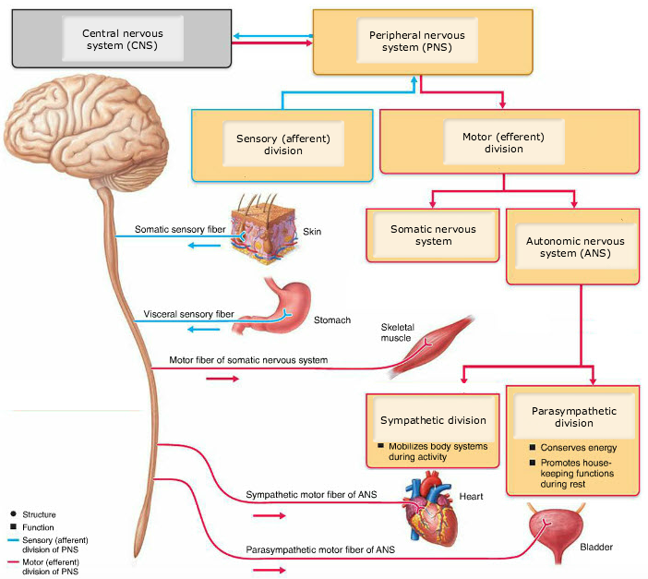
- As you start working out, you notice that your heart rate and breathing rate start to increase. Which division of your nervous system is generating this response? Be as specific as possible.
  - The afferent division of the nervous system
  - The somatic nervous system
  - The parasympathetic division of the autonomous nervous system
  - The sympathetic division of the autonomous nervous system

The sympathetic division of the autonomic, or involuntary, nervous system consists of visceral motor nerve fibers that regulate the activity of smooth muscles, cardiac muscles, and glands. This division is responsible for generating actions required during activity.

- Nerve impulses are sent to slow the heart’s rate of contraction. The nerve fibers sending these signals will most likely belong to which division of the nervous system?
  - Sensory (afferent) division
  - Somatic nervous system
  - Sympathetic division
  - Parasympathetic division
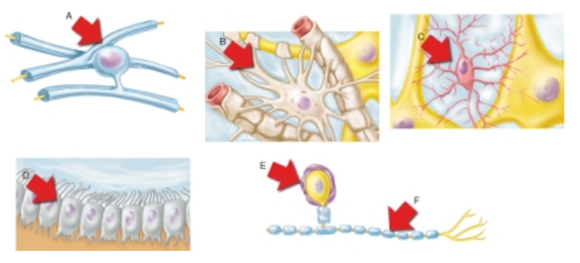
- Which of the cell types shown helps determine capillary permeability?
  - A
  - B
  - C
  - D

Extensions from these cells wrap capillaries and provide extra control over which materials enter or leave the intercellular fluid of the CNS.

- Which of the cell types shown is most associated with the production and flow cerebrospinal fluid (CSF)? (above)
  - A
  - B
  - C
  - D

These cells line central cavities of the CNS and, in certain places, produce CSF. The cilia of these cells help circulate the CSF that nourishes and cushions the brain and spinal cord.

- Which of the neuroglial cell types shown form myelin sheath within the CNS?
  - A
  - B
  - C
  - F

These cells form myelin sheaths within the white matter of the CNS.

- Which of the neuroglial cell types shown are found in the peripheral nervous system (PNS)?
  - A
  - B
  - C
  - E

The cell shown in E wraps and insulates the soma of neurons within ganglia in the PNS.

- Destruction of which of the neuroglial cell types leads to the disease multiple sclerosis (MS)?
  - A
  - B
  - D
  - F

The defects in nerve transmission associated with MS are caused by a loss of myelin within the CNS.

- Which of the following types of glial cells monitors the health of neurons, and can transform into a special type of macrophage to protect endangered neurons?
  - Astrocytes
  - Ependymal cells
  - Microglia
  - Oligodendrocytes

Microglial cells are small and ovoid with relatively long "thorny" processes. Their processes touch nearby neurons, monitoring their health, and when they sense that certain neurons are injured or are in other trouble, the microglial cells migrate toward them. Where invading microorganisms or dead neurons are present, the microglial cells transform into a special type of macrophage that phagocytizes the microorganisms or neuronal debris.

- Ependymal cells line many open cavities in the central nervous system (CNS). Ependymal cells have cilia on the side of the cell that face these openings. What is the most likely function of these ciliated cells?
  - Exchange of nutrients between the circulatory system and neurons
  - Act as macrophage cells to destroy microorganisms or neuronal debris
  - Create myelin sheaths for CNS cells
  - Movement and circulation of cerebrospinal fluid

Yes, cilia are an indication that the cells they appear on are moving fluids past the surface of the cells.

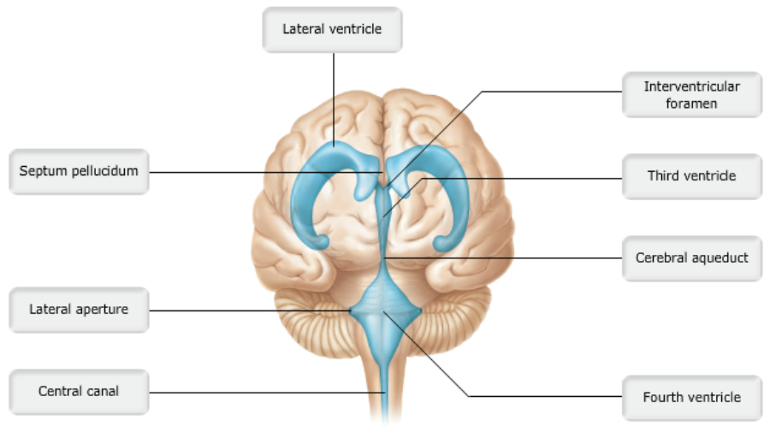

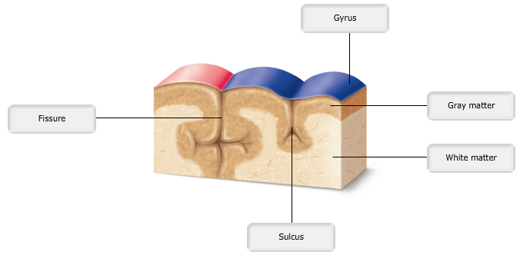

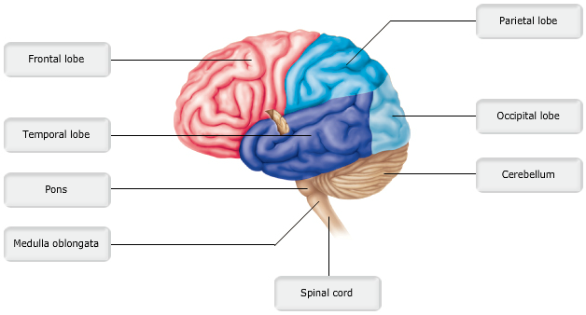
- White matter (myelinated fibers) is found in all of the following locations except the ________.
  - Cerebral cortex
  - Corpus callosum
  - Outer portion of the spinal cord
  - Corticospinal tracts

- Which of these would you NOT find in the cerebral cortex?
  - Interneurons
  - Cell bodies
  - Dendrites
  - Fiber tracts
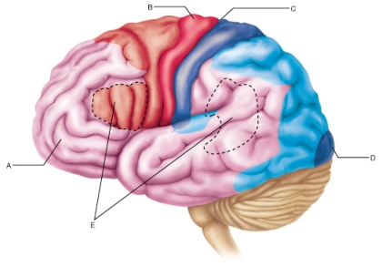

- What is the designation of the area at D?
  - Primary visual cortex
  - Multimodal association area
  - Primary olfactory cortex
  - Visual association area

The primary visual cortex receives sensory input from the eye via the optic nerves, thalamus, and optic radiations.

- The groove indicated by C is the __________.
  - Transverse fissure
  - Longitudinal fissure
  - Lateral sulcus
  - Central sulcus

The central sulcus is the shallow groove that separates the frontal and parietal lobes.

- Which of the following is the best description of the function of region B?
  - Region B houses voluntary motor commands.
  - Region B includes neurons whose axons carry motor commands from the cerebrum.
  - Region B contains neurons receiving somatosensory input from the thalamus.
  - Region B coordinates the movement of several muscle groups into complex tasks.

Region B is the precentral gyrus, the location of the primary (somatic) motor cortex. This is the origin of the descending corticospinal (pyramidal) tracts.

- The cortical regions indicated by E are involved in what functions?
  - The production and interpretation of language
  - The storage of motor patterns for skilled movements of skeletal muscles
  - The generation of emotional responses
  - They are the control centers for homeostatic and endocrine functions.

Regions indicated by E include Broca's area in the frontal lobe and Wernicke's area in the temporal lobe.

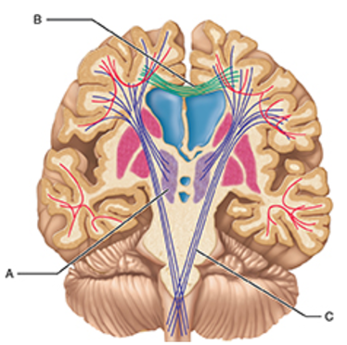
- The letter A in the figure indicates which of the following structures? (above)
  - Thalamus
  - Lateral ventricles
  - Hypothalamus
  - Cerebral nuclei

The letter A indicates the thalamus. Remember that the thalamus is composed of left and right bodies.

- What structure(s) is/are indicated by B?
  - Lateral ventricles
  - Association fibers
  - Pyramidal tracts
  - Corpus callosum

The corpus callosum is the most prominent example of tracts that connect the left and right cerebral hemispheres.

- Which of the following is true of the cerebral hemispheres of the human brain?
  - Nearly the entire surface of the cerebral hemispheres is marked by shallow grooves called gyri.
  - The longitudinal fissure separates the cerebral hemispheres from the cerebellum.
  - Nearly the entire surface of the cerebral hemispheres is marked by elevated ridges called sulci.
  - The cerebral hemispheres account for about 83% of total brain mass.

The cerebral hemispheres, which form the superior part of the brain, account for about 83% of total brain mass.
- Which of the following is NOT a correctly matched pair?
  - Superficial in the brain: gray matter
  - Gray matter: myelinated axons
  - Gray matter: location of brain nuclei
  - Spinal cord: inner gray matter

Gray matter is indicative of unmyelinated axons and cell bodies in the CNS.

- In most people, the left cerebral hemisphere has greater control over language abilities, math, and logic.
  - True
  - False

- Which part of the cerebral cortex is involved in intellect, cognition, recall, and personality?
  - Prefrontal cortex (anterior association area)
  - Posterior association area
  - Limbic association area
  - Combined primary somatosensory cortex and somatosensory association cortex

- The frontal lobe is separated from the temporal lobe by the ________.
  - Cranial fossa
  - Central sulcus
  - Lateral sulcus
  - Longitudinal fissure

- Broca’s area ________.
  - Controls voluntary movements of the eyes
  - Is usually found only in the right hemisphere
  - Serves the recognition of complex objects
  - Is considered a motor speech area

- Which type of white matter fiber tract connects the cerebrum to lower centers, like the spinal cord?
  - Commissures
  - Association fibers
  - Corpus callosum
  - Projection fibers

Projection fibers connect the cerebral cortex to the brain stem and spinal cord.

- Which of the following is NOT a diencephalon component?
  - Thalamus
  - Superior colliculus
  - Pineal gland
  - Hypothalamus

The superior colliculus is at the inferior border of the diencephalon, located in the midbrain region of the brain stem.

- Which of the following regions of the brains stem serves as a bridge between the brain stem and the cerebellum?
  - Midbrain
  - Pons
  - Medulla oblongata
  - Thalamus

The pons is the point at which all information entering or exiting the cerebellum is collected. Descending motor input and ascending sensory input that feed the cerebellum and all cerebellar output enter or exit the cerebellum through several cerebellar peduncles located in the pons.

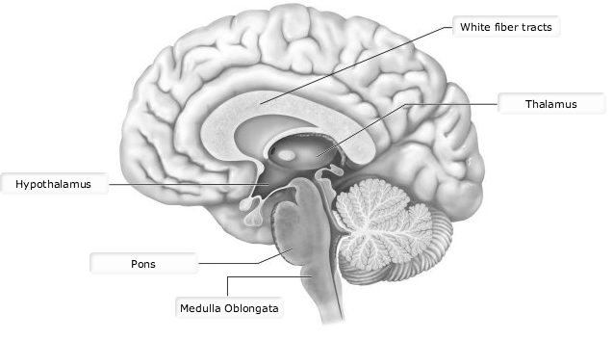
- Nuclei of cranial nerves V (trigeminal), VI (abducens), and VII (facial) are found in the _________.
  - Midbrain
  - Pons
  - Cerebrum
  - Medulla

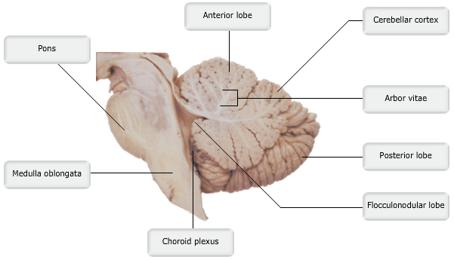

- Which protective covering of the brain provides passageways for cerebrospinal fluid (CSF) to drain into the superior sagittal sinus?
  - Pia mater
  - Periosteal part of the dura mater
  - Arachnoid matter
  - Membranous part of the dura mater

The subarachnoid space is filled with CSF. Knoblike projections of the arachnoid mater, called arachnoid villi, protrude superiorly through the dura mater and into the superior sagittal sinus. These villi provide a passageway for CSF to leave the subarachnoid space and enter the venous blood of the sinus.

- Meningitis is the most accurate term for inflammation of neurons.
  - True
  - False

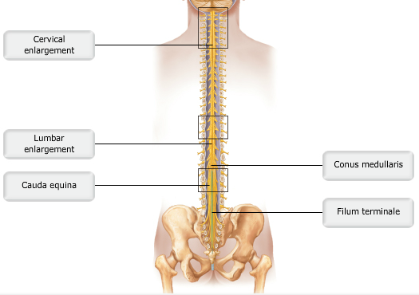

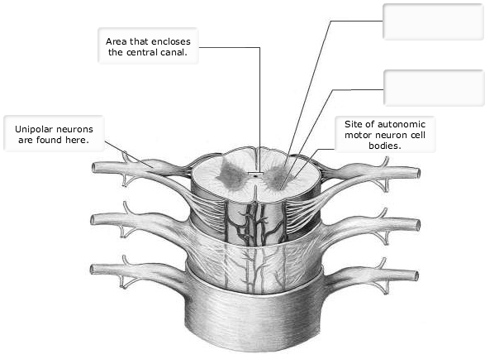
- The white matter of the spinal cord contains __________.
  - Unmyelinated nerve fibres only
  - Myelinated and unmyelinated nerve fibers
  - Cell bodies
  - Myelinated nerve fibers only
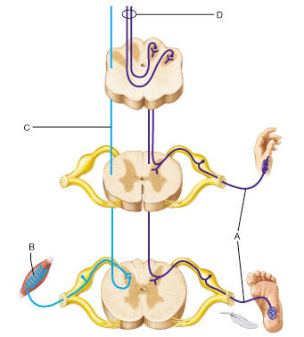
- The fiber tracts indicated by the letter C will terminate in the _________.
  - Cerebellum
  - Medulla oblongata
  - Sensory cortex
  - Thalamus

The letter C indicates the spinocerebellar pathways.

- The fiber tracts indicated by the letter D will terminate in the _________.
  - Thalamus
  - Primary somatosensory cortex
  - Primary motor cortex
  - Cerebral nuclei

The spinothalamic tracts indicated by D carry somatosensory information and terminate in the thalamus. Specific information will then be relayed to the appropriate area of the somatosensory cortex by third-order sensory neurons.

- Where are the cell bodies of the sensory neurons at A located?
  - In the posterior horn of the spinal cord
  - In the dorsal root ganglion
  - In the thalamus
  - In the medulla oblongata

All sensory neurons, including those of the autonomic nervous system, are found in the dorsal root ganglion.
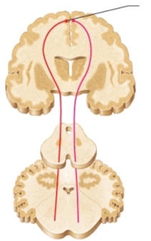
- Most of the descending fibers indicated in this figure cross over (decussate) to the opposite side of the body in which of the following?
  - Thalamus
  - Cerebellum
  - Peripheral nervous system
  - Medulla oblongata

Many descending fibers cross over to the contralateral side of the nervous system within the decussation of pyramids in the medulla.

