Muscles
- Fill in the blanks.
  - Antagonist – Muscle that opposes and reverse the action of another muscle.
  - Fixator – Muscle that stabilizes the origin of another muscle.
  - Agonist – Muscle that is primarily responsible for bringing about a particular movement.
  - Synergist – Muscle that aids another by promoting the same movement.

- In general, a muscle that crosses on the anterior side of a joint produces _________.
  - Extension
  - Abduction
  - Flexion
  - Adduction

- Which of the following is NOT used as a criterion for naming muscles?
  - The number of origins for the muscle
  - The shape of the muscle
  - The nervous system’s control of the muscle
  - The location of the muscle
  - The locations of the muscle attachments

Whether the muscle is controlled by the involuntary or voluntary nervous system is not a criterion used for naming muscles.

- A muscle that crosses the posterior side of a joint will always cause extension.
  - True
  - False

Most of the time this is correct. There are two exceptions, the knee and the ankle. These joints are reversed because of the rotation during development.

- Which of the following are correctly matched?
  - Transverse; parallel to the long axis
  - Deltoid; at a right angle to the long axis
  - Brevis; long
  - Rectus; straight

Rectus means “straight.”

- The sternocleidomastoid muscle inserts on the _________.
  - Mastoid process of the temporal bone
  - Sternum
  - Platysma
  - Clavicle

- Which of these is not a way of classifying muscles?
  - Muscle shape
  - The type of action they cause
  - Muscle location
  - The type of muscle fibers

- Which of the following muscles is named for its action?
  - Gluteus minimus
  - Biceps brachii
  - Frontalis
  - Levator labii superioris

The levator labii superioris is named for its action of elevating the upper lip.

- Which of the following are correctly matched?
  - Parallel arrangement of fascicles; characteristic of sphincter muscles
  - Pennute arrangement of fascicles; spindle-shaped muscle
  - Circular arrangement of fascicles; describes the deltoid muscle
  - Convergent arrangement of fascicles; fan-shaped muscle

A convergent muscle has a broad origin, and its fascicles converge toward a single tendon of insertion. Such a muscle is triangular or fan shaped like the pectoralis major muscle of the anterior thorax.

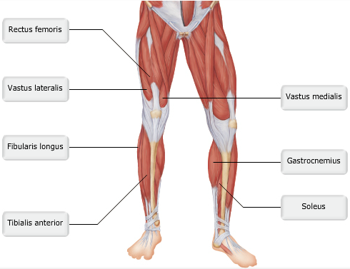

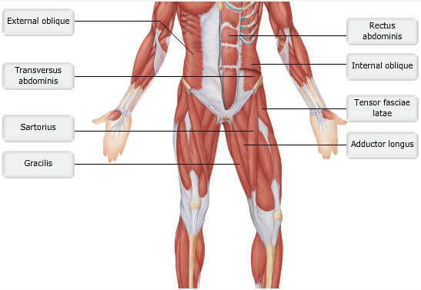

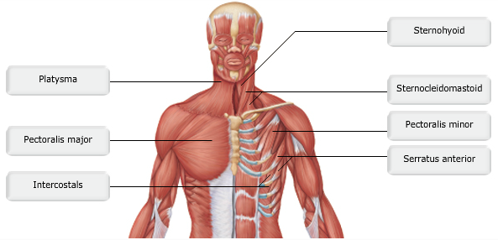

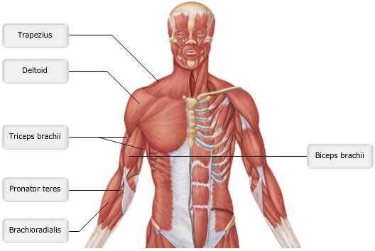

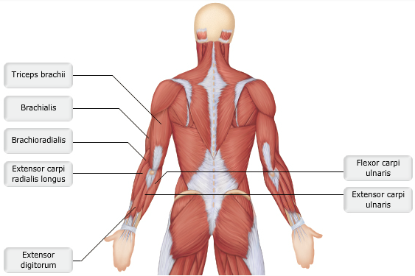

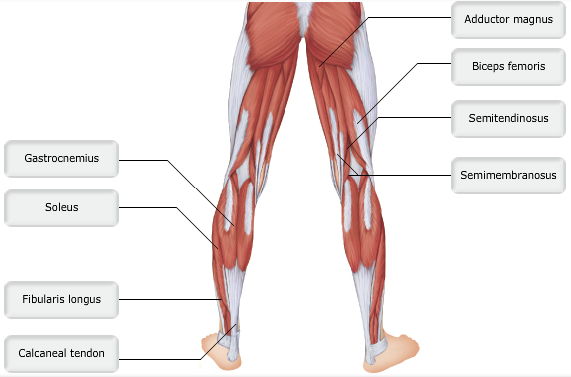

- Which muscle tenses the skin of the neck and assists in depression of the mandible?
  - A
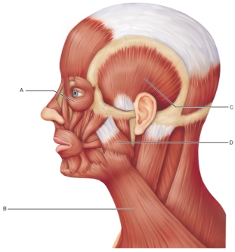
  - B
  - C
  - D

The platysma muscle tenses the neck skin and aids in depressing the mandible. It originates in the fascia of the upper chest.

- Two muscles in this image, identified by the letters C and D, share a function. What is that function? (picture above)
  - To open the mouth and depress the mandible
  - To compress the cheek
  - To close the jaw
  - To provide forward sliding side-to-side grinding movements of the lower teeth

The muscles at C and D originate on the skull and insert on the mandible. They exert powerful forces during chewing (elevation of the mandible).
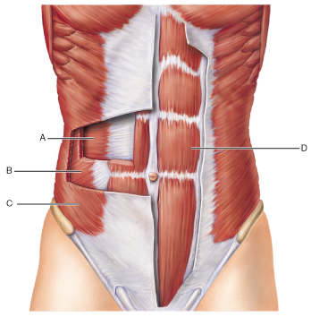
- Identify the action of the muscle at A.
  - Twist the trunk
  - Extend the spine
  - Flex the spine
  - Compress the abdomen

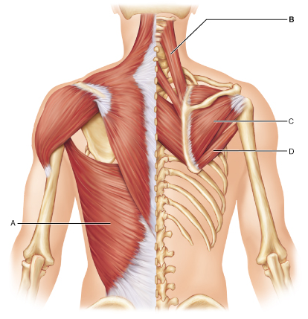
The transversus abdominis muscles are the deepest of the abdominal wall. They compress the abdominal contents.

- Which muscle inserts on the greater tubercle of the humerus?
  - A
  - B
  - C
  - D

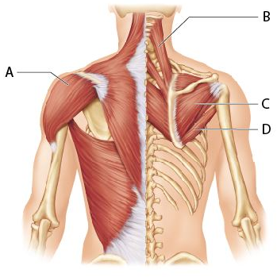
The infraspinatus typically originates on the infraspinous fossa of the scapula and inserts into the greater tubercle of the humerus posterior to the insertion of supraspinatus.

- Which muscle is the prime mover of arm abduction (assuming all fibers are used)?
  - A
  - B
  - C
  - D

The deltoid muscle has three sets of fibers. If all three are activated, the arm is abducted at the shoulder.
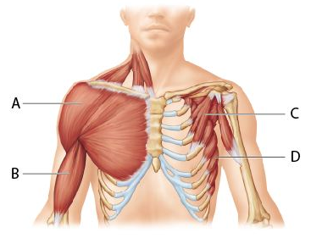
- Which muscle is known as the “boxer’s muscle” for its ability to move the arm horizontally, as in throwing a punch?
  - A
  - B
  - C
  - D

The serratus anterior can be used to violently pull the scapula laterally and thus pull the shoulder forward, adding strength to a horizontal punch.

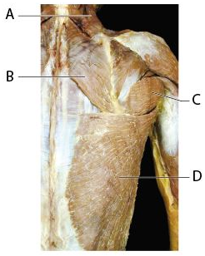
- Which of the following muscles is shown on this image but is NOT indicated with a letter?
  - Deltoid
  - Levator scapulae
  - Teres major
  - Latissimus dorsi

The deltoid, located in the upper right hand of the image, originates at the acromion of the scapula and inserts into the deltoid tuberosity of the humerus.

- Which muscle is an antagonist to the biceps brachii muscle?
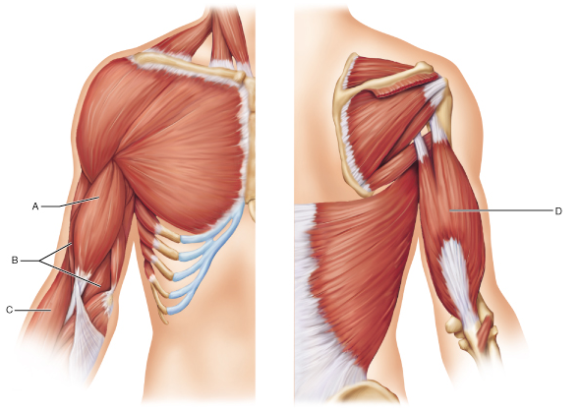
  - A
  - B
  - C
  - D

The triceps brachii muscle extends the forearm, while the biceps brachii flexes it, making them antagonistic.

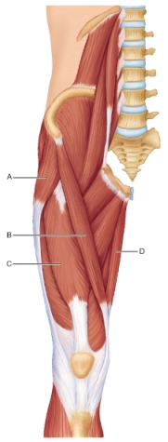
- Which muscle helps a person to cross a leg when seated (place one’s lateral ankle on the opposite knee)?
  - A
  - B
  - C
  - D

Sartorius laterally rotates and abducts the thigh, which would both necessary in placing one ankle on the opposite knee when sitting.
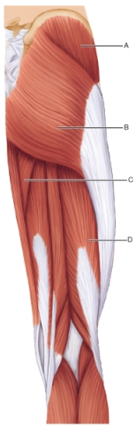
- What is the action of the muscle identified by the letter A?
  - The anterior part of this muscle adducts and medially rotates and flexes the thigh, while the posterior part of this muscle is a synergist of the hamstrings to extend the thigh.
  - It adducts the thigh and flexes and medially rotates the leg (especially during walking).
  - It is a major extensor of the thigh. It laterally rotates an abducts the thigh.
  - It abducts and medially rotates the thigh and steadies the pelvis. It is an extremely important muscle for walking.

This is the action of the gluteus medius muscle.

- The major head flexor muscles are the _________.
  - Scalene muscles
  - Sternocleidomastoid muscles
  - Splenius muscles
  - Trapezius muscles

The sternocleidomastoid muscles flex and laterally rotate the head. Acting alone, each muscle rotates the head toward the shoulder on the opposite side and tilts or laterally flexes the head to the shoulder on the same side.

- The primary function of the deep muscles of the thorax, such as the intercostals, is to promote ________.
  - Swallowing
  - Vomiting
  - Back posture
  - Breathing

The deep muscles of the thorax, like the internal and external intercostals and the diaphragm, promote movements necessary for breathing.

- The main forearm extensor is the _________.
  - Brachilais
  - Biceps brachii
  - Coracobrachialis
  - Triceps brachii

The main forearm (elbow) extensor is the triceps brachii.

- Which muscle acts as both a knee (leg) extensor and hip (thigh) flexor?
  - Biceps femoris
  - Rectus femoris
  - Gluteus maximus
  - Vastus lateralis

The quadriceps femoris (group of four muscles) is a powerful knee extensor. One of the quadriceps, rectus femoris, also acts as a hip flexor.

- All of the muscles that originate from the medial epicondyle of the humerus have one of two functions. Which of the following pairs is correct?
  - Wrist flexion and forearm pronation
  - Wrist extension and forearm suprination
  - Wrist flexion and suprination
  - Forearm flexion and wrist flexion

All of the muscles that originate from the medial epicondyle of the humerus are involved in either wrist flexion and forearm pronation.

- Which of the following statements is FALSE?
  - The hamstrings are fleshy muscles of the posterior thigh.
  - The hamstrings cross the hip and knee joints.
  - The hamstrings are prime movers of hip (thigh) flexion and knee (leg) flexion.
  - The medial hamstrings promote medial knee (leg) rotation.

The hamstrings are prime movers of hip (thigh) extension, not hip flexion. They are also prime movers of knee (leg) flexion.

- The anterior compartment of the thigh is involved in lower leg extension.
  - True
  - False

The quadriceps group sits in the anterior compartment of the thigh. These muscles extend the lower leg.

- What muscle is primarily responsible for preventing foot drop?
  - Fibularis tertius
  - Extensor halluces longus
  - Tibialis anterior
  - Extensor digitorum longus

- The _______ helps keep food between the grinding surfaces of the teeth during chewing.
  - Risorius
  - Orbicularis oris
  - Mentalis
  - Buccinator

- The _________ runs deep to the internal oblique.
  - Transversus abdominis
  - Latissimus dorsi
  - Rectus abdominis
  - External oblique

- The _________ tightens the neck and draws the corners of the mouth downward as in expressing horror.
  - Sternocleidomastoid
  - Mentalis
  - Platysma
  - Sternohyoid

- The quadriceps femoris is composed of three “vastus” muscles and the ________.
  - Semitendinosus
  - Rectus femoris
  - Semimembranosus
  - Biceps femoris

- The ________ is s synergist of the latissimus dorsi; it extends, medially rotates, and adducts the humerus.
  - Teres minor
  - Teres major
  - Supraspinatus
  - Infraspinatus

- The ________ extends the great toe.
  - Extensor hallucis longus
  - Tibialis anterior
  - Gastrocneumius
  - Fibularis (peroneous) tertius

- The broadest muscle of the back is the latissimus dorsi.
  - True
  - False

- Muscles connecting to the hyoid bone are important for swallowing and speech.
  - True
  - False

- The calcaneal tendon (Achilles tendon) is the largest tendon in the body.
  - True
  - False
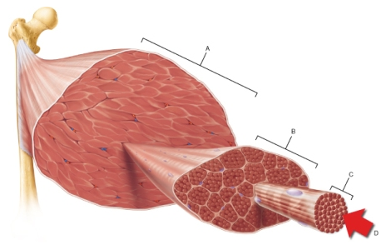
- Which structure in the figure corresponds to a single skeletal muscle cell?
  - A
  - B
  - C
  - D

Note that a skeletal muscle cell is commonly termed a muscle fiber.

- In the muscles of the limbs, the origin is usually the immobile muscle attachment.
  - True
  - False

In the muscles of the limbs, the insertion is pulled toward the immobile origin.

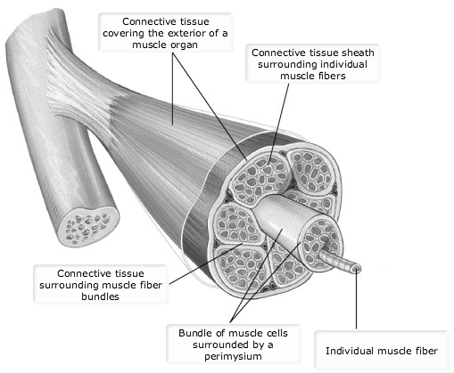

- Which of the following surrounds the individual muscle cell?
  - Endomysium
  - Epimysium
  - Perimysium
  - Fascicle

- Muscle Action
  - Muscle Action at the Shoulder Joint
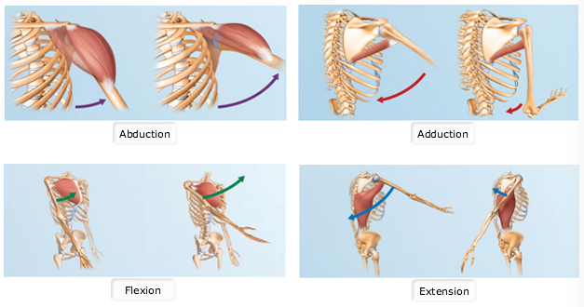
Fig.10.1
  - Which of the following statements is correct regarding muscle position and its related action?
    - The pectoralis major crosses on the anterior side of the shoulder joint to produce extension.
    - A muscle that crosses on the posterior side of the knee joint produces flexion.
    - A muscle that crosses the ankle joint anteriorly produces flexion.
    - The latissimus dorsi crosses the posterior side of the shoulder joint to produce flexion.

The position of the muscle relative to a joint can help determine the action produced. For example, the pectoralis major originates from the sternal end of the clavicle, sternum, cartilages of ribs 1–6 (or 7), and from the aponeurosis of the external oblique. It then crosses on the anterior side of the shoulder joint and inserts into the intertubercular sulcus and greater tubercle of the humerus. When the muscle contracts, the origin and insertion move closer together and produce flexion of the arm. This generality about flexion and extension is opposite in the lower limbs, where muscles that cross anteriorly produce extension and muscles that cross posteriorly produce flexion.

  - Which of the following statements is correct regarding muscle position and its related action?
    - The teres major crosses on the medial side of the shoulder joint to produce adduction.
    - A muscle that crosses the ankle joint posteriorly produces adduction.
    - A muscle that crosses on the lateral side of the hip joint produces adduction.
    - The deltoid crosses the shoulder joint medially produce abduction.

Just as with flexion and extension, the position of the muscle relative to a joint can help determine the action produced. A muscle that crosses on the medial side will produce adduction, whereas a muscle that crosses on the lateral side will produce abduction. Muscle position in the lower limbs produces the same muscle actions as that in the upper limbs with respect to abduction and adduction. Recall that a good way to remember the difference between adduction and abduction is that adduction "adds toward" the midline of the body.
  - Matching muscle names to blanks in sentences.
    - The pectoralis major crosses the anterior side of the shoulder joint and is the prime mover of arm flexion.
    - As the prime mover of arm abduction, the middle fibers of the deltoid contract to move the arm laterally away from the body.
    - The teres major is an antagonist of the deltoid for arm abduction.
    - The latissimus dorsi is an antagonist of the pectoralis major for arm flexion.
    - The latissimus dorsi and deltoid posterior fibers are prime movers of arm extension.

  - Muscle Position and Action Relative to the Shoulder Joint
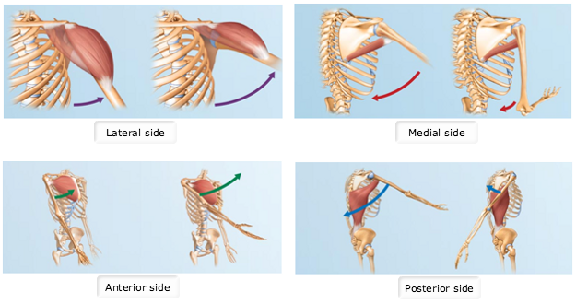
Another important factor to consider when determining muscle action is the type of joint. If you know the type of joint, you can determine the range of possible muscle movements. The shoulder (glenohumeral) joint is a ball-and-socket joint. This is the most freely moveable type of joint, and it permits flexion, extension, adduction, abduction, rotation, and circumduction. Other types of joints allow a limited range of movements. For example, the hinge joint permits only flexion and extension.

