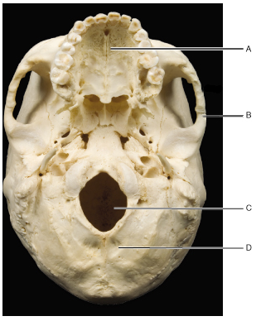
- Which of the following are indicated by letters A, B, and D?

A – maxilla
B – zygomatic
C – foramen magnum
D – occipital

- The highlighted bone articulates with which other bone(s) of the skull?
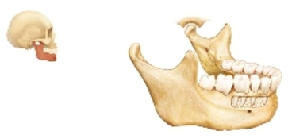
  - Maxillary bones, or maxillae
  - Ethmoid bone
  - Zygomatic bones
  - Temporal bone

The temporal bone bears a mandibular fossa that articulates with the condylar process of the mandible

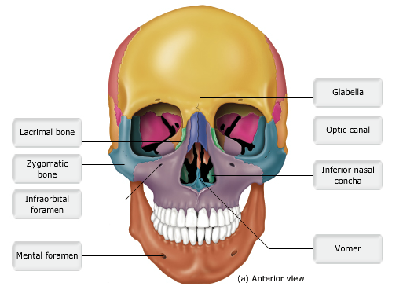

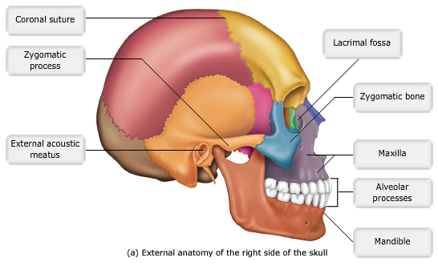

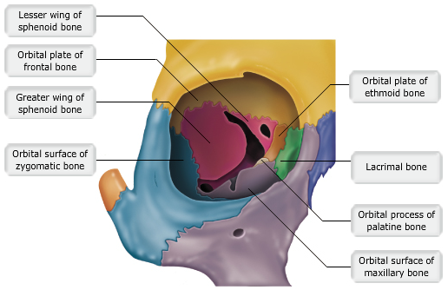

- Which of the following bones do NOT contain a paired paranasal sinus?
  - The ethmoid bones
  - The frontal bones
  - The sphenoid bones
  - The zygomatic bones
The zygomatic bones do not have paranasal sinuses

- Most facial bones articulate with the _________.
  - Vomer
  - Nasal bones
  - Mandible
  - Maxillary bones

The maxillary bones (maxillae) are considered the keystone bones of the facial skeleton. They form the central part of the facial skeleton, articulating with all facial bones except the mandible.

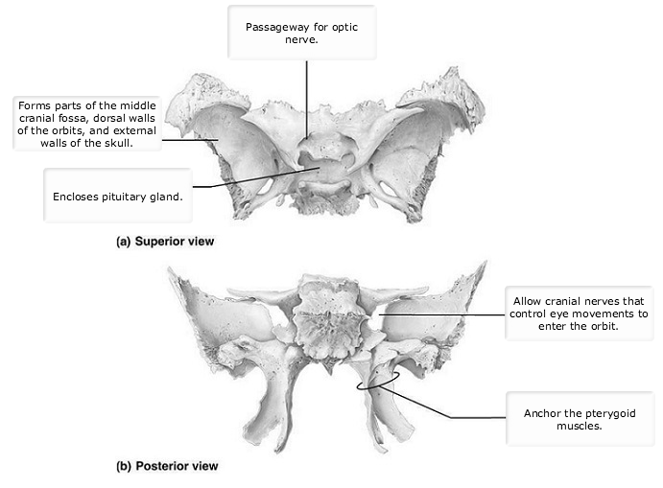

- Match the suture with what it connects.
  - Occipitomastoid suture – connects occipital and temporal bones
  - Squamosal suture – connects temporal and parietal bones
  - Lambdoid suture – connects occipital and parietal bones
  - Sagittal suture – connects right and left parietal bones
  - Coronal – connects frontal and parietal bones

- The hyoid bone is unique because it __________.
  - Is the only bone of the body that does not articulate with any other bone
  - Is the only bone formed by the fusion of right and left halves
  - Is the only irregular bone found in the neck
  - Is composed of three bones joined together

- Paranasal sinuses are found in which of these facial bones?
  - Zygomatic bones
  - Maxillae
  - Vomer
  - Nasal conchae

- Which bone forms the prominence of the cheek?
  - Palatine bone
  - Zygomatic bone
  - Sphenoid bone
  - Temporal bone

- The superior nasal concha is a part of which bone?
  - Sphenoid
  - Maxilla
  - Vomer
  - Ethmoid

- The temporal bone connects to the zygomatic bone via the temporal process of the temporal bone.
  - True
  - False

- The pituitary gland is housed in a saddlelike depression in the temporal bone called the sella turcica
  - True
  - False

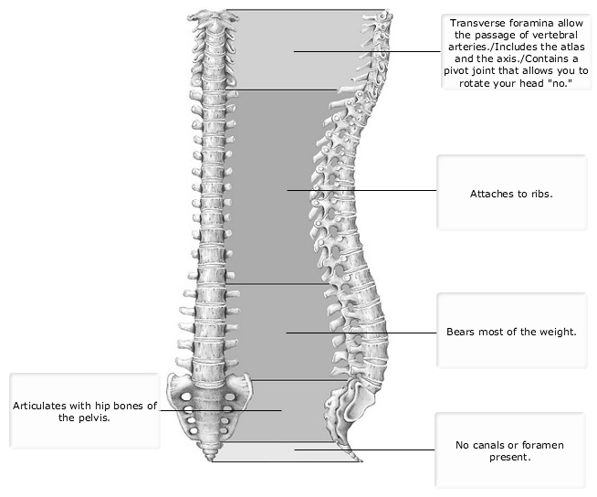

- All vertebrae possess a body, a spine and transverse foramina.
  - True
  - False

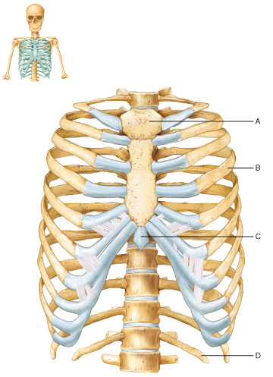
- Why is the rib at B considered a true rib?
  - It passes from the vertebral column to the sternum via its own costal cartilage
  - It possesses a costal groove
  - It is capable of movement during the action of breathing
  - It encloses the thoracic cavity and protects the vital organs within

True, or vertebrosternal, ribs make a complete circuit around the thoracic cage in a ring that includes their own costal cartilage.

- What is the most specific term you could apply to the rib at D?
  - False rib
  - True rib
  - Floating rib

This is a floating rib because it does not articulate with a costal cartilage and instead terminates in the body wall.

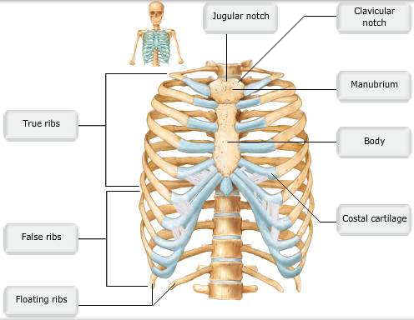

- Each of the 12 ribs articulates with one vertebrae. Is this statement true or false?
  - True
  - False

Each rub articulates with two separate vertebrae. The tubercle of the rib articulates with the rib facet of a thoracic vertebra on the transverse process. The head of the rib articulates with the bodies of two separate vertebrae.

- Which of the following is a bony articulation for the scapula?
  - The coracoid process
  - The suprascapular notch
  - Subscapular fossa
  - The acromion

Yes, the acromion forms a joint with the clavicle.

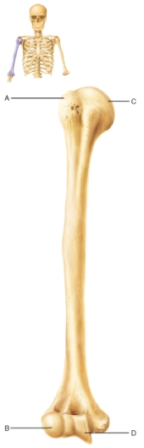
- Which of the following features of the humerus is NOT designated by a letter label?
  - Medial epicondyle
  - Greater tubercle
  - Trochlea
  - Capitulum

The medial epicondyle is located on the distal humerus on the side toward the body (in anatomical position).

- Which of the following is a bone marking of the humerus?
  - Radial tuberosity
  - Deltoid tuberosity
  - Styloid process
  - Radial notch

The deltoid tuberosity is a marking of the humerus. It is a roughened site where attachment to the deltoid muscle of the shoulder occurs.

- Which forearm bone(s) contribute(s) most heavily to the elbow joint?
  - The radius
  - The ulna
  - The humerus
  - The carpal bones

The olecranon articulates and moves across the humerus to form the elbow joint.

- The most common site of fracture in the humerus is the anatomical neck?
  - True
  - False

- In women of childbearing age, the dimensions of the true pelvis are of utmost importance?
  - True
  - False

- The ischium articulates with both the ilium and the pubis?
  - True
  - False

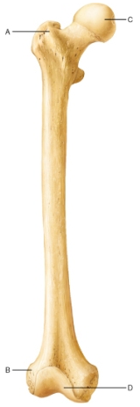
- Which letter represents the lateral epicondyle?
  - A
  - B
  - C
  - D

The lateral and medial epicondyle are located at the distal end of the femur.

- What is the bone feature at A?
  - Lesser trochanter
  - Greater trochanter
  - Fovea capitis
  - Linea aspera

The greater trochanter is separated from the lesser trochanter anteriorly by the intertrochanteric line and posteriorly by the intertrochanteric crest.

- Identify the group of bones known as the phalanges.
  - A
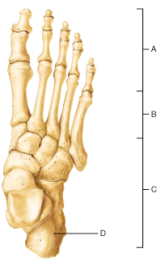
  - B
  - C
  - D

Both the hand and the foot contain 15 phalangeal bones that form the fingers and the toes.

- Which of the following areas/bones would absorb the impact of walking when a foot first touches the ground during a normal stride?
  - A
  - B
  - C
  - D

The calcaneus is the heel bone. The calcaneus belongs to the tarsus of the foot and strikes the ground first during a normal walking stride.

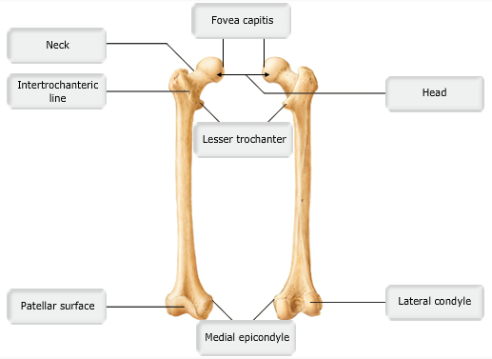

- Which portion of the fibula articulates with the talus?
  - Lateral malleolus
  - Calcaneus
  - Medial malleolus
  - Head

- Which is the largest, longest, and strongest bone in the body?
  - The femur
  - The os coxae
  - The fibula
  - The tibia

The femur is the largest, longest and strongest in the body. Its durable structure reflects the stress exerted on the femur as it bears the weight of the body when standing, walking, or running.

- Most of the body’s weight is carried by the talus and calcaneus?
  - True
  - False

- Which of the following is NOT a functional classification for joints?
  - Diarthrosis
  - Cartilaginous
  - Synarthrosis
  - Amphiarthrosis

Cartilaginous is a structural classification for joints.

- In the classification of joints, which of the following is true?
  - Immovable joints are called amphiarthroses.
  - Synarthrotic joints are slightly movable.
  - In cartilaginous joints, a joint cavity is present.
  - All synovial joints are freely movable.

- Synarthrotic joints ________.
  - Have large joint cavities
  - Are found only in adults
  - Characterize all cartilaginous joints
  - Are immovable joints

- Which of the following refers to a joint that is slightly movable?
  - Synovial
  - Synarthrosis
  - Diarthrosis
  - Amphiarthrosis

Amphiarthroses are slightly movable joints.

- The amount of movement permitted by a particular joint is the basis for the functional classification of that joint.
  - True
  - False

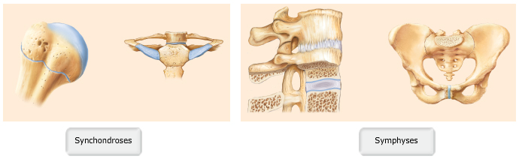

- Which of the following is NOT an example of a fibrous joint?
  - A symphysis
  - A suture
  - A syndesmosis
  - A gomphosis

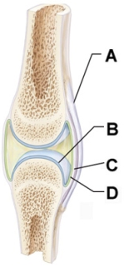
A symphysis is a cartilaginous joint, not a fibrous joint.

- Which of the following best describes the surface of the structure at D?
  - Hyaline cartilage
  - Dense irregular connective tissue
  - Simple columnar epithelium
  - Loose connective tissue

This is synovial membrane containing loose connective tissue that produces synovial fluid.

- Which of the following is NOT a distinguishing feature of a synovial joint?
  - Hyaline cartilage connecting two bones of the joint
  - Ligaments connecting the two bones of the joint
  - Synovial fluid
  - A capsule that creates a space in the joint

Hyaline cartilage makes up the articular cartilage in a synovial joint, but this does not connect the two sides together.

- Which movement decreases the angle between articulating bones?
  - Extension
  - Supination
  - Flexion
  - Protraction

Flexion is a bending movement that decreases the angle of the joint and brings the articulating bones closer together.

- Which of the following is true about the shoulder joint?
  - The glenohumeral joint is more mobile, making it less stable.
  - Many muscles cross the glenohumeral joint and limit the mobility of the joint.
  - Ligaments surround the glenohumeral joint on all sides and strengthen the joint.
  - The deepness the glenoid strengthens the joint overall.

The shoulder joint has the best mobility of all the joints in the body. However, the adaptations that make it mobile sacrifice strength to provide the mobility.

- Which of the following ligaments prevents the tibia from sliding forward in the knee joint?
  - Oblique popliteal ligament
  - Arcuate popliteal ligament
  - Tibial collateral ligament
  - Anterior cruciate ligament

The ACL prevents the tibia from sliding forward.

- Despite having an actual articulation with the humerus, the hinge-like action at the elbow is NOT dependent on the radius.
  - True
  - False

The radius articulates with the humerus at the Capitulum. However, the humeroulnar joint is responsible for the hinge-like flexion and extension at the elbow. The radius slides over the ulna, creating pronation and supination in the forearm.

- The main reason the hip joint is stable is because of the ___________.
  - Deep socket of the joint and strong capsular ligaments
  - Muscle tendons that cross the joint
  - Rotator cuff muscles
  - Bulky hip and thigh muscles surrounding the joint

The main contributors to hip-joint stability are the deep socket of the joint and the strong capsular ligaments. Joints that have shallow sockets, such as the shoulder and jaw (temporomandibular) joints, are relatively unstable and more easily dislocated.

- Compared to the shoulder, displacements of the hip joints are ________.
  - Rare because the rotator cuff stabilizes the hip joint
  - Common in all people who are overweight
  - Rare because of the ligament reinforcement
  - Common due to the weight bearing the hip endures

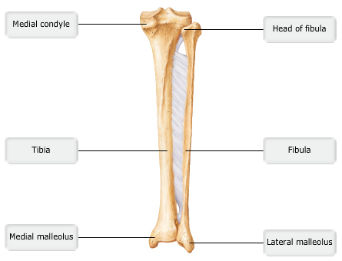

- Which bone is in direct contact with the first metatarsal?
  - Medial cuneiform
  - Cuboid
  - Lateral cuneiform
  - Calcaneus

