Exam 2015
Bolker

Human Genetics
Human-ape differences
• needles in haystacks (Varki et al. 2005; O’Bleness et al. 2012)
• differences:
– sequence divergence: human-chimp, human-bonobo ≈ 1.3%, human-gorilla ≈ 1.75%
– about 4% allowing for insertions/deletions
– about 70% of protein-coding genes differ (median 2 substitutions)
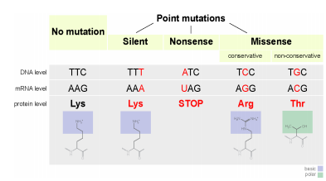
Synonymous Mutation: a change in the DNA sequence that codes for amino acids in a protein sequence, but does not change the encoded amino acid (aka silent mutation). Due to the redundancy of the genetic code (multiple codons code for the same amino acid), these changes usually occur in the third position of a codon.
Non-Synonymous Mutation: a nucleotide mutation that alters the amino acid sequence of a protein, therefore changes the amino acid that is encoded.
• dN/dS (non-synonymous to synonymous) ratio >1 for a few hundred genes

Regulatory changes
• hard to find
• highly accelerated regions [HAR1/reelin])
• good knowledge of regulatory function (transcription factors)
• copy number variation (need very good genomic data)
• RNA expression studies (need live tissue)

Human-Neanderthal differences
• much harder!
• smaller divergence (makes some things easier)
• difficulty with DNA evidence
• recent high-quality DNA (Prüfer et al. 2014)

Evidence for history and function of genes
• gene-trait associations: allele X is found in people with trait Y
• mechanistic arguments: allele X produces a protein that does Z
• gene-environment associations: allele X is found in environment A
• geographic variation in diversity: allele X is more variable in location B
• allele-geographic associations: allele X is found in a selected region

Mendelian traits
Deleterious alleles
• A deleterious allele gives lower average fitness (result of inbreeding depression, which is the decline of a population's fitness which is in result of inbreeding).
• fitness depends on
– alternative alleles
– genetic background (epistasis (the interaction of genes that are not alleles, in particular the suppression of the effect of one such gene by another) or G × G interaction)
– environment (G × E interaction)
• e.g. phenylketonuria
• overdominant selection

Mutation/selection balance
• purifying selection vs. deleterious genes
Purifying Selection: In natural selection, negative selection or purifying selection is the selective removal of alleles that are deleterious. This can result in stabilizing selection through the purging of deleterious variations that arise.
• m=rate of new mutation; s=selection coefficient
• dominant (m/s), recessive (√ m/s)
• e.g. m = 10−4 , s = 0.5 → 0.02% or 1.4%
• achondroplasia (midget)
– dominant, homozygous lethal
– rate ≈ 1/25,000
– s ≈ 1 (sporadic mutation in 80-90% of cases)
– therefore m ≈ 10−5
– FGFR3 gene: highest mutation rate known

Drift
Genetic Drift: variation in the relative frequency of different genotypes in a small population, owing to the chance disappearance of particular genes as individuals die or do not reproduce. Decreases genetic diversity.
• small/isolated populations
• founder effects/bottlenecks
• guevedoce/“penis at twelve” (only developing a penis at the age of 12)
• 5-α-reductase deficiency
• Probably a founder effect

Tay-Sachs disease
• Lethal abnormality in hexosaminidase A (lipid metabolism); early (infant/toddler) death
• Mendelian, recessive lethal (s = 1)
• allele frequency ≈ 1/300 in US population, 1/30 in Ashkenazi (E. European) Jews: also high in French Canadians, Cajuns, Pennsylvania Dutch . . .
• Population-genetic evidence suggests drift
• Speculation about overdominance or heterozygote advantage: Tb resistance, intelligence: ???

Sickle-cell
• overdominance (heterozygote advantage)
• selection for falciparum malaria resistance
• geographic patterns; consistency with malaria distribution
• mechanistic basis for protection
• evidence for positive selection (age??)

Balanced polymorphisms
Balanced Polymorphism: a situation in which two different versions of a gene are maintained in a population of organisms because individuals carrying both versions are better able to survive than those who have two copies of either version alone.
• Sickle-cell (and all cases of overdominance) depends on genetic makeup of the population
• chance of mating with a carrier is higher when allele is more common
• easier to do the math at the level of alleles

Selective sweeps
Selective Sweep: the reduction or elimination of variation among the nucleotides in neighboring DNA of a mutation as the result of recent and strong positive natural selection.
• strong selection on an allele
• individuals carrying that allele have high fitness
• lower (gene-specific) effective population size
• neighbouring loci carried along as haplotypes: hitchhiking
• haplotypes gradually erode (narrow) by recombination

Other malaria-protective variation
• hemoglobin variants:
– blood groups, Rh-negativity (older than malaria)
– thalassemia (any of a group of hereditary hemolytic diseases caused by faulty hemoglobin synthesis)
• enzyme variants:
– GP6D deficiency/favism
∗ Mediterranean populations
∗ X-linked
∗ arose 5-10K years ago: agriculture?
• Duffy antigens (protection against vivax malaria)

Cystic fibrosis
• Lethal lung disease: mucus build-up (1/4 chance of death before 30, previously much higher)
• 4% carriers in European whites (1/2500 diseased: 2pq = 0.04 → q 2 = 0.0004)
• Mutated cftr gene, changes chloride metabolism; age approx. 50 KYA
• Protection from cholera? (First European cholera epidemic 1817) Dehydrating intestinal diseases? Typhoid?
• Pleiotropy (multiple effects from one gene)

Summary: variation in Mendelian traits
• (relatively) simple inheritance
– recessive/dominant, autosomal/X/Y-linked
• estimate
• drift (assess historical population size/selection)
• balancing selection, G × E

Selection in changing environments
• selection pressures change
• T-S, malaria: opposing effects of reduced infectious disease, treatment, genetic counselling
• hard to see effects in the short term
• obesity/diabetes
– “thrifty phenotype” (hypothesis says that reduced fetal growth is strongly associated with a number of chronic conditions later in life. This increased susceptibility results from adaptations made by the fetus in an environment limited in its supply of nutrients.)
– genome-wide association studies (SNPs) (SNPs / Single Nucleotide Polymorphisms = variations in a single base pair in a DNA sequence)
– only explain 1.45% of variation
– may not handle G × E, copy-number variation
– hard to narrow regions to genes

Continuously varying traits
• quantitative (polygenic)
• e.g. height, weight, intelligence
• continuous vs. binary phenotype
• heritable (offspring trait average = average of mom and dad)
• look for changes associated with a locus (quantitative trait loci or QTLs)
• environmental variation is more obvious
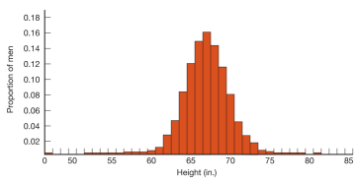
Quantitative variation
• partition variation:
– half-siblings: 25% related (+ environment)
– full sibs: 50% related (+ environment)
– dizygotic twins: 50% related + fetal env.
– monozygotic: 100% related + fetal env.
– adopted monozygotic: genes only
• GWAS
– 180 genes affecting height
– small effects (max. 4 mm)
– only explain 10%/80% genetic variation

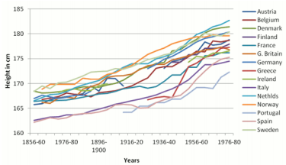
Body size
• genetic variation vs. phenotypic plasticity
Genetic Variation: diversity in gene frequencies. Genetic variation can refer to differences between individuals or to differences between populations.
Phenotypic Plasticity: the ability of one genotype to produce more than one phenotype when exposed to different environments. Phenotypic plasticity is the ability of an organism to change its phenotype in response to changes in the environment.
• rapid (one-generation) changes in immigrants
• increases even in upper class Europeans: not just nutrition?

Alcohol dependence
• environment related (no alcohol=no alcoholism; alcoholic parents=stress)
• effects of history on gene expression
• twin studies
• ALDH2, ADH1B: acetaldehyde metabolism, flushing response; protective against alcoholism? • most results are messy
• social, political, economic, factors stronger; comorbidity (the simultaneous presence of two chronic diseases or conditions in a patient.)
• correlation between allele and trait is complex

Human skin colour
• Darwin: sexual selection (natural selection arising through preference by one sex for certain characteristics in individuals of the other sex)
• skin cancer? probably not
• prevent photolysis of folate (UVA/UVB)
• allow UVB synthesis of vitamin D

What about race?
• genetic variation does exist
• distinct clusters don’t seem to exist
• overstated importance of markers associated with race
• confound economic/social with genetic variation
• focus on genetic/molecular differences distracts from sociological, economic drivers of health disparities . . .
• BiDil (Isosorbide dinitrate/hydralazine)

Cultural/genetic evolution
• Humans modify their environment (extended phenotype; niche construction)
• Agriculture → malaria → sickle-cell?
• Cultural evolution: heritable behaviours can be passed onto offspring
• much messier:
– horizontal transmission possible
– rules of inheritance?

Lactase persistence
• lactose-digestion enzyme (LHP; LCT gene); synthesis normally stops after weaning age
• Mendelian, dominant alleles for persistence
– C/T-13910 (Europe, Fulani); G/C-14010 (east Africa); others
• absence of C/T-13910 in 8 European human fossils
• other evidence: bones of dairy cattle; milk residues in pottery; earlier-weaned cows
• various selective sweeps
• C/T-13190 5-10 KYBP
• newer C/T-13910 haplotype (E Europe) 1.4-3 KYBP
Lactase persistence: dynamics
• epistatic, sort of (gene-culture interaction)
• dairying improves fitness of lactase persistence . . . and vice versa
• estimated strength of selection 0.05-0.15

Extended phenotype
• behaviour (including material culture) partly genetic
• also effects of
– history (gene expression, neural pathways; learning)
– environment (social/cultural, biological)
• is variation in behaviour genetic?
– between males and females?
– across cultures?

Biological substrates of behaviour
• biological underpinnings
• rats can learn from arbitrary cues and stimuli, but are better at learning about food (taste, sickness)
• learning is itself evolved

Environment of evolutionary adaptation
• organisms are adapted to their ancestors’ environments
• do we still act like hunter-gatherers?
• are current-day H/G good models?
• restricted diets; food-sharing; small groups

Skepticism
• How do we determine whether behaviour is hard-wired?
• Culture vs. genes, nurture vs. nature
• Cross-cultural studies (vs. WEIRD studies)
• Same as other traits: we need evidence of selection, mechanism, . . .
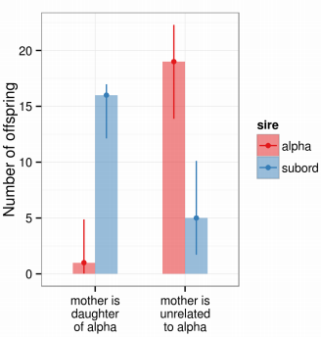
• descriptive vs normative

Inbreeding avoidance
Human inbreeding
• 3-5 lethal equivalents in average human genomes
• Spanish Habsburgs (1515-1700)
• Charles II: >25% inbreeding coefficient (more than parent-child or brother-sister)

Inbreeding avoidance (non-human)
• plants: self-incompatibility
• sex-specific dispersal (e.g. chimps: female dispersal, age-dependent mating)
• inbreeding aversion (e.g. capuchins)

Inbreeding avoidance (human)
• Westermarck effect: “childhood propinquity stifles desire”
• kibbutzes
• Taiwanese minor marriages
– why not selected against?
– fertility loss: behavioural or physiological?
• role for olfactory/HLA cues?

Cultural evolution
Non-human culture
Explanations for social learning (transmission of behaviour from one individual to another)
• social facilitation (local enhancement): living in an environment that facilitates learning
• observational learning: information transmission
• teaching: teacher’s behaviour changes
Examples: potato-washing, lobtail feeding

Tool use in non-humans
• use of objects: otters, monkeys, Caledonian crows, dolphin sponging
• modification of objects to create tools
• chimps: termite-fishing, honey-dipping, toothbrushing, nut smashing

Learning and cultural variation in non-humans
• different behaviours in different populations
• vocalization: cetaceans, songbirds
• chimps:
– termite-fishing learned by daughters
– Tai Forest vs. Gombe ant-fishing: functional differences?

Modeling cultural evolution
• vertical (from parents) horizontal (from others)
• allows faster (but potentially misguided) evolution
• ideas (memes) may spread via individual benefit; group benefit; or selfishness

Last words on cultural evolution
• cumulative cultural evolution allows extreme adaptation to novel environments
• we can apply evolutionary analyses (phylogenetics etc.) to cultural traits
• e.g. phylogenetic analyses of language

Mate choice
Sex asymmetries
• start with anisogamy (sexual reproduction)
• females invest more than males (usually)
• females limited by resources (“choosy”)
• males limited by mating opportunities (“promiscuous”)
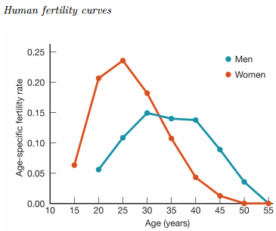
• polygyny (male has more than one female spouse) more common than polyandry (female has more than one male spouse)

Mating systems: polygamy
• polygyny is biologically unsurprising
• world cultures: 15% monogamous, 37% occasionally polygynous, 47% polygynous, 0.03% (4%?) polyandrous

Polyandry
• co-husbands are most often related
• skewed sex ratio (“best of a bad situation”)
• mate-guarding
• reproductive assurance • part physiological, part cultural
• 3-husband households preferred
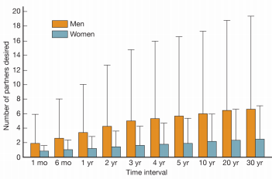
Mate choice: age difference
• preferred age differences
• can be driven by difference in fertility curves
• also drives difference in fertility curves

Mate choice: desired number of partners
• varies greatly between sexes
• male preferences are skewed (why?)
• stable across cultures

Heritability of preferences
Criticisms of choice studies
• psychological tests+evolutionary reasoning=?
• cross-cultural studies better, but rare
• cultural bias in responses?
• bias from forced choice studies?
• realism?

Parental care
Conflicts
• mother vs. father
– each parent wants to invest less
– mom gets stuck holding the bag
– dads have to demonstrate paternal quality
– paternal investment varies
• parent vs. offspring
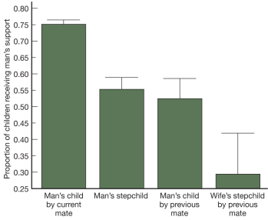
– kid wants more resources
– parent (mom) wants to maximize total fitness
• siblings
– related, but not 100%

Why should males contribute?
• genetic offspring: direct fitness
• genetic or stepchildren: impress your mate
• societal reputation: “deadbeat dads”
• coresidence matters too!
• similar patterns among Hadza (hunter-gatherers), US, South Africa

Parental investment drives mate choice
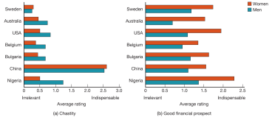
Step-children: the Cinderella effect (Daly & Wilson)
• fairy tales (cross-cultural)
• less investment in unrelated children
• more accidental deaths (Australia); more homicides; more physical abuse
• skepticism
– reporting bias?
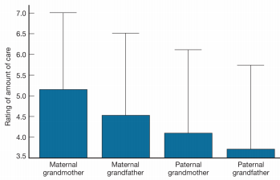
– socioeconomic confounding?

Grandparental care
• asymmetry in parental certainty suggests matrilateral bias
• grandmother hypothesis
– evolution of menopause
– female chimps and humans both lose fertility around 40, but female humans survive much longer
– evolutionary dynamics can work

Behaviour
Behaviour
• Behaviour: response to a stimulus
– short time scale
– overlaps with phenotypic plasticity
– gene expression vs. neuronal activity
– plant behaviour?

Proximate vs. ultimate
• proximate vs ultimate causation
• lobsters:
– navigation via magnetoreceptors (function)
– allows effective searching (functional)
– arose by natural selection (ultimate)

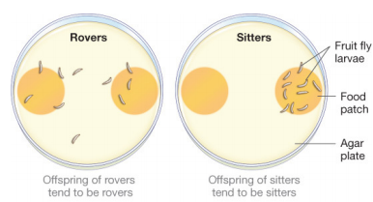
Genetics of behaviour
• rovers vs sitters: for gene
• cGMP-dependent kinase
• rover wins at high population density, sitter wins at low density
• adult as well as larval behaviour
• also acts in honey bees, other insects

Foraging ecology
• foraging for nutrients and energy
– foragers: predators, herbivores, frugivores, nectarivores, . . .
• what to eat, when and how?
– food type
– size/quality of prey
∗ energy/nutrient content
∗ handling time
∗ search time
∗ toxins
• location of prey: mortality risk?

Food choices
• food preference defined relative to availability
• given food abundance, what do you choose to eat?
• eating food in proportion to its availability is not “choice”
• over a longer time scale: may move to a location with more preferred items?

Foraging trade-offs
• bee-eaters go farther for richer resources: central-place foragers
• is reward linear?
• is travel cost linear?
• should there be a preferred distance?
• would prefer more precise predictions . . .
• another model: ideal free distribution

Rate maximization
• maximize energy gain per unit time: (energy gained)/(time spent)
• energy gained from food quality
– size, nutritional content, lack of toxins
• time spent
– searching time (s) + handling time (h: pursuit, eating, digesting)

Model predictions
• pick prey with maximal energy/time
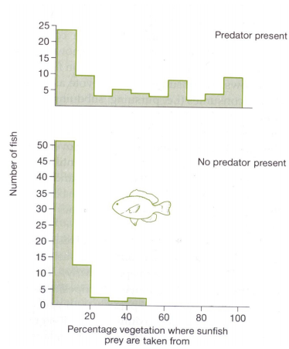
• be choosy when preferred prey are abundant (opportunity cost of handling crappy prey)
• wider diet breadth when prey are rare
• searchers (s > h) = generalists (insectivorous birds)
• handlers (h > s) = specialists (wolves, lions)
• ignore poor, abundant food unless preferred food is rare
• switching thresholds

Top-down control of foraging
• bluegill sunfish use habitat differently when predators are present
• balance mortality vs. energy gain
• “ecology of fear”
• creates indirect interactions between predators and resource

Foraging: summary
• optimization models of behaviour: energy gain, energy/time, fitness
• when models fail it tells you something interesting

Introduction to ecology
Ecology vs. environmentalism, science vs. policy
• tree huggers vs. Hummer drivers
• ecology 6= environmental science 6= environmentalism
• ecologists (in their professional capacity) should be descriptive, not normative

Definitions
• Ecology: “study of the factors determining the distribution and abundance of organisms” “and flows of energy and nutrients through biological systems . . . ”
• hierarchical levels
– organismal/behavioural
– population
– community
– ecosystem

Organismal (behavioural/physiological)
• interactions between individuals and their environment

Population
• interactions among individuals
• population growth, extinction

Community
• interactions among different species
• what maintains biodiversity?

Ecosystem
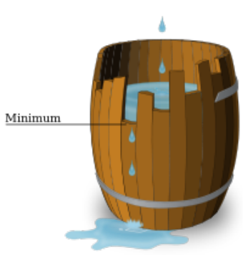
• mostly tracking energy and nutrient flows
• e.g. importance of allochthonous inputs

Ecosystems and biomes
Limiting factors in ecosystems: bottom-up
• bottom-up factors:
• needed for biochemical reactions, esp. photosynthesis
– light (photons)
– nutrients (esp. nitrogen/phosphorus/ iron)
– water
– temperature
• Liebig’s law of the minimum: growth is controlled not by the total amount of resources available, but by the scarcest resource (limiting factor).

Top-down factors
• top-down factors:
• regulate the rate of loss, rather than the rate of production
• predators (esp. grazers), fire
• feedbacks with plant community

Aquatic ecosystems
• temperature, nutrients, light, wind
• nutrient availability (especially P, sometimes Fe)
• water movement:
– upwelling (marine)
– turnover (lakes)
• water chemistry: salinity, pH
• depth gradient:
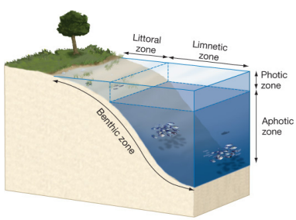
– dark, cold, low productivity, nutrient accumulation
– light, warm, high productivity, nutrient depletion

Freshwater ecosystems (mostly lakes)
• gradients of light, temperature, nutrients: by depth, distance from shore
• mixing by wind
• (temperate zones) stratification: seasonal overturning mixes nutrients
• (rivers)
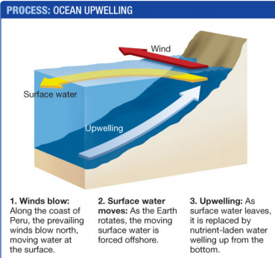
Marine ecosystems
• upwelling brings up nutrients
• iron fertilization experiments
• zones (intertidal, littoral, pelagic, benthic)

Benthic ecosystems
• deep ocean/ocean floor
• donor-controlled: whale falls
• chemoautotrophic: cold seeps, hot smokers
– (very long-lived organisms)

Terrestrial ecosystems
Terrestrial biomes
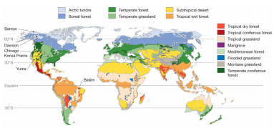
Holdridge zones
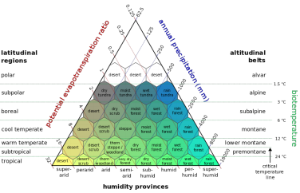
• Water+temperature = potential evapotranspiration
• Missing: top-down factors, seasonality

Population ecology
Population ecology: definition
• population: a group of conspecifics living in the same area at the same time
• population ecology studies how & why the population size changes over time
• applications
– protect endangered species
– manage harvested species
– control pest/invasive species
– control epidemics
– manage human population growth
• scale from survival & fecundity (fruitfulness and fertility, the ability to produce abundant healthy growth or offspring) to pop growth

The first law of population ecology
• change in population size = birth - death + immigration - emigration
• rates depend on both age (size) and population density
• negative density-dependence keeps populations in check
– per capita birth, immigration rates usually decrease with N
– per capita death, emigration usually increase
• age-dependence
– per capita fecundity increases, might later decrease with age
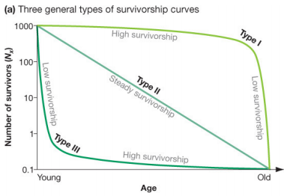
– per capita mortality decreases, might later increase

Demography and demographic tradeoffs
Survival curves
• Survival curves: fraction of initial population or cohort surviving to age a
• logarithmic scale
• Type III: invertebrates, fish (juvenile mortality)
• Type II: birds (constant per capita survival)
• Type I: e.g. humans, elephants (sort of): senescence

More interesting survival curves
• type I/II/III are idealizations
• steep slope=high mortality (juvenile mortality, senescence)
• depends on environment (historical human patterns are different)

Fitness tradeoffs
• fecundity also varies with age
• balance between reproduction and survival
• would like to maximize both, but it’s impossible (there are no “Darwinian demons”)
• example: maximum fitness at intermediate clutch size

Life history decisions
• life history is the entire schedule of an organism’s fitness decisions
• life table information
• “live fast, die young” vs. “slow and steady”
• iteroparity vs. semelparity (semelparity and iteroparity refer to the reproductive strategy of an organism. A species is considered semelparous if it is characterized by a single reproductive episode before death, and iteroparous if it is characterized by multiple reproductive cycles over the course of its lifetime.)
• r-K tradeoff metaphor

Life history evolution
• correlations among traits
– high fecundity, small offspring, early maturation, short life span
– low fecundity, large offspring, late maturation, long life span
• not always that simple: live slow, flower like crazy, die spectacularly?

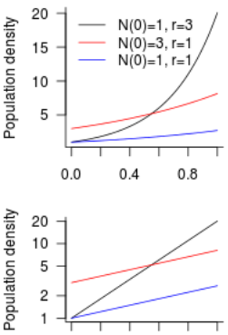
Population growth
• back to the first law: ∆N = birth - death + immigration - emigration
• ignore age-dependence, think about density-dependence instead (per capita fecundity f(N), per capita mortality µ(N)). . . but start with a null model, exponential growth

Exponential growth
• constant per capita birth and death rates
• (constant life table)
• geometric growth rate: (per generation)
• exponential growth: (per unit time)
• solution of

Exponential growth in practice
• unrealistic but sometimes useful
• e.g. populations that are far below their carrying capacity
– novel/invading species (Australian cane toads, Pribilof caribou)
– endangered species

Density-dependence
• life is harder when it gets crowded
• fewer resources (exploitation competition), more predators (apparent competition)
• per capita birth rate decreases and/or death rate increases
• simplest case: linear decline

Logistic growth
• Logistic growth
• max. per capita growth at N = 0
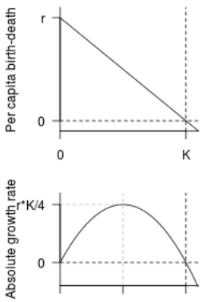
• max absolute growth at N = K/2
• growth rate negative when N > K
• encapsulate changes in birth (fecundity) and death

Logistic growth: time curve
• if population starts small (N ≈ 0 or N 1):
– initial exponential growth
– inflection point at N = K/2
– growth approaches zero as N → K
• if population starts large (above K)
– population falls to K.
• in the long run, bounce around K (stable equilibrium)

Population cycles
• mechanisms:
– time lags in development
– strong (overcompensating) density-dependence
– environmental variation
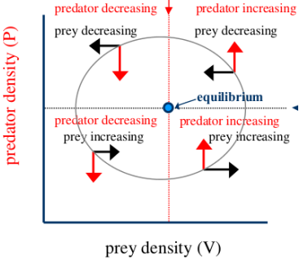
– trophic interactions (predator-prey, host-pathogen)
• applications
– insect outbreaks
– recurrent epidemics
– cycles in harvested populations

Predator-prey cycles
• predators kill prey: reduce growth rate
• prey nourish predators: increase growth rate
• induce population cycles

Red grouse
• 7-10 year cycles in grouse on English and Scottish moors
• simple system: grouse, heather, nematodes
• do parasites drive the cycles?
• alternate hypothesis: behavioural changes
Red grouse experiments
• treat grouse with anthelmintic on some moors
• control moors, 1x treatment, 2x treatment
• also low replication

Human demography
Age pyramids
Implications of age structure
• population momentum: “bottom-heavy”, younger populations keep growing even when fecundity drops
• bulges move through population (baby boom 1946-1965, Generation Y)
• shrinking populations are “top-heavy”; pensions, health care implications
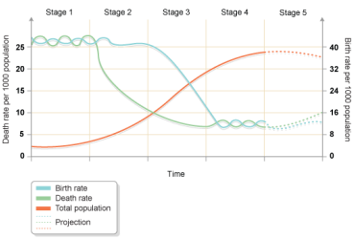
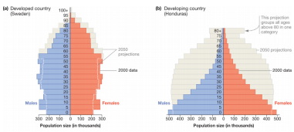
Demographic transition
• industrialize (reduce child labour)
• reduce child mortality
• educate women

Community ecology
Definitions
• community: a group of individuals of different species living in the same place at the same time (i.e., potentially interacting)
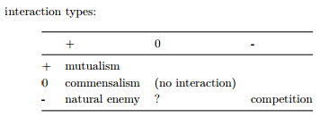
natural enemies: predator/prey, host/parasite

Competition
Competition types
• intra/inter specific
• resource (exploitation) competition
– using same resources (food, nesting space, refuge)
– niche overlap
• interference competition
– direct antagonism
– allelopathy
• apparent competition
– attract/encourage natural enemies

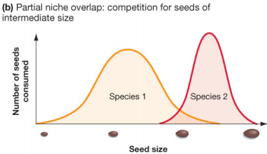
Niches
• many definitions
• “how the organism makes a living”
• set of resources, environmental conditions, etc.

Niche overlap
• Niche overlap occurs when two species use the same resources
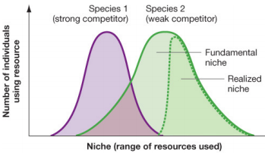
• Competitive exclusion principle: two species that are exactly identical (niches overlap completely) can’t coexist
• whichever can reduce resource level more wins

Fundamental vs realized niche
• fundamental: species can persist in isolation (r > 0)
• realized: species can persist when competing
• realized always < fundamental
• weaker competitor either moves or dies

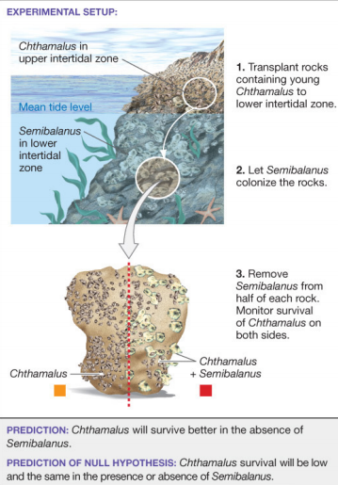
Experimental tests of competition
• usually can’t tell fundamental and realized niche apart without experiments
• remove or exclude (stronger) competitor, see if weaker competitor survives

Competition-colonization tradeoff
• if you can’t compete, get out of the way!
• disturbance opens up empty patches
• competitively weak species disperse well
• dispersal traits: parachutes, fruit . . .

Evolutionary responses
• character displacement: evolutionary response to niche overlap
• resource partitioning
• “ghost of competition past”
• Galapagos finches
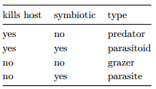
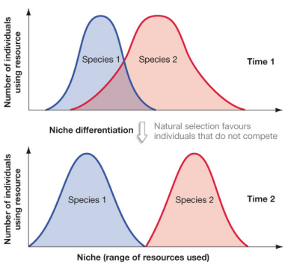
Natural enemies
Types of natural enemies
• taxon/trophic position: herbivore, top predator
• interaction strength

Predator-prey arms races
• prey defenses, predator tolerance
• garter snakes and rough-skinned newts
• tetrodotoxin
• snakes have modified sodium channel; locomotion cost

Trophic cascades
• adding predators modifies density or behaviour of lower trophic levels
• prey do worse, prey’s prey do better, etc..
• sea otters/sea urchin/kelp
• rinderpest/ungulates/ vegetation/tsetse flies
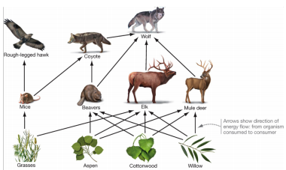
• wolves reintroduced to Yellowstone, 1995: top predator
• population up to 150 individuals
• elk declined
– aspen, cottonwood and willow increase
– beavers increase because more willow (ecosystem engineers)
• coyote declined
– mice increase
– hawks increase

Why is the world green?
• top-down control: natural enemies
– parasites, parasitoids, predators
• bottom-up:
– poor nutrition (nitrogen limitation)
– defensive compounds
• the ocean is blue: predators winning?

Mutualism Definitions
• positive/positive interaction
• mutualism: +/+
• symbiosis: close association

Mutualism types
• resource for resource:
– plants/mycorrhizal fungi
– plants/nitrogen-fixing bacteria
– chemoautotrophic bacteria/tubeworms
– lichen (fungus/cyanobacteria)
• defense/resource or shelter
– ant/acacia
– cleaner shrimp/fish
– coral/crustaceans
• resource for dispersal
– plant/pollinator
– plant/frugivore

Context-dependent benefits
• mutualisms may be fragile
• only persist when both species need it
• cheaters (nectar robbers, yucca moths)
• fixed associations: organelles (mitochondria, chloroplasts)

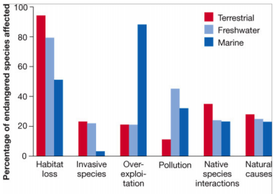
Biodiversity and ecosystem valuation
What is biodiversity?
• measures of diversity: richness, evenness
• levels of diversity:
– species
– functional groups
– phylogenetic
– genetic
What threatens biodiversity? ->

Why do we care? Ecosystem services
• seed banks
• pollination ($40B)
• bioprospecting
• ecotourism (8B visits, $600B)
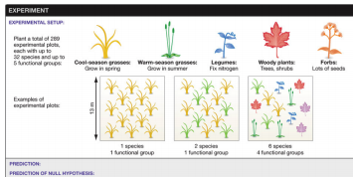
• flood control
• carbon storage

Biodiversity and productivity

Biodiversity and productivity: results
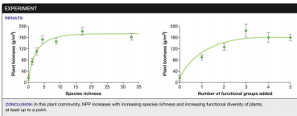

Biodiversity and stability
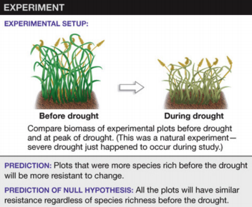

Biodiversity and stability: results
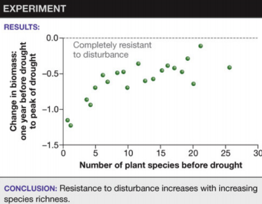

Biodiversity productivity/stability: mechanisms
• resource use efficiency (portfolio)
• facilitation
• sampling effects

Biodiversity: conclusions
• total value estimated $33 trillion (but is this the right number?)
• ethical vs. utilitarian arguments
• how should we protect it? (conservation vs. preservation)
– preservation: set aside pristine areas
∗ parks etc.
– conservation: ensure sustainability
∗ multi-use areas

Fisheries
Fishing down the food web
• Trophic level describes the average position of a species in the food chain
– e.g. zooplankton (krill) feed on phytoplankton (level 1) and some zooplankton (level 2)
– trophic level slightly above 1
• calculated from food web or from stable nitrogen isotope ratios
• high trophic level fish often preferred (e.g. salmon, cod, haddock)
• expect increasing catches, mean trophic level decreases

Fisheries: conclusions
• managing fisheries is hard
• fisheries collapses
– overexploitation
– interactions with politics
– trophic cascades and regime shifts
• is the glass half-full or half-empty?

The carbon cycle
Basics
• stocks: how much carbon is stored? (pG or gigatonnes)
• flows: how much carbon moves? (pG/year, gton/year)
• at equilibrium, all flows are balanced
• carbon sources: deforestation and fossil-fuel burning
• carbon sinks: net uptake, e.g. deep ocean or regrowing forests
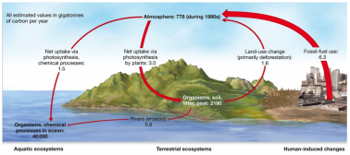

Tundra
Seasonal tundra dynamics
• negative exchange = carbon from atmosphere into soil
• warmer growing season (GS): more carbon uptake by plants
• warmer winter: more decomposition by microbes

The carbon cycle: future
• complex feedbacks
• predicting and quantifying effects is hard
– ecological impact?
– economic impact?
– human impact?
• control: carbon markets?
• local environmental changes have larger local impacts, but net impact of global change is enormous

