Chapter 7
Groups and Team work
Group development theory
Many groups develop through a series of stages over time, each stage presents the member a series of challenges they must master to achieve the next stage.
- Groups = “complex social devices”
- Require negotiation and trial-and-error before members begin to function as a “true group”
How do groups develop?
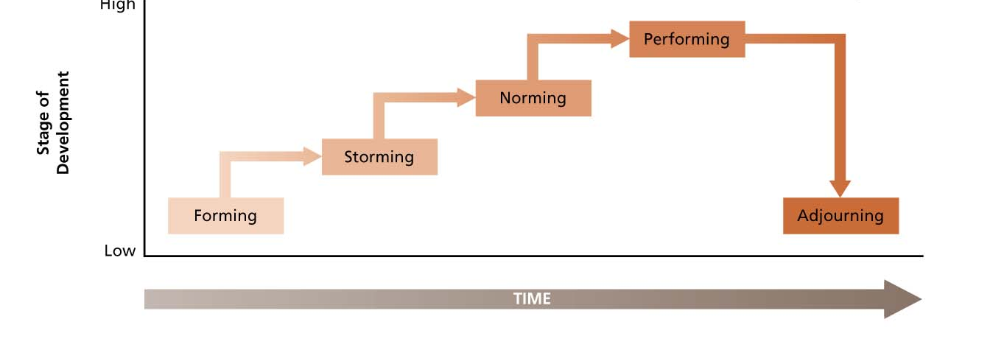
Forming:
- Members orient themselves by “testing the waters.”
- Situation is often ambiguous, and members are aware of their dependency on each other.
Storming
- Conflict emerges at this stage: sorting out roles and responsibilities.
- Confrontation and criticism occur as members determine whether they will go along with the way the group is developing.
Norming
- Members resolve issues that provoked the storming and develop consensus.
- Compromise is often necessary.
- Norms are agreed on and the group becomes more cohesive.
- Information and opinions flow freely.
Performing
- The group devotes its energies toward task accomplishment.
- Achievement, creativity, and mutual assistance are prominent themes at this stage.
Adjourning
- Rites and rituals that affirm the group’s previous successful development are common.
- Members often exhibit emotional support for each other.
Punctuated Equilibrium
Model of group development that describes how groups with deadlines are affected by their first meeting and crucial midpoint transitions.
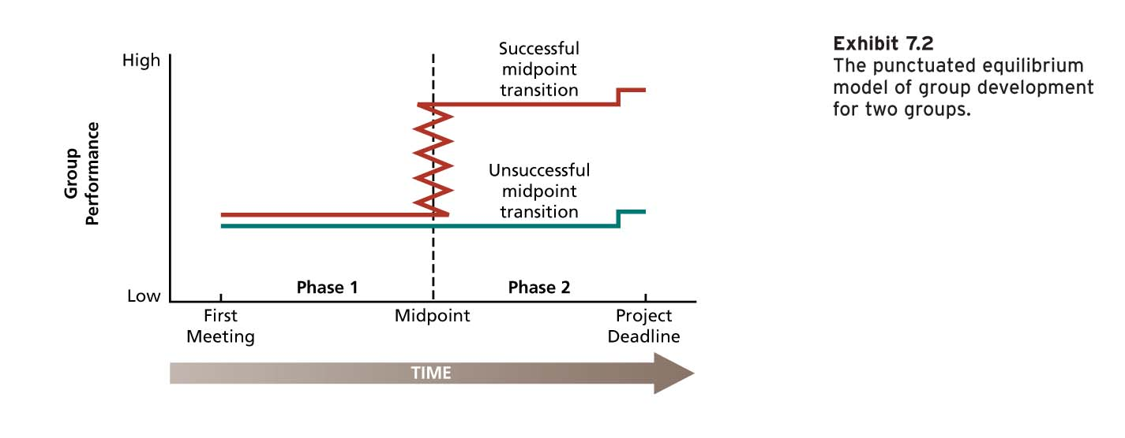
Phase 1
- 1st meeting is critical in setting the agenda for what will happen in the remainder of the phase.
- Group makes little visible progress toward the goal.
Midpoint
- Occurs at almost exactly the ½ time point toward the group’s deadline.
- The transition marks a change in the group’s approach.
- How the group manages it is critical for the group to show progress.
- This transition crystallizes the group’s activities for Phase 2.
Phase 2
- Decisions and approaches adopted at the midpoint get played out in Phase 2.
- It concludes with a final meeting that reveals a burst of activity and a concern for how outsiders will evaluate the product.
Advice for managing teams:
  - Prepare carefully for 1st meeting
  - As long as people are working, do not look for radical progress during Phase 1
  - Manage midpoint transition carefully
  - Be sure that adequate resources are available to actually execute Phase 2
  - Resist a deadline change because this could damage the midpoint transition
Group Structure and its consequences
Characteristics of the stable social organization of a group; the way a group is “put together”:
  - Size
  - Member diversity
  - Norms
  - Roles
  - Cohesiveness

  - Size
- Smallest possible group = 2 people; e.g., manager and employee.
- Most work groups (incl. task forces, committees) usually have 3-20 members.

- Group Size and Member satisfaction
Members of larger groups report ê satisfaction with group membership than those in smaller groups:
  - Chance to develop friendships ê as group size é
  - Larger groups might prompt conflict
  - Larger groups less satisfaction / small groups more satisfaction
  - Some are inhibited about participating in larger groups
  - As group size é, time for active participation by each member ê
  - In large groups, individuals identify less easily with success and accomplishments of group

- Group size and performance
- Do large groups perform tasks better than small groups?
- Relationship between group size and performance depends on task group needs to accomplish:
  - Additive tasks: dependent on the sum of the performance of individual group members. (performance increases as size increases)
  - Disjunctive tasks: dependent on the performance of the best group member. (Potential performance of groups doing disjunctive tasks increases as group size increases).
Process losses
Group performance difficulties due to problems of motivating and coordinating large groups:
  - Problems of communication and decision making é as group size é (increase)
Actual performance = potential performance – process losses
Process losses: Lessons
- Potential performance and process losses é with group size for additive and disjunctive tasks.
- Actual performance é with group size up to a point and then falls off.
- The average performance of group members ê as group size é.
- Conjunctive tasks: tasks in which group performance is limited by the performance of the poorest group member.
Both potential and actual performance of conjunctive tasks would ê (decrease) as group size é (increase)
- Teams must be real.
- Teams need a compelling direction.
- Teams need enabling structures.
- Teams need a supportive organization.
- Teams need expert coaching.

  - Member diversity
- Diverse groups = more difficult time communicating effectively and becoming cohesive
- Diverse groups = take longer to do their forming, storming, and norming
- Diverse groups perform better when task requires cognitive, creative, and problem-solving tasks
- Negative effects of “surface diversity” (e.g., age, gender, race) wear off over time
- “Deep diversity” (e.g., attitudes toward work, strategies of how to accomplish a goal) can badly damage cohesiveness
- Norms
- Collective expectations that members of social units have regarding each other’s behavior
Why do norms develop?
  - Provide regularity and predictability of behaviors
  - Save time and prevent social confusion
Shared beliefs and values -> Shared attitudes -> Norms
Some typical Norms
Norms existing in most organizations:
  - Dress norms (including grooming)
  - Reward allocation norms
    - Equity = reward according to effort
    - Equality = reward everyone the same
    - Reciprocity = reward people the way they reward you
    - Social responsibility = reward those in need
  - Performance norms
    - Standards of excellence
    - Breaks (frequency, length)

- Roles
- Positions in a group that have a set of expected behaviors attached to them
- Roles = norms applied to group members
2 basic kinds:
- Assigned roles (e.g., legitimate position) formally prescribed by an organization as a means of diving labor and responsibility to facilitate task achievement.
- Emergent roles (e.g., the “walking encyclopedia”) roles that develop naturally to meet the social, emotional needs of group members or to assist in formal job accomplishment.
Role Ambiguity
- Lack of clarity of job goals or methods
- Variety of elements lead to role ambiguity:
  - Organizational factors
    - Jobs not specified properly
    - Too many layers
    - Staff and line authority (i.e., reporting to many people)
  - Role sender (e.g., manager)
    - Lacking in leadership (i.e., laissez-faire)
    - Vague performance evaluations (lack of ‘SMART’ goals)
  - Focal person (e.g., employee)
    - Varies with tenure (ambiguity ↑ for newcomers)
Role Conflict
- A condition of being faced with incompatible role expectations
- 4 types of role conflict:
  - Intrasender role conflict (e.g., “Take it easy, but here’s more work!”) a single role sender provides incompatible role expectations to the role occupant.
  - Intersender role conflict (e.g., “Are you working for us or the client?”) if two or more sender differ in their expectations for a role occupant.
  - Interrole conflict (e.g., father-employee juggle) Organizational member play several roles at one time, the expectation inherent in these several roles are incompatible.
  - Person-role conflict (when role demands are clear but incompatible with the personality or skills of the role occupant).

- Cohesiveness

Group Cohesiveness
- Degree to which a group is especially attractive to its members.
- Members want to stay in the group and they describe the group in favorable terms.
Factors influencing cohesiveness
- Threat and Competition:
  - External threat to the survival of a group increases cohesiveness.
  - Improves communication and coordination.
- Success:
  - Groups become more cohesive when they successfully accomplish an important goal.
  - Winning groups = more cohesive
- Member Diversity:
  - Groups that are more diverse can have a harder time becoming cohesive.
  - If there is agreement about how to accomplish a task, its success will often outweigh surface dissimilarity.
- Size…larger groups:
  - More difficult time becoming and staying cohesive.
  - More difficult time agreeing on goals and more problems communicating and coordinating efforts.
- Toughness of Initiation:
  - Groups that are tough to get into tend to be more attractive than those that are easy to join.
Consequences of Cohesiveness
- Is more or less group cohesiveness desirable? What are the consequences?
- More participation in group activities:
  - Lower voluntary turnover and absenteeism.
  - Greater communication.
- More conformity:
  - Highly cohesive groups are able to induce greater conformity to group norms.
  - Can apply pressure to deviants to get them to comply with group norms.
- More success:
  - Cohesiveness contributes to group success.
  - Cohesive groups are good at achieving their goals.
  - Group cohesiveness is related to performance.
Social Loafing
- Tendency to withhold physical or intellectual effort when performing a group task.
- It’s a motivation problem.
- Social loafing is more pronounced in individualistic cultures than in more collective and group-oriented ones.
- Social loafing has two different forms.
- Free rider effect
People lower their effort to get a free ride at the expense of their fellow group members.
- Sucker effect
- People lower their effort because of the feeling that others are free riding.
- They are trying to restore equity in the group.
Ways to Counteract to social loafing
- Make individual performance more visible:
  - Keep group size small.
- Make sure that the work is interesting:
  - If work is involving, intrinsic motivation should counteract social loafing.
- Increase feelings of indispensability:
  - Use training and the status system to provide group members with unique inputs.
- Increase performance feedback:
  - Increase feedback from the boss, peers, and customers.
- Reward group performance:
  - Members are more likely to monitor and maximize their own performance and that of their colleagues when the group receives rewards for effectiveness.

