COMM 222

Chapter 2
What is personality?
An individual’s personal style of dealing with the world. A person’s personal style is reflected in the distinctive way that they react to people, situations, and problems.
- People have a variety of personality characteristics
Personality and OB
Personality was a very important factor in many areas of OB: motivation, attitudes, performance, and leadership.
Approaches to OBw
- Dispositional approach: it focuses on individual dispositions and personality. The individual possess traits that influence their attitudes and behavior.
- Situational approach: (more attention to factors in the work environment) characteristics of the org. setting such as, rewards and punishment, influence people’s feelings, attitudes, and behavior.
Both approaches have argued about the importance of dispositions versus the situation known as person-situation debate
Both approaches are important and they led to
- Interactionist approach: individual’s attitude and behavior are a function of both dispositions and the situation.
This approach is now the most widely accepted perspective in OB
Example
We will describe situations as being either “weak” or “strong”
Weak situations | Strong situations
- It is not always clear how a person should behave  - Personality has the most impact  - Loosely defined roles  - Few rules  - Weak reward  - Punishment contingencies | - Clear expectations for appropriate behavior  - Defined roles  - Rules  - Contingencies  - Personality has less impact
As you can see, personality influences people’s attitudes and behavior depends on the situation.
Five-Factor Model or the “Big Five”
This model provides a framework for classifying personality characteristics into five general dimensions.
- Extraversion: The extent to which a person is outgoing versus shy.

Extraverts (High extraversion) | Introverts (Low extraversions)
- Sociable  - Outgoing  - Energetic  - Joyful  - Assertive  - Enjoy social situations | - Avoid social situations  - Shy

- Emotional stability/ Neuroticism: The degree to which a person has appropriate emotional control.
- High emotional stability (low neuroticism): people who are self-confident and have high self-esteem.
- Lower emotional stability (high neuroticism): tend toward self-doubt and depression.
- Agreeableness: The extent to which a person is friendly and approachable. Most likely to contribute to jobs that require interaction and helping, cooperating.
- Conscientiousness: The degree to which a person is responsible and achievement-oriented. People with more conscientiousness are often orderly, self-disciplined, and hard-working. People with less conscientiousness are irresponsible, lazy, and impulsive.
- Openness to experience: The extent to which a person thinks flexibly and is receptive to new ideas. People are creative and innovative. Related to jobs that involve learning and creativity.
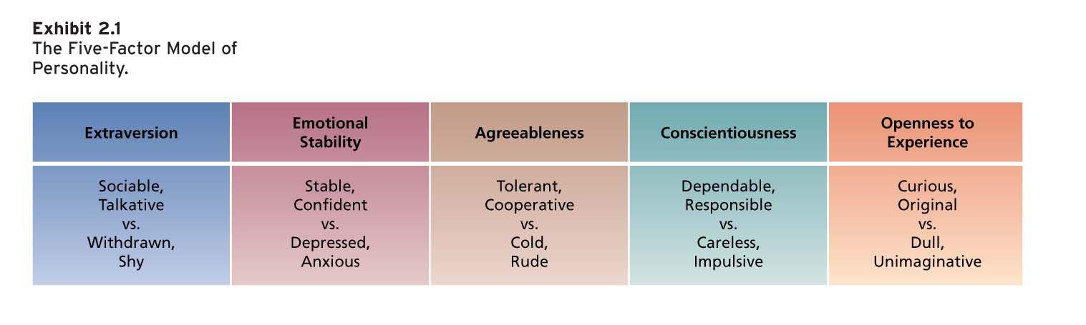
The Big Five dimensions are relatively independent
Locus of Control
The individuals’ belief about the location of the factors that control their behavior.
- High internals believe the opportunity to control their own behavior resides within themselves.
They tend to see stronger links between the effort they put into their jobs and the performance level they achieve. They are more satisfied with their jobs, more committed to their org, earn more money, and achieve higher organizational positions.
- High externals believe that external forces determine their behavior.
Self-Monitoring
The extent to which people observe and regulate how they appear and behave in social settings and relationships.
Low self-monitoring are not so concerned with scoping out and fitting in with those around them.
High self-monitoring take great care to observe the thoughts, actions, and feelings of those around them and control the images they project.
- Show concern for socially appropriate behavior and social cues, and regulate behavior and self-presentation according to these cues.
- Gravitate to jobs requiring role-play and use of self-presentation skills.
- More involved in jobs, perform better, and more likely to emerge as leaders.
- Experience more role stress and show less commitment to organization.
Disadvantages
They are unlikely to feel comfortable in ambiguous social settings in which it is hard to determine exactly what behaviors are socially appropriate. Dealing with unfamiliar cultures might provoke stress.
What do employees learn?
- Practical skills: Job-specific skills, knowledge, and technical competence. Employees learn new skills to improve performance. Learning can give an org a competitive advantage.
- Intrapersonal skills: skills such as problem solving, critical thinking, learning about alternative work processes, and risk taking.
- Interpersonal skills: include interactive skills such as communicating, teamwork, and conflict resolution.
- Cultural awareness: involves learning the social norms of organizations and understanding company goal, business operations, and company expectations and priorities.
Operant Learning Theory
The subject learns to operate on the environment to achieve certain consequences. These consequences usually depend on the behavior, and this connection is what is learned.
Increasing the probability of behavior
Reinforcer: Stimulus that follows some behavior and increases or maintains the probability of that behavior.
- Positive reinforces work by their application to a situation
- Negative reinforces work by their removal from a situation
Positive Reinforcement
Increases or maintains the probability of some behavior by the application or addition of a stimulus to the situation in question.
The appearance of the reinforcer is dependent or contingent on the occurrence of that behavior.
In general, positive reinforces tend to be pleasant things, such as food, praise, money, or business success.
Whether or not something is a positive reinforce depends only on whether it increases or maintains the occurrence of some behavior by its application.
Negative Reinforcement
- Usually an unpleasant stimuli
- Removal of a stimulus from a situation that increases or maintains the probability of some behavior.
- Removed or prevented stimulus is a negative reinforcer.
Managers who continually nag their employees unless the employees work hard are attempting to use negative reinforcement. The only way employees can stop the aversive nagging is to work hard.
- However, nagging could also serve as a positive reinforcement to increase the probability of unproductive responses if an employee has a need for attention and nagging is the only attention the manager provides.
In the first case, nagging is negative reinforcement (it is terminated following productive responses)
In the second case, nagging is a positive reinforce (it is applied following unproductive responses)
- In both cases, the responses increase in probability
Organizational errors involving reinforcement
Managers sometimes make errors in trying to use reinforcement.
The most common errors are:
- Confusing rewards with reinforcers
- Neglecting important sources of reinforcement
- Organizations often fail to appreciate individual differences in preferences for reinforcers.
Two important sources of reinforcement that managers often ignore
- Performance feedback: involves providing quantitative or qualitative information on past performance for the purpose of changing or maintaining performance in specific ways. It is mostly effective when it is
- Conveyed in a positive manner
- Delivered immediately after the performance is observed
- Represented visually (char or graph)
- Specific to the behavior that is being targeted for feedback
- Social Recognition: involves
- Informal acknowledgement
- Attention
- Praise and approval
- Genuine appreciation for work well done from an individual or group to another.
Reinforcement Strategies
To obtain fast acquisition of some response, continuous and immediate reinforcement should be used – the reinforcer should be applied every time the behavior of interest occurs, and it should be applied without delay after each occurrence.
Behavior tends to be persistent when it is learned under conditions of partial and delayed reinforcement. That is, it will tend to persist under reduced or terminated reinforcement when not every instance of the behavior is reinforced during learning or when some time period elapses between its enactments and reinforcement.
All this suggests that managers have to tailor reinforcement strategies to the needs of the situation. Often, manager must alter the strategies over time to achieve effective learning and maintenance of behavior
Summary of reinforcement strategies and their effects
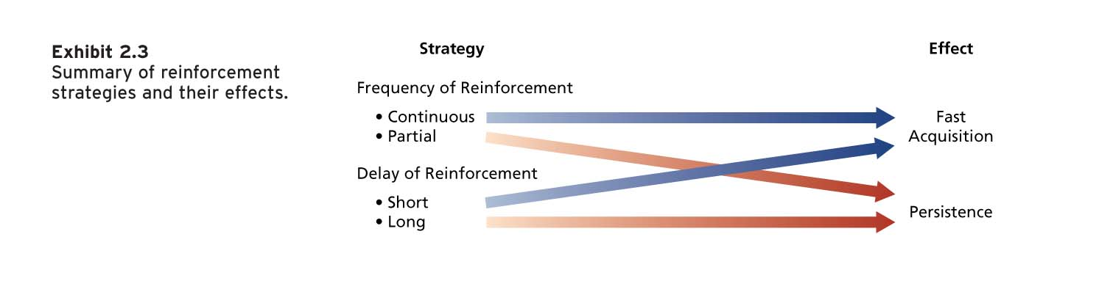

Reducing the probability of behavior
Two strategies that can reduce the probability of learned behavior
- Extinction: simply involves terminating the reinforcement that is maintaining some unwanted behavior. If the behavior is not reinforced, it will gradually be extinguished. See page 58 for example. Extinction works best = coupled with reinforcement of a desired substitute behavior.
- Punishment: involves following an unwanted behavior with some unpleasant, aversive stimulus. In theory, when the actor learns that the behavior leads to unwanted consequences, this should reduce the probability of the response. Applying aversive stimulus following unwanted behavior to decrease probability of behavior. Employee needs to know that his/her behavior is what leads to the undesirable consequences.

- In negative reinforcement a nasty stimulus is removed following some behavior, increasing the probability of that behavior. With punishment a nasty stimulus is applied after some behavior, decreasing the probability of that behavior.
Problems using punishment
- Does not demonstrate which behaviors should replace the punished response:
- Punishment temporarily suppresses unwanted behavior.
- Punishment can provoke strong emotional reactions from the punished individual.
Using punishment effectively
- Provide an acceptable alternative for punished response.
- Keep one’s emotions under control when punishing; e.g., do not punish employee in front of others.
- Make sure the chosen punishment is truly aversive.
- Punish immediately.
- Do not inadvertently punish desirable behavior (e.g., demoting someone who pointed out inefficiencies).
In general, reinforcing correct behaviors and extinguishing unwanted responses are safer strategies for managers than the frequent use of punishment.
Summary of learning effects
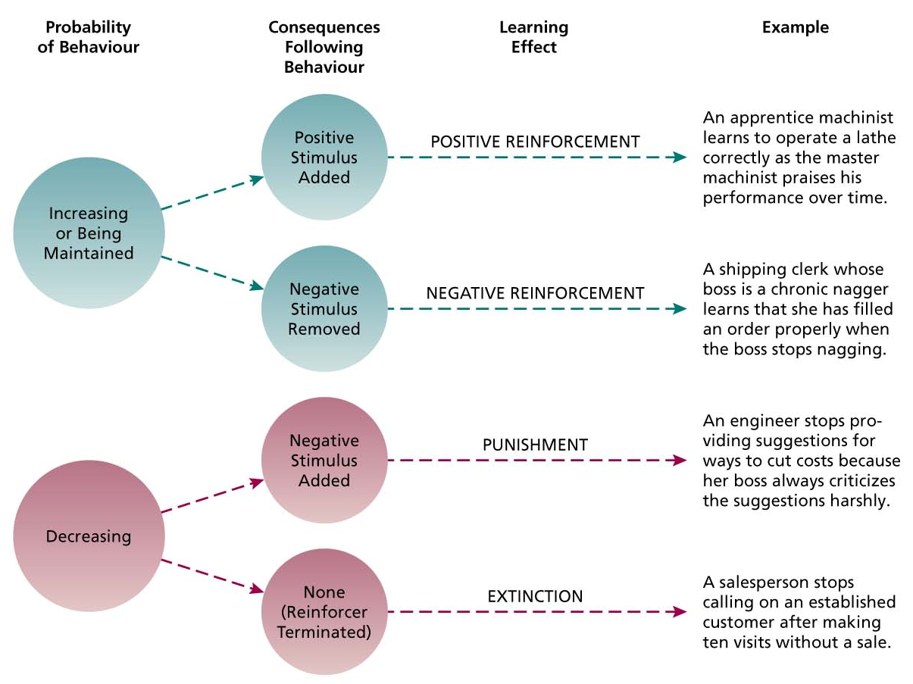
Social Cognitive Theory
- Emphasizes the role of cognitive processes in regulating people’s behavior.
- People learn by observing the behavior of others (vicarious learning).
- People regulate their own behavior by thinking about the consequences of their actions, setting goals, monitoring performance, and rewarding themselves.
- Human behavior can best be explained through a system of triadic reciprocal causation in which personal factors and environmental factors work together and interact to influence people’s behavior.
- People’s behavior also influences both personal and environmental factors.
Components of social cognitive theory by Bandura (1986):
Modelling;
- The process of imitating the behavior of others, resulting in self-reinforcement.
- Attractive, credible, competent, high-status people are most likely to be imitated.
- It is important that the model’s behavior result in positive consequences and that it is vivid and memorable (i.e., boring people often do not elicit much mimicking).
- Generally, observational learning involves examining the behavior of others, seeing what consequences they experience, and thinking about what might happened if we act the same way.
Self-efficacy;
- Beliefs people have about their ability to successfully perform a specific task:
- It is a cognitive belief that can be changed and modified in response to different sources of information.
- Self-efficacy ≠ self-esteem ≠ general self-efficacy
- Self-efficacy influences the activities people choose to perform, the amount of effort and persistence devoted to a task, affective and stress reactions, and job performance.
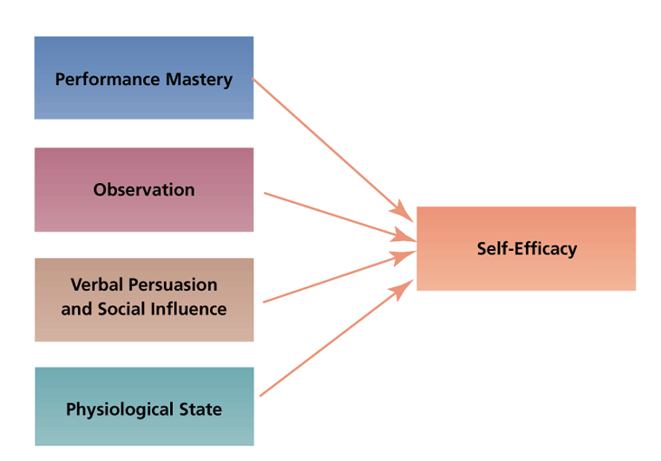
Self-regulation
- The use of learning principles to regulate one’s own behavior, rather than that of others.
- A key part of the process is people’s pursuit of self-set goals that guide behavior.
- This process involves: self-observation (observing one’s own behavior), self-evaluation (comparing the behavior with standard), and self-reinforcement (rewarding oneself if the behavior meets the standard).
- Two processes lie at the heart of self-regulation:
  - Discrepancy reduction (i.e., reduce discrepancy between unmet goals and performance).
  - Discrepancy production (i.e., produce discrepancy between attained present goals and more challenging future ones).
Self-regulation techniques:
- Collect self-observation data (data about one’s own behavior)
- Observe models
- Set goals
- Rehearse
- Reinforce oneself

CHAPTER 3

PERCEPTIon, attribution, and diversity
What is perception?
The process of interpreting the messages of our senses to provide order and meaning to the environment.
Components of perception
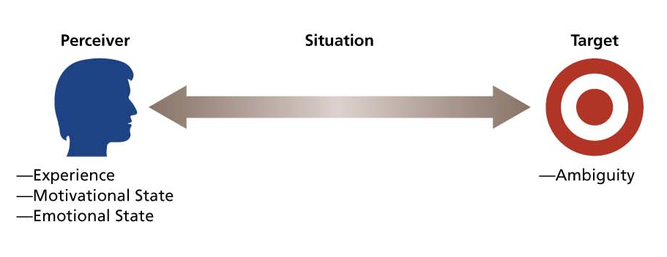
- The perceiver
- Past experiences lead the perceiver to develop expectations that affect current perceptions.
- Needs unconsciously influence perceptions by causing us to perceive what we wish to perceive.
- Emotions, such as anger, happiness, or fear, can influence our perceptions.
Perceptual defence, when our perceptual system defend us against unpleasant emotions. It is working to ensure that we do not see or hear things that are threatening.
- People often “see what they want to see” and “hear what they want to hear.”
- To ensure we do not see or hear things that are threatening:
- The target
- Ambiguous targets are susceptible to interpretation and the addition of meaning.
- Perceivers have a need to resolve ambiguities.
- The perceiver does not or cannot use all the information provided by the target.
- The situation
- Perception occurs in some situational context, and this context can affect what is perceived.
- Situation adds information about target.
- Perception of a target can change with the situation even when the perceiver and target remain the same:
  - E.g., Muslim employees reported a greater incidence of discrimination following 9/11
A model of the perceptual process
When the perceiver encounters an unfamiliar target, the perceiver needs information on which to base perceptions of the target and will actively seek out cues to resolve this ambiguity. The perceiver encounters familiar cues that enable her or him to make a categorization of the target, which follows from social identity theory.
Bruner’s model demonstrates three important characteristics of the perceptual process.
- Selective, perceivers do not use all the available cues, and those they do use are thus given special emphasis.
- Constancy, the tendency for the target to be perceived in the same way over time or across situations.
- Consistency, the tendency to select, ignore, and distort cues in such a manner that they fit together to form a homogenous picture of the target.
BASIC BIASES IN PERSON PERCEPTION
- Primacy and Recency Effects
Primacy effect: the tendency for a perceiver to rely on early cues or first impressions (lasting impact).
Recency effect: the tendency for a perceiver to rely on recent cues or last impressions (last impressions count most).
- Reliance on Central Traits
- Central traits, personal characteristics of a target person that are of particular interest to a perceiver.
- The centrality of traits depends on the perceiver’s interest and the situation.
- Central traits have a very powerful influence on our perceptions of others.
- Attractive people have more chances to be hired than unattractive people. As well as, physical height is related to job performance, promotions, and career success.

- Implicit Personality Theories
Personal theories that people have about which personality characteristics go together. Implicit theories are inaccurate; they provide a basis for misunderstanding.
  - E.g., hardworking people are more honest.
  - E.g., socially dominant people are less emotional.
  - E.g., “Think manager – Think male”
- Projection
The tendency for perceivers to attribute their own thoughts and feelings to others.
Also considered as an efficient and sensible perceptual strategy.
People with similar backgrounds or interests often DO think and feel similarly.
- Stereotyping
Tendency to generalize about others in a social category and ignore variations among them.
Categories on which people base stereotypes:
  - Race
  - Age
  - Gender
  - Ethnic background, including religion
  - Social class
  - Occupation
ATTRIBUTION: Perceiving causes and motives
Attribution, the process by which we assign causes or motives to explain people’s behavior. The attribution process is important because many rewards and punishments in organization are based on judgments about what really caused a target person to behave in certain way.
Dispositional attributions, explanations for behavior based on an actor’s personality or intellect.
Situational attributions, explanations for behavior based on an actor’s external situation or environment.
- Consistency Cues: Reflect how consistently a person engages in a behavior over time. Does he/she engage in the behavior regularly and consistently?
  - High consistency behavior → dispositional attributions.
- Consensus Cues: Reflect how a person’s behavior compares with that of others. Do most people engage in the behavior, or is it unique to him/her?
- Low consensus behavior → dispositional attributions
- Distinctiveness Cues: Reflect the extent to which a person engages in some behaviour across a variety of situations. Does he/she engage in the behavior in many situations, or is it distinctive to just one?
- Low distinctiveness behavior → dispositional attributions.
Biases in Attribution
- Fundamental attribution error
When we make judgements about the behavior of people other than ourselves. We fail to realize that the observed behavior is distinctive to a particular situation.
- Actor-observer effect
The propensity for actors and observers to view the causes of the actor’s behavior differently.
- Self-serving bias
The tendency to take credit for successful outcomes and to deny responsibility for failures.
PERSON PERCEPTION AND WORKFORCE DIVERSITY
Workforce diversity refers to the differences among employees or potential recruits in characteristics such as gender, race, age, religion, cultural background, physical ability, or sexual orientation.
The changing workplace
Facts:
- The workforce is becoming more diverse
- There is growing recognition that many organizations have not successfully managed workforce diversity
Competitive advantage to valuing work diversity
- Human resource-acquisition: best people will flock to these companies
- Marketing: Improvement in segmentation and target marketing
- Creativity and problem-solving: diversity of perspectives
- System flexibility: increased fluidity should create more expedient reactions to environmental changes
Stereotypes and workforce diversity
Occurs when members of social group (e.g. visible minorities or women) feel they might be judged or treated according to a stereotype and that their behavior and/or performance will confirm the stereotype.
- A major barrier to valuing diversity is the stereotype.
- Common workplace stereotypes include:
  - Racial and ethnic stereotypes
  - Gender stereotypes
  - Age stereotypes
Racial, ethnic, and religious stereotypes
Discrimination in hiring has also been found to occur when job applicants have and ethnic sounding name. Career advancement based on racial or ethnic stereotypes are common.
Attributions play an important role in determining how job performance is interpreted.
Racial and ethnic stereotypes are also important in the context of the increasing globalization of business.
Gender stereotypes
- One of the most problematic stereotypes for organizations is the gender stereotype.
- Women are severely underrepresented in managerial jobs.
- Stereotypes of women do not correspond well with stereotypes of businesspeople or managers.
- Successful managers = seen as more similar to men in qualities such as leadership, competitiveness, self-confidence, ambitiousness, and objectivity.
- Detrimental effects of gender stereotypes are reduced or removed when decision makers have:
- Good information about the qualifications and performance of particular women
- An accurate picture of the job that they are applying for or seeking promotion into.
Age stereotypes
Tendency to make assumptions about the person’s physical, psychological, and intellectual capabilities.
- Older workers are seen as:
  - having less capacity for performance
  - less productive
  - less creative
  - less logical
  - less capable of performing under pressure
  - less potential for development
- But:
  - More honest, dependable, and trustworthy.
  - Less likely to make impulsive decisions.
  - Better able to control their emotions.
  - Better able to abandon their goals and pursue other goals more “easily” than younger workers.
Managing Workforce Diversity
To have a positive impact on OB, management can use the following strategies to achieve and manage a diverse workforce:
  - Recruiting (e.g., diverse recruiting teams)
  - Retention (e.g., flexible work-life programs)
  - Development (e.g., mentoring programs)
  - Communication (e.g., celebrate diversity)
  - Training (e.g., group training)

chapter 4

VALUES, ATTITUDES, AND WORK BEHAVIOR
What are values?
Broad tendency to prefer certain states of affairs over others:
  - What we consider good and bad.
  - Motivational and very general.
  - Categorized into several categories (e.g., intellectual, economic, social, etc.).
  - Reinforced by parents and peers; reciprocally related with stereotypes.
  - People hold values structured around achievement, power, autonomy, conformity, tradition, and social welfare.
Occupational Differences in Value
- Members of different occupational groups hold different values:
  - E.g., purchasing and sales.
- Good “fit” between values of employees and supervisors and organization:
  - Enhances job attitudes (e.g., satisfaction, commitment)
  - Lowers unwanted behaviors (e.g., absenteeism, turnover).
Hofstede’s Study
Geert Hofstede questioned over 116,000 IBM employees in 40 countries about their work-related values.
Discovered 4 dimensions along which work-related values differed across cultures:
  - Power distance
- Extent to which an unequal distribution of power is accepted by society members.
In small power distance cultures:
- Inequality is minimized.
- Superiors are accessible.
- Power differences are downplayed.
In large power distance cultures:
- Inequality is accepted as natural
- Superiors are inaccessible
- Power differences are heightened.
Canada and the United States low power distance.
  - Uncertainty avoidance
- Extent to which people are uncomfortable with uncertain and ambiguous situations.
Strong uncertainty avoidance cultures stress:
- Rules and regulations.
- Hard work.
- Conformity.
- Security.
Cultures with weak uncertainty avoidance:
- Less concerned with rules, conformity, and security
- Risk taking is valued.
Canada and the United States are well below average on uncertainty avoidance.
  - Masculinity/femininity
- Masculine cultures:
- Differentiate gender roles.
- Support the dominance of men.
- Stress economic performance.

- Feminine cultures:
- Accept fluid gender roles.
- Stress sexual equality.
- Stress quality of life.
The GLOBE research identified to aspects to this dimension: how assertive people are and how much they value gender equality.
- Individualism/collectivism
Individualistic societies stress:
  - Independence.
  - Individual initiative.
  - Privacy.
Collective societies favor:
  - Interdependence.
  - Loyalty to family or clan.
The United States, Australia, Great Britain, and Canada are among the most individualistic societies.
Venezuela, Colombia, and Pakistan are among the most collective, with Japan falling about mid-pack.
The GLOBE research identified to aspects to this dimension: how much the collective distribution of resources is stressed and how much one’s group or org elicits loyalty.
- Long term/ Short term orientation (Eastern cultures)
Subsequent work by Hofstede with Canadian Michael Bond resulted in this 5th dimension.
Cultures with a long-term orientation stress:
  - Persistence.
  - Perseverance.
  - Thrift.
  - Close attention to status differences.
Cultures with short-term orientation stress:
- Personal steadiness and stability
- Face-saving
- Social niceties
What are attitudes?
- Tendency to respond consistently to some specific object, situation, person, or category
- Attitudes are a function of what we think and what we feel. That is, attitudes are the product of a related belief and value
Belief + Value = Attitude Behavior
Example
“My job is interfering with my family life.” (Belief)
“I dislike anything that hurts my family” (value)
“I dislike my job” (attitude)
“I’ll search for another job” (behavior)
What is job satisfaction?
Collection of attitudes that workers have about their jobs.
- 2 aspects of satisfaction:
  - Facet satisfaction, i.e., tendency for employee to be + or - satisfied with various facets of the job (work itself, compensation, career opportunities, recognition, benefits).
  - Overall satisfaction.
Most popular measure of job satisfaction is the Job Descriptive Index (JDI):
- Designed to evaluate around 5 facets of satisfaction.
- People
- Pay
- Supervision
- Promotions
- Work-itself
- Employees respond “yes,” “no,” or “?” in describing whether a particular word or phrase is descriptive of particular facets of their jobs.
Minnesota Satisfaction Questionnaire (MSQ) is also a popular measure of job satisfaction:
- Respondents indicate how happy they are with various aspects of their job on a scale ranging from “very satisfied” to “very dissatisfied.”
What determines job satisfaction?
2 employees might express same level of overall satisfaction for very different reasons.
- A person’s job satisfaction is determined by:
  - Discrepancy.
Job satisfaction stems from the discrepancy between the job outcomes wanted and the outcomes that are perceived to be obtained.
E.g., Satisfaction with one’s pay is high when there is a small gap between the pay received and the perception of how much pay should be received.
  - Fairness.
Issues of fairness affect both 1) what people want from their jobs, and 2) how they react to discrepancies.
Three basic kinds of fairness:
    - Distributive: occurs when people receive the outcomes they think they deserve from their jobs. Involves the distribution of work rewards and resources.
Equity theory offers a way of understanding how people determine what is fair.
Job satisfaction stems from a comparison of the inputs one invests in a job and the outcomes one receives in comparison to the inputs and outcomes of another person or group.
Equity perceived when the following distribution ratios exist:
My outcomes = Other’s outcomes
My inputs Other’s inputs
- Inputs: Anything that you give up or offer to your organization in exchange for outcomes.
- Outcomes: Anything your organization distributes to you in exchange for your inputs.
- Other: Co-worker performing the same job, your team, or even your conception of all the individuals in your occupation..
Inequity = dissatisfying state, especially when we are on the “short end of the stick.”
    - Procedural Fairness
- Process used to determine work outcomes are seen as reasonable.
- Concerned with how outcomes are decided and allocated.
- Procedural fairness is especially likely to provoke dissatisfaction when people also see distributive fairness as being low.
Relevant to outcomes:
- Performance evaluations
- Pay raises
- Promotions, layoffs, and work assignments.

    - Interactional Fairness how these matters were communicated to us
- The actual procedures used to the interpersonal treatment received when learning about the outcome.
- People feel that they have received respectful and informative communication about an outcome.
- Important because it is possible that fair outcomes or procedures are perceived as unfair when they are inadequately or uncaringly explained.
- People who experience interactional unfairness = most likely dissatisfied with boss.
- People who experience procedural unfairness = most likely dissatisfied with system.
- Disposition
Could your personality contribute to your feelings of job satisfaction?
Based on the idea that some people are predisposed by virtue of their personalities to be + or - satisfied despite changes in discrepancy or fairness.
- People who are extraverted and conscientious tend to be more satisfied with their jobs.
- Those high in neuroticism are less satisfied.
- People who are high in self-esteem and internal locus of control are more satisfied, as are those who are optimistic and proactive.

- Mood and emotion
“Affect” = broad label for feelings that includes emotions and moods.
Emotions are intense, short-lived feelings caused by a particular event such as a bad performance appraisal.
Affect also refers to moods which are less intense, longer-lived, and more diffuse.
- Jobs consist of a series of events and happening that have the potential to provoke emotions or to influence moods, depending on how we appraise these events and happenings.
- Perceived unfairness can affect job satisfaction via emotion
Affective events theory
Emotional contagion: a way in which mood an emotion can influence job satisfaction. The tendency for moods and emotions to spread between people or throughout a group.
- Mood and emotion can also influence job satisfaction through emotional regulation (ER).
- ER: Requirement for people to conform to certain “display rules” in their job behavior in spite of their true mood/emotions.
- AKA “emotional labor.”
- Frequent need to suppress negative emotions can lower job satisfaction and increase stress.
- Suppress negative emotions and fake emotions that you do not really feel take a toll on a job satisfaction and increase stress. Express positive emotions, especially when you really are feeling positive (boosts job satisfaction)
Key contributors to Job Satisfaction
  - Mentally challenging work (and performance feedback).
  - Adequate compensation.
  - Career opportunities (promotions signal self-worth).
  - People (competence > friendliness at higher levels).
Consequences of Job Satisfaction
  - Absence from work (or “absenteeism”).
- Absenteeism is very costly.
- Less satisfied employees = more likely to be absent
- Satisfaction with the content of the work = best predictor of absenteeism.
  - Turnover.
- Resignation; it can be extremely expensive
- Moderately strong connection between job satisfaction and turnover
- Less-satisfied workers = more likely to quit
- Intentions = good predictor of turnover.
- Due to: shocks, employee’s dissatisfaction, embedded in the community, weak job.
Hangover effect: overall satisfaction with the new job decreases.
  - Job performance.
- Job satisfaction = ↑ job performance.
- Most important facet for predicting performance = content of work itself.
- Job satisfaction ⇔ job performance
- When good performance is followed by rewards, employees are more likely to be satisfied.
  - Organizational citizenship behavior (“OCB”).
Voluntary, informal behavior that contributes to organizational effectiveness.
- Informal behavior that contributes to organizational effectiveness.
- Job satisfaction strongly related to OCB
- It extends beyond simply doing you a personal favor.
Characteristics:
- Voluntary and spontaneous.
- Helps to improve work.
- Unlikely to be rewarded by performance evaluation system.
Forms:
- Helping behavior
- Conscientiousness to the details of work
- Being a good sport
- Courtesy and cooperation
How does job satisfaction contribute to OCB?
  - Fairness, especially procedural and interactional fairness from a supportive manager.
  - Employees’ mood at work, especially pleasant/relaxed/optimistic moods.
FAIRNESS is the KEY -> job satisfaction
  - Customer satisfaction and profit.
Employee job satisfaction is indeed translated into customer or client satisfaction and organizational profitability. Organizations with higher average levels of employee satisfaction are more effective.
WHAT IS ORGANIZATIONAL COMMITMENT?
- Attitude reflecting strength of the relation between an employee and an organization.
- Employees can also be committed to various constituencies within and outside the organization.
- Each type of commitment could also apply to one’s work team, union, or profession.
  - E.g., supervisor commitment.
Three types of OC:
  - Affective commitment.
- Based on a person’s identification and involvement with an organization.
- People with high affective commitment stay with an organization because they want to.
  - Continuance commitment.
- Based on the costs that would be incurred in leaving an organization.
- People with high continuance commitment stay with an organization because they have to.
  - Normative commitment.
- Based on ideology or a feeling of obligation to an organization.
- People with high normative commitment stay with an organization because they think they should.
Key contributors to organizational commitment
- Best predictor of affective commitment = interesting and satisfying work.
- Also, role clarity and having one’s expectations met after being hired.
- Continuance commitment: when people feel that leaving the company will result in personal sacrifice or good alternative employment is lacking.
- Continuance commitment increases with time a person spends in an organization.
- Normative commitment = fostered by benefits that build a sense of obligation to the company.
- Strong identification with company’s product or service also fosters normative commitment.
- Socialization practices that emphasize loyalty to the company can stimulate normative commitment.
Consequences of Organizational Commitment
- All 3 forms of commitment reduce turnover intentions and actual turnover.
- Affective commitment is positively related to performance.
- Continuance commitment is negatively related to performance.
Downside to OC?
- High levels of commitment can cause conflicts between family life and work life.
- High levels of commitment have been implicated in unethical and illegal behavior.
- High levels of commitment to a particular form or style of organization can cause a lack of innovation and lead to resistance when a change in culture is necessary.

Chapter 5

Theories of work motivation
What is motivation?
Extent to which persistent effort is directed toward a goal.
- Basic characteristics of motivation:
  - Effort
  - Persistence
  - Direction
  - Goals
Extrinsic and Intrinsic motivation
Intrinsic: stems from the direct relationship between the worker and the task; it is usually self-applied.
- Motivators:
  - Feelings of achievement
  - Challenging work
  - Sheer interest in the work
Extrinsic: stems from the work environment external to the task; it is usually applied by others.
- Motivators:
  - Salaries and bonuses, including signing
  - Fringe benefits (e.g., tickets to the opera)
  - Stock ownership
Research suggests that the availability of extrinsic motivators can reduce intrinsic motivation.
  - Why? Because tangible rewards decrease one’s feelings of autonomy.
Both kinds of rewards are important and compatible in enhancing work motivation.
- Self determination theory (SDT): used by intrinsic and extrinsic motivation to explain what motivates people and whether motivation is autonomous or controlled.
Autonomous motivation: when people are motivated by intrinsic factors, where they are in control of their motivation.
Controlled motivation: when people are motivated to obtain a desired consequence or extrinsic reward, their motivation is controlled externally.
MOTIVATION AND PERFORMANCE
Performance: the extent to which and organizational member contributes to achieving the objectives of the organization.
General Cognitive Ability (GCA)
- A person’s basic information-processing capacities and cognitive resources
- GCA or CA = Mental ability
- GCA predicts learning, training success, and job performance.
- Better predictor of job performance for more complex and higher-level jobs.
Emotional Intelligence (EI)
- Ability to understand and manage not only one’s own feelings and emotions, but also those of others.
- Leaders are “managers of group’s emotions.”
- 4 interrelated sets of skills:
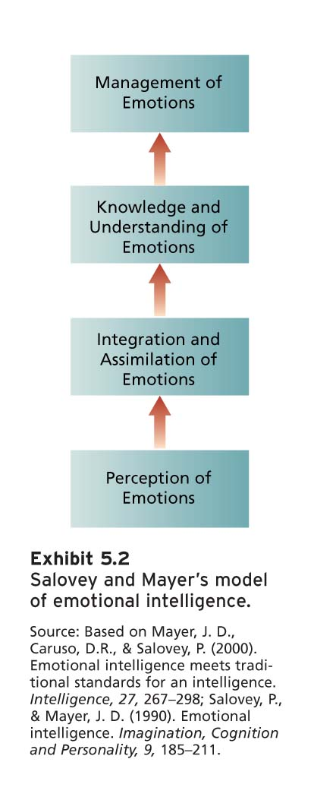
Summary
- It is possible for performance to be ↓ even when a person is highly motivated.
- We cannot consider motivation in isolation.
- ↑ motivation will not result in ↑ performance if employees are deficient in important skills and abilities.
NEED THEORIES OF WORK MOTIVATION
- Motivation theories specifying what motivates:
  - Kinds of needs people have (i.e., the “what”)
  - Conditions under which they will be motivated to satisfy these needs
NEEDS BEHAVIOR INCENTIVES & GOALS
McClelland’s Theory of Needs
- Outlines conditions under which certain needs result in particular patterns of motivation.
- Needs reflect relatively stable personality characteristics.
- 3 needs: 1) achievement, 2) affiliation, and 3) power.
Achievement
- Strong desire to perform challenging tasks well.
- Individuals with a ↑ nAch:
  - Prefer situations in which they showcase personal responsibility.
  - Set moderately difficult goals (calculated risks).
  - Desire performance feedback.
  - Concerned with innovation and long-term goal involvement
Affiliation
- Strong desire to establish friendly, compatible interpersonal relationships.
- People with a ↑ nAff have an ability to learn social networking quickly and a tendency to communicate frequently with others.
Power
- Strong desire to influence others, making a significant impact or impression.
- People with a ↑ nPow seek out social settings in which they can be influential.
- Power = used to serve the power seeker, other people, or the organization.
According to McClelland
- People with high ↑ nAch:
  - Sales jobs and entrepreneurial positions
  - People with ↑ nAff:
  - Social work and customer relations
  - People with ↑ nPow:
  - Journalism, politics, and management
PROCESS THEORIES OF WORK MOTIVATION
- Motivation theories specifying how motivation occurs.
Three important process theories:
  - Expectancy theory
  - Equity theory
  - Goal setting theory
- Vroom’s Expectancy Theory

Boost up valence, instrumentality and expectancy to move the motivation from low to high levels of performance.
- Components:
  - Outcomes: consequences that may follow certain work behaviors
- 1st-level outcomes interest the organization (e.g., performance), whereas 2nd-level outcomes interest the individual (e.g., money).
- Expectancy theory specifies how an employee attempts to choose one 1st-level outcome (e.g., high performance) over another (e.g., average or no performance).
  - Expectancy
- Probability that the worker can achieve a particular 1st-level outcome (e.g., either high or average performance).
- In other words, expectancy is the effort-performance link.
  - Instrumentality
- Probability that a particular 1st-level outcome will be followed by a particular 2nd-level outcome.
- In other words, instrumentality is the performance-rewards link.
- E.g., “Due to rumors that we’re about to fall in a recession, I’m not sure that the company will offer me the full 10%” (so, I = 0.5)
  - Valence
- Expected value of outcomes, of the extent to which they are attractive or unattractive to the individual.
- In other words, valence is the rewards-personal goals link.
- 3 values: +ve = preference for attaining outcome; -ve = preference for not attaining outcome; 0 = indifferent to attaining outcome.
  - Force
- End product of the theory’s components.
- Force = degree of effort that will be directed toward various 1st-level outcomes.
- Force directed toward a 1st-level outcome is:
force = first-level valence x expectancy
- We can expect an individual’s effort to be directed toward the 1st-level outcome that has the largest force product.
Expectancy Theory
- People are motivated to perform in work that they find attractive and feel they can accomplish.
- Attractiveness of work depends on extent to which it leads to favorable personal consequences.
- Based on perceptions of individual worker.
- Equity Theory
- Motivation stems from comparison of inputs one invests in a job and outcomes one receives in comparison with the inputs and outcomes of another person or group.
- Individuals are motivated to maintain an equitable exchange relationship.
- When the ratios are equal, the worker should feel that a fair and equitable exchange exists with the employing organization
Possible tactics for reducing inequity:
  - Perceptually distort one’s own inputs or outcomes
  - Perceptually distort inputs or outcomes of comparison person or group
  - Choose another comparison person or group
  - Alter either one’s inputs or outcomes
  - Leave the relationship
Gender and Equity
- Both men and women tend to choose same-sex comparison persons.
- This might provide a partial explanation for why women are paid less than men, even for the same job.
- Goal setting theory
Goal = object or aim of an action.
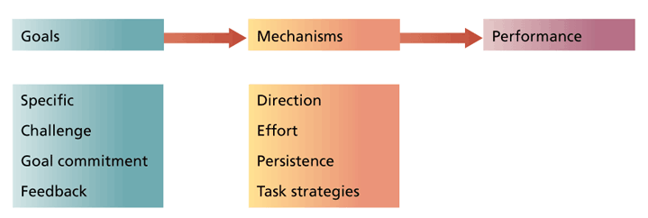
- Goals are most motivational when they are:
  - Specific (direction)
  - Challenging (effort)
  - Sought by committed employees (persistence)
  - Provided with feedback regarding the progress toward goal attainment (strategies)
Enhancing Goal commitment
- Participation improves goal commitment and facilitates performance at times:
  - When a climate of distrust exists between management and employees.
  - When participation provides information that assists in establishing fair and realistic goals.
  - When there is a need to increase the difficulty of the goals that employees adopt.
- Coercive supervisors can badly damage employee goal commitment.
- Supervisors must demonstrate a desire to assist employees in goal accomplishment and behave supportively if failure occurs.
- Specific, difficult goals → improved performance and productivity.
- Effects of goal setting on performance depend on a number of factors:
When individuals lack skills to perform complex tasks, a specific and challenging performance goal can decrease performance.
MOTIVATION THEORIES ACROSS CULTURE
- Most theories involving human needs will come up against some cultural limitations.
- Equity theory will be constrained by what is considered “fair” in a particular culture (e.g., equity vs. equality).
- Expectancy theory is very effective when applied cross-culturally.
- Setting specific and challenging goals is motivational when applied cross-culturally.
- The goal setting process must be adjusted to the culture (e.g., individual vs. group goals).
- Appreciating cultural diversity is critical for maximizing motivation.

chapter 6

motivation in practice
JOB CHARACTERISTIC MODEL
- Hackman & Oldham (1980)
- JCM: Several “core” job characteristics have a psychological impact on workers.
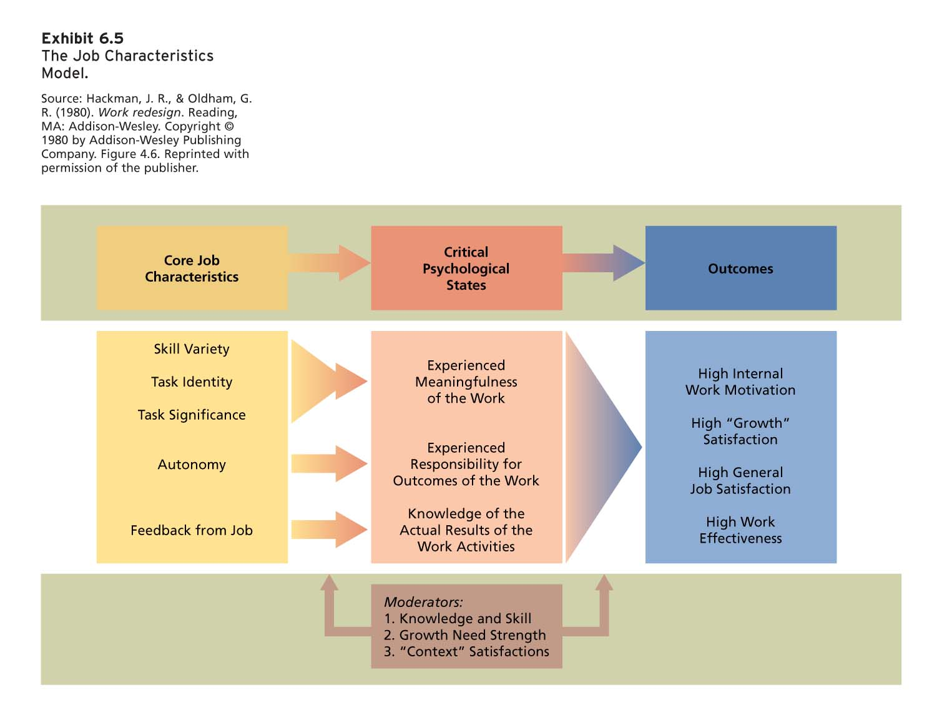
Five core characteristics:
- Skill variety: cutting, assembling,
- Task identity: whether the employee has the ability to complete the job from A to C. In other words, whether you are doing to job from beginning to end (more motivational)
- Task significance: whether or not you believe the task is important for the organization or for other people. Jobs that are making a change on people’s life or organization.
- Autonomy: whether you have some source of control. Decide the order you do things (any type of control)
- Marker: the teacher high autonomy
- When the teacher has markers their autonomy is low
- Feedback from Job: whether the job is able to give you feedback to know if you are doing a good job or not (tips)
Critical Psychological States
This 5 characteristics lead to critical psychological states:
  - Experienced meaningfulness of the work;
  - Experienced responsibility for the outcomes of the work;
  - Knowledge of the actual results of the work.
Leads to outcome
- Jobs that are high on skill variety, task significance, and task identity are perceived as more meaningful.
- Jobs that are high on autonomy provide for greater responsibility for work outcomes.
- Jobs that are high on feedback provide workers with knowledge of the results of their work activities.
Outcomes
- Presence of critical psychological states leads to outcomes that are relevant to the individual and the organization:
  - High intrinsic motivation
  - High-quality productivity
  - Satisfaction with higher-order needs
  - General satisfaction with job
  - Reduced absenteeism, turnover
Moderators
- 3 moderator (or contingency) variables intervene between job characteristics and outcomes:
  - Job-relevant knowledge and skills of the worker.
  - Growth need strength, i.e., extent to which people desire to achieve higher-order need satisfaction.
  - “Context” satisfactions (e.g., pay, supervision, company policies).
Job Enrichment
- Design of jobs to enhance intrinsic motivation, quality of working life, and job involvement.
- Involves increasing motivating potential of jobs by arranging their core job characteristics.
- Design a job with better characteristics (increase the job characteristics)
- Designing a job without taking into consideration the external environment does not leads to good outcome.
- Link between job characteristics and outcomes
- Do not increase tasks but increase skill
- If you have a new design you should have good employees which fit the moderators
- Design a job with already established employees, then you can train them
Job enlargement
Increase skill but do not increase tasks
Many job enrichment schemes include:
- Combining tasks (skill variety)
Involves assigning tasks that might be performed by different workers to a single individual.
Should increase the variety of skills employed and might contribute to task identity.
- Establishing external client relationships (significance)
Involves putting employees in touch with people outside the organization who depend on their products or services.
Might involve the use of new interpersonal skills, increase the identity and significance of the job, and increase feedback about one’s performance.
- Establishing internal client relationships
Involves putting employees in touch with people who depend on their products and services within the organization.
Advantages are similar to those that result from establishing external client relationships.
- Reducing supervision or reliance on others
Increases the autonomy and control one has over his/her own work.
- Forming work teams (task identity)
Teams can be formed when a product or service is too large or complex for one person to complete alone or to complete an entire product.
Can result in the development of a variety of skills and increase the identity of the job.
- Making feedback more direct
Permit workers to be identified with their “own” product or service so that if a customer encounters problems, he/she can contact the worker directly.
Usually used in conjunction with other job design aspects permitting workers to be identified with their “own” product or service.
Potential Problems with job enrichment
- Job enrichment can encounter a number of challenging problems:
  - Poor diagnosis
  - Lack of desire or skill
  - Demand for rewards
  - Union resistance
  - Supervisory resistance
--------------------------------------------------------------------------------------------------------------------------
Discrepancy theory: what they got from the job is different from what I wanted (discrepancy) -> unsatisfied (does not include a social comparison). If the other person earns more money, I have to get more money.
Equity theory: outcomes that you are getting. Comparison between two ratios. Equality on the operation -> satisfied.
- Individualistic cultures (more important)
- Collectivistic cultures (equally more important than equity0. Focus is not on the individual is on a group.
Restoring Equity: what you can do to increase your satisfaction?
Less input
More outcomes (stealing from the company)
Psychological ways to change equity theory
Good -> underpayment
Bad -> overpayment -> fails -> over equity
How to increase commitment?
- Participative decision-making to make the employee that they are part from the decision-making process
- Give a reward for completing the goal that the employee has
- Punishment, positive reinforcement, positive feedback
Task which needs a lot of innovation (complex) work better simple task (increase performance)

