Results

In the following table and graph, the dominant arm represents the subject’s right forearm, while the non-dominant arm represents the subject’s left forearm.

Exercise 1 & 3
Figure 1. Relationship between intensity of EMG activity and force of a muscle contraction in the dominant and non-dominant forearms.

Exercise 2 & 4
 | Dominant Arm | Non-Dominant Arm
Max Force (kg) | 8.581 | 7.880
Time to 50% Max (s) | 18.190 | 12.806
Half Max Force (kg) | 4.2905 | 3.940
Forearm Circumference (mm) | 265 | 266
V2-V1 (kg) | 8.596 | 6.017
Figure 2. Observations of length and strength of muscle contraction and EMG activity from the dominant and non-dominant forearms during a fatigue exercise.
Discussion

Yes, there is a linear relationship between the area under the EMG trace for each clench and the force of the clench. The reasoning for this linear relationship is due to the fact that with each clench, the force increased as the subject squeezed harder, which led to an increase in EMG activity. The area under the absolute integral of the EMG proves to be linearly proportional to the strength of the muscle contraction.

As the amplitude and duration of the EMG signal of a muscle contraction is increased, the motor units being recruited will start to become larger and larger. Initially, when a muscle is activated, small motor units will be recruited, which generate a weaker degree of tension. With increasing strength of a muscle contraction, continually larger and larger motor units will be recruited. This eventually leads to a smooth increase in muscle strength by the orderly addition of progressively larger and stronger motor units, also referred to as the size principle (Olson et al., 1968). The stimulation of each motor unit also increases with increasing muscle contraction, becoming the dominating mechanism to increase motor strength once all motor units have been recruited. The sequence of recruitment typically beings with Type I motor units, slow oxidative, which are slow twitch, fatigue- resistant and have the smallest force and contraction. Eventually, motor units progress to Type IIb units, fast glycolytic, which are fast twitch, easily fatigued, with the largest force and fastest contraction (Olsen et al., 1968). Between this progression, Type IIa motor units are recruited, fast oxidative, which are also fast twitch with large forces and fast contraction, but are fatigue resistant. The stronger forearm has a slightly greater grip strength and EMG than the non-dominant arm. Typically, the dominant hand is said to posses a 10% greater grip strength than the non-dominant hand (Armstrong et al., 1999). This could be due to multiple factors such as a difference in muscle size between forearms caused by more frequent use of the dominant arm, leading to a greater grip strength, or a temperature difference occurring between the two exercises, which would lead to a poor performance from the colder forearm. Although the difference between the two forearms wasn’t quite 10%, a difference was still observable.

Forearm circumference provides the most practical method of assessing muscle mass and grip strength for both men and women (Anakwe et al., 2007). The relationship between forearm circumference and hand grip strength is positively correlated, meaning typically the larger the circumference, the greater the grip strength. There may or may not be a difference in the circumference between forearms, but a difference may be seen in one who doesn’t exercise regularly. The difference in size between forearms can be accounted for by a difference in the diameter in each muscle fibre, rather than an increase in the number of muscle fibres. The diameter of muscle fibres may vary from motor units, with Type IIb having a larger diameter as they generate higher potentials due to their increased firing rate (Olson et al., 1968).

Antagonistic pairs of muscles create movement when one contracts and the other (the antagonist) relaxes. Antagonistic muscles are recruited during a bicep curl because as the bicep (agonist) contracts, the triceps (antagonist) relaxes when on the way up, but on the way down, the roles reverse. The contracting of the antagonist allows the movement to occur. Muscle spindles also play a role in this relationship, as they are attached to regular muscle fibres, and are able to sense when a muscle is being stretched, which then sends a signal to the muscle’s motor neurons, causing the muscle to reflexively contract (Brown, 2007). Many factors may affect the quality of EMG signals, such as skin preparation, electrode material, size and positioning. EMG activity of muscle shortening and lengthening during a bicep curl show different patterns. During the shortening phase, the EMG amplitude is lower for the same force output during lengthening muscle actions (Disselhorst-Klug et al., 2009).

Appendix

Exercise 5
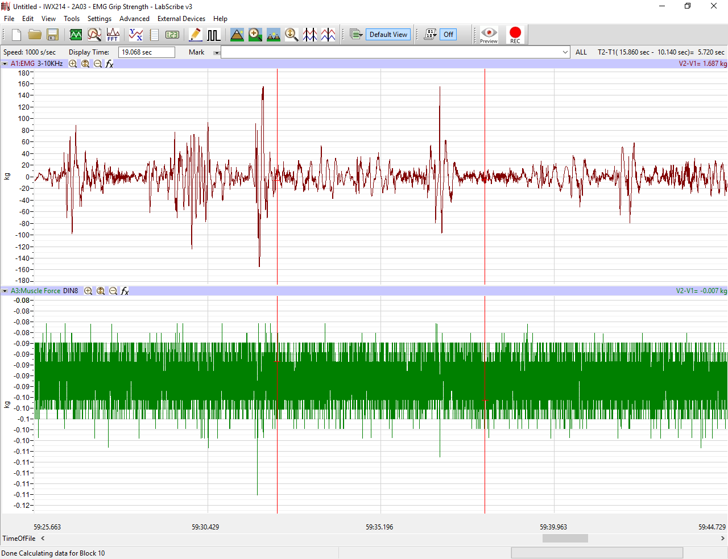
Figure 3. EMG during arm curls
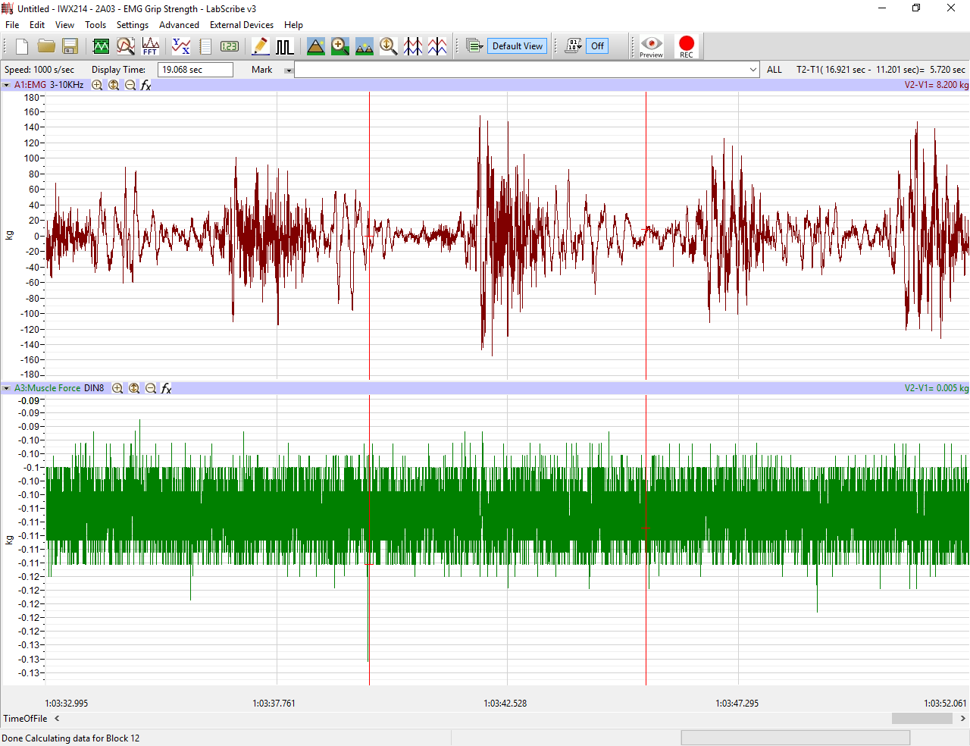
Figure 4. EMG during arm raises

References

Anakwe, R. E., Huntley, J. S., & McEachan, J. E. (2007). Grip strength and forearm circumference
in a healthy population. Journal of Hand Surgery (European Volume), 32(2), 203-209.

Armstrong, C. A., & Oldham, J. A. (1999). A comparison of dominant and non-dominant hand
strengths. Journal of Hand Surgery, 24(4), 421-425.

Brown, L. (2007). Strength training (1st ed.). Champaign, IL: Human Kinetics.

Disselhorst-Klug, C., Schmitz-Rode, T., & Rau, G. (2009). Surface electromyography and muscle
force: limits in sEMG–force relationship and new approaches for applications. Clinical
biomechanics, 24(3), 225-235.

Olson, C. B., Carpenter, D. O., & Henneman, E. (1968). Orderly recruitment of muscle action
potentials: motor unit threshold and EMG amplitude. Archives of Neurology, 19(6), 591-
597.

Stanfield, C. (2013). Principles of human physiology (5th ed.). San Francisco: Pearson Benjamin
Cummings.

