ENDURING THEMES IN CHILD DEVELOPMENT:
- Nature versus Nurture:
  - Nature: children are a product of their genes
  - Nurture: children are a product of their unique environments
  - Most psychologist will focus less on which one influences individuals and more on how they do it (because they already know that both influence)
  - Nativism: Nature-based belief that traits are innate; humans have traits that are already present at birth
  - Empiricism: experience/environment-based belief that traits are taught through experiences and environment
- Active Child:
  - What do researchers mean by “active Development”? Children play an active role in their environment
  - What are some examples of ways that children can actively influence their own development? 1. What I reach for 2. What I play with 3. What activities I play/participate in
- Continuity versus Discontinuity:
  - Qualitative change: discontinuous: you must obtain a certain amount of qualities before moving onto the next stage
  - Quantitative change: continuous: as you grow and develop, your development increases in size (gets LARGER, like numbers)
  - What do we call theories that assume underlying discontinuities in development? Stage Theories
  - Whether change looks continuous versus discontinuous depend on these (3) things
    - Frequency: how often do we look at it
    - What are we looking at
    - Perspective: how do we look at it
- Mechanism of Change:
  - What is meant by “mechanism of change”? Meant to describe how change occurs in development
  - Why is mechanism of change so difficult to identify? Some of the mechanisms are abstract
- Sociocultural Context:
  - What does sociocultural context refer to? The physical, cultural, and social world
    - SES, school system, physical environment, historical time
  - How can sociocultural context influence development? Different sociocultural context may influence what children play with, participate in, and learn
  - Bronfenbrenner
- Individual Differences:
  - What are individual differences? Seen in the following theories:
  - Mischel
  - Thomas, Chess, Birch
- Research and Child Welfare
  - Can you think of any examples of ways that research into child development improves the life of children?
    - such as in Autism Awareness, educational reform
  - Baron-Cohen
  - Bandura
REVOLUTIONARY THEMES:
Two main themes are evident in revolutionary studies. Describe the themes and why they may affect how revolutionary a study is
- Perspective: Many studies were revolutionary because they introduced a new perspective to child psychology
- Revolt: Many studies were revolutionary because they were challenging the “status quo” of current research

DEVELOPMENTAL METHODS:
  - What are the five steps in the scientific method?
    - Formulate a question
    - Formulate hypothesis
    - Develop test
    - Draw conclusion from observed data and regard hypothesis
    - repeat
  - What is validity? Measure what the test was intended for
    - Internal validity:
    - External validity:
  - What is reliability? Measurement must be consistent
    - Interrater reliability: results between observers (raters) must be similar
    - Test-retest reliability: results between test (repeated tests with no alerting condition) must be similar

RESEARCH DESIGNS
Method | Description | Pro | Con
Structured Interview | Interview is set with a set of already planned questions and answers | Can reach a large sample  Can be answered easily with choices | Does not provide follow up questions (does not allow to know why they answered that)
Clinical Interview | Interview with a set of questions that are answered in a conversation like manner | Flexibility to answers  Follow up questions for my in-depth answers | Time consuming (few are done)  Hard to code data for statistical use
Naturalistic observation  Bowlby | Observing participant in natural setting | Provide detail of nature of behavior occurring naturally | Time consuming  Observer influence
Structured observation  Bandura, Mischel, Harlow | Observing participants in a simulated setting | Decreases chance of confounding variables  Easier to observe tested behavior | Not representative of real life

DEVELOPMENTAL DESIGNS
Method | Description | Pro | Con
Cross-sectional  Bandura, Mischel, Bowlby, | Children of different ages are compared at one point in time | Observe a large vary of age groups quickly and easily | Uninformative about stability cohort effects
longitudinal | Observe same child over a period of time (or at different time points) | Shows individual stability and change | Attrition (losing participants), time consuming, validity due to repeated testing
Microgenetic | Same child studied closely and repeatedly over short period of time | Intensive observation of change (process) | Small samples  Hard to generalize  Stability (due to short period)

THEORIES:
I discussed three reasons theories are important to the study of child development. What are those three reasons?
- Framework for understanding (such as schemas)
- Motivate new research: raises critical questions
- Explanations: provide a unifying, mechanistic account

MONKEY SEE, MONKEY DO (Chapter 12)
Bandura
- -Training: Bandura was trained in the 50s and 60s by behaviorist.
- -Research Question: What is the origin of human aggression?
- -Relation to behaviourism: Behaviorism was the prime psychological field of the time. Learning was the concept trying to be understood (believed that you could teach a child most behaviors through conditioning and reinforcement.
  - For example: teaching a raccoon how to wash clothes could be easily done with using food as a reinforce (because, washing clothes corresponds to the raccoon’s abilities to wash food)
    - Bandura wanted to know how people learn behaviors with such use of reinforcement
      - Like teaching a pigeon to fly
The Research in Question (Bobo Doll):
- Developmental Mechanism: Social Learning Theory
  - Social Learning Theory: states that learning occurs interpersonally through observation or direct instruction, even if observation was not immediately re-enacted or reinforced
    - Vicarious Reinforcement: learning from the reinforcement someone else received
      - Learning can occur through the observations of the behaviors and consequences of others
    - Observational Learning: learning that occurs through observing behaviours of others
      - Involves observing, extracting, and evaluating the behaviors of others
    - Reciprocal Determinism: kids are passive and active in developmental changes
      - Learners, teachers, and the environment all influence each other
- Sample
  - Models: male and female (experimenters)
  - Boys and girls (around 3-5 years old)
- Design
  - Developmental: Cross-Sectional
  - Research: Structured Observations
  - IV: Girls and Boys in either the “aggressive” or “nonaggressive” male or female model
  - DV: amount of aggression
  - Conditions:
Experimental Condition |  |  | Control
Model
Participants
Girl | Aggressive (6) | Aggressive (6) | (12)
Girl | Nonaggressive(6) | Nonaggressive(6)
Boy | Aggressive (6) | Aggressive (6) | (6)
Boy | Nonaggressive(6) | Nonaggressive(6)
- Results
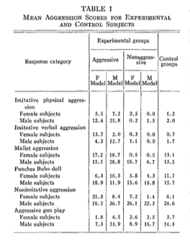
- Interpretation
  - Larger numbers of aggression in aggressive model (regardless of gender)
  - Children less aggressive in nonaggressive model than control condition
  - Males copied male models more than female models
    - Same not true for females
  - Females copied male models more than female models
    - Possible explanations: males were considered to be more dominate (of higher status) than females, thus modelling someone with high status is more sensible than someone with lower status (females in this case)
Key findings:
- Learning is more than behavior
- It can occur through vicarious reinforcement, observational learning/modelling
- Direct reinforcement is neither necessary nor sufficient for learning
  - Not necessary= we can learn through social contexts
  - Not sufficient = some behaviors are done without direct reinforcement (think of the pigeon pecking for food regardless of reinforcement, OR the children hitting the Bobo doll regardless of getting something in return.
Interpretations:
Extension: What is the evidence for and against the influence of media on aggression?
- Theme 7: Children’s Welfare
  - Aggressive behavior is believed to have an influence through violent media portrayals.
  - Questions on whether or not we should confine children in what they are watching and playing with
  - Research on media affecting learning is conflicting
    - May be due to the researchers and the bias of the companies paying for these studies to be done

In what way (s: perspective/rebellion) was Bandura revolutionary?
Bandura’s research was revolutionary as it rebelled against the traditional findings of behaviorism as well as bringing in a new perspective of children’s social development with the social learning theory. His bobo doll experiment brought an insight to how children learn to be aggressive and also how they learn without the use of reinforcement. His research can be included in the following themes
- Nature vs Nurture
  - While it differs rom traditional behaviorism, social learning theory does still have the elements that children can be conditioned to act out certain behaviors (NURTURE)
- Children’s Welfare
  - The findings bring light to how we should conduct ourselves around children
  - We need to act out positive behaviors so children can see it and hopefully be inclined to act out such behaviors
  - We need try to limit our aggressive behaviors in front of children as they will likely (evident from the research) repeat these behaviors in different settings
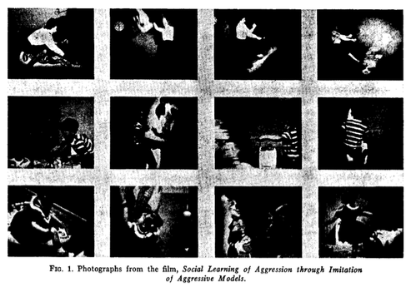
GOVERMENTS, GRADE SCHOOLS, AND GROCERIE STORES (Chapter 14)
What is a common criticism of psychology? Psychology does a poor job making specific predictions about human behavior, single individuals. However, they are good about predicting behaviors of a group.
- Think about the Dixon’s remark on 40 % of his students getting a D or F on the 1st exam. He was right but he could not predict which students would have gotten that grade
How is this limitation related to watermelons? Dixon makes an anecdote of asking a physicist to predict the precise outcome state of a watermelon (where the seeds ends up, where will the rinds crack, how will the flesh of the melon be distributed, etc.) Dixon claims that there are too many variables to predict a precise outcome. He claims that the same goes in psychology. To predict a person’s exact outcome is almost impossible as there are so many factors to consider. Thus, to say that psychology is too vague is not correct, because many “real” sciences are also vague and must make generalized predictions about different events
How are watermelons related to Bronfenbrenner? The level of complexity Bronfenbrenner goes into about the social-emotional-cultural factors on human development is comparable to the physical factors in determining the outcome of a falling watermelon.
Research Question: how can we understand human development if we do not put it in context?
Developmental Mechanisms: 4 levels of context: the mesosystems
Ecology: branch of biology that deals with the relation between organisms (each other) and their environment
Bioecological Model:
Person
Process
Context
Time
- The child is affect by the environment and social, contextual factors
What is “context”? Context can be loosely replaced with “surroundings”
- Microsystems: direct person-to-person interactions that have one-to-one engagement
  - The institutions and groups that directly interact with the developing child
  - Example: over the course of a day, a child might interact with his little brother (during breakfast), mom (drive to school), teacher and classmates (during class), etc.
- Mesosystems: interactions with one another may influence someone else
  - Interactions between the microsystems
  - Example: “boss telling manager to engage with employees” manager has a microsystem with boss and a microsystem with employees
- Exosystems: links between social setting in which the individual does not have an active immediate role
  - Example: the influence of a teacher’s home life on their interactions with their students; the influence of a student’s behavior on the teacher’s interaction with their partner at home
- Macrosystems: culture in which the child lives
  - Culture is not static, it changes over lifetime
  - Example
- Chronosystem: patterning of environmental events and transitions over the life course including sociohistorical circumstances
  - Sub category of the microsystem
  - Over the course of time, the macrosystems are being affected
  - Example
What are propositions? Assumptions/comments
Understand and give an example of each
Context: Microsystem
Direct interactions
- proposition 1. allow for reciprocal process
  - bidirectional influence on one another
  - Example: when a boy sits down to eat breakfast with his little brother, he may get upset that the little brother ate the last of the cereal. The boy lashes out by calling his little brother a name. The next day at breakfast, the little brother is more hostile to the boy, causing a fight between the two.
- proposition 2. consider the totality of the functional social setting
  - Example: experimenters bring bias mood and motivations when conducting experiments, which may influence the way the child performs
- proposition 3. larger systems must be analysed in terms of all possible subsystems
  - when we go beyond a dyadtic (2+) interaction, we need to analyze the interactions separately
  - Bronfenbrenner warns that we cannot make generalizations about a 2-person relationship without understanding the other relationships
  - Example: Jenny comes into the lab with Mom. Mom is acting flustered and agitated towards Jenny. Researchers cannot conclude that Mom is overly strict. They must take into account Jenny’s relationship with Dad, and Mom and Dad’s relationship.
- proposition 4. physical environment should be considered as possible indirect influence
  - Example: when it is cold outside and the computer doesn’t work, children may be frustrated because they can neither go outside nor play on the computer
Context: Mesosystems
Indirect, direct influences
(Mom and Dad get into a fight; Mom is affecting the child in a way that the fight influences mom)
- proposition 5. consider interactions between settings
  - different settings may cause changes in the child
  - Example: a harsh environment at home cause a negative affect in a child, but at school, the child exhibits a more positive affect
- proposition 6. take into account all possible subsystems that exist across settings
  - need to identify and take into account all the possible settings
  - Example: a teacher and mother make up a relationship across settings. When a teacher disciplines a child in the school setting, the relationship with mom may affect the way the teacher interacts with the child during the scolding
  - Children are a product of the surrounding they influence and are influenced by
- proposition 7. embrace ecological transitions
  - ecological transitions: changes in role and setting as a function of the person’s maturation or of events in the life cycle of others responsible for his or her care and development
  - understand that not only children change and develop, but so do their surroundings
  - When we embrace these changes, we are able to see how they affect the development of the child
  - Example: a child moving to a new home with a basketball hoop provides an opportunity for the child to improve their sports skills
Context: Exosystem
Indirect influences
- proposition 8. look beyond the child’s immediate setting to the broader social systems that may influence the child
  - Example how we pay teachers + how we feel about teaching children affects the child’s environment and overall development
Context: Macrosystem
Most global and remote
Evolve over time because of cultural innovation and evolution
- proposition 9. experiments should embrace transformative experiments
  - Example take an individual that is raised in a certain set of values and place them in a different situation (observe their effects)
What is a WEIRD kid?
- White Educated Industrialized Rich Democratic
Why should we care about WEIRD science? Coincides with ACTIVE CHILD Theme: children will choose what they participate in and this in turn effects their development
We have easy access to them and are willing to partake in research, so they make up the majority of our studies (THINK THOMAS). A limitation to WEIRD kids is that the results are hard to generalize
How is Bronfenbrenner related to WEIRD science? WEIRD children are all raised in the same macrosystem. Thus to observe their effects of changes in development, researchers should attempt to remove children from this environment and place them into a new one
In what way (s: perspective/rebellion) was Bronfenbrenner revolutionary?

PATIENCE MAKES THE HEART GROW FONDER (Chapter 15)

What kind of innovation was the marshmallow task? Methodological
Why was this methodological innovation so theoretically important? Psychology was moving away from behaviorism, thus there was a need to provide a new methodology to exemplify this movement

The Research in Question (Marshmallow Study):
- Mischel & Ebbesen (1970)
  - Research question: What is the role of self-regulation in children’s delay of gratification?
    - Mischel was looking more at the mechanism than the delay
  - Sample: boys and girls from Stanford University nursery (WEIRD children)
  - Design:
    - Developmental: Cross-Sectional
    - Research: Structured Observations
    - IV:
    - DV:
    - Conditions:
  - Results
  - Interpretation
- Mischel, Ebbesen, & Zeiss (1972)
  - Ex 1: research question
  - Sample
  - Design
    - IV
    - DV
    - Conditions
  - Results
  - Interpretation
  - Ex 2: research question
  - Sample
  - Design
    - IV
    - DV
    - Conditions
  - Results
  - Interpretation
  - Ex 3: research question
  - Sample
  - Design
    - IV
    - DV
    - Conditions
  - Results
  - Interpretation
- Mischel, Shoda & Rodrigez (1989)
  - research question
  - Sample
  - Design
    - IV
    - DV
    - Conditions
  - Results
  - Interpretation
- Relate these series of studies to one another
  - How did they build
  - What conclusions do the general of pattern of results support?

In what way (s: perspective/rebellion) was Mischel revolutionary?

EXCEPT WHEN IT DOESN’T (Kidd, Palmeri, & Aslin, 2013)
The Big QUESTION: What are the developmental mechanisms underlying delay of gratification?
Background
- Mischel et al.
  - Deficient capacity
  - Rational decision making
The SPECIFIC question: seeking support between two mechanisms
Method
- Sample
- Design
  - IV
  - DV
  - Conditions
- Results
- Interpretation

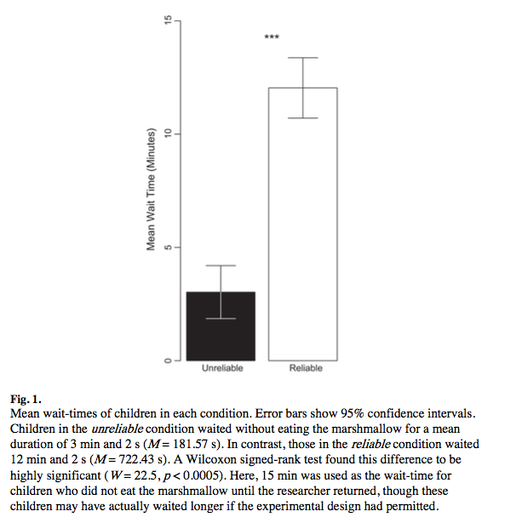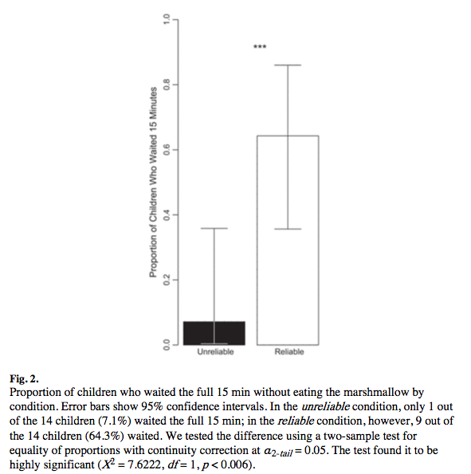

How do these findings support, update, on conflict with other theories/findings we’ve discussed in class?
Why are these findings revolutionary?

SHE LOVES ME, BUT SHE LOVES ME NOT (Chapter 16)
Why did Harlow write his chapter?
- Five important affectional systems
  - Infant-Mother
    - Binds the infant to mother
  - Mother-Infant (Maternal Affectional System)
    - Ensures the mother develops a sense of protectiveness over the infant
  - Infant-Infant (Peer Affectional System)
    - Infants and children interrelate with each other and develop persisting affection for each other
  - Sexual/Heterosexual
    - Culminating in adolescent sexuality and leading to adult behaviors for procreation
  - Paternal
    - Positive responsiveness of adult males toward infants, juveniles, and other member of their social group
- Series of experiments on emotional development in monkeys

Infant Mother Affectional System
(describe each stage. What is the interaction like and how maintained)?
- Reflex stage
  - Automatic behaviours needed for survival
  - Infants maintain bonds through reflexes
    - Rooting: Anything touching face causes infant’s face to move to the sensation until they find a nipple
    - Sucking: once they find the nipple, the infant will suck on it
    - Climbing: infants will climb all the way until they find the nipple
    - Grasping: infants will grasp onto their mother to help them hold on while sucking and climbing
- comfort and attachment
  - the primary goal of this stage is to maintain closeness to the mother and to feel belongingness
  - They achieve this through nursing and physical contact
  - However,these two do not hold the same importance
    - Physical contact seems to be of greater importance
  - once the baby maintain closeness and contact, they will be able to explore their environment
    - first mother's body
    - Then nearby things
- Security
  - Exploratory behaviour when mother available
  - After babies establish the comfort and security, they will go and explore new environment
- Separation
  - Last stage
  - Conflicts arise between mother and baby
  - Mom is less willing to continue nursing
  - This causes the baby to decrease contact with mother
  - Once separation is complete, conflicts cease

The Research in Question (Wire mommy/Cloth mommy):
  - Research question: How does infant-mother love develop?
  - Sample
    - Macaque monkeys that were separated from their mothers within the first half-day after birth
  - Design
    - Developmental: comparative research
    - Research: structured observations
    - IV: Cloth vs. Wire Mother
    - DV: Monkey’s reaction to stressful situations
    - Conditions: Monkeys were either raised by a wired or cloth contraption that acted as surrogate mothers. Each of these monkeys were put through stressful situations and their reactions were observed. They were also placed with the option of either wire or cloth mother (however only the wired mother provided food)
  - Results
    - Monkeys preferred cloth mothers (even if they were raised by wired mothers)
    - They would only go to the wired mother for food (but only for a little bit) until returning to the wired mother
    - Interpretation
      - Caregivers go beyond the basic belief of only providing food
https://www.youtube.com/watch?v=hsA5Sec6dAI
https://www.youtube.com/watch?v=OrNBEhzjg8I
In what way (s: perspective/rebellion) was Harlow revolutionary?
Harlow’s experiments were a rebellion against behaviorism and Freudian psychology. Behaviorism at the time would have predicted the monkeys to only seek out the wired/food-providing mother because the child would have been reinforced with a basic necessity of food. Therefore, “I get reinforcement when being nursed from the wired mom, I love that about mom because she gives me food. Thus, I will only go to the wired mom.” Freudian psychology hypothesized that at the age of the monkeys, they would have been in the oral fixation stage, thus their primary drive is nursing (something to suck on), thus they would be attracted to the wire mother.
Harlow’s studies show that these two perspectives were wrong in predicting infant’s behavior.
His research lead the way for Ainsworth, Bowlby,Johnson to further explore the relationship between mother and infant.
The findings go to the following themes:
Children’s Welfare: the findings were able to be used to contradict the popular practice of the 50s/60s, which was providing little comfort to children and only providing them with the necessary things to survive.
Continuity vs Discontinuity: Described that children go through different stages in a infant-mother affectional system
WHAT A STRANGE BUNGEE CORD (Chapter 17/18)
Bowlby: The Invisible Bungee Cord
What was Bowlby’s training? Bowlby was trained as a psychoanalyst. Thus the primary focus on research was to look at early years retrospectively. However, when looking at our early years, people are generally bias about their experiences. For instance, if someone has depression in adulthood, then they may be more inclined to blame their childhood for their current disorder (however, it could be due to a number of factors)
What was his goal? Bowlby wanted to look at research prospectively (how will current experiences effect a child in the future?)
Prospective Psychoanalytic Psychology
OBSERVATIONS TO BE EXPLAINED
- no theoretical presuppositions
- acknowledge skills and limits
- develop theory inductively

The Research in Question (Attachment Theory)
- Research question: What do typical parent child interactions look like? How do parent-child interactions relate to psychopathology?
- Sample (what characteristics were particularly important)
- Design
  - Developmental: cross-sectional
  - Research: naturalistic observations
  - IV: Separated by other in a hospital setting/institutionalized
  - DV: observe how children reacted when their mother left in a natural setting
- Conditions: James Robertson did extensive video recording and editing on the children and made it into a narrative
- Results: found that children displayed a pattern of behaviours that were categorized into 3 phases of separation
- Interpretation

Phases of separation (describe behaviourally)
- Protest
  - Intense behavioural reaction to mother’s separation
  - Children attempt to reengage with mother
  - No one can soothe child
  - Highest energy
  - Individuals vary in time with this phase
    - Related to quality of bond between mother and infant
- Despair
  - low energy
  - Acceptance that mother will not return
    - State of mourning
    - Learned helplessness
  - Reduced intensity
    - child ran out of steam to fight against
  - withdrawn and non responsive
- Detachment
  - Infant will start accepting care from others
  - Indifferent to mom’s reappearance
  - Some positive affect
  - Begin rejecting mother

Ethology and Adaptation
Explaining behavior in context
-environment of adaptedness: the specific environment that a particular system, through natural selection, was built to work best in

Attachment System:
- what factors, if any, contribute to the innate desire to be near the mother?
- Imprinting
  - Phase-sensitive learning that is rapid and independent of consequences
    - Example: baby chicks imprint right away to their mothers
- Filial Imprinting
  - Young acquire behavioural characteristics from paren
    - time in life where infants zone in on mother
- what factors, if any, contribute to a mother’s natural urge to be near baby?
- Instinct
  - Innate, fixed pattern of behaviour in response to a certain stimulus
  - “Maternal instinct”

How is attachment theory used in therapy?

In what way(s: perspective/rebellion) was Bowlby revolutionary?
Bowlby’s theory was revolutionary as it rebelled against the Freudian psychoanalyst perspective of the time.His theory provided insight to possible mechanisms behind future psychopathology by looking at a child’s upbringing in the present and predicting how it will affect them in the future. His theory does not provide strong empirical evidence, however it does provide observations and a theory that could be used to explain future evidence. Bowlby’s theory coincides with the following themes
Nature vs. Nurture: Attachment system is believed to be predisposed in humans, that we have a deep-seated desire to attach to mom and mom wants to care for us. Bowlby believed that mothers and babies had innate behaviours that caused them to want to be near one another (babies to mother = imprinting; mothers to babies = instinct). All this is an example of NATURE. On the other hand, Bowlby’s observations of babies when separated from mom is an example to how children will adapt to their environment. He examples this with ethology and environmental adaptiveness. This is an example of NURTURE.
Mechanisms of change: Bowlby wanted to see how children’s environment could affect their development. Specifically, how mother-child interaction could predict the future development of a psychological disorder. Possible
Continuity vs Discontinuity: Bowlby’s observations made during his study caused him to develop a pattern of behaviours that he categorized into phases. (Protest, despair, detachment) this is an example of DISCONTINUITY
Children’s Welfare: Bowlby’s findings help provide evidence to how children react when separated from their mothers. This could be used in a series of settings, such as hospitals (limiting the amount of time a mother is away from her newborn), home (moms who are absent from their children). However the findings also provide some hope that children can still have a positive affect despite separation from mom.

Ainsworth: What a Strange Situation
- Secure base
- Mental models “cognitive maps”

The Research in Question (Strange Situations)
- Research question
- Sample (what characteristics were particularly important)
- Design
  - IV
  - DV
- Conditions
- Results
- Interpretation

Attachment related behaviours (describe and provide an example):
- proximity and contact
- contact maintenance
- resistance
- avoidance
- search
- distance interaction
Maternal sensitive response

Why groups?

Group __
- Common name
- Stress behaviour
- Reunion behaviour
- General description
- Parenting behaviour
Group __
- Common name
- Stress behaviour
- Reunion behaviour
- General description
- Parenting behaviour
Group __
- Common name
- Stress behaviour
- Reunion behaviour
- General description
- Parenting behaviour

Influence of modern life (day care etc.)
In what way (s: perspective/rebellion) was Ainsworth revolutionary?

REPRESENTING RELATIONSHIPS (Johnson, Dweck, & Chen, 2007)
What kind of innovation was the Johnson study?
Why was this methodological innovation so theoretically important?
Method
The Research in Question (visual habituation of IWM)
- Sample
- Design
  - IV
  - DV
  - Conditions
- Results
- Interpretation

Describe the habituation event and test events. Identify the test event “preferred” by secure/insecure participants. What does “preferred” mean?

How do these findings support, update, on conflict with other theories we’ve discussed in class?

What is the relation between the four previous studies? How do they build? How do they diverge?
WHY CAN’T YOU BE MORE LIKE YOUR SISTER?! (Chapter 19)
How was Thomas, Chess, & Birch’s perspective unique and revolutionary?
- Nomothetic
What Enduring Developmental Theme is core to the Thomas et al research?
Individual and Environment

Research goals:
- figure out how to study temperament
- use temperament to identify high-risk kids
- document children’s environment

Temperament

The Research in Question (new york longitudinal study)
- Research question
- Sample (what characteristics were particularly important)
- Design
  - IV
  - DV
- Conditions
- Results
- Interpretation

Temperament dimensions
- activity level:
- rhythmicity:
- approach/withdrawal:
- adaptability:
- intensity of reaction:
- threshold of responsiveness:
- quality of mood:
- distractibility:
- attention span and persistence:
  - attention span:
  - persistence:

Relations between temperament and behavioural disturbances
(describe the disorder and related temperament dimensions)
  - externalizing
  - internalizing
Temperament clusters:
(describe each)
- difficult:
- easy:
- slow-to-warm-up:

What is goodness-of-fit? Why does it matter? How does if interact with temperament?
What are the benefits of a difficult temperament?

How do these findings support, update, on conflict with other perspectives we’ve discussed in class?

WHY YOU CAN’T BE MORE LIKE YOUR SISTER. (Caspi et al. 2004)
Behavioural Genetics:
Heritability:

What are sources of variability:
A.
C.
E.

Why are twins an important research opportunity?
What is non-shared environment and why is it so important?

The Big QUESTION: Why are children so different from one another?
Background
  - previous studies have not measured non-shared experiences
The SPECIFIC question: What role does Mom’s emotions towards her child have on the development of antisocial behaviour?
Method
- Sample
- Design
  - IV
  - DV
  - measures
  - Conditions
- Results
- Interpretation

Maternal Expressed Emotion (describe each)
“For the next 5 minutes, I would like you to describe [child] to me; what is [child] like?”
- individual specific expressed emotion
- emotions observed in the manner in which an adult talk about a child
- includes both verbal and vocal elements
- emotions about child as individual
Conclusions and Discussions

How do these findings support, update, on conflict with other theories/findings we’ve discussed in class?
Why are these findings revolutionary?

MIND OVER MATTER (Chapter 22)
Naïve Psychology
Mental state understanding
- desires
- beliefs
- false beliefs
- development

Explaining Theory of Mind Development
- Theory-of-mind module (TOMM): a hypothesized brain mechanism devoted to understanding other human beings.
- Interactions with other people are crucial for developing theory of mind.
- General information-processing skills are necessary for children to understand people’s minds.

Autism
- Persistent difficulties in social communication and interaction
  - social emotional reciprocity
  - nonverbal communication
  - developing, maintaining, and understanding relationships
- Restricted, repetitive patterns of behaviour, interests activities
  - stereotyped or repetitive motor movements
  - insistence on sameness
  - highly restricted, fixated interests, high intensity and abnormal
  - hyper- or hyporeactivity to sensory input
- Symptoms present in early development
- cause clinically significant impairment in social, occupational, or other important areas of functioning
- Symptoms are not better by intellectual

The Research in Question (Sally Ann Task)
- Sample
- Design
  - IV
  - DV
  - measures
  - Conditions
- Results
- Interpretation

How do these findings support, update, on conflict with other perspectives we’ve discussed in class?

MIND OVER OTHERS (Dunfield, 2014)
What is prosocial behaviour?

Producing prosocial behaviour
- Recognize negative state
- Cause of negative state
- Motivation to act

Describe and give an example of each of the following:
- Instrumental need
- Material desire
- Emotional distress

Describe and give an example of each of the following:
- Helping
- Sharing
- Comforting

Describe how social-cognitive development relates to the emergence of prosocial behaviour
- Helping: understand goal directed action
- Sharing: give away a potentially desirable good
- Comforting: engage in affective perspective taking

Caring for others:
  - Varieties of prosocial behaviour
unique ages of onset
unique, uncorrelated patterns of production
distinct variability across a variety of variables

How do these findings support, update, on conflict with other perspectives we’ve discussed in class?

