DVM 2106 Midterm Study Guide
Millennium Development Goals
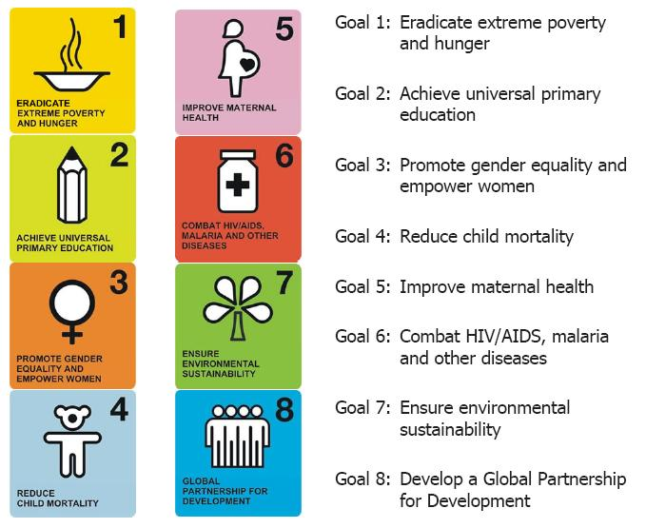

Chapter 13: Poverty
Textbook: David R. Morrison
Readings: Paul Collier: The Bottom Billion
Jeffrey Sachs: Millennium Villages
International Aid Regime | - Principles, norms, procedures and institutions concerning ODA associated with multilateral and bilateral aid donors
Neoliberal Orthodoxy | - Synonym for the Washington Consensus,  - Advocates a development strategy based on SAPs to correct external and fiscal imbalances  - Downsizing the state  - Privatization  - Promoting market as engine of DVM  Recently, we have been moving past this
Alan Thomas | - 200 years ago most people were poor; it was natural and normal for the time in the eyes of the elite  - We are in a ‘unique era’ with soaring populations and per capita income  - BUT this general uprising masks disparities
Branko Milanovic | - Expresses deep ethical concerns about poverty  - “can one seriously argue that colonization had nothing to do with furthering civil wars and adding to the misery of the poor countries?”  - Argues against the notion that rich/elite powers have no responsibility for the poor conditions; only the poor are to blame
Paul Streeten: Why pursue poverty alleviation? | - Higher productivity of labor force  - Lower fertility rates  - Good for environment  - Greater civil society, social stability  ethical and moral imperative
Bottom Billion | - Paul Collier  Many areas are improving but some of the poorest areas are getting poorer  Causes:  - Conflict Trap  - Natural Resource Trap (corruption no tax revenue)  - Landlocked  - Bad Governance in small country (no investment)
How to fix poverty? | - Trickle down?  - Expand capabilities?  - Basic human needs?  - Challenge social inclusion?
Kuznets Curve  Inequality gets worse before improving due to trickle down | 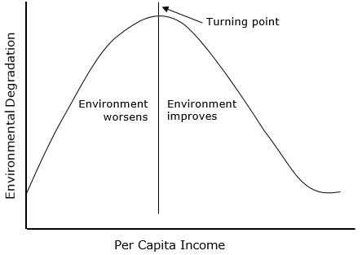
NIEO | - New International Economic Order  - In late 1960s, wanted to use MNCs to foster beneficial changes in the rules of international trade
Timeline of poverty reduction strategies | 50s/60s ~~~ market driven strategies (trickle down)  70s ~~~ redistribution with growth (really just a new name for the same market system) and basic human needs  80s ~~~ magic of the market (again) SAPs  90s ~~~ human dvm but (Washington Con. paramount)  00s ~~~ strengthen global commitment through the MDGs
Redistribution of Growth  (RWG) | - Tacked onto prevailing ideology without fundamentally changing focus  - Did not address factors which generate poverty  - Felt a combination of interests is needed to identify advantages of directing more $$ to poor  - Resulted in ambiguities of work at project level
World Employment Conference | - 1976  - Tried to advocate for RWG in more concrete terms through BHN
BHN Approach | - Basic Human Needs Approach  - Basically relabeled current efforts  - Sought to meet most urgent food, shelter, water, health, and edu needs  - Viewed poor as target groups, not participants
WDR 1980 | - Focused heavily on poverty  - Interest in BHN over RWG  - Symbolized end of a short ODA discourse era
The Washington Consensus | - Agreement between the IMF , WB, and US executive branch to introduce neoliberal policies  - Fiscal discipline  - Reduce state spending  - Interest rate liberalization  - Trade liberalization  - Competitive exchange rate  - Tax reform  - Liberalization of foreign direct investment  - Privatization  - Deregulation of trade  - Secure property rights
HDI | - Human Development Index  - Based on Amartya Sen’s “Capabilities Approach”  - Established by the UNDP that equally weights 3 factors:  - Life expectancy at work (Long and healthy life)  - Adult literacy rate + educational enrollment ratios (Knowledge)  - GDP per capita (Standard of living)  - Goes beyond the traditional income level index of economic poverty
PRSPs | - replaces SAPs  - PRSP should be country-driven, result-oriented, comprehensive, partnership-oriented, and based on a long-term perspective
2002 Monetary Conference
Sach’s Prescriptions | Millennium Villages Project with the UNDP  - “Shock Aid”  - mosquito net per person  - 100$ per person  - seeds/fertilizer  - ag, ed, health, infra, sanitation, gender equality.  Criticism  - “Development Darlings” Sauri, Kenya  - Top down? No control groups? New dependency?  - drip feeding for decades

Defining the Poor
Recent trends for poverty and development | - more focus on causation  - more focus on human rights  - moving past neoliberalism
Relative Poverty | - Measured against societal standards which vary considerably across countries, regions, and demographic groups, and also change over time
Absolute Poverty | - Involves some measurement against a benchmark, such as food costs, caloric intake, or being able to write one's name  - < $1.25/day (in 2005 prices)
Moderate Poverty | - $1-2/day
Extreme Poverty | - $1.25/day originally $1/day
Features of very poor
World Bank Benchmarks | - Originally $1.00/day changed to $1.25/day at 2005 PPP = extreme poverty  - $1-2/day = moderate poverty  - Based solely on income and consumption information derived from household surveys  - Fails to account for intra-household distribution
H. White | - Poverty goes beyond income shortage; multidimensional  - Non-income data reflects depth of extreme poverty  - Deprivation in any sphere is poverty (Includes all measures beyond economic (environmental, social, political freedoms and capabilities)
GNI Per Capita | - Gross national income  - Calculates all output from citizens from one country whether domestic or abroad  - i.e: Canada calculates all output from Canadian citizens within Canada as well as Canadian citizens abroad. It does not include the output from immigrants living within Canada.
Income/Consumption (IC) | - GNI per capita cannot measure inequality  - Defines a poverty line and asks people how much they make or how much they consume to see if they meet this line.  - UTILITY DEPRIVATION
B.S. Rowntree | - Developed the ‘Poverty Line’  - An income/consumption approach  - Household surveys are distributed to discover the minimum budget required for typical families to live  - Looks at how much money is accumulated by a household as well as how much is spent
Poverty Gap | - A measure of how many people are below the poverty line and by how far.
Capabilities Approach | - Amartya Sen  - Development as expansion of capabilities and human freedom  - Highlights how various factors that contribute to a lack of functioning are interrelated  - Contributed to the UNDP’s HDI and HPI
Advantages of CA | - Greater scope to include human well being  - Deprivation can be analyzed in a multitude of ways that look beyond economic indicators  - More relevant in developing countries
Laderchi | - both I/C and CA are too individualistic and stuck at one point in time don’t focus on the cause.
Social Exclusion Approach | - Addresses deficiencies of income/consumption and capabilities approaches  - Central focus on political and social perspectives  - Inequality and redistribution  - Focus on women, aged, handicapped & other minorities  - Points towards policies for eliminating discrimination  - A conceptualization of poverty that denies basic human entitlements  - a) resident of society b) would like to participate c) but cannot do so
What SE highlights | a person is poor if they are a resident, can’t participate, wants to  social/political/cultural issues are central
Policies SE promotes | anything that eliminates discrimination against women, aged, disabled, minorities, etc.
Participatory Assessment | Local ownership  Bottom up  everyone gets a say.  - problem ranking, resource mapping and transect walks, timelines, seasonal calendars, daily clocks
Robert Chambers | - Promotes sustainable livelihoods  - Participatory Rural Appraisal = ethical guidelines  - Must look at power/interests of local elites  - Little likelihood of success if they are not involved/ do not benefit in some way
Pros of PA | involves all stakeholders to allow for greater ownership
Cons of PA | are we just involving stakeholders for the sake of it?
Poverty Assessment Tools | Door to door community surveys
Biases of Rural Poverty Assessment | - Spatial (roadside)  - Project  - Person  - Dry Season  - Diplomatic  - Professional
Results Based Management (RBM) | 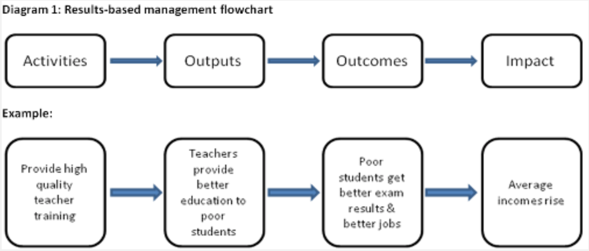  Sustainable? Who is benefiting? Who are the stakeholders?
Logic Model | Used to evaluate the effectiveness of a project  Three Key Considerations  - Stakeholder Involvement  - Gender analysis  - Environmental analysis
Performance Based Management | - Helps you identify and evaluate different stages of project  - Outcome: What’s the ultimate goal?
DGD Notes
How we present poverty  - Rusty radiator award | Bad: Appeal to emotion,

Mehrota/Delamonica Agenda – Eliminating Human Poverty
Macroeconomic Policy aimed at pro-poor growth | - redistribution partnered with policy aimed at improving the lives of the poor.  - FDI good
Public Spending on Social Services
Decentralization | - national democracy  - decentralize service delivery to local gov’ts  - institutions give voice to the people

Chapter 18: Hunger +Rural Development
Textbook: Joshua Remisch
Undernutrition | Includes being underweight for one’s age, too short for one’s age (stunted), dangerously thin (wasted) and deficient in vitamins and minerals (malnutrition).
Undernourishment | The measure of dietary energy deprivation (cannot capture fully the complexity and multidimensionality of food security)
2008 Global Food Crisis | - Food price crisis linked to oil price surge  - Input/output prices rose but rural communities/farmers did not benefit  - Then the worldwide recession reduced demand for commodities = food prices dropped
Food security | The ability (derived from land, labor, capital, and/or political power) to meet food consumption needs either directly (personal farming) or indirectly (supermarket)
Michael Bell | Material Reality  - spatial identity  - opposition to urban (low pop density, agriculture)  Ideal Reality  - village, community, maternal, patriarchal  - nature-based
Rural features | - A relative abundance of natural capital  - A relative abundance of labor  - A relative isolation  - A relative importance of social factors
Agriculture-based countries | - Ag is dominant component of overall GDP and GDP growth  - Where most of the poor are in rural areas  - Most are in sub-Saharan Africa
Transforming countries | - Ag no longer major contributor to growth, but rural poverty remains widespread  - Most of the world’s rural poor found in transforming countries  - Most of East + South Asia, Middle East, North Africa
Urbanized Countries | - Poverty is predominantly urban  - Rural poverty still exists, just not major  - Ag/food industry capable of making up ⅓ of GDP  - Includes:  - Latin America, Caribbean, Eastern Europe
Peasant societies | - Rural cultures highly reliant on local production  - Nation-state affects distribution of wealth/power  - Hierarchy structures enforced by cultural, economic, religious, gendered systems, etc.
Tradition-bound servant peasant | - Image looked down upon by leaders/planners  - Idea of oppressive landlords/village chiefs  - Neglects local knowledge/experience
Rural Transformations
Societal Perspectives | - Industrial revolution  - Resource exploitation  - Lessons learned
Rural DVM: Japan | - Agricultural intensification based on limited land and large rural population
Agricultural intensification | - Increasing amount of food produced through additional labour/ capital with a limited land base  - i.e: fertilizer, irrigation, chemical pest control
Rural DVM: United States | - Agricultural extensification based on lots of land but scarce labour
Agricultural Extensification | - Increasing food production through expansion of total cultivated area instead of increases in labour or capital
A. Wood | - US as an example for Africa (extensification)  - Land rich in relation to its population with a predominant primary sector  - Internal transportation (no water paths) = higher costs and therefore Africa will have urban concentration along coasts and less densely settled interior with a focus on agriculture/mining
Disengagement from ‘top-down’ rural development | - Failures of large, state-led integrated rural development projects (IRD)
The Green Revolution
Why gender matters in sustainable livelihoods
Why environment matters

Models
Rural reconstruction movement
Community Development  Process/method facilitating the transfer of technology to a community for more effective solution of its problem | 1950s  - Derived from Britain ‘preparing’ India for independence in 1940s  - Guided US ODA in Asia  - Flourished post WWII  - Relied heavily on multipurpose village workers  - Spawned large bureaucracy on all levels to coordinate shift  - Oversimplification → Targets not reached
IRD - Integrated Rural Development | - large scale ‘balanced’ development  - favoured by multilateral institutions  - development that would target all areas of a country. urban/industrial growth and rural efficiency  - criticism: top-down, needed unsustainable amount of foreign support
Participatory Rural Appraisal  PRA | toolkit for people centered solutions to their own problems  We now see these people as being able to make their own rational choices and want to get their opinions  - ‘new tyranny’  - including them for the sake of it  Tools  - Priority Mapping/Needs Assessment  - Resource Map  - Social Map  - Wealth Ranking Objectives:  - Local Perceptions of Malnutrition Mapping Objectives:  - Venn Diagram on Institutions  - Resource Cards  - Seasonal Calendar  - Income and Expenditure Matrix  - Daily Activity Clocks  - Focus group discussion: Constraints and Opportunities to achieving Nutrition and Household Food Security  - Semi Structured Interview: Household Case Study  - Community Workshop  - Daily Evaluation and Planning Meeting
Biases for Rural Development | - Spatial (urban, tarmac, and roadside, those close to the road the best off)  - Project bias (we look at the ones that are successful)  - Person bias (elites, leaders, males, adopters of projects, etc)  - Dry Season bias (people will have more time to talk in some seasons, going during rainy season is important to understand those issues  - Diplomatic bias (a ‘polite’ bias, where people aren’t honest about what happens to leaders, tell them what they want to hear)  - Professional bias (professionals don’t necessary understand what’s going on as well as locals)
Farming systems research (FSR)
Rapid rural appraisal (RRA) | collect, analyse and evaluate information on rural conditions and local knowledge in close co-operation with the local population in rural areas.
Sustainable Livelihoods | - Draws heavily on Chamber’s work  - Sen’s work on famines  - not everyone who is living in a rural area is a farmer

Challenges - Crisis
Problems: Depicting  Rural DVM = Agricultural DVM | - Real price of every agricultural commodity has fallen  - Environmental limitations of ag: soil, water
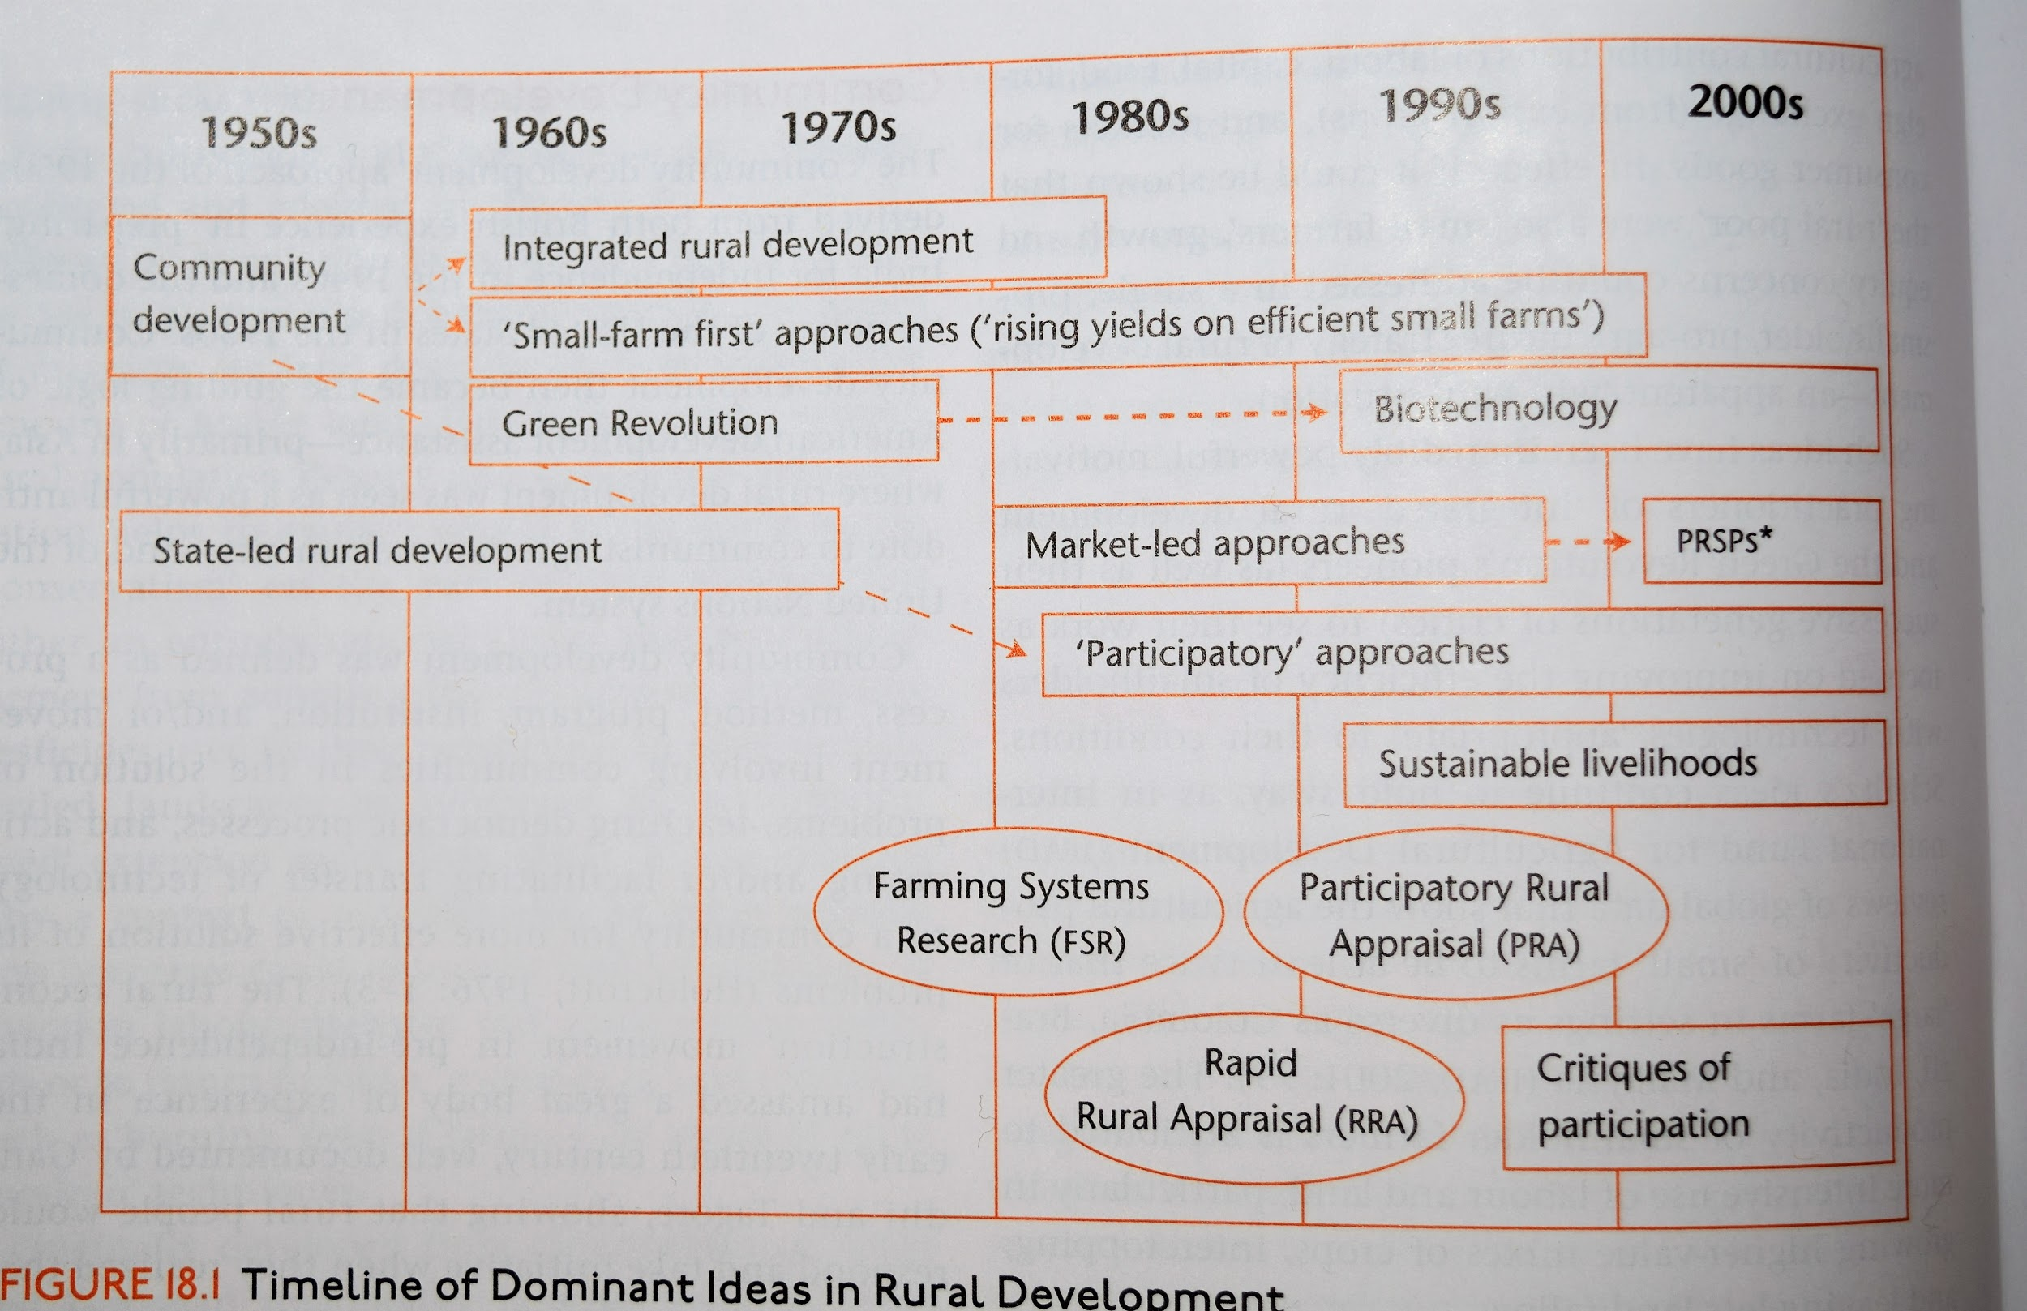

Chapter 20: Health
Textbook: Ted Schrecker
Threshold (US $) for increases in income per capita improving health status  Millennium Preston Curve | $5,000. after that increases in $ only slightly improve health status  - Mexico doing well  - USA and Russia are outliers  - Southern African countries outliers (AIDS)
Income and Health Relationships  - Access to health care | Lack of medical establishments or inability to travel prevents people from getting cares and taking preventative measures
Income and Health Relationships  - Social determinants of health | The conditions people work/live under determine opportunities to lead healthy lives
# of people suffering from insufficient calorie intake | 1 billion
Paul Farmer | - Physician/anthropologist  - Access to health care and social determinants of health reflect similar distributions of social disadvantages
Socio-economic gradients | - Pattern in rich and poor countries  - Health status varies with income, wealth, education, etc.  ** Health improves with wealth, income, education, and other assets **
Szreter’s 4 D’s | - Disruption  - Deprivation  - Disease  - Death
Globalization | A pattern of transnational economic integration animated by the ideal of creating self-regulating global markets for goods, services, tech, and skills
Globalization depends on advances in _______ declines in the cost of ______ and ________ | - Technology  - information processing, transportation
1981-2005  Value of the world’s economic product quadrupled | 500 million “escaped” extreme poverty  - Decline was accounted for entirely by China  # of people in developing # of people falling into  world (outside China) = extreme poverty in a  escaping extreme poverty different part of the world
van Doorslaer findings | - Lots of people have escaped poverty because of catastrophic medical expenses
Export Processing Zones
‘Integrated, precarious, and excluded workers’ | - Coined by Cox  - Hierarchical labor force structure resulting from globalization
Positives: Globalization | - Although precarious work, (e.g. EPZs) these jobs have more economic opportunity potential  - Nutrition Transition → rapid urbanization
Negatives: Globalization | - Declined wages for low-skilled workers  - Increased economic inequality  - Awful tradeoffs for taking jobs with the potential for greater economic opportunity and health/safety  - Trade liberalization has wiped out some small-scale ag producers  - Nutrition Transition → rise in obesity in LMICs  - Double Burden of Disease
WHO - Funding | - Less than ¼ of core WHO budget comes from obligatory UN member contributions  - Relies on discretionary contributions from member states  - WHO programs/priorities are donor-driven
CPHC | Comprehensive Primary Health Care  - 1978  - Strategy for integrating prevention & treatment to achieve “Health for All in the Year 2000”  - Failed
World Bank Influence | - Funding and research capabilities make it important  - But not above politics, WB health care reform policy prescriptions have been heavily market-dominated
World Bank 1987 | - Policies calling for partial cost recovery through user fees at the site of care administration  - Expansion of insurance as finance mechanism
WDR 1993 | - Made it clear the bank preferred market resource allocation  - Recommended public provision be limited to a package of low-cost interventions which demonstrated ‘value for money’ which could not be provided with private financing
PSRPs - Requirements | - Must be approved by executive board members of both the IMF and World Bank before debt relief can be obtained  - Modern form of conditionalities?
TRIPs - Agreement on Trade-Related Aspects of International Property | Agree. on Trade- Related Aspects of International Property  - Extended patent protection to medications  - Binded even the poorest of countries  - Struggled to gain access to AIDS meds  - Led to Doha Declaration of 2001??
Doha Declaration of 2001 | - Establishing the principle that harmonization of patent protection under TRIPs would NOT always prevent the compulsory licensing of patented drugs  - Ex. Brazil can negotiate lower drug prices  - This change has little value if country does not have its own pharma infrastructure
Why 2003 WTO interpretation is problematic | - Countries may import generic meds, and that countries may issue compulsory licenses for such export production  - Changing domestic legislation is difficult  - Viewed as compromise/not practical
Global Health Governance | - Term reflects lack of overarching international authority directing health care efforts  - Reflects increasing role of NGOs/non-multilateral agencies
The Global Fund | - Found in 2001 by G8 countries  - International granting council  - Criticized for emphasizing ‘vertical’, disease-specific programs directed at AIDS, TB, and malaria  - No guarantee on long-term funding, relies on ‘passing around a hat’ (periodic replenishment meetings)
Bill & Melinda Gates Foundation | - Long term private healthcare option

Canadian Context, Malaria, Human Security, AIDS/HIV
Life expectancy, average Canadian male | 67-76
Human Security  *People centered* | To foster security, peace, and freedom it is necessary to:  - Rid world of starvation  - Alleviate poverty  - Address injustices
MDGs + Human Security | - MDGs used to make Human Security measurable  - Weak implementation
Cons of Human Security  (Health) | - Too all encompassing/too ambitious  - Security is global issue. not just developing world
End of 2013 HIV/AIDS Stats | - 5 million people living with HIV  - 2.1 million people became newly infected.  - 12 million people in low- and middle-income countries receiving antiretroviral therapy  - 35 million people infected worldwide  - South Africa highest (6,300,000)
How AIDS impacts human security | - Creating millions of orphans  - Threatens political stability  - Fertile ground for other infections  - High rates of HIV in military/PK

Chapter 21: Education
Utilitarian View | · Highly economic view of education, views education for development in a linear trajectory—growth defined by governing elites and those with technical experience  l  - Teaches how to uphold the status quo
Transformative View | · - Encouraging learners to view the world critically, acquire the skills and aptitudes necessary for generating for realizing social change
Jomtien Conference | To achieve universal education
Education For All (EFA)
Conscientization | Awareness  - As a step toward praxis (the power and knowledge to take action against oppression)
Praxis | · Conscientization (awareness) as a step toward praxis (power and knowledge to take action against oppression)  - Political action arising from praxis in the realization of human freedom
What SDG relates to education? | 4
Why factors affect school enrollment? / Why aren’t certain children attending? | - war  - school teachers dont show up  - kids are nowhere to be found  - teachers are enticed by UN jobs  - no locations  - fear of being abused
Experiential Learning | Going out, experiencing, hands-on work results in most effective learning

Chapter 5: Gender
Sex | - biologic
Gender | - created by society
Women’s Triple Role  (Part of GAD) | Reroductive  - Guarantees the perpetuation of society via procreation and the care of children/elderly/sick  Productive  - Assures the production of marketable goods, services, and subsistence production for direct consumption (farm to table)  - Community
Gender Division of Labor | - roles given to men and women, girls and boys, and transgendered peoples  - GDOL is societally constructed, cultural, and flexible
Discrimination
Patriarchy | - Social construction  - System of power  - Society organized into gendered systems  - Oppressive to women + men  - Values masculinist power
Hegemonic Masculinity | a practice that legitimizes men's dominant position in society and justifies the subordination of women, and other marginalized ways of being a man.
Intersectionality | the interconnected nature of social categorizations such as race, class, and gender as they apply to a given individual or group, regarded as creating overlapping and interdependent systems of discrimination or disadvantage.  "through an awareness of intersectionality, we can better acknowledge and ground the differences among us"
Gender Stratification | Gender stratification refers to the social ranking, where men typically inhabit higher statuses than women. Often the terms gender inequality and gender stratification are used interchangeably.
WID | Women IN Development  Neoliberalism. Trickle down is favouring men. We should get women more involved in the market.  - Favored mid-1970s  - Its call for equality rose out of the liberal feminist movement and was fueled by publications by Ester Boserup  - Highlighted how official statistics ignored and underestimated the value of work performed by women  - called for programs for education and skills acquisition to advance the position of women
WAD | neo-Marxism ~~ explores the relationship between capitalism and patriarchy
GAD | Explores socially constructed roles of men and women.  We should challenge these gender roles.
MDG 3 | promote gender equality and empower women
MDG3 Indicators
Gender Mainstreaming | aim for gender equality - socially, economically, and politically
EMB | Engaging Men and Boys
GBA | Gender Based Analysis

3 Multiple Choice
7 True/False
10 All short answers (80% weight)
- What are the core components of?
- Point form
- Not obscure terms
- Link *key* ideas to authors
- Understanding of DVM realities, processes, and practices, tools
- Gender, 50% of world is men, but not everyone gets equal to opportunities
- Quality/sustainability
- Sen, people centered DVM
- Rural poverty, chambers
  - 6 biases
  - Person bias, professional
- Invisible backpack

PRA can be a powerful toolkit. However, some of the challenges with PRA include….
The sustainable livelihoods approach offers an important perspective on development because….
Food insecurity and/or famine persist in the world today because …. (see the course readings for more information)
What does the SDG on ending hunger call for? see: https://sustainabledevelopment.un.org/?page=view&nr=164&type=230&menu=2059 and how can we best achieve this goal?

