ADM1300 FINAL EXAM REVIEW (MO’s)
- Must go through week 11 powerpoint (unanswered questions)
- First 14 key questions from the final exam...
  - Go on pg 288
  - answer questions 1/2/4
  - and then questions 12 and 13 as well
  - 15-17
  - chapter 8 questions 20-21

Week Eight
- What are the key functions of setting objectives? Organizational objectives are the end states or targets that managers aim for while plans are the means by which managers hope to hit the desired targets.
- Define strategic plans: Strategic plans focus on the board future of the organization and incorporate both external environmental demands and internal resources into action managers need to take to achieve the long-term goals of the organization.
- What are the key elements of operational plans? Operational plans translate tactile plans into specific goals and actions for small units of the organizations and focus on the near term (12 months or less). These plans are the least complex of the three and rarely have a direct impact beyond the department or unit for which the plan was developed.
- What are the key issues that managers at the corporate level focus on relative to planning? Corporate level executives would primarily focus on questions such as the following:
- What industries wouldn’t get into or out of?
- What markets should the firm be in?
- In which businesses should the corporation invest money?
- What types of plans do people at the business level primarily undertake? At this level managers focus on determining how they are going to compete effectively in the market.
- Why is forecasting critical to the planning process? Forecasting is or can be made about virtually every critical element in the environment that managers believe could affect the organization and their area of responsibility.
- What is benchmarking and what role does it play in planning? Benchmarking is the investigation of the best results among competitors and non-competitors and the practices that lead to those results. In term of results, managers might assess competitors that have the highest revenue-to-employee ratio as a means of assessing productivity. For example, managers would then compare their own revenue to employee ratio to get an idea of where they stood relative to competitors.
- Why is determining the priority of objectives important? Not all objectives are of equal importance or values. Furthermore some objectives might be important now and less important later and without a clear understanding of which objectives are most important and temporal priorities employees may be working at odds with each other or create unnecessary conflicts.
- What is the difference between defining requirements and assessing resources in the planning process? In determining resources managers are determining the key drivers of specific goals and plans and this determines what is needed. Assessing resources involves determining how much of a resource is needed.
- How can a Gantt chart facilitate the sequence and timing issues in planning? The chart shows when actions are to be started and how long they are expected to take for completion. It shows which actions are first second or last in the process and whether a preceding action must be completed before a subsequent one can be started or whether there is expected overlap in the timing of specific actions.
- What are the seven elements in the planning process?
- Analyze the environment
- Set objectives
- Determine requirements
- Assess resources
- Develop action plan
- Implement plans
- Monitor outcomes
- How can budgeting can be used as a planning tool? Budgets can be used to quantify and allocate resources to specific activities.
- What are the five key elements in effective goal setting? Effective goals are smart meaning specific, measurable, achievable, relevant, and time framed.
- What is the role of MBO in strategy formulation and implementation? With MBO specific goals are set. Participation by subordinates in setting their goals tend to lead to difficult but achievable goals. In addition the goals need to be accepted by subordinates. Goal acceptance has a positive impact on both motivation to perform and actual performance. Participation by subordinates in the goal setting process increases goal acceptance. Subordinates performance improves according to the quality of feedback given by subordinates.
- DO QUESTIONS: 1,2,4,6-10,12,13,15,16,17,20,21 on pg. 288… these are on the exam.

Week Nine (I)
- Define culture: culture is a learned set of assumptions, values, and behaviours that have been accepted as successful enough to be passed on to newcomers.
- Know this: An understanding of assumptions is necessary to understand, change, or even create a new culture.
- Describe the 3 levels of culture:
Culture consists of three distinct but related evils.
- Artifacts are visible manifestations of a culture such as its art, clothing, food, architecture and customs.
- Values are the enduring beliefs that specific conduct or end states are personally or socially preferred to others.
- Assumptions are beliefs about fundamental aspects of life.
- Different groups make assumptions about humanity’s relationships to the environment, human nature, human relationships, human activity, truth and reality and time.
- The key differences between theory X and theory Y managers:
  - Theory x managers assume that the average human being has an inherent dislike for work and will avoid it if possible;
  - Theory Y managers assume that work is as natural as play or rest.
- What is a subculture? A subculture is a part of a culture in which values are deeply help but not widely shared.
- Five critical strategies to effectively manage organizational culture:
  - Selection: Select individuals who assumptions, values, and behaviours already match those you desire.
  - Socialization: orientation, training and arranged interactions with experienced organizational members.
  - Stories and Symbols: Stories communicate company values and rituals play a key role in the symbolic communication of an organizations culture.
  - Performance appraisal: Clarify for new employees what the organization measures and evaluates.
  - Rewards and Compensation: Signal what the organization values by reinforcing desired behaviours in newcomers.
- What are the key differences between high and low context cultures? How do they affect managerial behaviour? Cultural context: degree to which a situation influences behaviour or perception of “appropriateness”. In high-context cultures, people pay close attention to the situation and its various elements in assessing appropriate behaviour. In low context cultures the situation may or may not make a difference in what is considered appropriate behaviour, but in high context cultures, the context makes all the difference.

Week Nine (II)
- Define Organizational Structure: Organizational Structure can be defined as the sum of the ways an organization divides its labour into distinct tasks and then coordinates them.
- What is the main purpose of organizational charts? Organizational charts illustrate relationships among units and lines of authority among supervisors and subordinates through the use of labeled boxes and connecting lines.
- What are the key advantages and disadvantages of the functional structure?
Strengths
- Small to medium-sized firms with limited product diversification
- Specialization of functional knowledge
- Less duplication of functional resources
- Facilitates coordination within functional areas
Weaknesses
- Weak coordination across functional groups
- Restricted view of overall organizational goals
- Limits customer attention
- Slower response to market changes
- Burdens chief executives with decisions involving multiple functions
- What are the key advantages and disadvantages of the product structure?
Strengths
- More focus on products and customers
- Easier to evaluate performance of the product (profit )
- Product responsiveness to market changes
- Less burden on the top executive in making operating decisions
Weaknesses
- Duplication and lack of economies of scale
- Problems for customers purchasing across multiple product groups
- Conflicts between product group and corporate objectives
- Conflict between product groups
- How is line of authority different from chain of command? Line of authority essentially specifies who reports to whom in the organization.
- What are the key pros and cons for both centralization and decentralization in organizational structure?
  - Centralized organizations restrict decision making to fewer individuals, usually at the top of the organization.
  - Decentralized organizations tend to push decision-making authority down to the lowest level possible.
- What are the critical elements of an organization’s internal and external environments that a manager should assess in considering a new organizational structure?
  - In designing organizations, managers face the challenge of capturing both specialization and integration advantages.
  - A key factor in determining the match between the environment and organizational structure is environmental uncertainty.
- What role does information play in the context of organizational uncertainty?
  - Information can play a critical role in organizational uncertainty from a number of perspectives.
  - Information or a lack of it can impact product creation and production, supplier and customer communication, technology, and competitor intent.
- What are some of the key warning signs of a poor structure-environment fit?
  - One of the first warning signs is decision makers’ inability to anticipate problems.
  - Another key warning sign is an increase in conflict that prevents effective implementation.
  - There may also be signs at the individual level.

Week 10
- Basic Model of Communication
  - Communication: the process of transferring information, meaning, and understanding from sender to receiver…
    - Encoding
    - Medium
    - Decoding
    - Noise
- Modes of Communication

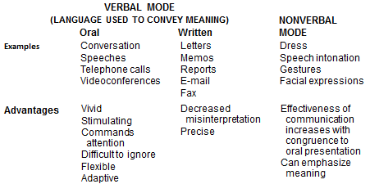
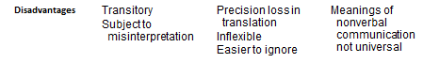
- Organizational Context of Communication
  - Organizational characteristics that affect communication
    - Composed of individuals and groups
    - Oriented toward goals
    - Differentiated functions
    - Intended coordination
    - Continuity through time

Directions of Communication
- 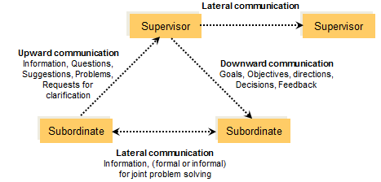
- Channels of Communication
  - Formal communication channels
    - Specify individuals responsible for tasks
    - Specify individuals responsible for communicating information above and below them
    - Indicate persons (positions) to whom work-related messages should be sent
  - Informal communication channels
    - Tend to operate laterally more than vertically
    - Move information quite rapidly
    - Carry both work-related and non-work information
- Channels of Communication:
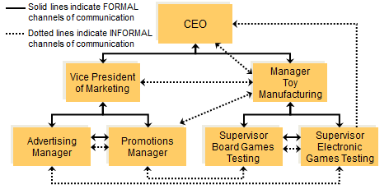

- Patterns of Organizational Communication
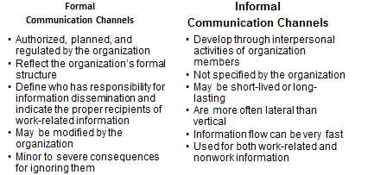
- Patterns of Organizational Communication
  - Networking: A process of developing regular patterns of communication with particular individuals or groups to send and receive information.
    - Can be a significant advantage to a manager
    - Can be a source of important information, both formal and informal that might otherwise have taken longer to obtain.
    - Easier to access and influence others in established networks.
- Barriers to Communication:
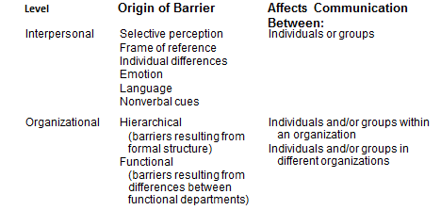
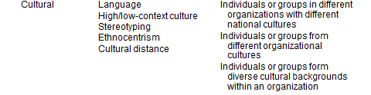

- Communication Differences in High and Low Context Cultures
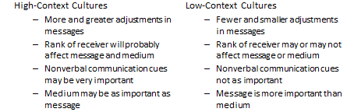
- Cross-Cultural Barriers
  - Ethnocentrism
    - The belief in the superiority and importance of one’s own group
  - Stereotyping
    - The tendency to oversimplify and generalize about groups of people
  - Cultural distance: the overall difference between two cultures’ basic characteristics such as language, level of economic development and traditions and customs.
- Improving Communication: Listening Skills
  - Be more open-minded
  - Develop empathy
  - Listen actively
  - Observe nonverbal cues
- Improving Communication: Sending Skills
  - Simplify the language
  - Organize the writing
  - Understand the audience
    - What is the direction of the communication?
    - Does the receiver have any expectations concerning this communication?
    - Is the communication formal or informal?
    - Does the receiver have preferences for certain channels of communication?
- Improving Communication: Organization Level
  - Gatekeepers
    - Individuals at the communication interface between separate organizations or different units within an organization
    - Increase formal communication
    - Replace some face-to-face communication with electronic communication
    - Develop communication networks
    - Create centralized office to manage communication activities
- Communication and Negotiation
  - Negotiation
    - Process of conferring to arrive at an agreement between different parties, each with their own interests and preferences.
  - Two types of negotiation activities
    - Day-to-day activities of the manager’s organizational unit
    - Part of a formally appointed negotiating team representing unit or organization
- Key Factors in Cross-National Negotiations
  - Three principal variables generally determine the outcome of negotiations
    - People
      - Listening skills
      - Orientation toward people
      - High self-esteem
      - Influence in the home organization
- Key Factors in Cross-National Negotiations
  - Three principal variables generally determine the outcome of negotiations
    - Situation
      - Location
      - Physical arrangements
      - Emphasis on speed and time
      - Composition of the negotiating teams
    - Negotiation process
- Stages in the Negotiation Process:
  - Stage 1: Planning and preparation
    - Advance planning analysis
    - Background research
    - Gathering of relevant information
    - Planning of strategies and tactics
    - Setting objectives
    - Predetermining possible concessions
  - Stage 2: Relationship building between negotiation parties
    - Developing trust
    - Developing personal rapport
    - Establishing long-term association
  - Stage 3: Information exchange
    - Learning about the needs and demands of the other set of negotiators
    - Acquiring and exchanging other information.
  - Stage 4: Persuasion attempts
    - American managers treat as the most important stage
    - Mixture of approaches
      - Assertive and straightforward
      - Warning or threats
      - Calculated delays
  - Stage 5: Concessions/Agreement
    - Permit each party to take away something of value
    - American managers tend to have less leeway for concessions
    - Some use normative appeals such as “it’s your obligation”
Week 11
- A firm’s ability to survive and prosper is increasingly a function of the human resources they have. Managers’ career success depends on how well they manage their firms’ resources.
- Two main HRM goals: i) Getting the right people. HRM activities must be aligned with corporate strategy. Ii) Maximizing their performance and potential.
Success of failure of either goal can influence the success or failure of the other.
- I) Getting the right people:
  - Planning
    - Forecasting demand
    - Assessing supply
    - Formulating fulfillment plans
- Job analysis (assessing the job)
  - Scope and depth of jobs
  - Requisite skills, abilities and knowledge that people need to perform their jobs successfully
  - Job description
  - Job specification
- Selecting
  - Valid selection technique
  - Interviews (Unstructured/structured)
  - Work sampling
  - Assessment centers
  - Work simulation
  - Written tests
  - Background and reference checks
  - Physical examinations
Tips for interviewees:
  - Prepare by researching company through its website and other articles.
  - Smile and provide a warm greeting and handshake if the interview extends his hand.
  - Make sure that you overall appearance matches the nature of the business and culture of the company.
  - Watch your nonverbal behaviour to ensure that you maintain good eye contact and convey enthusiasm without being overly expressive with your hands or other body movements.
  - Try to solicit the interviewer’s needs early in the interview.
  - Get a complete picture of the job by asking questions such as “Can you tell me what has led people to succeed in this job in the past?”
  - Relate yourself and capabilities to the interviewer’s needs through statements such as “You mentioned that one of the keys to this position is the ability to motivate others. In my experience at XYZ…”
  - Take time before answering; you do not need to being talking the instant the interviewer asks a question.
  - Conclude the interview by thanking the person for the opportunity and expressing you interest in the company and the position.

II) Maximizing performance
  - Orientation
    - Minimize paperwork
    - Informal meeting with new hire’s immediate supervisor
    - Alternate heavy and lighter information
    - Provide glossary of terms unique to organization
    - Match new employees with experienced worker
- On-the-job training
- Off-the-job training
- Training objectives
Training objectives:
  - Understanding correct and incorrect behaviours
  - Knowledge of why certain behaviours are correct or incorrect
  - Opportunities to practice desired behaviours
  - Feedback on performance
  - Opportunities to practice and improve.
Job Design
- Job sharing
- Reengineering
Performance appraisal
- Graphic rating scales
- Behaviourally anchored rating scales
- 360-degree feedback
- Effective performance feedback
  - Critical incidents
Maximizing Performance
- Compensation
  - Pay
    - Pay structure
    - Broad band system
    - At-risk system
    - Incentive plans
- Benefits
- Rewards and motivation

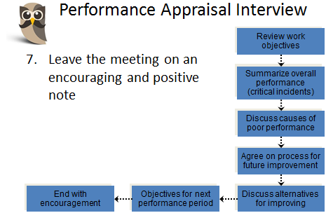

- Laws and Regulations
  - Affirmative action programs
  - Expatriate employees
  - Glass ceiling
  - Bona fide occupational qualifications
  - Sexual Harassment
  - Workforce diversity
    - Managing workforce diversity
- Globalization

Week 12
- Content Theories of Motivation: Need Hierarchy
  - Five needs arranged in a hierarchy of strength and influence.
    - Physiological
    - Security (safety)
    - Social (belongingness0
    - Esteem
    - Self-actualization
- Satisfy most basic (prepotent) needs first
- Move to the next level of needs after preceding needs are satisfied.
- Content Theories of Motivation: ERG Theory
  - Three classifications of needs
    - Existence
    - Relatedness
    - Growth
- Different levels of the needs can be active at the same time
- Person may revert to focusing on level, if frustrated by trying to attain the next higher level.

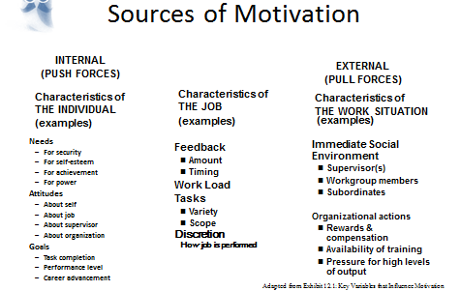
- Content Theories of Motivation: Two-Factor Theory
  - Motivators
    - Can increase job satisfaction
    - Factors related to doing the job (work itself, responsibility, personal growth, sense of achievement, recognition).
- Hygiene factors
- Can prevent dissatisfaction, but cannot increase satisfaction.
- Factors extrinsic to or surrounding the job (supervision, relations with co-workers, working conditions, company policies and practices).
- Process Theories of Motivation
  - Deal with the way different variables combine to influence the amount of effort people put forth
    - Equity theory
    - Expectancy theory
    - Social cognitive theory
    - Goal-setting theory

- Core Job Characteristics:
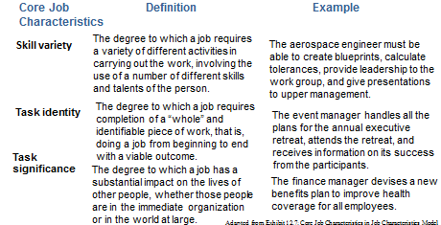
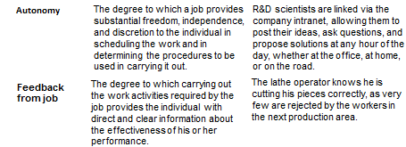

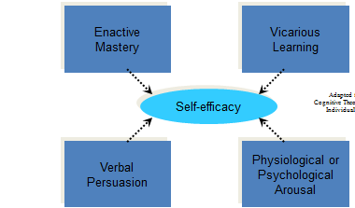
- Process Theories of Motivation : Goal-Setting Theory
  - Human action is directed by conscious goals and intentions
    - More challenging (higher or harder) goals, if accepted, result in higher levels of an effort than easier goals.
    - Specific goals result in higher levels of effort than vague goals.
- Role of Reinforcements and Consequences
  - Events that happen to an individual following a particular behaviour
    - Positive consequence
    - Neutral consequence
    - Negative consequence
    - Magnitude of the consequence

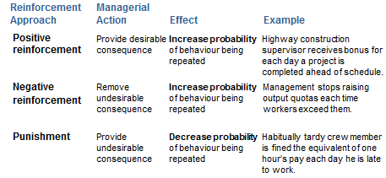
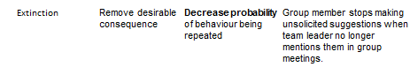
- Social Influences on Motivation:
  - Influence of the immediate workgroup
    - Individual is a member of the “in-group”
    - Individual has strong desire to be part of that group and to receive that group’s approval
  - Influence of supervisors and subordinates
  - Influence of organization’s culture
- Strategic Leadership:
  - Strategic leadership
    - Thinking and acting strategically while working with others to create a viable future for the organization
    - Anticipate events (analyze the external environment)
    - Envision the organization’s future (analyze the internal resources and develop a vision for the organization or some unit within it)
    - Remain flexible in order to adapt to conditions as they change
- What is Leadership?
  - Organizational leadership
    - Social influence process
    - Attempts to influence other people in attaining some goal
  - Positions labeled as management or supervision have more opportunities to exercise influence
  - Effective leadership
    - Influence that assists a group or an organization in meeting its goals and objectives and performing successfully
    - Enabling behaviour
      - Helps other people accomplish more than if there had been no such leadership
- Types and Sources of Power:
  - Position power
    - Based on a manager’s rank in an organizational structure
    - Given to the manager by supervisors
- Personal power
  - Based on a person’s individual characteristics
  - Stay with the individual regardless of his or her position in the organizational structure.
- Types of Power
  - Position Powers
    - Legitimate- How much authority does the organization give to your position?
    - Reward- Are you able to give others the rewards they want?
    - Coercive- Are you able to punish others or withhold rewards?
  - Personal Powers
    - Expert- Do you have knowledge that others need?
    - Referent- Do others respect you and want to be like you?
- 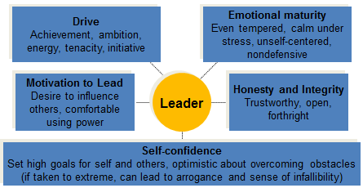
- Three Leadership Variables: The Leader
  - Leaders’ skills and competencies
    - Technical
    - Interpersonal
    - Conceptual
    - Emotional intelligence
    - Social intelligence
  - Leaders’ behaviours
- Charismatic Leadership:
  - Charisma is a strong form of referent power
  - Influence is based on individual inspirational qualities rather formal power
  - Followers or subordinates identify with charismatic leaders because of these exceptional qualities.
- Transformational Leadership:
  - Leaders empower and coach followers
  - Followers identify with the leader
  - Motivate followers (to)
    - Ignore self-interest
    - Work for the larger good of the organization
    - Achieve significant accomplishments
    - Make major changes
- Transactional Leadership:
  - More passive
  - Emphasizes exchange of rewards or benefits for compliance with leader’s requests.
  - Appeals to followers’ self-interests to motivate their performance.
- Guidelines for Transformational Leadership: Those who want to be transformational leaders should:
  - Develop a clear and appealing vision
  - Develop a strategy for attaining the vision
  - Articulate and promote the vision
  - Act confident and optimistic
  - Express confidence in followers
  - Use early success in small steps to build confidence
  - Celebrate successes
  - Use dramatic, symbolic actions to emphasize key values
  - Lead by example

Week 12 (II)
- Control Function in Management:
  - Control
    - Regulation of activities and behaviours within organizations
    - Adjustment or conformity to specifications or objectives
  - Effective control depends heavily on other functions that precede it and feeds back to them
    - Planning
    - Organizing
    - Leading
2.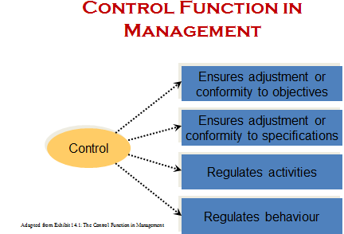
3. 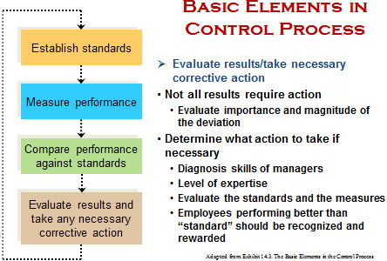
4. Scope of Control: Strategic Control
- Assess and regulate how the organization fits its external environment and meets its long-range objectives and goals
- Control becomes less efficient in uncertain or changing environments
- The topic of scope of control is divided into strategic, tactical, and operational control
5. Scope of Control: Tactical Control
- Assess and regulate day-to-day functions of the organization and its major units in implementing its strategy
  - Financial controls
  - Budgetary controls
  - Supervisory structure controls
  - Human resource controls
  - Contrasting approaches to using tactical controls
    - Bureaucratic control
    - Commitment, or clan, control
6. Budgetary Control:
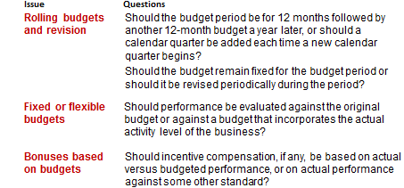
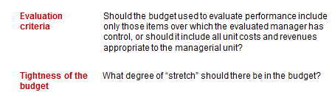
7. Scope of Control: Operational Control
- Assess and regulate specific activities and methods used to produce goods and services
- Pre-control of operations
- Concurrent control of operations
- Post-control of operations
8. Effectiveness of Controls
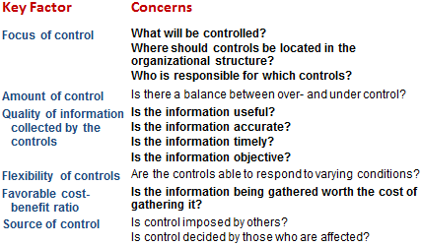
Week 13
1. Marketing: Planning and executing the development, pricing, promotion and distribution of ideas, goods and services to create exchanges that satisfy both buyers’ and sellers’ objectives.
- What is a sustainable competitive advantage? Something the firm can consistently do better than its competitors.
- A segment is a group that responds similarly to a firm’s marketing efforts.
- One of the keys in place and value delivery is to provide the consumer ___________________.

