Muscle Overview Part 1: Gross Anatomy and Function

Different Movements:
- Flexion: A muscle that crosses on the anterior side of a joint produces flexion. Example: Pectoralis major
- Extension: A muscle that crosses on the posterior side of a joint produces extension. Example: Latissimus dorsi (Is an antagonist of the pectoralis major)
- Supination and pronation: Are a pair of unique movements possibly only in the forearms and hands, allowing the human body to flip the palm either face up (supination) or palm face down (pronation).
- Inversion: Is the movement of the sole towards the median plane
- Eversion: Is the movement of the sole of the foot away from the median plane.
- Abduction: A muscle that crosses on the lateral side of a joint. Example: Deltoid middle fibers.
- Adduction: A muscle that crosses on the medial side of a joint produces adduction. Example: Teres major, it is an antagonist of the deltoid
- Dorsiflexion: When walking on the heels the ankle is described as being in dorsiflextion.
- Plantar flexion: The movement which decreases the angle between the sole of the foot and the back of the leg.

Muscle Interactions:
- Prime mover: A muscle that has the major responsibility for producing a specific movement.
- Antagonist: Muscles that oppose, or reverse, a particular movement.
- Synergist: Help prime movers by adding a little extra force to the same movement or by reducing undesirable or unnecessary movements.
- Fixators: When a synergists immobilize a bone, or a muscle’s origin so that the prime mover has a stable base on which to act.

CT wrappings:
- Deep fascia, Epimysium (wrapped around muscle fibers), Perimysium (wrapped around perimysium), Endomysium (between fibers)

Neuroanatomy Overview:

Supporting cells of the Nervous System:
Peripheral Nervous System:
- Satellite cells: Surround neuron cell bodies located in the peripheral nervous system, and are thought to have many of the same functions in the PNS as astrocytes do in the CNS.
- Schwann cells (also called neurolemmocytes): Surround all the nerve fibers in the PNS and form myelin sheaths around the thicker nerve fibers.
Central Nervous System:
- Astrocytes: Are the most abundant and versatile glial cells. Their numerous radiating processes cling to neurons and their synaptic endings, and cover nearby capillaries. They support the brace and brace the neurons and anchor them to their nutrient supply lines.
- Microglia: Are small and ovoid with relatively long “thorny” processes. Their processes touch nearby neurons, and monitoring their health, an when they sense that certain neurons are injured or in other trouble, the microglial cells migrate toward them.
- Ependymal cells: Range in shape from squamous to columnar, and many are ciliated. They line the central cavities of the brain and the spinal cord, where they are form a fairly permeable barrier between the cerebrospinal fluid that fills those cavities and the tissue fluid bathing the cells of the CNS.
- Oligodendroyctes: They branch, and have fewer processes than astrocytes. They line up along the thicker nerve fibers in the CNS and wrap their processes tightly around the fibers, producing an insulating covering called a myelin sheath.

White matter vs Grey matter?
- White Matter: Myelinated axons
- Grey Matter: Cell bodies
Cerebral white matter can run in several different directions
What is Cerebral cortex made out of? Grey matter 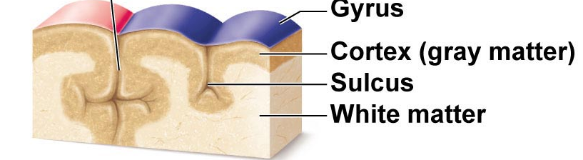

What do you call fibers that run:
- Vertically to the thalamus or brain stem?
-Projection fibers

- Form connections between the two hemispheres?
-Commissural fibers

- Form connections within a hemisphere?
-Association fibers

How about in the spinal cord? What makes up the outer layer? White matter!

The five cerebral lobes:
- Frontal- Conscious thought, mood
- Parietal- Integrates sensory information
- Occipital- Sense of sight
- Temporal- Auditory and smell
- Insular- Pain

Three types of functional areas of the cerebral cortex:
Motor Areas:
- Primary Motor Cortex
- Premotor cortex
- Broca’s area
- Frontal eye field

Sensory Areas
- Primary somatosensory
- Somatosensory association area
- Visual areas
- Auditory areas
- Vestibular cortex
- Olfactory cortex
- Gustatory cortex
- Visceral sensory areas

Multimodal Association Areas
- Anterior association area (prefrontal cortex)
- Posterior association area (part of posterior lobes)
- Limbic association area

The Diencephalon (The three thalamuses)

Thalamus
- Very important
- Gateway to cerebral cortex
- Sensory sorting and modification

Hypothalamus
- Master of endocrine system and many homeostatic variables

Epithalamus
- Contains choroid plexus which forms CSF
- Contains pineal gland which produces melatonin (sleep-wake cycle)

The Brainstem

Midbrain
- Substantia nigra
- Red nucleus
Pons
- “Pons are pudgy” (pyramidal tracts)

Medulla Oblongata
- Pyramids
- Motor fibers decussate after pyramids
- Life-supporting reflexes: Respiratory, cardiovascular, vomiting

Horns of the spinal cord
What makes up these horns? (hint: grey matter)
Cell bodies!

What neurons make up the: Ventral/anterior horn?
Somatic motor neurons

Dorsal/posterior horn?
Sensory INTERNEURONS

Lateral horn?
Autonomic motor neurons

Meninges (sing: meninx)
Dura mater
-Two layers: periosteal, meningeal

Arachnoid mater
-Subarachnoid space (sub=below) filled with CSF and large blood vessels!

Pia mater
-Small blood vessels
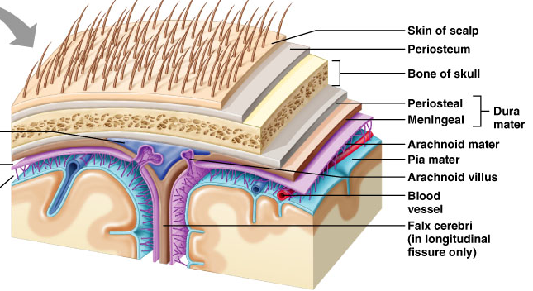

Cranial Nerves
-12 pairs!

Mnemonic to remember order:
“On occasion, Our Trust Truck Acts Funny. Very Good Vehicle Anyhow”
Mnemonic to remember sensory/motor/both
“Some Say Marry Money But My Brother Says (its) Bad Busniess (to) Marry Money”

Vagus Nerve: ONLY cranial nerve to extend beyond head-neck
-Very important parasympathetic motor signals

Midterm Style Questions
- 99% of the neurons in the body are what type of neuron?
- Astrocytes
- Sensory neurons
- Interneurons
- Peripheral nervous system neurons

- A patient is brought into the hospital. He has no paralysis, but lacks coordination of fine movements and balance. What is wrong with him?
- He has a lesion in his spinal cord
- His motor cortex is damaged
- He has frontal lobe damage
- Dysfunction of his cerebellum

- Reticular formation is responsible for:
- Controlling heart rate
- Arousal of the brain
- Produces melatonin as part of sleep-wake cycle
- Filters sensory information
- B and D

- A mixed nerve:
- Contains both nerves and tracts
- Contains both grey matter and white matter
- Contains both afferent and efferent nerves
- Can release different types of neurotransmitters

- Prime mover(s) of forearm flexion at the elbow is/are:
- Brachialis
- Triceps brachii
- Biceps brachii
- Flexor digitorum longus
- A and C

- Neurons that send impulses from Wernicke’s area to neurons in Broca’s area are:
- Commissural fibers
- Projection fibers
- Association fibers
- Corpus callosum

- Which of the following is NOT part of the brainstem
- Medulla
- Cerebellum
- Pons
- Midbrain

- Cell bodies of first order sensory neurons are:
- At the site of sensation (eg. Fingertips)
- Dorsal root ganglion
- Dorsal horn of spinal cord
- Somatosensory cortex

- Primary motor cortex is in the:
- Precentral gyrus
- Postcentral gyrus
- Parietal lobe
- Precentral sulcus
- A and C

- Vastus medialis and vastua lateralis are antagonists for which movement:
- Forearm extension
- Knee extension
- Hip flexion
- Knee flexion
- C and D

- The cell type responsible for formation of cerebrospinal fluid
- Astrocytees
- Oligodendrocytes
- Arachnoid villi
- Ependymal calls

- Broca’s Area:
- Is found in the occipital lobe
- Is usually found in the right hemisphere
- Is considered a motor speech area
- Is involved in the understanding of written and spoken language

