Anatomical Terms and Bone Tissue:

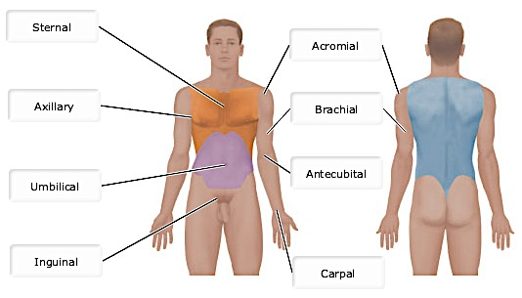
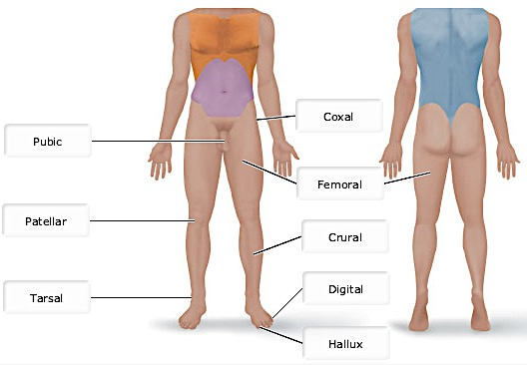

- Which of the following is the proper description of the human body in the anatomical position?
  - The body is erect with feet slightly apart and palms facing forward with thumbs pointing away from the body.
  - The body is erect with feet slightly apart and arms extending perpendicular to the torso along a straight line with the clavicle.
  - The body is erect with feet together, palms facing backward, and thumbs pointing toward the body.
  - The body is erect with feet together and palms facing the thighs with thumbs pointing forward.

In the anatomical position, the body is erect with feet slightly apart and arms at the sides. This position is easy to remember because it resembles “standing at attention,” except that the palms face forward and the thumbs point away from the body.

- Which of the following statements is correct?
  - The sternum is dorsal to the spine.
  - The sternum is posterior to the spine.
  - The heart is dorsal to the sternum.
  - The heart is posterior to the spine.

The heart is dorsal (posterior) to the sternum. In humans, the terms dorsal and posterior are synonymous with one another, meaning “toward or at the back of the body,” or behind.

- Which of the following is the regional term that includes the head?
  - Coronal
  - Appendicular
  - Superior
  - Axial

The axial part of the body, which makes up the main axis of our body, includes the head, neck and trunk.

- Which of the following cuts could cross the umbilical, pelvic, and nasal regions?
  - Coronal section
  - Transverse section
  - Sagittal section
  - Oblique section

A sagittal section is a cut mad through the sagittal plane – a vertical plane that divides the body into right and left parts. A midsagittal plane would cross the nasal, umbilical and pelvic regions.

- Fill in the blanks; lateral, anterior, medial, distal, proximal
  - The fingers are distal to the wrist.
  - The lunges are lateral to the heart.
  - The bridge of the nose is medial to the left eye.
  - The stomach is anterior to the spine.
  - The upper arm is proximal to the forearm.

- Which of the following describes a parasagittal plane?
  - A transverse cut just above the knees
  - Any cut dividing the body into anterior and posterior portion
  - Two cuts dividing the body into left and right halves
  - Any sagittal plane except in the midline

- What is a vertical section through the body, dividing it into left and right, called?
  - Frontal
  - Sagittal
  - Transverse
  - Regional

- Anatomical position is important because _______.
  - It is the position most comfortable to hospital patients
  - It allows a common point of reference for body position to help communicate anatomical relationships
  - It provides the greatest circulation to the extremities
  - It allows diagrams within textbooks to display a greater surface area of the body with one simple diagram

- Which of the following regional anatomy terms matches the anatomical description “anterior and most distal”?
  - Carpal
  - Metatarsal
  - Acromial
  - Popliteal

The metatarsal region is the most distal region on this list. Additionally when you view the posterior plane, the metatarsal region is not visible (instead you would see the plantar region).
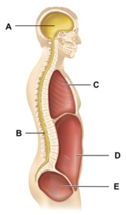
- What is the mediastinum?
  - A subdivision of the cavity indicated by the letter C.
  - The structure that connects cavities A and B.
  - The structure that separates the cavities indicated by the letters C and D.
  - The cavity formed by the combination of subdivisions indicated by the letters D and E.

The mediastinum is a cavity contained within the thoracic cavity.

- The dorsal body cavity is divided into which of the following subdivisions?
  - The vertebral/spinal, cranial and pleural cavities
  - The vertebral/spinal and cranial cavities
  - The vertebral/spinal and thoracic cavities
  - The thoracic, pleural, and abdominopelvic cavities

The dorsal body cavity, which protects the fragile nervous system organs, has two subdivisions: the cranial cavity and the vertebral, or spinal, cavity.

- The dorsal body cavity is the site of which of the following?
  - Brain
  - Intestines
  - Liver
  - Lungs

- The body cavities that protect the nervous system are located in the _____ cavity.
  - Cranial
  - Vertebral
  - Thoracic
  - Dorsal
  - Ventral

- Which body cavity is further separated into other cavities?
  - Pericardial
  - Thoracic
  - Abdominopelvic
  - Pleural

The thoracic cavity contains the pericardial and pleural cavities, which in turn house the heart and lungs, respectively.

- Which type of cartilage is NOT properly matched with its function?
  - Skeletal cartilage; reinforce airways
  - Elastic cartilage; withstand repetitive bending
  - Fibrocartilage; withstand pressure and stretch
  - Hyaline cartilage; cover the ends of bones

Skeletal cartilage is not a specific cartilage type but rather a description of the collection of cartilage in the body.

- The pubic symphysis connects the two hip bones anteriorly and provides a little movement during childbirth. Choose the most appropriate tissue for this structure that is subjected to both pressure and stretch.
  - Fibrocartilage
  - Hyaline cartilage
  - Elastic cartilage
  - Bone

- Bones do NOT have a role in _________.
  - Blood cell formation
  - Glycogen production
  - Support
  - Movement
  - Fat storage

Glycogen production (glycogenesis) is not a role of bone; it takes place primarily in muscle and liver cells.

- Which of the following statements in FALSE?
  - Sesamoid bones form within certain tendons.
  - The sternum is an example of a flat bone.
  - Irregular bones include the vertebrae and hip bones.
  - Long bones include all limb bones except the patella.

This is false; long bones include all limb bones except the patella, tarsals and carpals.

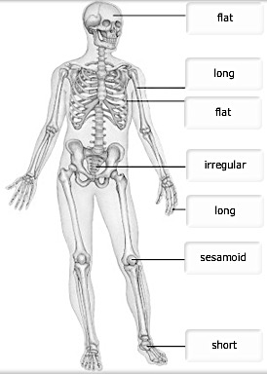

- At an archeological site you discover a bone that is cylindrical in shape, about one inch long and a quarter of an inch wide. Choose the correct classification.
  - Long
  - Short
  - Sesamoid
  - Irregular

- Which of the following pairs is MISMATCHED?
  - Tarsals; short bones
  - Sternum; long bone
  - Femur; long bone
  - Skull bones; flat bones

The sternum is a flat bone.

- Bones are classified by whether they are weight bearing or protective in function.
  - True
  - False
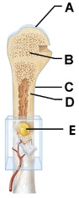
- What material makes up most of the structure at A?
  - Hyaline cartilage
  - Elastic cartilage
  - Dense irregular connective tissue
  - Fibrocartilage

The articular cartilage at the ends of long bones is formed from hyaline cartilage.

- Which of the labeled parts of the bone is composed primarily of compact bone?
  - A
  - B
  - C
  - D
  - E

The shaft of an adult long bone is composed of compact bone.

- In which of the labeled parts of the adult long bone would hematopoietic tissue be located?
  - A
  - B
  - C
  - D
  - E

Hematopoietic tissue is found in the spaces within the red bone marrow found within certain body locations consisting of spongy bone. Examples include diploe of flat bones and the proximal epiphyses of the femur and humerus.

- The blood vessels and nerve in the figure are found within which type of space?
  - Central (Haversian) canal
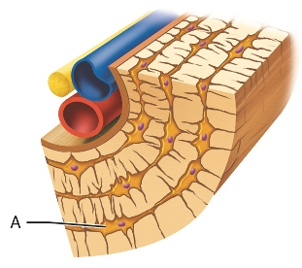
  - Marrow cavity
  - Canaliculi
  - Perforating (Volkmann’s canal)

A central (or Haversian) canal runs lengthwise at the center of each osteon.

- What type of cell is shown at A?
  - Osteoclast
  - Osteocyte
  - Osteoblast
  - Mesenchymal

Osteocytes, literally “bone cells,” are the primary structural and maintenance cells found in bone.

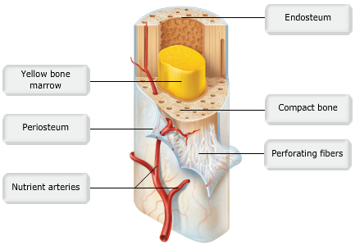

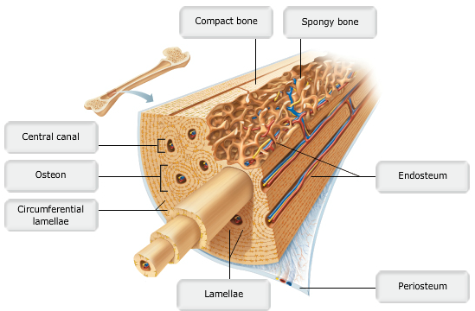

- Which of the following cells are NOT matched with its appropriate function?
  - Bone lining cells; maintain matrix
  - Osteoblasts create new bone matrix
  - Osteocytes; produce new bone cells
  - Osteoclasts; bone reabsorption
.
Osteocytes are mature bone cells that monitor and repair mature bone tissues

- Osteoblasts __________.
  - Form new bone
  - Maintain bone matrix
  - Break down bone
  - Form skeletal cartilage

Osteoblasts are the bone-forming cells that produce new bone.

- Flat bones consist of spongy bone sandwiched between compact bone.
  - True
  - False
Flat bones consist of two thin plates of compact bone enclosing a spongy bone layer.

- Match terms to appropriate blanks:
  - Endosteum – The lining of the marrow cavity.
  - Osteoclasts – Cells that can dissolve the bony matrix.
  - Lamellae – Layers of bone matrix.
  - Canaliculi – Small channels that radiate through the matrix of bone.
  - Osteoblasts – Cells that can build bony matrix.

- The structure of bone tissue suits the function. Which of the following bone tissues is adapted to support weight and withstand torsion stresses?
  - Trabecular bone
  - Spongy bone
  - Compact bone
  - Irregular bone

- The periosteum is secured to the underlying bone by _________.
  - Volkmann’s canals
  - A bony matrix with hyaline cartilage
  - The struts of bone known as spicules
  - Perforating (Sharpey’s) fibers

- Bones are constantly undergoing resorption (breaking bone down) for various reasons. Which of the following cells accomplishes this process?
  - Osteocyte
  - Osteoblast
  - Osteoclast
  - Stem cell

- Choose the structures that most directly provide nutrients and remove wastes from osteocytes in compact bone.
  - Perforating (Volkmann’s) canals
  - Canaliculi
  - Nutrient foramens
  - Central canals

- When an osteoblast becomes completely surrounded by its own matrix secretions it is referred to as an __________.
  - Chondrocyte
  - Osteoclast
  - Osteocyte
  - Osteogenic cell

- Yellow bone marrow contains a large percentage of ________.
  - Sharpey’s fibers
  - Elastic tissue
  - Fat
  - Blood-forming cells

- The cell responsible for secreting the matrix of bone is the _________.
  - Osteoblast
  - Osteocyte
  - Chondrocyte
  - Osteoclast

- The term diploë refers to the ________.
  - Two types of marrow found within most bones
  - Fact that most bones are formed of two types of bone tissue
  - Internal layer of spongy bone in flat bones
  - Double-layered nature of the connective tissue covering the bone

- What is the structural unit of compact bone?
  - Osseous matrix
  - Lamellar bone
  - Spongy bone
  - The osteon

- An imbalance that activates these bone cells would lead to a loss of bone density.
  - Osteocytes
  - Chondroblasts
  - Osteoblasts
  - Osteoclasts

Osteoclasts are the bone cells that break down bone. If they were activated more than normal, you should expect to see bone loss.

- What is the structural unit of compact bone?
  - Osteon
  - Osteoid
  - Haversian canal
  - Canaliculus

The structural unit of compact bone is the osteon, an elongated cylinder oriented parallel to the long axis of the bone.

- The periosteum is a tissue that serves only to protect the bone because it is not supplied with nerves or blood vessels.
  - True
  - False

- Short, irregular, and flat bones have medullary cavities in order to keep the weight of the bones light.
  - True
  - False

- Which of the following best describes the process shown in the figure?
  - Bone repair at a site of fracture
  - The formation of bone in a preexisting cartilage model
  - Bone remodeling in response to changes in mechanical stress
  - The formation of bone in a membrane

The figure illustrates the formation of new bones within a fibrous membrane (“intramembranous”) during embryonic development.

- Classify the cells seen at the arrow in A.
  - Osteoblasts
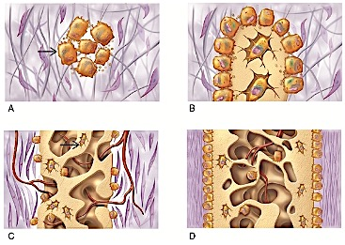
  - Osteoclasts
  - Osteocytes
  - Chondroblasts

Osteoblasts (“bone makers”) begin bone formation by secreting the bone matrix.

- What bone-associated structures in panel C are indicated by the arrow?
  - Periosteum
  - Trabeculae
  - Epiphyseal plate
  - Osteon

The honeycomb-like network of spongy bone is constructed of bony plates called trabeculae.

- Which step in the figure contains compact bone?
  - A
  - B
  - C
  - D

Osteoblasts in the periosteal layer form compact bone characteristic of the exterior surface of a mature bone.

- Which bone-forming process is shown in the figure?
  - Endochondral ossification
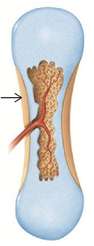
  - Intramembranous ossification
  - Bone remodeling
  - Bone fracture repair

The figure illustrates a step in the embryonic formation of a bone from a cartilage model.

- The area where blood vessels are penetrating the center of the bone used to be occupied by which tissue?
  - Adipose tissue
  - Dense connective tissue
  - Fibrocartilage
  - Hyaline cartilage

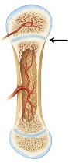
In this type of ossification, the bone is first modelled from cartilage and then replaced by bone vessels invade the model.

- The arrow in the figure is pointing to which of the following structures?
  - The epiphyseal plate
  - The articular cartilage
  - A primary ossification center
  - A secondary ossification center

During endochondral ossification, an epiphyseal plate is formed at the boundary between primary and secondary ossification centers
- The structure indicated by the arrow (previous page) is composed primarily of what tissue?
  - Fibrocartilage
  - Dense connective tissue
  - Mesenchyme
  - Hyaline cartilage

The cartilage models used to form bones are composed of hyaline cartilage. This tissue persists within the epiphyseal plate at the boundary between primary and secondary ossification centers until early adulthood.

- During bone growth, which significant event occurs at the surface indicated by the letter C?
  - Appositional growth
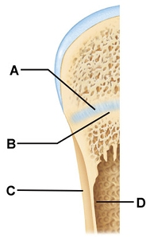
  - Expansion of the articular cartilage
  - Bone resorption
  - Conversion of spongy bone to compact bone

Growth in width involves the adding of layers of lamellar (compact) bone along the bone’s outer surface. This process of growth by “layering” is termed appositional growth and is distinct growth by expansion of the interior matrix (interstitial growth).

- During bone growth, which significant event occurs at the surface indicated by the letter D?
  - Production of compact bone
  - Interstitial growth
  - Bone resorption
  - Production of hyaline cartilage

As the bone widens, the matrix at the endosteal surface is resorbed to maintain the proper thickness of the walls surrounding the medullar cavity.

- Which of the following statements is true?
  - Most bones in the body are formed by intramembranous ossification.
  - Endochondral ossification occurs within fibrous connective tissue membranes.
  - Endochondral ossification converts hyaline cartilage “bone” models into true bones (i.e., hyaline cartilage serves as a template for bone formation).
  - Endochondral ossification leads to the formation of the clavicles and cranial bones.

Endochondral ossification is the formation of bone within hyaline cartilage. Hyaline cartilage “bones” are used templates for the formation of true bone. Most bones below the base of the skull form by endochondral ossification.

- During infancy and childhood, the most important stimulus of epiphyseal plate activity is _____.
  - Estrogen
  - Testosterone
  - Growth hormone
  - Thyroid hormones

During infancy and childhood, the single most important stimulus for bone growth is growth hormone. It directly stimulates growth of the hyaline cartilage that forms the epiphyseal plates in long bones, causing the bones to lengthen

- Ossification of the ends of long bones _________.
  - Involves medullary cavity formation
  - Is produced by secondary ossification centers
  - Takes twice as long as diaphysis ossification
  - Is a characteristic of intramembranous bone formation

- Which structure allows the diaphysis of the bone to increase in length until early childhood?
  - Epiphyseal line
  - Osteon
  - Epiphyseal plate
  - Lacuna
- Which of the following is the single most important stimulus for epiphyseal plates activity during infancy and childhood?
  - Growth hormone
  - Calcium
  - Thyroid hormone
  - Parathyroid hormone

- For intramembranous ossification to take place, which of the following is necessary?
  - A medullary cavity forms.
  - The cartilage matrix begins to deteriorate.
  - A bone collar form around the cartilage model.
  - Ossification centers form in the fibrous connective tissue membrane.

- Ossification (Osteogenesis) is the process of __________.
  - Making collagen fibers for calcified cartilage
  - Bone formation
  - Making a cartilage model of the fetal bone
  - Bone destruction to liberate calcium

- Lengthwise, long bone growth during infancy and youth is exclusively through ________.
  - Differentiation of osteoclasts into osteocytes
  - The secretion of bone matrix into the medullary cavity
  - Interstitial growth of the epiphyseal plates
  - Calcification of the matrix of the zone underlying articular cartilage

- Growth of bones is controlled by a symphony of hormones. Which hormone is of greatest importance for bone growth during infancy and childhood?
  - Thyroid hormone
  - Calcitonin
  - Growth hormone
  - Parathyroid hormone

- What tissue forms the model for endochondral ossification?
  - Bone
  - Fibrous membrane
  - Fascia
  - Cartilage

- Cranial bones develop __________.
  - From a tendon
  - Within osseous membranes
  - From cartilage models
  - Within fibrous membranes

- In the epiphyseal plate, cartilage grows ___________.
  - From the edges inward
  - In a circular fashion
  - By pushing the epiphysis away from the diaphysis
  - By pulling the diaphysis toward the epiphysis

- In some cases the epiphyseal plate of the long bones of children closes too early. What might be the cause?
  - Too much vitamin D in the diet
  - Elevated levels of sex hormones
  - Osteoblast activity exceeds osteoclast activity
  - Overproduction of thyroid hormone

- What is intramembranous ossification?
  - The formation of bone from preexisting fibrocartilage models
  - The formation of bone from preexisting hyaline cartilage models
  - The formation of bone from preexisting elastic cartilage models
  - The formation of bone from fibrous membranes

The formation of bone from fibrous membranes is called intramembranous ossification.
- What would be the physical sign that a bone CANNOT continue longitudinal growth?
  - The presence of hyaline cartilage on the ends of the bone
  - An epiphyseal line
  - The presence of osteoblasts
  - The presence of osteons

The epiphyseal plate is a zone of hyaline cartilage between the epiphysis and diaphysis of a long bone. When the cartilage is replaced with bone and the plate closes, the bone has reached its maximum length. This is called the epiphyseal line.

- Closure of the epiphyseal plate stops all bone growth.
  - True
  - False

- Which hormone increases osteoblast activity to release more calcium ions into the bloodstream?
  - Parathyroid hormone
  - Calcitonin
  - Estrogen
  - Thyroxine

