Civil Engineering Materials
CVG 2141
Lab 1- Metals
Tensile Strength of Steel and Aluminum
Lab Group 15
Lab Performed September 29th, 2016
Submitted by Gregory Loncaric- 8261365

Abstract
Exposing a material to a controlled tensile force provides a large amount of useful data that can allow civil engineers make a most educated decision when choosing a material for a project. In this experiment, three materials were tested, cold rolled steel, hot rolled steel, and aluminum. By measuring the change in length caused by the force applied to the material, values of stress and strain were calculated and studied. As expected, the hot rolled steel was the most ductile with moderate ultimate stress, the cold rolled steel had the highest ultimate strength while being the most brittle, and the aluminum has relatively low ductility with a low ultimate strength.

Table of Contents
Objective..........................................................................................................................................5
Background......................................................................................................................................5
Equipment........................................................................................................................................6
Procedure.........................................................................................................................................6
Data Presentation.............................................................................................................................6
Calculations......................................................................................................................................9
Discussion......................................................................................................................................11
Conclusion.....................................................................................................................................12

Table of Figures
Table 1. Cross-sectional areas of the different materials before and after applied force................6
Table 2. Initial and final dimensions for length between nodes for hot rolled steel.......................6
Table 3. Initial and final dimensions for length between nodes for cold rolled steel.....................7
Table 4. Initial and final dimensions for length between nodes for aluminum..............................7
Table 5. Reduction of area for each material..................................................................................7
Graph 1. Stress- strain curve for hot rolled steel............................................................................8
Graph 2. Stress- strain curve for cold rolled steel..........................................................................8
Graph 3. Stress- strain curve for aluminum....................................................................................9
Graph 4. % Elongation for all three materials................................................................................9

Objective
The objective of this lab is to analyze the effect of tensile force applied to the material by measuring the deformation and analyzing the stress-strain curve to find the following characteristics of each metal being tested:
- Stress-strain relationship
- Modulus of elasticity
- Yield strength
- Tensile or ultimate strength
- Tensile strength at failure point
- Resilience
- Toughness
- Percentage of elongation
- Reduction of cross sectional area
Sanchez, L. (2016). Lab 1- Metals. Tensile Strength for Steel and Aluminum, p2.
Background
Testing the tensile strength of a material can provide important information on the material in question. The test is done by applying controlled, measurable tension to a sample of the material and recording its ability to take the force until failure. The deformation of the material is measured using an extensometer. These results produce a stress-strain curve, measuring the deformation over time under a stress. This curve provides civil engineers with important information. These include:
Stress and Strain (deformation)
Stress= σ = F/A (F = force, A = original cross-sectional area)
Strain= ε =ΔL/L (ΔL = elongation, L= original gauge length).
Modulus of Elasticity
E= Δσ/Δε, also expressed as the slope of the straight line portion of the stress strain curve. The higher this value, the stiffer the material.
Yield Strength
The yield strength can be recorded by observation of the graph or by using the 2% offset method. This method is performed by drawing a straight line over the initial slope of the graph then drawing a parallel line to this shifted over 2% of the max strain of the curve on the x axis. The point where this line intersects the curve is the yield point.
Tensile or Ultimate Strength
The maximum amount of stress a material can stand before failure.
Modulus of Resilience
∫ curve before yield point (area).
Modulus of Toughness
∫ entire curve before failure (area).
Percent Elongation
%elongation= (L_{f}-L_{i})/L_{i} x 100 (L_{i}= initial length, L_{f}= final length). This value is expected to be the largest at the breaking point.
Percent Area Reduction
%area reduction= (A_{f}-A_{i})/A_{i} x 100 (A_{i}= initial cross-sectional area, A_{f}= final cross-sectional are). This value is expected to be the largest at the breaking point.
Having obtained all of this information, it is possible to compare different materials more effectively, leading to a more appropriate selection of material based on the specific goal of the project.
Sanchez, L. (2016) Lab 1- Metals. Tensile Strength for Steel and Aluminum, p2.
Equipment
Refer to page 1 of the laboratory manual for Lab 1- Metals. Tensile Strength for Steel and Aluminum.
Procedure
Refer to page 1 and 2 of the laboratory manual for Lab 1- Metals. Tensile Strength for Steel and Aluminum.
Data Presentation
Legend:
CS= cold rolled steel
HS= hot rolled steel
Al = aluminum
Table 1. Cross-sectional areas of the different materials before and after applied force.
Material | Initial Width (W_{i}) (mm) | Initial Depth (D_{i}) (mm) | Initial Area (Ai) (mm²) | Final Width (W_{f}) (mm) | Final Depth (D_{f}) (mm) | Final Area (A_{f}) (mm²)
HS | 19.36 | 6.74 | 130.49 | 12.95 | 4.77 | 61.77
CS | 19.45 | 6.45 | 125.47 | 15.55 | 4.54 | 70.60
Al | 19.41 | 6.65 | 129.08 | 16.95 | 5.54 | 93.90

Table 2. Initial and final dimensions for length between nodes for hot rolled steel.
Node Number | Initial Length (L_{i}) (mm) | Final Length (L_{f}) (mm) | Percent Elongation (%E)
1-2 | 25.4 | 27.85 | 9.65
2-3 | 25.25 | 27.93 | 10.61
3-4 | 25.2 | 27.98 | 11.03
4-5 | 24.51 | 29.10 | 18.73
5-6 | 24.87 | 34.33 | 38.04
6-7 | 24.58 | 34.39 | 39.91
7-8 | 24.44 | 29.79 | 21.89
8-9 | 24.94 | 29.67 | 18.97
9-10 | 24.83 | 28.47 | 14.66

Table 3. Initial and final dimensions for length between nodes for cold rolled steel.
Node Number | Initial Length (L_{i}) (mm) | Final Length (L_{f}) (mm) | Percent Elongation (%E)
1-2 | 25.12 | 25.91 | 3.15
2-3 | 24.73 | 26.38 | 6.67
3-4 | 25.34 | 26.5 | 4.58
4-5 | 25.73 | 31.12 | 20.95
5-6 | 24.74 | 26.95 | 8.93
6-7 | 25.42 | 25.94 | 2.05
7-8 | 25.89 | 26.30 | 1.58
8-9 | 24.73 | 25.85 | 4.53
9-10 | 25.3 | 25.55 | 0.99

Table 4. Initial and final dimensions for length between nodes for aluminum.
Node Number | Initial Length (L_{i}) (mm) | Final Length (L_{f}) (mm) | Percent Elongation (%E)
1-2 | 25.1 | 26.04 | 3.75
2-3 | 24.9 | 27.22 | 9.32
3-4 | 24.8 | 29.01 | 16.98
4-5 | 24.7 | 26.29 | 6.44
5-6 | 25.2 | 26.78 | 6.27
6-7 | 24.85 | 26.39 | 6.20
7-8 | 24.7 | 26.74 | 8.26
8-9 | 25.18 | 27.28 | 8.34
9-10 | 24.46 | 25.74 | 5.23

Table 5. Reduction of area for each material.
Material | Initial Area (A_{i}) (mm²) | Final Area (A_{f}) (mm²) | Area Reduction (%A_{r}) (mm²)
HS | 130.43 | 61.77 | 52.64
CS | 125.47 | 70.60 | 43.73
Al | 129.08 | 93.90 | 27.25

Graph 1. Stress- strain curve for hot rolled steel.
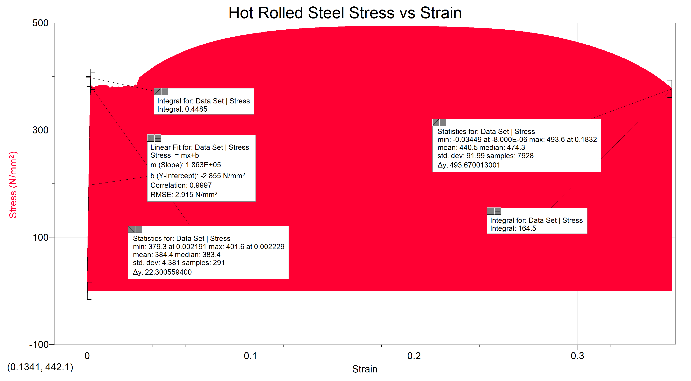
Graph 2. Stress- strain curve for cold rolled steel.
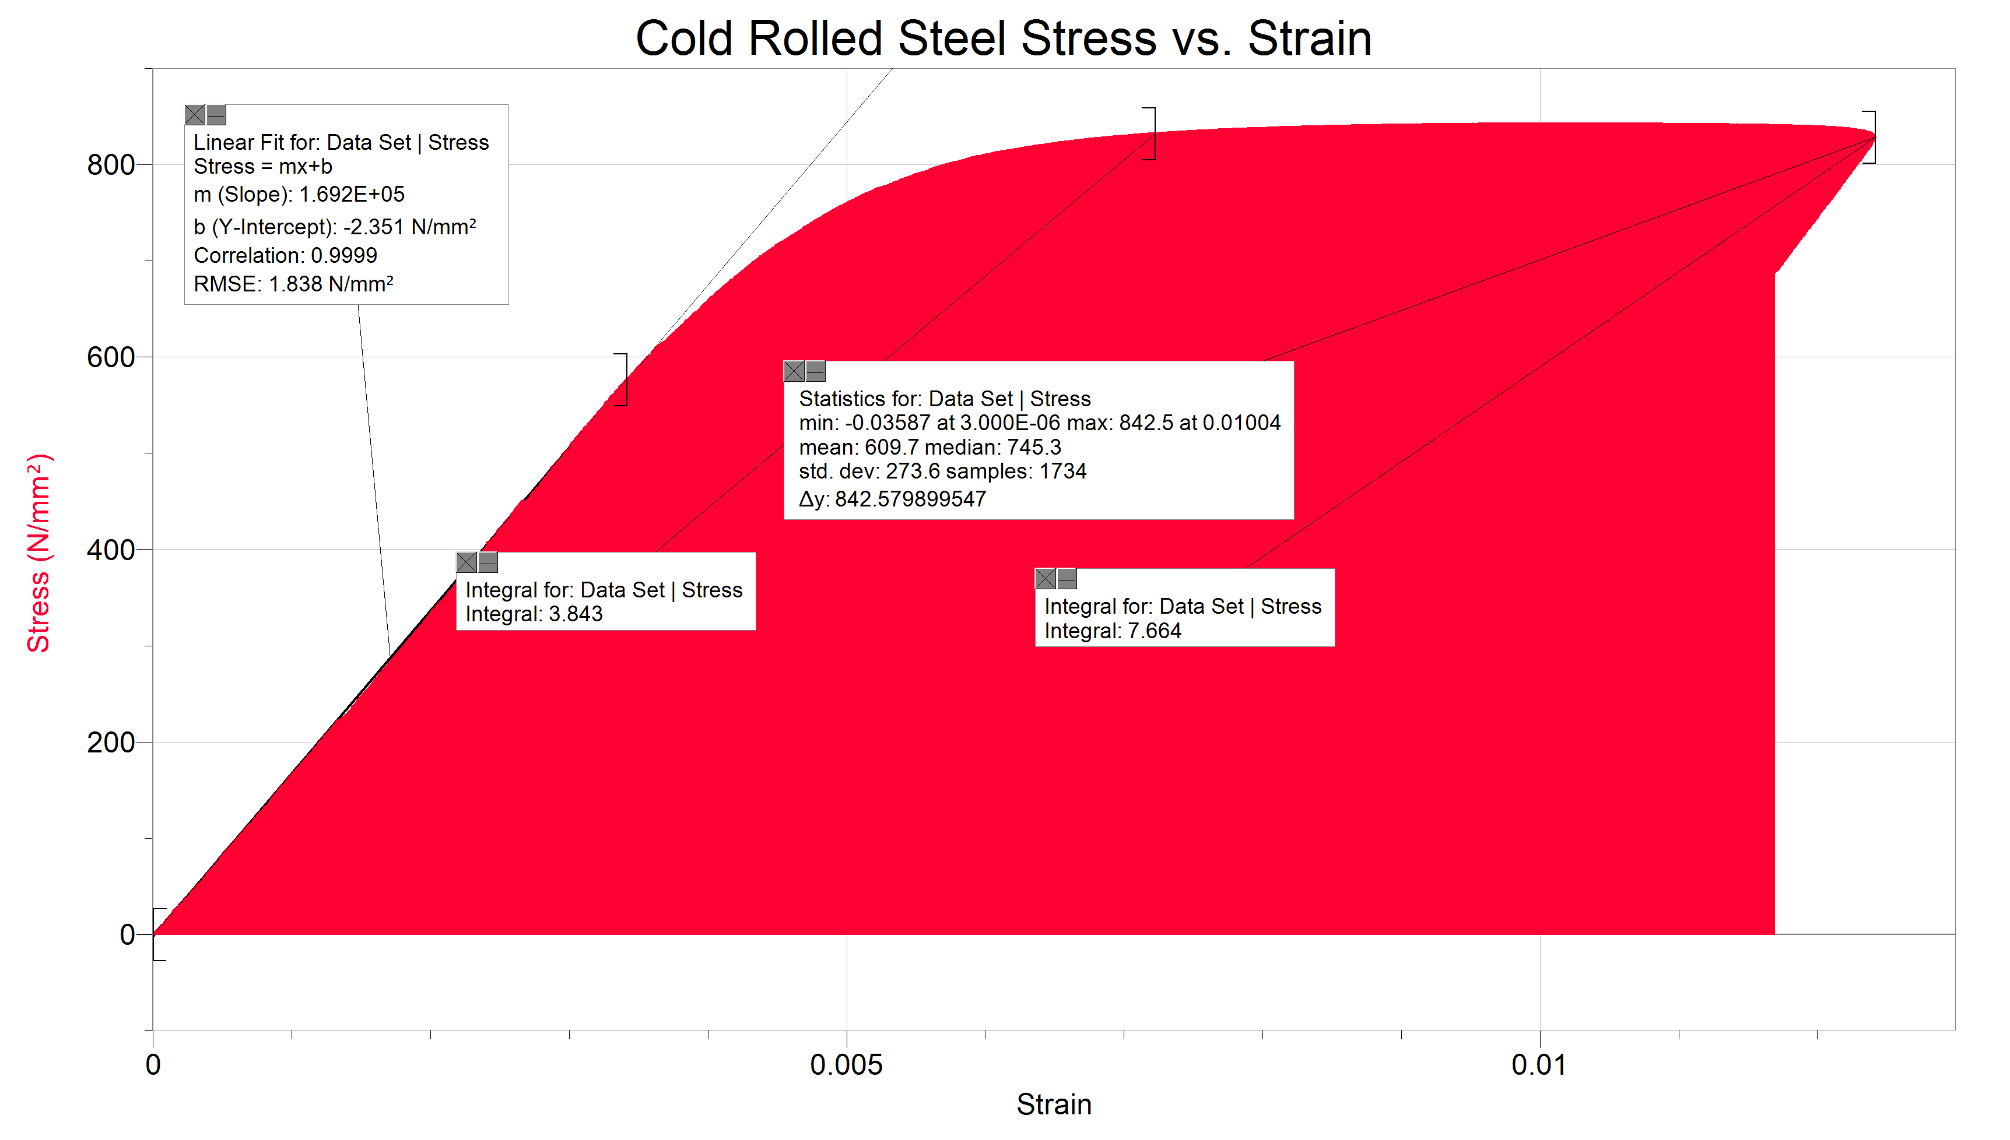
Graph 3. Stress- strain curve for aluminum.
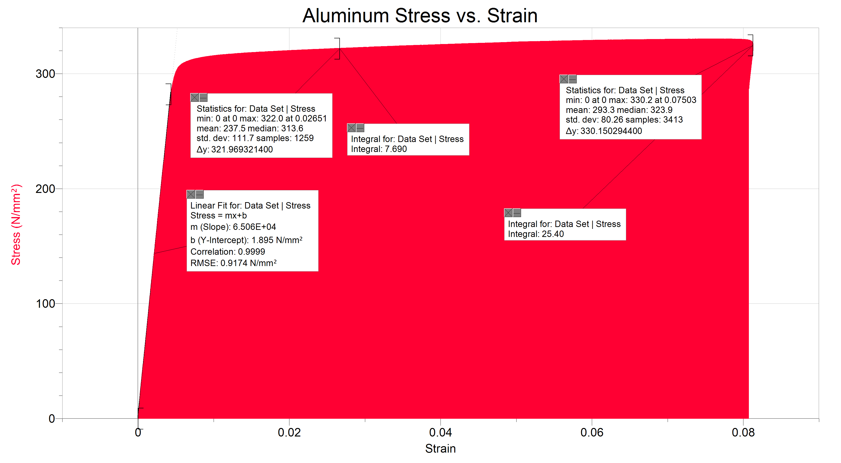
Graph 4. % Elongation for all three materials.

Calculations
Samples
Area
A_{i}= W_{i} x D_{i}
A_{i}= 19.36mm x 6.74mm
A_{i}= 130.49mm²
% Elongation
%E= ((L_{f} – L_{i})/L_{i}) * 100
%E= ((25.74mm – 25.46mm)/25.46mm) * 100
%E= 5.23%
% Area Reduction
%A_{r} = ((A_{f} – A_{i})/A_{i}) *100
%A_{r} = ((93.90mm² – 129.08mm²)/129.08mm²) *100
%A_{r} = 27.25% reduction
Stress
σ = F/A
σ = 42587.3N/ 129.08mm²
σ =329.93N/mm²
Strain
ε = ΔL/L
ε = 3.50395mm/50mm
ε = 0.07
From Graphs
Hot Rolled Steel
Ultimate tensile strength= 493.6 N/mm²
Upper yield= 401.6 N/mm²
Lower yield= 379.3 N/mm²
Modulus of elasticity= 1.863 x 10⁵ (slope of elastic)
Modulus of resilience= 0.4485 (integral up until yield)
Modulus of toughness= 164.5 (integral of the whole graph)
Tensile strength at fracture= 376.891N/mm² at a strain of 0.357606
Proportional limit= 401.6N/mm² at a strain of 0.002229
Cold Rolled Steel
Ultimate tensile strength= 842.5 N/mm²
Yield= 832.22 N/mm² (by using the 2% offset method)
Modulus of elasticity= 1.692 x 10⁵ (slope of elastic portion)
Modulus of resilience= 3.843 (integral up until yield)
Modulus of toughness= 7.664 (integral of the whole graph)
Tensile strength at fracture= 828.748N/mm² at a strain of 0.0124185
Proportional limit= 576.329N/mm² at a strain of 0.003411
Aluminum
Ultimate tensile strength= 330.2 N/mm²
Yield= 322.0 N/mm² (by using the 2% offset method)
Modulus of elasticity= 6.506 x 10⁴ (slope of elastic portion)
Modulus of resilience= 7.69 (integral up until yield)
Modulus of toughness= 25.4 (integral of the whole graph)
Tensile strength at fracture= 324.706N/mm² at a strain of 0.081288
Proportional limit= 281.971N/mm² at a strain of 0.004363
Discussion
The three metals focused on in this experiment were three materials widely used in the civil engineering world today. Comparing these metals provides insight into their strengths and weaknesses.
Firstly, hot rolled steel is tough and is very ductile compared to the other materials. Since it is the most ductile, the deformation was the most obvious. With a high toughness and high ductility, this material is very good for carrying loads as it will give you a fair warning before fracturing while still taking a large amount of force.
Secondly, cold rolled steel retains the largest force without deformation. However, it is very brittle and very suddenly deforms then snaps. If used in structures, it will give the least amount of warning before snapping. This is not ideal as it is beneficial to have warning before failure.
Lastly, aluminum is a soft metal compared to the other two. Although it has a higher ductility than cold rolled steel, it is still very weak in comparison to both the steels. However, the aluminum weighs substantially less than the steels, making it possible for different applications where weight is a factor.
All three metals have different mechanical properties which makes them all good for use in different projects. The hot rolled steel is the most ductile, the cold rolled steel is the strongest, and the aluminum is the lightest.
Sources of Error
Measuring the cross sectional area may not have been as precise as it could be due to the width of the calliper did not completely fit into the grooves of the break.
Also, the measuring itself may have been inconsistent, due to the dots not being measured from the middle.
Comparing Results
According to Engineers Edge, the yield points for hot rolled steel, cold rolled steel, and aluminum are 448N, 951N, and 241N. Our results were 401.6N, 832.22, and 322N. These results are fairly close. It was said that our piece of cold rolled steel was an old one. This would have an effect on its mechanical properties.
Engineering Edge. (2016). Yield Strength- Strength (Mechanics) of Materials. http://www.engineersedge.com/materials_science/yield_strength.
Conclusion
In conclusion, this lab provided insight into the mechanical properties of the different materials. Many properties were found including the modulus of elasticity, stress strain relationship, proportional limit, yield point, toughness, resilience, rupture strength, maximum tensile strength, percent elongation, and reduction of area. Comparing these properties makes it possible to actually compare the materials’ mechanical properties under tensile force.

References
Sanchez, L. (2016) Lab 1- Metals. Tensile Strength for Steel and Aluminum.
Engineering Edge. (2016). Yield Strength- Strength (Mechanics) of Materials. http://www.engineersedge.com/materials_science/yield_strength.

