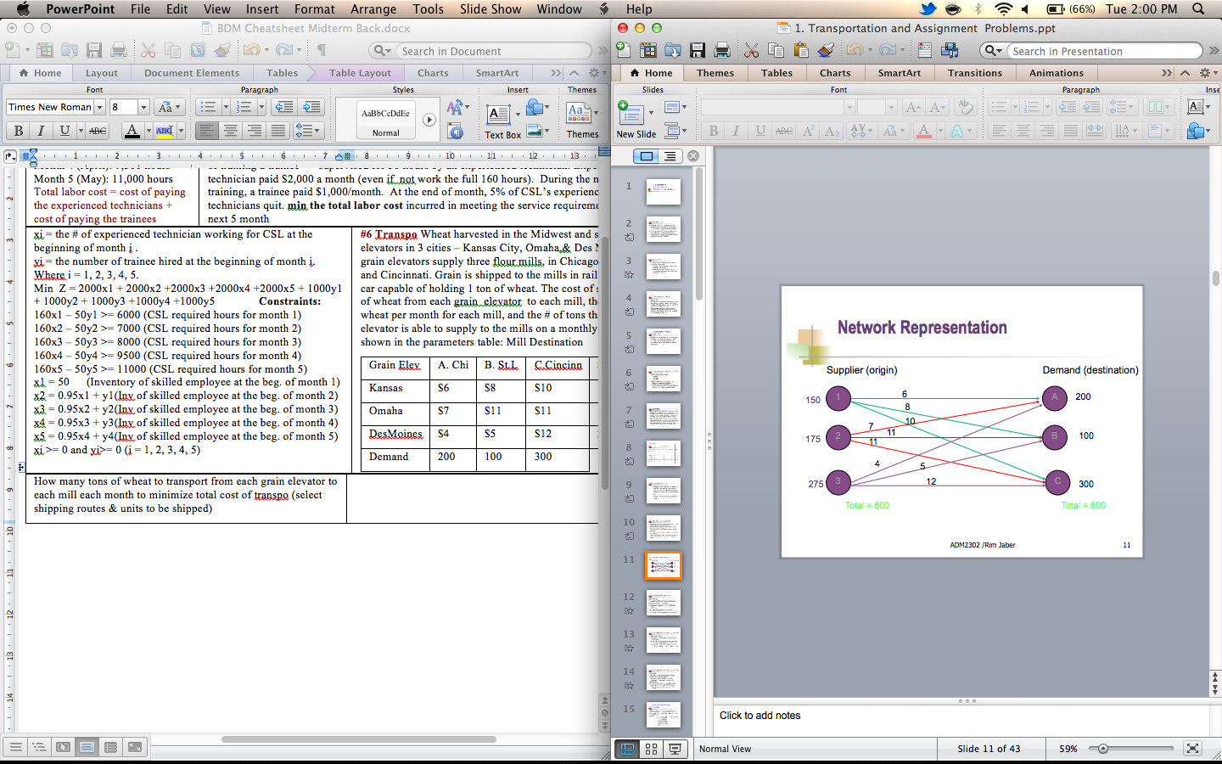
TRANSPORTATION How many tons of wheat to transport from each grain elevator to each mill each month to minimize total cost of transpo (select shipping routes & units to be shipped)
Decision Var: Xij: number of units shipped from origin I to destination J (where i=1,2,3) to mill j (where j=A,B,C) Object: min Z = $ 6x_{1A} + 8x_{1B} + 10x_{1c} + 7x_{2A}+ 11x_{2B} + 11x_{2C} + 4x_{3A} + 5x_{3B} + 12x_{3C}
Constraints: deal with capacities at each origin, deal with req at each destination (demands), six constraints: one for each elevator supply also for each mill demand
x_{1A} + x_{1B} + x_{1C} = 150 x_{1A} + x_{2A}+ x_{3A} = 200
x_{2A} + x_{2B} + x_{2C} = 175 x_{1B}+ x_{2B} + x_{3B} = 100
x_{3A} + x_{3B} + x_{3C} = 275 x_{1C} + x_{2C} + x_{3C} = 300 x_{ij} ≥ 0
When Total Supply>Total Demand: appear as slack Total Supply<Total Demand: some destination unsatisfied demand
Route capacities: Xij <= Lij or minimum: Xij >= Mij Unacceptable routes: make Xij = 0

ES | EF | LS | LF | Slack
Max EF of immediate predecessors | ES+duration | LF-duration | Min LS of immediate following activities | ES-LF or LF-EF
PROJECT SCHEDULING Earliest Start, Earliest Finish, Latest Start, Latest Finish
Activity | A | B | C | D | E | F | G | H | I
Immediate Predecessors | -- | A | A | B | B | C,E | D,E | F,G | H
Duration | 5 | 18 | 13 | 3 | 10 | 11 | 4 | 9 | 2
a) max # working days needed to complete all activities if no delays? 55 days
b) crit activities? the ones with no slack CPM

PERT
Most likely time =(m) optimistic time =(a) pessimistic time= (b)
Expect Activity Time (t) = (a+4m+b)/6
Variance = [ (b - a) / 6 ] ²
Standard deviation = √Variance = (b - a) / 6
Expected Project Completion Time (t_{p) =} Sum of the expected (mean) time of all the activities on the critical path.
Project variance = Σ(variances of activities on critical path)
Project standard deviation (σ_{p}) = √(Project variance)
Z = (due date – expected completion time) / σ_{p}
Due Date = Expected completion time + Z x σ_{P}

DECISION ANALYSIS
1. Clearly define the problem at hand
2. List all the possible alternatives (decisions to be made)
3. Identify the possible outcomes (state of nature) of each alternative
4. List the payoff or the profit of each combination of alternatives and outcomes
5. Select 1 of the mathematical decision theory models(ex:Decision Making under Risk)
6. Apply the model and make your decision
If Under Certainty
Maximax: choose max value of all the max pay-offs - optimistic
Maximin: choose max of all the min pay-offs - conesrvative
Equally Likely Criterion: calc row average -> choose max
Minimax: take minimum of the calculated max regret
Under Risk (probabilities assigned to states of nature)
Ex: based on economic forecast, able to estimate 60% good economy, 40% poor
EMV(Expected Monetary Value)=outcome 1st nature*its prob + outcome 2nd * its prob
Best decision is one with the highest EMV(if in terms of cost, choose lowest)
EOL(Expected Opp Loss) = regret 1st nature *its prob + regret 2nd nature *its prob…
Choose the minimum of all these values
EVPI(Expected val of Perfect Info)= (best outcome for first state of nature)x(its prob.) + (best outcome for second state of nature)x(its prob.)
EV of PI = EV with PI – EMV
Shows max amount that would be paid to gain info that would result in decision better than one made without perfect info
EVSI = expected value with information – expected value without information
Efficiency,η = EVSI / EVPI
A high efficiency rating indicates that info is very good, or close to being perfect info
A low ‘η’ rating indicates that the additional information is not very good.
If relatively high; it is doubtful that the investor would seek additional information from an alternative source.

GOAL PROGRAMMING Decide what to produce over the next quarter. A product cannot be produced unless the associated set-up cost is paid. If the set-up cost is paid, the amount of a product which is produced is limited by the associated capacity. Product B is always packaged in quantities of 100(if produced either: 100, 200 or 300 units). However, the other products have no such packaging requirements. If all 4 products produced, an extra charge of $1000 is incurred for training
There are three goals (equally weighted):
1) total profit should be at least $8000 2) total set-up cost should be at most 950
3) exactly three products should be produced
The objective as usual is to minimize the sum of the appropriate deviations (i.e., the deviations which are deemed to be undesirable). FORMULATE the above problem.
* Let A, B, C and D denote the number of units of each of the products produced
* Let yA, yB, yC and yD = 1 if the corresponding product is produced, 0 otherwise
* Let zi = 1 if 100i units of C are produced, 0 otherwise (i=1,2,3)
* Let w = 1 if all four products are produced, 0 otherwise Let di+ and di– denote the amounts by which the ith goal is over(under)-achieved
* Minimize d1+ + d2– + d3+ + d3–
* A≤400yA * B≤300yB * C≤500yC * D≤250yD
** B = 100z1 + 200z2 + 300z3 ** z1 + z2 + z3 ≤ 1
** yA + yB + yC + yD ≤ 3+w
* 10A + 8B + 6C + 7D – 1200yA – 600yB – 700yC -1000w = 8000 + d1+ – d1–
* 1200yA + 600yB + 700yC = 950 + d2+ – d2–
* yA + yB + yC + yD = 3 + d3+ – d3–
* A, B, C and D either ≥ 0 or integer deviation variables ≥ 0 * yi, zi, w binary
d₁⁻: underachievement of the profit target
d₁⁺ : overachievement of the profit target
As much profit above 3000$ as possible d- Fully utilize available wiring d+
Avoid overtime in assembly d+ Meet contract to produce at least seven ceiling d+
eg: $600X1 + $700X2 + d₁⁻ - d₁⁺ = $3,000 (profit goal – always minimize d’s)
all d_{i} variables >= 0 in 4th step
If equally important goals
Min. total deviation = d₁⁻ + d₂⁻ + d₃⁺ + d₄⁻
$600X1 + $700X2 + d₁⁻ - d₁⁺ = $3000 (profit constraint)
2X1 + 3X2 + d₂⁻ - d₂⁺ =12 (wiring hours)
If priority goals
Min. total deviation = P₁d₁⁻ + P₂d₂⁻ + P₃d₃⁺ + P₄d₄⁻ (as priorities are listed)
If weighted goals
Min. total deviation = 40d₁⁻ + 30d₂⁻ + 20d₃⁺ + 10d₄⁻ (as weights are listed)
If you can go above the goal then MinZ = d⁻, below then MinZ = d⁺

INTEGER PROGRAMMING Want to determine locations for cab waiting points.
Location | Can Serve Areas | Cost/ Day
1 | A, E | $400
2 | A, C, D | $500
3 | B, C, E | $450
4 | B, D | $440
5 | D, E | $430
Wants to be sure all areas can be served and wants done for as little cost as possible. Determine choice of locations to accomplish this goal.
Xi = 1 if location 1 used, 0 if otherwise (i= 1 to 5)
Min Z = 400x1 + 400x2 + 450x3 + 440x4 + 430x5
Area A x1 + x2 >= 1 Area D x2 + x4 + x5 >= 1
Area B x3 + x4 >= 1 Area E x1 + x3 + x5 >= 1
Area C x2 + x3 >= 1 Xi E [0,1]
No more than 2 products can be produced
Yi = 1 if prod 1 produced y1+y2+y3+y4 <=2
If prod 3 or 4 produced then prod 1 or 2 must be produced
Y3 <= y1 + y2 y4 <= y1+y2
INTEGER PROGRAMMING Product can be made on only 1 of 2 machines: x1 or x2. Machines have different process req, profit & cost structures. Differences:
Machine | Profit/Unit $ | Setup Cost | Raw Mat #1 /unit | Raw Mat #2/unit
X1 | $50 | $250 | 2 lbs | 4 quarts
X2 | $40 | $210 | 3 lbs | 2 quarts
Determine whether all output should be produced on one of machines or split between two machines. Maximize contribution to profit. 30 lbs of raw mat #1 and 36 quarts of raw mat #2 available for the production run.
x1 = # units to produce machine 1 x2 = # units produce machine 2
y1 = 1 if machine 1 used, 0 otherwise y2 = 1 if machine 2 used, 0 otherwise
max Z= 50x1 + 40x2 – 250y1 – 210y2 where M is a very large #
2x₁+3x₂ <= 30 4x₁+2x₂ <= 36 x1 <= My1 x2 <= My2
x1, x2 integers >= 0 y1, y2 E [0,1] x1 – My1 <= 0 x2 – My2 <= 0

