Chapter 2 – Personality and Learning

WHAT IS PERSONALITY

Personality: The relatively stable set of psychological characteristics that influences the way an individual interacts with his or her environment and how they feel, think and behave.

*An individual’s personality summarizes his/her personal style of dealing with and responding to the world.
*Relatively stable but can change

Reflected in distinctive way people react to:
- People
- Situations
- Problems

Determined by:
- Genetic predispositions
- Long-term learning history

PERSONALITY AND OB

Dispositional approach: individuals possess stable traits or characteristics that influence their attitudes and behaviours.
**Predisposed to behave in certain ways.

Situational approach: characteristics of the organizational setting influence people’s attitudes and behaviour.
*work-related attitudes are largely determined by situational factors such as job tasks.

Interactionist approach: individuals’ attitudes and behaviour are a function of both dispositions and the situation.
*Combo of personality and setting

Trait activation theory: Traits lead to certain behaviours only when the situation makes the need for the trait salient. Personality characteristics influence people’s behaviour when the situation calls for a particular personality characteristic.

The five factor model of personality (Big Five)

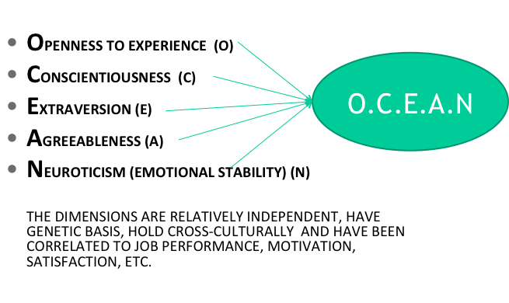
Openness to experience: degree to which a person thinks flexibly and is receptive to new ideas.
- Creativity
- Innovation

*Important for jobs that involve learning and creativity given that they tend to be intellectual, curious and imaginative.

Conscientiousness: degree to which a person is responsible and achievement-oriented.
- Self discipline
- Hard working
- Dependable
- Orderly

*Most likely to perform well on most jobs because they are hard working.

Extraversion: comfort level in social situations (outgoing vs. shy)
- Sociable
- Outgoing
- Energetic
- Joyful
- Assertive
- Enjoys social situations

*Important for jobs that require interpersonal interaction (sales & management)

Agreeableness: extent to which a person is friendly and approachable.
- Warm
- Considerate
- Altruistic
- Cooperative
- Ready to help

*Good for job that involves helping, cooperating and nurturing others, teamwork and cooperation.

Emotional stability/neuroticism: degree to which an individual has appropriate emotional control
- Self-confident
- High self esteem
- More calm and secure

Low neuroticism = High emotional stability
High neuroticism = someone who has self-doubt and depression.

**The dimensions are relatively independent of each other
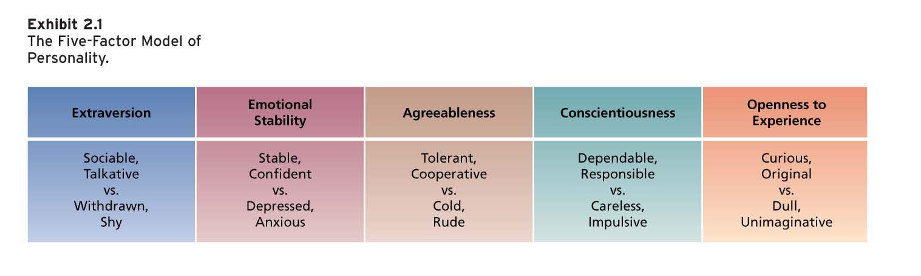

Locus of control

Locus of control: a set of beliefs about whether one’s behaviour is controlled mainly by internal or external forces.

AKA. The individual’s beliefs about the location of the factors that control their behaviour.

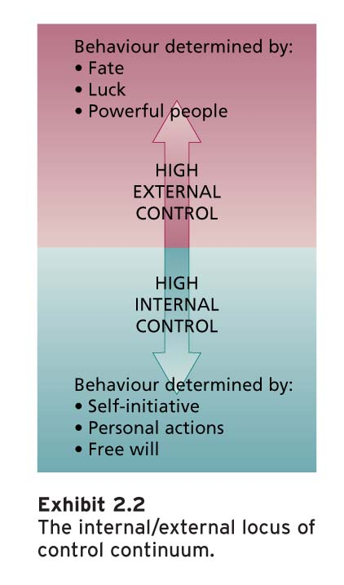

High external control - external forces determine their behaviour
High internal control – opportunity to control their own behaviour resides within themselves.

Internals:
- See links btwn effort they put in and performance they achieve
- Perceive that the organization will notice increased performance and reward it.
- More satisfied with their jobs, more committed to their organizations
- Earn more money / higher organizational positions.
- Perceive less stress, cope better, less burnout

Self monitoring
Self monitoring: the extent to which people observe and regulate how they appear and behave in social settings and relationships.

Low self monitors:
- Wear their heart on their sleeve

High self monitors:
  - Take great care to observe and control the images that they project.
  - Show concern for socially appropriate emotions and behaviours, and tune into social and interpersonal cues; they regulate their behaviour and self-presentation according to these cues.
  - Go for jobs that require a degree of role-playing and the exercise of their self presentation skills.
  - Tend to be more involved in their jobs and perform to a higher level.

Qualities:
- Ability to adapt
- Good communication skills
- Persuasive abilities
- Flexibility/adaptivness

Self-esteem
Self-esteem: the degree to which a person has a positive self-evaluation.

*Behavioural plasticity theory – people with low self-esteem tend to be more susceptible to external and social influences than those who have high self-esteem.
-> More likely to seek social approval from others and they do not react well to stressful situations.
So.. be careful with negative comments to people with low self-esteem

How to boost self-esteem?
-> Give opportunity for participation in decision-making, autonomy, interesting work

WHAT IS LEARNING

Definition: A relatively permanent change in behaviour potential that occurs due to practice or experience.

- The practice/experience that prompts learning comes from the environment that provides feedback about the consequences of that behaviour.

What do employees learn?

Practical skills – Job-specific skills, knowledge, technical competence
*To continually improve performance and keep organizations competitive

Intrapersonal skills – Problem solving, critical thinking, alternative work processes, risk taking.

Interpersonal skills - Interactive skills such as communicating, teamwork, conflict resolution.

Cultural awareness – Learning the social norms of organizations, company goals, business operations, expectations, and priorities.

2 theories about how we learn:
- Operant Learning Theory
- Social Cognitive Theory

Operant learning theory
Operant learning theory - the subject learns to operate on the environment to achieve certain consequences.

- Operantly learned behaviour is controlled by the consequences that follow it.
- It is the connection between the behaviour and the consequence that is learned.

Behaviour Stimulus More Behaviour

Ex:
-Rats operating lever to achieve food.
-Salespeople learn selling techniques to achieve commission

INCREASING THE PROBABILITY OF BEHAVIOUR

Reinforcement: the process by which stimuli strengthen behaviours.
*A reinforcer is a stimulus that follows some behaviour and increases or maintains the probability of that behaviour.
- Positive reinforcement (commission for salespeople)
- Negative reinforcement (criticism)

Positive reinforcement: the application or addition of a stimulus that increases or maintains the probability of some behaviour.

- Works by its application to a situation
- Tend to be pleasant
- Positive reinforcers can be food, praise, money or business success.

Ex: Analyst tends to read a specific newspaper regularly because it helps him make favourable decisions

What is added? Favourable decisions -> reinforce the habit of reading the newspaper

Negative reinforcement: removal of stimulus that in turn increases or maintains the probability of some behaviour.

- The removed stimulus is the negative reinforcer. Negative reinforcers increase the probability of behaviour.
- Occurs when a response prevents some event or stimulus from happening
- Tends to be unpleasant (shock, nagging or threat of fines)

Ex: Nagging maintains the probability of productive responses by its removal. Can avoid nagging if they work hard.

Organizational errors involving reinforcement

- Confusing rewards with reinforcers – Rewards (pay, promotions, fringe benefits, paid vacations) can fail to work as reinforcers because they are not contingent on specific behaviours.

- Neglecting diversity in preferences for reinforcers - Someone who always works more hours and puts in extra effort might enjoy a more challenging task rather than a day off.

- Neglecting important sources of reinforcement
- Performance feedback (providing quantitative or qualitative information on past performance for the purpose of changing or maintaining performance)
- Social recognition (informal acknowledgement, attention, praise, approval, or genuine appreciation for work well done from one individual of group to another)

** Managers should understand that positive feedback and a “pat on the back” are positive reinforcers that are easy to administer and likely to reinforce desirable behaviour.

REINFORCEMENT STRATEGIES

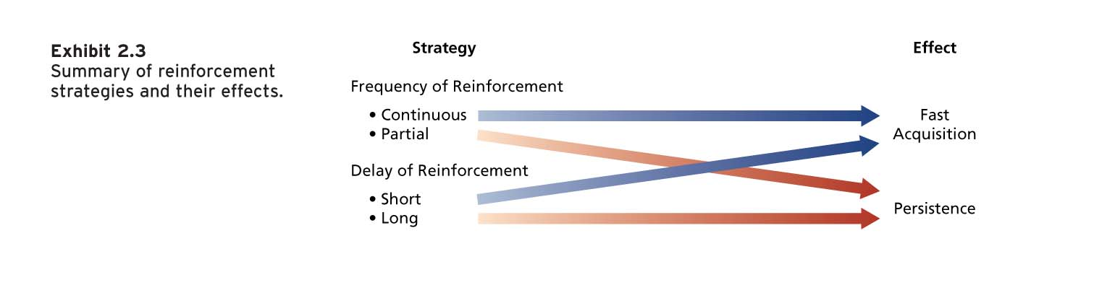
-> Problem with continuous: behaviour learnt under that condition tends to not persist when reinforced less frequently
->Behaviour is persistent when it is learnt under conditions of partial and delayed reinforcement

*Managers need to tailor reinforcement strategies to needs of a situation

Reducing the probability of behaviour
- Learned behaviours that we wish to stop from occurring.
There are some behaviors we don’t want at work
- Harassment, theft, surfing online all day, rudeness to customers etc..

2 strategies to reduce the probability of learned behaviour:
- Extinction
- Punishment

Extinction: The gradual dissipation of behaviour following the termination the reinforcement

  - If the behaviour is not reinforced, it will gradually dissipate or be extinguished.
  - Extinction works best when you also reinforce some desired substitute behaviour.

Punishment: The application of a nasty/aversive stimulus following some behaviour designed to decrease the probability of that behaviour. (a nasty stimulus is applied after some behaviour, decreasing the probability of that behaviour.)

Ways to increase the effectiveness of punishment:
- Provide substitute alternative for punished response
- Make sure emotions are under control before punishing and avoid to do it in front of other people
- Make sure that the punishment is aversive (don’t make them take time off)
- Punish immediately.
- Do not reward unwanted behaviours before or after punishment.
- Do not inadvertently punish desirable behaviour.

**Reinforcing correct behaviours and extinguishing unwanted responses are safer strategies for managers than the frequent use of punishment.

Summary of Learning Effects
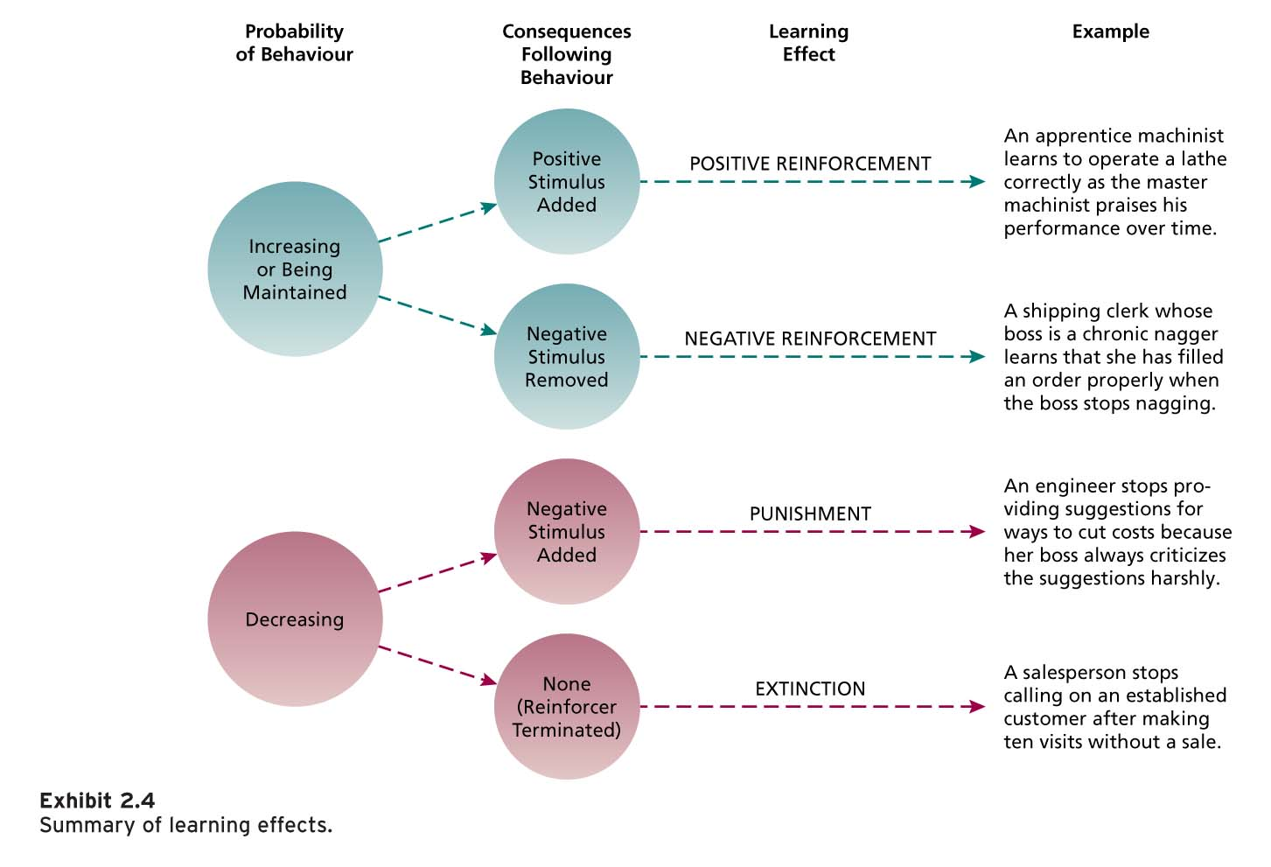

SOCIAL COGNITIVE THEORY

Social cognitive theory (SCT): emphasizes the role of cognitive processes in learning and in the regulation of people’s behaviour.

People learn by observing, thinking about the consequences of their actions, setting performance goals.

**Smed case example -> employees observe that Smed acts like a jerk, but the results is that his business is thriving and he’s a millionaire.

Human behaviour can be explained through a system of:
Triadic Reciprocal Causation – personal and environmental factors work together and interact to influence behaviour

Social learning involves:
  - Observing the behaviour of others
  - Seeing what consequences they experience
  - Thinking about what might happen if we act the same way
  - Imitating the behaviour if we expect favourable consequences

3 Components of Social Cognitive Theory

- Modelling/Observational learning: the process of observing and imitating the behaviour of others.

- Involves self-reinforcement (reinforcing to acquire an understanding of others who are viewed positively and it is expected that the reinforcers the model experiences will come our way when we imitate the behaviour)

- What helps/ what makes someone a good model?
  - Attractive, credible, competent, high-status
  - The model’s behaviour should result in positive consequences
  - The behaviour is vivid and memorable

**All about observing consequences (favourable consequences makes us want to imitate the behaviour)

- Self-efficacy beliefs: Beliefs people have about their ability to successfully perform a specific task.

It influences:
- the activities you choose to do in the first place
- the amount of effort and persistence you put in
- affective and stress reactions
- job performance.

*Things that influence self-efficacy beliefs:
- Performance Mastery
- Observation
- Verbal persuasion and social influence

- Self-regulation: The use of learning principles to manage one’s own behaviour.

* The basic process involves observing one’s own behaviour (self-observation), comparing the behaviour with a standard (self-evaluation), and rewarding oneself if the behaviour meets the standard (self-reinforcement)

Self-management can improve learning and change one’s own behaviour :
- Self-observation
- Observe others
- Set goals
- Rehearse
- Reinforce oneself

Basically, you self-regulate to model someone’s behaviour. It’s how you go about trying to imitate the model.

When there is discrepancy between one’s goal and performance, individuals are motivated to modify their behaviour in the pursuit of goal attainment, a process known as discrepancy reduction.

When individuals attain their goals, they are likely to set higher and more challenging goals, a process called discrepancy production.

