Econ 203 – Macroeconomics

Midterm Review

Chapter 4

GDP (GROSS DOMESTIC PRODUCT)

- Nominal GDP = PRICECURRENT * QUANTITYCURRENT
- Real GDP = PRICEBASE * QUANTITYCURRENT
- GDP Deflator = (nominal GDP/real GDP) * 100

CPI

- Expenditure (for CPI) = PRICECURRENT * QUANTITYBASE
- CPI = (Expenditure current/Expenditure base) *100

**Note**
- GDP and CPI are used to find price level or inflation
- For GDP deflator, the base year will always be 100

Recession
- Two consecutive quarters of negative economic growth (6 months)

INFLATION

- Inflation Rate = [ (New CPI – Old CPI) / Old CPI ] * 100
- Real Interest = Nominal interest – Inflation

**Note**
- If inflation rate goes up, then the real interest rate goes down which is good for borrowers but bad for lenders
- If inflation rate goes down (deflation), real interest rate goes up which is good for lenders but bad for borrowers

UNEMPLOYEMENT

Definition – People who are not working but are looking for a job
- Labor Force = Employed + Unemployed
- Employment Rate = Employed / Population 15+
- Unemployment Rate = Unemployed / Labor Force
- Participation Rate = LF / Population 15+

Types of Unemployment

Structural Unemployment – mismatch between the skill and the demand for workers (e.g. uber)
+
Frictional Unemployment – in between jobs
+
Seasonal Unemployment – e.g. ice cream parlour, ski lodge
___________________
**Note**
Actual UR > Natural UR = Recessionary Gap
Actual UR < Natural UR = Inflationary Gap (Boom)

= Natural Unemployment Rate (7%) – Potential GDP
+
Cyclical Unemployment – business cycles (e.g. 2%)
___________________
= Actual Unemployment (e.g. 9%)

GDP (OUTPUT APPROACH)

- Value Added = Final Price – Intermediate Goods (e.g. $15,000 - $10,000 = $5000)
- Double Counting – counting the same product more than once; to prevent we do not include second-hand transactions (e.g. just use $5000 not 15k or 10k)

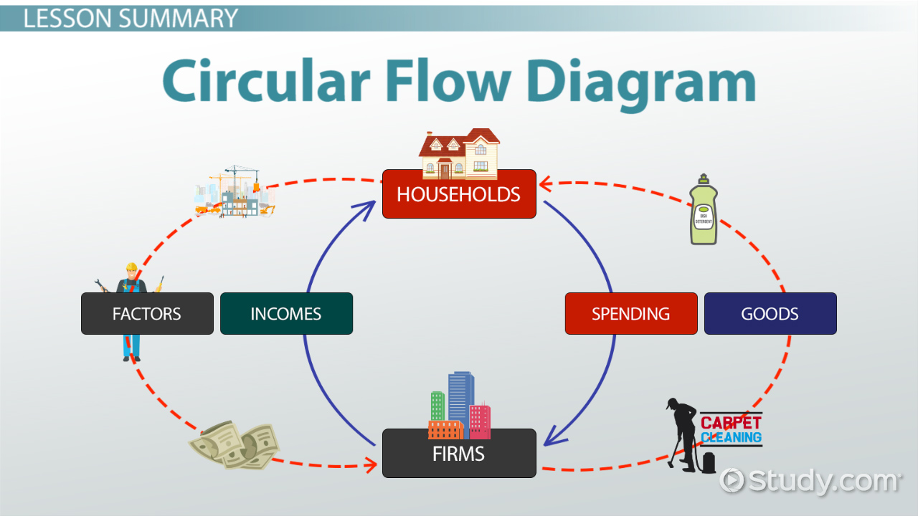

GDP EXPENDITURE

GDP = C + I + G + X – IM

C = Consumption
I = Investment Fixed capital (e.g. factories, machinery, inventory)
Net investment + CCA (depreciation)
G = Government
X = Imports
IM = Imports

GDP (INCOME)
**Note**
W + B + I = Net Domestic Income (NDI)
GDP at Basic Price = W + B + I + CCA

W = Wages
B = Business Profit
I = Interest & Investment Income (stocks & bonds)
CCA = Capital Consumption Allowance (depreciation)

GDP at Market Price = W + B + I + CCA + TIN + FRM + UNFRM

TIN = (Net indirect tax – Subsidies)
FRM = Farmer’s Income
UNFRM = Unincorporated non-farm income (e.g. small business like a dep)

GDP vs. GNP

GDP = Produced in Canada
GNP = Produced by Canadian citizens
when; GDP > GNP
Income of foreigners in Canada > Income of Canadians Abroad
TRUE
*** Canadian producing in Canada cancels out***

CHAPTER 5

AS & AD GRAPH
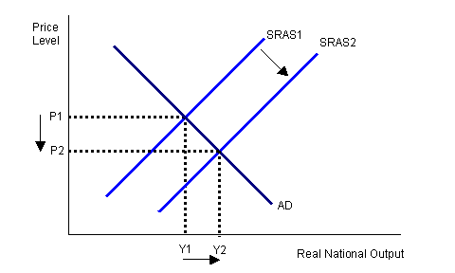

Y = Real GDP, Real Output, Real Income

Shifts in AS
Wages ↑, AS ↑ (right)
Wages ↓, AS ↓ (left)
POIL ↓, AS ↑ (right)
POIL ↑, AS ↓ (left)
P ↓, Equilibrium Y ↑

- Wages
- Prices of Oil
Factor Prices / Input Prices

Shifts in AD

C, I, G, X, IM
- If C - I - G - X increases, then Demand ↑
- If C - I - G - X decreases, then Demand ↓
- If IM increases, then Demand ↓
- If IM decreases, then Demand ↑
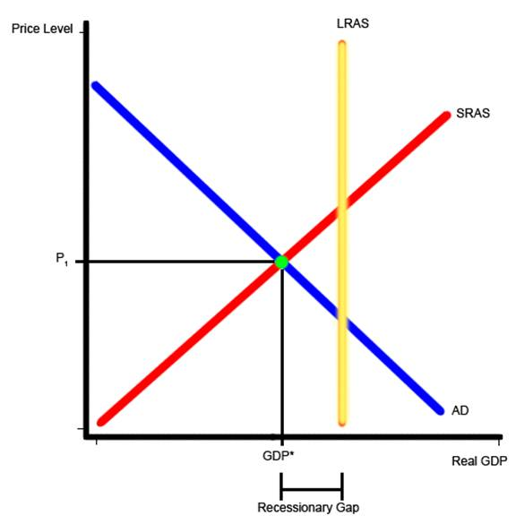

AUTOMATIC (SELF) ADJUSTMENT – RECESSIONARY GAP

**no government involved**

Yp = maximum Y
Output gap – gap between equilibrium Y and Yp
- Y - Yp = +positive # means Recession
- Y - Yp = -negative # means Inflation

In Recession:
- Unemployment ↑
- In the LR, workers are willing to work for less
- Wages ↓
- AS ↑ (right) until it removes output gap

AUTOMATIC (SELF) ADJUSTMENT – INFLATIONARY GAP

In inflation:
- Price Level ↑
- Wages ↑
- AS ↓ (left) until it removes output gap

**Why is AD downward slopping? **
- Wealth Effect – Price level ↑, Purchasing Power ↓, AD ↓
- Substitution (NX/Foreign Trade Effect) – Price level ↑, Exports ↓, AD ↓
- Interest Rate Effect - Price Level ↑, Interest Rate ↑, AD ↓

Chapter 6+7

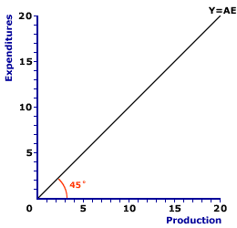

AE ↑, Y ↑, AD ↑

AE ↓, AD ↓

AE = C + I + G + X – IM

MPC = Marginal Propensity to Consume Change in C / Change in Y

CONSUMPTION

C = Co +MPC(Yd)
Co = Automonous Consumption

To find Co; check first row of table where Y equals 0 then make that equal Co (y-intercept)

Y | C
0 | 70
50 | 100
100 | 130
150 | 160
Co = 70 Y intercept

Change in C / Change in Y = 30/50 = 0.6 SLOPE

C = 70 + 0.6Y

MPS + MPC = 1 **always**

SAVINGS

S = -Co + MPS (Yd)

So keep the Co from the previous and 1 minus the slope of AE to find equation
C = -(70) + (1 - 0.6)Yd
C = -70 + 0.4Y
- I, G, X are all completely autonomous
- IM = Mo + MPMY
Mo = Autonomous imports
MPM = Marginal Propensity to Import (Change in Imports / Change in Y)

Multiplier = Change in Y / Change in AO OR 1 / (1-Slope of AE)

DISPOSABLE INCOME Yd

**income after tax**

2 Types of Tax

- Lump sum-tax (t) – Yd = (Y-T) e.g. 1000-300
*has no effect on slope of AE

- Tax Rate – t= 20%, 0.2Y
*effects slope of C but not Y intercept decreases slope of C & AE

