Intro to Business midterm review:
- Business: All profit-seeking activities and enterprises that provide goods and services necessary to an economic system
- Profits: Rewards for businesspeople who take the risks involved to offer goods (products) and services
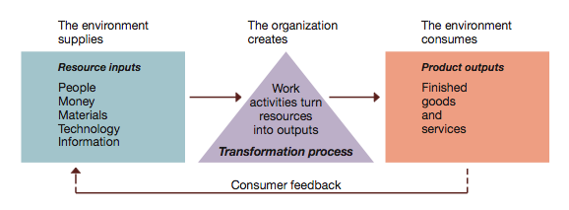
- Economic: Health of the Economy
- Legal-political: Norms, Customs, Social Values
- Socio-cultural: Philosophy/Objectives of the Government
- Technological: Development and Availability
- Natural environment: Nature and Conditions of Environment
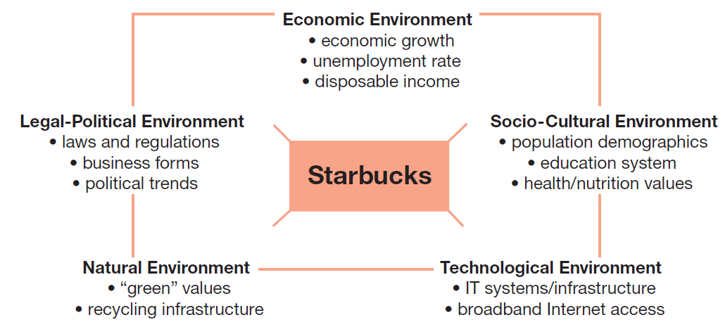
- Management: Defined as the art and science of getting things accomplished through others in organizations.
- Top managers — responsible for the performance of the organization as a whole or for one of its larger parts
- Middle managers — in charge of relatively large departments or divisions
- Team leaders or supervisors — in charge of a small work group of non-managerial workers
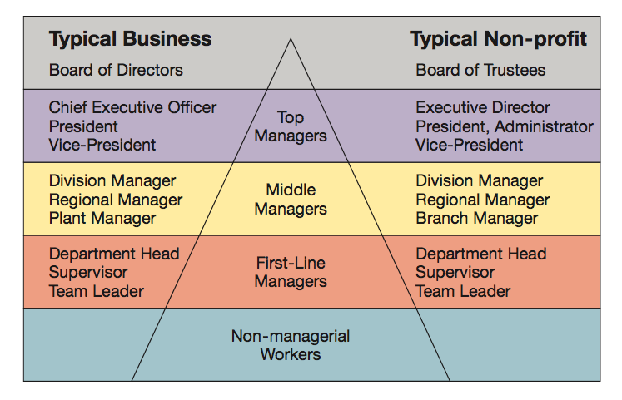
Week 2:
- The Management Process: Management is the process of planning, organizing, leading, and controlling the use of resources to accomplish performance goals.
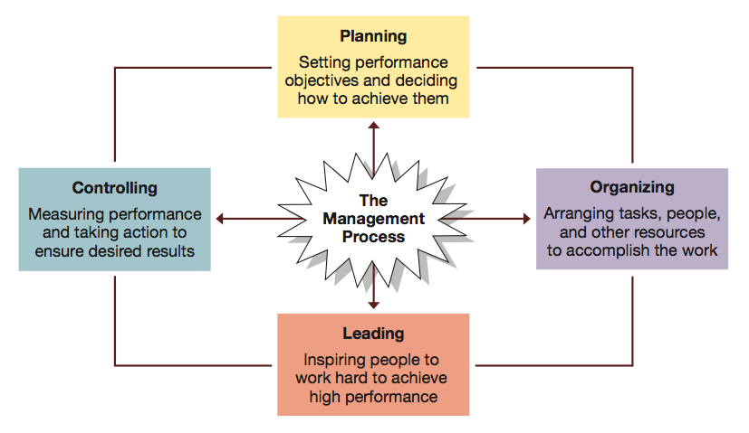

- Informational: Giving, receiving, and analyzing of information.
- Interpersonal: Interactions with persons inside and outside the work unit.
- Decisional: Using information to make decisions in order to solve problems or address opportunities
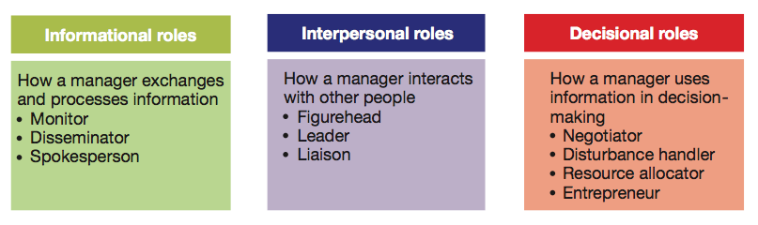
- Managerial Agendas: John Kotter studied the behaviour patterns of successful general managers and identified the following categories of behaviour:
- Agenda setting
- Agenda Implementation (Networking and Social Capital)
- Agenda Setting: What they wanted to accomplish for the organization. Almost always informal and unwritten and concerned with people issues
- Agenda Implementation: Use networks to implement their agendas, Employ a wide range of influence tactics. Sustain a high degree of informal interaction and concern with people issues necessary to achieve the goals and successful implementation of their agendas
- Networking: Formal and informal networks of key people inside and outside of the organization
- Robert Katz’s Managerial Skills:
- Technical: Applying a special proficiency or expertise to perform particular tasks.
- Human/Interpersonal: Working well in cooperation with others.
- Emotional Intelligence: Managing self and relationships effectively
- Conceptual: Thinking critically and analytically to solve complex problems
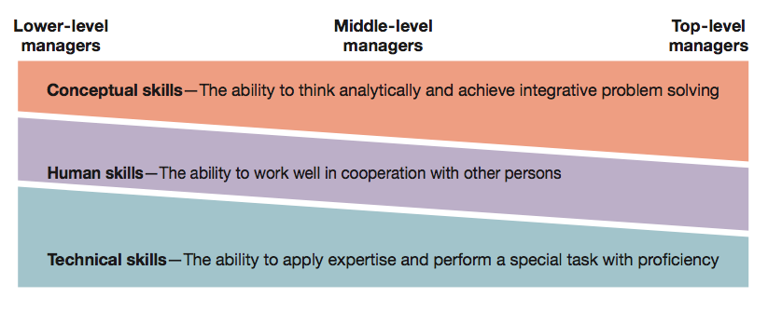
- Daniel Pink: Competencies:
- Communication: Sharing ideas and findings
- Teamwork: Working effectively
- Self-Management: Evaluating and modifying actions
- Leadership: Influencing and supporting others
- Critical Thinking: Gathering and analyzing information
- Professionalism: Impression management and career advancement
- Managerial Minds: Good intuition is problem identification and problem solving based on a long history of systematic education and experience.

3rd power point:
- Global economy: Resource supplies, product markets, and business competition are worldwide, rather than local
- Globalization: The process of growing interdependence of these components in the global economy
- Global Management: Management in organizations with business interests in more than one country
- Global Manager:
  - Informed about international developments
  - Transnational in outlook
  - Competent in working with multicultural people
  - Aware of regional developments in a changing world
- Global Businesses: Conduct for-profit transactions of goods and services across national boundaries
- Global sourcing: Process of purchasing materials or services around the world for local use
- Exporting: Selling locally made products in foreign market
- Importing: Buying foreign-made products and selling them domestically
- Licensing Agreement: One firm pays fee for rights to make or sell another company’s products
- Franchising: Fee is paid for rights to use another firm’s name and operating methods
- Joint Ventures: Operates in a foreign country through co-ownership by foreign and local partners
- Global Strategic Alliances: A partnership in which foreign and domestic firms share resources and knowledge for mutual gains
- Foreign Subsidiaries: Local operation completely owned by a foreign firm
- Greenfield Investment: Builds an entirely new operation in a foreign country
- Political risk: Potential loss in value of a foreign investment due to instability and changes in host country
- Local legal systems: Complex and unfamiliar laws can create problems
- World Trade Organization (WTO) resolves trade and tariff disputes among countries
- Protectionism can complicate global trading relationships

- Ethical Issues
  - Corruption: Illegal practices that further one’s business interests
  - Sweatshops: Employing workers at low wages for long hours and in poor working conditions
  - Child Labor: Full-time employment of children for work otherwise done by adults
  - Sustainable Development: Meeting current needs without compromising future needs
- Culture: The shared set of beliefs, values, and patterns of behaviour common to a group of people
- Culture Shock: Confusion and discomfort a person experiences in an unfamiliar culture
- Ethnocentrism: Tendency to consider one’s own culture as superior to others
- Cultural intelligence: Ability to adapt and adjust to new cultures
- Low-Context Cultures: Emphasize communication via spoken or written words
- High-Context Cultures: Rely on nonverbal and situational cues as well as on spoken or written words in communication
- Monochronic Cultures: People tend to do one thing at a time
- Polychronic Cultures: Time is used to accomplish many different things at once
- Proxemics: How people use space to communicate
- Comparative Management: How management perspectives and practices systematically differs among countries and cultures
- Global Leadership and Organizational Behaviour Effectiveness): Researches the leadership, organizational practices, and diversity among world cultures

4th power point:
- Moral obligation to identify what is right from wrong
The set of moral principles or values that defines right or wrong for a person or group
- Antiquity: The older the more apt it is to be correct
- Numbers - How many hold it (the majority is always right – the bandwagon effect)
- Prestige – How many important prestigious persons hold this viewpoint
- Culture often establishes the limits on what are considered acceptable and unacceptable behaviours; it pressures individuals and groups into accepting and following certain behaviours
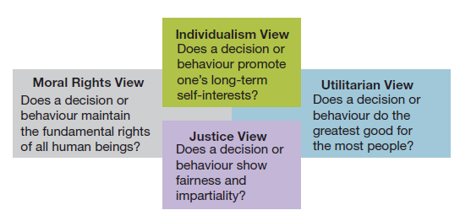

- Preconventional: acts in own best interest (few people operate here)
- Conventional: upholds moral and legal laws, does what is expected
- Principled: lives by an internal set of moral codes, values and ethics (i.e., the Golden Rule - upheld regardless of consequences)
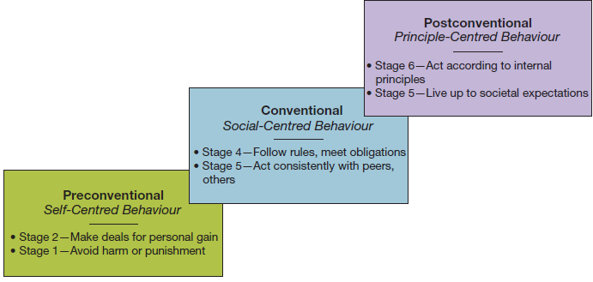
- Social entrepreneurship: a unique form of entrepreneurship that seeks novel ways to solve pressing social problems at home and abroad
- Housing and job training for homeless
- Bringing technology to poor families
- Improving literacy among disadvantaged youth
- Offering small loans to start minority-owned businesses
- Corporate Social Responsibility: Obligates organizations to act in ways that serve both its own interests and the interests of society at large.
5th power point:
- Entrepreneur: A person who seeks a profitable opportunity and takes the necessary risks to set up and operate a business
- Differs from many small-business owners in their strong desire to make their business grow
Differs from managers through their overriding responsibility to use the resources of the organization to accomplish their goals
- Social entrepreneurs
- Represents a unique form of ethical entrepreneurship that seeks novel ways to solve pressing social problems
- Social enterprises have a social mission to help make lives better for underserved populations

- Why Entrepreneurship:
- Being Your Own Boss: Self-management is the motivation that drives many entrepreneurs
- Financial Success: Entrepreneurs are wealth creators and idea generators
- Job Security: Over the past several years, large companies have eliminated more jobs than they have created
- Quality of Life: Starting a business gives the founder some choice over when, where, and how to work
- Vision: an overall idea for how to make business ideas successful
- High energy level: a willingness to work hard
- Need to achieve: want to excel and achieve difficult goals
- Self-confidence: fearlessness in the face of difficult odds
- Tolerance for failure: not easily discouraged
- Creativity: devise innovative ways to overcome difficult problems and situations; have new ideas for good and services
- Tolerance for ambiguity: take business uncertainties in stride
- Internal locus of control: belief in control of own fate
- Companies promote in a variety of ways:
- Skunkworks: a project initiated by an employee who conceives of an idea and then recruits resources from within the company to turn it into a commercial product
- Pacing Programs: company-initiated projects that focus on a few products and technologies in which company sees potential for rapid marketplace winners
7th power point:
- Planning: The process of setting objectives and determining how to best accomplish them
- Objectives: Identify the specific results or desired outcomes that one intends to achieve
- Plan: A statement of action steps to be taken in order to accomplish the objectives

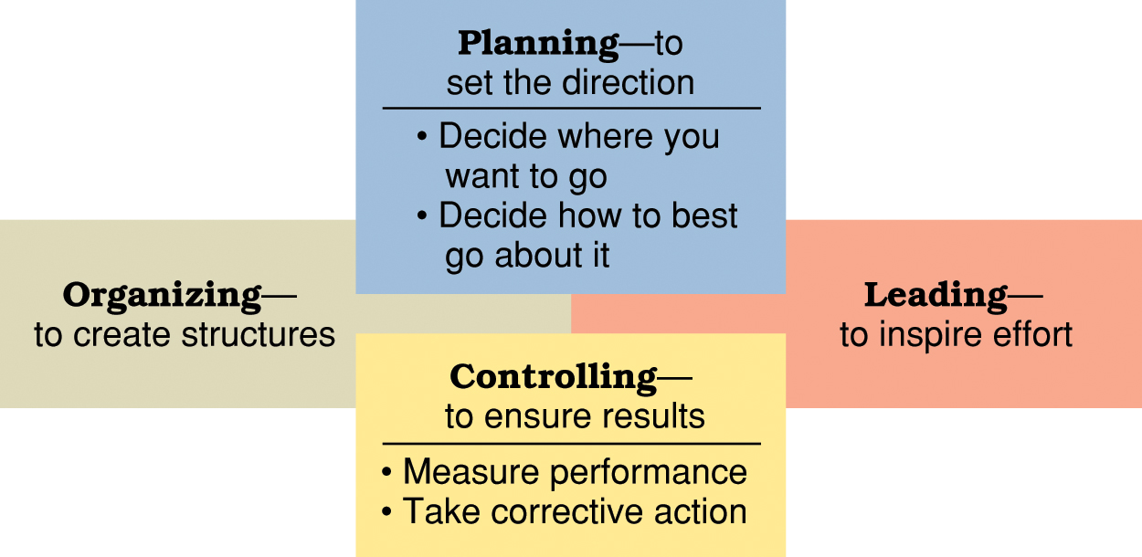
- Short-range plans = 1 year or less
Intermediate-range plans = 1 to 2 years
Long-range plans = 3 or more years
- Strategic plans: Set broad, comprehensive, and longer-term action directions for the entire organization
- Tactical plans: Define what needs to be done in specific functions to implement strategic plans
- Operational plans: Policies and procedures
- Policy: Broad guidelines for making decisions and taking action in specific circumstances
- Rules or procedures: Plans that describe exactly what actions are to be taken in specific situations
- Budgets: Single-use plans that commit resources to activities, projects, or programs (Fixed, flexible, and zero-based budgets)
- Contingency planning: Identifying alternative courses of action that can be implemented if circumstances change
- Scenario planning: A long-term version of contingency planning
- Benchmarking: Use of external and internal comparisons to better evaluate current performance and identify possible actions for the future
- Effective goals are SMART:
- Set Specific goals
- Make sure goals are Measurable
- Ensure goals are Attainable
- Goals must be Referred to Regularly
- Goals must be Timely
- Goal Alignment: To make sure that goals and plans are well integrated across the many people, work units, and levels of an organization as a whole
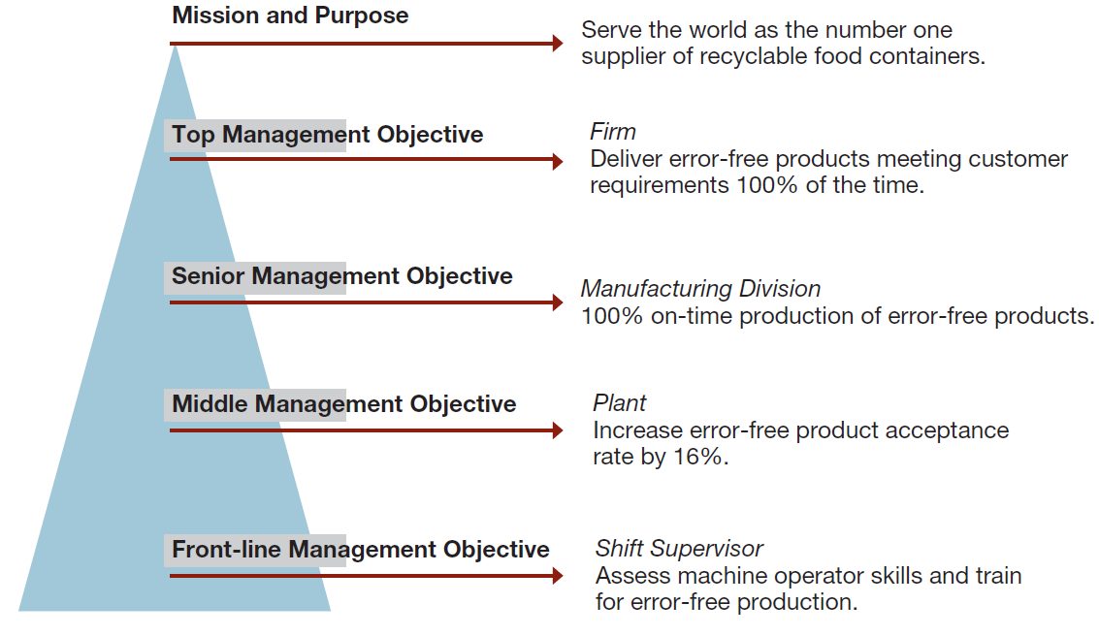
- Management By Objectives (MBO): A structured process of regular communication,
Supervisor/team leader and workers jointly set performance objectives and workers jointly review results.
Formal agreement specifying:
- Workers’ performance objectives for a specific time period
- Plans through which performance objectives will be accomplished
- Standards for measuring accomplishment of performance objectives Procedures for reviewing performance results

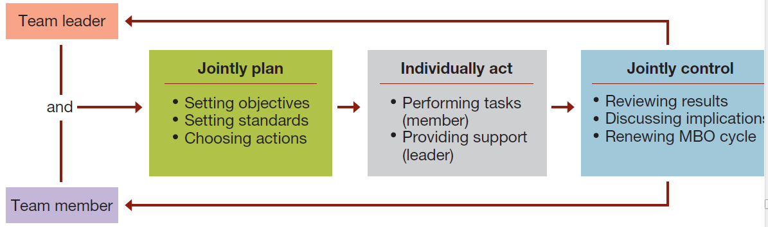

- Pitfalls to avoid in using MBO
  - Tying MBO to pay
  - Focusing too much attention on easily quantifiable objectives
  - Requiring excessive paperwork
  - Having managers tell workers their objectives
- Advantages of MBO
  - Focuses workers on most important tasks and objectives
  - Focuses supervisor’s efforts on important areas of support
  - Contributes to relationship building
  - Gives workers a structured opportunity to participate in decision making
- Participation and involvement
  - Participatory planning requires that the planning process include people who will be affected by the plans and/or will help implement them
- Benefits of participation and involvement:
  - Promotes creativity in planning
  - Increases available information
  - Fosters understanding, acceptance, and commitment to the final plan

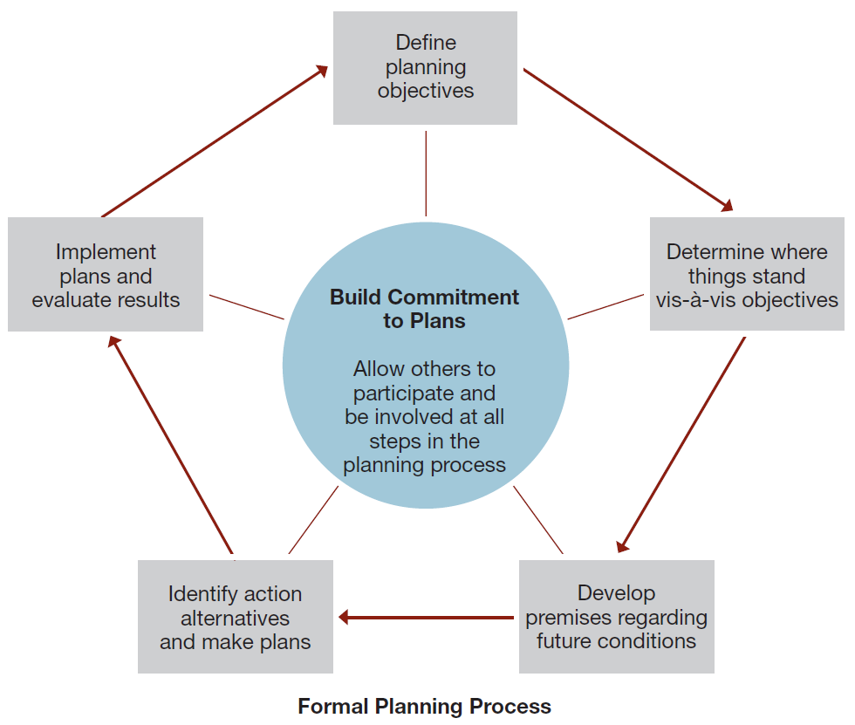

8th power point:
- Organizing: The process of arranging people and other resources to work together to accomplish a goal.
- Organization structure: The system of tasks, workflows, reporting relationships, and communication channels that link together diverse individuals and groups
- Formal Structures: the structure of the organization in its official state
- An organization chart is a diagram describing reporting relationships and the formal arrangement of work positions within an organization
- An Organization Chart identifies the following aspects of formal structure:
- The division of work
- Supervisory relationships
- Communication channels
- Major subunits
- Levels of management
- Informal Structures: A “shadow” organization made up of the unofficial, but often critical, working relationships between organization members
Potential advantages of informal structures
  - Helping people accomplish their work
  - Overcoming limits of formal structure
  - Gaining access to interpersonal networks
  - Informal learning
Potential disadvantages of informal structures
- May work against best interests of entire organization
- Susceptibility to rumor
- May carry inaccurate information
- May breed resistance to change
- Diversion of work efforts from important objectives
- Feeling of alienation by outsiders
- Departmentalization: Grouping positions and teams so as to enhance coordination
- Functional Structures
- People with similar skills and performing similar tasks are grouped together into formal work units
- Members work in their functional areas of expertise
- Are not limited to businesses
- Work well for small organizations producing few products or services
- Divisional Structures
  - Group together people who work on the same product or process, serve similar customers, and/or are located in the same area or geographical region
  - Common in complex organizations
  - Avoid problems associated with functional structures

Types of Divisional Structures and how they group job and activities:
- Product structures focus on a single product or service
- Geographical structures focus on the same location or geographical region
- Customer structures focus on the same customers or clients
- Process structures focus on the same processes

- Horizontal Organization Structures:
Team Structures
  - Permanent and temporary teams to solve problems, complete special projects, and accomplish day-to-day tasks
  - Often use cross-functional teams composed of members from different functional departments
  - Project teams are convened for a specific task or project and disbanded once completed
Network Structures
  - A central core that is linked through networks of relationships with outside contractors and suppliers of essential services
  - Own only core components and use strategic alliances or outsourcing to provide other components

Potential advantages of network structures
- Firms can operate with fewer full-time employees and less complex internal systems
- Reduced overhead costs and increased operating efficiency
- Permits operations across great distances
Potential disadvantages of network structures
- Control and coordination problems may arise from network complexity
- Potential loss of control over outsourced activities
- Potential lack of loyalty among infrequently used contractors
- Excessively aggressive outsourcing can be dangerous
- Boundaryless organizations: Encourage creativity, quality, timeliness, flexibility, and efficiency

  - Eliminate internal boundaries among subsystems and external boundaries with the external environment
Key requirements
  - Absence of hierarchy
  - Empowerment of team members
  - Technology utilization
  - Acceptance of impermanence
Virtual organization
- A special form of Boundaryless organization
- Operates in a shifting network of external alliances that are engaged as needed, using IT and the Internet

- Fewer levels of Management:
- Shorter Chains of Command
- Less Unity of Command
- Wider Spans of Control
- More Delegation and Empowerment
- Decentralization with Centralization
- Reduced Use of Staff
9th power point:
- Leadership: The influence that particular individuals exert on the goal achievement of others in an organizational context
- Contemporary leadership challenges:
- Shorter time frames for accomplishing things
- Expectations for success on the first attempt
- Complex, ambiguous, and multidimensional problems
- Taking a long-term view while meeting short-term demands
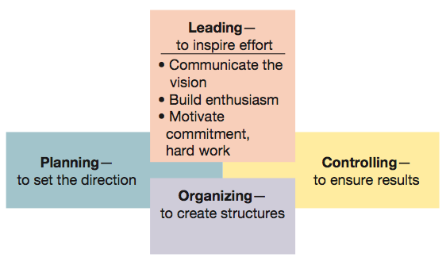
- Thus, subordinates who work for managers with good leadership skills will generally:
- know how to achieve higher levels of performance
- want to perform well
- like their jobs
- want to stay within the organization
- Strategic Leadership: Leadership that involves the ability to anticipate, envision, maintain flexibility, think strategically, and work with others to initiate changes that will create a viable future for the organization
- Formal Leadership: Individuals with titles such as manager, executive, supervisor, and department head occupy formal or assigned leadership roles, they are expected to influence others, and they are given specific authority to direct employees.
- Managers Can Be leaders, Leaders Can bé managers But Not all leaders are managers. And vice versa !
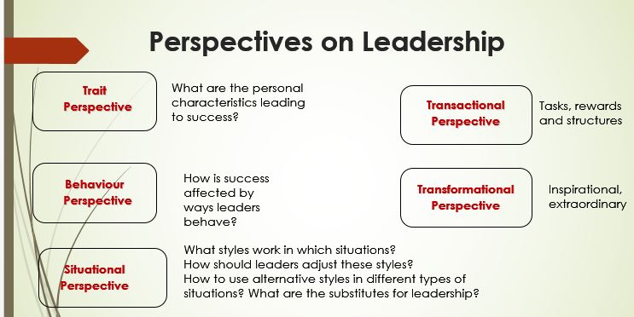

- Power: Ability to get someone else to do something you want done or make things happen the way you want,
- Position power: Based on a manager’s official status in the organization’s hierarchy of authority
Sources of position power:
  - Reward power
Capability to offer something of value
  - Coercive power
Capability to punish or withhold positive outcomes
  - Legitimate power
Organizational position or status confers the right to control those in subordinate positions

- Personal power: Based on the unique personal qualities that a person brings to the leadership situation
Sources of personal power:
  - Expert power
    - Capacity to influence others because of one’s knowledge and skills
  - Referent power
    - Capacity to influence others because they admire you and want to identify positively with you

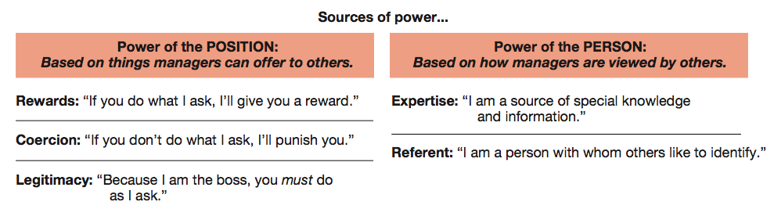
- Classic leadership styles:
  - Autocratic style
Emphasizes task over people, keeps authority and information within the leader’s tight control, and acts in a unilateral command-and-control fashion
  - Human Relations style
Emphasizes people over work
  - Laissez-faire style
Shows little concern for task, lets the group make decisions, and acts with a “do the best you can and don’t bother me” attitude
  - Democratic style
Committed to task and people, getting things done while sharing information, encouraging participation in decision making, and helping people develop skills and competencies

- Hersey-Blanchard Situational Leadership model
Leaders adjust their styles depending on the readiness of their followers to perform in a given situation
Readiness — how able, willing and confident followers are in performing tasks

- House’s Path-Goal leadership theory
Effective leadership deals with the paths through which followers can achieve goals
- Leadership styles for dealing with path-goal relationships:
Directive leadership
Supportive leadership
Achievement-oriented leadership
Participative leadership

MIDTERM END

Power point 10:
- Explicit leadership theory: each culture has different assumptions for leadership traits.

- Communication
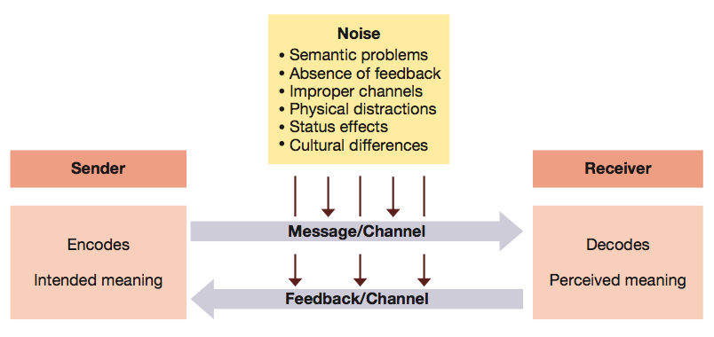

Communication consists of two phases:
  - Transmission phase: information is shared by 2 or more people
Feedback phase: a common understanding is assured
Sender: wants to share info.
Noise: anything that harms the comm process.
Medium: the way the message is delivered through.
Receiver: person getting the message/
Decoding: interpreting the message
Feedback: the receiver stating that he understood the message or that it must be resent.
  - Encoding of messages can be done verbally or non-verbally
    - Verbal: spoken or written communication
    - Nonverbal: facial gestures, body language, dress
Perception: can lead to biases that hurt comm.
Nonverbal messages: are the foundation of fist impressions and carry more weight when they contradict verbal messages.

- Verbal Communication | - Nonverbal Communication
- Based on culturally agreed upon set of symbols  - usually deliberate  - Learned later in life  - Come in an orderly sequential way  - Has a definite ending point | - Based on culturally agreed upon set of symbols  - Often governed biologically/involuntarily  - Learned earlier in life  - Do not come in an orderly sequential way, but simultaneously from a multiple of channels  - Continuous process, never ending

Communication within orgs: downward comm. Goals, objectives etc.. and upward comm. Information, suggestions etc... and lateral comm. Is coordination related info. Informal comm. Channels tend to be lateral and are extremely fast and can carry work and non work related info.

Interpersonal barrier | Org. barrier | Cultural Barrier
- Selective perception  - Frames of reference  - Individual differences  - Emotions  - Language  - Nonverbal cues | - The hierarchical structure  - Differences between levels of authority | - Culture cannot exist without communication and human communication occurs within a cultural context  - Ethnocentrism  - Stereotyping  - Cultural distance

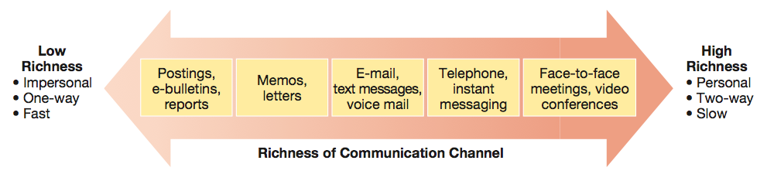

PowerPoint 11:
Controlling: measuring performance and taking actions to ensure desired results.
Feedforward control: Employed before a work activity begins and ensures that objs. Are clear and everything is ready to proceed.
Concurrent controls: focuses on what happens during the work process and makes sure that everything is going according to plan.
Feedback controls: takes place after the work Is completed. Focuses on the quality of the end result. int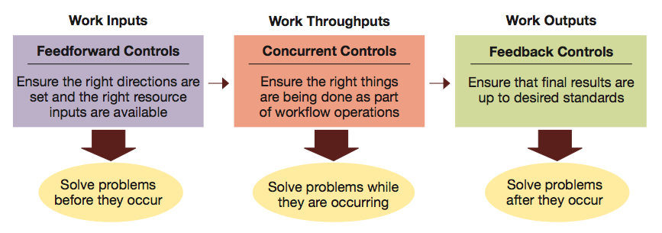
Internal control: allows motivated people and groups to excersice self discipline in fullfilling job excpectations.
External control: occurs through formal supervision and administrative control.
Bureaucratic control: influences behavior through authority and policies.
Clan control: through norms and expectations established by the organizational culture.
Market control: through market control.
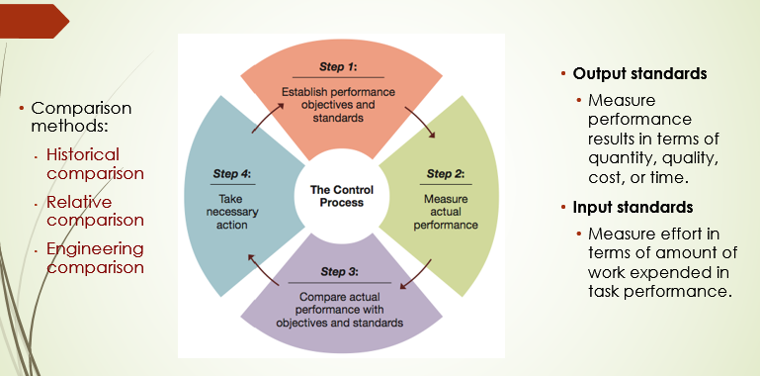

Gantt Chart: graphic display of tasks required to finish the project.
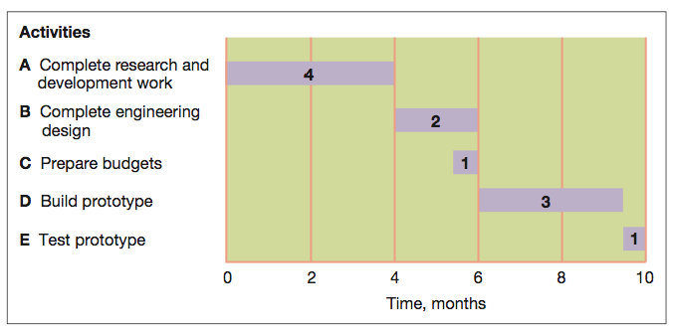

- CPM/PERT: combination of the critical path method and program evaluation and review technique
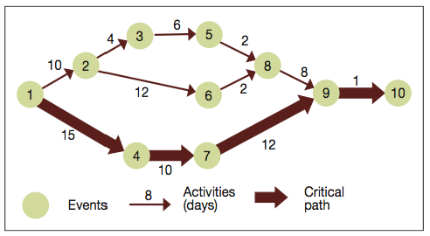
Economic Value Added: A performance measure of economic value created in respect to profits being higher than the cost of capital
Market Value Added: A performance measure of stock market value relative to the cost of capital
Liquidity: the ability to generate cash to play bills.
Leverage: the ability to earn more in returns that the cost of debt.
Asset management: the ability to use resources efficiently and operate at a minimum cost.
Profitability: the ability to earn revenues greater than cost.
Balanced Scorecard: Factors used to develop scorecard goals and measures:
- Financial performance
- Customer Satisfaction
- Internal process improvement
- Innovation and learning

PowerPoint 12:
- Accounting is the recording, measurement, and interpretation of financial information
- Managerial Accounting: focused on internal operations
- Financial Accounting: focuses on preparing financial statements for persons inside and outside the company
- Bookkeeping: recording transactions (in journals, ledgers
- Generally Accepted Accounting Principles (GAAP): Principles that outline the conventions, rules, and procedures for deciding on the acceptable accounting practices at a particular time
- Accounting Standards Board (AcSB): The organization that interprets and modifies GAAP in Canada for private and not-for-profit businesses
- Canadian public companies are required to use International Financial Reporting Standards (IFRS). These standards allow for financial statements to be more easily compared from country to country
- Senior executives must personally certify that the financial information reported by the company is correct
- Corruption of Foreign Public Officials Act: A federal law that prohibits Canadian citizens and companies from bribing foreign officials to win or continue business
- Revenue recognition: Revenues are recorded for the accounting period in which sales are completed and collectible (or collected)
- The earnings cycle must be completed and this occurs when:
The sale is complete and the product has been delivered; and,
The sale price to the customer has been collected or is collectible (accounts receivable)
- Matching: Expenses will be matched with revenues to determine net income for an accounting period
- Full disclosure: Financial statements should include not just numbers, but also interpretations and explanations by management so that external users can better understand information contained in the statements
- Assets: things owned by the firm and include all capital.
- Liabilities: debts owed by the firm to others which include salaries, taxes and interest etc…
- Owners’ Equity (or Shareholders’ Equity): the amount owners (or shareholders) invest in the business plus accumulated profits less dividends or other withdrawals of profits
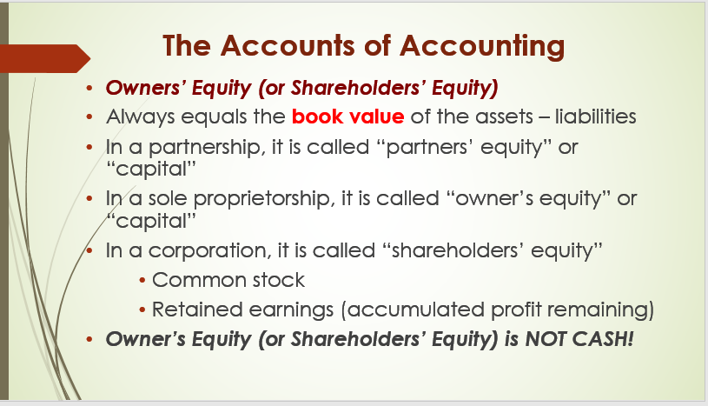
- Revenue accounts: where income from all revenue sources is recorded.
- Cost of goods sold accounts: Used when a company sells products (not services)
Shows all the costs of selling the products that were recorded in the sales (revenues) account
- Expense accounts: where expenses of running a business are recorded
- Fundamental accounting equation:
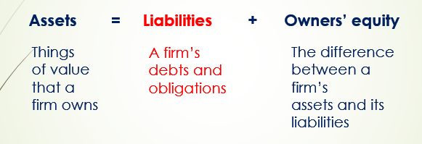
- Double Entry bookkeeping:
- A debit entry will increase an account with a debit balance, but decrease an account with a credit balance. Those typically having a debit balance (those the company owns or receives i.e. assets), and,
A credit entry will increase an account with a credit balance but decrease an account with a debit balance. Those typically having a credit balance (those the company owes or pays i.e. liabilities, equity

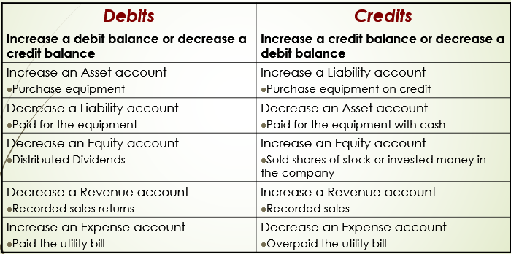

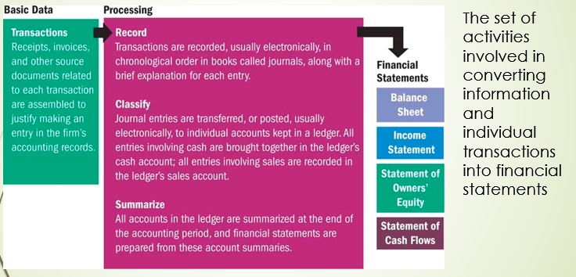
- Income statement: A financial record of a company’s revenues, expenses, and profits over a specific period of time. Reports on profit and loss.

- Balance sheet: A statement of a firm’s financial position, what it owns and the claims against its assets—at a particular point in time
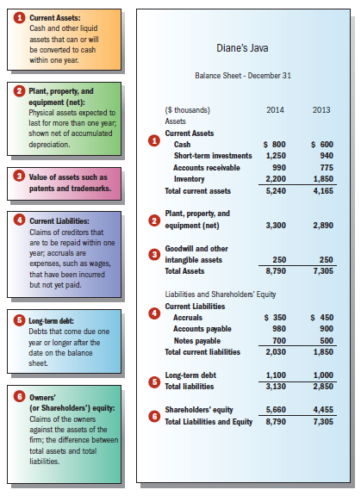

- Statement of changes in equity: A record of the change in equity from the end of one fiscal period to the end of the next fiscal period
- Statement of cash flows: A record of the sources and uses of cash during a period of time
- Accrual accounting: An accounting method that records revenue and expenses when they occur, not when cash actually changes hands

PowerPoint 13:
- Sustainable competitive advantage relies on creativity and innovation
- Creativity is the generation of a novel idea or unique approach to solving problems or crafting opportunities
- Innovation is the process of creating new ideas and putting them into practice
- Product: Creation of new or improved goods and services
- Process: Better ways of doing things
- Business model innovation: New ways of making money
- Sustainable innovation
Creation of new products and processes that have lower environmental impacts than the available alternatives.
- Green innovation
The process of turning ideas into innovations that reduce the carbon footprint of an organization or its products.
- Social Business Innovation
Using micro-credit lending to help create small enterprises and fight poverty.
- Social Entrepreneurship
Pursues creative and innovative ways to solve pressing social problems.
- Strategic leadership creates the capacity for ongoing strategic change
- Five steps of the Hamel innovation “wheel” process:
Imagining
Designing
Experimenting
Assessing
Scaling
- Commercializing innovation
Process of turning new ideas into products or processes that increase profits through sales or cost reductions

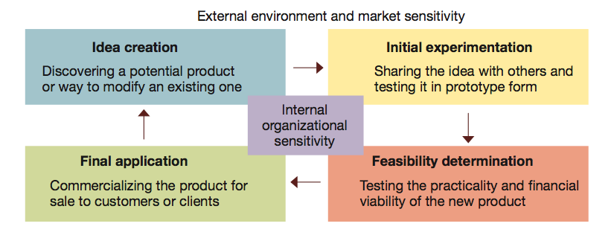

- Disruptive innovation
  - Harvard scholar Clay Christensen defines it as ‘the creation of an innovative product or service that starts out small scale and then moves up market to where it becomes so widely used that it displaces prior practices and competitors
  - Examples include: cellular phones and discount retailers
- Organizational culture: “the way we do things here” – helps to distinguish them from one another and bind members together with some sense of collective identity
- Socialization: builds strong cultures by acclimating new members
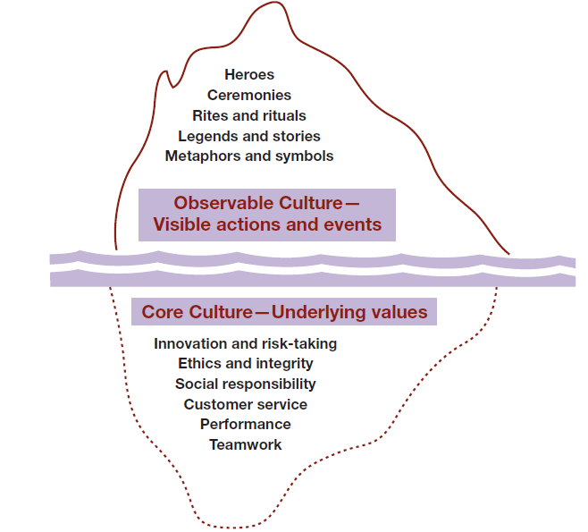
- What is the core culture?
  - Underlying assumptions and beliefs that influence behaviour and contribute to the observable culture
- Core culture and values:
  - Core values are beliefs and values shared by organization members
  - Strong cultures have a small but enduring set of core values
  - Commitment to core values is a key to long-term success
- What is observable culture?
  - What one sees and hears when walking around an organization.
- Elements of observable culture:
  - Heroes, Stories, Rites and rituals, Symbols
PowerPoint 14:
- Unplanned organizational change: occur spontaneously or randomly (e.g., a wildcat strike that results in a plant closure)
- Planned organizational change: the result of specific efforts by a change agent in response to someone’s perception of a performance gap – a discrepancy between the actual situation and the situation that is wanted
- Lewin’s approach to org change: Unfreeze the status quo, move to a new state, refreeze the change
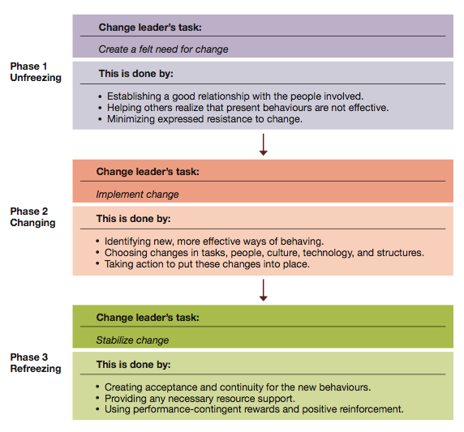

- Kotter: Create a compelling reason for change and establish a sense of urgency;

- Action Research:
Change process based on the systematic collection of data and then selection of a change action based on what the analyzed data indicate
- Appreciative Inquiry:
Identify unique qualities and strengths of an organization that can then be built on to improve performance
- Rational-economic:
People evaluate the outcomes of different courses of action and select the one which maximizes the benefit they receive
Emotions have no place in management-employee relationships and must be prevented from interfering in the works situation
- Social:
People are basically motivated by social needs and achieve a sense of identity through relationships with others
For people to respond to management, the manager must meet the individual’s social needs and needs for acceptance
Attention should not be directed solely at task efficiency
- Self-actualizing
People are primarily self-motivated and self-controlled and do not need external incentives and controls to make them work
Instead of telling people how to do the job, managers explain what is to be achieved and allow the employee to exercise his own discretion
- Complex
People are complex and variable
People can adopt new motives as a result of their experiences
People’s motives may vary in different organizational situations
No single correct managerial strategy exists
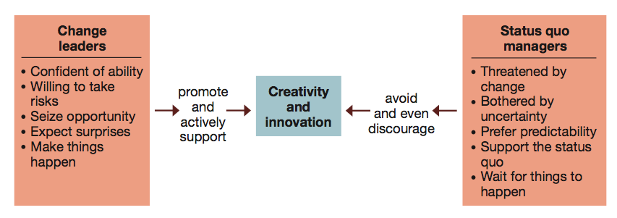

Barriers:
- Perceptual barriers: Stereotyping (seeing what one expects to see)
Difficulty in isolating the problems
Tendency to delimit the problem area too closely (defining the problem too narrowly)
Inability to see the problems from various viewpoints
Saturation (information overload)
Failure to use all “sensory inputs” (including the experience of other organizations)
- Emotional Barriers
Fear of taking a risk
Incapacity to tolerate ambiguity
Preference for judging, rather than generating ideas
Inability to incubate (an unwillingness to ‘sleep on the problem’ due to pressures for solutions
- Cultural Barriers
Taboos (issues which cannot be discussed and therefore cannot be faced)
Focus rather than fantasy (creativity should not be stymied by placing stress on the value of channelled mental activities)
Problem-solving is a serious business (humour is one essential ingredient for problem-solving)
Reason and intuition (reason, logic and numbers are good, but so are feelings and intuition)
Tradition and change
- Environmental Barriers
Lack of support
Not accepting and incorporating criticism
Bosses who know the answer
- Cognitive Barriers
Using incorrect language
Inflexible use of strategies
Lack of the correct information
Resistance:
Six major sources of organizational resistance:
- Structural inertia
- Limited focus of change
- Group inertia
- Threat to expertise
- Threat to established power relationships
- Threat to established resource allocations

Coping:
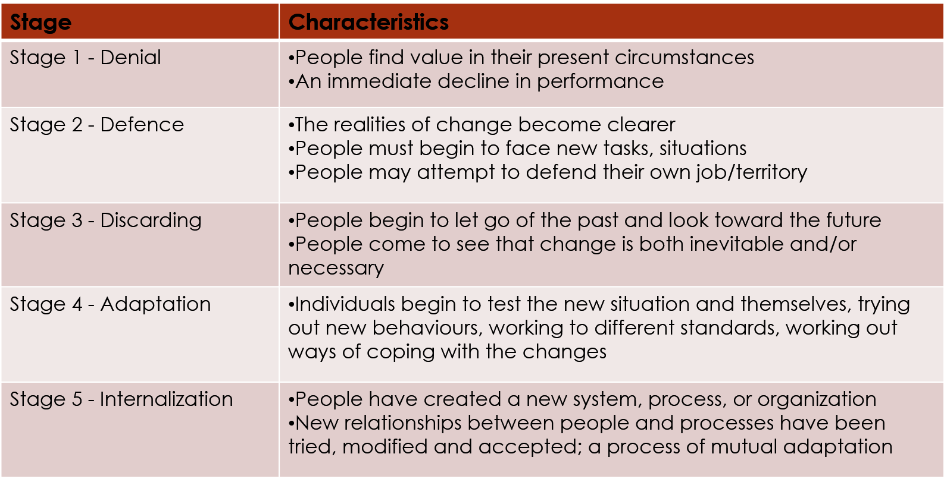

Org. Change:
- Change leader
  - A change agent who takes leadership responsibility for changing the existing pattern of behaviour of another person or social system
- Change leadership
  - Forward-looking
  - Proactive
  - Embraces new ideas
- Top-down change
  - Strategic and comprehensive change that is initiated with the goals of comprehensive impact on the organization and its performance capabilities
  - Driven by the organization’s top leadership.
  - Success depends on support of middle-level and lower-level workers
- Bottom-up change
  - The initiatives for change come from any and all parts of the organization, not just top management
  - Crucial for organizational innovation
  - Made possible by:
    - Employee empowerment
    - Employee involvement
    - Employee participation

- Integrated change leadership
Successful and enduring change combines advantages of top-down and bottom-up approaches.
- Top-down:
Breaks up traditional patterns
Implements difficult economic adjustments
- Bottom-up:
Builds capability for sustainable change
Builds capability for organizational learning
- Transformational and incremental change
  - Unplanned change
    - Response to unanticipated events.
    - Good leaders act on opportunities for reactive change.
  - Planned change
    - Aligning the organization with anticipated future challenges
    - Activated by proactive leaders who are sensitive to performance gaps
    - Transformational change ↓ major and comprehensive redirection
    - Incremental change ↓ adjusting existing systems and practices

Rational persuasion strategy of change.
  - Bringing about change through persuasion backed by special knowledge, empirical data, and rational argument
  - Relies on expert power
  - Relies on belief that reason guides people’s decisions and actions
  - Useful in the unfreezing and refreezing phases
  - Produces longer-lasting and internalized change

Shared power strategy of change
  - Engages people in a collaborative process of identifying values, assumptions, and goals from which support for change will naturally emerge
  - Time consuming but likely to yield high commitment
  - Involves others in examining sociocultural factors related to the issue at hand
  - Relies on referent power and strong interpersonal skills in team situations
  - Relies on belief that people respond to sociocultural norms and expectations of others
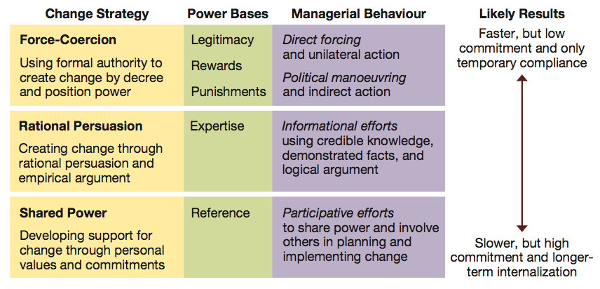
Checklist for dealing with resistance to change:
  - Check the benefits – those involved see a clear advantage
  - Check the compatibility – keep change similar to existing values/processes
  - Check the simplicity – make it as easy as possible to understand
  - Check the triability – allow people to slowly try the change adjusting as progression is made
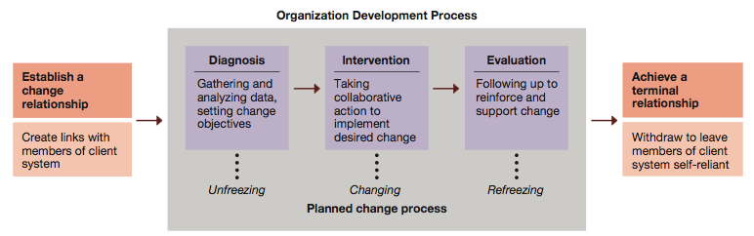
Action research
  - The process of systematically collecting data on an organization, feeding it back to the members for action planning, and evaluating results by collecting more data and repeating the process as necessary
  - Is initiated when someone senses a performance gap

- Individual OD interventions
  - Sensitivity training (T-groups)
  - Management training
  - Role negotiation
  - Job redesign
  - Career planning
Team OD interventions
  - Team building
  - Process consultation
  - Inter-group team building
Organization-wide OD interventions
  - Survey feedback
  - Confrontation meeting
  - Structural redesign
  - Management by objectives (MBO)

PowerPoint 15: strategic management
Basic concepts of strategy:
  - Competitive advantage — operating with an attribute or set of attributes that allows an organization to outperform its rivals
  - Sustainable competitive advantage — one that is difficult for competitors to imitate
Typical source of competitive advantage (how to outperform your competition):
  - Cost and quality
  - Knowledge and speed
  - Barriers to entry
  - Financial resources
  - Technology

Basic concepts of strategy
  - Strategy — a comprehensive action plan that identifies long-term direction for an organization and guides resource utilization to accomplish organizational goals with sustainable competitive advantage
  - Strategic intent — focusing all organizational energies on a unifying and compelling goal
Levels of strategies:
  - Corporate strategy
    - sets long-term direction for the total enterprise
  - Business strategy
    - identifies how a division or strategic business unit will compete in products or services
  - Functional strategy
    - guides activities within one specific area of operations
Strategic Management Process:
  - Strategic analysis – process of analyzing the organization, the environment, its competitive position and current strategies
  - Strategy formulation – the process of crafting strategies to guide allocation of resources
  - Strategy implementation – putting strategies into action
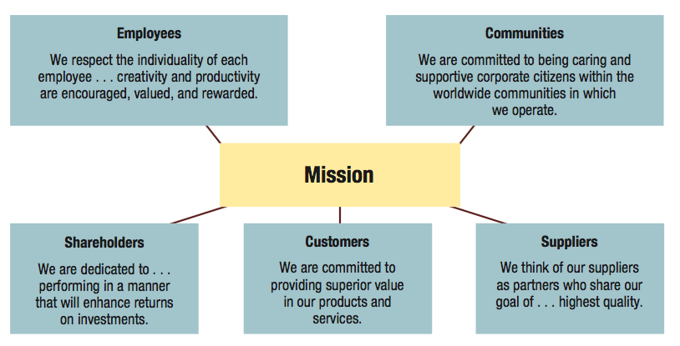
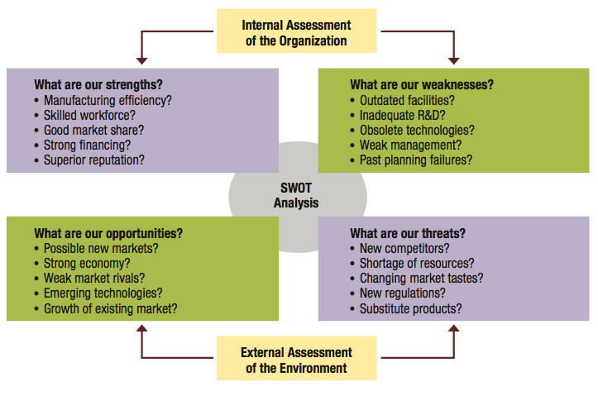
Porter’s Model of Five Strategic Forces Affecting Competition:
  - Industry competition: the intensity of rivalry among firms and their competitive behaviour
  - New entrants: the threat of new competitors entering the market
  - Substitute products or services: the threat of substitute products or services
  - Bargaining power of suppliers: the ability of resource suppliers to influence the cost of products or services
  - Bargaining power of customers: the ability of customers to influence the price they will pay for products or services

Strategy formulation – the process of crafting strategies to guide allocation of resources
Strategy Formulation: Corporate Level Strategies
    - Master Strategies
    - Growth & Diversification Strategies
    - Restructuring Strategies
    - Global Strategies
    - Cooperative Strategies
    - E-Business Strategies
Strategy Formulation: Business Level Strategies
- Differentiation strategy
- Cost leadership strategy
- Focused differentiation strategy
- Focused cost leadership strategy
Corporate level: Grand or Master strategies:
  - Growth strategies: seek an increase in size and the expansion of current operations.
  - Stability strategy: maintains current operations without substantial changes
  - Renewal strategy: tries to solve problems and overcome weaknesses that are hurting performance.
  - Combination strategy: pursues growth, stability, or retrenchment in some
Growth and diversification strategies:
  - Growth strategies
    - Seek an increase in size and the expansion of current operations
  - Types of growth strategies:
    - Concentration strategies
    - Diversification strategies
      - Related diversification
      - Unrelated diversification
      - Vertical integration
Restructuring strategies:
  - Tries to correct weaknesses by changing the mix or reducing the scale of operations
    - Restructuring through turnaround
    - Restructuring through downsizing
    - Restructuring through divestiture
Global strategies:
  - Globalization strategy
    - World is one large market; standardize products and advertising as much as possible
    - Ethnocentric view
  - Multidomestic starategy
    - Customize products and advertising to local markets as much as possible
    - Polycentric view
  - Transnational strategy
    - Balance efficiencies in global operations and responsiveness to local markets
    - Geocentric view
Cooperative strategies
  - Strategic alliances — two or more organizations partner to pursue an area of mutual interest.
  - Types of strategic alliances:
    - Outsourcing alliances
    - Supplier alliances
    - Distribution alliances
    - Co-opetition
Porter’s generic strategies model
  - Business-level strategic decisions are driven by:
    - Market scope
    - Source of competitive advantage
  - Market scope and source of competitive advantage combine to generate four generic strategies
Porter’s generic strategies for gaining competitive advantage:
  - Differentiation strategy
  - Cost leadership strategy
  - Focused differentiation strategy
  - Focused cost leadership strategy
PowerPoint 16: Groups vs. Teams
- Synergy
  - The creation of a whole that is greater than the sum of its parts
Team and teamwork roles for managers:
  - Supervisor — serving as the appointed head of a formal work unit
  - Network facilitator — serving as a peer leader an network hub for a special task force
  - Participant — serving as a helpful contributing member of a project team
  - External coach — serving as the external convener or sponsor of a problem-solving team staffed by others
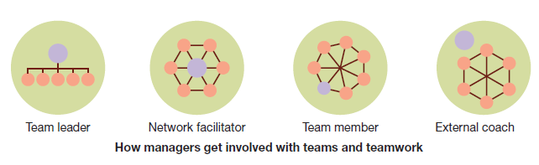

Five-Stage Model
  - Forming
  - Storming
  - Norming
  - Performing
  - Adjourning
Punctuated Equilibrium Model
  - Phase 1 – first meeting sets the teams direction followed by a period of inertia (stands still or follows a particular direction)
  - Phase –2 recognition that work needs to be done followed by a burst of changes to old patterns, setting a new direction, ending with a final burst of activity to finish its work
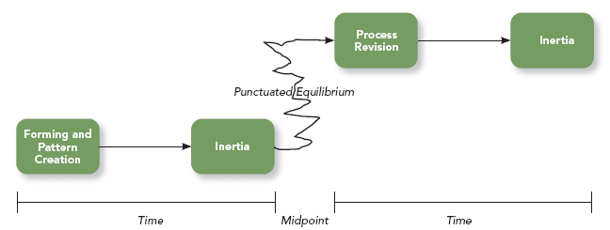
Symptoms of groupthink:
  - Illusions of group invulnerability
  - Rationalizing unpleasant and disconfirming data
  - Belief in inherent group morality
  - Negative stereotypes of competitors
  - Pressure to conform
  - Self-censorship of members
  - Illusions of unanimity
  - Mind guarding
Conflict:
  - A disagreement between people on:
    - Substantive issues regarding goals and tasks, allocation of resources, distribution of rewards, policies and procedures, and job assignments
    - Emotional issues arising from feelings of anger, distrust, dislike, fear, and resentment, as well as personality clashes
  - Conflict that is well managed can help promote creativity and high performance

- Functional conflict
Moderately intense conflict.
Constructive and stimulates people toward greater work efforts, cooperation, and creativity
- Dysfunctional conflict
    - Low-intensity and very high-intensity conflict
    - Destructive and hurts task performance
PowerPoint 17: HR Management
Human Resource Management includes all activities used to attract & retain employees and to ensure they perform at a high level in meeting organizational goals
All activities used to attract & retain employees and to ensure they perform at a high level in meeting organizational goals
- Three main objectives:
- Providing qualified, well-trained employees for the organization
- Maximizing employee effectiveness in the organization
- Satisfying individual employee needs through monetary compensation, benefits, opportunities to advance, and job satisfaction
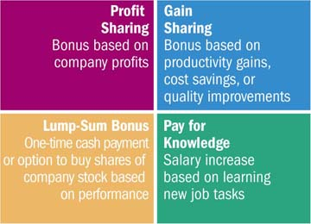
- Employee benefits: Additional compensation-such as vacation time, retirement savings plans, profit-sharing, health insurance, gym memberships, child and elder care, and tuition reimbursement-paid entirely or in part by the company
- Voluntary turnover: Employees may leave firms to start their own businesses, take jobs with other firms, or retire
- Involuntary turnover: Employers may terminate employees because of poor job performance, unethical behaviour, or the need for downsizing
- Downsizing: The process of reducing the number of employees within a firm by eliminating jobs
Downsizing has negative effects:
Anxiety, health problems, and lost productivity among remaining workers
Expensive severance packages paid to laid-off workers
A domino effect on the local economy
- Outsourcing: Using outside vendors to produce goods or fulfill services and functions that were previously handled in-house or in-country
To save expenses and remain flexible, companies will try to outsource functions that are not part of their core business
Although outsourcing might work on paper, the reality might be different
PowerPoint 19: Marketing
- Group of activities designed to expedite transactions by creating distributing (Place), Pricing, and Promoting Products (goods, services, and ideas)
The Ability Of A Product To Satisfy Human Wants And Needs
- Place utility – making the product available where the buyer wishes to buy it
- Time utility – making the product available when the buyer wishes to buy it
- Ownership utility – created by transferring ownership of the product to the buyer
- Form utility – created through the production process: transforming raw materials or inputs into a form the buyer wants
A marketing strategy is a plan of action for developing, pricing, distributing, and promoting products that meet the needs of specific customers
Two key ingredients:
- Target market
- Marketing mix
- Total market approach: firms try to appeal to everyone and assume that all buyers have similar wants and needs
  - Sugar, flour, salt, heating oil
- Market segmentation: dividing the total market into groups of people who have relatively similar needs and wants
  - A concentration approach to market segmentation: developing one marketing strategy for a single market segment
    - Jaguar, Lotus, Patek Philipe, Rolex, Omega, Gucci
A multi-segment approach: aiming marketing efforts at more than one segment in a similar product market and developing a marketing strategy for each
    - Bicycles: racers, commuters, children
A market is a group of people who have a need, purchasing power, and the desire and authority to spend money on goods, services and ideas
  - i.e. purchasers of automobiles

A target market is a more specific group of consumers on whose needs and wants a company focuses its marketing efforts
  - i.e. purchasers of the Ford F150 pick-up truck vs. others
  - Target marketing requires market segmentation
- Demographic: Age, sex, race, ethnicity, income, education, occupation, family size, religion, social class
- Geographic: Climate, terrain, natural resources, population density
- Psychographic: Personality characteristics, motives, lifestyles
- Behaviouristic: Consumer’s behaviour toward the product
- Marketing mix – refers to the four marketing activities – Product, Price, Promotion, and Place (Distribution) – that the firm can control
- The target market is the central focus
Product Classification includes:
  - Convenience products are bought frequently and for immediate consumption without a lengthy search
  - Shopping products are purchased after buyer has compared competitive products
  - Specialty products are products that the buyer searches for and makes a special effort to obtain
Two key intermediaries (or middlemen):
- Wholesalers: buy from producers or from other wholesalers and sell to retailers (usually do not sell in significant quantities directly to consumers)
- Retailers: buy products from wholesalers and sell them to consumers for home and household use, rather than for re-sale
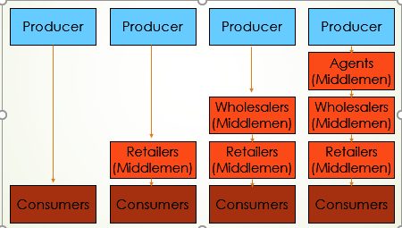
The Promotion Mix
- A persuasive form of communication that attempts to expedite a marketing exchange by influencing individuals, groups, and organizations to accept goods, services, and ideas
- Objective is to communicate directly or indirectly with individuals or groups or organizations to facilitate exchanges
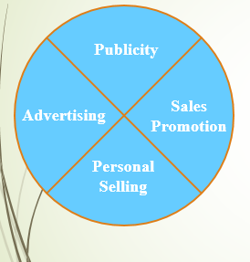
Advertising:
- A paid form of non-personal communication transmitted through a mass medium
- All advertising possesses four basic features:
  - A verbal and/or visual message
  - A sponsor who is identified
  - Delivery through at least one medium
  - Payment by the sponsor to the media carrying the message
Personal selling:
- Direct, two-way communication with buyers and potential buyers
- Most flexible of the promotional methods

Publicity:
- Non-personal communication transmitted through the mass media but not paid for directly by the firm
- Mechanisms include:
- News releases
- Feature articles
- Captioned photographs
- Press conferences
- Interviews
Sales promotions:
- Direct inducements offering added value or some other incentive for buyers to enter into an exchange
- Intended to:
  - Stimulate demand
  - Stabilize sales
  - Inform, remind, and reinforce products/services to customers
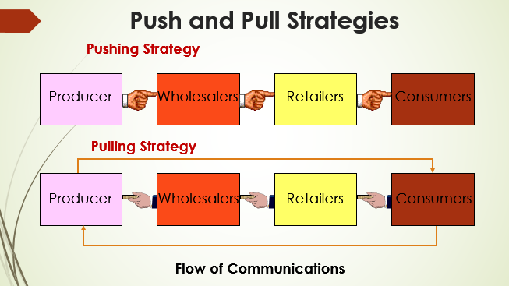

The Marketing process:
A multi-step process:
  - Conduct research
  - Identify a target market
  - Design a product to meet the need based on research, then conduct product testing
  - Determine a brand name and design a package
  - Set a price
  - Select a distribution system
  - Design a promotional program

