Overview of Marketing

Learning Objectives:

LO1: Define the role of marketing and explain its core concepts
LO2: Describe how marketers create value for a product and service
LO3: Summarize the four orientations or marketing
LO4: Understand the importance of marketing both within and outside the firm

Building Value
- Build & maintain a loyal customer base
- Distinguish from competitors
- Strong brad, customer appeal
- Constantly need to protect the brand
What is Marketing? Marketing is a set of business practices designed to plan for and present an organization’s products or services in ways that build effective customer relationships.
- Marketing is used to create value in products & services
- The interrelated marketing mix – or 4 P’s – creates, transacts, communicates & delivers value

Core Aspects of Marketing

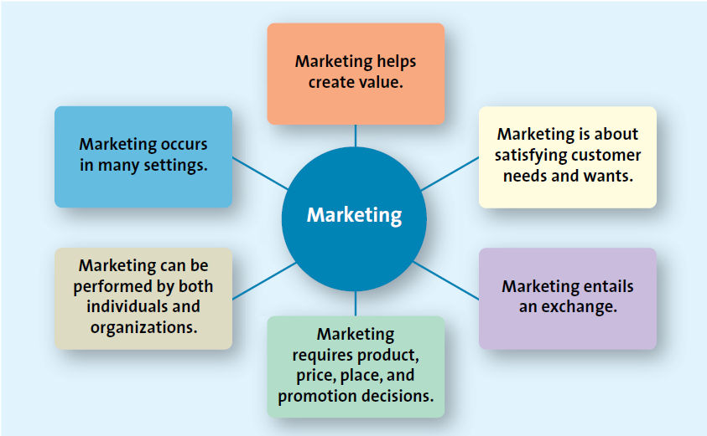

Satisfying Customers’ Needs & Wants

Need: basic necessities Want: how to fulfill that need
Entails a Marketing Exchange

- The exchange can occur between any two parties
- Not simply a buyer and seller exchanging money for good or service
- Can be an exchange of information for convenience

- Marketing is ultimately about an exchange – the trade of things of value between the buyer & the seller so that each is better off as a result
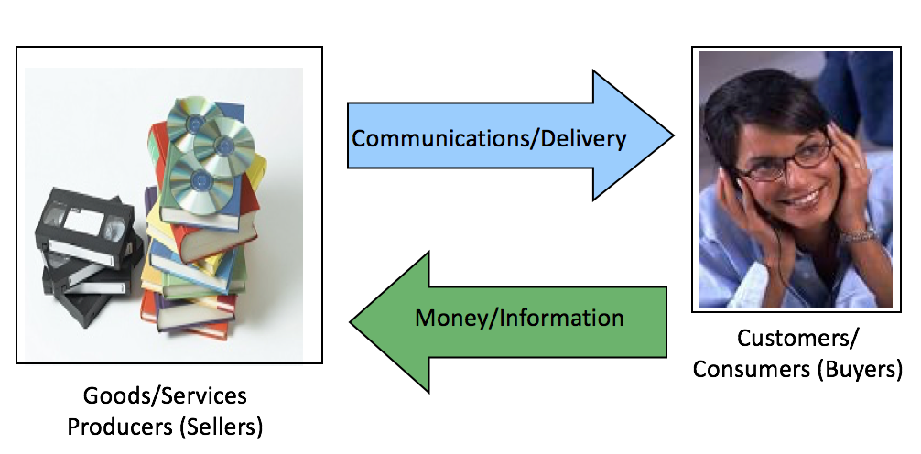

- Each party to the exchange fives up something of value. The customer gives up not only money but also time and information, and the firm gives up the good or service.
- The exchange in the end is mutually beneficial

Marketing Requires Marketing Mix Decisions
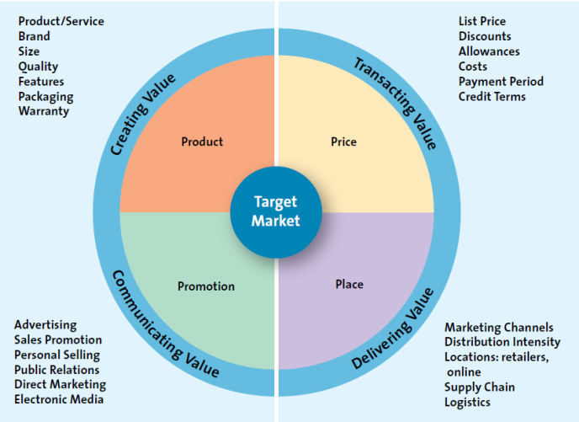
- This is an overview of the 4P’s

Product: Creating Value

- Goods, services and ideas.

- The fundamental purpose of marketing is to create value by developing a variety of offerings, including gods, services and ideas, to satisfy customer needs.

Organizations such as Mothers Against Drunk Driving or Students Against Drunk Driving often receive support from brewers and distillers in promoting responsible drinking and safe driving.

Q: What is the exchange these groups are asking consumers to enter?
A: They want you to consume alcohol in a manner that is consistent with safety, which means giving up some consumption or drinking responsibly- do not get behind the wheel if you drink.

Price: Transacting Value

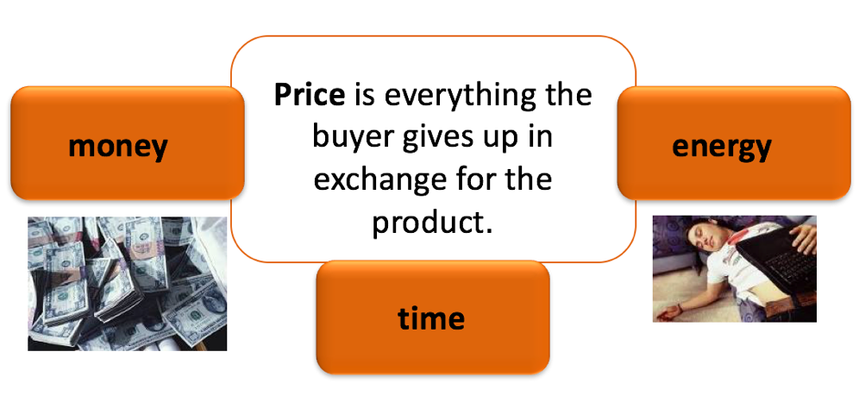

- Everything has a price, though it doesn’t always have to monetary
- Price is everything that the buyer gives up, money, time, energy, in exchange for the product or service.

A good example of how price expresses value is the variations in price associated with air travel. The prices can vary based on demand for the flight timing and destinations.

Place: Delivering Value

- All activities necessary to get the product to the right customer when that customer wants it.
- Supply chain management is the filed that examines these activities

- Place delivers the product to the customers. Student may overlook the importance of this component of the marketing mix because of all the areas in marketing, place is not as readily visible from the consumer perspective. Students tend not to think about the importance of getting goods from manufacturers to consumers, which currently requires global approaches.

Place: Marketing Channels Distribution Strategy

- Distribution strategy can be complex and requires consideration of many factors, as well as a high level of coordination. This topic appears in greater detail later in the chapter.

Promotion: Communicating Value

- The communication activities of marketing
- Used to inform, persuade and remind potential buyers
- Used to influence their opinions or elicit a response

- Even the best products & services will go unsold if markets cannot communicate their value to customers.

With ads targeting to a youthful audience. The provocative advertising has helped create the image that is filled with youth, style and sex appeal.

Marketing Can Be Performed by Both Individuals & Organizations

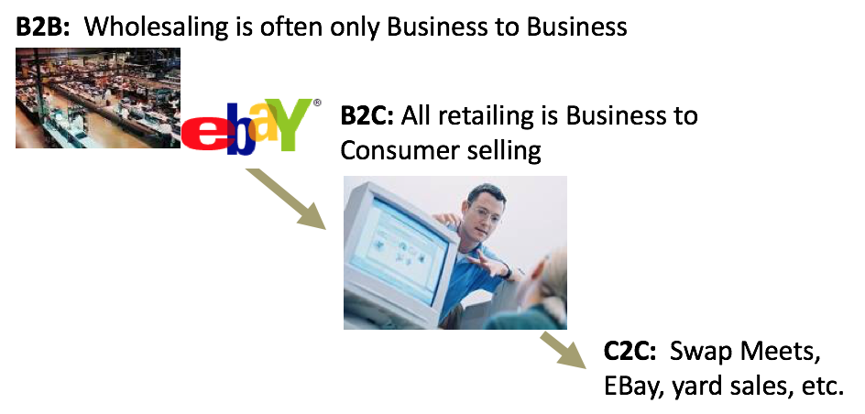

- Marketing intermediaries such as retailers, accumulate merchandise from producers in large amounts and then sell it to you in smaller amounts.
- Students often fail to consider that the products they purchase have changed hands before.

(B to B). If you sell your computer to your roommate, you have engages in C to C selling. Thus, the same product might be a part of all three types of marketing.

Marketing Impacts Many Stakeholders

- Both profit and non-profit entities
- Developing economies
- Entire industries

- Most people think of marketing as a way for firms to make profits, but marketing works equally well in the non-profit sector
- Marketing is often designed to benefit an entire industry, which can help many firms simultaneously. Think of the dairy industry (Got Milk campaign)

Social Media & Marketing

- The use of digital tools to easily & quickly create & share content to foster dialogue social relationships & personal identities.

- Social media has quickly become an integral part of marketing & communication strategies.

A Facebook application developed by TD Bank for students to allow them to monitor and track expenses that need to be shared (split) with roommates. Of course, when student use the application, it gives TD Bank access to information about the users

The Four Orientations of Marketing
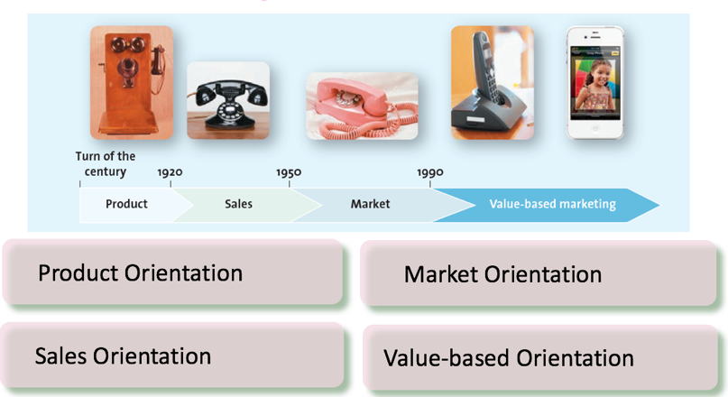
- Marketing has been through several eras. This exhibit graphically represents the changes over time from an emphasis on production to one based on value-based marketing. The production-oriented era took place aroundthe turn of the 20th century, when most firms believed a good product would sell itself. In the sales-oriented era, production and distribution techniques improved and supply outpaces demand. Firms found an answer to overproduction by focusing on sales. In the market-oriented era, the focus was on what consumers wanted. Now, we are in the value-based era, which maintains the market orientation but also includes a focus on giving greater value than the competition.

- Value reflects the relationship of benefits to costs. Value-based marketing means implementing a marketing strategy according to what customers value. Value-based marketing isn’t just about low price, it is also about creating strong products and services.
- A relational orientation is based on the philosophy that buyers and sellers should develop a long-term relationship for the benefit of both parties.

Consider each incarnation of the telephone presented in the photos. How has each of them made an improvement?

Value-Based Orientation
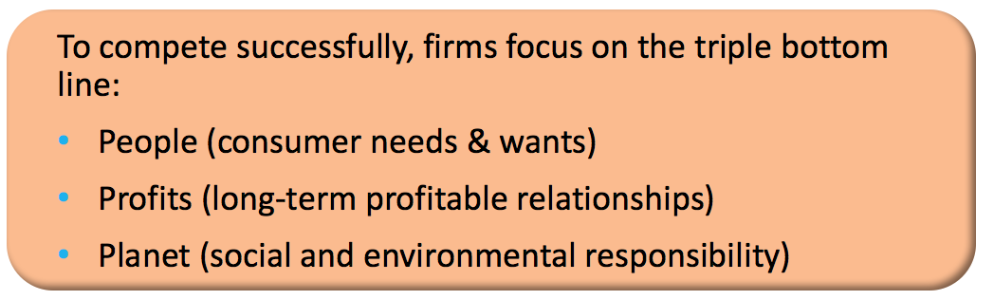

- Value-based companies provide their customers with greater value than the competitors do
- Valuable customer’s benefits can include: speed, convenience, size, accuracy, price, cost-savings, user-friendliness.
- Value is in the eye of the beholder.

How Do Firms Become More Value Driven?

Firms focus on four activities:
  - Sharing information
  - Balance customer’s benefits & costs
  - Build relationships with customers
  - Use technology to connect with customers

Sharing Information

- Why is sharing and coordination information such a critical success factor for any firm?

- Marketing share information about customers & competitors that have been collected through customer’s relationship management (CRM), & integrate it across the firm’s various departments.

Balance Benefits with Costs

- Understand key benefits
- Focus on key benefits
- Eliminate cost of less strategic benefits

- With information the firm can understand what are the key benefits to customers seek, focus on those and eliminate the cost of providing other less strategic benefits.

Building Customer Relationships

- Take a long term view of customer relationships
- Use data to assist in maintaining the relationship

- Relational orientation: think about customers in terms of relationships rather than transitions
- Focus is on the lifetime value of the relationship, not how much money is made during each transition
- In early conceptions of marketing (before value-based marketing), firms often viewed the closing of the sales as the termination of their relationship with the customer. Today, firms strive to create lifetime value among customers, hoping they will return to the firm for all their future needs.
- Use CRM to collect information about customer needs and wants and use that information to target their best customers.

Connect with Customers Using Social Media

- Embrace social media to connect better with customers
- ¾ of North American companies now use social media for marketing purposes
- Users are driving the way brands stores are interacting with social media

- Marketers steadily embrace new technologies, such as social & mobile media to allow them to better connect with their customers & thereby serve their needs more effectively.

Why is Marketing Important?

- Marketing has shifted its focus dramatically, it also has evolved into a major business function that crosses all areas of a firm or organization.
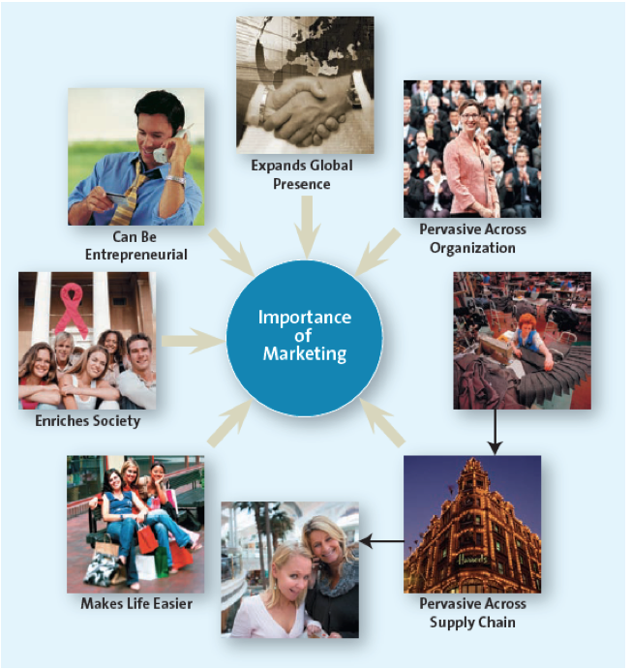

Marketing Expands Firms’ Global Presence

- Good are available to consumers from many countries from the far reaches of the globe
- Must understand customers’ needs & wants
- Segment-by-segment, region-by-region

- Today, many products are manufactured outside of Canada and the United States.
- Whether it is groceries of apparel, chances are you will find goods from many countries around the world.

Q: Why has Starbucks been so successful globally?
A: Starbucks provides: product (beverages are universal), customer need (luxury and convenience items), local product and adaptations, etc.

Marketing is Pervasive Across Channel Members

- Each step in the supply chain involves marketing
- All members in the chain must ultimately focus on creating value for their customer and the end user consumer.
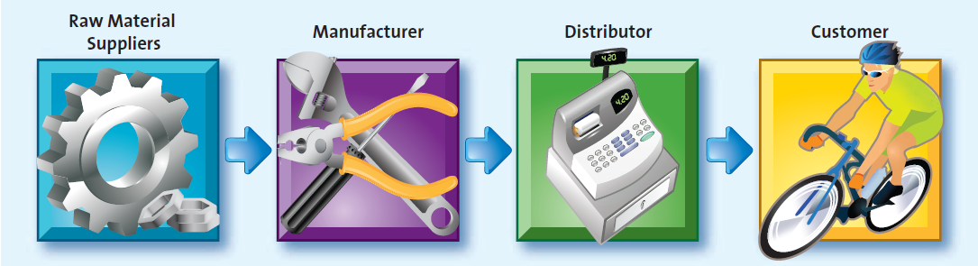

- A supply chain is the group of firms & set of techniques & approaches firms use to make & deliver a given set of goods & services.

Marketing Enriches Society

- Marketing often focuses on factions other than financial profitability.
- This can include good corporate citizenry.
- Firms have realized that good corporate citizenry through socially responsible actions should be a priority because it will help their bottom line in the long run.

Marketing Can Be Entrepreneurial

- Though important to large firms, marketing is equally important to the success of small ventures- especially new ventures.

- Marketing is at the centre of the successes of numerous new ventures initiated by entrepreneurs, or people who organize, operate & assume the risk of a business venture.
- The key to the success of many such endeavours is that they launch products or services that satisfy unfilled needs.

Entrepreneurial Marketing

- More than ½ million people launches new businesses in 2012 in Canada
- Dragons’ Den is a popular show where aspiring entrepreneurs “pitch their wares”.
- The Dragons’ are successful entrepreneurs in their own right that have become household names.

