CHAPTER 1

- Check this answer…
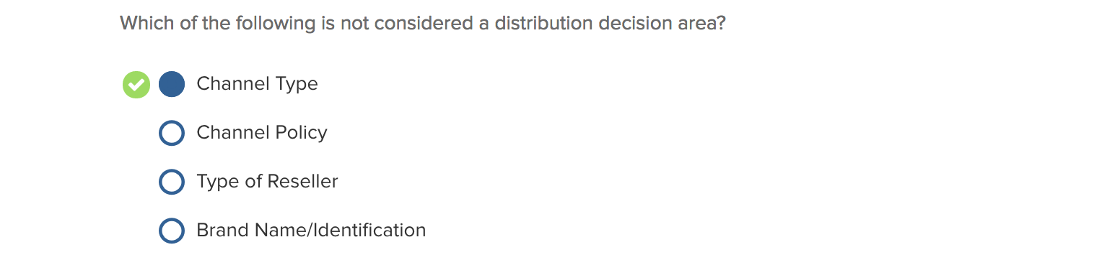
*Answer should have been Brand Name/Identification that is a product decision area not distribution decision.

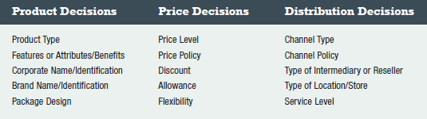

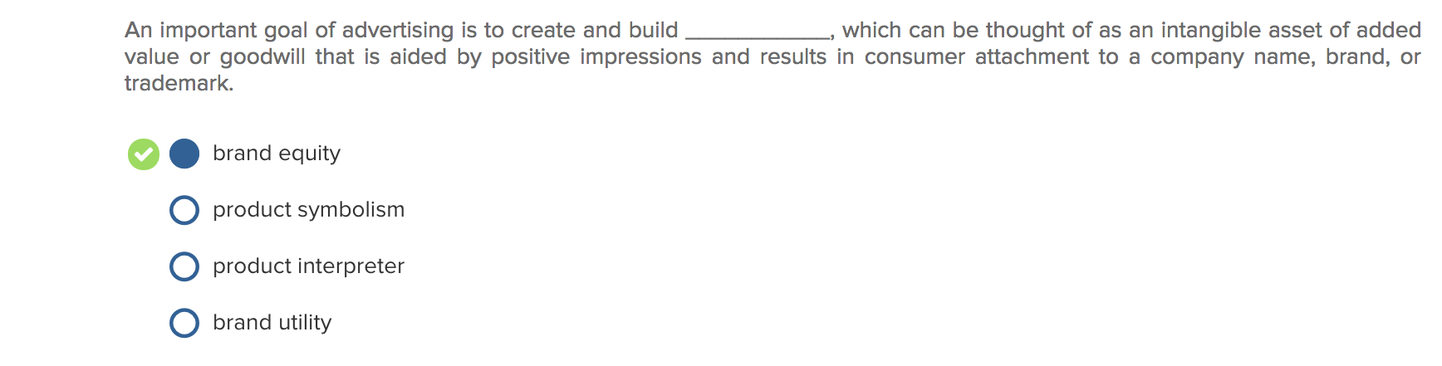
Brand Equity : An intangible asset of added value or goodwill that results from the favourable image, impressions of differentiation, and/or strength of consumer attachment to a company name, brand name, or trademark.

Brand Identity : A brand or corporate name and its identification through its logo, symbol, or trademark represent critical product decisions.

Product symbolism : What a product or brand means to consumers and what they experience in purchasing and using it. For products with strong symbolic features, the social meaning of the experiential or psychological benefits may be more important than functional utility.

Product interpreter: NA
Brand utility: NA

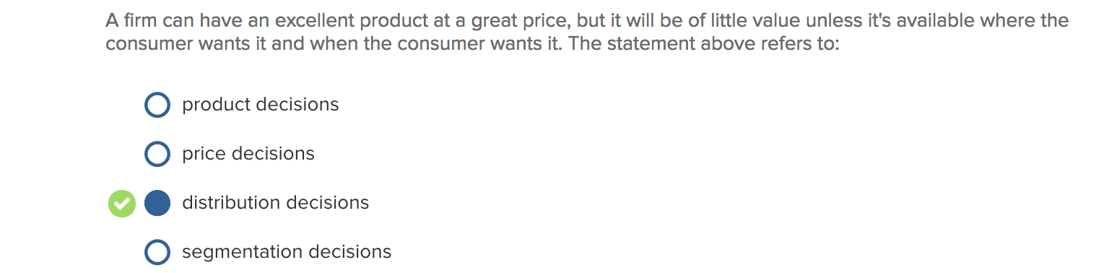

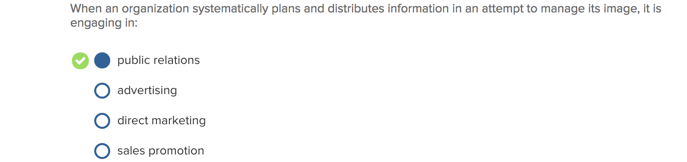

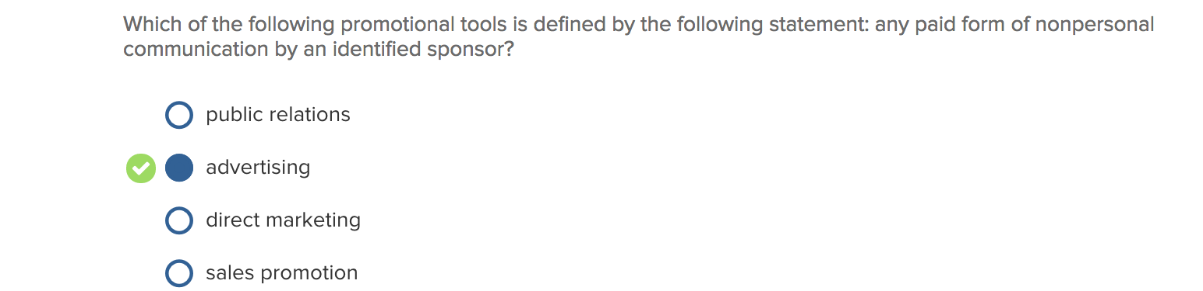

Public Relations:
The management function that evaluates public attitudes, identifies the policies and procedures of an individual or organization with the public interest, and executes a program to earn public understanding and acceptance.

Advertising:
Any paid form of non-personal communication about an organization, product, service, or idea by an identified sponsor. Important because:
- Cost-efficient
- Cost-effective
- Brand effects
- Brand interaction
- Flexible tool
- Multiple domains

Direct Marketing:
A system of marketing by which an organization communicates directly with target audiences to generate a response and or a transaction. Direct marketing includes telemarketing and call centres, direct mail, mail-order catalogues, and direct-response ads in broadcast and print media.

Sales Promotion:
Marketing activities that provide extra value or incentives to the sales force, distributors, or the ultimate consumer and can stimulate immediate sales.
- Consumer sales promotion is targeted to the ultimate user of a product or service and includes tools like coupons, samples, premiums, rebates, contests, events, and point-of-purchase materials. These promotional tools encourage consumers to make an immediate purchase,

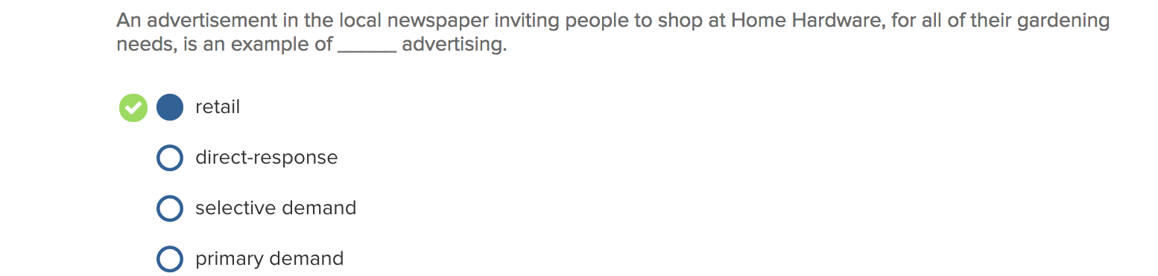

Retail advertising: The retail advertiser focuses on bringing customers into the store for their shopping needs, while the message appeal of brand advertisers attempts to build demand for a specific brand that may be available at a number of retail outlets.

Direct-response advertising: A form of advertising for a product or service that encourages the consumer to purchase directly from the manufacturer.

Selective demand advertising: involves the placement of advertising messages intended to persuade customers about the benefits of your specific brand.

Primary demand advertising: involves messages promoting the benefits of a general product category.

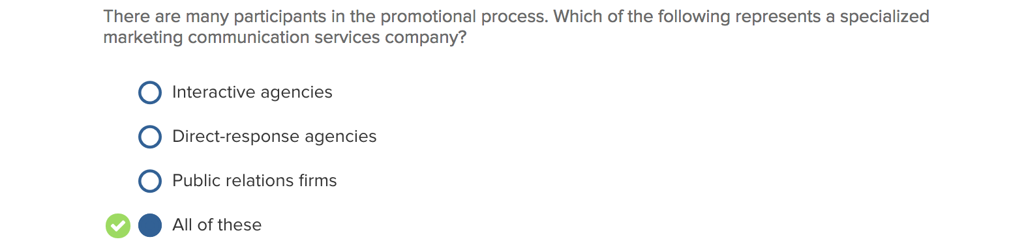

Specialized marketing communication services company:
One of the five major participants in the promotional process: organizations that provide promotional services in their areas of expertise; include direct marketing agencies, sales promotion agencies, interactive agencies, public relations firms, and media buying agencies.

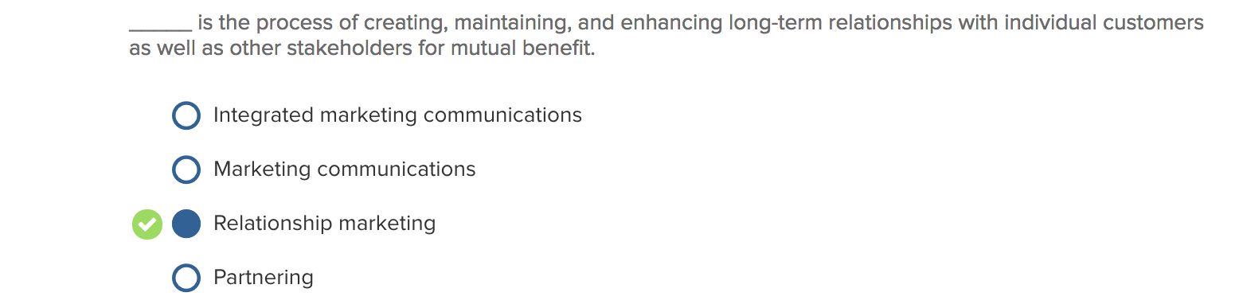

Integrated marketing communication (IMC):
A concept of marketing communications planning that evaluates and combines the strategic roles of a variety of communication disciplines (general advertising, direct response, sales promotion, and public relations) to provide clarity, consistency, and maximum communications impact.

IMC characteristics
- Unified communication for consistent message and image.
- Differentiated communication to multiple customer groups.
- Database-centred communication for tangible results.
- Relationships fostering communication with existing customers.

Partnering: NA

Relationship marketing:
Creating, maintaining, and enhancing long term relationships with individual customers as well as other stakeholders for mutual benefit. This relationship focus is generally more profitable since it is often more cost-effective to retain customers than to acquire new ones

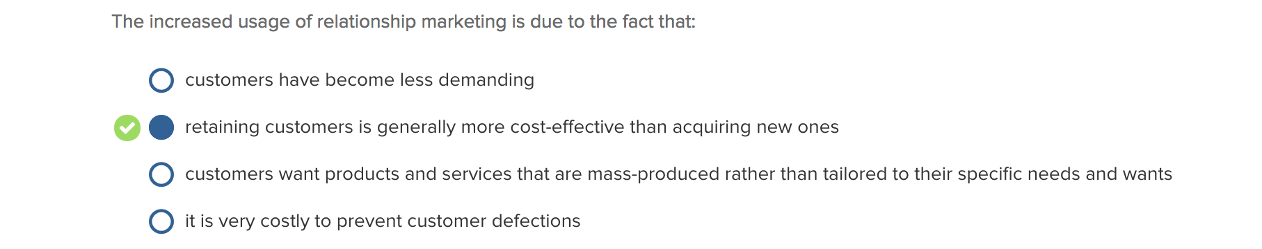

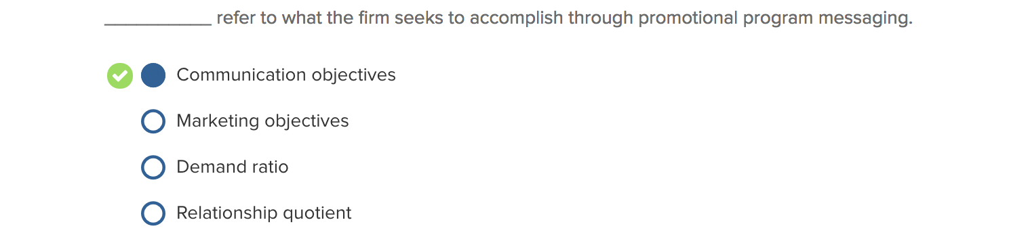

Marketing objectives
Refers to what is to be accomplished by the overall marketing program. They are often stated in terms of sales, market share, or profitability and are determined when the marketing plan is constructed.

Communication objectives
Refers to what the firm seeks to accomplish with its IMC program. They are often stated in terms of the nature of the message to be communicated or what specific communication effects are to be achieved, such as awareness.

Behavioural objectives
Goals the organization seeks to accomplish with its IMC program, often stated in terms of trial purchase or repeat purchase.

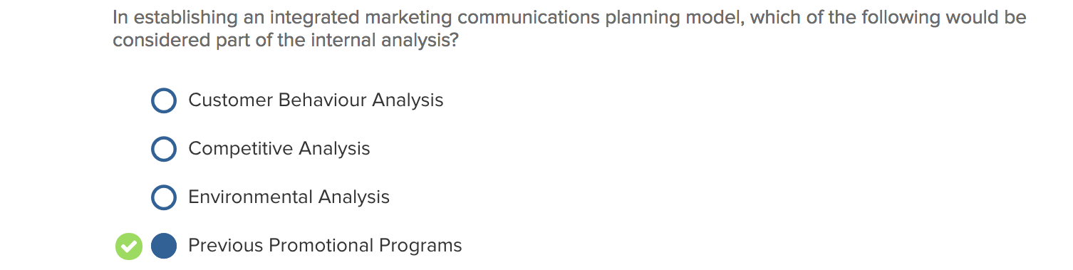

IMC plan (Integrated marketing communication planning model):
A concept of marketing communications planning that evaluates and combines the strategic roles of a variety of communication disciplines to provide clarity, consistency, and maximum communications impact.

The marketer decides which promotional tools to use and how to combine them to achieve IMC objectives. Furthermore, the marketer decides on the role and function of the specific elements of the promotional mix, develops strategies for each element, and implements the plan.

Message development, often referred to as creative strategy, involves determining the basic message the advertiser wishes to convey to the target audience.

Media strategy involves determining which communication channels will be used to deliver the advertising message to the target audience. Decisions must be made regarding which types of media will be used (e.g., newspapers, magazines, radio, TV, billboards) as well as specific media selections (e.g., a particular magazine or TV program).

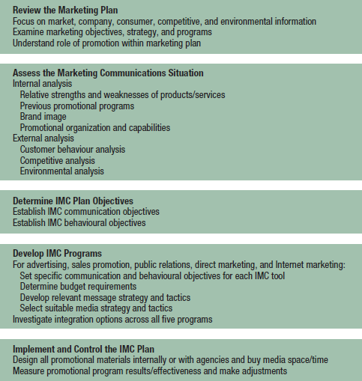

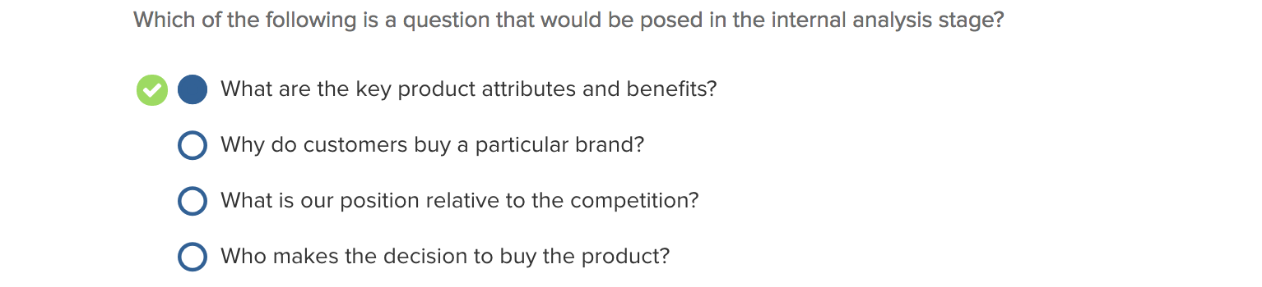

Internal analysis stage
The phase of the promotional planning process that assesses four relevant areas: product, previous promotional programs, firm or brand image, and organizational capabilities.

External analysis stage
Focuses on factors such as characteristics of the firm’s customers, market segments, competitors, and environment. A detailed consideration of customers’ characteristics (e.g., demographics, psychographics) and buying patterns, their decision processes, and factors influencing their purchase decisions are all relevant for promotional planners to make effective decisions.

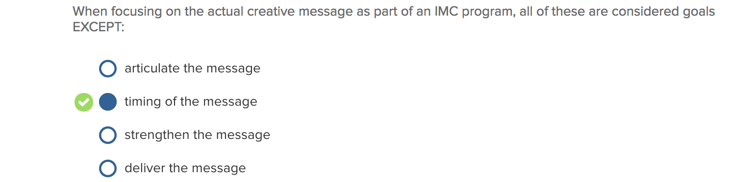
CHAPTER 3

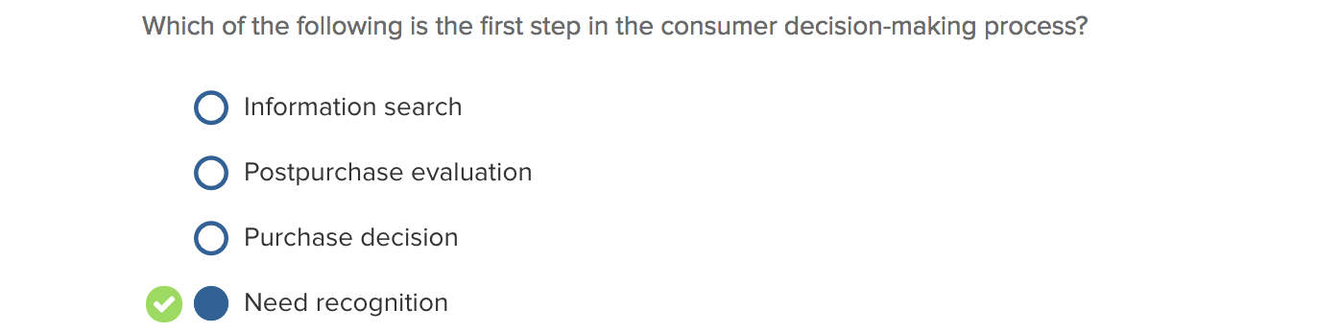

Consumer decision-making process steps:

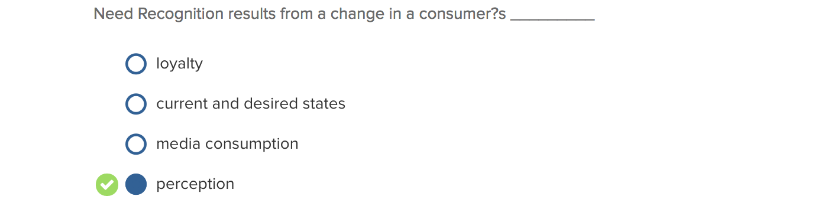

Perception
The process by which an individual receives, attends to, interprets, and stores information to create a meaningful picture of the world.
- Depends on internal factors (person’s beliefs, experiences, needs, moods, and expectations.)
- Also influenced by the characteristics of a stimulus (such as its size, colour, and intensity) and the context in which it is seen or heard.

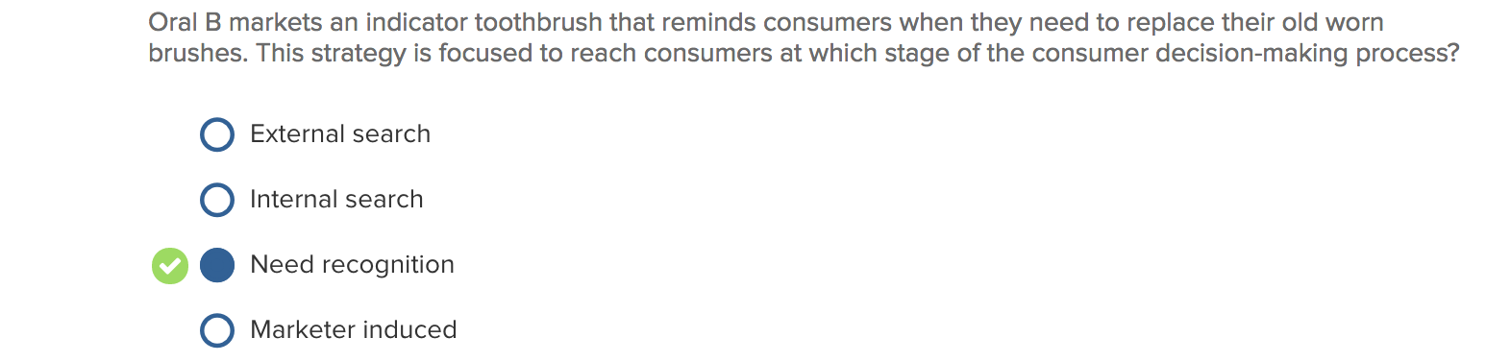

Need recognition
The first step in the consumer decision-making process and it occurs when the consumer perceives a need and becomes motivated to enter a decision-making process to resolve the felt need.

External search
External sources of information include:
- Personal sources (e.g., friends, relatives, or co-workers, face-to-face or via social media)
- Marketer-controlled sources (e.g., advertising, salespeople, displays, Internet)
- Public sources (e.g., articles in print media, reports on TV, Internet discussion boards)
- Personal experience (e.g., past use, actually handling, examining or testing the product)

Internal search
The initial search effort often consists of an attempt to scan information stored in memory to recall past experiences and/or knowledge regarding purchase alternatives

Marketer induced: NA

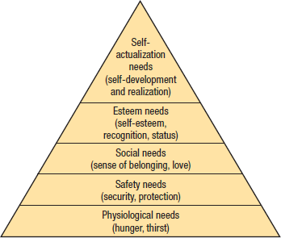
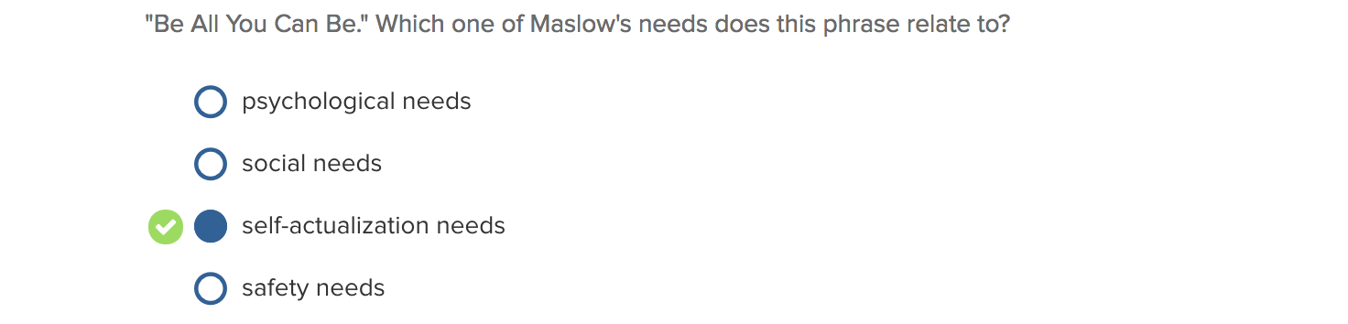

Maslow’s needs theory

Self-actualization: self-development and realizations
Esteem needs: self-esteem, recognition, status
Social needs: sense of belonging, love
Safety needs: security, protection
Physiological needs: hunger, thirst

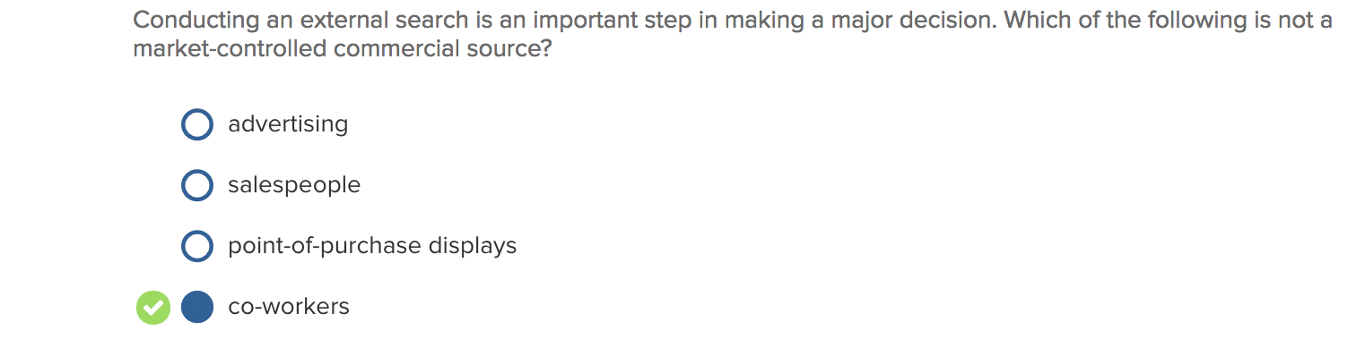

Market-controlled commercial source:

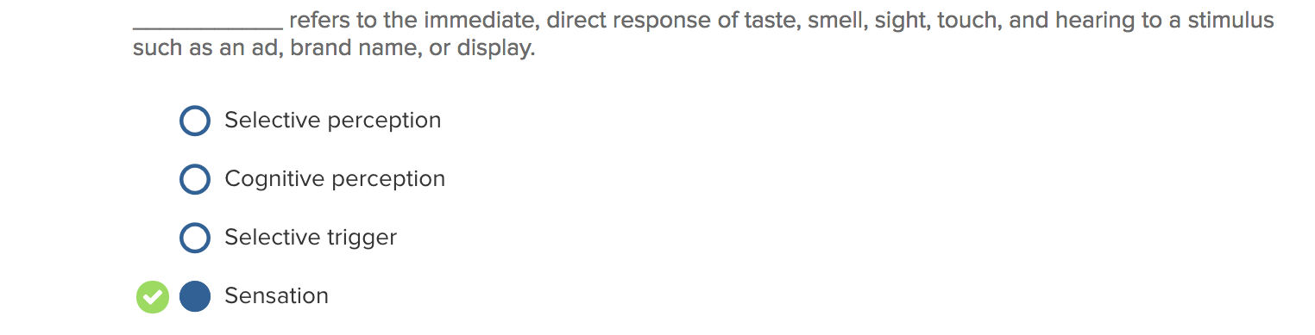
Selective perception
The perceptual process involving the filtering or screening of exposure, attention, comprehension, and retention. (See figure below)

Cognitive perception:

Selective trigger:

Sensation
The immediate, direct response of the senses (taste, smell, sight, touch, and hearing) to a stimulus. Perception uses these senses to create a representation of the stimulus. Marketers plan certain marketing stimuli to achieve consumers’ physiological reactions.

Selective perception process

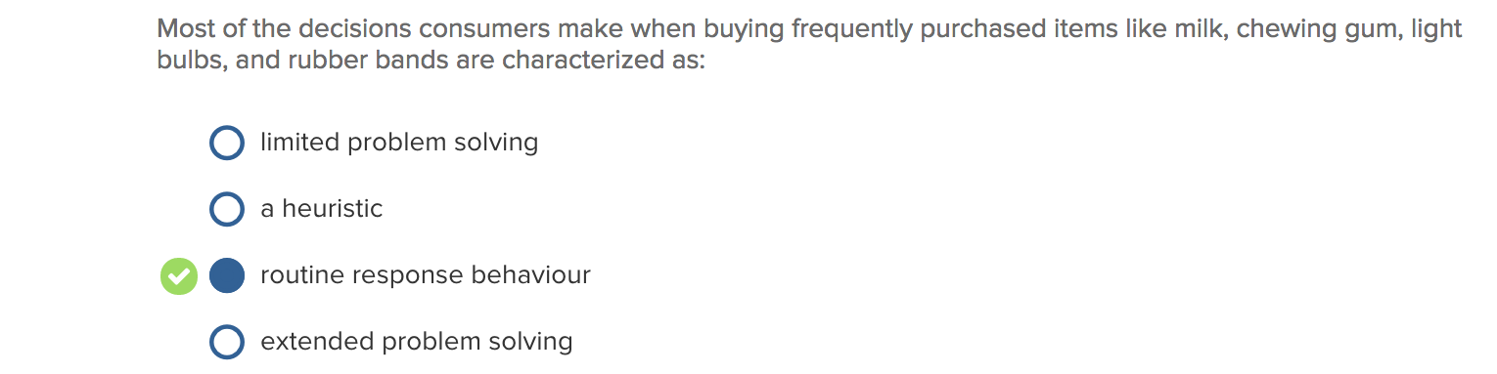

Limited problem solving/Extended problem solving:
Occurs when consumers have limited experience in purchasing a particular product or service and little or no knowledge of the brands available and/or the criteria to use in making a purchase decision. Consumers learn what attributes or criteria should be used in making a purchase decision and how the alternatives perform on these dimensions.

Heuristic
Simplified or basic decision rules that can be used by a consumer to make a purchase choice. Heuristics are easy to use and are highly adaptive to specific environmental situations (such as a retail store)
- Consumers in a family store use price-based heuristics (buy the least expensive brand) or promotion-based heuristics (choose the brand for a price reduction through a coupon, rebate)

Routine Response Behaviour/Routine Problem Solving
The decision process consists of little more than recognizing the need, performing a quick internal search, and making the purchase. The consumer spends little or no effort with external search or alternative evaluation.

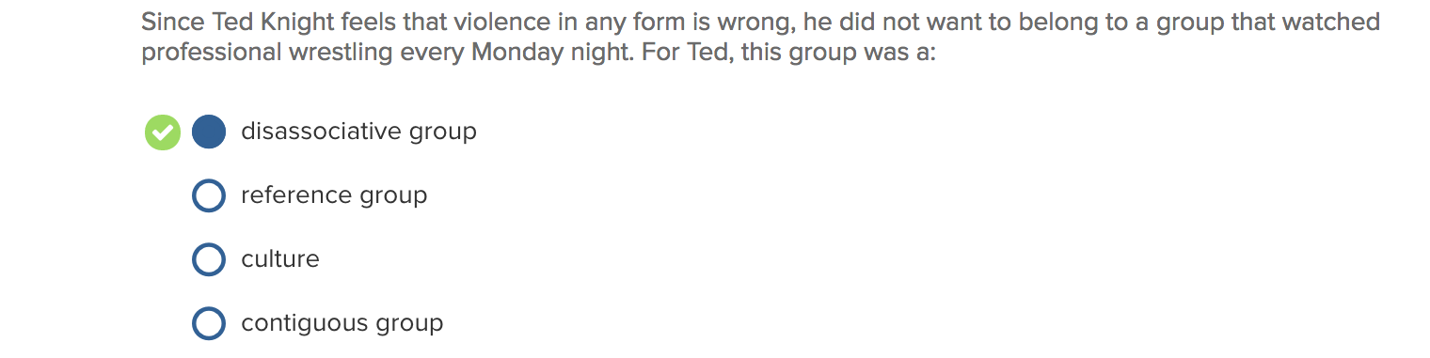

Dissociative group
Type of reference group that we do not wish to belong to.

Contiguous group:

Reference group
A group whose presumed perspectives or values are being used by an individual as the basis for his or her judgments, opinions, and actions.” Consumers use reference groups as a guide to specific behaviours, even when the groups are not present.

Culture
The complexity of learned meanings, values, norms, and customs shared by members of a society.

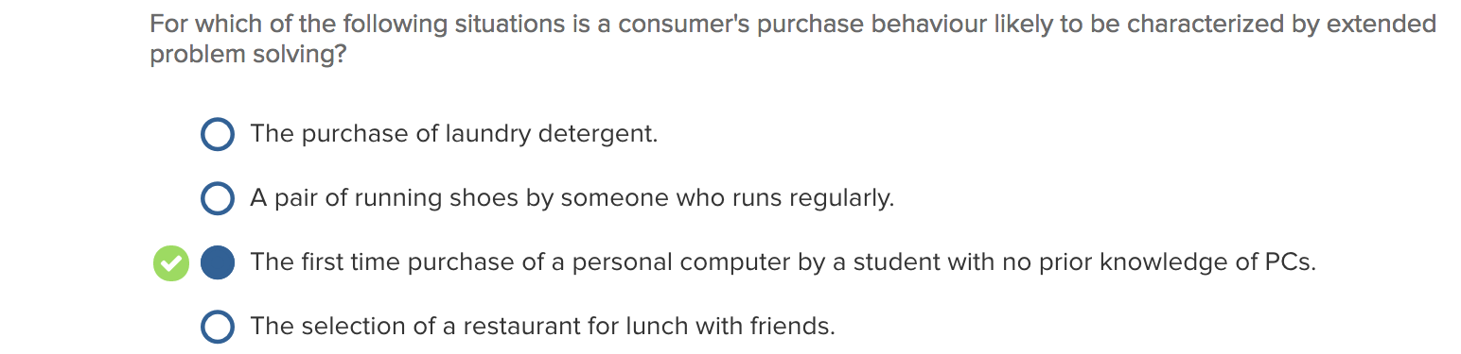

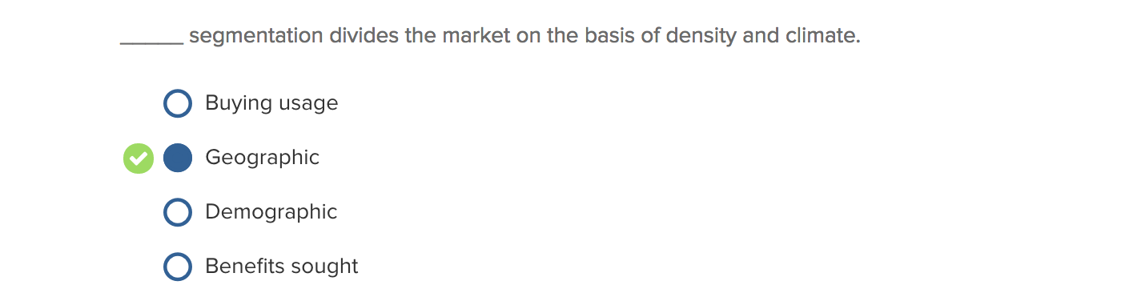

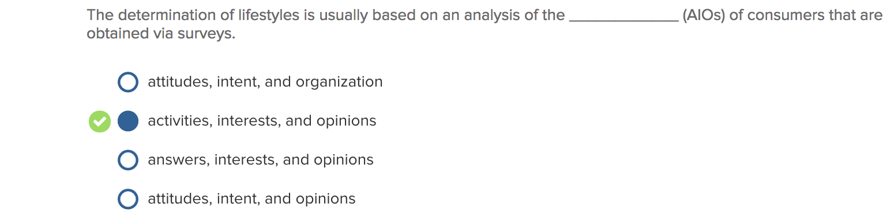

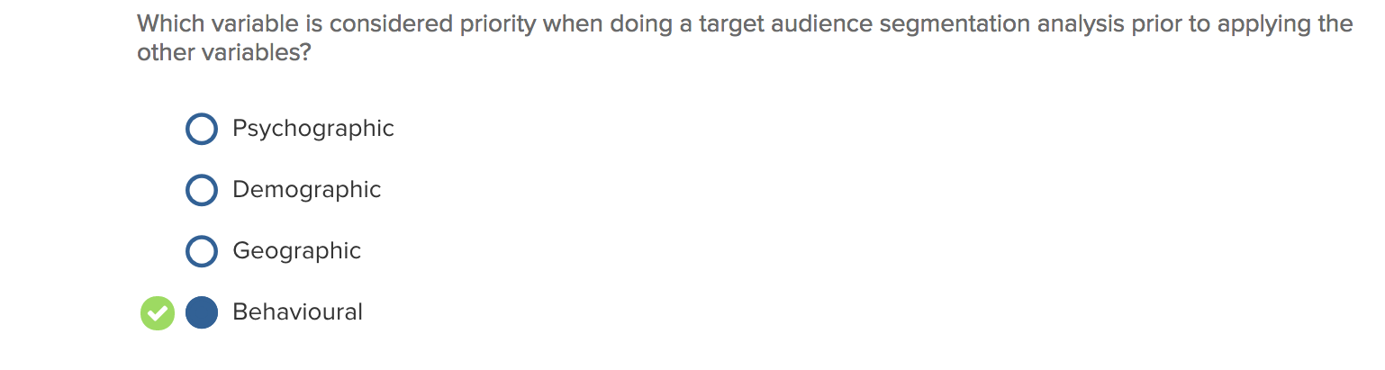



Subcultures
Smaller groups within a culture that possess similar beliefs, values, norms, and patterns of behaviour that differentiates them from the larger cultural mainstream.

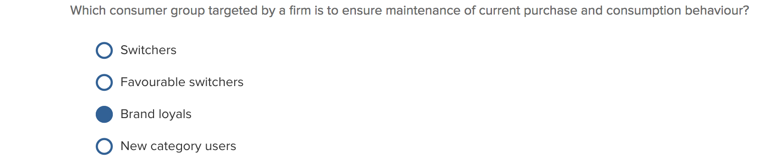

(From manager’s point of view)

Brand loyals
Buys only our brand.

Favourable brand switchers
Buys our brand and other brands too

New category users
Enter category buy buying our brand

Other-Brand Switchers
Buys other brands but not ours

Other-Brand Loyals
Loyal to another brand but not ours

CHAPTER 4

- ***
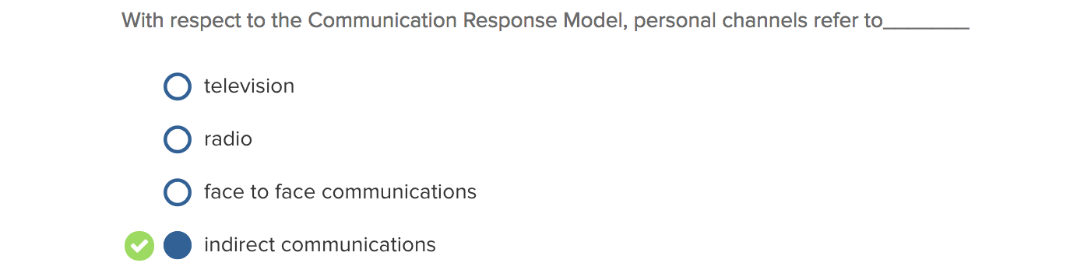
*Answer should be face to face communication

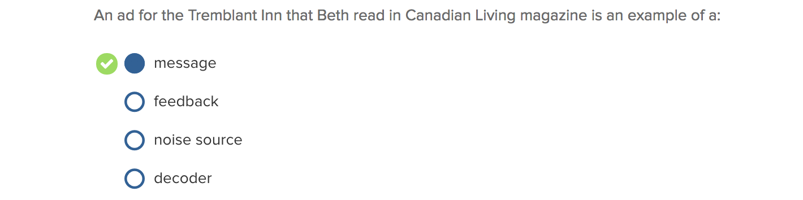

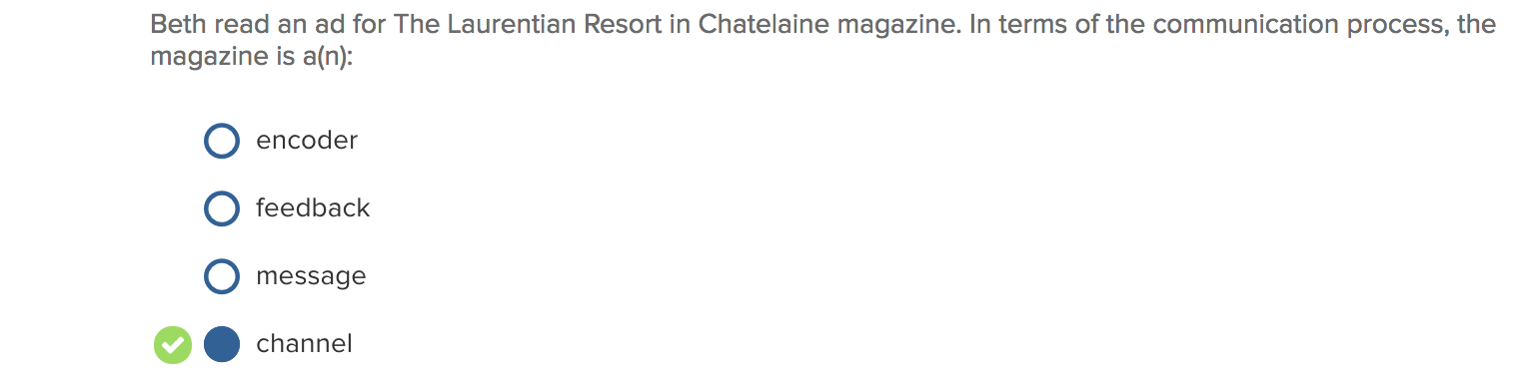

Message: Communication containing information or meaning that a source wants to convey to a receiver.

Source : The person involved in communicating a marketing message, either directly or indirectly. It is the person or organization that has information to share with another person or group of people.

Encoder : Occurs when the source puts thoughts, ideas, or information into a symbolic form in such a way that the message will be understood by the receiver.

Noise : Extraneous factors that create unplanned distortion or interference in the communication process.
Channel:
The method or medium by which communication travels from a source or sender to a receiver.
Personal
- Direct interpersonal (face-to-face) : sales people
- Word of mouth communication: friends, neighbours, associates, co-workers, or family
Non-Personal: Methods of communication that carry a message without interpersonal contact between sender and receiver
- Mass media/mass communication
- Print (newspaper/magazine)
- Broadcast (television/radio)

Receiver: The person(s) with whom the sender shares thoughts or information. Generally, receivers are the consumers in the target market or audience

Decoder: The process by which a message recipient transforms and interprets a message. Heavily influenced by the receiver’s frame of reference or field of experience, which refers to the experiences, perceptions, attitudes, and values he or she brings to the communication situation.

Feedback : Part of the message recipient's response that is communicated back to the sender; can take a variety of forms and provides a sender with a way of monitoring how an intended message is decoded and received.

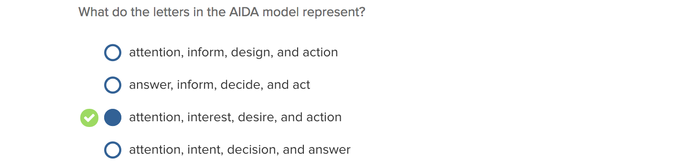

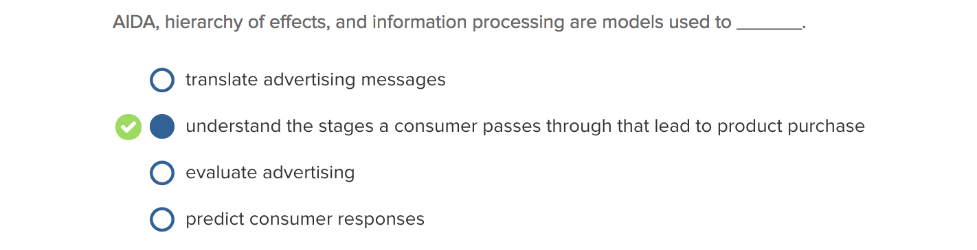
AIDA model: developed to represent the steps a salesperson must take a customer through in the personal selling process.
Hierarchy of effects model: assumes a consumer passes through a series of steps in sequential order from initial awareness of a product or service to actual purchase.¹⁹ A basic premise is that advertising effects occur over a period of time.

Information processing model: assumes the receiver in a persuasive communication situation like advertising is an information processor or problem solver. **Retention, or the receiver’s ability to retain that portion of the comprehended information that he or she accepts as valid is important since most promotional campaigns are designed not to motivate consumers to take immediate action but rather to provide information they will use later when making a purchase decision.

Traditional Response Hierarchy Models
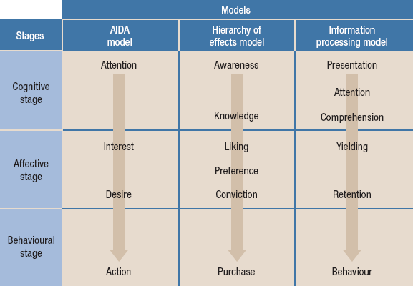

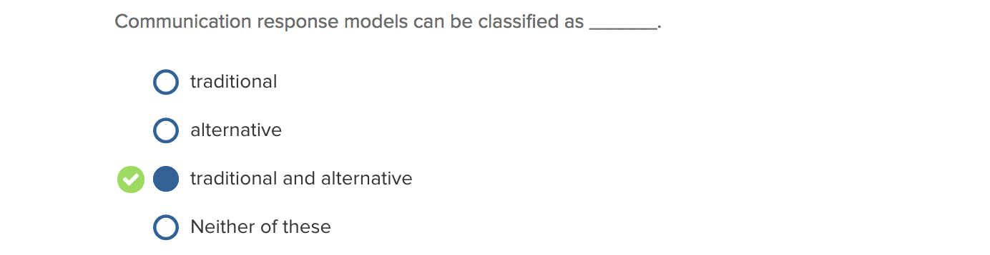

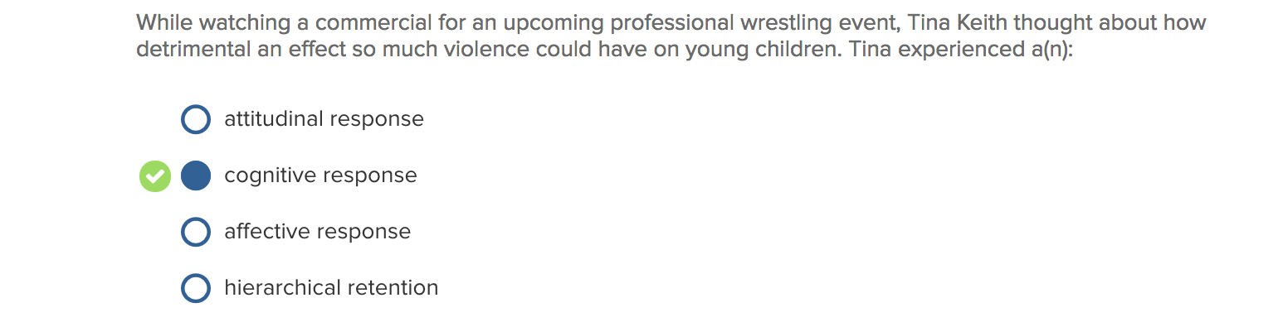

Cognitive stage: what the receiver knows or perceives about the particular product or brand. This stage includes awareness that the brand exists and knowledge, information, or comprehension about its attributes, characteristics, or benefits.

Cognitive responses: Thoughts that occur to a message recipient while reading, viewing, and or hearing a communication.
- Product/message thoughts: counterargument (vs) support argument
- Source oriented thoughts: source derogations (vs) source bolsters
- Ad execution thoughts: can be favourable or unfavourable

Affective stage: refers to the receiver’s feelings or affect level (like or dislike) for the particular brand. This stage also includes stronger levels of affect such as desire, preference, or conviction.

Affective reaction: are an effect of cognitive responses, something not included in the previous models

Conative or behavioural stage: refers to the consumer’s action or behaviour toward the brand such as purchase.

***READ PAGE 93-95

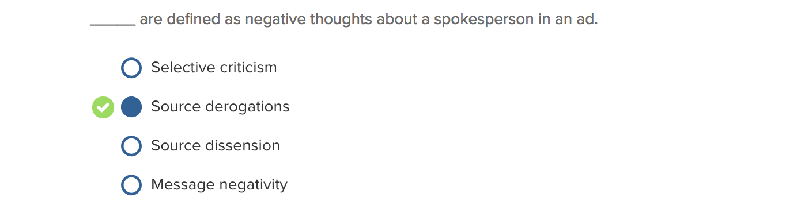

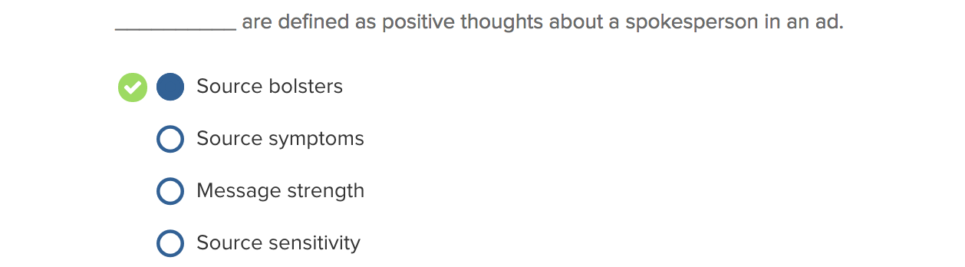

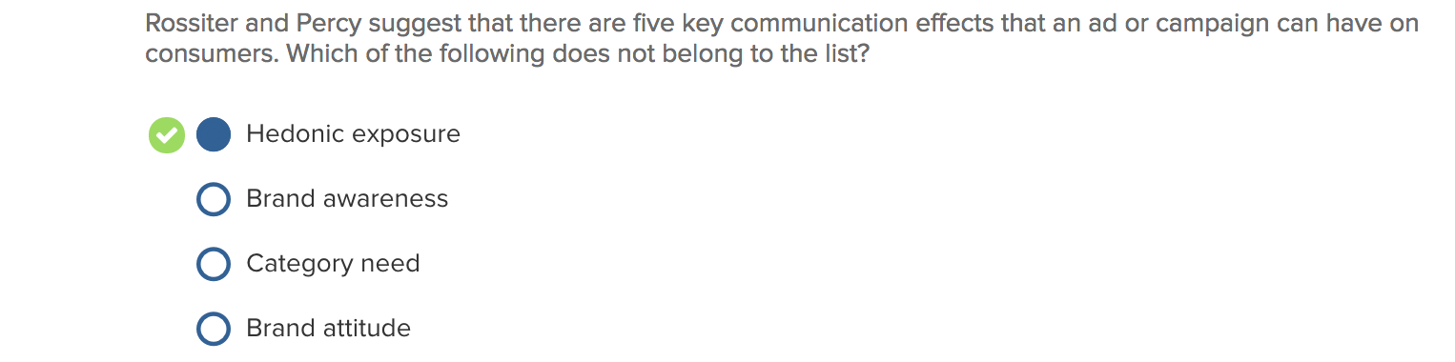

Communication effects: Messages that are established more permanently in the target audience's memory; may include category need, brand awareness, brand attitude, and brand purchase intention.
- Brand awareness: involves the target audience’s ability to recognize and/or recall the brand within the product category in sufficient detail to make a purchase.
- Category need: involves the target audience’s perception of requiring a specific product category to satisfy a particular need.
- Brand attitude: involves the target audience’s overall evaluation of the brand in relation to its ability to satisfy the reason why they want it (involves cognitive and affective components).
- Brand purchase intention: involves the target audience’s self-instruction to respond (shopping behaviour, purchase) to the brand.

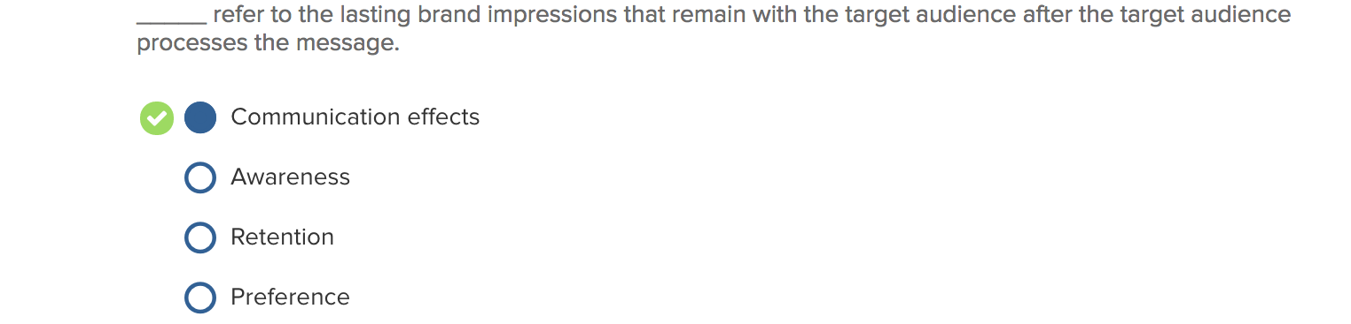

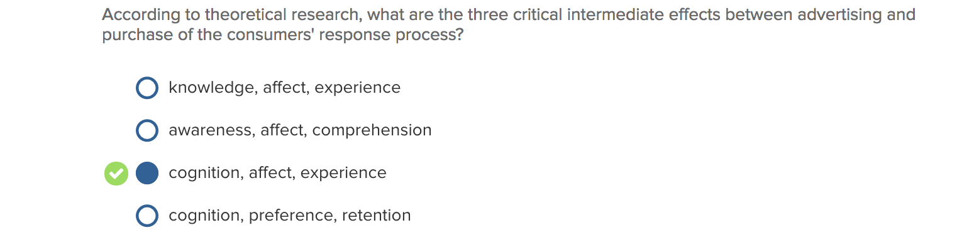

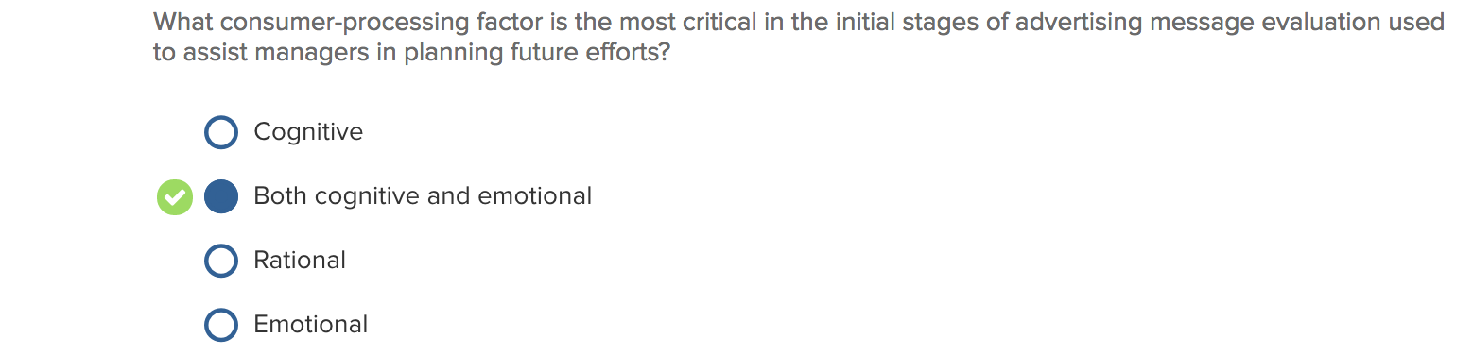

CHAPTER 5

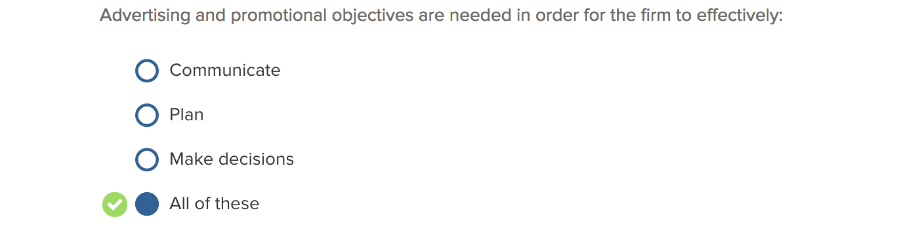

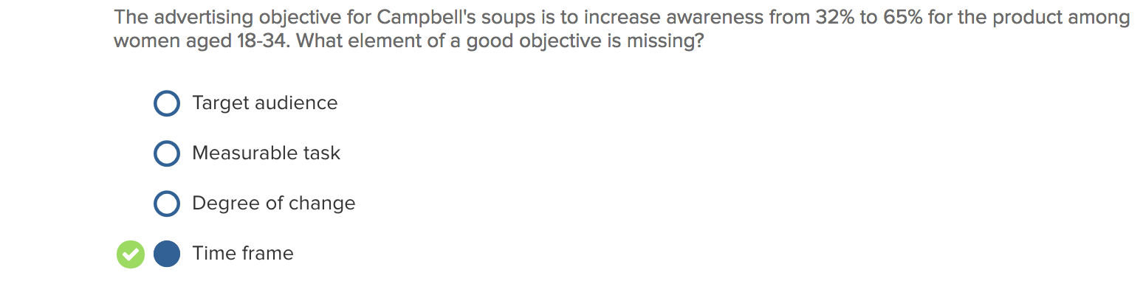

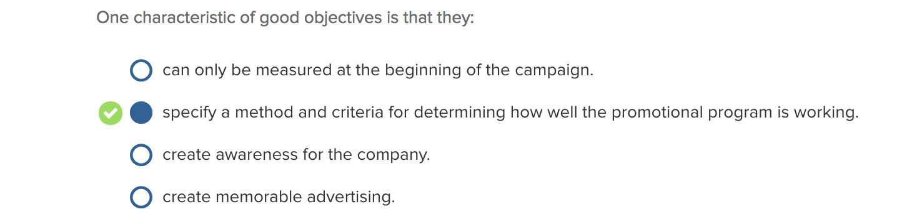

Good objectives:

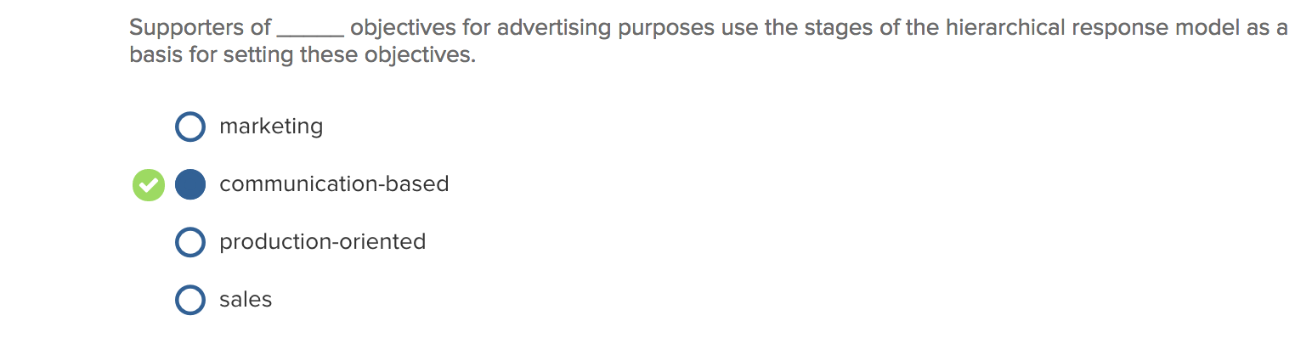

Marketing objectives: Statements of what is to be accomplished by the overall marketing program within a given time period; usually are defined in terms of specific, measurable outcomes such as sales volume, market share, profit, or return on investment.

Communication-based objectives: statements of what the IMC tools will accomplish, and are usually based on one or more of the consumer response models discussed in Chapter 4. We can speak of communication objectives on three levels depending upon the decision at hand.

Behavioural objectives: When a firm sets a sales growth objective (e.g., increase sales by 10 percent) for a brand, the increased sales can arise from a greater number of purchases from current customers (e.g., brand loyals).

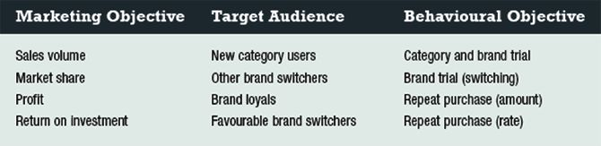

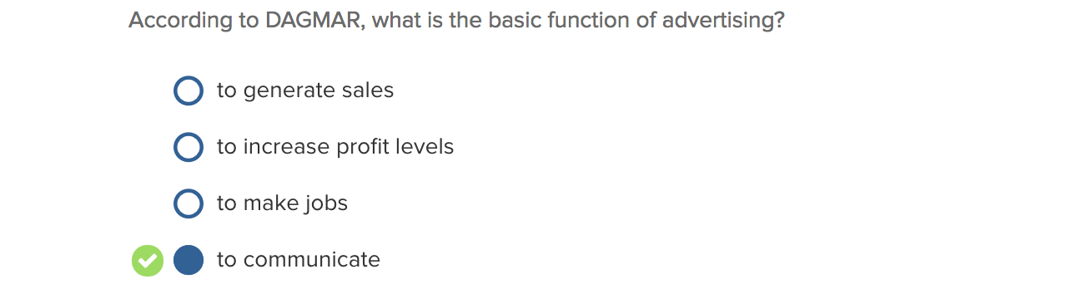

DAGMAR: Defining Advertising Goals for Measured Advertising Results

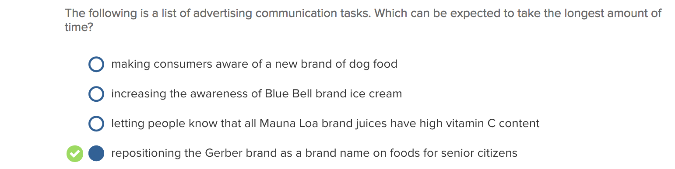

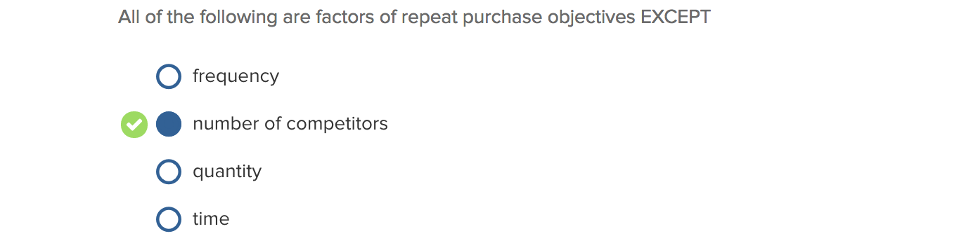

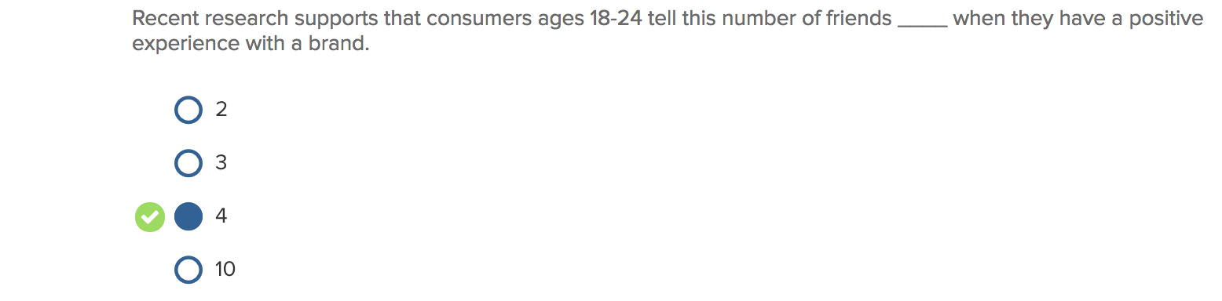

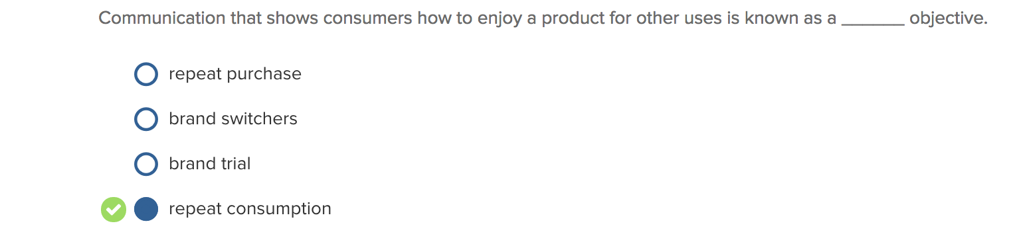
Repeat purchase: A consumer's continued purchase of a brand within a specified time period. This form of purchase behaviour is most critical. (Purchase frequency, purchase amount, purchase timing).

Brand trial: A consumer's first purchase of a brand.

Repeat consumption: The continued consumption of the brand once purchased.

Brand re-trial purchase: Defined as a consumer's first purchase of a brand after a time delay.
EX: Becel desires brand re-trial from lapsed users who gravitated to butter for a while.

Category trial: a consumer's first purchase in a product category that the consumer has not purchased in previously. EX: smartphone market.

Brand switching: a consumer's purchase toward a brand from another competing brand. A brand-switching purchase occurs whereby the consumer makes a re-trial purchase of a brand and leaves the new favourite and returns to an old favourite.

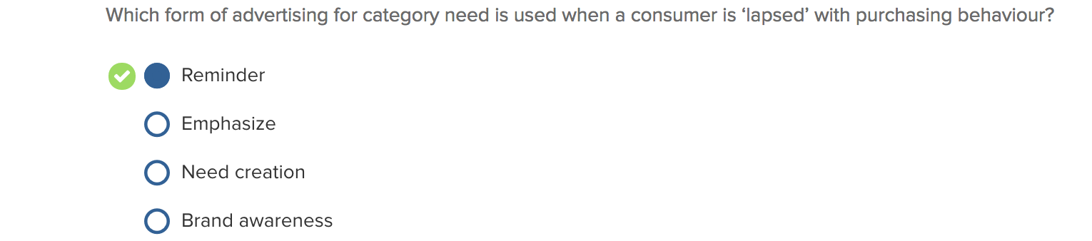

Category need: pertains to whether the target audience believes that purchasing within a particular product category will fulfill the consumer's need. EX: smartphones, transportation.
- Category need is reminded for lapsed users
- Category need is also emphasized

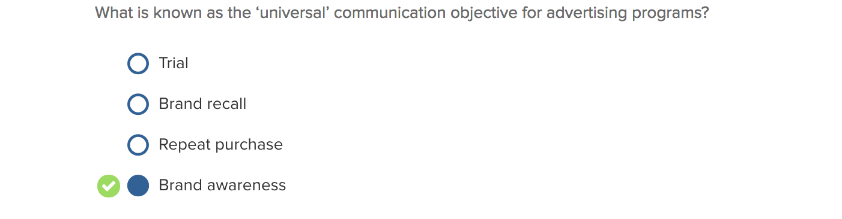
Brand awareness: every single point of communication should contribute to a target audience's understanding and knowledge of the brand name.

Brand recognition: If the target audience makes a choice at the point of purchase, then simple recognition of past brand messages can be sufficient for brand consideration or purchase. Recognition is important when consumers are driving by the store and see familiar signage that prompts need recognition for shopping in the product categories offered.

Brand recall: Brand recall is often referred to as unaided brand awareness when measuring. Recall is important as consumers would often decide at home where to shop when in need of personal care, beauty, or other products that the store offers.

Brand attitude: A universal communication objective meaning that every aspect of a firm's IMC program should contribute to the overall evaluation of the brand from the perspective of the target audience.

Brand purchase decision:
Assume Brand Purchase Intention: In situations of low involvement where the strength of an intention to purchase is consistent with brand attitude.

Generate Brand Purchase Intention: In contrast, managers need the target audience to have a plan to purchase a brand in situations of high involvement.
CHAPTER 6

Strategic marketing plan: usually evolves from an organization's overall corporate strategy and serves as a guide for specific marketing programs and policies

Positioning: The art and science of fitting the product or service to one or more segments of the broad market in such a way as to set it meaningfully apart from competition.

Market position: The consumer response to the marketing program once developed and implemented; organizations may find results at, above, or below expectations.

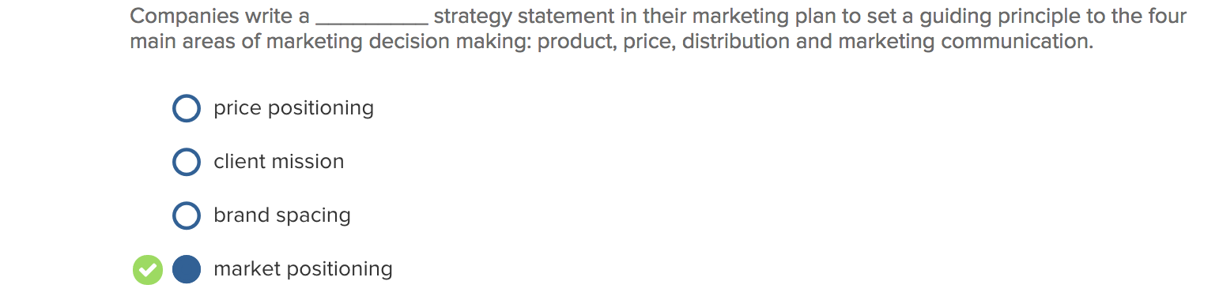

Price positioning:

Client mission: NA

Brand spacing: NA

Market positioning: Concerns the final decision of the market(s) in which firms wish to compete, combined with the specific elements of the marketing mix that are designed to fulfill the respective needs of the market(s). This statement provides direction for each of the four areas of decision within the marketing program development phase: product, price, distribution, and marketing communication.

Brand positioning strategy: The intended image of the product or brand relative to competing brands for a given competitive space as defined by certain product market or category characteristics.
Brand position: The target audience's overall assessment or image of the brand resulting from brand related communication that tells the prospective buyer what the brand is, who it is for, and what it offers.

* Distinct vocabulary between brand positioning strategy (i.e., plan) and brand position (i.e., result)

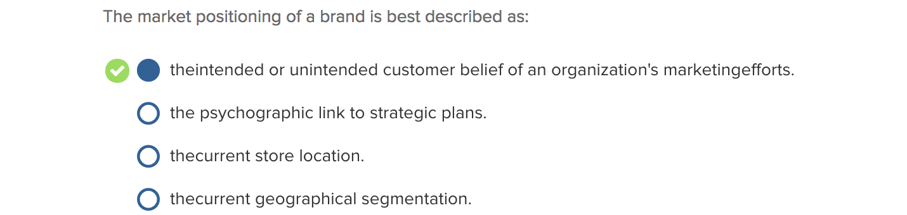

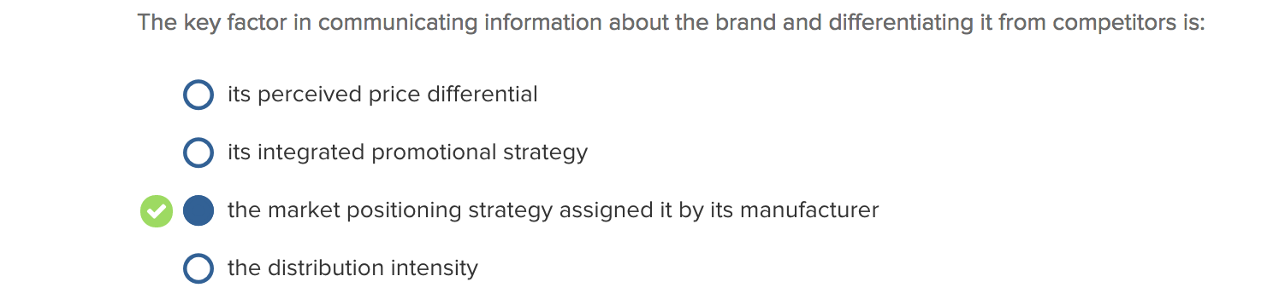

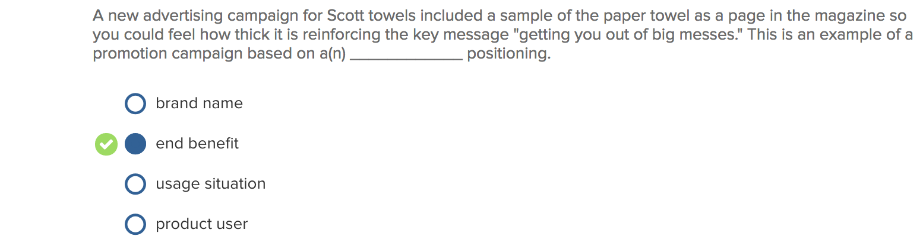

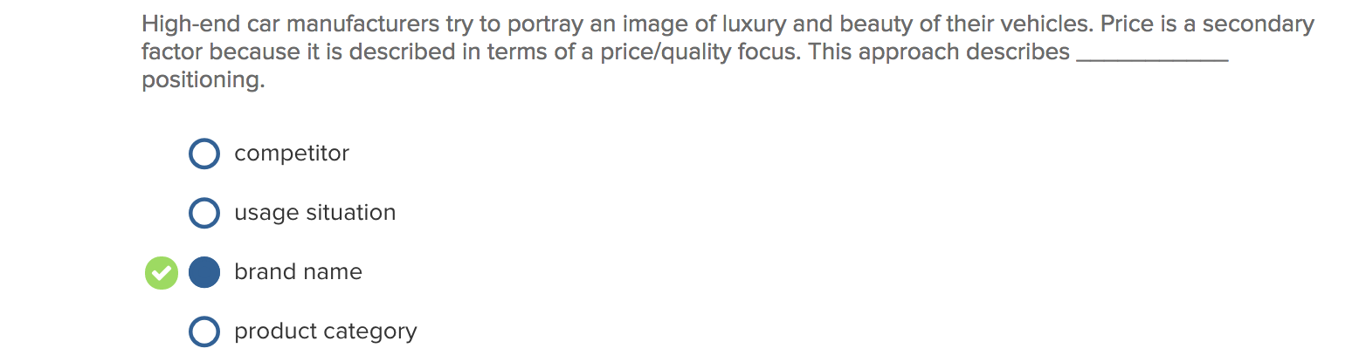
*READ PAGE 141-144

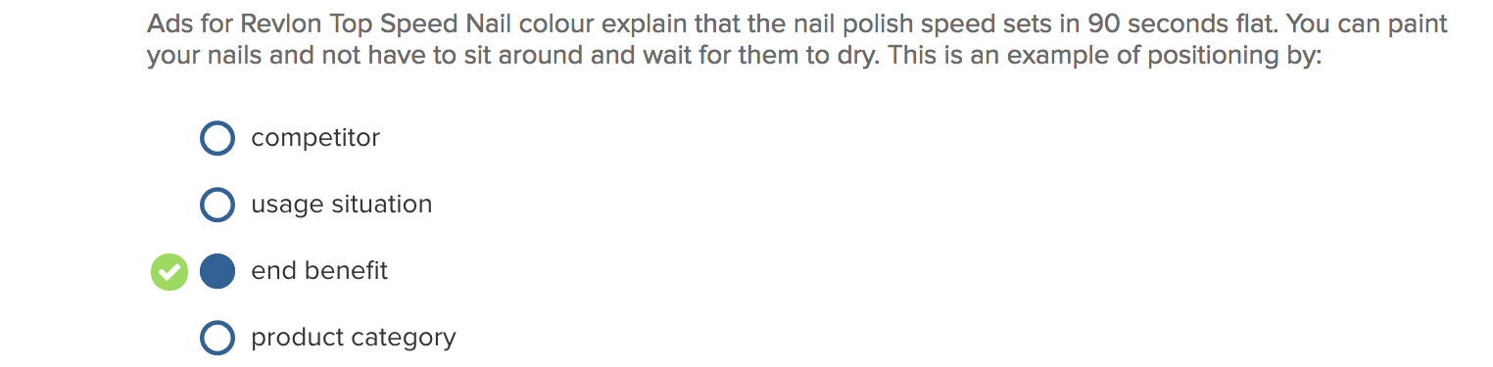

Market definition (p.145)
Brand name positioning: Marketers often use price/quality characteristics to position their brands. 1) Ads that reflect the image of a high-quality brand where cost, while not irrelevant, is considered secondary to the quality benefits derived from using the brand. 2) Focus on the quality or value offered by the brand at a very competitive price.

End benefit positioning: setting the brand apart from competitors on the basis of its primary end benefit offered; a brand may be positioned on multiple benefits if necessary.

Usage situation positioning: associate the brand/image with a specific use.

Product category positioning: Rather than positioning against another brand, an alternative strategy is to position the brand against another product category.

Brand benefit positioning: A strategy based on emphasizing a product's most important benefits compared to others.

Product user positioning: A strategy based on emphasizing a product's association with a particular user or group of users.

Competitor positioning: NA

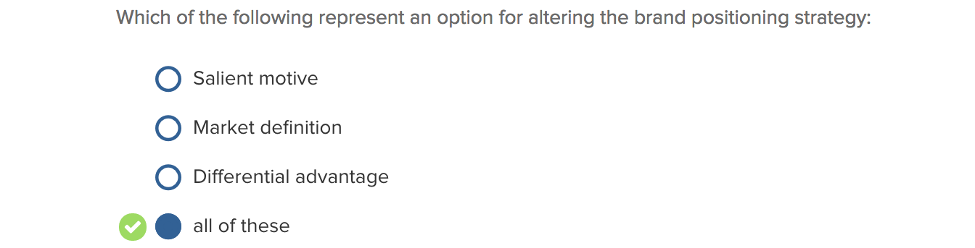

Salient attributes: Attributes considered important to consumers in the purchase decision process.
Brand attitude persuasion:
- Influence attribute belief
- Influence attribute importance
- Add new attribute belief
- Influence attribute belief of competitor’s brand

Purchase motives:
Informational motives: Occur when the consumer perceives their current consumption situation as a deficit in which the purchase of the product would minimize the shortfall and bring the consumer a neutral or normal state.
Transformational motives: Occur when the consumer perceives their consumption situation as requiring improvement from a neutral state.

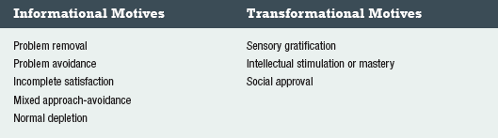

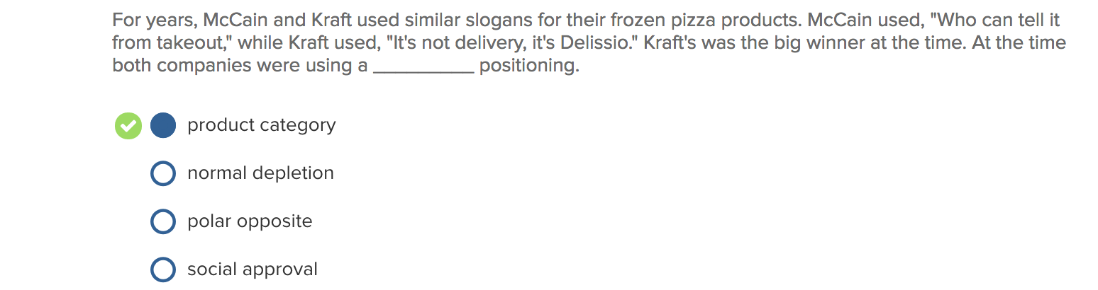

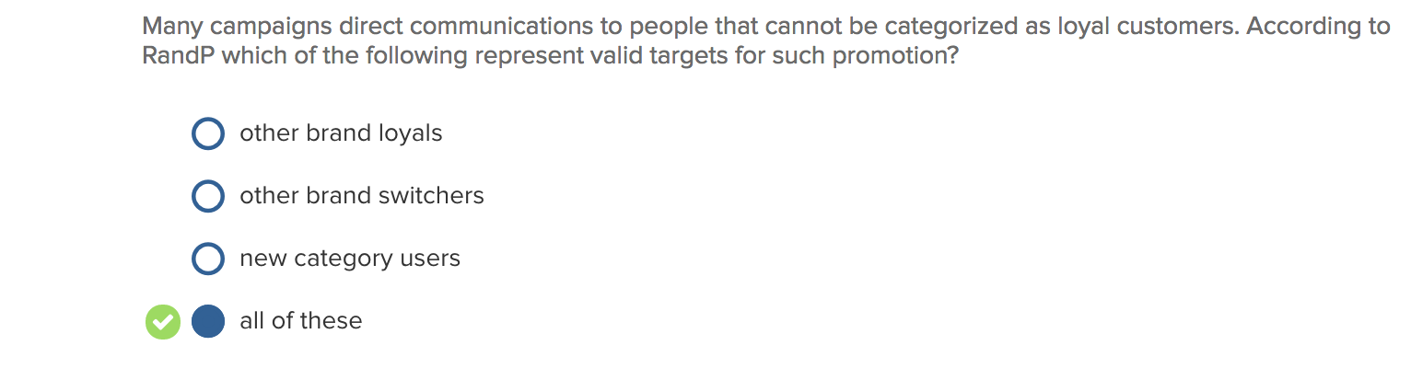

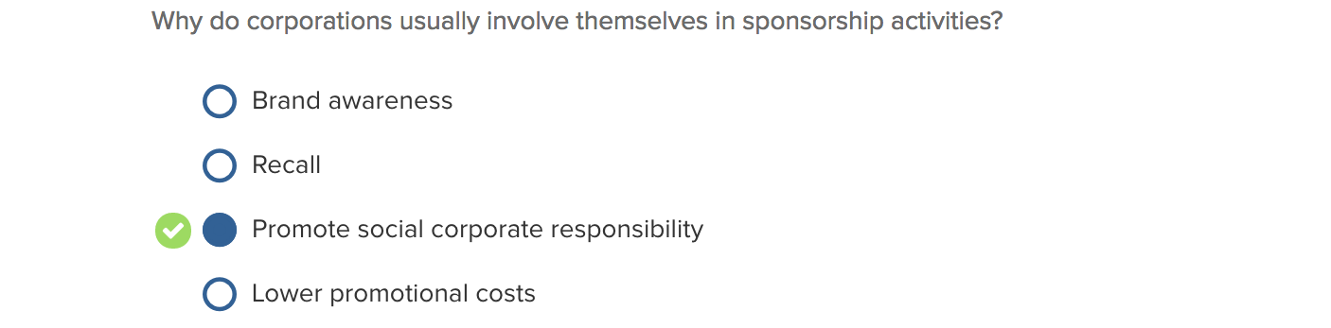

Market definition:
End benefit
Brand name
Usage situation
Product category

Differential advantage:
Differential
Central
Brand benefiting positioning
User positioning

New target audience:
Brand loyal customers
Favourable brand switchers customers
New category users
Other brand loyals
Other brand switchers

Purchase motivation:
Problem-solution
Sensory gratification

CHAPTER 7

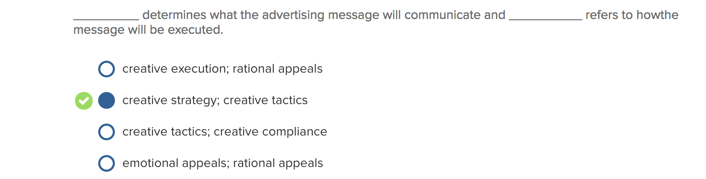
Creative strategy: A determination of what an advertising message will say or communicate to a target audience.

Creative tactics: A determination of how an advertising message will be implemented so as to execute the creative strategy.

Appropriate and effective creativity should offer divergence as well since the message must break through media clutter and attract the target audience's attention. Advertising creativity is divergent in terms of originality, flexibility, elaboration, synthesis, and artistic values.

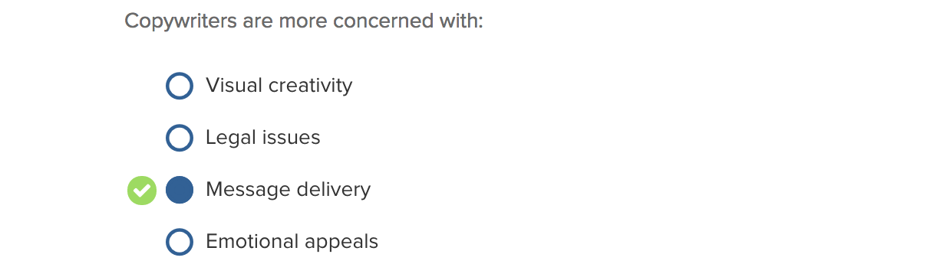

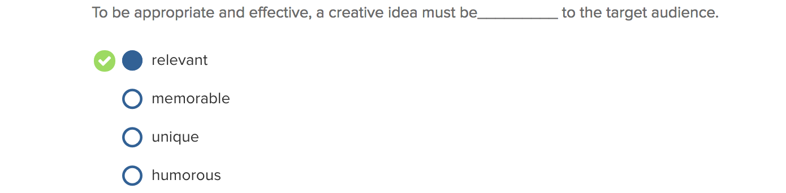

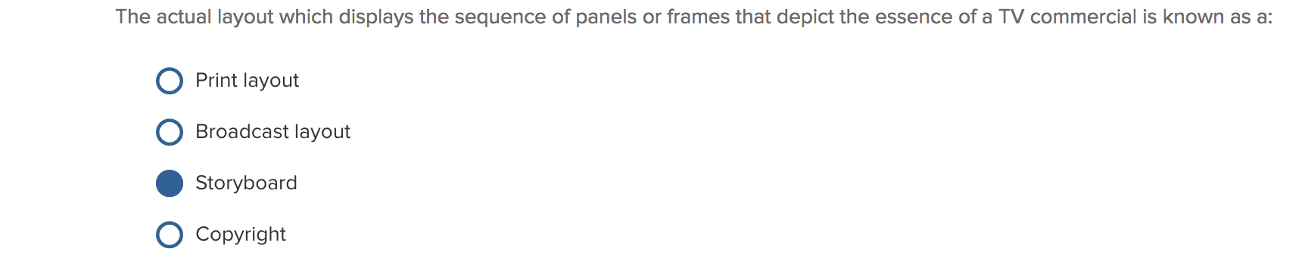

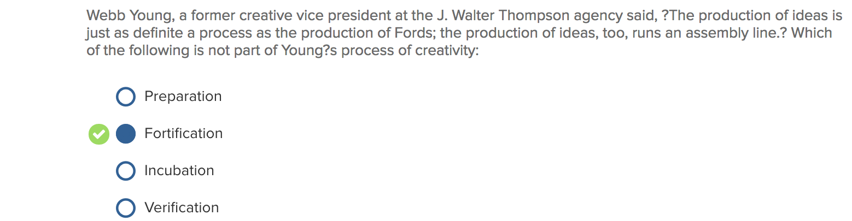
Young's process of creativity follows a four-stage approach:
- Preparation. Read background information regarding the problem.
- Incubation. Get away and let ideas develop.
- Illumination. See the light or solution.
- Verification. Refine the idea and see if it is an appropriate solution.
An investigation along these lines reveals four individual factors: orientation toward the creative work, approach to the communication problems, mindscribing (i.e., free-flow thinking), and heuristics (i.e., quick creative decision rules).

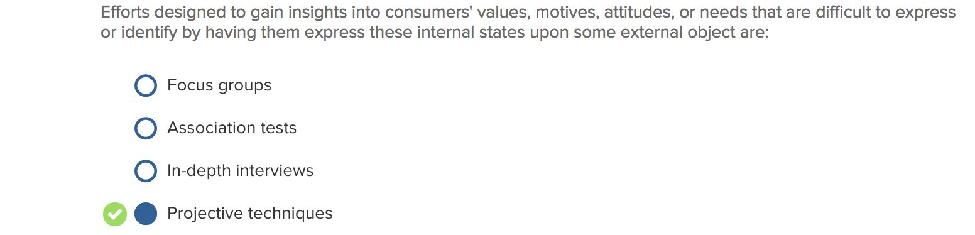
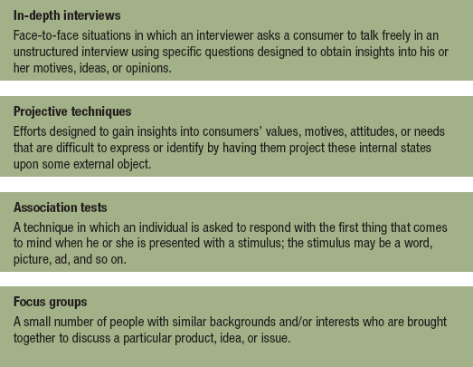

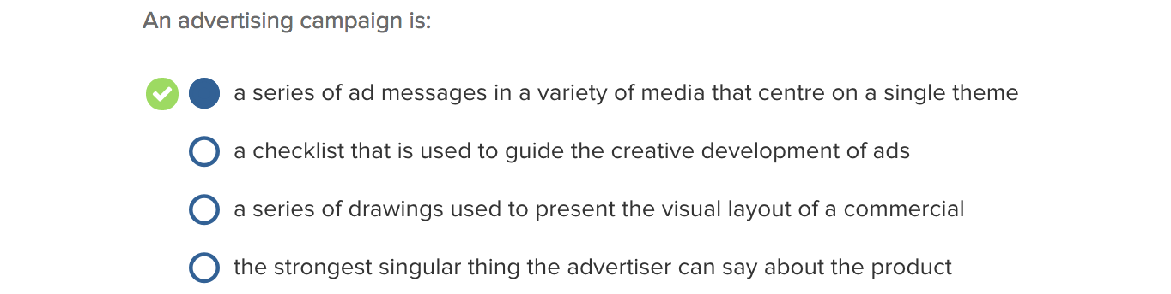

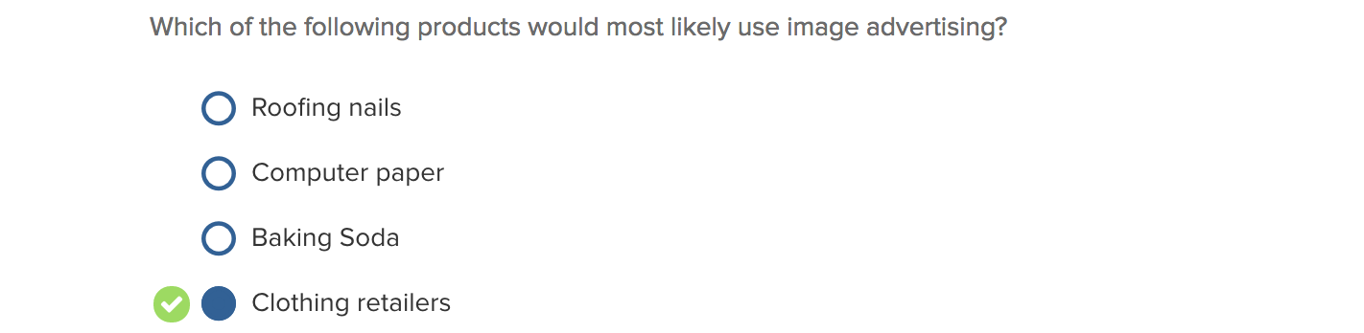

Image advertising: Advertising that creates an identity for a product or service by emphasizing psychological meaning or symbolic association with certain values, lifestyles, and the like. Image advertising is designed to give a brand a unique association or personality, and create a certain feeling or mood that is activated when a consumer uses a particular product or service.

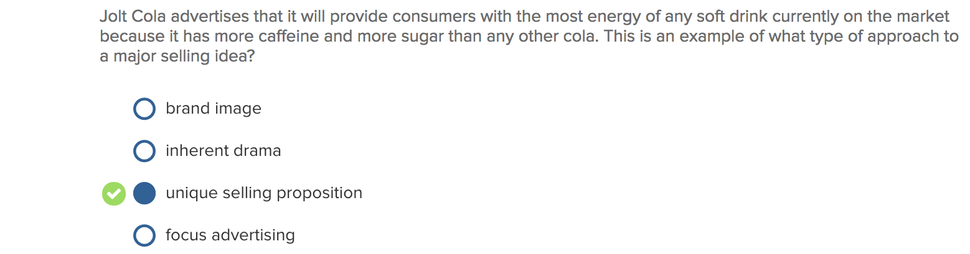
Unique selling proposition: An advertising strategy that focuses on a product or service attribute that is distinctive to a particular brand and offers an important benefit to the customer. The proposition must be one that the competition either cannot or does not offer. It must be unique either in the brand or in the claim.

Brand image: Advertising that creates an identity for a product or service by emphasizing psychological meaning or symbolic association with certain values, lifestyles, and the like.

Inherent drama: (Leo Burnett) Inherent drama or characteristic of the product that makes consumers buy it.

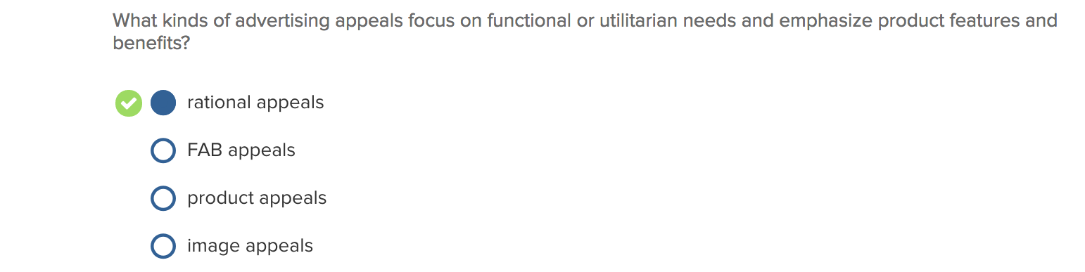

Rational appeals: focus on the consumer's practical, functional, or utilitarian need for the product or service and emphasize features of a product or service and/or the benefits or reasons for owning or using a particular brand. The content of these messages emphasizes facts, learning, and the logic of persuasion.
- Feature appeals: focus on the dominant traits of the product or service. These ads tend to be highly informative and present the customer with a number of important product attributes or features that will lead to favourable attitudes

- Comparitive appeals: directly or indirectly identify competitors and compare the brands (or products) on one or more specific attributes or benefits.

- Price appeal: price offer as the dominant point of the message

- News appeal: When an announcement about the product, service, or company dominates the ad

- Popularity appeal: Stress the popularity of a product or service by pointing out the number of consumers who use the brand, the number who have switched to it, the number of experts who recommend it, or its leadership position in the market.

- Reminder appeal: objective of the ad is to build or maintain awareness

Emotional Appeals: Relate to the customer's social and/or psychological needs for purchasing a product or service. Relates to emotion.

Fear Appeals: Advertising messages that invoke an emotional response to a threat that expresses or at least implies danger and arouse individuals to take steps to remove the threat.

Humour Appeals: Advertising messages that enhance effectiveness by putting consumers in a positive mood, increasing their liking of the ad itself and their feeling toward the product or service. Often the best known and best remembered of all advertising messages.

FAB appeals, Product appeals, Image appeals: NA

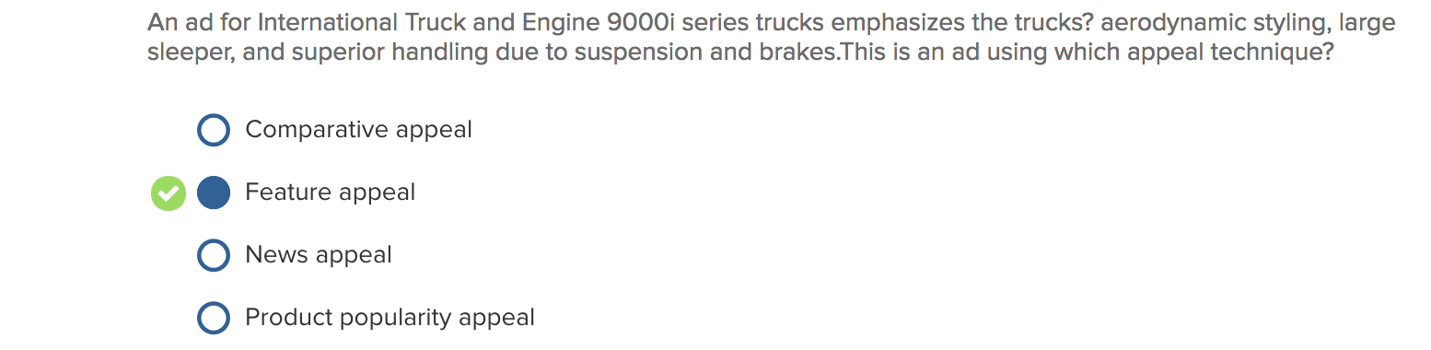

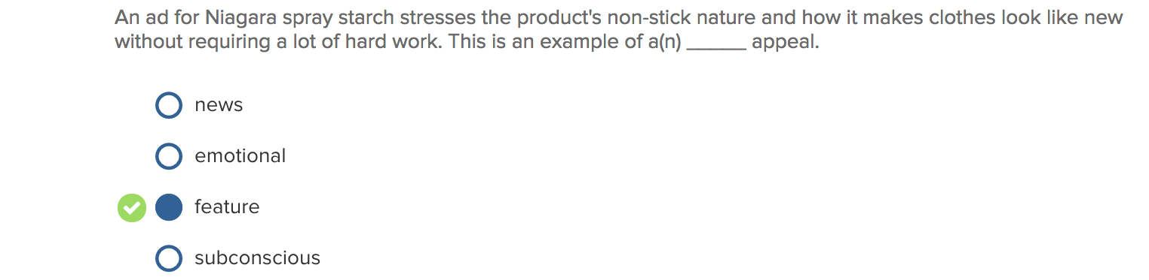

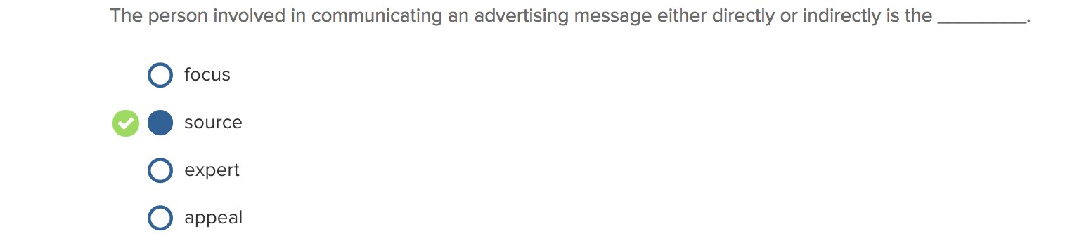
Appeal, Focus, Expert: NA

Source: The person involved in communicating a marketing message, either directly or indirectly.
Direct source is a spokesperson who delivers a message and/or demonstrates a product or service.
Indirect source (e.g., a model) doesn’t actually deliver a message but draws attention to and/or enhances the appearance of the ad.

Source Credibility:
- Lleads to customer internalization
- Expertise
- Trustworthiness
*A low-credibility source may be as effective as a high-credibility source because of the sleeper effect, whereby the persuasiveness of a message increases with the passage of time.

Source attractiveness: A source characteristic that encompasses similarity (slice-of-life), familiarity, and likability (dove campaign). Leads to persuasion by:
- Identification: The process whereby the receiver is motivated to seek a relationship with the source and thus adopts similar beliefs, attitudes, preferences, or behaviour.
- Celebrity endorses:

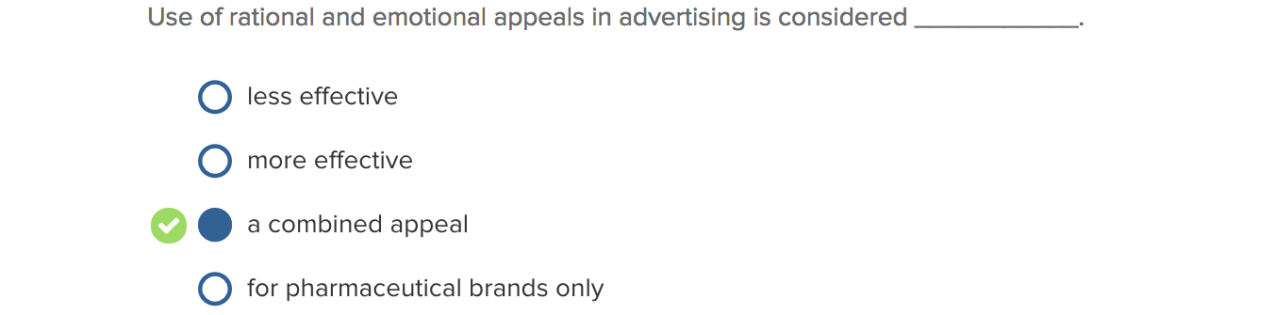

Creative brief: Should (1) be objective, (2) have proper vocabulary, spelling, and grammar, (3) demonstrate logical thinking, (4) be both creative and brief, (5) have specific recommendations, and (6) be viewed as a firm agreement

Four critical factors for promotional planners (when dealing with celebrity endorsements):
- Overshadowing the product
How will the celebrity affect the target audience's processing of the advertising message? Consumers may focus their attention on the celebrity and fail to notice the brand.

- Overexposure
Celebrity endorses too many products.

- Target audience's receptivity

- Risk
Entertainers and athletes have been involved in activities that could embarrass the companies whose products they endorsed

