Module 1 Introduction

WHAT IS MARKETING?

Marketing is the organizational function and a set of processes that subject to constraints, attempts to establish mutually satisfying product exchange relationships between any two interested parties

PRODUCT EXCHANGE RELATIONSHIPS
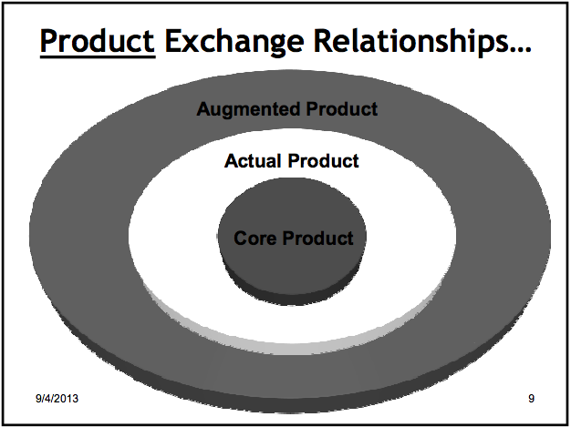

Augmented Product

Actual Product

Core Product

Core product

The product is giving you more than just a physical tangible good or service. It is an experience. Brings status and knowledge

Benefit of the product that makes it value to you

EXAMPLE: Dog ice cream

The product is “gilt relief” for the consumer… Shows other consumers that they care more for their dog

With products there is often a core benefit or service

Actual Product

-Tangible, physical, product

Involves: Packaging, features, brand name, and quality

Branding alone can create different types of products

More or less it is legally recognized that products are as more than just physical goods

The brand image, experience, marketing strategies differentiates different products

EXAMPLE: CONTACT LENSES

-Price discrepancies in their products (daily VS monthly etc)….. Companies taken to court. However the lenses companies says they are different products because they are marketed differently. They are VISION SYSTEMS not just lenses

Augmented Product

The ‘after product’ experience

Added value

Involves installation, warranty, delivery and credit

BENEFIT CORE

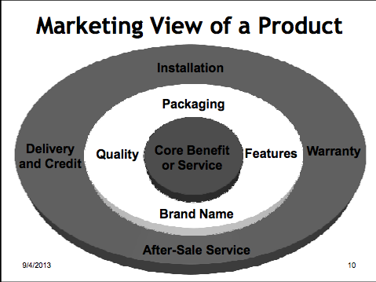

CONSUMING ACTUAL

AFTER PRODUCT EXPERINCE AUGMENTED

MARKETING AND NEEDS

Does Marketing satisfy needs

There is a difference between needs and wants
- Needs: the difference between a consumer’s actual and some ideal or desired state
- Wants: Desire to satisfy need in ways that are influenced by culture and society
- Benefits: The outcome sought by a consumer that motivates buying behavior

Does Marketing Create Needs?
- Consumers cannot be forced into buying something
- Marketing thus makes you more aware of your needs
  - Takes the needs that you already have and brings them forward

Are All Customers Alike?
- In marketing you look for clusters of people with similar likes/needs
  - Market segmentations
- Within these clusters you find similar behaviors
- But this does not mean all people are alike!

EVOLUTION IN MARKETING THOUGHT

To understand the Marketing Concept we have to look at the Evolution of Business

Evolution of Business

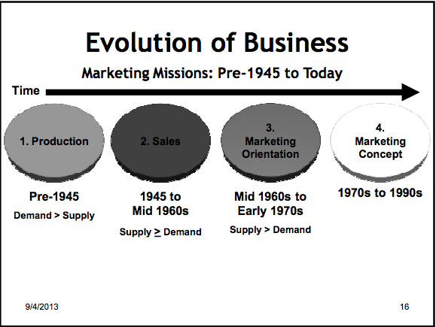

1) Production (PRODUCTION CONCEPT)
- Pre 1945
- Demand was greater than supply
- No matter what product is produces it would sell

2) Sales (PRODUCT CONCEPT)
- 1945-id 1960’s
- Supply was greater than demand
- Companies were pushing the products onto consumers
- Make products with better features, performance, etc sell themselves.

3) Marketing Orientations (SELLING CONCEPT)
- Mid 11960’s-early 1970’s
- Supply still greater than demand
- However, instead of pushing the product they made ‘better’ products. More variations (blue car instead of all black)
- Aggressive promotions, and advertising

4) Marketing Concept (MARKETING CONCEPT
- 1970’s-1990’s
- Finding out what customer wants and focusing on that… but do so in a coordinated way
  - Each department should all be working together towards the super ordinate goal of customer satisfaction
  - But do so with a profit motive

The Marketing Concept
- Identify and satisfy customer needs while making a profit
- Satisfaction of consumer wants and needs… the super-ordinate goal
- Coordinated with other business functions
- Profit maximization

CURRENT STATE OF MARKETING

Marketing Realities of Today (6)
- 1) Information clutter Overload of information today. We don’t have and useful processes information. We don’t have knowledge
  - Knowledge is critical
  - Successful companies (ex apple, google) do well because they can generate USEABLE an FEASIBLE knowledge
    - Data mining
  - Some companies are in the business of selling knowledge
- 2) Declining Brand Loyalty
  - People have access to large amounts of information, changing brand loyalty
    - The ‘ignorance premium’ has disappeared they less they know they more loyal they are
- 3) Consumer cynicism- distrust
- 4) Need for knowledge (usable information)
- 5) Internet Based
  - allows for customization.. you can customize almost anything online
- 6) Globalization

Business Today
- Many business look at different types of marketing
  - Super-fast marketing, Super-Value Marketing, Guarantee Marketing, Network Marketing, Synergistic Marketing, Marketing Engineering, Upside down/crowd Marketing

All of these have 1 thing in common: they are building long term sustainable relationships with customers Relational Marketing

RELATIONSHIP MARKETING

Satisfying Needs to Relationship Marketing

Consumer satisfaction leads to consumer relationships

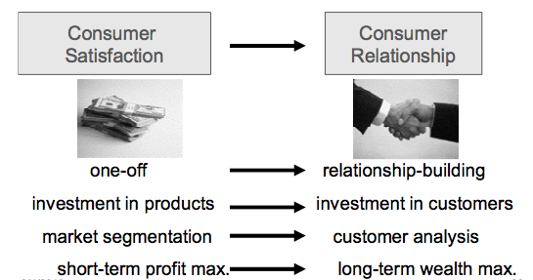
- Retaining customers is more profitable than constantly gaining new customers
  - Keep they happy & build relationships with them

Attracting and Retaining Customers
- Forming strong customer bonds
  - Listen to the voice of the customer
  - Create superior offering
  - Reward outstanding employees
- Adding financial benefits
  - EX. Starbucks gold card
  - Frequency programs
- Adding structural ties
  - Create long-term contracts
  - Lower price for high volume
  - Turn product into long-term service

Relationship Marketing

All about forming strong customer bonds
- Online ‘ads’ aren’t really just ads
  - They are forms of communicating…. Dialogue a conversation. Great way to build relationships
- Drivers of Relationship Marketing?
  - Technology
  - Need for real time marketing research
  - Need for integrating design and manufacturing
  - Need for knowledge
  - Need for dialogue and integrated communications
    - Dialogue is far superior form of communication, because it is ‘two-way’
    - Dialogue is cheaper than spending money on a full proper campaign

EXAMPLE: Ritz Carlton and Prof. Kindra
- In Mexico he had a beer called ‘dos-aques?’… became favorite beer
- Went to New York and stayed at Ritz Carlton
  - Asked for a bottle of ‘dos-aques’ with 1 cube of ice
  - Treated with respect, poured and served
    - He felt good
  - He is also allergic to feather pillows
- Few months later went to China.
- Extremely long flight, he is tired, gets to the Ritz Carlton very late and just wants to sleep. Gets to room and the bed is covered with non-feather pillows
  - Just as going to sleep a knock on the door and they served him complimentary ‘Dos-aques’ with 1 cube of ice
- Built a relationship with the hotel. Made him feel good about the hotel itself. He comes to love it (prefer it)
  - They even send a hand written birthday card
  - Another card saying “dear gurprit, long time no see”
- This is an example of the early steps of relationship marketing

Module 2 Strategic Marketing

There are two types of strategic marketing: Corporate and Product

CORPORATE MARKETING STRATGEY

Is environmental analysis…Looking at overall financial forecast…Main risk scenarios and contingency planning (anticipating future events) 6 COMPONENTS

1) Industry Outlook
  - Looking at where in industry as a whole is going.
  - Not really a decision, but rather an informed and inspired conclusion
  - Key factors:
  - Recent trends, developments, forces, experience, gut feelings, inspiration and role, and presence of champions
    - Porters 5 forces ( type of industry outlook)
    - Yes you are competing with direct competitors but you are also in a fight for profits with customers, suppliers with bargaining power, new competitors that will gain a part of the action, and possible substitutes.

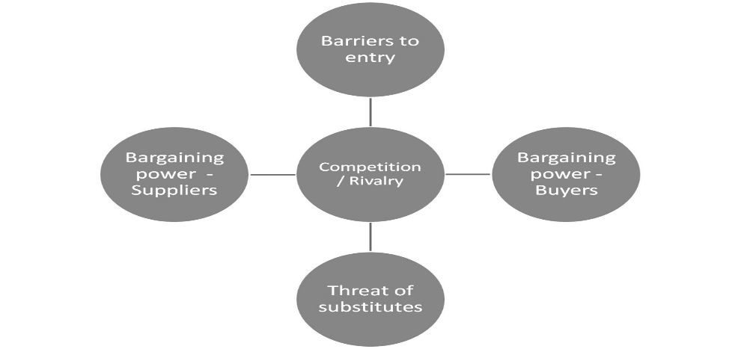

2) Corporate Goals
  - Defined as a corporation’s institutional standards of behavior
    - This builds corporate brand image, reputation and credibility, leadership, public relations, corporate crisis management
  - More and more companies are including ‘Ethics and Integrity’ in their value statement

3) Corporate Vision and Mission
- Within industry outlook, have to establish ‘where the company is going’

EXAMPLE: MARKETING MYOPIA ARTICLE
- Industries like railroad never considered the broader spectrum of their services
- Thought they were only in the business of trains… They were in the business of TRANSPORTATION. Not in the business of gasoline, but ENERGY. Not making cars but TRANSPORATION
- Companies that are unable to do this will eventually fail. Have to establish this in their mission statement

  - When defining the corporate mission looking at 3 things
    - What is our business perspective (global, environmental, safety?)
    - What is of value to the customer? (Consumer value focused)
    - What do we aspire to become (vision component)

4) Corporate Positioning/Image/Branding
  - Corporate positioning
    - How we want to be seen by stakeholders in terms of what we do
  - Corporate Image
    - How we want to be seen in terms of what kind
  - Corporate Branding
    - An active campaign to establish an awareness of the corporation, its name, its desired positioning and image, and to create positive affect for the corporation

5) Corporate Growth Though New Market Development
  - Global firms offering better products or lower prices can attack the company’s domestic market
  - The company discovers that some foreign markets present higher profit opportunities than the domestic market. The company needs a larger customer base to achieve economies of scale
  - The company wants to reduce its dependence on any one market

PRODUCT-MARKET EXAMPNSION GRID

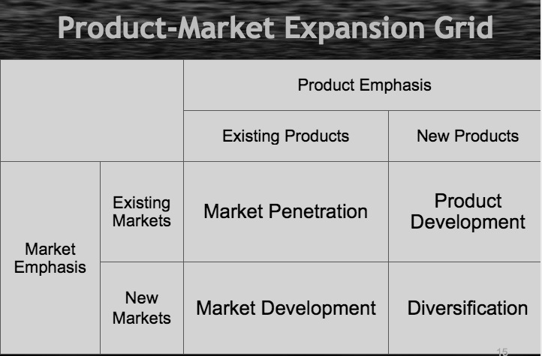

6)The Business Portfolio: SBU’s
  - Single business entity that has its own collection of competing business, that has its own top management, that plans its own operations independently and has a management that is responsible for strategic planning and profit making, but part of a larger organization
  - Telfer is a strategic business unit like other faculties in the university of Ottawa, University of Ottawa is the umbrella organization telfer is the SBU operating under that umbrella organization.
    - EXAMPLE: PEPSICO CORPORATION, and its CEO
      - SBU’s Pepsi, Frito Lay, Tropicana, Quaker, Gatorade
      - Head of overhead corporation looks at each SBU’s performance, viability etc
      - Critical issue at the larger level becomes how you allocate resources among each SBU.
      - Also how do you keep tabs with what is going on within each SBU?
      - Two approaches
  - SBU Analysis
  - The idea of looking at specific SBU’s and deciding how the corporate level resources are going to be allocated to the specific strategic business units, which deserves more attention, which needs to be eliminated, etc.
  - Looking at the resource allocation merit of different SBU.
    - BOSTON CONSULTING GROUP MATRIX

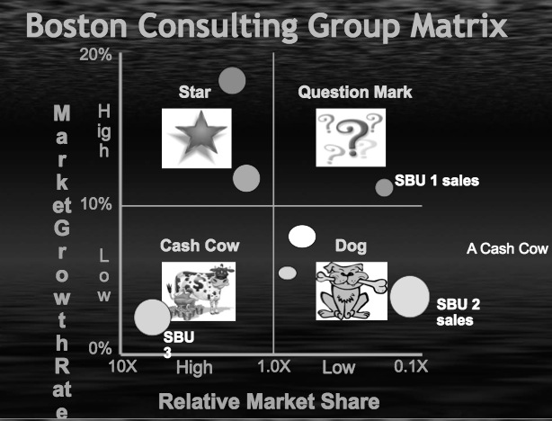
    - Size of circles- Sales of SBU’s
    - Relative market share and relative growth rate
    - SBU’s located in one of the four catagories (question mark, stars, cash cows, and dogs)
    - Dogs- low market share, low growth rate not much of a future (company still making black and white television)
    - .1x – 10% share of the largest competitor of the industry, 10x- leader in industry 10x the share of the next best in the industry.
    - Question marks market share low, high growth rate we do not know what will happen them in the future have to keep close tabs on them.
    - Stars high growth rate, high market share must eventually turn into cash cows or they can be a pain because they burn cash.
    - Cash cow high market share, growth rate has stabilized money from these will fund question marks. 9x the next best competitor.
    - Ex. Kodak rolls of film knew it would go from star to dog never became a cash cow. Digital camera question mark star. Kiosks question marks dog.

    - GE Strategic Planning Grid looks at business strength and industry attractiveness
    - Green zone, yellow zone, and red zone
    - Green zone SBU exist in a healthy environment
    - Yellow zone analogist to question marks (be careful about)
    - Red zone analogist to dogs
    - Have business strengths and industry attractiveness
    - Size of circle is the size of industry, shaded area represents your share in that industry in terms of sales.
    - SBU 1 lots of profits large share in industry about 25% but industry is not very attractive could be bad for environment about to regulated maybe maybe new technology will wipe out this industry and you for whatever reason do not have much strength in this industry

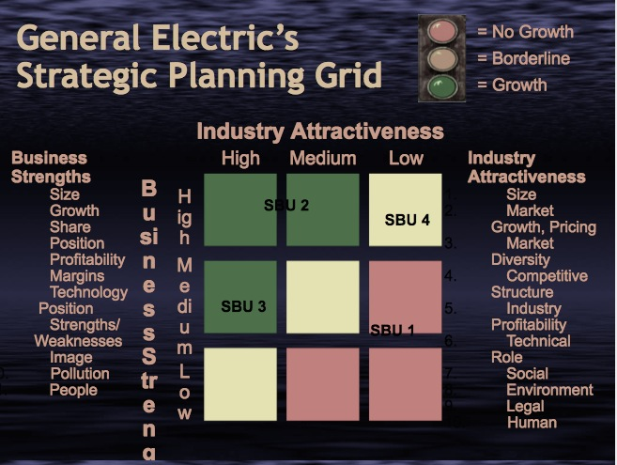

Levels of Planning
- Strategic Planning
  - Performed by top management. Focused on firm’s overall objectives and strategy
  - Emphasis on current market situation and opportunities
  - Implies choice of value, what kind of value are you offering
- Tactical Planning
  - Performed by middle managers. Focused on specific brand or SBU
  - Details specific marketing tactics (example merchandising, pricing, advertising, channels, service)
  - Communicating value.

Corporate level marketing overview

PRODUCT LEVEL MARKETING

BIG PICTURE
- Corporate level marketing leads into Product/Brand Level Marketing

Outline of a Product Level Marketing Plan
- Executive summary
- Table of contents
- Situation Analysis
- Marketing Strategy
- Financial Projections
- Implementation Controls
- Two critical aspects of a marketing plan are situational analysis and a marketing strategy. Heart of a strategic plan.

Elements of a Product Level Marketing Plan

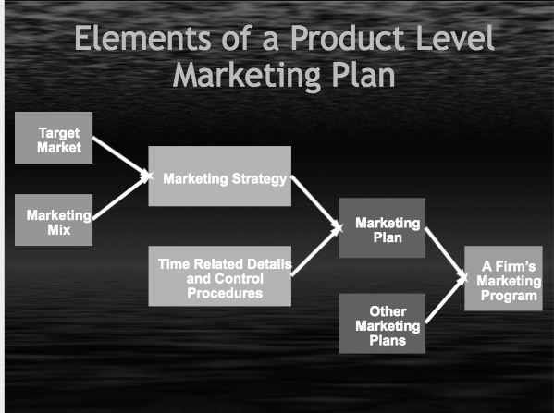

Selecting a target market (group you are selling to), and developing a marketing mix these two make up developing a marketing strategy.

- Once you add time related details to you’re strategy then it becomes a marketing plan.

- Combine the plan with other marketing plans for you’re company now you have a firms marketing program.

The Marketing Mix

Traditional marketing mix

At the center is the Target market

There are 4 major components to the Target market: The 4 p’s

1)Product decisions 2) Price decisions 3) Promotion decisions 4) Place decisions

Modern world 4p’s look very different does not necessarily relate today.

Marketing strategy questions

Who are you’re customers?

What does youre target market want?

Can you provide what they want?

Scan the environment?

The right Marketing mix

- Satisfied with these then you have probably got a good strategic plan fighting chance that it will work.

Stakeholder Analysis

- Looking at various stakeholders in terms of their viewpoint of a product, in terms of marketing, nature of a product, etc.

- viewpoints of different organizations that impact you

SWOT Analysis

-environmental analysis

- A conclusion of youre environmental analysis, do a 40 page environmental analysis then do SWOT to summarize.

Beer Marketing in Canada

- Beer is beer, ordinary beer drinkers can not really tell the difference between brand a, brand b, and brand c. When it comes to marketing and creating loyalty how do you develop that loyalty and issues involved.

Module 3: Environmental Scanning
- Short sited companies do not survive only companies that describe their company in a broader context will survive (marketing myopia).
The Marketing System
LONG TERM FACTORS (environmental variables not under the control of the marketing manager, but they still need to keep them in to account in order to develop a marketing strategy.
- Demographic
- Cultural
- Technological
- Competitive
- Economic
- Regulatory (legal)
SHORT TERM CONTROLLABLE FACTORS (under control of marketing manager)
- Product
- Price
- Promotion
- Place
Environmental Scan everyone does it (business, consumers); can be formal or informal
Buy a house, invest money in stock market all do an environmental analysis
Yanklvich pole environmental analysis consulting firm that provides and environmental analysis
Environmental monitor own by environics do same thing for public and private sector in Canada does it for when government makes any decisions (cicis)
Sindicated reports sindicate companies come together mcdonalds, environment Canada, and health Canada looking for topic that was interest to all three of them shared in benefits shared in costs.
Environmental analysis is a common practice.

EXTERNAL ENVIRONMENTMacro Influences (long term factor) (6)
1) Demography
- Demographics: statistical Study of human population and its distribution. Can track consumer tastes & preferences by age group
- Aging Baby Boomers
- Marketing faces challenges with so many different market segments
  - Baby boomers, Gen X, Gen Y, Gen Z
  - World Wide population explosion that is causing the ‘average’ or normal Canadian family to change.
Demographic Change
- There is a world wide population explosion provides great opportunities for Canadian firms.
- Slowdown in birthrate smaller families companies that sell baby food do not say that they just sell baby food anymore they are more focused on the geriatric population rather then young kids.
- Aging of population Average age is over 40 years, 1971 was in 20’s people are much older.
- changing Canadian families
- rise in non family householdsgay, etc.
- Large ethical changes.
- Large opportunities in furniture, housing, etc.
2) Cultural Forces
- Culture: the characteristics of society.
- Personality culture is the personality of a society we all have different personalities but so do cultures.
- With changing demographics we have changing values and beliefs
- 4 Characteristics of Culture
  - Adaptive: Culture adapts, what was acceptable once changes over time
  - Cumulative: Enrich’s itself; grows over a period of time
  - Value Laden: forces what is wrong and right on people. Things that are ok and not ok from a cultural perspective.
  - Learned: not something you are born with
- Culture is the Personality of a Society
- Dimensions of Culture
- Space: Sense of space- social space, personal space (ex. Go into elevator in desmarais four people go in four corners of the elevator when fifth person comes in they try to stand right in the center sixth then trouble starts because peoples social distance is being approached upon and are becoming uncomfortable. Europe does not matter so much. India adm machine all hovering over you.
- Colours: Colour a symbol. White a symbol of purity in western, symbol of death in india. Blue for boys, pink for girls. Leads to culture shock mixing of cultural norms and codes.
- Symbols: Hand gestures
- Time: Canada sells things that save time. Arriving on time to meetings. In Canada meeting at 6 its at 6. Important meeting you may want to be early. In other cultures if you get there early you are a loser.
- Values: Vary in different parts of the world.
- Norms: something that is conventional. Expected forms of right behavior. What is expected. Rightness and wrongness of things. In Canada pull out 20 dollar bill to pay a cop not acceptable, other cultures it’s the norm.
- Customs: similar idea to norm, more central, more stable and powerful (its customary that people go to cottage in august, but other cultures do not understand).
- Have to understand cultural differences around the world in order to sell products
- We acquire culture through 2 ways: Enculturation, and Acculturation
  - En process of learning the value of one’s own culture (through school system you are getting encultured)
  - Acprocess of learning the value system of another culture (immigrants)
Canadian culture
- Time oriented, performance oriented, individuality, youth oriented, materialistic.

- Car by the name of noah came out as the word no go in latin countries. Vix vaper rub translated into piece of shit in Germany. Pepsi come a live with pepsi bring ancestors to life in mandarin. Frank ferdu chicken- put hand on waste makes a tough man to make a tender chicken, did literal translation, in hong kong it takes a hard man to make a chick tender.
3) Legal and Regulatory
EXAMPLE CASE STUDY: DIRECT TO CONSUMER ADVIRTISING (DTC)
- Pharmaceutical companies are not allowed to do DTC advertising
- CANWEST (media company) approached gov. to make DTC advertising legal, government said no. CANWEST sued saying consumers have right to be informed. At the explicit level (for CNWEST) people have the right to be informed. At the implicit level CANWEST wanted to generate more advertising revenues…. Pharmaceutical companies were on their side of course.
- Kindra worked for justice department. His argument was that they should not be allowed.
- Covert level added tremendous to the cost required for health care.
- Overt level People need to be protected from advertising encouraging irresponsible use of drugs, would encourage irresponsible use of drugs, to much pressure on doctors.
- Canwest side and pharmaceutical
- Overt level people have the right to be informed, and they have the right to communicate about the various products on the market
- Covert level improve their bottom line
- Results were Canwest lost this demonstrates how the legal environment is created to protect consumers
- Symptom advertising only in us not Canada. Us, Japan, and New Zealand where prescription drugs can be advertised to people directly.
Legal Environment
- Purpose is to (1) ensure fair competition and (2) protect consumers
- Some of the laws in Canada were a result of changes that were taking place in the us
- US examples demonstrate why the legal environment has evolved.
- Why do we have business laws two purposes; to ensure fair competition, and protect consumers from unfair business practices.
- CASE STUDY: chocolate monopoly hurts consumers treating them in an unfair manner
- In US SHERMAN ACT
  - It is illegal to contract, combine, and conspire in restraint of trade. Idea is to protect small businesses, remove barriers to trade, and discourage large businesses from cannibalizing small business.
  - Illegal to monopolize, illegal to even talk about it
  - Illegal to lessen competition.
  - Problems with Sherman act example.
EX: Alcoa Can Company: Monopolize aluminum can business. They had a market share of 93% in their industry. The government said they had a monopoly. Response not in the business of making aluminum cans rather they were in the business of making containers. However, the company defended themselves saying they manufactured different types of containers (meaning their market share fell to only 30%). However, what percent do you actually declare a monopoly 30% or what?
- Two problems with us legal market Definition of the product, and at what point does a company practice a monopolistic practice. Another problem is that intent has to be shown needs to be deliberate action, they would say in respond to that saying its not our problem we are so good. (ex Microsoft- We are so good no one can take the heat, how is that our fault).
- In Response they created Clayton Act:
- Because of these problems more laws were made.
  - Things such as price discrimination, promotional allowance, exclusive dealings, tying contracts.
  - Per se violations illegal regardless of whether it has a negative impact or not
  - Section 3 exclusive dealings are illegal (situation where everyone must get the same offer from the company, can not exclude other companies in B2B deals).
  - Microsoft browser does not operate optimally without their operating system, so Microsoft lost the case so the two products could be sold separately.
  - Reciprocal deals you buy this from me and I will buy this from you.
  - Railroad company and GM railroad company transports GM vehicles and railroad company bought motors from GM.
- These acts are all present to protect consumers and the competition
  - Canada’s is: Competition Act
  - Predatory pricing air canada lower prices so low to drive other company out.
  - Misleading advertising Mcdonalds advertised chicken nuggests as 100% chicken 80% chicken rest is oil, etc. had to discontinue practice.
  - Campbell soup high in calcium not in the soup comes from milk you put in soup lost case. Also would put a bunch of soups together and say high in fiber but not all were high in fiber this was misleading and deceptive.

4) Economic Forces
- Business cycles
- Prosperity, recession, recovery, depression
- Consumer income
- Gross, disposable, and discretionary income
- Consumer Confidence
- Spending patterns
- Inflation
5) Technology
- Marketing itself has changed in the last 10-15 years. Major technological revolution in the past 50 years.
- Information Technology has had one of the biggest impacts
- 3 miracles with technology
  - (1) Digitization:
  - Typical computer chip in car more powerful then computer used to send first man to the moon.
  - All this info can be stored at very low costs
    - Can store more and more storage moores law (it doubles every 18 months)
    - The cost of storage has also drastically decreased
  - (2) Network Effect:
    - Robert medcalfe v=n^2
      - The value of the product increases exponentially with the numbers of owners.
      - Fax machine sent note to presidents publisher friends from calafornia fax machine he was going to return the store became indispensable to him.
    - Robert Solow said there is a ‘paradox’ I don’t understand why the US productivity hasn’t increased despite how much more money has gone into IT. How did it not have a measurable impact in business”
      - He said this right before a ‘boom’ in technology
    - SO… in 1995 a whole buncha shit went down with technology. Computers started to communicate with each other. They started linking
    - Technology started to naturally grow between consumers. Without the need of major marketing.
    - Major increases in productivity started to become obvious at this point.
  - (3) Telecommunications
    - Transmitting
    - Wireless communications has greatly surpassed that of cable
    - Sending info costs literally nothing
- GDP- 1995-1996 internet era large increase in GDP per person.
- Total factor productivity- how efficient the resources are being used (labour, capital, information and technology). Proxy measure of efficiency. Today marketing today is much different then it was 10 years ago, any marketing strategy that you formulate must take into account 4 environmental factors.
(6) Competition
- Firms monitor competitive trends (competitive intelligence)
- They Consider how consumers frame competition
- In-Kind competitors: similar attributes
- Functional competitors: similar low-level consequences
- Ego-Emotive competitors: compete at psychosocial consequence or value level
Module 5: Segmentation, Differentiation, Positioning (STP)
SEGMENTATION, DIFFERENTIATION (TARGETING), POSITIONING
All plans ask 3 questions
- Where are we now Situational Analysis (Environmental analysis)
- How are we going to get there the 4 p’s (how are we going to get where we want to get)
- Where do we want to go Segmentation, differentiation, positioning
We at this point are dealing with question 3
Promotion seeks to shift the demand curve (to the right, and to be more inelastic)
- the idea is to make youre product differentiated, different, make it stand out so people will pay a high price for it. Want to shift the demand curve from D1 to D2.
- Most products can be differentiated. Salt by itself is a commodity is not differentiated, put it in a fancy container, it becomes differentiated. (raisins, water, clothes- all differentiated)
- D1 to D2 in first graph D2 implies that no matter what the price of the product the demand will remain unchanged. (that’s ideal- not many products like it though)
- D1 to D2 in second graph More of the product will be purchased at any given price (ads for milk, eggs, etc adds by industries that want the generic consumption of their product to increase)
- D1 to D2 in third graph Lifestyle
- Product differentiation can be real (product actually has superior attributes) or psychological (better branding, packaging, etc)

Differentiation: Product and Market Specialization
Three way a product can be differentiated
- One product for 3 different markets. P2 could be a facial cream for working women, housewives, teenagers three different markets.
Market specialization
Second situation 3 products for one vertical three products for one market All types of cosmetics for teenagers.
Concentration
Third possibility company selects one particular segment of the market and focuses on only that segment called concentrated marketing.

Segmentation
Segmentation variables
- Psychographics are the operational measure of lifestyles. The attitudes for example. 4-6 (or more) combines make up lifestyle pictures. Lifestyle is an overall portrait of how people live. Psychographic singular measure of a lifestyle operational measure of lifestyle.
  - can then segment the market (or products) for similar groups of people with similar psychographics
- Ex. Timex watches peoples incomes had nothing to do with the purchase of the watch. People bought expensive and inexpensive watches based on their personality. Extroverts-> expensive watches, Introverts cheaper watches.
- Benefits Segment based on the benefits that people are looking for from the product. Common products could be detergents, alcohol, toothpaste. Toothpaste Benefits people look for (1. Cavity prevention, 2. Whiter teeth, 3. Bad breath, 4. Children-taste). Point being there are a number of variables involved in segmentation.

What Is segmentation?
- Segmentation: the process of aggregating prospective buyers into groups, or segments, that (1) have common needs and (2) will respond similarly to a marketing action

Criteria to use in forming the segments
- Looking for homogenous people, but how homogenous do you want to get.
1. Profitability
2. Common within
3. Sizable
4. Reachable
5. Identifiable
- Problem becomes when it is not reachable enough, or not sizable enough, etc.
Power of segmentation
- Ex. PedigreeBritish dog food market – Segment that treats dog like a substitute child super premium segmentStrategy focused on intense relationship between human and dog gained 10% of dog food market quickly Product priced high, almost as expensive as human food.

Positioning
-Defining what the product is so that consumers have a clear understanding of what the product does and represents in comparison to competing products.
- Taking the product concept and positioning it in the minds of the consumer, what is it that comes the mind of the consumer when they here colgate what are the thoughts and feelings they have when they here youre brand name.
- EX:Positioning in the mind video
Peoples minds have limited processing capacity when it comes to brand names.
  - Each ladder represents a products category. Each step on the ladder represents a brand name. About 3-4 steps per ladder. No matter what people don’t take into account more than 3-4 competing brands
  - Brand that is at the top of the ladder is in a very enviable position. Number 2 still has power. Number 3 still present but not to much. Number 4 most people can not recall the number 4 brand in a product.
  - 4 types of colas- coca, pepsi, arsi, then draw a blank.
  - Battle for share of the mind is very intense. Cola x want to be 5th best cola in Canada. They will either have to dislodge one of the high end brands, or they have to create another latter Uncola latter such as 7up position yourself right at the top of that latter.
  - If you want to come up with a new product of your own you can…
    - Knock off the top brands, but this would cost millions a year isn't feasible SO
    - ***Even though there is a limited number of a step on a ladder, the number of ladders you create is unlimited. When you create a new category, you are at the top of the new ladder

Product space Representing Consumer Perception for different cars
- Product positioning is something that takes place in the consumers mind It is their concept of a product
  - These stereotypes can be both positive and negative. (Could be hurdles companies have to overcome… EX when instant coffee was introduced)
  - Companies have to (consciously) create and maintain the intended product concept in the consumers mind
- Product positioning involves three things
  - Determinant attributes
  - Attributes of eminent interest to the consumer.
  - Located or measured through statistical research
  - Buying of car kicking tires, wiping blades, etc numerous things that people do but of these only 3-4 make a difference these are called umbrella attributes because
    - The umbrella that covers many other sub attributes
    - Key reasons for the purchase of the product…they represent key information for the product positioning
    - When relating back to r² the variable that is the highest (ex .7) means that 70% of consumers behavior (variation) can be attributed to this variable
      - EX: WHAT MAKES COFFE GOOD: some say bitterness, coffee shop music, flavor, temperate etc. If the bitterness attribute has a .7, then 70% of customers behavior is associated with this characteristic.
    - This allows marketers to know their products position
  - Position of various brands
  - Perceptual position of brands, where people perceive you’re brand to be located.
  - Ideal Brand Concepts
  - Determine the ideal product that appeals to each market
  - Their imagination of a perfect car (could be a product in top right, or top left quadrant as ideal).
    - Clusters of peoplemakes the target markets (homogenous thoughts from a large group of people).
    - Corrective advertising tries to change peoples opinions of the product
    - EX: CARS
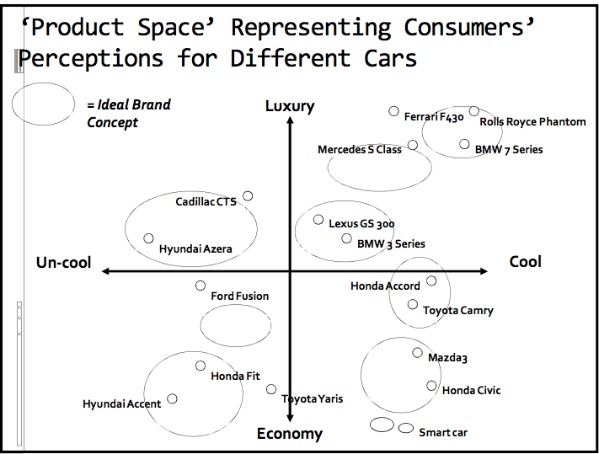

Positioning and Competition
- Coca cola- associating itself with tradition
- Pepsi- Taking traditional viewpoint and turning it into a negative suggesting it is passe and pepsi is the new.
Creating a successful position for a product is one thing but that successful position needs to be communicated in an effective manner.

Communicating and Delivering the Chosen Position
All the company’s marketing mix efforts must support the positioning statement.
Designing the marketing mix – product, price, place, promotion – involves working out the tactical details of the positioning strategy.
Creating a good positioning strategy is much easier than implementing it!
Establishing or changing a positioning strategy takes a long time, but can be lost easily

CASE STUDY: BROKERAGE INDUSTRY (applying segmentation, differentiation and positioning)
- Consumers perceptions of the industry: technology based VS human interaction, premium service VS basic service
- Level service on y, type of interation with firm two determinant attributes when communicating with the brokerage industry.
- Creates 5 ‘bubbles’ (or clusters)
  - We get ‘ideal’ positions in the consumers’ minds
  - 5 types of people different companies looking for their position at the centre of the circle encouraging customers to go to them apposed to other companies in the industry.
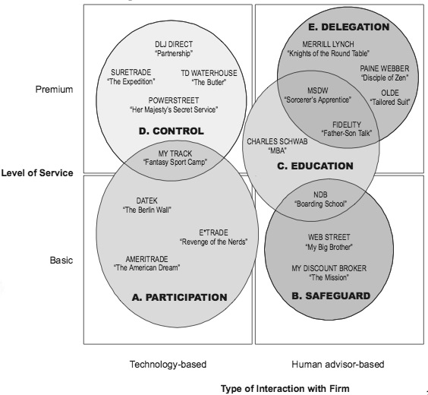
- DATEK product concept: viewed as revolutionary, the customer is oppressed (they are tired of being exploited and excluded). The company then advertised that they are the fighters who are using technology to allow the average man to trade
- Going to allow people to be freedom fighters by allowing average people to use same technological advantages as elite.
- MORGAN STANLEY they say customer shouldn’t do it on their own, let them handle it, ‘we are the professionals’, ambition from unknowledgeable consumers is dangerous, let the professional handle it.
- They want to be a mentor, they are going to protect the consumer pull people away from the control by instilling fear in them in order pull them from left side of the map to the right side of the map. Do not try to do things on your own let professionals handle it.
Module 6: Product, Branding, and Services
Products
The Product
- Two different views of a product (first product as experience, property, anything of value to consumer, second view core, augmented, etc)
- Different types of products
  - Physical goods, Services, Experiences, Events, Persons, Places, Properties, Organizations information
  - There is also the marketing view of a product*

Product VS Brand

Product | Brand
- Occupies functional territory | - Occupies mental & emotional territory
- Made in factory | - Bought by customer
- Does something  - Performs a function | - Stands for something in someone’s mind, in addition to doing something
- Seeks out their customers | - Sought out by customers  - Intangible aspect of a product
Product Mix
All of the different products sold by a company
- The product mix means two thing
  - (1) The width of the product mix ie. The different lines a company sells (paper, health care, beauty etc.) (also called product line)
  - (2) The depth the company sells each of those lines
    - This can also refer to packaging, labeling etc.
Ex: P&G product mix
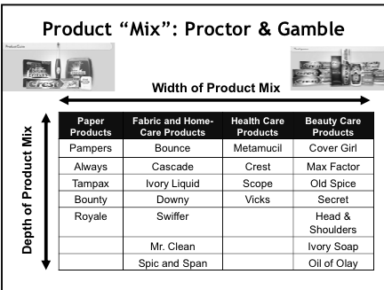

Branding
Very important part of product strategy
A brand is a name, a term, a symbol of any other unique element of a product that identifies one firms’ product(s) and sets them apart from the competition (URL is a form of brand)

Brand Identification
Trademark -Part of brand name which is legally protected (nike checkmark)
Brand name- That part of the brand that can be vocalized, can be spoken (crest)
Generic name- A situation where a product is So well known that people refer to it to describe an entire product category (cola, escalator, nylon, etc). Bitter sweet- Bitter side is it is taking away value of you’re brand name it is becoming generic.
Private brand name- Brand name that belongs to a retailer (presidents choice)
National brand- Manufactures brand it belongs to the manufacturer
Packaging- 1. Promotes, 2. Protects, 3. Reuse of the product. Comes an important part of brand identification.

The Role of Brands
- Identify the maker
- Signify quality
- Simplify product handling
- Organize accounting
- Create barrier to entry
- Serve as competitive advantage
- Offer legal protection
- Secure price premium

Good brand name is easy to pronounce.
A brand name adds differentiation and distinction to a product and that leads to a competitive advantage.
Everything is in a brand name
Brands are traded like baseball cards between organizations with portfolios.
Brands need to be protected like cohiba
Anheurser-Busch owned by abinBev This company owns over 200 brands. These brands hold equity and value for the company, they trade, sell, buy them. Tools of transferring equity.

Why brand Portfolio?
Enhances the firms market coverage by offering an array of offerings
Also enhances it marketing, channel, and operational effeciencies.
If you have a dosen breweries spread out across country you will be an efficient manufacturer and distributor.
Brand Elements
- Different parts and components ranging from:
  - Name
  - URLS
  - Logos
  - Symbols
  - Characters
  - Slogans
- Different ways we identify brands
  - Brands, brand name, trade mark, generic name, Individual Brand, Private Brand, National Brand, Packaging
Brands and Country of origin
Certain countries are known for higher quality of product
EX: Russia for vodka
The Brand Portfolio
- The brand portfolio enhances the firms market coverage by offering an array of offerings
- It also enhances its marketing, channel and operation efficiencies
  - Drink companies have soft drinks, energy drinks, juices, sports drinks, tea and coffee, and water
- Matching brands to markets
  - Each different product within the portfolio then has different attributes associated with it
  - From quality, to level of service etc
    - EX: hotels the Marriott has the high end luxury hotel the Ritz Carleton, contemporary quality JW Marriott, Quality destination hotels like Courtyard by Marriott, and eventually the Value hotels like Fairfield by Marriott

Brand Meaning
Brands allow firms to create a sustainable advantage
Differentiation + distinctiveness = competitive advantage
- Differentiation
  - The brand has advantages that consumers experience and value
    - Product form, features, performance, conformance, durability, reliability, repair ability, style, design, ordering ease, deliver, installation, customer training, maintenance
- Distinctiveness
  - The brand has a unique & unmistakable identity
Brands, Products, and Consumer Relationships
Products and brands often adopt a personality help to stand out
Consumers are then effected by the brand personality and a relationship is created
- What brands do they trust the most? Which do they love, and which do they loathe
- Core values and the brands character are demonstrated via its actions (not just PR window dressing)
Brand Evaluation
- A brands worth is more than just numerical facts, and physical goods sold
- It worth goes beyond these physical assets
  - Ie what people think of it
Brand Personality and Animism
Companies can use celebrities to sell products but if this falls through then it is dangerous to the success of company (Jessica simpson allergic to pizza but represented them, tiger woods nike cheating scandle) Thus companies now like to use their own personalities (ex. Pillsbury, telus) They do not require a lot of money, gives company full control over product message.
- Level 1
  - Associating the product with the soul of a human being
- Level 2
  - Objects are anthropomorphized ie. Given human characteristics
- Used for product positioning
- With Celebrities and endorsements
  - Gets peoples attention
  - Feel the brand can be trusted since person x is using it
    - “ If Kim K is using sketchers step ups, they must be good!”
  - But people are unreliable the celebrity could have a personal issue become public
    - Get bad press
    - Thus negative associations with their name and eventually the product they endorse

NEW PRODUCT DEVELOPMENT
Categories of new products
(high risk to low risk)
- New-to-the-world (discontinuous innovations, true innovation, first fax machine, starts a new industry)
- New product lines (concept of the product already existed, its not new, new ways of doing the same thing, dynamically continuous innovation)
- Additions (continuous innovation, do not need massive resource)
- Improvements(continuous innovation)
- Repositioning (launching a product as new and improved)
- Cost Reductions (continuous innovation)
The higher the risk the higher the reward (or loss)

Understanding Innovations
- Innovation: a product that consumers perceive to be new and different from existing products.
- However, developing new products is important to an organization allows to remain competitive, keep up with technology, follow changing consumer preferences, replace dying products, diversify product offering and lower risk
- Innovation can be divided by the amount of learning required
- Continuous Innovation: a modification of an existing product that sets one brand apart from its competitors. Mostly incremental improvements of an existing product EX: creating microwavable mac & cheese
- Dynamically Continuous Innovation: a change in an existing product that requires a moderate amount of learning or behavior change EX: switching from VCR to DVD
- Discontinuous Innovation: a totally new product that creates major changes in the way we live. This type of innovation requires the most amount of leaning on the part of the consumer EX: the laptop changed how people live their day to day live

New domestic products by industry
- thousands of new products introduced to marketplace every year
- What about all the products that do not make it, why do so many not make it.
- Children toys 93% are failures
- With all the educated people why do so many failing
Utility functions based on conjoint analysis
Market researchers do spend a lot of time looking at various options with product introductions
Look at consumer preferences, with different packaging, different brand names, different retail prices, money back guarentees, etc.
- Conumers continually express their opinions
- Despite all this research we still end up with huge numbers of failures
- Most reasons are market failures it does not relate to the consumer.

Developing New products
- Waterloo, Kitchener, Ottawa, etc companies have tested products before large scale commercialization across the country
- Large scale market testing not very popular 1) time- short product life cycles- not much time to test products- they want to be first on the market, 2) cost, 3) they want to keep it secret. They would rather find other ways. What you have is alternate ways of testing products that are becoming popular. Simulation test marketing- people recruited in malls handed out samples of product fill out questionnaire. Scanner base test market select number of consumers givin cards for when they go to grocery stores cards record what products they are buying or are not buying all kinds of info. Test marketing through electronic store pick product among all kinds available to you, goes into you’re cart.

Diffusion of innovation
- Bell curve- All products go through four stages- introduction, growth, maturity, and decline.
- Innovators, early adopters, early majority, late majority, laggards
  - Innovators the first segment of a population to adopt a new product. Usually those highly involved in the category
  - Early adoptersthose who adopt an innovation early in the diffusion process but later than innovators
  - Early majority those whose adoption of a new product signals a general acceptance of the innovation
  - Late majority the adopters who are willing to try new products when there is little or no risk associated with the purchase or economic necessity (social pressure)
  - Laggards last to consumers to adopt an innovation these people are now buying DVD players
- Marketers can use this information to design promos to reach each successive group
- Never actually a bell curve product life cycles are messy, not always sure where it is heading.
Consumer Adoption Process
Innovations tend to be adopted far more quickly now days then they were in the past
What influences the rate of adoption of an innovation?
What slows down the rate of adoption of an innovation? Once companies become aware of what the hurdles are that slow innovation then they can do something about it.
- Awareness Interest Evaluation Trial Adoption
Factors that influence the adoption
  - Relative Advantage: the perceived difference between this product and others. For some people it is obvious, others not
  - Compatibility: The fit between the new product and peoples present habits
  - Complexity: Ease of understanding
  - Trialibility: risk of getting product can be reduced if it can be purchased and tried in stages
  - Communicability: is the product visible to others, can is usage be easily described to others?
Influences on rate of adoption
- Relative advantage advantage of product is very clear in some cases laptop half the price of everything else on the market with high speed you can see the advantage.
- Compatibility- Fit between product and peoples attitudes, personalities
- Complexity- Has to be easy to understand
- Triability- Some products you can try it. Birth control pills why it was not adopted early because it had very poor triability.
- Communicability-Some products are each to talk about in a public sense, easy to promote (Viagra- does not lend itself to easy communication makes it difficult).
Quality
How do you access quality with regards to service?
The Five Dimensions of Quality Service
- Tangibles
  - Appearance of physical facilities, equipment, personnel, communication materials
- Reliability
  - Ability to perform dependably and accurately
- Responsiveness
  - Willingness to help customers and provide prompt service
- Assurance
  - Knowledge of customers, courtesy, ability to inspire confidence and trust
- Empathy
  - Caring and individualized attention (putting yourself in someone elses shoes)

Relative Importance of Quality dimension by industries
- All rated in same order in all industries
- Reliability is number one, responsiveness is number two, assurance number three, empathy number four, and tangibles number five across all companies.
- Five different categories where problems occur, when it comes to providing good service what are some of the problem areas that arise.
- Problem one has to do with quality

Model of Quality
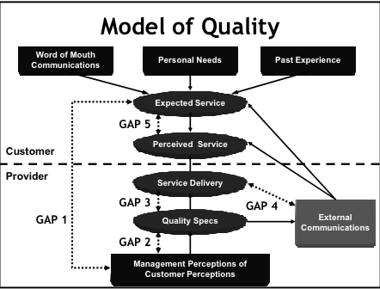

- Gap 1
  - What management perceives customers want VS what they actually want
  - Ex. Currier company initial push to bring product to people in certain time that is what people want but point came where they reached critical point of 99% delivery on time Then that 1 additional percent people were looking beyond efficiency 100% efficiency is not what people were looking for 95% is enough.
- Gap 2
- Arises when there is a problem between management’s quality expectations, and quality specs.
- Gap 3
  - Quality specification and Service delivery: what is expected to be delivered and what is actually delivered. (quality control)
  - Answer phone on third ring be polite to customer but in reality when it comes to service delivery do to poor quality control the individual is abrupt and rude to the customer.
- Gap 4
  - Service delivery and external communication
  - External communication holiday inn portrays it as being a five star hotel, but when they stay there they claim it isn’t actually five star more like a three star.
- Gap 5
  - Perceived service and expected service: both reside in the minds of the consumer. Customer expects something, but they got something else. There isn't much a company can do about it. Expectations are this not in line with perceptions. In head of consumer company can not control it. Only way to deal with gap 5 is to ensure expectations are not overblown and they are realistic.
Pricing Approaches
Mysterious part of marketing mix cause no one really knows what the best way to price a product is
Different Price Perceptions
Price has a lot to do with perceptions.
- Pair of shoes shown to people
- Artsy portrayal of shoes
- Product being associated with movie stars
People looked at the first treatment thought the product was worth about 120 dollars, second treatment thought the product was almost 300 dollars, in the third scenario the price of the product jumped to over 500 dollars
This was students which tells us that ordinary people like you and I are influenced by our perceptions have to do with who says what and how the information is presented to us. Not just people that do not know about marketing everyone gets influenced by our perceptions.
Price has something to do with perceptions more to do with psychology then accounting
Country of origin
- Depending on where the product is made we will ascribe certain value to the product
- Product made in Canada we are apt to prescribe higher value then one made in bangledesh
- Vodka Melville vodka chose label on the right the reason is because that one appears to be more Russian then the label on the left. They want they want there product to be associated with Russia, because people will assume that is a better product cause Russia is known for their vodka. The reality however is that they have a bottling plant in alberta and one in Quebec, very Canadian product but they do not want people to know cause it would lower the value of the product.

- Trajically Hip We should have charged a higher price for the tickets because skelpers were making all kinds of money off them selling them 3-5x times the actual price of the product.
the price and value of the product is a mystery. How do you determine a price of a product that matches the perceived value that people ascribe to that product.

Price Versus value
--> Price is one thing and value is another thing
The value of coffee
Adding value is what it is all about. As you move from coffee as a commodity to coffee as an experience the value of the product increase increases exponentially
The many names of price
Tuition, Rent, Fairs they are all the same thing just different names used in different situations.
The actual cost is very different then the price often. Cost vs Value.

Price sensitivity is lower when?
Product is distinct, highly differentiated not very price sensitive
more of a commodity more price sensitive
Can not store the product less price sensitive
Paid for by another person work for a company that pays for youre cab then you will have less price sensitivity.

Other pricing terms
Cash discount reduction in price of invoice if buyer pays the invoice prior to the ned of the discount period.
Trade discount discount of retail price when a manufacturer sells to a reseller apposed to end consumer.
Promotional allowances Manufactures give retailers discounts for promoting their brand
Promotional pricing reducing the price of the product in the short term to attract customers and increase sales
Psychological pricing certain prices have a bigger psychological impact on consumers then other. A product for 1.99 seems a lot cheaper than 2 dollars.
Bait and switch advertise items for a low price without intent to really sell any. Lure customers to store with low price only to pressure them to buy a higher price item.
Uniform delivered pricing shipper charges one rate no matter where the buyer is located
Zone pricing shipping increases as shipping distances increase done by drawing zones on a map.

The pricing range
price ceiling to price floor
within this range you can price anywhere in this range and make money.
go to high no one will buy the product at that price
go to low it would be illogical
discovering the feasible range is what is important

Setting the pricing ceiling
Products that are familiar to us (ex. contact lens) we have some notion to what is a reasonable price range. They have a reference for price range. In reference scenarios companies with use something called versioning.
In any market people are willing to pay more for a product. There is no perfect price.
If the organizer set the price at 40, 90, 200 dollars there will always be someone willing to pay 500
how do you tap into that part of the market and get them to pay that for the product.
Versioning If we choose one price we leave money on the table, we get to all different types of people by creating different versions of the product.
Versioning attempts to capture that access value that some people are willing to pay for the product.
4 different product versions and 4 different prices

Pricing strategies
The list is endless, the terms here try to capture the most popular ways of pricing strategies. Farmers selling garlic how do they price the product? Stores selling high fashion products how do they price the product? A lot cases they do it informally, sometimes they price based on intuition or what the customer is doing, sometimes they price based on what the competition is doing.
Grey goose vodka—Probably not cost oriented probably more about prestige

Cost and value based pricing
Cost oriented product look at the product, estimate cost, determine the price, assign value to product, and try to push it down to the consumer at that price.
not a lot to do with marketing research or understanding consumer needs push approach
Value based pricing step 1 consult the customer find out what they think about the value of the product and work youre way up to designing the product pull approach (better then push)

Cost oriented pricing
Percent mark-up = to amount added to cost / selling price
SP= cost x 100/ 100-mark-up amount
Product that cost the manufacture 47.60 dollars ends up being sold to the consumer for 100 dollars because everyone is adding a mark-up the manufacture, the retailer, wholesaler.
Someone wants a profit, the total cost is 94,400 dollars, seller wants a profit of 5,600 dollars. They hope to sell 80,000 units of the product so you take the total cost plus the expected profits of 5,600 divided by the number of units at 80,000 and the product jumps from 1.18 per unit to 1.25 per unit.
Problem is maybe at 1.25 they will not be able to sell 80,000 units maybe only 60,000 units. Still commonly used because it is easy, people doing this are relatively sure they will be able to sell 80,000 units.

Setting the price floor
No one aspires to break even
Optomistic ,realistic, and pessimistic just in case something goes wrong in the economy.
Best to create a number of different breakevens rather than focusing on one simple breakeven point.

Break even Analysis
Variable cost cost ascribed to manufacturing of the product one unit costs you 1 dollar to produce.
Ex. You are a well known manufacture of drives variable cost is 30 per unit, fixed 50 per unit, total cost is 80 per unit. Michael dell calls you wants to buy a million drives but I can pay you only 50 dollars per unit. What do you do? 30 dollars less than you’re drive. You still jump at the offer because fixed costs will not change it’s a liability, it always will be there. Variable costs is what matters, so even if you were get 30 dollars and 50 cents multiply that by one million disk drives that is half a million about the variable costs of youre disk drives. This is called a contribution to overheads and profits. In real life for a business that already exists no one cares about fixed costs. This half a million could go to whatever you want. This is the key takeaway. Breakeven analysis is meaningless, what you need to focus on is variable costs.

Demand curve for normal & prestige products
in real life you face weird demand curves, if you continue to increase the price of the product people will stop buying the products. Any product where you associate emotions with the product, or price becomes a surrogate indicator of quality, we associate price with quality. Things like baby food (emotional product), eye shadow lower the price of the product people stop buying the product.

Pricing based on perceived value
how much will a customer pay for a product, what is the highest you can charge and get away with it.
Most logical what better way to find out the best price of a product then to ask youre potential customers.
industry Canada director general approached Kindra saying that industry Canada was lose market share to other provinces. You are not supposed to talk about interprovincial competition, the federal government is not supposed to be viewed as competing with the provinces. But in real life it happens all the time. If you want to incorporate you can incorporate federally or provincially and the two are fairly identical so most would incorporate provincially because it cost less to incorporate provincially. Director wanted to reverse declining market share at federal level. Kindra suggested we look at the marketing mix. Focused on pricing need to lower it ask the consumer what federal corporation is worth to them. Also suggested coming up with versioning.
Trade commissioner consultations how much do you charge for this. How do you find the right price for making climatic forecasts for transportation companies

Perceived value measurement
Need to ask 4 different question
To cheap would be industry Canada selling incorporation for 9.99 or to expensive may be paying a trade commissioner 500 dollars per hour.
the cumulative of the first two questions is reversed to get the not cheap and not expensive curves combine with the last two questions and you get this analysis.
Where the two red curves intersect is the optimum price of the product, at this point (OPP) there is minimum resistance to the price in the marketplace.
When the two blue lines meet Point of minimum cheapness
Do not want to go above PME or below PMC
That range is the range of acceptable prices. The gap between these two is usually very small
OPP is what you want to focus on. OPP is 500 dollars, PMC is 300, PME 550 dollars, Indusrty Canada is charging 700 dollars well then obviously no one want to buy it may be way being the rang of acceptable pricing.
Contact lenses for chicken, how do you price these lenses, chickens peck on each other which results in problems. Someone came up with the idea of giving chicken pink contact lenses, because it calms chickens. It never made it to market. However the best way to price the product would involve asking a bunch of poultry farmers how much the product should be sold for.

Demand oriented pricing
More theoretical, beyond the reach of most businesses. More complicate, and new businesses have not established demand for the product yet.
Marginal revenue= marginal costs is the point of profit maximization because total revenue curve and total cost curve are at the greatest distance from each other and the net profit curve is at its peak.
Marginal cost is the added cost of manufacturing one more unit of the product, marginal revenue is the added revenue for selling one more unit of the product.

Demand oriented pricing
Requires you to establish demand curve for the product. You have to know the marginal cost and marginal revenue for different units of the product.
Point where marginal revenue and marginal cost curve meet is extended to meet the demand curve and that gives you the optimal pricing for the product.
79 is the best price that you can charge, and 6 units.
Priceline.com a company that uses demand oriented pricing for different hotels that they sell to consumers.

Pricing and the marketing mix
Price is not independent of other variables in the marketing mix
Four p’s work in harmony
Price is not independent of how you package the product, or sell the product.
Cuban Canada company- Wanted to sell candy in Canada, they didn’t know how to price the product so kindra recommended they meet with wholesalers such as loblaws and ask them how you should price the product.
Administered pricing one channel member tells another channel member as to what the price can be.

Pricing strategy based on competition
Follow the leader
if the leading airline company is charging 200 from Ottawa to Halifax then that is what we should charge.

The psychology of price
1.99 sound a lot less than 2 dollars so they view it cheaper

Payment pricing advertise 300 dollars a month once you add in all the additional costs it ends up being something more like 1000 dollars a month
Price bundling season tickets, rogers.
Captive pricing no choice to buy the same kind of razor blades
Groupon Prcing model Seems like a good deal at the time, but there are other costs associated with groupon
Ignorance premium The premium that companies can charge you because you are ignorant. In the pre-internet days you call travel agent ask him if he can find you tickets to go from Ottawa to Halifax. He would come back in a few days tell you he found a good deal 749 dollars. How do you know that this is a good deal you can call airline agents but this could take a lot of time, maybe the tickets only 500 dollars and the rest of it is the ignorance premium charged to me. Ignorance pricing is common in the non internet world, hard in internet cause sites like kiak provide you with all different prices from a number of companies.

Honest pricing
Instead of a rental company saying 18 dollars a day and adding additional costs it would be more appreciated if they just advertised with everything it will cost you 32 dollars per day.
People are suckers for deals, people do not appreciate honest pricing.
Stubhub honest pricing that includes everything, sales declined by well over 40% in the first year they did this. JC penny did the same experiment. Sell of vacations.com they do not want to display full cost pricing in places other than Quebec where they have to because people are not impressed by full cost pricing. If all agencies used full cost pricing maybe people would appreciate it. Energy guide gives you a full disclosure of the total cost of the product will be for you.
Gurprit Kindra- Promotional strategies traditional
Kardashian sisters everytime they tweet they are advertising, companies paying them to advertise.
Not many people actually do not know that. Vast majority of people are unaware.
deceptive and misleading advertising illegal but they haven’t caught onto this type of advertising
false stories deceptive and misleading advertising also

History of advertising
early 1800’s salespeople go door to door.
Full service add agency did everything, marketing research, advertising, etc.
15% billing, 18% production
70’s big companies proctor and gamble, gender foods we want some discounts, quantity discounts because we give you so much service
proctor and gamble wanted to do research and strategy, its not longer full service so give us a discount
tv was the sexy part of the business, most add agencies focused on television because it brought them the greatest return, brought them more money then newspaper. Big companies said give us some results.
Global product mandate you can sell our product over the world but there has to be a trade off reduce commission
big companies wanted to integrate services, they want them to handle everything and tie them to results with half a million dollars.
In Canada and Us a lot of companies have disappeared, French agencies in Quebec started to murge with French, English went bankrupt they did not have the resources to do integrated services.
One-stop shopping
Traditional ad agencies only about 5-6 in the world that control business.

in early stages of consumer readiness, you have a lot of advertising and very little sales promotion, and lots of publicity.
Ads advertising because it is very expensive, 30s spot 2 million dollars.
Internet advertising is going up, where as tv advertising is going down proportionally but massive organizations will use all

Pre-test the ad
ad is gross
people not happy about cat killed

Milk ad
goodness of milk
kids reach a certain age and stop drinking milk, now they are back to drinking milk
this case study they did research and found out no one cared that milk is good about you, no one argues that. They found out that you actually miss milk when you do not have it, people take it for granted, when you don’t have milk this is when you freak out. They created advertisements showing how people reacted crazy when they did not have milk.
Got milk is their them now

Source credibility It does not make sense to come out with advertising for not drinking or not smoking if you do not have a credible source, someone that kids can related to. The beatles song used by nike, great associative advertising, almost like the beatles are advertising for nike.

Some times ads are more psychological nike is good, helps you destroy evil sells shoes
Sales promotion lance Armstrong paid by suburu to advertising their car.
Publicity part of the promotional mix and advertising, its free usually related to sex, or something ridiculous. Sometimes you have bright ideas in publicity. Twins to show the differences between different bras, same genetic material, so likely same breast size. (very clever idea) Its free and its credible. You can lose the control the message though.

Fear appeals Health Canada changed from extreme amounts of fear (eggs frying in a frying pan) does not work with young kids, stupid to put that amount it fear. Middle level of fear is better. Selective perception, retention, etc.
Health Canada social fear is better smoking gives you bad breath and girls will be turned off, this is terror.
45 year old man little girl left alone if he gets into an accident when drinking and driving not what will happen to him this is social fear.

Andrew Milne Lecture- Promotional Strategies
Three dimensions of web
- Used to be search (find what you need when you need it online)
- Connecting to people (facebook environments people talking to each other online)
- Connecting consumer to business (consumers determine how good a brand is and how valuable it is to me) (big box stores losing ground but online stores are doing well)
Todays consumer will search, ask their friend, then deal directly with a consumer directed product which is a lot different than it used to be. Effects the way marketers are approaching and understanding their audiences analytics are at the core of this

Making data decisions
We have to much data we do not know what to do with it what we actually want to do is make decisions on live data. It changes the way we interact. Twitter, linkdn, rss feeds environments in live conversation.

How to build a brand journey?
The next time we interact what the expectation on the user and on our side is and using that to our benefit to convert to a relationship. Getting very specific with a very specific audience and getting away from mass marketing.

Freemium
- I will give you access to my data but you better give me something in return. The internet has failed to give something in return so far. However good brands are taking that algorithm and coming back with deals in order to give something of value to consumers.
- Use a wearables is a new trend in order to get access to that information

Digital fingerprint
Its not about the data that we get from people specifically its about building meaningful connections. If you can create meaningful connection then you will be on that brand journey. Learn about the journey that consumers go through to get to a particular product engagement and be there at the right time and create a connection that is meaningful when they need it.

Meaningful
trust, value, timing, location, context
its live information do not offer something to someone for cold whether when it is warm or something for warm whether when it is cold.
Meaningful connections at the right time

Dashboards
gather the info, build in analytic tools only valuable if you create meaningful connections and understand how to monitor it live.
Building in tools for analytics of traffic, demographics, geographics, mail engagement, social engagement, sentiment, buinsness leads.
Blend these together to create meaningful connection

Omni- channel world
were are not just use one channel, we are using multiple channels, constant in moving, engagements can happen in many channels.
one channel is a mistake cause we do not buy, or research in one channel we research in all channels. They may not be connects but each has their own value set. There is a twitter space, facebook space, etc.

Create contextual experiences
build what youre brand journey is for your customers, get to the point where meaningful connections for youre company has a score, once you reach that point conversions will go up dramatically. Thinking about youre audience in a whole new way.

Current view of relationship
one company buying from another company, or one person buying from a company in b2b or b2c environment is how it used to be viewed.
It is always actually two people engaging, but now we are using social influence to guide our decision making. Now looking to our networks.
Maven someone out there talking about a product that is really involved
connector help us connect to the people who are deep rooted
if you went to a car, art enthusiast and you ask them a question you know you will get an answer that is based on research, and experience and you go to them and collect them in youre network. The same thing is happening when we shop for ourselves and for our businesess.
We use traditional reports but we still use our gut by going to the individuals that we know and trust. The people we go to for brand advice are people we do not even know we go to the maven.
we use to trust salespeople but that’s not the case anymore users are becoming quite informed about a brand.
Brand is now looking to sell to consumers who are right for them those consumers who are in line with their journey map.

Social CRM
client or customer relationship managers
designed to engage in a collaborative conversation in order to provide a mutually beneficial value in a trusted and transparent business environment
it’s the companies response to the customers owning of the relationship.
Gather everything about the individual
understand about consumers, track their journeys and know what is the right time to engage.
If you do not know information about the consumer, about what was the last product introduced, etc then every conversation you have with the customer is a brand new one it’s a lost opportunity. They gave you a little bit of information but you have to do something with it, and create conversation.

Digital footprint
Inside in large corporations there is emarketing, story telling, analytics, reporting, paper click, etc. They are all connecting, and all creating an experience where we want to create a digital footprint for the company. Individuals have a digital fingerprint where as we have a digital footprint as a company from a marketing point of view. How do we integrate those things into the customer experience. The larger customer experience will formulate when and how we engage.

What does the web look like today
thousand of points of data coming at us at a maximum velocity and we are not viewing it in real time we are looking at reports telling us yesterday this happened or last month this took place.
what happens now? Web is about real time, people are looking to engage real time. Twitter, linkden are all real time, people are looking to find out this engagement.

Conversation prism
each one of the icons represents over a million users in each one of the platforms, each one of these platforms are designed for someone who wants to go into an environment. As a marketer or salesperson or company who wants to get into an environment and lead the way in order to be successful.

The customers are always connected
Pay with a phone, stand at a kiosk without talking to individual, etc
people are not doing this for the incentive they are doing it because it is easy, ease of use, the experience.
Now that technology goes with us everywhere you go we are now seening the seemless integration of blending online and offline. I can get what I want when I wont in a speedy manner.
Pulling out phone to pay makes it easy, becomes part of a seemless engagement that enhances the experience.
payment process makes people feel uncomfortable, if the experience is amazing the dollar matters less and less. They will pay for a good experience.

Contextual marketing
When I look at this content where am I ? in a subway, a field, riding a bus, etc. This matters. Personalize.

What does the web mean for business ?
Business is shifting
We need to do what we have been doing all along asking the question of who are the audience what problems are we trying to solve, what challenges are we facing.
But now we are doing it with a digital experience, now we need personalization
Coffee the more I personalize it the more I make it mine.
Baseline then add to it
black cup of coffee vs a personalized coffee all you are paying for is the experience, paying for the personalization.
Value is created around personalization or customization to what the individual needs, how do we track that. Social CRM tracking it, engaging with it and getting on the journey map at the right time. Do it any other way the rhythms are wrong and you end up putting the wrong product in front of the wrong person at the wrong time. If you are not personalizing or customizing you will realize that one size does not fit all, that you are not building relationships and you will not see the benefits of marketing online.

1-9-90 model
talking about coffee, someone puts a blog about coffee, all kinds of info about coffee, people come on and comment about the coffee and agree or disagree. When you analyze the information about 1% are heavy contributors so maybe the person who actually made the blog, 9% are the circulators they repost, reshare and keep the conversation alive and give it the value. 90% who went to it read the blog then went to the comments for proof.
90% who are doing the searchable engagement want to know about that information search the term the blog comes up (huge value).
companies do not know how to take the information. They felt like the brand was not doing what they should by having products that are getting bad ratings. Maybe you should change the product because this social algorithm is giving you real time feedback about what the product itself. Change the product and offer a different product it improves the experience. Switched out products for products that consumers were recommending they carry.
The individuals commenting could be 1%, 9% or 90% not the point of the stage that matters. Its about understanding that when you insert yourself into a marketplace you can use these audiences to benefit youre products.

3rd phase connecting consumers to business
busnesses connecting to consumers trying to build social engagements
People to people percentage, people are engaging and taking ownership to the product it is up to the business to take advantage of that

Gurprit Kindra – New approaches to advertising and Promotional
Buzz- Sex, scandal, something funny. Buzz can be negative such as fake news. Ex. Somebody saw buss loads of people loading on to 10-12 busses, someone took a picture and said they were being bussed by the democratics to demonstrate against trump. They were actually going to a professional conference.
Tulip bulb like weed stock market rose by 300% now dropping. Tulip bulbs very expensive so everyone quit their jobs, one bulb was 40,000 dollars. The buzz reached its peak then turned negative. When it began to turn negative, and the buzz spread then it hit a huge low.
Word of mouth Hotmail (first example of viral marketing)
Textbooks talk about magic bullet models of marketing, the way mass media works. Mass communication targeted at millions of people and that’s not the way it works. Marketing today works through a two step approach message is targeted to opinion leaders then the opinion leaders transmit that message to the rest of the population. Most messages are targeted to opinion leaders for those products.
Proctor and gamble Focus on marketing to panel and the panel transmits the information to the rest of the target market.
Icecard send out free cards to teenagers fill out youre information comes the database for the company. Cost effective campaign.
Mattel new fishers choice toy that measured iq test for babies 10 point test that measured toddlers intelligence. Measured intelligence for babies so people called it iq test. Every parent was told there child was a prodigy. Huge publicity.
Branded promotional games M&M games, Nike games interact with friends through games and end up talking about nike
Blogs fake blogs not very ethical. Find blog talking about stock market then have to spend twice as much time finding out if the blog was written with a vested interest.

