BU 398 – Midterm Review Notes

Chapter 1
The Evolution of Organization Theory and Design
- Organization theory is not a collection of facts; it is a way of thinking about organizations
- It is a way to see and analyze organizations more accurately and deeply than we otherwise could (based on patterns, regularities, definitions, measurements and making them available to everyone)
- The facts are not as important as the patterns and insights

Historical Perspectives
- The emergence of factory system during the Industrial Revolution posed problems of working on a larger scale by a larger number of workers, people began thinking about how to design and manage work in order to increase productivity and help organizations achieve maximum efficiency
- Elements:
- Efficiency is everything
- Scientific management assumes that decisions about organizations and job design should be based on precise, scientific study of individual situations (technical core)
- Managers developed precise, standard procedures for doing each job, selecting workers and training, gave incentives
- Getting organized
- Administrative principles looked at the design and functioning of the organization as a whole
- Ex: unity of direction, unity of command, etc.
- Bureaucratic organizations emphasize designing and managing organizations on an impersonal, rational basis through elements such as clearly defined authority and responsibility, record keeping and standard rules
- What about people?
- Hawthorne studies showed that positive treatment of employees improved their motivation and productivity
- Laid the groundwork for treatment of workers, leadership, motivation and human resources management

Current Challenges
- Globalization
- Markets, technologies and organizations are increasingly interconnected – the ability to feel “at home” anywhere in the world
- Environment for companies is becoming extremely complex/competitive
- Ethics and Social Responsibility
- Maintaining an honest and well respected business
- Speed of Responsiveness
- Responding quickly to environmental changes, organizational crises, or shifting customer expectations
- Globalization and advancing technologies have accelerated the pace at which organizations in all industries must roll out new products and services to stay competitive
- The Digital Workplace
- Affects how organizations are designed and managed
- These advances mean that organizational leaders not only need to be technologically savvy but also are responsible for managing relationships that reaches far beyond the boundaries of the physical organization (i.e. with suppliers, contract partners and customers)
- Diversity
- As organizations increasingly operate on a global field, the workforce is changing dramatically
- Managing diversity may be one of the most rewarding challenges for organizations competing globally

What is an Organization?
- Defined as:
- Social entities
- Goal directed
- Designed as deliberately structured and coordinated activity systems
- Linked to the external environment
- Ex: family, prison, hospital, Air Canada, etc.
- An organization exists when people interact with one another to perform essential functions that help attain goals
- It cannot exist without interacting with customers, suppliers, competitors and other elements of the external environment (many form mutual advantages)
- Types of Organizations
- Large, multinational corporations
- Small, family-owned shops
- Manufacturers products
- Not-for-profit (bottom line economic, social and environmental)
- Services
- Importance of Organizations
- Bring together resources to accomplish goals
- Organizations also produce goods and services efficiently that customers want at competitive prices
- Organizations create a drive for innovation rather than a reliance on standard products and outmoded ways of doing things
- Organizations adapt to and influence a rapidly changing environment
- Organizations create value for their owners, customers and employees
- Organizations have to cope with and accommodate today’s challenges of workforce diversity and growing concerns of ethics and social responsibility
- Use modern manufacturing and information technology

Perspectives on Organizations
- Closed Systems
- Does not depend on its environment – stable and predictable therefore won’t cause problems
- It is autonomous, enclosed, and sealed off from the outside world
- The primary management issue would be to run things efficiently
- Open Systems
- Must interact with the environment to survive – it both consumes resources and exports resources to the environment
- It must continuously adapt to the environment
- Must find and obtain resources, interpret and act on environmental changes, dispose of outputs and control/coordinate activities
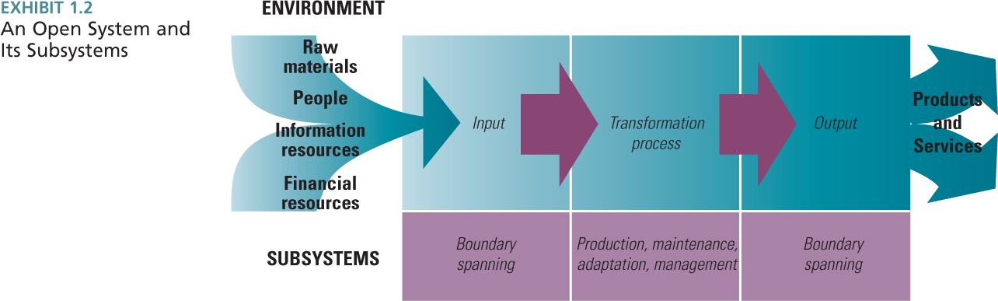

Understanding the Organization
- System: a set of interacting elements that acquires inputs from the environment, transforms them and discharges outputs to the external environment
- Subsystems: perform specific functions required for organizational survival, such as boundary spanning, production, maintenance, adaptation and management

(Henry Mintzberg’s) Organizational Configuration
- Technical Core: includes people who do the basic work of the organization, performs the production subsystem function and produces the product and service outputs of the organization (turning inputs into outputs)
- Management: Distinct subsystem, responsible for directing and coordinating other parts of the organization
- Top management – provides direction, strategy, goals and policies
- Middle management – responsible for implementation and coordination at the department level
- Technical Support: Helps the organization adapt to the environment through support of engineers and researchers and scanning the environment
- Administrative Support: Responsible for operations and upkeep of the organization through physical and human elements (i.e. HR and Operations)
- The five parts are interrelated and serve more than one subsystem function
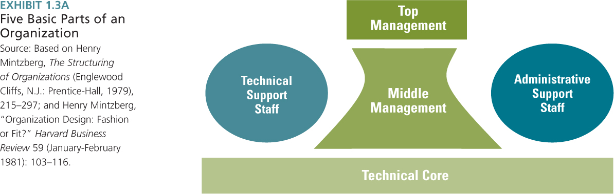
- Boundary spanning occurs when different people manage, coordinate and direct different parts of the system

Dimensions of Organizational Design
- Contextual dimensions: characterize the whole organization, including its size, technology, culture, environment and goals/strategy
- Can be confusing as they represent both the organization and the environment, so they are envisioned as overlapping elements including (see below for 5 components of contextual)
- Structural dimensions: provide labels to describe the internal characteristics of an organization – they create a basis for measuring and comparing organizations
- Formalization – amount of written documentation in the organization (including job descriptions, regulations and policy manuals)
- Measured by counting the # of pages of documentation
- Specialization/Division of Labour – the degree to which organizational tasks are subdivided into separate jobs
- If low, employees perform a wide range of tasks
- If high, employees perform only a narrow range of tasks
- Hierarchy of Authority – describes who reports to whom and the span of control for each manager (i.e. span of control)
- Centralization – the hierarchical level that has authority to make a decision
- When decision making is kept at top level, the organization is centralized
- When decisions are delegated to lower levels, it is decentralized
- Professionalism – the level of formal education and training of employees
- Considered high when employees require long periods of training to hold jobs in the organization
- Measured as average # of years of education
- Personnel Ratios – the deployment of people to various functions and departments including admin. ratios, clerical ratios, ratios of indirect to direct labour employees
- Determined by dividing the # of employees in a classification by the total # of organizational employees

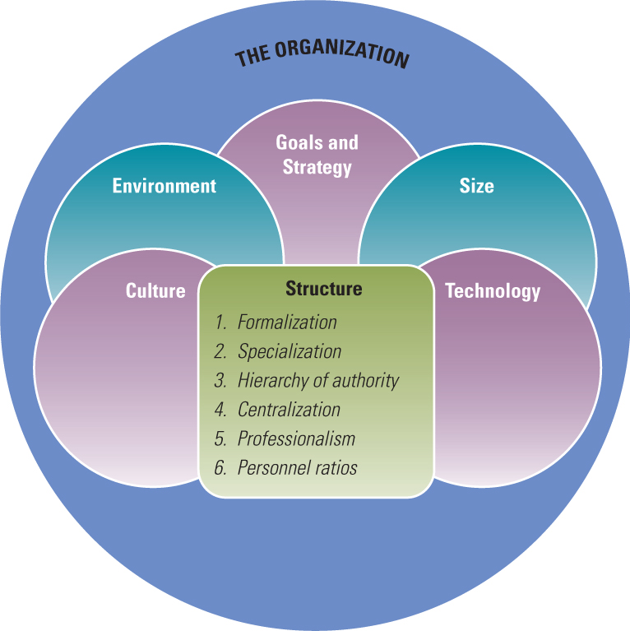
Contextual Dimensions
- The organizations goals and strategies (plan of action) define the purpose and competitive techniques give scope on operations and relationships
- The environment includes all elements with employees, customers and competitors (i.e. industry, government, customers and suppliers)
- Size is the magnitude (the # of people in the organization)
- Culture is the underlying, shared set of key values, beliefs, and norms
- Technology are the tools, techniques and actions used to transform inputs into outputs

Performance and Effectiveness Outcomes
- Managers need to adjust structural and contextual dimensions and organizational subsystems to most efficiently and effectively transform inputs into outputs and provide value
- Efficiency: refers to the (min.) amount of resources used to achieve the organization’s goals – based on the quantity of raw materials, money and employees necessary to produce a given level of output
- Effectiveness: the degree to which an organization achieves its goals
- Includes clear, focused goals and appropriate strategies to achieve
- Achieving effectiveness is not simple because different people want different things from the organization
- Stakeholder approach uses organizational activities to look at various organizational stakeholders and what they want from the organization
- Stakeholder is any group within or outside the organization that has a stake in the organization’s performance
- Research has shown that the assessment of multiple stakeholder groups is an accurate reflection of organizational effectiveness, with respect to organizational adaptability
- The environment causes many problems where all organizations are treated as similar – however this is not plausible
- Contingency means that one thing depends on other things, and for organizations to be effective, there must be a “goodness of fit” between their structure and the conditions in their external environment
- Contingency theory means “it depends”

Contemporary Organizational Design
- The perspectives of the past do not provide a road map for today’s organizations – today everyone is shifting from a mind-set based on mechanical systems to one based on natural and biological systems
- The environment for today’s organizations is not stable
- Chaos theory: suggests that relationships in complex, adaptive systems are non-linear and made up of numerous interconnections and divergent choices that create unintended effects and render the universe unpredictable
- In response, people are shifting from vertical systems, to horizontal collaboration to adapt to the changing environment
- Many managers are redesigning their companies toward something called the learning organization
- Learning organization: promotes communication and collaboration so that everyone is engaged in identifying and solving problems, enabling the organization to continuously experiment, improve, and increase its capability
- Based on equality, open information, little hierarchy, and a culture that encourages adaptability and participation, enabling ideas to bubble up from anywhere

Efficient Performance vs. Learning Organization
- From Vertical to Horizontal Structure
- Most common organization structure is one where all activities are grouped together by common work from bottom to top
- Little collaboration and coordination
- Promotes efficient production and in-depth skill development and there is a hierarchy of authority
- Problem: in a changing environment, the hierarchy becomes overloaded and they cannot react quickly enough
- In learning organization, the vertical structure that creates distance between managers at the top of the organization and workers in the technical core is disbanded and they work cross-functionally
- Self-directed teams are the fundamental work units
- Employees are continuously forming and re-forming into self-directed teams that work on specific projects
- From Routine Tasks to Empowered Roles
- Another shift is between the degree of formal structure and control placed on employees in the performance of their work
- Task: narrowly defined piece of work assigned to a person
- Tasks are broken down into specialized, separate parts
- Knowledge and control are centralized at the top of the organization and employees do what they are told
- Role: a part in a dynamic social system
- A role allows a person to use his or her own discretion and ability to achieve an outcome/meet a goal
- Roles may be redefined and adjusted
- From Formal Control Systems to Shared Information
- In young, small organizations, communication is generally informal and face-to-face (i.e. top leaders work directly with employees in the day-to-day operations of the business)
- When organizations grow large, the distance between top leaders and workers increases and formal systems are implemented to manage the complex information and detect deviations
- In a learning organization sharing of information keeps the organization functioning
- They strive to return to the condition of a small, entrepreneurial firm in which all employees have complete information about the company so they can act quickly
- Rather then using information to control employees, a manager’s job is to find ways to open channels of communication so ideas flow
- From Competitive to Collaborative Strategy
- In traditional, organizations are designed for efficient performance, strategy is formulated by top managers and imposed on the organization
- In learning organizations, the actions of the workforce contribute to strategy development (since they are all in touch with customers, suppliers, and new technology)

- From Rigid to Adaptive Culture
- For an organization to remain healthy, its culture should encourage adaptation to the external environment
- In learning organizations the culture encourages openness, equality, continuous improvement and change – people are aware of the whole system, how everything fits together and how the various part of the organization interact with one another

Levels of Analysis
- Level of analysis are four categories within an organization
- Individual level of analysis – basic building block
- Group level of analysis – departments (collection of individuals)*
- Organization level of analysis – collection of departments/groups***
- External environment – inter-organizational set, community**
- Organizational behaviour – micro approach to organizations because it focuses on the individuals within organizations as the units of analysis
- Examines concepts such as motivation, leadership style, and personality – cognitive and emotional differences among people
- Psychology of organizations
- Organization theory – macro approach to organizations because it analyzes the whole organization as a unit
- Concerned with people aggregated into departments and organizations, and with the differences in structure and behaviour at the organization level of analysis
- Sociology of organizations
- Mostly relevant to top management
- Meso (“in between”) theory – concerns the integration of both micro and macro levels of analysis
- Individuals/group affect the organization and vice versa

Chapter 2
The Role of Strategic Direction in Organizational Design
- An organization is created to achieve some purpose, which is often decided by the chief executive officer (CEO) and the top management team
- The “direction setting” process begins with an assessment of the opportunities and threats in the external environment (including the degree of change, uncertainty and resource availability) and assess internal strengths and weaknesses to show the distinctive aspects of the company in comparison to the industry – SWOT
- Organizational design is the administration and execution of the strategic plan whereas organization direction is the implementation through decisions of structural form, control, production, technology, HR policies and culture

Organizational Purpose
- A purpose may be referred to as the overall goals, or mission, but each organization establishes their own goals and objectives to help meet the overall goal/mission/purpose of the organization
- Mission: officially stated goals or ‘overall’ goal for an organization – i.e. the reason for the organization’s existence
- It describes the vision; its shared values and beliefs
- While the mission focuses on goals, the vision captures the core ideology and the envisioned future for an organization
- Main Purpose: to communicate to current and prospective employees, customers, investors, suppliers and competitors what the organization stands for and what it is trying to achieve
- Official Goals: define business operations and may focus on values, markets and customers that distinguish the organization
- Operative Goals: designate the ends sought through operating procedures of the organization and quantify official goals
- Overall Performance
- Expressed in terms of net income, earnings per share, or return on investment
- Resources
- Pertains to the acquisition of needed material and financial resources from the environment
- Involves: financing for new plants, less expensive sources, etc.
- Market
- Relate to the market share or market standing desired by the organization
- Market goals are the responsibility of marketing, sales and advertising departments
- Employee Development
- Refers to training, promotion, safety and growth of employees
- Innovation and Change
- Pertain to internal flexibility and readiness to adapt to unexpected changes in the environment
- Goals are often defined in terms of the development of specific new services, products or production processes
- Productivity
- Goals concern the amount of output achieved from available resources – ratio of inputs required to reach desired outputs

The Importance of Goals
- Goals and mission statement describe a value system for the organization; operative goals represent the primary tasks of the organization
- Official goals legitimize the organization
Competitive scope (market) | Competitive  Advantage | Strategy | Example
Broad | Low cost | Low-cost  Leadership | Wal-Mart
Broad | Uniqueness | Differentiation | Bull-Frog
Narrow | Low cost | Focused low-cost  Leadership | West-Jet
Narrow | Uniqueness | Focused Differentiation | Four Seasons
- Operative goals are more explicit and represent primary tasks
- Appropriate goals can act as a set of constraints on individual behaviour and actions so that employees behave within boundaries that are acceptable to the organization and larger society
- Goals also provide a standard for assessment: in terms of profits, units produced, degree of employee satisfaction, level of innovation or # of customer complaints standard for measurement

A Framework for Selecting Strategy and Design
- A strategy is a plan for interacting with the competitive environment to achieve organizational goals
- Some managers think of goals and strategies as interchangeable, but goals also define where the organization wants to go and how to get there
- The essence of formulating strategies is choosing whether the organization will perform different activities than its competitors or will execute similar activities more efficiently than its competitors do

Porter’s Competitive Strategies (see below)
- Michael Porter studied a number of businesses and described three competitive strategies: low-cost leadership, differentiation and focus

- Strategy
- Evaluate two factors: competitive advantage and competitive scope
- Differentiation
- Organizations attempt to distinguish their products or services from others in the industry
- May use advertising, distinctive product features, exceptional service or new technology to achieve a product perceived as unique
- Used to target customers who are not particularly concerned with price so it can be profitable
- Can reduce rivalry with competitors and fight off threat of substitute products because customers are loyal to the company’s brand
- Also requires costly activities to differentiate, such as product research and design and extensive advertising – need strong marketing abilities and creative employees
- Low-Cost Leadership
- Tries to increase market share by emphasizing low cost compared to competitors
- Aggressively seeks efficient facilities, pursues cost reductions and uses tight controls to produce products or services more efficiently than competitors
- The low-cost leadership is concerned with stability rather than taking risks or seeking opportunities for growth
- They can undercut competitors’ prices and still offer comparable quality and earn profits
- Helps defend against current competitors because customers cannot find lower prices elsewhere – helps prevent lost market share
- Focus
- The organization concentrates on a specific regional market or buyer group
- The company will try to differentiate or lower costs in a narrowly defined market
- Porter’s competitive strategy model has been criticized for being too generic and therefore of minimal use to managers. It also doesn’t account for organization’s that are successful even though they are not pursuing one particular strategy

Miles and Snow’s Strategy Typology
- Their typology is based on the idea that managers seek to formulate strategies that will be congruent with the external environment
- Prospector
- Purpose: to innovate, take risks, seek out new opportunities and grow
- Suited to a dynamic, growing environment, where creativity is the more important than efficiency
- Ex: Nike, Volvo, Google
- From Notes: learning orientation; flexible, fluid, decentralized structure, strong capability in research, values creativity, risk-taking, and innovation
- Defender
- Opposite of the prospector – rather than taking risks and seeking opportunities, they are concerned with stability and holding on to current customers (neither innovates, nor seeks to grow)
- Concerned with internal efficiency and control to produce reliable, high-quality products for steady customers
- From Notes: centralized authority and tight cost control, emphasis on production efficiency, low overhead, close supervision; little employee empowerment
- Analyzer
- The analyzer tries to maintain a stable business while innovating – lies between the prospector and defender
- They attempt to balance efficient production for current product lines with the creative development of new product lines
- From Notes: balances efficiency and learning; tight cost control with flexibility and adaptability, efficient production for stable product lines; emphasis on creativity, research, risk-taking for innovation
- Reactor
- Reactors respond to environmental threats and opportunities in an ad hoc fashion with no long range plan or given the organization
- Leads many companies to failure
- From Notes: no clear organizational approach; design characteristics may shift abruptly depending on current needs

Other Factors Affecting Organizational Design
- Strategy
- Type of environment (stable vs. ability to change)
- Organizational culture (values teamwork, collaboration, creativity and open)

Contingency Effectiveness Approaches
- Contingency focus on different parts of the organization – they bring resources in from the environment and those resources are transformed into outputs, which are delivered back into the environment
- The goal approach is concerned with the output side and whether the organization achieves its goals in terms of desired levels of output (control)
- The resource-based approach assesses effectiveness by observing the beginning of the process and evaluating whether the organization effectively obtains resources necessary for high performance (innovation)
- The internal-process approach looks at internal activities and assesses effectiveness by indicators of internal health and efficiency (performance)

Resource-based Approach
- Looks at the input side where it assumes the organization must be successful in obtaining and managing valued resources in order to be effective
- Indicators
- Bargaining position – the ability to obtain resources from the environment (i.e. financial, raw, human resources, knowledge, etc.)
- The abilities of the organization’s decision makers to perceive and correctly interpret the real properties of the external environment
- The abilities of managers to use tangible and intangible resources in day-to-day organizational activities
- The ability to respond to change
- Usefulness
- Useful when other indicators are difficult to obtain
- This approach only vaguely considers the organization’s link to the needs of customers in the external environment
- Critics have challenged that the approach assumes stability in the marketplace and fails to adequately consider the changing value of various resources
- It is the most valuable when measures of goal attainment cannot be readily obtained

Internal Process Approach
- Effectiveness is measured as internal health and efficiency – employees are happy and satisfied and department activities ensure high productivity
- Indicators
- Organization’s economic efficiency and human relations:
- Strong organizational culture and positive work climate
- Team spirit, group loyalty and teamwork
- Confidence, trust and communication between workers and management
- Sharing of relevant facts and feelings
- Rewards to managers for performance, growth and development of subordinates and effective work groups
- Usefulness
- Important because the efficient use of resources and harmonious internal functioning are ways to assess organizational effectiveness
- Only shortcoming is that total output and the organization’s relationship with the external environment are not evaluated

Goal Approach
- Effectiveness consists of identifying an organization’s outputs goals and assessing how well the organization has attained those goals
- Indicators
- Reflects activities the organization is actually performing (operative goals)
- Usefulness
- Measure in terms of profitability, growth, market share and return on investment
- Two problems are the issues of multiple goals and subjective indicators of goal attainment

An Integrated Effectiveness Model – Competing Values Model
- The competing values model tries to balance a concern with various parts of the organization rather than focusing on one part
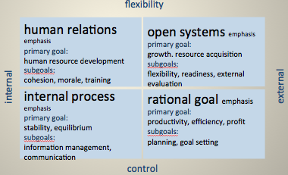
- Indicators (“RIHO”)
- Organizational focus: internal (management concern for the well-being and efficiency of employees) or external
- Organizational structure: stability vs. flexibility
- (1) Open-systems emphasis –flexible and external
- Goals: growth, resources acquisition
- Sub-goals: flexible structure, readiness, external evaluations
- (2) Rational-goal emphasis –stable/controlled and external
- Goals: productivity, efficiency, profit
- Sub-goals: planning, goal setting
- (3) Internal-process emphasis – stable/controlled and internal
- Goals: stability, equilibrium
- Sub-goals: information management, communication
- (4) Human-relations emphasis – flexible and internal
- Goals: human resource development
- Sub-goals: cohesion, morale, training
- Usefulness
- Integrates diverse concepts of effectiveness into a single perspective
- Second, it calls attention to criteria as management values exist

The Balanced Scorecard
- A comprehensive management control system that balances traditional financial measures with operational measures relating to the organization’s critical success factors
- Four perspectives: financial performance, customer service, internal business processes and the organization’s capacity for learning/growth
- Financial: “Do actions contribute to better financial performance?”
- Examples: Profit, Return on Investment
- Customer Service: “How well do we serve our customers?”
- Examples: Customer satisfaction and Customer loyalty
- Internal Business Process: “Do work processes add value for customers or shareholders?”
- Examples: Order-rate fulfillment, Cost per order
- Learning and Growth: “Are we learning, changing and improving?”
- Examples: Continuous improvement, employee retention
Chapter 3
Organizational Structure
- There are three key components for the definition of organizational structure:
- Designates formal reporting relationships, including the number of levels in the hierarchy and the span of control of managers and supervisors
- Identifies the grouping together of individuals into departments and of departments into the total organization
- Includes the design of systems to ensure effective communication, coordination and integration of efforts across departments
- These elements pertain to both vertical and horizontal aspects of organizing
- To see all activity being performed, an organization chart is used as a visual representation of a whole set of underlying activities and processes in an organization at a particular time

Information-Processing Perspective on Structure
- IF a structure does not fit the information requirements of the organization, people either will have too little information, or will spend time processing information that is not vital to their tasks (reducing effectiveness)
- While vertical linkages are designed primarily for control, horizontal linkages are designed for coordination and collaboration (reducing control)
- Vertical
- Specialized tasks
- Strict hierarchy, many rules
- Vertical communication and reporting systems
- Few teams, task forces, or integrators
- Centralized decision making (problems and decisions are funneled to top levels of the hierarchy for resolution)
- Horizontal
- Shared tasks, empowerment
- Relaxed hierarchy, few rules
- Horizontal communication: face-to-face
- Many teams and task forces
- Decentralized decision making (decision-making authority is pushed down to lower organizational levels)
- Linkage: extent of communication/coordination of organizational elements
- Vertical Information Linkages
- Vertical linkages are used to coordinate activities between the top and bottom of an organization, and are designed primarily for control of the organization
- Employees at lower levels should carry out activities consistent with top-level goals and top executives must be informed of activities and accomplishments at the lower levels
- (1) Hierarchical referral (chain of command) where if a problem arises, that employee can refer up to the next level and when the problem is solved it can be passed back down to lower levels
- (2) Rules and plans are put in place for problems that are repetitious so employees know how to respond without communicating directly with their manager (provide a standard)
- (3) Vertical information systems, which includes periodic reports, written information and computer-based communications
- Horizontal Information Linkages
- Horizontal linkages is the amount of communication/coordination horizontally across the organizational departments
- (1) Horizontal information systems, which is the use of cross-functional information systems to enable employees to routinely exchange information about problems, opportunities, activities and decisions encourages building relationships (“support system”)
- (2) Direct contact/liaison also works as a way to communicate roles between departments by having someone represent the department
- (3) Task forces for temporary issues to come together to solve problems and reduce the information load of the vertical hierarchy and then disbanding after their tasks is accomplished
- (4) Full time integrators used to liaison, but they are located outside the specific department (eliminates bias)
- (5) Teams can be used as permanent task forces to help create strong coordination over a long period of time

Organizational Design Alternatives
- Required Work Activities
- Reporting Relationships
- Departmental Grouping Options
- Departmental grouping affects employees because they share a common supervisor and common resources
- Functional grouping – places together employees who perform similar functions or work processes or who bring similar knowledge and skills to bear
- Divisional grouping – people are organized according to what the organization produces (people are grouped together under one executive to make one product)
- Multi-focused grouping – an organization embraces two structural grouping alternatives simultaneously (matrix)
- Horizontal grouping – organized around core work processes, the end-to-end work, information and material flows that provide value directly to customers (group working on a process)
- Virtual network grouping – organization is loosely connected through electronics and sharing of information (good for globalization)

Functional Structure
- Functional structure activities are grouped together by common function from the bottom to the top of the organization
- All human knowledge and skills for specific activities are consolidated
- Most effective when in-depth expertise is critical to meeting organizational goals, when the organization needs to be controlled and coordinated through vertical hierarchy
- Strength:
- Promotes economies of scale within functions – when all employees are located in the same place and share facilities
- Also promotes in-depth skill development for each employee
- Enables organization to accomplish functional goals
- Is best with only one or few products
- Weakness:
- Slow response to environmental changes that require coordination across departments (vertical hierarchy overload)
- Innovation is also slow and there are restricted goals
- Lead to poor horizontal coordination among departments
- Involves restricted view of organizational goals
- …With Horizontal Linkages
- Very few companies today can maintain a horizontal structure, therefore they compensate for vertical by installing horizontal linkages
- Example: Split into each “function” of marketing, engineering and manufacturing

Divisional Structure
- Divisional structure is when divisions can be organized according to individual products, services, product groups, major projects or programs, divisions, businesses or profit centres
- Grouping is based on organizational outputs
- Strengths:
- Suited to fast change in unstable environment
- Leads to customer satisfaction because product responsibility and contact points are clear
- Involves high coordination across functions
- Units adapt to differences in products, regions, customers
- Best in large organizations with several products
- Decentralizes decision making - horizontal
- Weaknesses:
- Eliminates economies of scale in functional departments
- Leads to poor coordination across product lines
- Eliminates in-depth competence and technical specialization
- Makes integration and standardization of product lines difficult
- Example: Split into different products (1, 2 and 3) with all “divisions” within each product specialization

Geographical Structure
- The most common structure in this category is geography since each region of the country may have distinct tastes and needs
- Each geographic unit includes all functions required to produce and market products or services in that region
- Strengths and weaknesses are similar to divisional organization characteristics – they can adapt to specific needs of its own region and employees identify with regional goals rather than with national goals

Matrix Structure (“The Last Resort”)
- The matrix structure can be used when both technical expertise (functional) and product innovation (division) and change are important for meeting organizational goals – answer when functional, divisional, geographical with horizontal linkage mechanisms will not work
- Unique characteristics is that both product division and functional structures are implemented simultaneously (managers have equal authority horizontal and vertical)
- Conditions for the Matrix
- Condition 1: Pressure exists to share scarce resources across product lines. The organization is typically medium sized and has a moderate number of product lines. It feels pressure for the shared and flexible use of people and equipment across products.
- Ex: organization not large enough to assign engineers full time, so they are assigned part-time to several products/projects
- Condition 2: Environmental pressure exists for two or more critical outputs, such as in-depth technical knowledge and frequent new products. This dual pressure means a balance of power is needed between the functional and division sides and dual-authority
- Condition 3: The environmental domain of the organization is both complex and unstable. Frequent external changes and high interdependence between departments require a large amount of coordination and information processing in both vertical and horizontal directions
- Under these three conditions, vertical and horizontal lines of authority must be given equal recognition
- Many organizations have found a balanced matrix hard to implement and maintain because one side of the structure often dominates
- In functional, bosses have primary authority and in division or product, project or product managers have primary authority
- Strengths:
- Achieves coordination to meet dual demands from customers
- Flexible sharing of human resources across products
- Suited to complex/frequent changes in unstable environment
- Provides opportunity for functional and product skill development
- Best in medium-sized organization with multiple products
- Weaknesses:
- Participants experience dual authority = frustrating and confusing
- Participants needs good interpersonal skills and extensive training
- Time consuming; frequent meetings and conflict-resolution sessions
- Will not work unless participants understand it and adopt it
- Requires great effort to maintain power balance


Product
Manager a

Product
Manager b

Product
Manager c

Product
Manager d

Director

Horizontal Structure
- Horizontal structure organizes employees around core processes and usually happens when re-engineering is happening
- (Business) Re-engineering means the redesign of a vertical organization along its horizontal workflows and processes
- A process is an organized group of related tasks and activities that transform inputs into outputs that create value for customers (order fulfillment, product development & customer service)
- When a company is re-engineered to a horizontal structure, all the people throughout the organization who work on a particular process have easy access to one another so they can communicate and coordinate their efforts
- Characteristics
- Structure is created around cross-functional core processes rather than tasks, functions or geography – boundaries between departments are obliterated
- Self-directed teams, not individuals, are the basis of organizational design and performance
- Process owners have responsibility for each core process
- People on the team are given the skills, tools, motivation and authority to make decisions central to the team’s performance – team members cross-trained to perform one another’s job and the combined skills are sufficient to complete a major task
- Teams have freedom to think creatively/flexibly to new challenges
- Customers drive the horizontal corporation – effectiveness is measured by end-of-process performance objectives, as well as customer satisfaction, employee satisfaction and financial contribution
- Strengths
- Promotes flexibility and rapid response to changes in customer needs
- Directs attention of everyone toward the production and delivery of value to the customer
- Each employee has a broader view of organizational goals
- Promotes a focus on teamwork and collaboration
- Improves quality of life for employees by offering them the opportunity to share responsibility, make decisions, and be accountable for outcomes
- Weaknesses
- Determining core processes is difficult and time consuming
- Requires changes in culture, job design, management philosophy and information and reward systems
- Traditional managers may not like giving up power/authority
- Requires significant training of employees to work effectively
- Can limit in-depth skill development
of Product
Operations
VP Design
VP Manuf.

VP Marketing

Controller

Procurement

Virtual Network Structure
- With a virtual network structure (modular) the firm subcontracts many or most of its major processes to separate companies
- How the Structure Works
- It may be viewed as a central hub surrounded by a network of outside specialists, where services are outsourced to separate companies that are connected electronically to a central office
- Free-market style to replace the traditional vertical hierarchy
- Strengths
- Enables small organizations to obtain talent and resources worldwide
- Gives a company immediate scale and reach without huge investments in factories, equipment or distribution facilities
- Enables the organization to be highly flexible to changing needs
- Reduces administrative overhead costs
- Weaknesses
- Managers do not have hands-on control over activities and employees
- Requires time to manage relationships and conflicts with partners
- Risk of organizational failure if partner fails/goes out of business
- Employee loyalty and organizational culture might be weak because employees feel they can be replaced by contract services

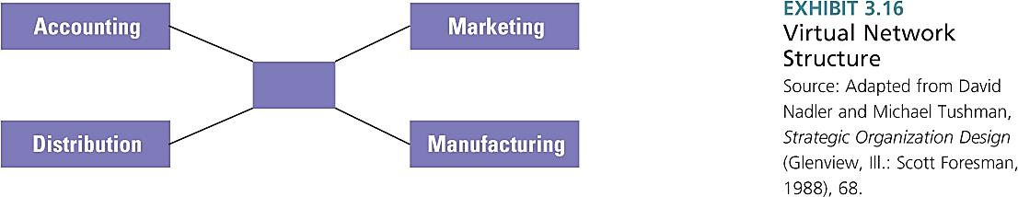
Hybrid Structures
- A hybrid structure that combines characteristics of various approaches tailored to specific strategic needs – combine functional, divisional, geographic, horizontal or network to take advantages of all the strengths
- Structural Alignment
- The most important decision that managers make about structural design is to find the right balance between vertical and horizontal control and coordination
- Vertical = efficiency and stability
- Horizontal = learning, innovation and flexibility
- Functional = task specialization, strict chain of command
- Virtual = rapid response and flexibility

team
3
team
2
team
1
top
management
team
team
3
team
2
team
1
customer
customer
process
owner
process
owner
product
planning
research
market
analysis
new product development process
material
flow
purchasing
analysis
procurement and logistics process

director and
process owner
director and
process owner
human
resources
strategy and
communication
finance
vice president and
general manager
teams
teams

Symptoms of Structural Deficiency
- Decision making is delayed or lacking in quality
- Poor quality: loaded hierarchy, delegation to lower levels, information may not reach the correct people, inadequate information linkage
- The organization does not respond innovatively to a changing environment
- Lack of innovation, no coordination, identification of customer needs
- Employee performance declines and goals are not being met
- Structure may not provide clear goals, responsibilities, etc.
- Too much conflict is evident
- Horizontal linkage mechanisms are inadequate

Chapter 4
The Environmental Domain
- The organizational environment is defined as all elements that exist outside the boundary of the organization that have the potential to affect all or parts of the organization
- The environment of an organization can be understood by analyzing its domain within external sectors
- Domain is an organization’s chosen field of action – it is the territory an organization stakes out for itself for its products, services and markets served
- Domain defines the organization’s niche and defines those external sectors with which the organization will interact to accomplish its goals
- Sectors/Subdivisions of the external environment contain similar elements (i.e. industry, raw materials, human resources)
- The sectors and a hypothetical organizational domain can be further subdivided into the task and general environment

Task Environment
- The task environment includes sectors with which the organization interacts directly and that have a direct impact on the organization’s ability to achieve its goals
- Typically includes: industry, raw materials, market sectors and HR and international sectors
- Industry
- Ex: Netflix has been a disruptive force in the home entertainment industry, virtually wiping out Blockbuster and creating their own shows
- Raw Materials
- A beverage market went out of business because a new company came in and introduced a recycling program
- Market Sector
- Appealing to “Generation C”, those born after 1990, who were defined by the Internet, mobile devices, social networking – this cohort of consumers wants a different approach to products than their grandparents did
- Human Resources
- Significant concern to every organization
- International Sector
- Part of the task environment because of globalization and intense competition (i.e. outsourcing)

General Environment
- The general environment includes sectors that might have an indirect impact on the daily operations of a firm (PEST- F)
- Includes: government, sociocultural, technology, and financial and economic
- Government (Political)
- Difference between EU legislation and NA legislation – one rule requires one to do something the other may not
- Sociocultural
- As birth rate declines, immigration is expected to be the primary source of labour
- Technology
- Blogs, social media, digital music, online shopping, etc.
- Financial Resources
- Venture capitalists, financial investors, etc.
- Economic Conditions
- How different countries suffer from economic meltdowns and how it influences countries not involved

International Context
- The international sector can directly affect many organizations and it has become extremely important in the last few years
- The distinctions between foreign and domestic operations have become increasingly irrelevant
- The growing importance of the international sector means the environment of all organizations – still face uncertainty domestically/globally

Environmental Uncertainty
- Certain dimensions boil down to two essential ways the environment influences organizations:
- The need for information about the environment
- The need for resources from the environment
- The environmental conditions of complexity and change create a greater need to gather information and to respond based on that information
- Environmental uncertainty applies primarily to those sectors that an organization deals with on a regular, day-to-day basis (generally focusing on sectors from the task environment how many elements the organization deals with regularly, how rapidly these elements change, etc.)
- Assessed based on degree of instability and degree of complexity
- Uncertainty means that decision makers do not have sufficient information about environmental factors, and they have a difficult time predicting external change

Simple-Complex Dimension
- The simple-complex dimension concerns environmental complexity, which refers to the # and dissimilarity of external elements
- The more external factors that regularly influence the organization and the greater number of other organizations in the domain, the greater the complexity
- “Complex” meaning an environment in which the organization interacts with and is influenced by numerous diverse and different external elements (vs. a simple which interacts with few similar)

Stable-Unstable Dimension
- The stable-unstable dimension refers to whether elements in the environment are dynamic
- A domain is stable if it remains the same over a period of months or years, or experience readily predictable change
- Under unstable, environmental elements shift abruptly and unexpectedly
- Although environments are more unstable for most organizations today, an example of a traditionally stable environment is a public utility

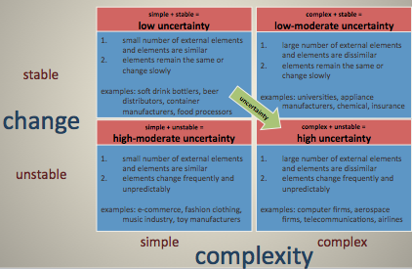
Framework

Adapting to Environmental Uncertainty
- Positions and Departments
- As the complexity and uncertainty in the external environment increases, so does the number of positions and departments within the organization, which in turn increases internal complexity
- Part of an open system – requires an employee or department to deal with each of their roles depending on their department
- Buffering and Boundary Spanning
- Buffering roles are used to absorb uncertainty from the environment
- They surround the technical core and exchange materials, resources and money between the environment and the organization (tangible)
- Many organizations have dropped the function of a buffer because they believe being well connected to customers and suppliers is more important than internal efficiency
- Boundary spanning roles link and coordinate an organization with key elements in the external environment and is primarily concerned with the exchange of information (intangible) to:
- (1) Detect and bring into the organization information about changes in the environment (incoming)
- (2) Send information into the environment that presents the organization in a favourable light (outgoing)
- A new approach to boundary spanning is “business intelligence”, which refers to the high-tech analysis of large amounts of internal and external data to spot patterns and relationships that are significant
- Another approach is “competitive intelligence”, giving top executives a systematic way to collect and analyze public information about rivals and use it to make better decisions
- Differentiation and Integration
- Differentiation is “the differences in cognitive and emotional orientations among managers in different functional departments, and the difference in formal structure among these departments”
- Success in each sector requires special expertise/behaviour
- Integration is the quality of collaboration among departments
- Sometimes integrators are called liaison personnel project managers, brand managers or coordinators
- Organic vs. Mechanistic Management Processes
- A mechanistic organization is one with centralized decision making at the top of the hierarchy
- Tasks are broken down into specialized, separate parts
- Tasks are rigidly defined
- There is a strict hierarchy of authority
- Knowledge and control of tasks are centralized at the top of the organization
- Communication is vertical
- An organic organization is used when hierarchy of authority is decentralized (not clearly structured)
- Employees contribute to the common tasks of the department
- Tasks are adjusted and redefined through employee teamwork
- There is less hierarchy of authority and control, and there are few rules
- Knowledge and control of tasks are located anywhere in the organization
- Communication is horizontal
- Planning, Forecasting and Responsiveness
- The point of shifting to an organic process is to enhance the organization’s ability to quickly respond to sudden changes in an uncertain environment
- With increasing environmental uncertainty, planning and forecasting become necessary

Resource Dependence
- Resource dependence means that organizations depend on the environment but strive to acquire control over resources to minimize their dependence
- Organizations become vulnerable if vital resources are controlled by other organizations – they want to be independent of them
- Organizational linkages require coordination and they reduce the freedom of each organization to make decisions without concern for the needs and goals of other organizations
- Dependence on shared resources gives power to other organizations – put pressure on vendors to lower costs

Controlling Environmental Resources
- Organizations maintain a balance between linkages with other organizations and their own independence through attempts to modify, manipulate or control other organizations
- Two strategies were adopted to manage resources in the external environment:
- Establish favourable linkages with key elements in the environment
- Ownership:
- Companies use ownership to establish linkages when they buy a part of or a controlling interest in another company
- A greater degree of ownership is obtained through acquisition or merger

- Formal Strategic Alliances
- When there is a high level of complementarity between business lines, geographical positions or skills of two companies the firms often make an alliance
- Contracts and joint ventures (creation of a new organization) may reduce uncertainty and come in the form of licence agreements or supplier arrangement
- Cooptation, Interlocking Directorates
- Cooptation occurs when leaders from important sectors in the environment are made part of an organization
- Interlocking directorate is a formal linkage that occurs when a member of the BOD of one company sits on the BOD of another company (creating a communication link between companies)
- Direct interlock – one individual is the link between two companies
- Indirect interlock – when a director of company A and director of company B are both directors of company C
- Executive Recruitment
- Transferring or exchanging executives also offers a method of establishing favourable linkages with external organizations
- This creates personal contacts between organizations that serve to reduce financial uncertainty and dependence for an organization
- Advertising and Public Relations
- Used to influence taste of consumers – important in competitive industries & industries w variable demand
- Public relations is used to cast an organization in a favourable light in speeches, press reports and on TV
- Shape the environmental domain
- Change the Domain
- The organization may decide to change markets, suppliers, employees and location to use
- They can also modify domains (mentioned earlier)
- Political Activity, Regulation
- Includes techniques to influence government legislation and regulation – used to erect barriers, hiring lobbyists and working with other organizations
- Trade Associations
- By pooling resources, organizations can pay people to carry out activities such as lobbying, legislators, influencing new regulations, developing public relations campaigns and making contributions

- Illegitimate Activities
- Represent the final technique to control the environment, using illegal activities to cope with resource scarcity

Organization-Environment Integrative Framework
- Theme 1: the amount of complexity and change in an organization’s domain influences the need for information and hence the uncertainty felt within an organization
- Greater information uncertainty is resolved through greater structural flexibility and the assignment of additional departments and boundary roles
- Theme 2: the scarcity of material and financial resources
- The more dependent an organization is on other organizations for those resources, the more important it is to either establish favourable linkages with those organizations or control entry into the domain – need for resources
- If dependence is low, they can maintain autonomy

Chapter 6
Motivations for Global Expansion
- Economies of Scale
- Economies of scale is all about expanding an organization’s scale of operations
- Through large-volume production, they were able to achieve the lowest possible cost per unit of production
- Economies of Scope
- Economies of scope refers to the number and variety of products and services a company offers, as well as the number and variety of regions, countries and markets it serves
- Low-Cost Production Factors
- Factors of production include obtaining raw materials and other resources at the lowest possible cost through global expansion
- This has led to over-seas trade, cheap labour and looking at lower costs of capital, sources of cheap energy and reduced government restrictions

Globalization Issues
- Stages of International Development
- Domestic Stage
- Company is domestically oriented, but managers are aware of the global environment and may want to consider initial foreign involvement to expand volume and realize economies of scale
- Strategic Orientation: Domestically oriented
- Stage of Development: Initial foreign involvement
- Structure: Domestic, plus export department
- Market Potential: Moderate, mostly domestic
- International Stage
- Company takes exports seriously and begins to think multi-domestically - Competitive issues in each country are independent
- Strategic Orientation: Export oriented
- Stage of Development: Competitive positioning
- Structure: Domestic, plus international division
- Market Potential: Large, multi-domestic
- Multinational Stage
- Company has extensive experience in a number of international markets and has established marketing, manufacturing, or research and development facilities in several foreign countries
- Strategic Orientation: Multi-national
- Stage of Development: Explosion
- Structure: Worldwide geographic, product
- Market Potential: Very large, multi-national
- Global
- The company transcends any single country and the business is more than just a collection of domestic industries; rather, subsidiaries are interlinked to the point where competitive position in one country significantly influences activities in another
- Strategic Orientation: Global
- Stage of Development: Global
- Structure: Matrix, trans-national
- Market Potential: Whole world

Global Expansion Through International Strategic Alliance
- Typical alliances include licensing, joint ventures, consortia
- A joint venture is a separate entity created with two or more active firms as sponsors – created to share development and production costs and penetrate new markets
- They can be with either customers or competitors
- Take advantage of a partner’s knowledge of local markets, achieve production cost savings through economies of scale, share technology or distribute new products and services
- A consortia is a group of independent companies (including suppliers, customers and competitors) that join together to share skills, resources, costs and access to one another’s markets
- A type of consortia, “the global virtual organization” is increasingly being used and offers a promising approach to meeting worldwide competition

Designing Structure to Fit Global Strategy
- A structure must fit its situation by providing information processing and focusing employees on specific functions, products or geographic regions
- Model for Global vs. Local Opportunities
- One dilemma managers face is choosing whether to emphasize global standardization vs. national responsiveness (i.e. be standard or affiliate globally/customizable)
- A “globalization strategy” means that product design, manufacturing and marketing strategy are standardized throughout the world
- Coca-Cola is a natural for globalization because only advertising needs to be tailored for different regions
- Services are less suitable for globalization
- Economic and social changes have prompted consumers to be less interested in global brands and more in favour of local
- A “multi-domestic strategy” means that competition in each country is handled independently of competition in other countries
- Encourages product design, assembly and marketing tailored to the specific needs of each country
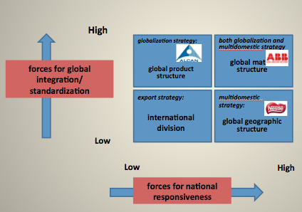

International Division
- As companies begin to explore international opportunities, they typically start with an export department that grows into an international division
- Has a status equal to other major departments or divisions within the company and is organized according to geographic interests
- It has a hierarchy to handle business in various countries, selling the products and services created by domestic divisions
- Although functional structures are used domestically, they are less frequently used to manage worldwide business – firms start with international department and later use product/geographic division structures
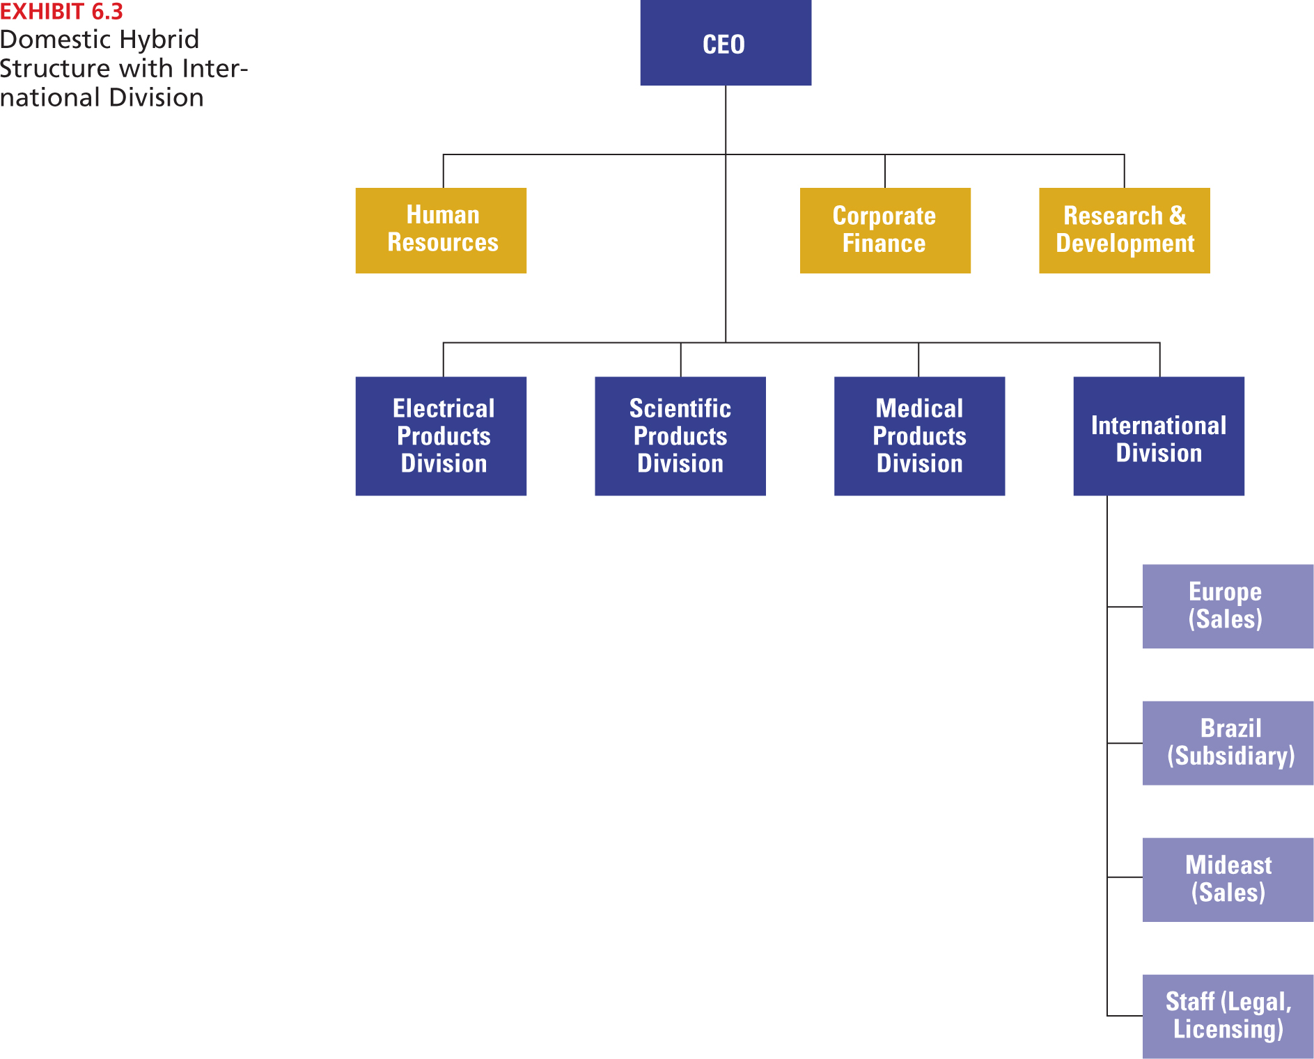

Global Product Structure
- Global product structure is when the product divisions take responsibility for global operations in their specific product area
- Managers in each “function” can focus on organizing international operations as they see fit and directing employees’ energy toward their own division’s unique set of global problems or opportunities
- The structure provides top management with a broad perspective on competition, enabling the entire corporation to respond more rapidly to a changing global environment
- Each division manager is responsible for planning, organizing and controlling all functions for the production and distribution of its products for any market around the world
- This model works best when products technology is similar and can be standardized for marketing worldwide
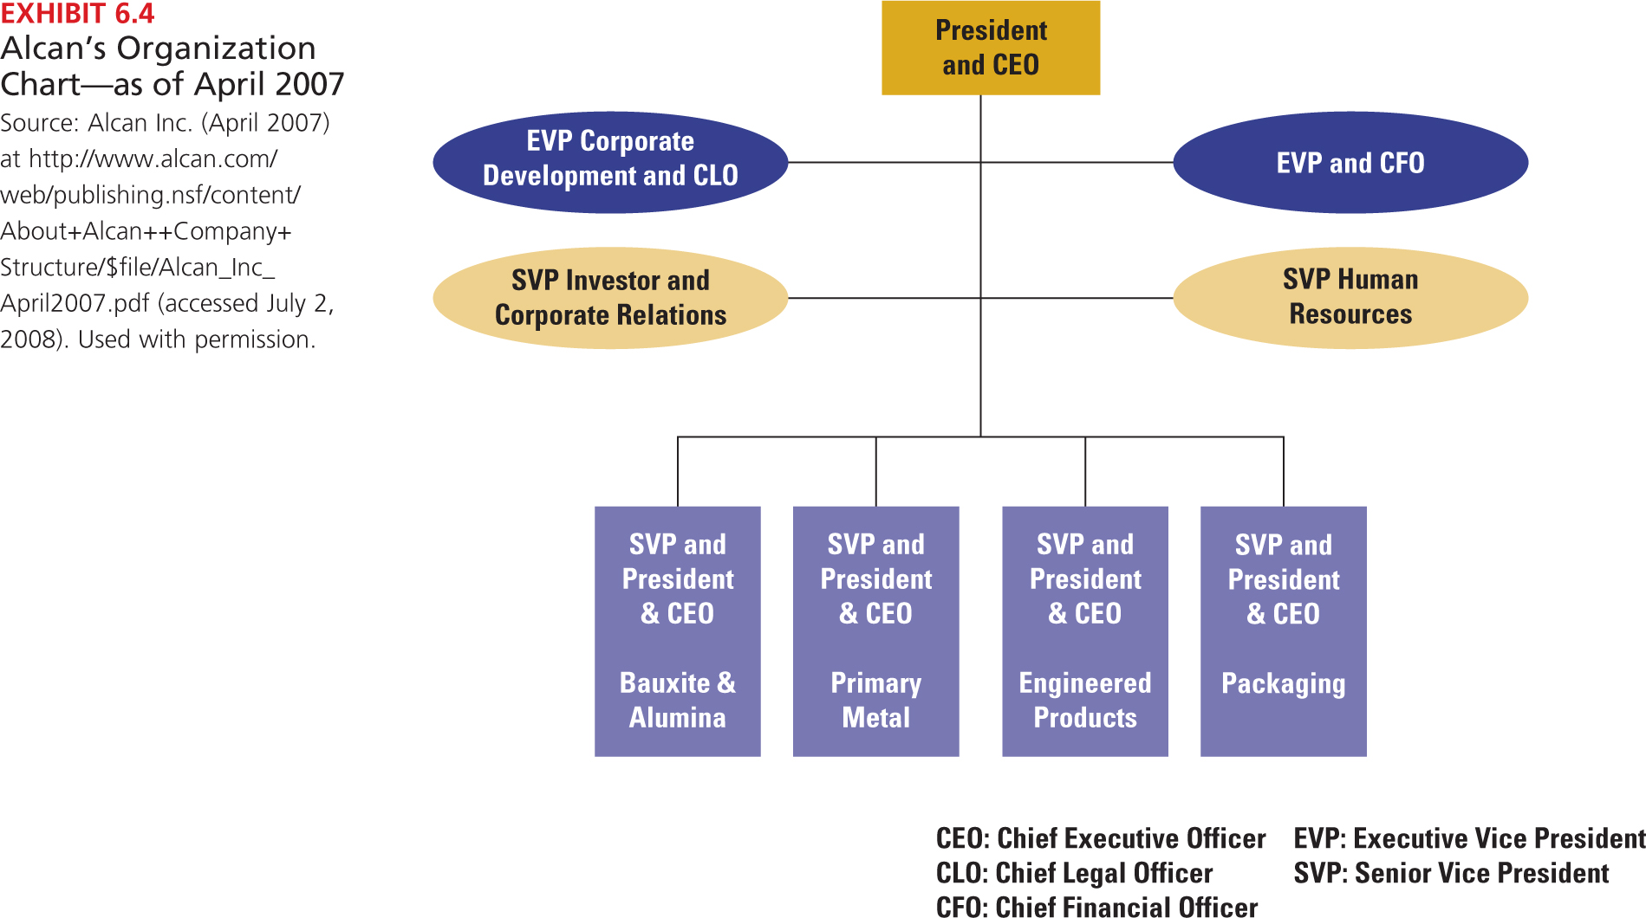
Global Geographic Structure
- In the global geographic structure the world is divided into geographic regions, with each geographic division reporting to the CEO, but each has control within its area
- Companies that use this type of structure have typically been those with mature product lines and stable technologies
- They must keep up with local needs and thus have the ability to customize their products (local and regional responsiveness)
- Problems are only encountered based on the autonomy of each regional division – difficult to do global planning since each division only looks to meet the needs of its own region

Global Matrix Structure
- A global matrix structure is similar to the matrix in Ch. 3, expect that for multinational corporations the geographic distances for communication are greater and coordination is even more complex
- Hybrid structures are typical in highly volatile environments
- Use when (1) Sharing resources
(2) Multiple outputs required
(3) Complex/unstable environment
- There are shared resources across countries, shared knowledge across divisions and will have an ability to adjust in unstable environments (customize and standardize)
- Problem: We have divisions (business areas) and geographic areas, but where are the functions (HR, marketing, finance)?
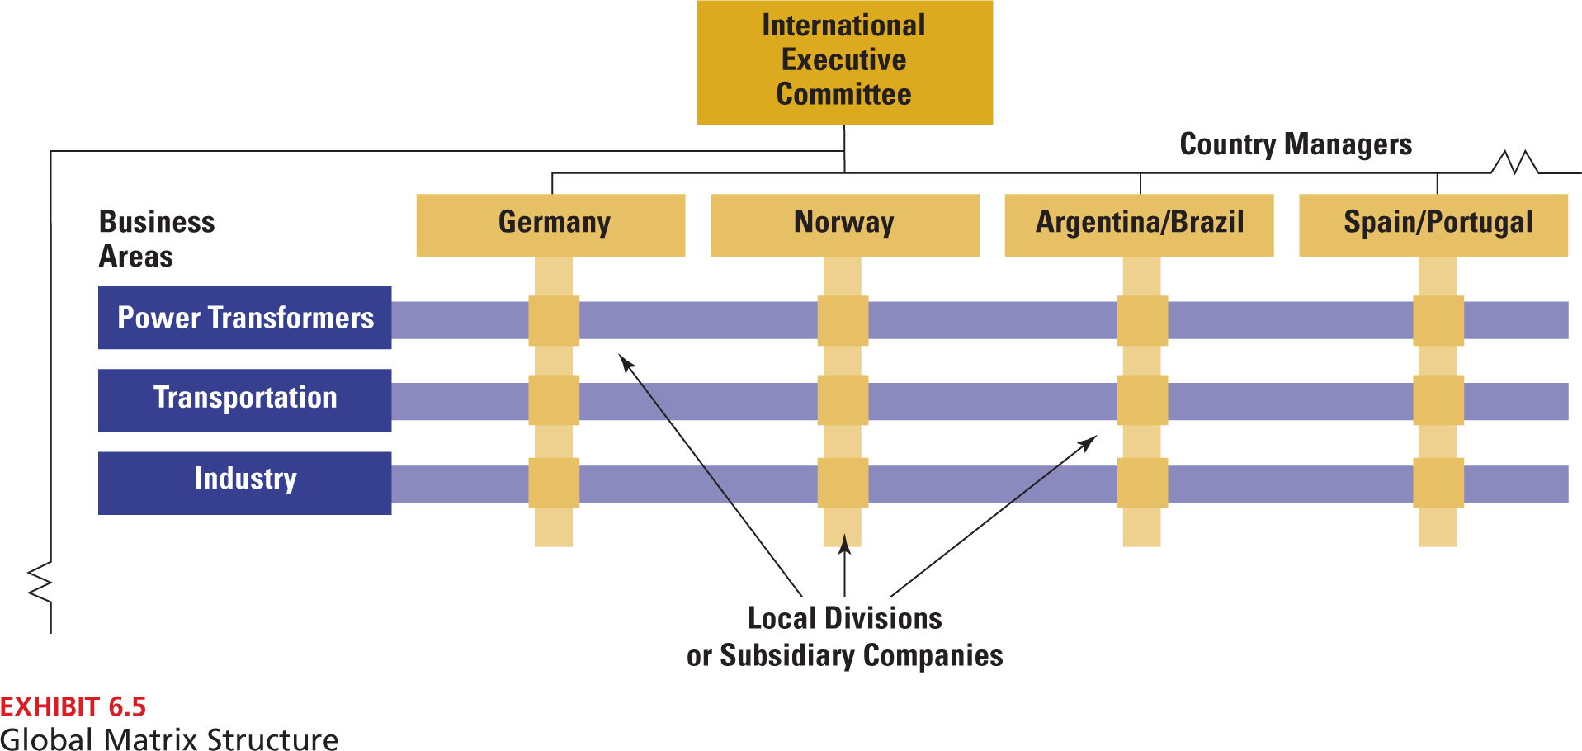

Building Global Capabilities
- The Global Organizational Challenge
- Increased Complexity and Differentiation
- When they enter the international market, they encounter a greater level of internal and external complexity than anything experienced on the domestic front
- Companies have to create a structure to operate in numerous countries that differ in economic development, language, political systems and government regulations
- Another factor that is increasing complexity for organizations is that a growing number of global consumers are rejecting the notion of homogenized products
- All the complexity is mirrored in greater organizational complexity

- Need for Integration
- As organizations become more differentiated, with multiple products, divisions, departments and positions scattered across numerous countries, managers face integration challenge
- Companies are divided by geographic distance, time difference, cultural values and language – must find ways to share information, ideas, new products and technologies
- Transfer of Knowledge and Innovation
- The diversity of the international environment offers extraordinary opportunities for learning and the development of diverse capabilities
- Organizations only tap a fraction of the potential that is available from the cross-border transfer of knowledge

Global Coordination Mechanisms
- Global Teams
- Global teams also called “transnational teams” are cross-border work groups made up of multi-skilled, multi-national members whose activities span multiple countries
- Typically teams from different countries meet face-to-face to share information about technologies, ideas and learning
- Advantages:
- First, teams help companies address the differentiation challenge, enabling them to be more locally responsive by providing knowledge to meet the needs of different regional markets, consumer preferences and political/legal systems
- Provide integration benefits, help organizations achieve global efficiencies by developing cost advantages & standard designs
- Finally, these teams contribute to continuous organizational learning knowledge transfer and adaptation on a global level
- Stronger Headquarters Planning
- Headquarters planning, scheduling and control to keep the widely distributed pieces of the global organization working together and moving in the same direction
- With strong leadership, highly autonomous divisions can act like independent companies…not coordinated parts of a global whole
- Specific Coordination Roles
- Creating specific organizational roles or positions for coordination is a way to integrate all the pieces of the enterprise
- Some organizations create formal network coordinator positions to coordinate information and activities related to key customer accounts
- Advantages:
- Cost savings, Better decision making, Greater revenues, Increased innovation
Cultural Differences in Coordination and Control
- National Value Systems

Globe Dimensions | Characteristics
Power Distance | Extent to which a society expects power to be distributed equally
Gender Egalitarianism | Degree to which society discourages gender role differences and inequality
Uncertainty Avoidance | Extent to which society relies on rules, procedures, and policies to minimize ambiguity and unpredictability of the future
Collectivism (Institutional) | Degree to which a society encourages and rewards collective action and resource distribution
Collectivism (In-Group) | Extent to which members express pride and cohesiveness in their relations with others
Future Orientation | Extent to which members engage in such behaviours as planning for and investing in the future
Assertiveness | Extent to which members are confrontational toward each other
Performance Orientation | Extent to which a society rewards individuals for innovation
Humane Orientation | Extent to which a society encourages altruism and caring for others

- Deal-focused vs. relationship-focused deal-focused individuals approach business in an objective and impersonal way and relationship-focused believe in building close personal relationships as the appropriate way to conduct business
- Informal vs. formal place low value on status and power vs. hierarchical and status conscious
- Rigid time vs. fluid time flexible about time scheduling
- Expressive vs. reserved Can create a major communication gap where expressive tend to talk louder and use hand gestures vs. reserved who interpret those actions as hostile

Three National Approaches to Coordination and Control
- Centralized Coordination in Japanese Companies
- When expanding, Japanese companies have developed coordination mechanisms that rely on centralization
- Enables them to leverage the knowledge and resources located at the corporate centre, attain global efficiencies and coordinate across units to obtain synergies
- Strong structural linkages to avoid overloading decision making
- Negative: Quality of decision making may suffer, making it difficult to understand and respond to local needs in each region
- European Firms’ Decentralized Approach
- International units tend to have a high level of independence and decision-making autonomy - decentralized
- Companies rely on a strong mission, shared values, and informal personal relationships for coordination
- Careful emphasis on selection, training and development of key managers with a focus on local markets and meeting diverse needs
- Negative: Cost of ensuring training and development
- North American Coordination and Formalization
- These organizations have delegated responsibility to international divisions, yet retained overall control of the enterprise through the use of sophisticated management control systems and the development of specialist headquarters
- Decision making is based on objective data, policies and procedures, which provides for many operating efficiencies
- Negative: involves larger headquarters and higher costs

The Transnational Model of Organization
- The transnational model represents the most advanced kind of international organization – many diverse units and organizational coordination with mechanisms for integrating the varied parts
- Rather than building capabilities primarily in one area, the transnational model seeks to achieve all three simultaneously (global efficiency, national responsiveness and global learning)
- Maximization goals are normally mutually exclusive, but with this unit you can tackle the challenges at the same time
- Similar to horizontal structure (flexible, decentralized)
- Distinctions:
- Assets and resources are dispersed worldwide into highly specialized operations that are linked together through interdependent relationships – widely distributed to help the organization and respond to stimuli
- Materials, people, products, ideas, resources and information are continually flowing among the dispersed parts of the integrated network
- Structures are flexible and ever-changing operates on a principle of flexible decentralization
- Subsidiary managers initiate strategy and innovations that become strategy for the corporation as a whole recognize each of the worldwide units as a sources of capabilities and knowledge used to benefit the organization
- Unification and coordination are achieved primarily through organizational culture, shared vision and values and management style, rather than through formal structures and systems

Chapter 10
Innovate or Perish: The Strategic Role of Change
- One theme is that organizations must keep up with changes:
- The results are decentralized structures, improved inter-organizational relationships, improved horizontal coordination and the creation of network structures

Incremental vs. Radical Change
- An incremental change represents a series of continual progressions that maintain the organization’s general equilibrium and often affect only one organizational part
- A radical change breaks the frame of reference for the organization, often transforming the entire organization
- Ex: An incremental change is the implementation of a sales team in the marketing department, whereas a radical change is shifting the entire organization from a vertical to a horizontal structure
- Incremental change occurs mainly through the established structure and management process and it may include technology improvements or product improvements
- Radical change involves the creation of a new structure and new management processes – the technology is likely to be breakthrough and new products thereby created will establish new markets
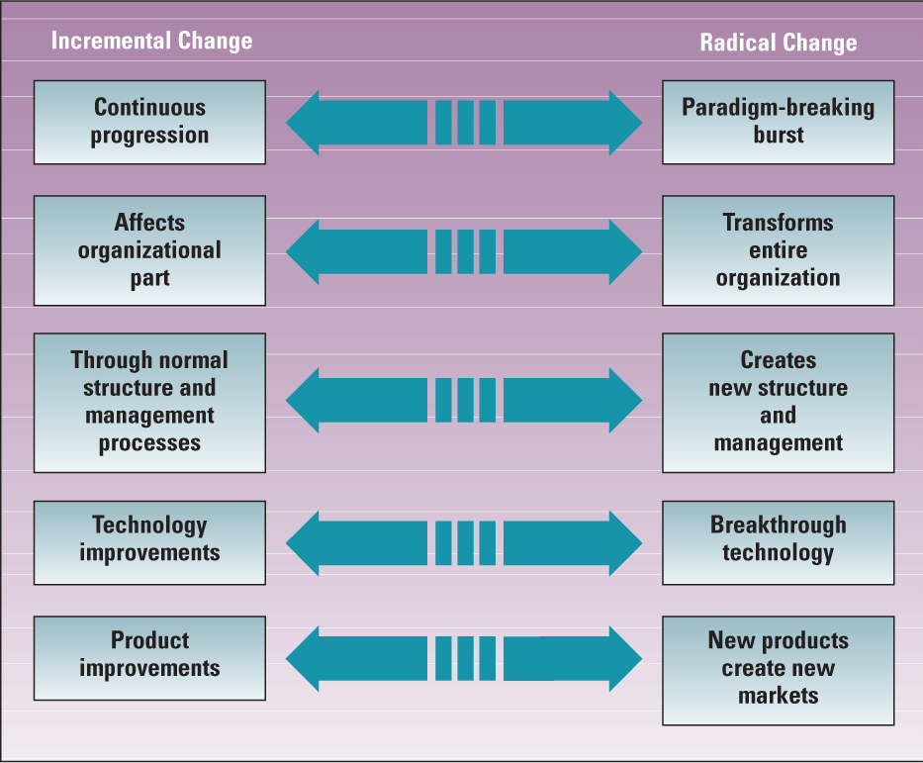

Strategic Types of Change
- Product and service change: product or service outputs of an organization
- New products include small adaptations of existing products or entirely new product lines – bottom up
- They are designed to increase market share or to develop new markets, customers, or clients
- Strategy and structure change: administrative domain in an organization
- Involves the supervision and management of the organization
- Changes in organizational structure, strategic management, policies, reward systems, labour relations, coordination devices, management information and control systems, and accounting and budgeting
- They are usually top-down – mandated by top management
- Culture change: values, attitudes, expectations, beliefs, abilities & behaviour
- Pertains to changes in how employees think
- They are a mind-set rather than technology, structure or products
- Technology change: changes in an organization’s production process
- Includes knowledge and skill base, with distinctive competence
- Changes designed to produce more efficiently/ greater volume
- Changes in technology involve the techniques for making products and services – include work methods, equipment and workflow
- Works in top-down management style
- All four types of change are interdependent – i.e. a change in one often means a change in another

Elements for Successful Change
- Organizational change is considered the adoption of a new idea or behaviour by an organization
- Organizational innovation is the adoption of an idea or behaviour that is new to the organization’s industry, market or general environment
- The first organization to introduce a new produce is considered the innovator and organizations that copy are considered to adopt changes
- If elements are missing, the Change Process will fail. Elements include:
- Ideas (creativity)
- No company can remain competitive without new ideas; change is the outward expression of those ideas
- Can come from within or outside the organization
- Creativity is the generation of novel ideas that may meet perceived needs or respond to opportunities
- *Ensure employees have plenty of opportunities to interact with people different from themselves, give employees time and freedom for experimentation and support risk taking and making mistakes
- Needs (perceived problems/opportunities)
- Ideas are not considered unless there is a need for change
- A perceived need occurs when managers see a gap between actual performance and desired performance in the organization – they try to establish a sense of urgency
- A study suggests that organizations that encourage close attention to customers and market conditions and support entrepreneurial activity produce more ideas and are more innovative
- Adoption
- When decision maker choose to proceed with proposed idea
- Implementation
- Occurs when organization members use a new idea, technique or behaviour (i.e. new materials acquired, new training, etc.)
- Resources
- Human energy and activity are required to bring about change
- Involves time, resources, developing a proposal, etc.

Technology Change
- Organizations face a contradiction when it comes to technology change, because the conditions that promote new ideas are generally not the best for implementing for routine production
- An innovative organization is characterized by flexibility and empowered employees and the absence of rigid work rules
- Organic organizations contribute to people’s freedom to be creative and introduce new ideas (also encourage bottom up processes)
- Mechanistic structure, by contrast, stifles innovation with its emphasis on rules and regulations, but is often the best structure for efficiently producing routine products
- Challenge is to achieve both organic and mechanistic ambidextrous

The Ambidextrous Approach
- The ambidextrous approach incorporates structures and management processes that are appropriate to both the creation and the implementation of innovation/efficiency
- Looks to take elements that are important for exploring new ideas vs. the design elements that are most suitable for exploiting current capabilities
- Exploration: encouraging creativity and developing new ideas
- Exploitation: implementing ideas to produce routine products
- Organizations that use an ambidextrous approach by designing for both exploration and exploitation are significantly more successful in launching new products and services
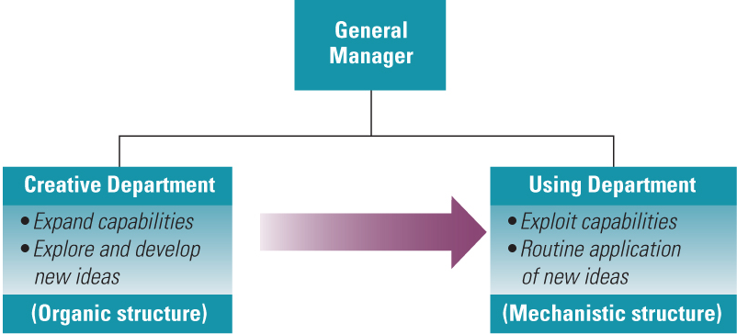

Techniques for Encouraging Technology Change (Ways to Create Ambidextrous)
- Switching Structures
- Means an organization creates an organic structure when such a structure is needed for the initiation of new ideas
- Finding creative ways to be ambidextrous, establishing organic conditions for developing new ideas in the midst of more mechanistic conditions for implementing and using those ideas
- Separate Creative Departments
- Staff departments, such as R&D, engineering, design and systems analysis, create changes for adoption in other departments
- Departments that initiate change are organically structured to facilitate the generation of new ideas and techniques
- Departments that use those innovations tend to have a mechanistic structure more suitable for efficient production
- Another type of creative department is the idea incubator, which is used to facilitate the development of new ideas within the organization
- Gives people a place to go rather than having to shop a new idea all over the company and hope someone will pay attention
- Venture Teams
- A technique used to give free rein to creativity within organizations
- Venture teams are often given a separate location and facilities so they are not constrained within a large company
- Used to free creative people from the bureaucracy of a large corporation (i.e. Google X)
- Many companies use Internet-based operations to give teams freedom and authority to explore and develop new technology
- Skunkworks is a separate, small, informal, highly autonomous and often secretive group that focuses on breakthrough ideas for the business – “mosh pits of creativity”
- The essence is that highly talented people are given the time and freedom to let creativity reign
- New-venture funds provide financial resources for employees to develop new ideas, products or businesses
- Corporate Entrepreneurship
- Attempt to develop an internal entrepreneurial spirit, philosophy and structure that will produce a higher-than-average number of innovations
- May involve the use of creative departments and new venture teams, but it also attempts to release the creative energy of all employees
- An important outcome is to facilitate idea champions – provide the time and energy to make things happen
- They right to overcome resistance to change and to convince others of the merits of new ideas
- They do not need to be within the organization (i.e. customers)
- Two types:
- Technical champion (product champion)
- Person who generates or adopts and develops an idea for a technological innovation and is devoted to it, even to the extent of risking position or prestige
- Management champion
- Acts as a supporter and sponsor to shield and promote an idea within the organization (they have the authority to get the idea a fair hearing and ability to allocate resources to it)

New Products and Services
- New Product Success Rate
- Experts estimate that about 80% of new products fail upon introduction and another 10% disappear within five years
- To be successful, the product has to pass three stages – technical competence, commercialization and market success
- Of all projects that get started, less than one third were fully marketed and commercialized
- Only 12% achieved economic success – i.e. one project in eight returned a profit to the company
- Reasons for New Product Success
- Studies indicate that innovation success is related to collaboration between technical and marketing departments – they are technologically sound and tailored to customer needs
- Successful innovating companies make more effective use of outside technology and outside advice, even though they do more work in-house
- Horizontal Coordination Model
- Specialization
- Specialization component means that the personnel in R&D, marketing and production are highly competent but they are differentiated in terms of goals, skills and attitudes
- Boundary Spanning
- Each department involved with new products has excellent linkage with relevant sectors in the external environment
- Horizontal Coordination
- The technical, marketing and production people share ideas and information – the decision to launch a product is then jointly a decision among all three departments
- Achieving Competitive Advantage: The Need for Speed
- Time Based Competition: means delivering products and services faster than competitors, giving companies a competitive edge

Strategy and Structure Change
- Problem: convincing people to follow new structures/systems
- Solution/Condition to Make Change Easier: The Dual Core Approach
- Compares administrative and technical changes
- Administrative changes is the design and structure of the organization itself (restructuring, downsizing, teams, control systems, information systems and departmental grouping)
- These changes occur less frequently
- Above the technical core in the hierarchy
- Technical core is concerned with the transformation of raw materials into organizational products and services, and involves the environmental sectors of customers and technology
- If change is coming from Administrative Structure – mechanistic design makes life easier to push things top-down
- If change is coming from Technological Core – organic design makes creativity and new ideas easier to push bottom-up
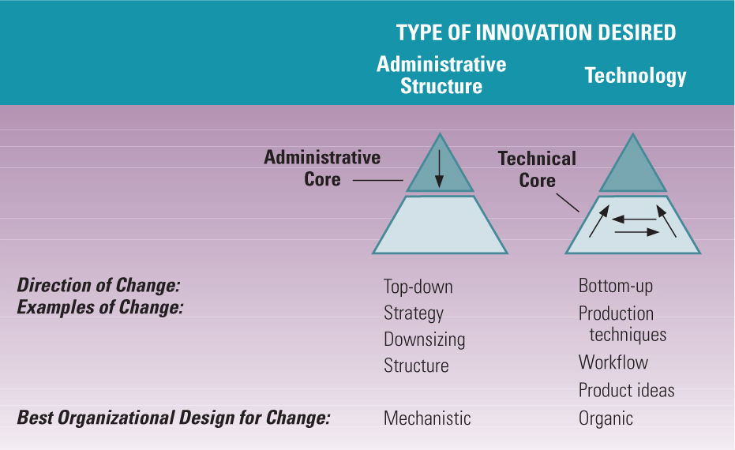

Culture Change
- Changes in areas such as strategy, structure, technologies and products do not happen on their own – they change because of changing people
- Sometimes achieving a new way of thinking requires a focused change in the underlying cultural values and norms
- Changing organization culture can renew commitment and empower
- Forces for Culture Change
- Re-engineering and Horizontal Organizing
- Involves redesigning a vertical organization along its horizontal workflows (workers need to accept changes)
- Involves mutual trust, risk taking and tolerance for mistakes
- Diversity
- New implementation: recruiting, mentoring, promotion methods, diversity training, tough policies, new benefits
- However if the underlying culture does not change, all other efforts to support diversity will fail
- The Learning Organization
- Involves breaking down boundaries both within and between organizations to create companies that are focused on knowledge sharing and continuous learning
- Structures becomes horizontal and empower teams, there are fewer rules and procedures, and everyone plays a role in the strategy all involve new values/attitudes of working together, which cannot exist without a culture that supports it

- Organization Development Interventions
- Organization development focuses on the human and social aspects of the organization as a way to improve the organization’s ability to adapt and solve problems
- It emphasizes: values of human development, fairness, openness, freedom from coercion and individual autonomy (learning enviro)
- Techniques:
- Large Group Intervention
- Involves 50-500 people and lasts for several days, which brings together participants from all parts of the organization in an off-site setting to discuss problems and opportunities and plan for change
- Team Building
- Promotes the idea that people who work together can work as a team – to discuss conflict, goals, decision making, communication, creativity and leadership
- Interdepartmental Activities
- Representatives from different departments are brought together in a mutual location to expose problems or conflicts, diagnose the causes and plan improvements in communication and coordination

Strategies for Implementing Change
- Leadership for Change
- Leaders must have personal qualities, skills and methods needed to help their companies remain competitive – “change leaders”
- Leadership style of the top executives sets the tone for how effective the organization is at continuous adaptation and innovation
- Change commitment process
- First, preparation, employees hear about the change through memos, meetings, speeches or personal contact and become aware that the change will directly affect their work
- Second, acceptance, leaders should help employees develop an understanding of the full impact change will have (+ and -)
- Third, commitment, involves the steps of installation (i.e. the trial process for change) and institutionalization (viewing the change as something new but normal)
- Barriers to Change
- Excessive focus on costs
- Failure to perceive benefits
- Lack of coordination and cooperation
- Uncertainty avoidance
- Constant communication needed so employees know what is going on and how it affects their jobs
- Fear of loss
- Managers and employees may fear the loss of power and status
- Techniques for Implementation
- Establish a sense of urgency for change
- Establish a coalition to guide the change
- Create a vision and strategy for change
- Find an idea that fits the need
- Develop plans to overcome resistance to change
- Alignment with needs and goals of users
- Communication and training
- An environment that affords psychological safety
- Participation and involvement
- Forcing and coercion (last resort)
- Create change teams
- Foster idea champions

Dyer Chapter 1 – Critical Thinking
Introduction
- Sometimes questioning our beliefs about what we read comes naturally, but other times we may accept ideas and statements uncritically
- “Critical” the way we question, analyze and make sense of things
- Critical thinkers are: self-aware, curious and independent
- They work at knowing their own biases and can name the strategies they are using when they make judgments
- They explore issues by challenging ideas that seem obvious and seek new viewpoints to extend their knowledge
- They listen to others and learn from them, but use the learning to develop their own opinions and make personal judgments

Critical Thinking about Business
- Many believe this is the “age of information” based on the dominant discourses of economics, global markets, financial investments, consumer awareness and unemployment
- However, the collapse of Enron, the financial crisis of 2007-2010 and public reactions to business scandals have contributed to a decreased interest in the writings of managements gurus and retired executives
- Based on the volume of information, critical thinking skills play a vital role in helping us to sift through the multitude of ideas
- Critical thinkers recognize that the same idea can appear in radically different forms and search for commonalities among diverse texts
- It is also said that this is the “age of the expert” – where we count on experts to tell us how to look for a job, how to invest, how to deal with people at work, etc.
- The problem is that experts ideas contradict one another

Buyer Beware
- Many best-selling books offer expert advice based on successful executives and companies, but “caveat emptor” (buyer beware), the ideas are not necessarily reliable, valid or scientifically sound
- Purchase may be based on popularity, driven by marketing technique OR could be based on insecurities from managers buying the books
- A critical thinker does more than just passively accept the ideas of others, even those of business experts

The Sponge
- A “sponge” is a reader who soaks up information and knowledge
- It is preliminary to the next step – evaluating and judging critical idea

Dimensions of Critical Thinking
- The critical thinking process can be divided into five major parts:
- Purposeful – when we use strategies, we are trying to settle a problem, develop an answer to a question or decide appropriate action thinking must have a significant and useful purpose
- Quality – the information should be supported and accurate
- Viewpoints – evidence selected can be powerfully shaped by our basic assumptions and beliefs
- Cause and Effect – involves judging the validity of relationships
- Expression of Ideas – looks at how key concepts are presented, how evidence is managed and how words can sway judgment (persuasion)

Example
- Richard explained that based on current economic conditions, since other companies are doing it, to keep up with competition he would be willing to work “under the table” and avoid paying taxes with customer orders
- Facts: Underground economies represent between 5-20% of GDP based on the expansion of small businesses and increased tax levels
- Questions to think about:
- If taxes are reduced, will compliance increase?
- How do his personal expenses relate to this argument?
- What is the position of the author in this piece?
- Once you have begun critically thinking, you can decide to (1) believe the views of the author, (2) accept them cautiously and seek out further information or (3) reject the ideas

Critical Thinking and Effective Communication
- An important outcome of developing critical thinking is to improve your own argument when you write or speak stating views clearly and providing appropriate justification for them
- Careful attention to words can make our writing clearer and more persuasive

Dyer Chapter 2 - Claims
Introduction
- If you are going to evaluate an argument, you must identify the “claim”
- Claim: the major conclusion of a piece of writing that the author is trying to persuade you to accept
- If the claim is implicitly stated in the author’s statement, you may have to state the claim in your own words
- A claim can be found in the beginning, in the title or headline of a case
- Certain words such as “therefore, the data shows, etc.” can be used to indicate a claim cue words
- Most of the other statements in the article will be evidence (anecdotes and statistics are provided in support of the claim)

Uncontested Claims
- Conditions of accepting a claim without challenge, even if no evidence is provided:
- We don’t contest claims that are consistent with our own experiences and observations, things we have seen, heard or touched before
- Some claims appear to be facts that are independent of interpretation (i.e. events)
- Areas in which there is agreement among experts or strongly supported general claims that are common sense
- Technical or mathematical claims are accepted without challenge
- As new information arises, we are free to re-examine the situation and challenge claims that we no longer believe to be true

Contestable Claims
- When a claim does not fall into one of the categories, we question its truth using our critical thinking strategies (i.e. not common knowledge)
- Ex: Political commentaries and editorials in newspapers
- The problem is that contestable claims are more interesting and significant than claims that stand without challenge, which stimulates curiosity and causes people to think about things in new ways
- On occasion, contestable claims are presented as if they were facts (“The fact is…” or “There is no doubt…”)
- Simply labeling a claim as a fact does not mean that it is an uncontested claim everyone has varying opinions
- When making contestable claims, authors provide evidence to justify their positions and our job is to examine and evaluate the justifications these types of claims cannot stand on their own

Example – “Self-praise is no praise at all”
- The author says that you need to toot your own horn and that it is a ‘dog-eat-dog’ world – that you have to give your own praise and tell people about it, in order to be successful in the new competitive environment
- While all the comments were colorful, they are not intelligible outside of the context of this passage and none of them provide a summary of the main point

Presenting Claims
- We have said that a good statement of the author’s claim is the first step to evaluating it critically – state the essence in an accurate and concise manner
- For longer texts, where a single sentence will not suffice, authors may provide a list of important concepts and a series of propositions about how these concepts are related
- This can also be shown in a concept map through a picture, boxes and arrows and figures that highlight the main issues and show relationships (i.e. geographical maps, diagrams, creative images)
- To develop a concept map:
- Start with a list of main ideas to be represented, create subheadings and headings with single words and short phrases
- Structure can be boxes and arrows, pictorial images, timelines, tree and branch organization, overlapping circles, etc.
- It may be highly individual – images and symbols that are meaningful to you (colours and shapes used judiciously)
- If intended for illustration, make sure it is well labeled and that the significance of the images are described in the text

Writing Effectively
- Critical thinking about claims has implications for your own writing – put the claim near the beginning or end of your report and use the cue words

Exercises – Finding Claims (pg. 18 – 19)
- Chartered Accountant
- “Productivity is what education is all about” before entering university, every young person should spend a year working in their chosen discipline so their knowledge in school can be applied
- “After all”, “socializing phenomenon”, “it is my view”
- Contestable – may be more than one reason why unsuccessful
- Professor
- Expert in field – Exeter University in England, research in sport/arts
- “As a result of studies”, “…and his colleagues”, “
- “The notion of innate ability is a myth”… “Rather success is determined by training, motivation and long hours of practice”
- Unproblematic
- Jam
- Expert study – “professor…at the Columbia Business School in New York”…“research”
- “Too much choice, according to the research…” will make people buy less real-life examples such as career, music, cereal, etc.
- Contestable – may be another reason they didn’t buy
- Bank
- “According to a study…bankers are reporting that these new duties are causing levels of pressure and job stress to rise”
- Contestable – stress could be related to pay, people, time of day, etc.
- Animal Testing
- “Testing consumer products on animals must stop”
- Tried to prove through many statistics “100,000 people die”, “do not prove the products are safe for human use”
- Contestable – although true, these statements are not supported by all experts or known as ‘facts’

Exercises – Contestable and unproblematic claims (pg. 20)
- Employment equity legislation has made salary discrimination a thing of the past Contestable
- Children should be protected from commercial advertising Contestable
- A brain drain occurs when large numbers of skilled, college-educated workers emigrate from a country Unproblematic
- The use of cross-functional teams increases the success rate of new product innovations Contestable
- There won’t be enough money in the Canadian Pension Plan to allow young people to have a comfortable retirement when they turn 65 Contestable
- In 2010, a debt crisis in Greece causes turmoil in the European Union Unproblematic
- Rewards motivate employees Contestable
- In econ. equilibrium exists when supply equals demand Unproblematic
- The glass-ceiling syndrome is a primary reason why woman leave large organizations and start their own businesses Contestable
- Pollution from industrial waste has been a leading factor in environmental degradation and decline Contestable

Dyer Chapter 3 - Evidence
Introduction
- We have defined a claim as the central idea that the author of a piece of writing is trying to persuade you to accept
- Evidence is then any statement that is a response to the question
- Used because in the absence of evidence, a claim is merely an unsubstantiated opinion
- Can be in the form of a statistic, details of past events, anecdotes, written accounts, previously established claim or other statements

Finding the Evidence
- An “argument” is the combination of a claim and the evidence
- Certain cue words indicate that the author is about to present a piece of evidence (i.e. because, as a result, in the first place, in the second place, for example, in addition, etc.)
- Note: Each piece of evidence needs to be supported

Quality of Evidence
- Accuracy
- If you know that the information provided in justification is false, it undermines, if not negates the claim
- Accuracy is impossible to judge without an independent and infallible source of information
- We must research on our own using “proxies” or other “cues” to decide whether the information is accurate
- Even trivial errors, like grammar and spelling mistakes or inaccurate quotations undermine the confidence of the author’s reliability
- Precision
- Using numbers and providing direct quotations of what people actually said are the common ways of increasing the precision
- Being “too precise” in certain fields is bad – i.e. an accountant to show exactly how many hours they worked to the exact second vs. a sprinter who precisely needs the time they ran
- Sufficiency
- Evidence cannot be substantiated by a single piece of data and the amount of evidence provided varies with the importance of the claim
- When evidence is not sufficient we call it “fallacy of hasty generalization” – being erroneous and jumping to conclusion
- Representativeness
- As a rule, the variety in the sources of evidence should match the variety in the population relevant to the claim
- The facts must represent the claim (i.e. asking the right people)
- If not it is called “fallacy of hasty generalization” – not coming from a fair sample of information
- Authority
- Everyone relies on experience of others, specifically experts
- Authority is context-dependent – and if the context does not fit it is called a “fallacy of false appeal to authority” – someone who doesn’t have expertise in the field
- Another fallacy is “argumentum ad populum” which means appealing to the people the bandwagon effect
- Clarity of Expression
- Evidence should be stated clearly - this should be shown in explaining the tables, graphs and figures presented
- Numbers do not speak for themselves
Dyer Chapter 4 – Underlying Assumptions
Why are they “underlying”?
- Answer: once a person’s assumptions about a certain topic are formed, they are the foundation of everything a person thinks, says and does on that topic
- They are deeply ingrained and taken for granted
- It becomes part of that person’s tacit belief system – “natural thought”
- Authors who leave them out are not necessarily hiding them or trying to fool us – they are just taking them for granted as well all do uncovering assumptions and making them explicit is an important step in evaluating

How to find underlying assumptions
- We find underlying assumptions by looking at what people write, then guessing why they wrote it: look for gap between the evidence and the claim
- Questions to ask:
- What must be true if the claim is to follow from this evidence?
- What general principle might link this particular claim to this particular evidence?
- What beliefs might I expect from this type of person?
- Could someone believe this evidence and still disagree with the claim?
- Reconstructing and evaluating underlying assumptions sometimes requires that we learn more about issues and a variety of points of view

Reality Assumptions
- Reality assumptions are our beliefs about what events have taken place, what exists, or how things work in the world – the way we believe things are
- Examples: our first hand experiences, our conversations with others, the things we read or see on TV all shape our beliefs
- They are often taken-for-granted beliefs about what things are
- Challenging reality assumptions
- Usually consists of critiquing the quality of the assumptions
- This can be done by seeing if the information is logically inconsistent, or to provide data that would show that the assumption is incorrect
- Often, people who have developed great expertise find it harder to communicate their knowledge, since they have forgotten what is was like to be naïve about the information

Value Assumptions
- Values are our ideals, our standards of right and wrong – the ways things “ought” or “should” be
- Some values are very commonly held such as being honest, helping those less fortunate, having freedom of expression
- However, although there is a widespread agreement about some values, value conflicts are common too – where values become ranked by people in different situations
- Challenging value assumptions
- Value conflicts & differential value rankings are reasons for disagreements about relevance of the evidence presented for a claim
- Values are developed early in life and are resistant to change
- Our value preferences form a significant part of our self-concept and are not relinquished lightly therefore challenging them is difficult
- You must: demonstrate that since some people might have different values, the argument is not universally accepted

Effective Writing
- As you compose your text, articulate all your underlying assumptions and examine them with care. Ask yourself:
- Is this assumption always true?
- Are there circumstances in which reality assumptions might not hold?
- Are there people whose value preferences might be different or in conflict with my own?
- Are all of the assumptions that underlie my argument logically consistent with one another?
- After this, you are able to determine which assumptions you should include explicitly in the text and which can be left unstated
- State all your values explicitly and argue for them so that your audience can at least appreciate your viewpoint

Dyer Chapter 5 – Causal Claims
Introduction
- Many of the claims authors make can be classified as causal claims – they argue that certain events or factors (causes) are responsible for bringing about other events or situations (effects)
- Sometimes we know the “cause” and we are trying to predict the “effect”

Causal Reasoning is Natural and Useful
- Trying to identify connections between causes and effects is human nature – much of our thinking is devoted to figuring out why things occurred and predicting what is likely to happen next
- The identification of causal relationships gives meaning to the world that surrounds us
- Cause-and-effect relationships are also the basis for decision making and reasoned action

Causal Reasoning Can Be Difficult
- The difficulty in determining cause-and-effect links arises from the fact that outcomes may have multiple causes
- As critical thinkers, we must examine carefully the causal claims of authors to see if there are plausible rival causal explanations:

- Rival causes related to differences between groups
- Correlation between characteristics
- Post hoc ergo propter hoc fallacy

(1) Differences Between Groups
- Ex: A survey showed that graduates of Academy University are more successful on the job market than graduates of Ivory Tower University
- In general whenever an author says that an outcome is caused by a specific difference between groups, we must pause and think: Are there any other differences between these groups that may be relevant?
- If there are some other relevant factor that differs between the groups, we have a plausible rival cause

(2) Correlation Between Characteristics
- Ex: It is important for all companies to have a strategic vision
- Sometimes two factors may be strongly correlated, but there is no causal link at all between the two (CAUSATION IS NOT CORRELATION)
- Correlation is high because there is a third factor linked to both variables
- Correlation between two factors can be explained in one of three causal links:
- There may be a direct causal relationship
- A reverse causal relationship
- No relationship

(3) The Post Hoc Ergo Propter Hoc Fallacy
- “Post hoc ergo propter hoc” is a Latin phrase translated to mean: After this (post hoc) therefore (ergo) because of this (propter hoc) Key words being after ______ therefore _______because of _______
- This is a fallacy – an error in our reasoning - just because an event was followed by another event does not necessarily mean that the first event caused the second

Can We Ever Be Sure?
- We have shown that there are multiple causes for many outcomes and when an author makes a causal claim it is difficult to come up with rival causes to provide equally good explanations for the outcome
- Often experiments are used to rule out a rival causal explanation

Dyer Chapter 6 – Techniques of Persuasion
Introduction
- What makes an argument persuasive?
- The quality of the evidence presented for the claims
- Accurate, precise, sufficient, representative, authority & clear
- It is essential to evaluate the evidence that is presented and the evidence that is omitted
- What evidence is left out because it is incompatible with argument?
- The soundness of the causal argument
- Ex: A caused B, B caused A, C causes both A and B
- The extent to which readers agree with the underlying assumptions
- Conflicts in value preferences or reality assumptions

A “How to” Approach
- It must be stressed that we are not recommending that words be used as a smokescreen to conceal weak reasoning – as critical thinkers we must always analyze the structure of the argument
- Always think about your audience
- How much they may already known about an argument
- How familiar they are with the evidence you will present
- If they have formed their own ideas about an issue
- …You must write for a very diverse audience

Anticipate and Counter Reader’s Objections
- The first step is a brainstorming, troubleshooting process in which you should put yourself in the shoes of your audience and perform “destructive testing” on your ideas
- To be persuasive you have to answer expected questions that could arise, think presently about an objection and provide a convincing answer
- By mentioning and refuting objections, you will show your readers that you have considered the issue fully
- Some objections to anticipate:
- Readers are aware of negative evidence that refutes your claim
- Readers can come up with alternative causal explanations that are consistent with your evidence
- Readers disagree with your value preferences or reality assumptions

Negative Evidence
- When doing research to support a claim, writers often have the experience of finding data and descriptions of events that run counter to the claim
- Readers will think of contrary evidence that would undermine your argument
- Mention the negative evidence and then show why it is misleading

Rival Causes
- If the claim you are proposing is a causal claim, it is likely that there are rival causal explanations of your evidence
- Rival causes may be located in differences among groups, reverse causation, the effect of a third variable or the post hoc fallacy
- Part of the brainstorming process, you must discipline yourself to (1) find and propose alternative causes, (2) then rebut it, showing the reader why they are unlikely to be the real explanation

Debatable Assumptions
- To write persuasively, you must anticipate challenges to your assumptions
- If there are reality assumptions that your audience might feel are debatable or wrong, you must provide explicit data to back up your assumptions
- When your readers’ values differ from your own, you job is to show them that your values are worth serious consideration
- If your writing is strong and logical challenge to their value assumptions, they may discover that they are not all that committed to certain values

Limit Your Claims when you have no Rebuttal
- You must concede points that you cannot refute:
- Limits to your generalizations
- Assessment that level of probability of your claim is less than 100%
- A refinement or re-defining of your terms
- It may seem to you that making these connections and describing limitations to the truth of your claims weakens your argument, but it does the opposite
- Acknowledging limitations makes your writing more persuasive
- Readers can see that you weighted the pros and cons

Rhetoric
- The art of using language to persuade is known as rhetoric – we use it to understand the techniques used by authors and speakers to convince an audience of the rightness of their views
- An “empty rhetoric” means the use of language is artificial, elaborate and showy, with little real substance to support the arguments
- In this sense it means a deliberate intent to mislead
- On the other hand, people use language to convey sincerely held opinions, to inform, enlighten and share their human experiences
- Rules of rhetoric:
- Be complete – present it in full and clear detail; present your writing with sufficient points to allow potential readers to make the connection to their own experience
- Use an appropriate tone – create a relationship between yourself and your audience; the quality of writing is known as the tone (i.e. the difference between formal/scholarly and formal/narrative)
- Scholarly used for rational exposition of the structure of your argument, using logic, technical language, reference to ideas of academics, experts or researchers appeals to authority
- The narrative tone is used for stories and anecdotes, vividness valued, many descriptions and examples, use quotations when relevant, first-and observations and dramatic case studies appeals to emotion
- Be vivid – bring your evidence to life, attracting attention to your points and making them memorable for your readers; use concrete details and avoid clichés

Effective Reading
- The intelligent use of rhetoric goes hand-in-hand with the development of a sound, logical argument – neither is sufficient by itself
- However, many author’s excellent command of rhetoric is accompanies by a weak argument structure criticize the claims, evidence, assumptions, etc.

