WHAT ARE THEY
- the stars of phytochemicals
- when first discovered, called ‘Vitamin-P’, P = pigment. Vitamin concept later dismissed
- subclass of polyphenols
- sub-group of low molecular weight polyphenolic substances
o star of plant polyphenols
o most common group of polyphenols
o research on possible nutritional role of polyphenols focused on flavonoids
- ubiquitos; present in most plants
o concentrated in seeds, fruit skin or peel, bark, flowers
(no deficiency disease syndrome with low intakes)

STRUCTURE OH 31
- common structure of diphenylpropanes (C6-C3-C6)
o 2 aromatic rings linked through 3 carbons
- Basic flavonoid structure:
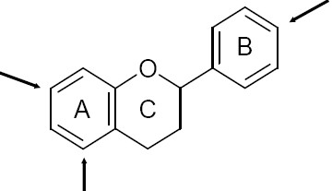A ring from acetate pathway
B ring from Shikimate pathway
Both A & B rings have OH groups attached (→)
C ring determines the major class of flavonoid

FUNCTION
- shown to enhance Vitamin C function – improves absorption and protects it from oxidation
o beginning evidence supporting potent antioxidant effects

CLASSIFICATION
- over 5000 have been discovered
- 6 major subclasses –based on C ring
o (1) Flavones
o (2) Flavonols
o (3) Flavanones
o (4) Flavanols
o (5) anthocyanidins
o isoflavones

DISTRIBUTION IN PLANTS
- same concept as polyphnols
- mainly in leaves, flowers and outer parts of the plant (skin, peel)
- decreased concentrations toward the central core
- only trace amounts found in subterraneous parts of plant
o some exceptions – onions, garlic

FOOD SOURCES
- widely distributed in foods and beverages of plant origin
o fruit, vegetables, tea, cocoa, wine

FLAVONOID INTAKE
- similar concepts to polyphenols
- challenges in determining dietary intake relating to determination of flavonoid composition
o Content variation – species & genetic variations, light, environmental conditions, germination, degree of ripeness, processing and storage
e.g. cherry tomatoes contain 6x more quercitin (flavonoid)/g fresh weight than normal size varieties – maybe because we eat more skin with cherry tomatoes as opposed to larger tomatoes (higher skin/weight)
o Analytical methodology
lack of standardization
information in the literature is often contradictory
Ex: how do we get tital polyphenol content lack of standardization can contribute to variability
-if don't have good urinary biomarkers --> dietary assessment (record what they eat)
-food intake and then quantify how much flavonoid in food (limitations)
- determining intake – analytical studies not always correct
- flavonols and flavones are the most measured
*problem is that htey only estimated some of the sub-classes or they should be more specific and do o

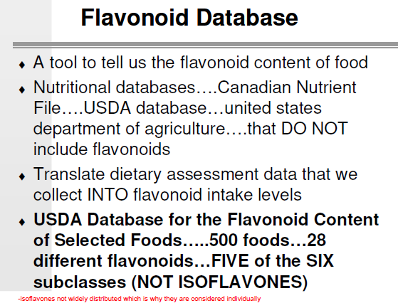
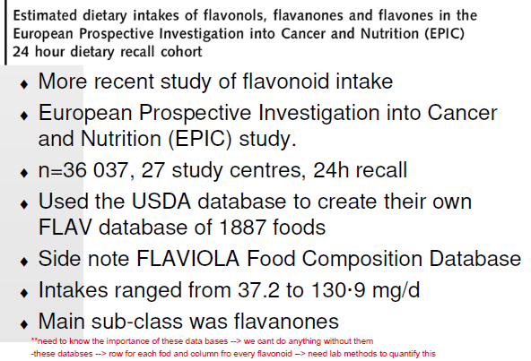

FLAVONOID GLYCOSIDES
- flavonoids typically attached/conjugated to carbohydrate moieties in food
- Terminology... sugar molecule?
o YES = flavonoid glycoside
o NO = flavonoid aglycone
- majority of flavonoids appear in plants as glycosides

Purposes of flavonoid glycosylation
- increase polarity
- necessary for storage in plant vacuoles
- most common sugar residue:
o glucose
o others include: arabinose, galactose, xylose, other less common carbohydrate
substitutions

BIOAVAILABILITY
- initially thought to be negligible since bound to glycosides - not the case!
- present in blood and urine
- flavonoids are absorbed and reach concentrations of varying magnitudes in our biological fluids
- aglycone is what is absorbed and then can circulate and go to liver --> measure in blood what is made in liver with this
- if flavonoid has sugar then it is heavier
-if study and quantify how many flavonoids you need to pay attention to the glycoside --> overestimating if dont get rid of glycoside --> should report as aglycone
-ex: genesteineion vs genesteinaion (little difference between terminology of
glycoside form versus aglycone form)

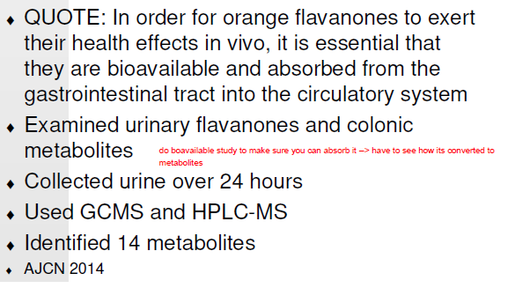

BIOLOGICAL EFFECTS

1. Antioxidant
- direct free radical scavengers
- protect vitamin E from oxidation
- regenerates vitamin E that has been oxidized
- chelate (inactivate them, can’t normally react with substrate) metals involved in the initiation of lipid peroxidation (free radicals steal electrons from lipid membrane causing cell damage), namely iron
- Induce antioxidant-related enzymes
o glutathione transferase (GST

increase resistance of cells to H2O2 (antioxidant)
detoxify xenobiotics with mutagenic potential (carcinogenisis)

2. Hormonal/Antihormonal
- primarily estrogenic and anti-estrogenic (compete or add to hormone)
- relation to cancer – breast cancer
- main flavonoid in this area = isoflavones

3. Anti-proliferation
- inhibition of cellular transformation and proliferation
- inhibit growth of cancer cells in vitro (enxyme stabilizing the DNA of cancer)
- interact with enzymes associated with DNA
o inhibit DNA topoisomerase II, which facilitates apoptosis (good in cancer)

4. Other biological effects:
- anti-bacterial
- anti-viral
- anti-fungal
- anti-inflammatory
- anti-allergic
- anti-mutagenic

- all intuitive based on their role in the plant itself
- all these biological effects have potential relevance to human health and disease

HEALTH EFFECTS
- research evaluating the role of various flavonoids in reducing the risk of several diseases or conditions including:

Cancer
- antioxidant properties
- anti-estrogenic properties
-all 3 main biological effects relate to cancer
-hard to study cancer because not alot of biomarkers for cancer prevention
-observational experiments are more common --> association (animal + cell culture)
-humans --> bery few biomarkers (estrogen metabolites)
Cardiovascular disease
- antioxidant properties
- estrogenic properties
- anti-inflammatory properties
- anti-thrombotic properties
post-menopausal women have higher risk than pre-menopausal --> less estrogen

Other possibilities:
- aging, diabetes, etc.
- virtually any condition associated with oxidative stress

EPIDEMIOLOGICAL DATA
FLAVONOID AND HEALTH ISSUES FOR RESEARCH
- numerous studies report a protective effect of fruits and vegetables against cancer and CVD
o is it the flavonoids?

o Is there a protective effect independent of the micronutrients

Some thoughts to consider...
- how is the intake of flavonoids assessed?
o Food frequency questionnaire?
ask people about intake & frequency of certain food – usually over a year
o Is it validated to measure flavonoid intake?
o Is the nutrient analysis programs set up properly to quantify the flavonoids
relates to accuracy of food composition data for flavonoid content
o What about bioavailability?
null ypothesis (high / low expsure risk) - = 1 = risk of getting it with high and low flavonoid is 1
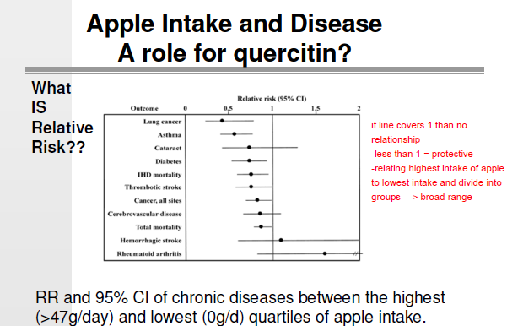

SUMMARY OF FLAVONOID AND HEALTH ISSUES FOR RESEARCH

Flavonoid intake:
- level of consumption of flavonoids
- lack of standardized biomarkers of intake
- availability of food composition databases
-rely on dietary markers so need compsotion databases
-since relying on databases -->> food matrix, processing, gut microbio,

Flavonoid metabolism/biological fate
- bioavailability
o effect of food matrix
o effect of food processing
o contribution of colonic microflora
- pharmacokinetics – see a lot of metabolites in urine?
- existence of unknown metabolites
-limiting = cant reach consensus which is needed for SSA :
-inconsistent use of nmemclature in description (not being specific to type of flavonoid, flavonois is attached to cho so weight is diff)
-incomlete application of analytical methods (food content and dietary intake level challenging)
-limitrd decription of intervetion treatment (content, source, variety and details of product is needed)
-challeneges in methods for bioavalability and metabolite formation

UNIVERSAL CONCEPT REVIEW
- key phytochemical concepts so far...
o role of polyphenols and flavonoids in the plant
o influences on amount in the plant
o role of polyphenols and flavonoids in food
o influences on amount in the plant
o challenges in quantifying accurate intake amounts
proper dietary assessment
need database
o glycoside/aglycone concept
carb moiety needs to be cleaved
o relevance of bioavailability

