Chemistry Lab 3: Extractions
By: Kennedey Vessio (8623019)
Lab Partner: Umara Hansen (8780394)
BIO 1140-C08
Procedure:
- Placed 1 mL of ether, 1 mL of distilled water and 1 drop of a 0.006 M methylene blue solution in a test tube and mixed the contents by shaking vigorously for a few seconds. Allowed the layers to settle and determined if the dye was in the aqueous, organic or both.
- Placed 1 mL of ether, 2 mL of distilled water and 1 drop of a 0.006 M methyl red solution in a test tube and mixed the contents by shaking vigorously for a few seconds. Allowed the layers to settle and determined if the dye is in the aqueous, organic or both layers.
- Mixed the contents of the tubes from steps 1 and 2 together and shook vigorously for a few seconds. Allowed the layers to settle and determined the colour of each layer. Explained observations.
- Prepared two test tubes, each containing 5 mL of distilled water, 1 drop of 0.003 M aqueous crystal violet and 0.5 mL of 1-butanol. Shook the two test-tubes until the colour of the crystal violet was distributed throughout both layers.
- Added some solid NaCl to one of the tubes until the aqueous layer was saturated. Shook the tube until salt was dissolved. Compared the distribution of the dye between the two tubes. Explained what happened.
- Obtained an unknown sample from the demonstrator. Measured a mass of the sample. Noted the exact mass. Dissolved it in 10 Ml dichloromethane in a 50 mL Erlenmeyer flask. Kept a small amount aside for a TLC reference.
- Poured the solution into a separatory funnel. Rinsed the 50 mL Erlenmeyer flask with 5 mL of dichloromethane and transferred the contents of the flask to the separatory funnel. Saved all extracts until the end.
- Added 10 mL of a 2M solution of NaOH in water to the separatory funnel and inverted the funnel. Was sure that the tip was pointed away from anyone else. Opened the stopcock to vent the funnel. Heard some gas escape. Closed the stopcock and shook for 30 seconds. Was careful to vent the funnel occasionally as the dichloromethane was partly evaporated and generated pressure. Remembered to close the stopcock each time.
- Placed the separatory funnel on the wooden rack. Removed the stopper and allowed the layers to separate.
- Carefully drained the lower phase into a cleaned 50 mL Erlenmeyer flask. Transfer the upper phase into a second 125 mL Erlenmeyer flask and set it aside.
- Poured the organic phase back into the separatory funnel and extracted twice more with 2M NaOH. Combined the basic aqueous phases.
- Acidified the aqueous extracts by the drop wise addition of conc. HCl until the solution is strongly acidic and no more precipitate was formed.
- Cooled the mixture in an ice bath and collected the solid product by suction filtration.
- Spread the product on a dry filter paper on a watch glass and allowed it to air-dry.
- Weighed the product and calculated a percent yield.
- Prepared three TLC plates. On the first two plates, spotted the original sample as the reference and co-spot. On the first plate, spotted the organic layer from the extraction as the sample and co-spot. On the second plate, spotted the product from the aqueous layer dissolved in a few drops of dichloromethane as the sample and co-spot. On the third plate, spotted biphenyl in one lane, benzophenone in the second lane, and the unknown mixture in the third lane.
- Developed all three plates using the 2:8 mixture of ethyl acetate (EtOAc) and hexanes as your eluant. Drew a picture of each plate and explained what was seen.
Observations:
- Ether is a clear liquid with a strong scent. It was mixed with 0.006 M methylene a dark blue dye. The water and dye sat at the bottom in the aqueous phase and the ether at the top in the organic phase.
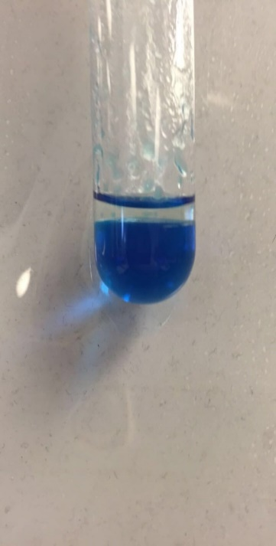
- Methyl red is an opaque red liquid with no scent. It was mixed with the ether, a clear liquid with strong scent, and the ether and red dye sat at the top in the organic phase while the water stayed at the bottom in the aqueous phase.
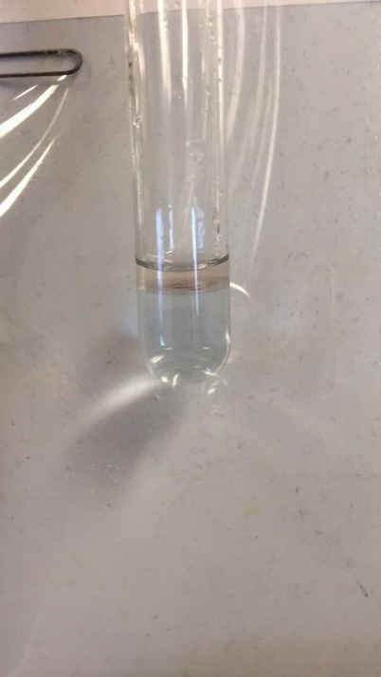
- When the previous steps were combined it created a transparent blue liquid at the bottom and a transparent red liquid at the top.
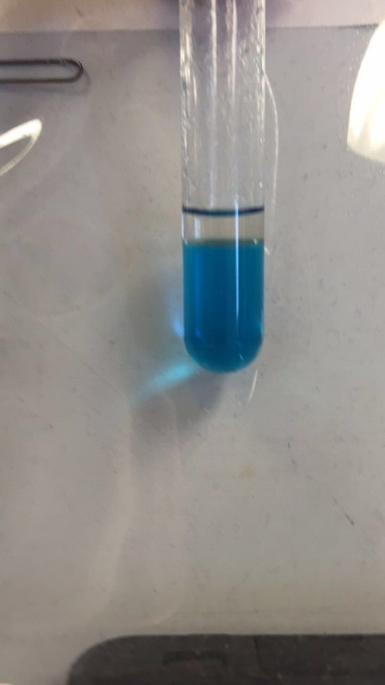
- 1-butanol is a clear liquid with a string scent. When mixed with dye it turned into a bright opaque purple. During this extraction, there was no separation.
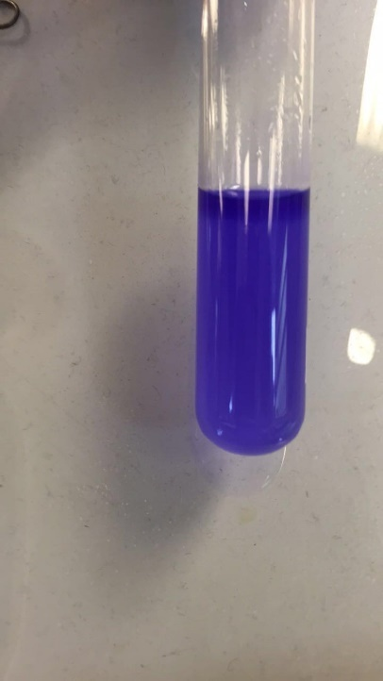
- NaCl looks like white small solid particles. Once dissolved in the above test tube the bottom portion turned opaque and the purple sat at the top.
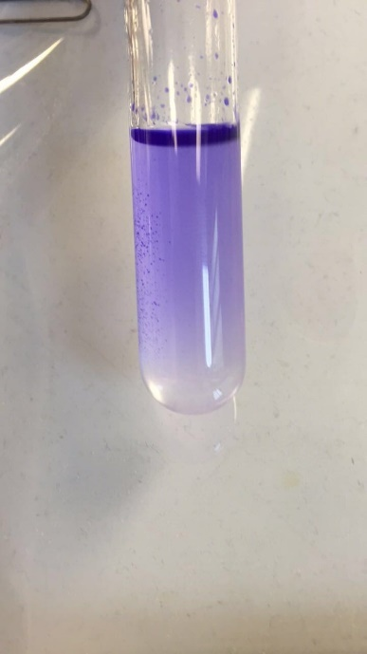
- Unknown substance number 1 was a white solid crushed into many small particles, with no scent. It was dissolved with dichloromethane which is a clear liquid with a strong scent. It was then placed in a separatory funnel with 2 M NaOH which is a clear liquid with a strong scent.
- HCL, a strong smelling transparent liquid was mixed with the unknown compound and it turned white and cloudy with small white precipitate. After cooled in the ice bath the compound became less cloudy and the white precipitate became larger.

TLC Plates:
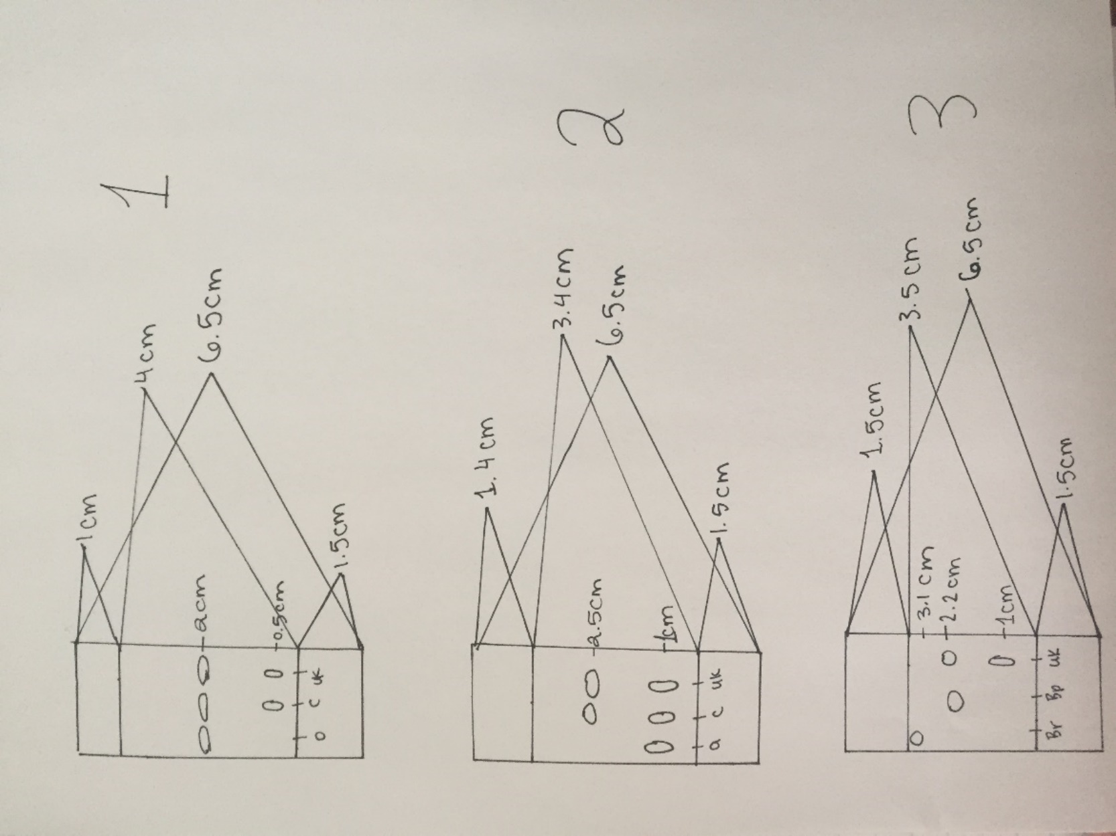

Flow chart:

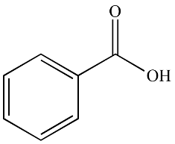 ⁺ 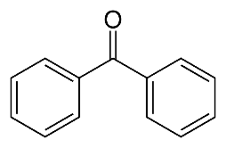
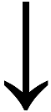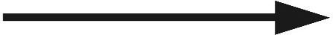
Aqueous phase Organic phase
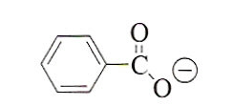

Table of Results:
Unknown number | Initial mass | Mass obtained | Composition%
#1 | 0.59g | 0.22g | 37.29%

Calculations:
Composition % = Experimental yield x100%
Theoretical yield
= 0.22g x100%
0.59g
=37.29%
R_{F unknown}=Distance solvent line travelled by solute
Distance from solvent line to solvent front travelled by solvent
= 2.2 cm
3.5 cm
= 0.63

Discussion:
The ether and distilled water were mixed in 0.006 M methylene blue solution to determine the organic and aqueous layers. The dye settled at the bottom with the water creating the aqueous layer. The ether created the organic layer at the top. Next, the ether and the distilled water were placed in 0.006 M methyl red solution. The ether and dye at the top was the organic layer and the water was at the bottom and was the aqueous layer. The ether and distilled water in 0.006 M methylene blue solution and the ether and distilled water in 0.006 M methyl red solution were mixed together and there was a good separation from ether and water. The 0.003 M aqueous crystal violet and 1-buanol are miscible. This is shown as there was no separation once the 0.003 M aqueous crystal violet was dissolved in 0.5 mL of 1-butanol and distilled water. After NaCl was dissolved in 1-butanol it separated to the bottom and was the organic layer. The water was at the top with the dye and is the aqueous layer. Next, unknown substance number 1 was 0.59g. The stopcock on the separatory funnel was opened every few seconds to ensure that there was not a gas build and so gas could be released. Once the dichloromethane and the unknown sample had separated it was clear that the lower organic layer contained the dichloromethane and the upper aqueous layer was the unknown substances. The final weight of the of benzoic acid was 0.22g.
In this experiment an unknown sample was given and the objective was to extract it and be able to identify the unknown sample. Unknown sample number 1 was benzophenone. This was determined by its high polarity shown on third TLC plate after it was extracted 3 separate times. On the first TLC plate, it was also shown that the organic substance contained the same polarity as the unknown substance. Lastly, on the second TLC plate the aqueous solution did not match up with the unknown compound. This shows that the unknown compound was an organic substance.
There are many possible errors that could have taken place during this lab. For example, with any of the extractions from the separatory funnel once the layers were separated and one phase was drained out, it is possible that the entire phase was not drained out. Also, when retrieving the unknown mixture after it was extracted three separate times it is possible that not every gram was taken off the filter paper. This would explain the composition yield being 37.29%.

Questions:
- It would be hard to perform an extraction using ethanol and water because ethanol is soluble in water. Once shaken together they will not form two distinct layers. When performing an extraction, the substances being extracted will be soluble with the ethanol and the water and there would be no way to properly extract the substance as there would be nothing to extract from.
- Adding NaCl would reduce the amount of dye in the aqueous solution. After decreasing the solubility of the organic molecule, the NaCl will then push it into the organic layer. This is because NaCl will have an affect on the ionic component of water and increase it.
- x = 10
(1.8-x)
x = 18 - 10x
x = 1.64g
Therefore, there would be 1.64g would be removed from the Y solution.
- x = 10
(1.64-x) 2
x = 8.2 - 5x
x = 1.37g
The mass removed from compound Y was 1.37g.
- It is possible to determine which phase is the aqueous phase by adding a few drops of water. Whichever phase the water mixes with is the aqueous phase.
- Converting benzyl amine to its catalytic salt form would allow the separation of benzyl amine and naphthalene. This is because benzyl amine is a base and if an acid was added it would be able to separate away from the naphthalene as it will remain in the organic phase and they would become separated.

Rough Work:

