Homeostasis
(Pg 8-11)
Define homeostasis, giving at least 2 physiological examples
Homeostasis: a system in which variables are regulated so that internal conditions remain stable and relatively constant
- Temperature regulation
- Blood ion concentration control
• not unchanging - rather a dynamic state of equilibrium involving many systems:
(i) adequate blood levels of vital nutrients
(ii) heart activity/blood pressure monitored & adjusted as needed
(iii) wastes must not accumulate
(iv) body temperature

- essential components of a homeostatic control mechanism
- Receptor: senses change (stimulus) and sends info (afferent pathway) to the second component
- Control center: Determines set point for variable maintenance. Analyzes info and determines the correct response
- Effector: provides means for response (output along efferent pathway)
- (negative/positive) allows for regulation within a range/enhanced response

Positive and negative feedback

NEGATIVE FEEDBACK MECHANISMS: Output reduces or shuts off stimulus
(i). 1 hormone regulating a process: negative feedback decreases secretion
(ii). Process regulated in opposite directions by 2 different hormones (blood, glucose)
Goal: prevent sudden, severe changes
-Also monitors heart rate, bp, rate and depth of breathing, blood levels of oxygen, carbon dioxide and minerals

POSITIVE FEEDBACK MECHANISMS: Response of mechanism enhances original stimulus (output further stimulated)
-change occurs in same direction as original response
-goal to be attained
-control parts which continuously requires adjusting
Example: blood clotting
Example: oxytocin levels increase when baby about to be delivered but positive feedback system shuts off when the baby has been born

Homeostatic Imbalance
most disease seen as a disturbance of homeostasis = homeostatic imbalance
aging associated with progressive decrease in our ability to maintain homeostasis greater risk for illness

-The control center for regulating body temperature is in the hypothalamus of the brain. When the body is fighting an infection, the hypothalamus allows body temperature to climb higher than the normal value of about 38⁰C. This process involves both positive and negative feedback.

AUTONOMIC NERVOUS SYSTEM
Auto = self; nom = govern
Autonomic Nervous System: System of motor neurons to smooth & cardiac muscle & glands to allow responses usually without our awareness

The flow chart indicates the position of the autonomic and somatic nervous systems in the structural organization of the nervous system as a whole

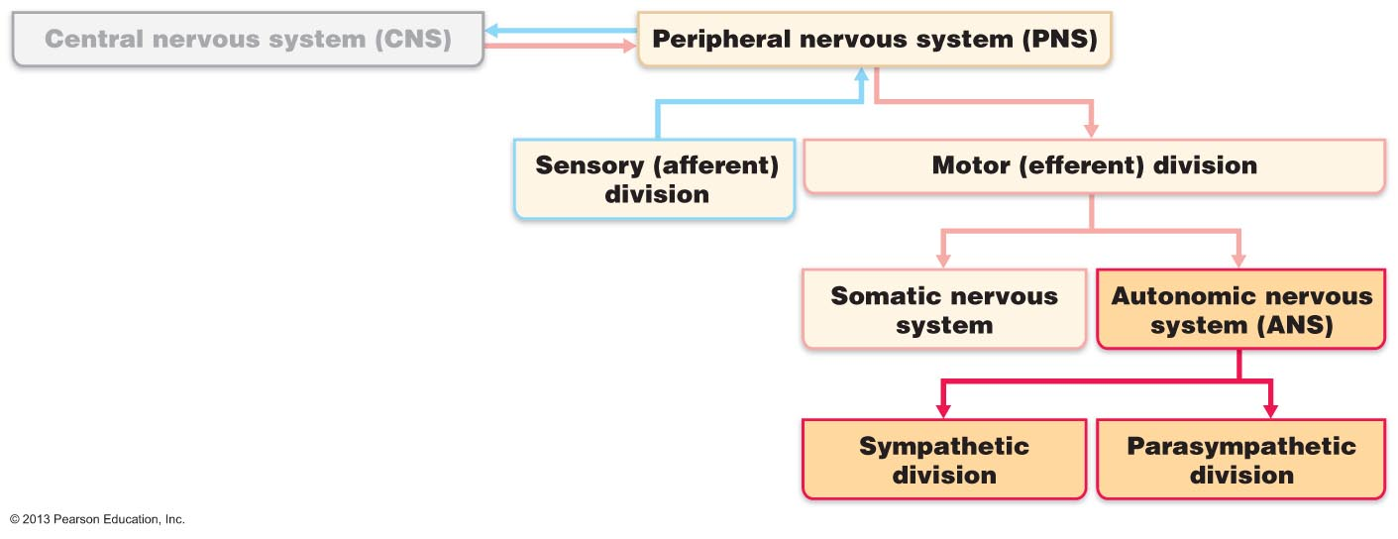

This flowchart…
(i) Shunt blood to more needy areas
(ii) Speed/slow heart & respiratory rates
(iii) Adjust blood pressure, body temp
(iv) Increase/decrease gastric secretions

Compare the autonomic and somatic nervous systems in terms of effectors, pathways, use of ganglia, transmitter effects

 | AUTONOMIC | SOMATIC
Effectors | Smooth muscle, cardiac muscle, glands | Skeletal muscle
Pathways | Two-neuron chain: preganglionic neuron: originates in brain or spinal cord  -preganglionic axon synapses with 2nd motor neuron (postganglionic) in ganglion outside CNS postganglionic axon to effector organ | Thick, myelinated axon from spinal cord to skeletal muscle
Use of ganglia | Has ganglia | No ganglia
Transmitter effects | Conduction is slow; preganglionic axons are thin & lightly myelinated; postganglionic axons are thinner & unmyelinated | Rapid conduction of impulses

Distinguish between the parasympathetic and the sympathetic nervous system

Parasympathetic Division:
-active in non-stressful situations
- keeps body’s energy use low while regulating « housekeeping » activities (digestion, elimination of feces & urine)
-“D” system: digestion, defecation, diuresis
Sympathetic Division:
-“ fight or flight” system; also important during exercise: increased heart rate, rapid, deep breathing, cold sweaty skin(why: sweat evaporates), dilated eye pupils
- “E” system: exercise, excitement, emergency, embarrassment

Define: sympathetic tone, parasympathetic tone

SNS and vascular tone: alpha blocking drugs to treat hypertension; blood shunting possible via vasoconstriction/vasodilation
PNS & tone: heart, smooth muscle of GI & urinary tracts- can be overridden by SNS

Identify: (i) systems regulated in opposite directions by the SNS and PNS, (ii) cooperative effects of the SNS & PNS, (iii) unique regulatory roles of the SNS

Interactions of the Autonomic Divisions
• most visceral organs receive dual innervation
Antagonistic Interactions:
• eg: activity of heart, GI system, respiratory system
Cooperative Effects:
• eg: regulation of external genitalia during intercourse:
a) PNS: dilation of blood vessels in penis
b) SNS: ejaculation, reflex peristalsis of female’s vagina
Unique Roles of Sympathetic NS:
SNS regulation only: adrenal medulla, sweat glands, arrector pili muscles of skin, kidneys, most blood vessels
also:
> thermoregulatory responses to heat
> renin release from kidneys - result will be increased blood pressure
Metabolic effects:
(i) increases metabolic rate of body cells
(ii) raises blood glucose levels
(iii) stimulates mobilization of fats
(iv) increases mental alertness
(v) increases speed/strength of muscle contraction

The PNS and ANS differ as to:
- Sites where nerves originate
- Relative lengths of pre- and post-ganglionic fibers
- Locations of ganglia

List the 3 levels of regulation of autonomic function, giving examples

1. Brain Stem & Spinal Cord Controls
- significant direct effects on ANS-regulated activities
- motor centres in ventro-lateral medulla (eg: cardiovascular centre heart rate, blood vessels; also GI, respiratory centres)
2. Hypothalamic Controls:
• hypothalamus = integration centre of ANS
> anterior regions parasympathetic
> posterior areas sympathetic
• hypothalamus contains centres to coordinate heart activity, blood pressure, body temp, water balance, endocrine activity; also centres that help mediate emotions & biological drives

- After surgery, patients are often unable to urinate and bowel sounds are absent. What division of the ANS is affected by anaesthetic? Parasympathetic

2. Stress-induced stomach ulcers are due to excess sympathetic stimulation. eg: one suspected cause of ulcers is almost total lack of blood flow to the stomach wall? How is this related to sympathetic function?

3. Cortical Controls:
• e g: meditation & biofeedback allow some conscious control over visceral activities
> e g: during meditation, can lower heart & breathing rates, oxygen use, metabolic rate
> biofeedback to improve management of migraine headaches, stress & cardiac function
Homeostatic Imbalances of ANS
• e g: hypertension:

