Topic 1
Introduction to cell biology and the cell’s features

- How did life evolve into organisms and cells? (Review from BIO1130 and/or BIO1109)
- What are the different types or classes of organisms?
- What is a cell?
- What is a cell made of? Define the different features, organelles and explain the roles/functions for each
- What are the different scales/sizes for cells and organelles?
- Explain the theory of the cell and the theory of endosymbiosis – can you provide some examples?
- What are the main groups or types of cells and how do they differ?
- Understand different types of microscopy and their requirements for use in cell biology

- What is a cell? Mid 1600s
-Small rooms = Cellulae = Cells
-Robert Hooke
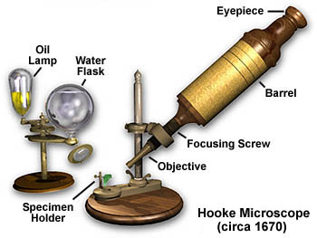
- How did we learn more about cells?
-200 years of observations and gathering data
-Better tools, better microscopes, better questions
-Writing down what we observe
= lead us to have a better understanding of cell biology.

- What is Cell Theory – mid 1800s
-All organisms composed of one or more cells
-Cell is basic structural and functional unit of all living organisms (Schwann, 1839)
-Cells arise only from division of pre-existing cells (Virchow, 1855)

Are there any life forms that exist that don’t have any cells?

-Yes
-Viruses are not life forms
-Require a host
-Aren’t living because they aren’t able to reproduce without a host
-They don’t have RNA and DNA
-No machinery to create protein on their own. No mitochondria.

- Cell features/Characteristics?
Diversity
- Wide range of sizes (nm to m)
- Simple or complex shapes; related to function
- General or very specialized role
Common Characteristics
- Components
- Basic chemistry
- Metabolism (ATP)
- DNA

-Single vs multicellular
-Ciliated vs flagellated
-Some have a nucleus and organelles and some do not.
-Aerobic vs Anaerobic environment
-Membranes and walls
-All have some form of metabolism
-Need a way to get rid of waste
-Defined function
-Different abilities
-Kind of environment they can thrive in
-Kind of things they can defend themselves against.
All of these structural differences give them different types of cells and different abilities.

-what’s in nucleus? DNA
Cells that don't have Nucleus still have same DNA
-All these different types of cells still have the same type of DNA.

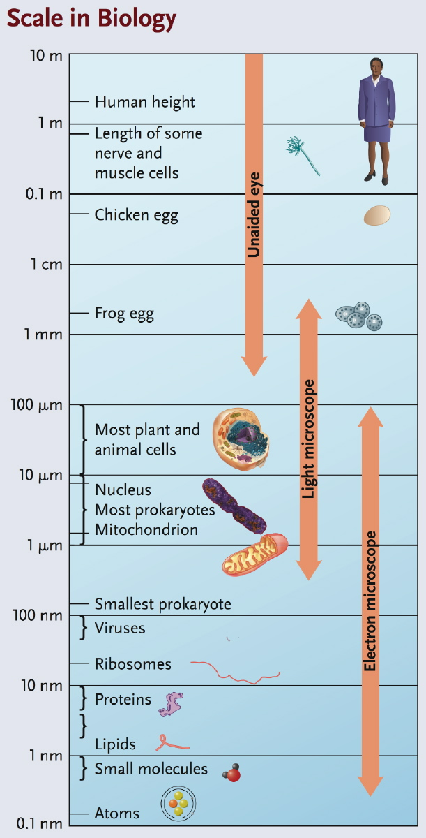
- Cell size and scale
- Relevant units:
1µm = 10⁻⁶m
1nm = 10⁻⁹m
- Typical cell sizes:
Prokaryote: 1-5 µm
Eukaryotes 10-100 µm
- Why are cells small?

Match the items below with the proper size from the list on the right
1. Ribosome diameter | a) 0.007 µm
2. Nucleus diameter | b) 30 nm
3. Mitochondrion length | c) 0.006 mm
4. Giraffe axon length | d) 1 x 10⁶ µm
5. Microfilament diameter | e) 3 x 10⁻⁶ m

Mitochondria the same size as prokaryotes because they used to be prokaryotes (the theory of endosymbiosis)

- But why are cells small?
-SA:V ratios
-Rates of diffusion
-Adequate concentrations or synthetic capacity
-Harder to maintain cell if it was larger size
-If cell was bigger/shuffles in and out, longer to reach equilibrium.
-Many smaller cells can manage efficiently
-Many different cells working together as a team
-Small= fewer nutrients needed for survival.

- Four types of Tissues:
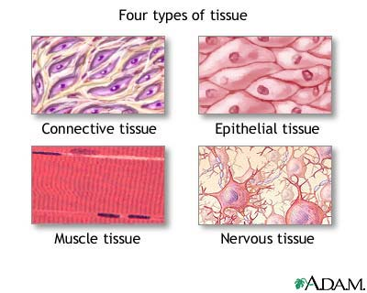

-Cells can remain individual (for example in blood) or assemble together to form functional tissues and organs
-Eukaryotes cells will assemble together
-Tissues are a whole bunch of cells working together.

how do all the cells work together? how do cells communicate together?

- The tree of life: 3 domains
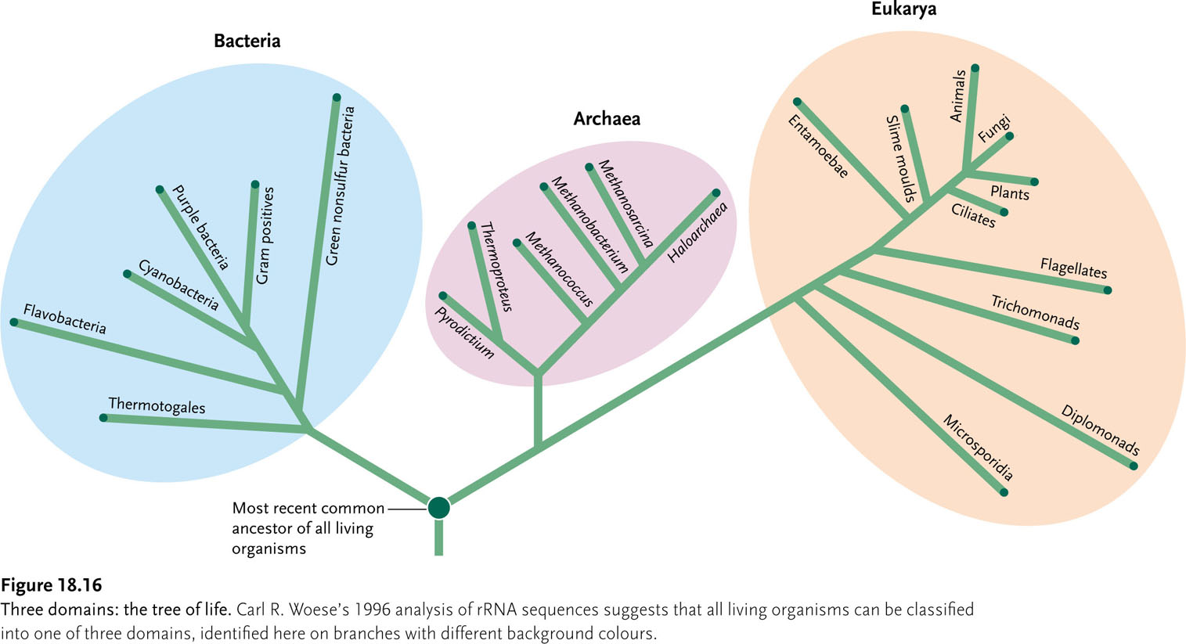

bacteria vs Eukarya?
-Archaea more extreme than bacteria
-Different DNA sequences, protein, structural features
-Particular abilities that set them apart from different cells.
Eukaryotes structural differences:
-Nuclear membrane, structures that allow them to accomplish certain things.
-Genes highly conserved in different species. Help u look at different kingdoms, but DNA won’t help us pin point.

What elements of organisms can we use to classify them in phylogenetic trees?
-tRNA brings AA to ribosomes
-mRNA: is a transcription of the DNA
-rRNA: look at this the most because the way they make proteins are different, proteins have different structures and are very similar in different groups.
-Within the membrane, there are phospholipids. Made up of different membranes.

- Prokarya; Bacteria and Archea
-Archaea:
-grow in extreme enviroments
-eg: Halophiles need higher concentrations of salt to survive.
-eg: thermoacidphiles grow in extremely hot sulfur springs w. pH under 2.
rRNA, membrane phospholipids: more similar to eukarya
-If we take the ancestral eukaryote and look at the different branches and look at the opisthokonts and look at the flagellas.

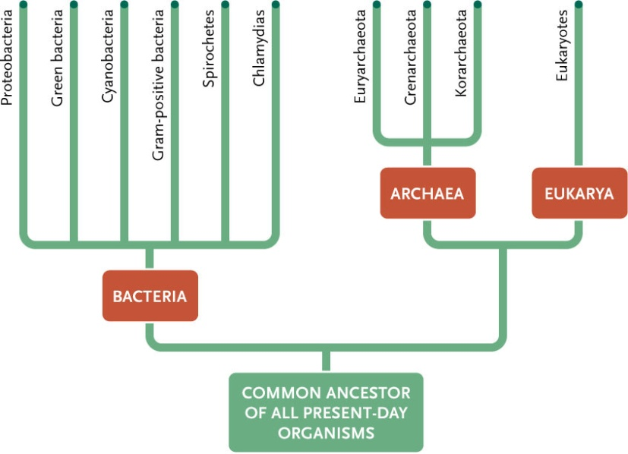

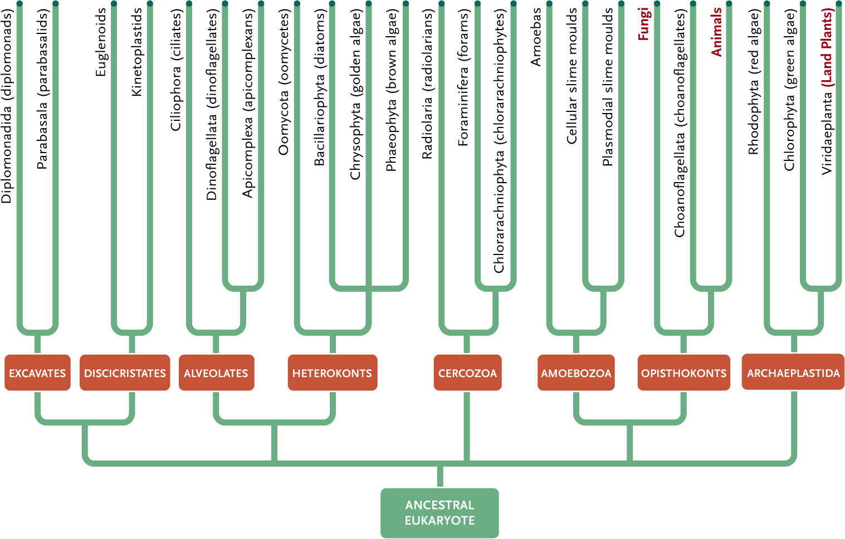

- Two main types of cells: Dealing with size
Prokaryotes
-Unicellular
-Bacteria
-DNA in bacteria is condensed into the central region of the cell
-ribosomes found in DNA free region of the cell
-Don’t have a defined nucleus
-Mesosome: synthesis of DNA secretion of proteins.
-Not completely devoid of internal organization
-cell wall adjacent to the external side of plasma membrane
composed of peptidoglycan and complex proteins/sacharides
=protects cell/maintains shape
-some don’t get stained by gram technique. Classified as gram-negative.

-Archea (more similar to eukaryotes tbh)
Eukaryotes
- Unicellular (protists)
- Multicellular
-Plants
-Fungi (yeasts, mushrooms, molds)
-protozoans
-Animals

- Prokaryotes VS Eukaryotes
Prokaryotes
-Stay small (1 – 5 μm)
-Keep it simple
-Highly adaptable (extremophiles)
-Small genomes (10⁶ bp), plasmids
-Easy to adapt.
-Lack a defined nucleus
-single close compartment containing cytosol bound by plasma membrane
-In prokaryotes, a single, circular double-stranded DNA molecule constitutes the bulk
the genetic material.
-

Eukaryotes
-Larger (10 – 100 μm or larger)
-Elaborate membranes allow compartments to organize cellular functions to separate them from rest of cytoplasm
-internal membrane
-Highly organized and more complex
-Transport systems
-Larger genomes (10⁶ to 10⁹ bp), linear, w. associated proteins
-more specialized to do different things.
-Need more nutrients, more wastes produced
-Offspring with more variability
-DNA in Cytoplasm: Transcription and Translation can occur simultaneously
-Membrane limited Nucleus
-Most organelles are surrounded by single phospholipid membrane, but several, including the nucleus, are enclosed by two membranes.
-Nucleus houses cellular DNA

- Typical bacteria: Escherichia coli
-bacterial lineage of prokaryotes.
-found in animal intestines, experimental organism, photosynthetic organics (blue algae), cyanobacteria.
-have thing cell wall and an unsual outer membrane separated from the cell wall by periplasmic space
/
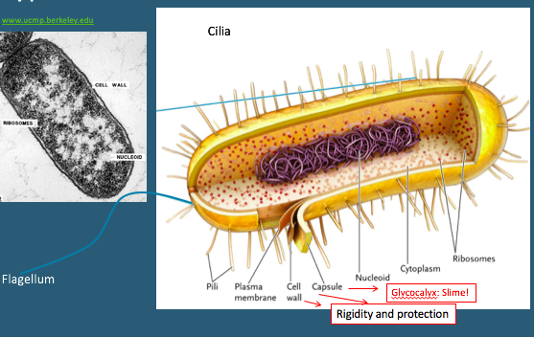

-General sense of how a bacteria is built:
-No Nuclear membrane. Ribosomes. Takes longer to build proteins. cell wall with a plasma membrane. capsule that can be rigid and slimy. DNA more vulnerable, need extra layer of protection from Glycocalyx. Unicellular organism needs all the defense it can get. Allows different areas for bacteria to defend itself. Could it have a postive reason, be benefical. slimy Glycocalyx contribute to go get Have a general sense of how a bacteria is built. no cuclear membrane. ribosomes. takes longer to build proteins. cell wall with a plasma membrane. capsule that can be rigid and slimy. dna is more vulnerable, so we need extra layer or protection from Glycocalyx. unicellular organism needs all the defence it can get. allows different areas for bacteria to defend itself. could it have a postive reason, be benefical. slimy Glycocalyx contribute to go get

- Typical animal eukaryotic cell
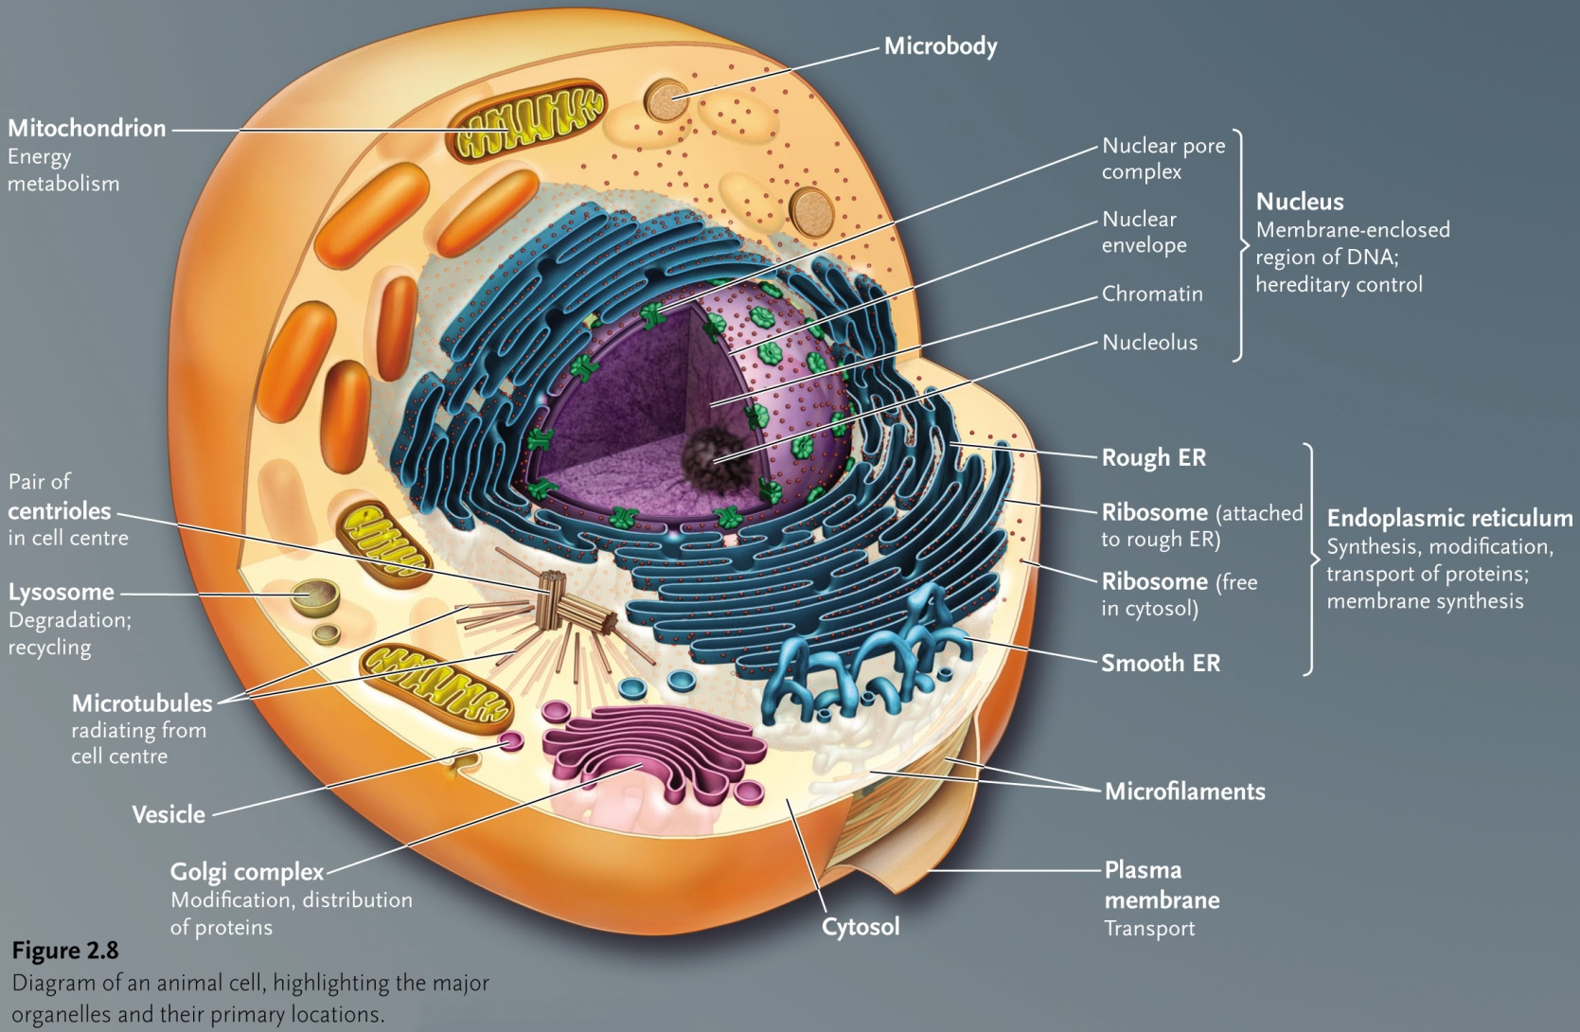

-recognize all the different structural components
-labeling with description, annotations, point to mitochondria, nucleus, -structure responsible for translation and transcription.

- Typical plant cell
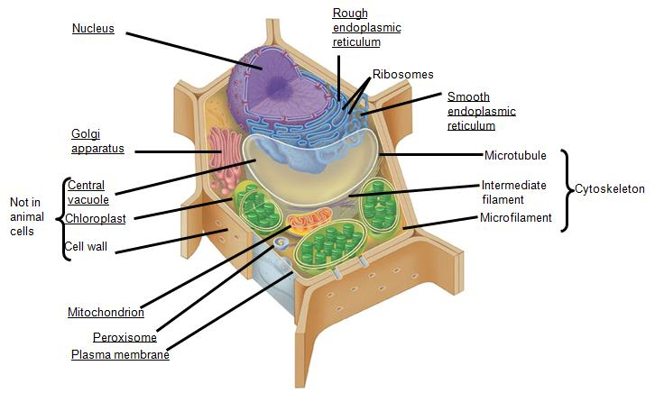
-Plant cells have a large Vacuole.
-Role is to fill in entire space to encompass the space.
-What do the chloroplasts do? What does the cell wall do? No cell wall in which ones?

 | Prokaryotes | Eukaryotes
Cell size
Cellular organization
Genome
Organelles

- Eukaryotic cell organelles
-Subcellular compartments within the cytosol surrounded by a membrane
-Single subcellular compartment without a membrane: Ribosomes
-Their functions are varied, and depend on the cell’s role
-cytoskeleton-array of fibrous proteins

Where does Transcription occur?
-Nucleus
-DNA to mRNA

Where does Translation occur?
- Translation: mRNA to protein.
-Ribosomes on rough ER
-Cytosol (free floating ribosomes)

- Nucleus
-Nucleus protects DNA
-Largest membrane-bounded organelle in eukaryotic cells
-Contains DNA organized into chromosomes
-synthesis and processing of RNA and ribosome assembly occur in the nucleus.
-bound by 2 membranes, phospholipid bilayer w/ different proteins.
-The inner nuclear membrane defines the nucleus
-Outer nuclear membrane: continuous with RER
-space between the inner and outer nuclear membranes is continuous with the lumen of RER
-nuclear membranes fuse at nuclear pores
-nucleus is metabolically active
Produce DNA and RNA
-Mature erythrocytes: nucleus is inactive or dormant and minimal synthesis of DNA and RNA
-chromosomes only visible during cell division in light microscopy
-nucleolus easily recognized by light microscopy
-most of cells ribosomal RNA synthesizes in nucleolus
-ribosomal subunit passes through a nuclear pore into the cytosol
-electron microscopy: nonnuclear regions (nucleoplasm) seen to have high DNA concentration

-describe how its built, structure, feature, structural components, things that go on in and around a nucleus. know this for all organelles, cellular features for prokaryotes. basic vocabulary. know what we're talking about
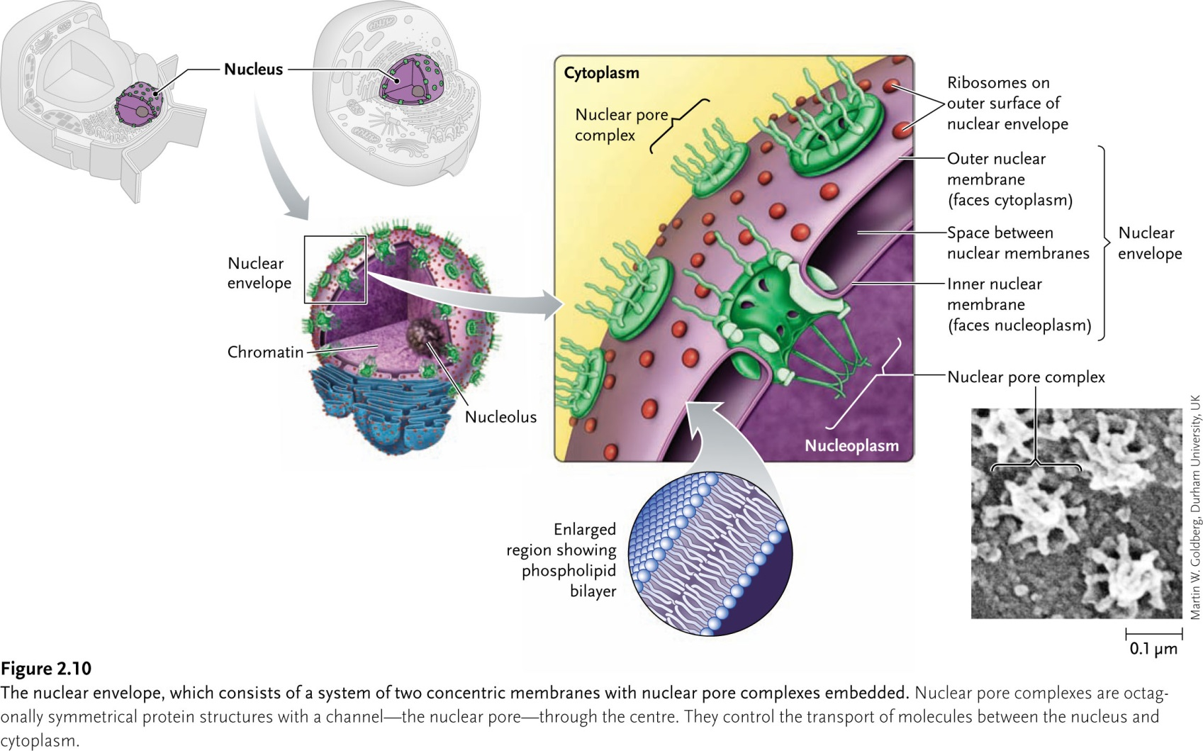
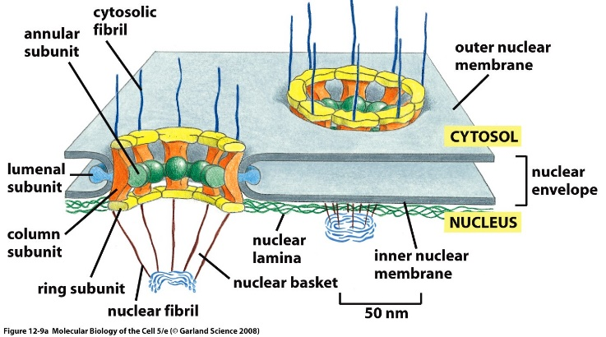

- Ribosomes
- packaged in vesicle and free in cytosol
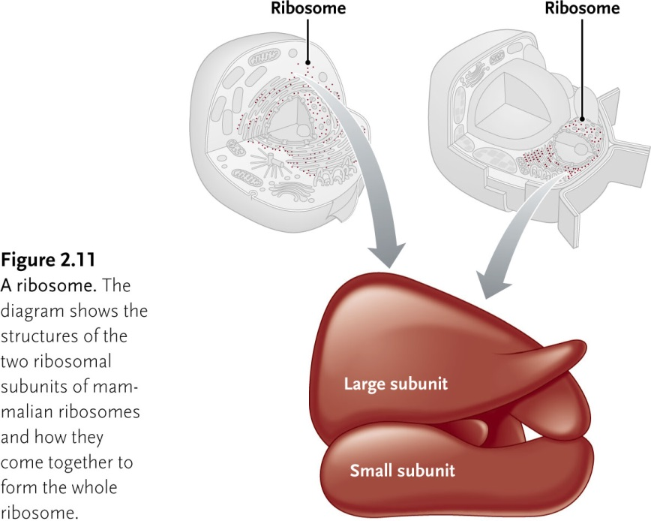

- Endoplasmic reticulums
-largest membrane encloses it
-compartment of membrane bound vesicles
-synthesis of lipids and proteins
Rough ER vs Smooth ER?
- Smooth ER:
-lacks ribosomes
-synthesis of fatty acids, phospholipids
-abundant in Hepatocytes
-In live, enzymes modify or detoxify hydrophobic chemicals (pestisides, carcinogens)
- Rough ER:
-synthesis membrane and organelle proteins
-ribosomes bounded to ER

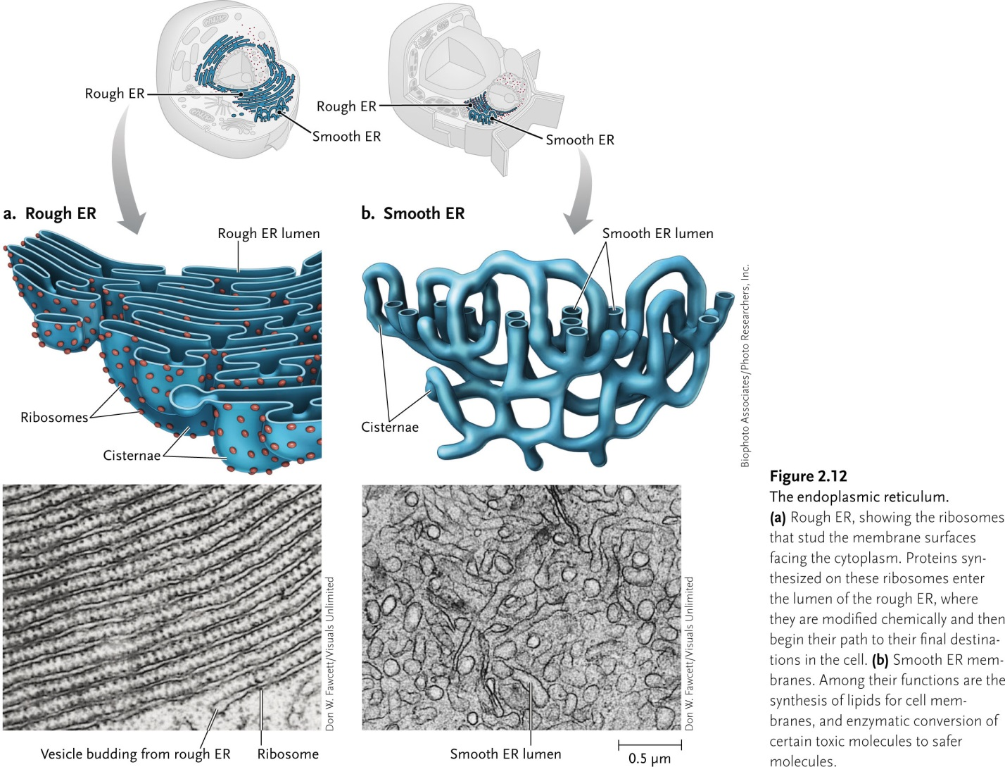

- Golgi complex?
-processing and sorting of proteins and lipids destined for other cellular compartments or for secretion
-also called Golgi apparatus
-series of flattned sacs near nucleus
-3 defined regions:
1) cis region
-deposit proteins
2)medial
3)trans
-Each region= different enzymes that modify secretory and membrane proteins differently, depending on their structures and their final destinations.
-After secretory proteins modified, transported by transport vesicles (bud of side of trans side)
Transport proteins surrounded by an outer protein cage composed of Clathrin.

-
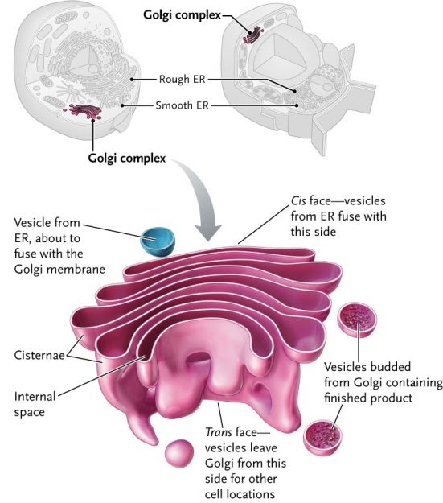

- peroxisomes
-degradation of fatty acids and amino acids
-by reactions that generate hydrogen peroxide, which is converted to water and oxygen by catalase.
-single bounded membrane
-not in erythrocytes
-Several oxidases:
enzymes that use molecular oxygen to oxidize organic substances, in the process forming hydrogen peroxide (H₂O₂), a corrosive substance.
-Enzyme catalase: degrades hydrogen peroxide to yield water and oxygen

- Lysosomes?
-digestive unit of the cell:
-bound by single membrane
-Enzymes will breakdown macromolecules
-Bud-out from the Golgi
-pH in lysosome is more acidic than in cytosol (about pH 4-5) (acidic ph helps to denature proteins, making them accessible to action of lysomal hydrolases)
-Waste elements end up there
-When we need to destroy cell we can rupture lysosome to destroy cell.
-Attractive for cell to send waste there because of Enzymes.
-If lysosome ruptures, the digestive enzymes are released in cell. They'll become inactive, but most of them remain active and chew up interior of cell
-only in animal cells
-Materials taken into a cell by endocytosis or phagocytosis also are degraded in lysosomes.
Endocytosis: extracellular materials are taken up by invagination of a segment of the plasma membrane to form a small membrane-bounded vesicle (endosome)
Phagocytosis: large particles are enveloped by the plasma membrane and internalized.
-enzymes degrade polymers into monomeric subunits.
Nucleases degrade RNA and DNA into mononucleotide building blocks.
-Tay-Sachs disease is caused by a defect in one enzyme catalyzing a step in the lysosomal breakdown of certain glycolipids called gangliosides, which are abundant in nerve cells
-vary in size and shape
-Primary lysosomes=
roughly spherical and do not contain obvious particulate or membrane debris
-Secondary lysosomes=
larger and irregularly shaped, result from fusion of primary lysosomes with other membrane organelles; they contain particles or membranes in the process of being digested
-Autophagy=eating oneself=aged organelle is degraded in a lysosome

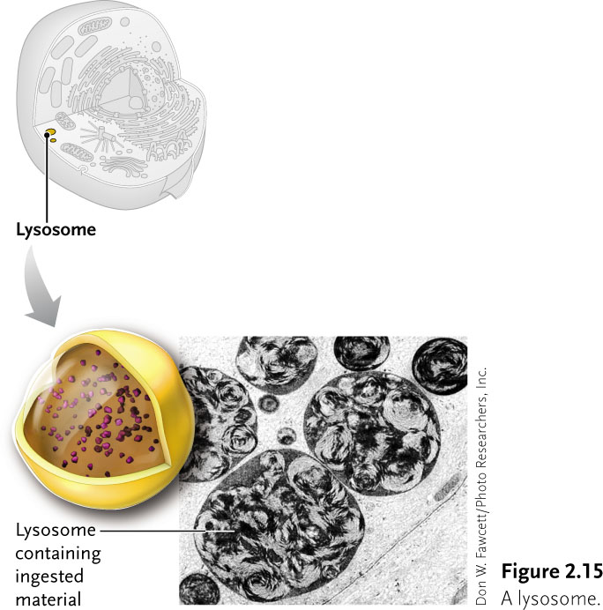

- Mitochondria
-cell’s energy metablism
-surrounded by 2 phospholipid membranes
-principle sight of ATP production in Aerobic Cells
-outer and inner membrane separated by the intermembrane space
Outer membrane: half lipids and half proteins
Inner membrane: much less permeable. More proteins. SA increased by infoldings and cistae that protrude into the matrix
-Contains own DNA

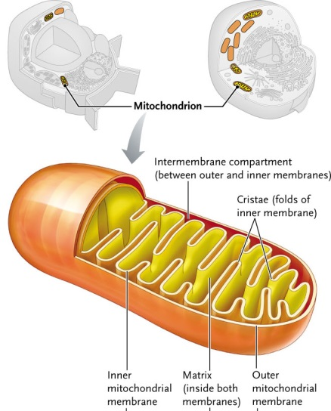
- Chloroplasts
-plant cells
-green algae and plants
-surrounded by inner and outer membrane
-extensive internal system of interconnected membrane limited sacs, thylakoids.
Flattened to form discs
grouped in stacks called grana
embedded in a matrix, stroma
-thylakoid membranes pigments, and other enzymes to absorb light and generate ATP during photosynthesis.
-contains own DNA

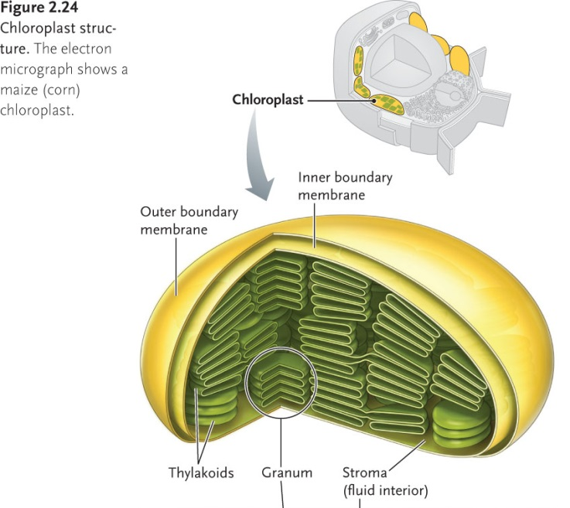

- Plastids?
-Chloroplasts, Amyloplasts, Chromoplasts

- Central Vacuole
-Surrounded by tonoplast
-Turgor pressure
- large, fluid-filled organelles in which nutrients and waste compounds are stored and some degradative reactions occur.
-Plant cells store water, ions, and nutrients such as sucrose and amino acids
-Vacuoles also act as receptacles for waste products and excess salts taken up by the plant and may function similarly to lysosomes in animal cells
-acidic pH maintained by proton pump and Cl- channel protein.
-storgage vacule in green algae and yeast
-membrane is permeable to water not to small molecules stored within it
Solute concentration=higher in the vacuole lumen than in cytosol extracellular fluids, =water tends to move by osmotic flow into vacuoles
=vacule expans, water moves into the cell=hydrostatic pressure/tugor pressure.
Pressure balance by cell wall via mechanical resistance

- Cell wall
-rigid
-cellulose and polymers
-strength and ridgity
-useful to get things across from one cell to another
-more difficult to get things across
-has small holes called plasmodesmata
-Don’t allow everything to get across. limited to very few compounds.
-cell to cell communication in the form of ions how they support the theory.
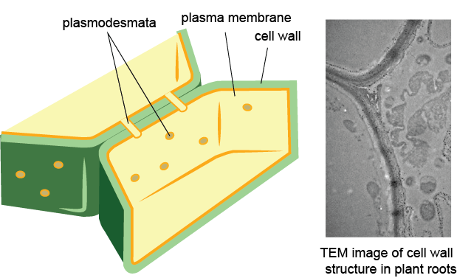

Make a chart like this:

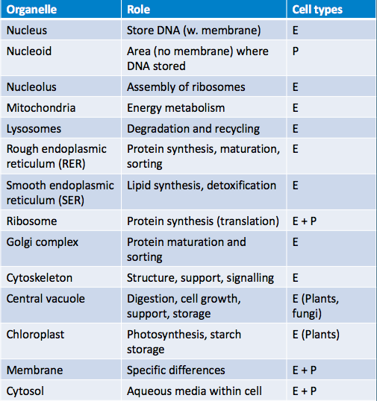

- What distinguishes eukaryotes from Bacteria and Archaea?
- Nuclear envelope (separating DNA from rest of intracellular components)
- Membranous compartments with specific roles (ER, mitochondria, etc.)

-All eukaryotic cells have energy-transforming unit (mitochondria, chloroplasts).
-Could this be the key to evolving from the common ancestor?

2 things you can observe in cells to support theory of Endosymbiosis:

- Theory of endosymbiosis:
-Symbiosis: interdepended relationship between 2 species
-shaped evolution of complex organisms
-endosymbiosis: partner lives within host. Represents the most intimate contact between organism
-Mitochondria and chloroplasts result from endosymbiotic events of lasting significance that extended the range of acceptable habitats for life.
-Facultative mutualist: A beneficial symbiont that associates with the host, but can also live apart from it. Examples include Rhizobium spp. that associate with legumes, but also have a free-living stage to their life cycle.
-Obligate mutualist: A beneficial symbiont that lives exclusively with its host and depends on the host for survival. Examples include many nutritional endosymbionts of insects, which cannot survive outside of the insect host cell. These associations are reciprocally obligate when the host cannot survive without the endosymbiont.
-Parasite: A symbiont that has a negative effect on host fitness, in contrast to a mutualist, which increases host fitness.
-Reproductive parasite: A symbiont that manipulates host reproduction to its own benefit, but at the expense of host fitness. Reproductive parasites typically bias offspring toward infected females.
-Symbiosis: An association between two more species.

- Morphology:
-Shape of mitochondria
-chloroplasts
-size (μm) are similar to bacteria and archea
- Reproduction:
-Only by binary fission
- Genome:
-circular mDNA and cpDNA
- Transcription and translation:
-machinery in place
- Electron transport:
-double membrane with ETC
- Sequence:
-bacterial branch on tree of life
(mitochondria = proteobacteria; chloroplasts =cyanobacteria)

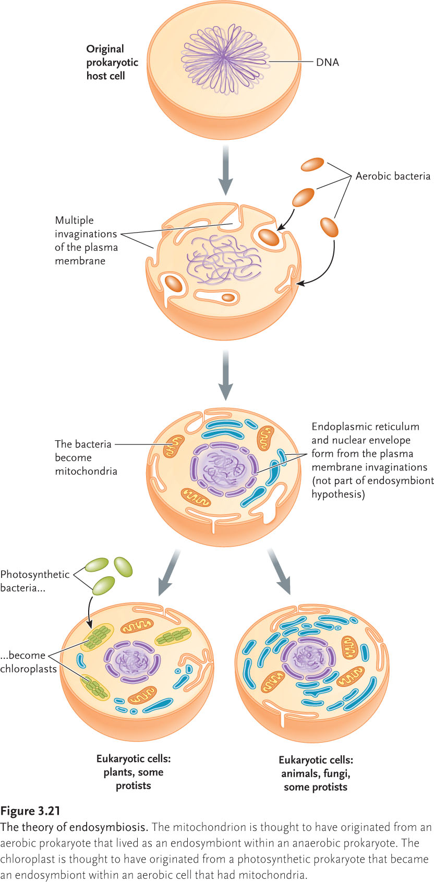

- Examples today of endosymbiotic relationships:
- The spotted salamander (Ambystoma masculatum) and green algae are endosymbiotic:
-algae cells infiltrate the embryos.
-provide O2, while they use the N2 produced by the salamanders
2) Elysia chlorotica (sea slug) steals the chloroplasts from Vaucheria litorea -process is termed Kleptoplasty
3) Coral reefs are clusters of animals related to anemones;
-they harbour zooxanthella (an algae) that exchanges housing protection with sugar (produced by photosynthesis) as a source of nutrient for the coral.

Cell Membrane:
-Water impermeable membranes
-Built to keep the interior contents from leaking out into the surrounding environment
-Environment around cells is a watery one (blood and other bodily fluids)
-To maintain integrity, need to be surrounded by environment where water can’t flow
-Membrane composed of fatty molecules serves this purpose
-plasma membrane: membrane surrounding a cell that separates the cell from its external environment. Consists of phospholipid bilayer and proteins.
-Membrane given rigidity by interspersion of cholesteral
-Phospholipid molecules oriented with fatty chains facing inward and their water-seeking head groups facing outward.
-Plasma membrane is really weak so in plants, its surrounded by a cell wall or animals have proteins attached to exterior
-membranes also store energy. Entraps energy from molecules moving across.

Cytosol:
- Unstructured aqueous phase of the cytoplasm excluding organelles, membranes, and insoluble cytoskeletal components.
-inclusion bodies, granules that are not bounded by a membrane
muscle cells and hepatocytes contain cytosolic granules of glycogen, glucose polymer, function as a storage form of usable cellular energy.
-major site of cellular metabolism
-large number of different enzymes
-20-30% is protein
-highly organized
-proteins either bound to fibers or localized in specific regions.

Cytoskeleton:
-cell strength and rigidity
-Help maintain cell shape
-Cytoskeletal fibers also control movement of structures within the cell;
-3 classes of fibers:
1) Microtubules
-Components of cilia, flagella, the mitotic spindle, and other cellular structures
-protein tubulin

- Microfilaments
-important role in muscle contraction, cytokinesis, cell movement, and other cellular functions and structures.
-built of protein actin

- Intermediate filaments
-Constitute the major structural proteins of skin and hair
-form the scaffold that holds Z disks and myofibrils in place in muscle;
- Important structural components of many animal cells and tissues.
- built of one or more rod-shaped protein subunits
Chromosomes:
-Structural unit of the genetic material consisting of a single, linear double-stranded DNA molecule and associated proteins.
-During mitosis, chromosomes condense into compact structures visible in the light microscope
-number and size the same in organism
-but different types in different organism
-each Chromosomes=single DNA molecule with numerous proteins
-23 pairs of chromosomes in humans

The First Cell:
-3.8 billion years ago
-750 million years after Earth
-1920:
-Suggested that simple organic molecules could form and polymerize into
macromolecules.
-Environment had little to no oxygen.
-Consisting of CO₂ and N₂ & smaller amounts of gases such as H₂, H₂S, and CO
-Atmosphere provides reducing conditions in which organic molecules, given a source of energy such as sunlight or electrical discharge, can form spontaneously
-next step of evolution:
-formation of macromolecules
-polymerize spontaneously under prebiotic conditions
-critical characteristic of macromolecule from= ability to replicate itself
-First Cell rose by enclosure of self-replicating RNA

Evolution of Metabolism:
-obtain food and energy directly form environment
-use ATP as source of energy to dry synthesis of cell constituents and carry out energy requiring activities (movement)
1) Glycolysis (Anerboic break down of glucose to lactic acid or ATP)
2) Photosynthesis (The process by which cells harness energy from sunlight and synthesize glucose from CO₂and water)
3) oxidative

