Chapter 7:
The Skeleton:
- Intro:
-cast immonilizez broke bone
-skeleton/skeletal system=bones, cartilages, joints, ligaments. 20% of body mass
-bones make up most of skeleton
-cartilage occur in isolated areas-nose, ribs, joint
-ligament=connects bone, reinforces joints, allows movement and restrictions motions in other directions

- Axial Skeleton:
-80 bones in 3 regions
skull, vertebral, thoracic cage
-forms longitudinal axis
-supports head, neck, trunk
-protects brain, spinal cord, organs in thorax

- Skull:
-8 cranial bones, 14 facial bones=22
-most complex bony structure
-cranial bones/cranium
=enclose/protect fragile bone
=Attachment sites for head, neck muscles
-facial bones:
=forms frame work,
=cavities for sight, taste, smell
=secure teeth
=anchor facial muscles of expressions
-flat bones (except mandible)
mandible connected to skull using joints
-skull bones united by interlocking joints called sutures
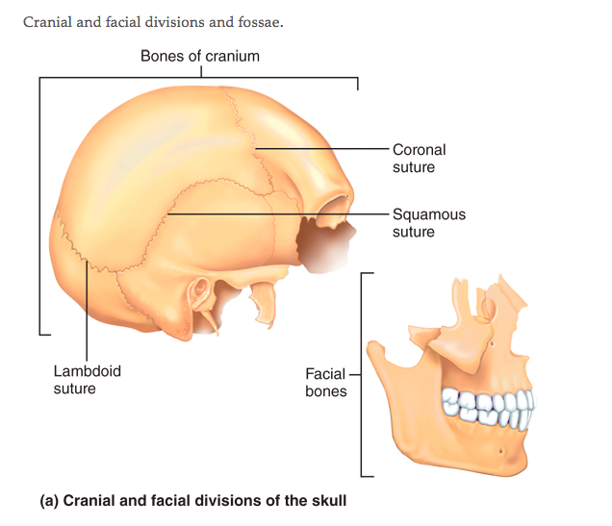

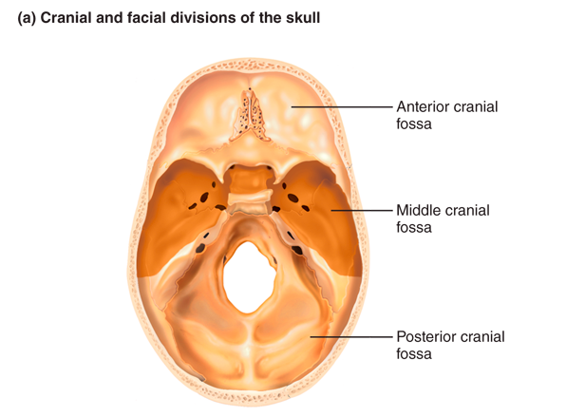

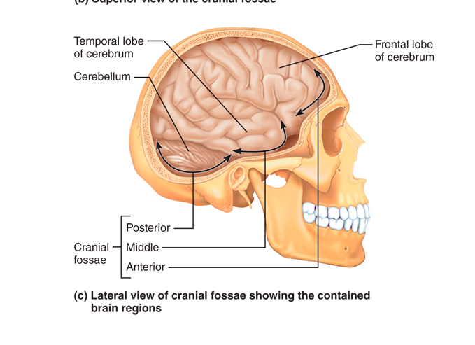
- Cranium:
- Vault
-Calvaria
-bald part of skull
-superior, lateral and posterior aspects of skull/forehead
- Base
-bony ridges
-3 fossae
anterior, middle, posterior cranial fossae
-brain sits snugly in these
-enclosed by cranial vault

-brain occupies cranial cavity
-skull has many smaller cavities
-include middle and internal ear cavities and anteriorly the nasal cavity and orbits
-sinuses=lighten skull, air filled
-85 openings (foramina, canals, fissures)
Passage way for spinal cord, major blood vessels, 12 pairs of cranial nerves, transmit info to and from brain
-8 cranial bones=paired parietal, temporal
unpaired= frontal, occipital, sphenoid, ethmoid bones.
=brains protective helmet
-cranium is curved=allows bones to be strong

- Frontal bone:
-articulates posteriorly with the paired parietal bones via the prominent coronal suture
-most anterior part=vertical squamous part=forhead
-frontal squamous region ends inferiorly at the supraorbital margins=thickened superior margins of the orbits that lie under the eyebrows
-frontal bone extends posteriorly forming superior wall of the orbits and anterior cranial fossa
-fossa supports the frontal lobes of the brain
-supraorbital margin is pierced by a supraorbital foramen (notch)
-allows supraorbital artey and nerve to pass through the forehead
-smooth portion of frontal bone between orbits=glabella
-frontonasal suture
-lateral to glabella=sinuses=frontal sinuses

- Parietal bones and major sutures:
-2 large curved, rectangular bones
-form superior and lateral aspects of the skull
-form bulk of the cranial vault
-4 largest sutures=parietal bones articulate (form a joint)
1) Coronal suture= parietal bones meet frontal bone anterior
2) sagittal suture= parietal ones meet superiorly at the cranial midline
3) lambdoid suture= parietal bones meet occipital bone posteriorly
4) squamous suture= where the parietal and temporal bones meet on the lateral aspect of the skull

- Occipital bone:
-skulls posterior, wall and base
-anteriorly with the paired parietal and temporal bones via lambdoid and occipitomastoid sutures
-basilar part of the occipital bone joins with the sphenoid bone of the cranial base
-occipital bone=wall of posterior cranial fossa
supports cerebellum of brain
-base of occipital bone=foramen magnum
inferior part of brain connects with spinal cord
foramen magnum flanked laterally by 2 occipital condyles
-occipital condyles=articulate with the first vertebra of the spinal column
-hidden medially/superiorly to each occipital condyle=hypoglossal canal=cranial nerve (X11) passes)
-median protrusion=external occipital protuberance=bulges from posterior skull
-external occipital crest and superiar, inferior nuchal lines mark occipital bone near the foramen magnum
-external occipital crest secures ligamentum nuchae
-sheetlike elastic ligament connects vertebrae of the neck to the skull
-nuchal lines, bony regions anchor many neck and back muscles
-superior nuchal line marks upper limit of the neck

- Temporal bones:
-2 temporal bones
- view from lateral skull surface
-meet them at the squamous sutures
-temporal bones form inferolateral aspects of the skull and part of the cranial base
-3 major parts:
1) squamous
-ends at the squamous suture
-zygomatic process meets zygomatic bone of face anteriorly
=zygomatic arch=cheekbone
-mandibular fossa=inferior surface of zygomatic process=condylar process of mandible (lower jawbone) forming temporomandibular joint

2) tympanic
-tympanic part(=eardrum) temporal bone surrounds external acoustic meatus
-external ear canal

3) petrous parts
-temporal bone houses middle and internal ear cavities
-contain sensory receptors for hearing and balance
-extending from occipital bone
-posteriorly to sphenoid bone anteriorly
-contributes to the cranial base
-floor of the cranial cavity
-petrous part of the temporal bone= miniature mountain ridge
-posterior slope of this ridge lies in the cranial fossa
-anterior slope is in the middle cranial fossa
-sphenoid bone and the petrous portions of the temporal bones construct the middle cranial fossa
-supports temporal lobes of the brain

