Chapter 1
Economics: Social science that studies how we allocated limited resources to satisfy unlimited wants.

Rationality: Based on what you know at the time, you will always choose what you think is best for you (on how you make decisions)

PPF shifts
- Economic growth
- Increase in available recourses

Macroeconomics studies the economy as system in which feedback among sectors determine national output, employment and prices.

Microeconomics is the study of individual behaviour in the context of scarcity.

Mixed economy: goods and services are supplied both by private suppliers and government.

Model is a formalization of theory that facilitates scientific inquiry.

Theory is a logical view of how things work, and is frequently formulated on the basis of observation.

Opportunity cost of a choice is what must be sacrificed when a choice is made.

Production possibility frontier (PPF) defines the combination of goods that can be produced using all of the resources available.

Consumption possibility frontier (CPF): the combination of goods that can be consumed as a result of a given production choice.

Economy-wide PPF is the set of goods combinations that can be produced in the economy when all available productive resources are in use.

Productivity of labour is the output of goods and services per worker.

Capital stock: the buildings, machinery, equipment and software used in producing goods and services.

Full employment output
Yc=(number of workers at full employment)×(output per worker)

Recession: when output falls below the economy's capacity output.
Boom: a period of high growth that raises output above normal capacity output.

Chapter 2

Economists...
- Study economic behavior
- Think in terms of economic costs, benefits and incentives
- Try to understand causes and consequences (theorize)
- Use models

Value of Index= |value in year t|/|abs value in base year| x 100

Government...
- Provides the legal framework essential for a mixed economy – market and public sectors
- Intervenes to support efficient market functions through...
- Competitions policy and regulatory frameworks
- Social policy
- International policy
- Monetary growth and fiscal policy
- Intervenes to redistribute to individuals and other levels of government

Variables: measures that can take on different sizes.

Data: recorded values of variables.

Time series data: a set of measurements made sequentially at different points in time.

High (low) frequency data series have short (long) intervals between observations.

Cross-section data: values for different variables recorded at a point in time.

Repeated cross-section data: cross-section data recorded at regular or irregular intervals.

Longitudinal data follow the same units of observation through time.

Percentage change=(change in values)/original value×100

Consumer price index: the average price level for consumer goods and services.

Inflation (deflation) rate: the annual percentage increase (decrease) in the level of consumer prices.

Real price: the actual price adjusted by the general (consumer) price level in the economy.

Index number: value for a variable, or an average of a set of variables, expressed relative to a given base value.

Regression line: representation of the average relationship between two variables in a scatter diagram.

Positive economics studies objective or scientific explanations of how the economy functions.

Normative economics offers recommendations that incorporate value judgments.

Economic equity is concerned with the distribution of well-being among members of the economy.

Chapter 3

Demand curve shifts
- Prices of related goods
- Consumer incomes
- Tastes and networks
- Expectations

IF | THEN DEMAND SHIFTS...
INCOME ⬆ | Demands shifts to RIGHT (for normal goods vs. inferior goods)
TASTE/DESIRE ⬆ | Demand shifts to RIGHT
PRICE OF SUBSTITION ⬆ | Demand shifts to RIGHT (we want more of our good)
PRICE OF COMPLEMENT ⬆ | Demand shifts to LEFT
FUTURE PRICE EXPECTATION ⬆ | Demand shifts to RIGHT
# OF CONSUMERS ⬆ | Demand shifts to RIGHT

Equilibrium vs Price
- Price BELOW equilibrium = Qd exceeds Qs
- Price ABOVE equilibrium = Qs exceeds Qd
- Price at equilibrium = balanced

Effects of consumers income
- Demand for normal goods rises, inferior goods falls (wine vs cheap beer)
Supply curve
- Effects of technology
- Effects of input costs
- Effects of number of suppliers

IF | THEN SUPPLY SHIFTS...
PRICE OF INPUT ⬆ | Supply shifts LEFT
TECHNOLOGY/ PRODUCTIVITY ⬆ | Supply shifts to RIGHT
TAX ⬆ | Supply shifts to LEFT
SUBSIDY ⬆ | Supply shifts to RIGHT
FUTURE PRICE EXPECTATION ⬆ | Supply shifts to LEFT
# OF PRODUCERS ⬆ | Supply shifts to RIGHT

Price controls
- Price ceilings (leads to excess demand/ shortage/black market)
- Price floors (leads to excess supply/ surplus)
- Quotas (reduces supply)

Ceteris Paribus: (law of demand) as price goes up, your willingness to buy goes down.

Market: a set of arrangements by which buyers and sellers interact in order to exchange goods/services.

Demand is the quantity of a good or service that buyers wish to purchase at each possible price, with all other influences on demand remaining unchanged.

Supply is the quantity of a good or service that sellers are willing to sell at each possible price, with all other influences on supply remaining unchanged.

Quantity demanded defines the amount purchased at a particular price.

Quantity supplied refers to the amount supplied at a particular price.

Equilibrium price: equilibrates the market. It is the price at which quantity demanded equals the quantity supplied.

Excess supply exists when the quantity supplied exceeds the quantity demanded at the going price.

Excess demand exists when the quantity demanded exceeds quantity supplied at the going price.

Short side of the market determines outcomes at prices other than the equilibrium.

Demand curve is a graphical expression of the relationship between price and quantity demanded, with other influences remaining unchanged.

Supply curve is a graphical expression of the relationship between price and quantity supplied, with other influences remaining unchanged.

Substitute goods: when a price reduction (rise) for a related product reduces (increases) the demand for a primary product, it is a substitute for the primary product.

Complementary goods: when a price reduction (rise) for a related product increases (reduces) the demand for a primary product, it is a complement for the primary product.

Inferior good is one whose demand falls in response to higher incomes.

Normal good is one whose demand increases in response to higher incomes.

Comparative static analysis compares an initial equilibrium with a new equilibrium, where the difference is due to a change in one of the other things that lie behind the demand curve or the supply curve.

Price controls are government rules or laws that inhibit the formation of market-determined prices.

Quotas are physical restrictions on output.

Market demand: the horizontal sum of individual demands.

Chapter 4

E=[(Q₂-Q₁)/(Q₁+Q₂)/2]/ [(P₂-P₁)/(P₁+P₂)/2]

Elasticity values at intercepts
- Vertical intercept Q=0 (elasticity becomes infinitely large)
- Horizontal intercept P=0 (elasticity=0)

Elastic: E_{d}>1
Inelastic: 0< E_{d} <1
Unit Elastic: E_{d} =1
Determinants:
- Luxuries are ELASTIC
- Necessities are INELASTIC
- Substitutes are INELASTIC

Perfects
- Perfectly inelastic: Q remains constant regardless of P (Elasticity=0)
- Perfectly elastic: small change in P causes huge change in Q

IF | THEN TR... AS PRICE ⬆ 
E_{P}=0 | TR ⬆
0<E_{p}<1 | TR ⬆
E_{p}=1 | TR stays the SAME because P changes by 1 and Q changes by 1
1<E_{p}<∞ | TR ⬇
E_{p}=∞ | TR ⬇

Short-run/Long-run
- Demand tends to be more elastic in long-run
- Demand tends to be more inelastic in short-run

Cross price elasticity=[(Q₂-Q₁)/(Q₁+Q₂)/2]/ [(P₂-P₁)/(P₁+P₂)/2]
Q= quantity of X
P= price of Y
- E_{x}=0 (UNRELATED GOODS)
- E_{x}= negative (COMPLIMENT)
- E_{x}=positive (SUBSTITUTE)

Income elasticity=[(Q₂-Q₁)/(Q₁+Q₂)/2]/
[(INCOME₂-INCOME₁)/(INCOME₁+INCOME₂)/2
- Normal goods have positive income E_{d} (curve shifts RIGHT)
- Inferior goods have negative income E_{d} (curve shifts LEFT)
- Luxury goods have an income E_{d} greater than 1

Summary
- Ceteris Paribus, the more substitutes the more elastic
- Ceteris Paribus, the more of your income the more elastic
- Ceteris Paribus, the more time to respond the more elastic
- Ceteris Paribus, the more of a luxury the more elastic

Taxes
- Tax incidence is the manner in which the tax burden is divided between buyers and sellers
- When supply is more elastic than demand, buyers bear most of the tax burden. When demand is more elastic than supply, producers bear most of the cost of the tax.
- Tax revenue is larger the more inelastic the demand and supply are.

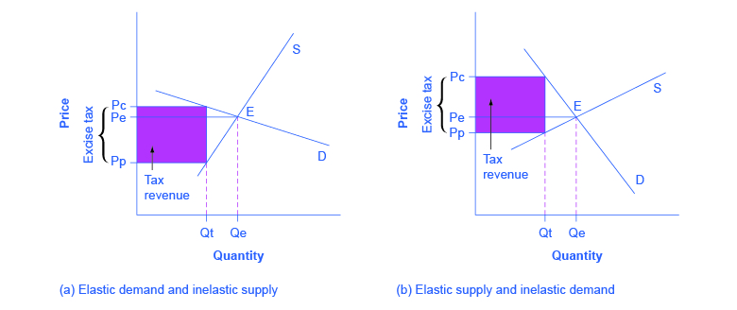

Price elasticity of demand is measured as the percentage change in quantity demanded, divided by the percentage change in price.

Demand is elastic if the price elasticity is greater than unity. It is inelastic if the value lies between unity and 0. It is unit elastic if the value is exactly one.

Cross-price elasticity of demand is the percentage change in the quantity demanded of a product divided by the percentage change in the price of another.

Income elasticity of demand is the percentage change in quantity demanded divided by a percentage change in income.

Luxury good or service is one whose income elasticity equals or exceeds unity.

Necessity is one whose income elasticity is greater than zero and is less than unity.

Inferior goods have a negative income elasticity.

Elasticity of supply is defined as the percentage change in quantity supplied divided by the percentage change in price.

Tax Incidence describes how the burden of a tax is shared between buyer and seller.
Chapter 5

Solutions to externalities:
- Negative= internalize it by taxing it
- Positive= subsidize it

Negative externalities
- Tend to over produce and under price
- If they are not dealt with, they will lose the deadweight loss
- When demand is perfectly elastic, there is no consumer surplus

Positive externalities
- If the government cant afford to subsidize, people can make donations

Pigouvian tax/subsidies

Public good
- Privatized or everyone is taxed
- Non rival (if you consume, you don’t stop someone else from consuming)
- Non exclusive

Welfare economics assesses how well the economy allocates its scarce resources in accordance with the goals of efficiency and equity.

Efficiency addresses the question of how well the economy's resources are used and allocated.

Equity deals with how society's goods and rewards are, and should be, distributed among its different members, and how the associated costs should be apportioned.

Consumer surplus is the excess of consumer willingness to pay over the market price.

Supplier or producer surplus is the excess of market price over the reservation price of the supplier.

Efficient market: maximizes the sum of producer and consumer surpluses.

Tax wedge is the difference between the consumer and producer prices.

Revenue burden is the amount of tax revenue raised by a tax.

Excess burden of a tax is the component of consumer and producer surpluses forming a net loss to the whole economy.

Deadweight loss of a tax is the component of consumer and producer surpluses forming a net loss to the whole economy.

Distortion in resource allocation means that production is not at an efficient output.

Externality is a benefit or cost falling on people other than those involved in the activity's market. It can create a difference between private costs or values and social costs or values.

Corrective tax seeks to direct the market towards a more efficient output.

Greenhouse gases that accumulate excessively in the earth's atmosphere prevent heat from escaping and lead to global warming.

Marginal damage curve reflects the cost to society of an additional unit of pollution.

Marginal abatement curve reflects the cost to society of reducing the quantity of pollution by one unit.

Tradable permits are a market-based system aimed at reducing GHGs.

Carbon taxes are a market-based system aimed at reducing GHGs.

Chapter 6

MU/$= MU/P

Budget=P₁× Q₁+ P₂× Q₂

- When marginal utility is the same for both products, you will alternate between the 2 (MU_{B}/P_{B}=MU_{A}=P_{A})

Cardinal utility is a measurable concept of satisfaction.

Total utility is a measure of the total satisfaction derived from consuming a given amount of goods and services.

Marginal utility is the addition to total utility created when one more unit of a good or service is consumed.

Diminishing marginal utility implies that the addition to total utility from each extra unit of a good or service consumed is declining.

Consumer equilibrium occurs when marginal utility per dollar spent on the last unit of each good is equal.

Law of demand states that, other things being equal, more of a good is demanded the lower is its price.

Ordinal utility assumes that individuals can rank commodity bundles in accordance with the level of satisfaction associated with each bundle.

Budget constraint defines all bundles of goods that the consumer can afford with a given budget.

Affordable set of goods and services for the consumer is bounded by the budget line from above; the non-affordable set lies strictly above the budget line.

Indifference curve defines combinations of goods and services that yield the same level of satisfaction to the consumer.

Indifference map is a set of indifference curves, where curves further from the origin denote a higher level of satisfaction.

Marginal rate of substitution is the slope of the indifference curve. It defines the amount of one good the consumer is willing to sacrifice in order to obtain a given increment of the other, while maintaining utility unchanged.

Diminishing marginal rate of substitution reflects a higher marginal value being associated with smaller quantities of any good consumed.

Consumer optimum occurs where the chosen consumption bundle is a point such that the price ratio equals the marginal rate of substitution.

Chapter 7

Individuals have diminishing marginal utility: successive equal increments in consumption yield progressively less additional utility

Sole proprietor is the single owner of a business and is responsible for all profits and losses.

Partnership: a business owned jointly by two or more individuals, who share in the profits and are jointly responsible for losses.

Corporation or company is an organization with a legal identity separate from its owners that produces and trades.

Shareholders invest in corporations and therefore are the owners. They have limited liability personally if the firm incurs losses.

Dividends are payments made from after-tax profits to company shareholders.

Capital gains (losses) arise from the ownership of a corporation when an individual sells a share at a price higher (lower) than when the share was purchased.

Real return on corporate stock: the sum of dividend plus capital gain, adjusted for inflation.

Real return: the nominal return minus the rate of inflation.

Limited liability means that the liability of the company is limited to the value of the company's assets.

Retained earnings are the profits retained by a company for reinvestment and not distributed as dividends.

Principal or owner: delegates decisions to an agent, or manager.
- Usually RISK NEUTRAL (ex: equally happy to win $100 vs. lose $100)

Agent: usually a manager who works in a corporation and is directed to follow the corporation's interests.
- Usually RISK AVERSE (does not like risk... losing $100 is way worse than wining $100)

Principal-agent problem: arises when the principal cannot easily monitor the actions of the agent, who therefore may not act in the best interests of the principal.
- Solution: give an incentive to the agent (ex: share the profit with the agent)

Stock option: an option to buy the stock of the company at a future date for a fixed, predetermined price.

Accounting profit: is the difference between revenues and explicit costs.

Economic profit: is the difference between revenue and the sum of explicit and implicit costs.

Explicit costs: are the measured financial costs.

Implicit costs: represent the opportunity cost of the resources used in production.

Capital market: a set of financial institutions that funnels financing from investors into bonds and stocks.

Portfolio: a combination of assets that is designed to secure an income from investing and to reduce risk.

Risk pooling: a means of reducing risk and increasing utility by aggregating or pooling multiple independent risks.

Risk spreading: Works by reducing the stake of each participant: insurers reduce
their risk exposure by spreading the risk to other insurers

Risk: the risk associated with an investment can be measured by the dispersion in possible outcomes. A greater dispersion in outcomes implies more risk.

Diversification reduces the total risk of a portfolio by pooling risks across several different assets whose individual returns behave independently.

Chapter 8

Production function: a technological relationship that specifies how much output can be produced with specific amounts of inputs.

Technological efficiency means that the maximum output is produced with the given set of inputs.

Economic efficiency defines a production structure that produces output at least cost.

Short run: a period during which at least one factor of production is fixed. If capital is fixed, then more output is produced by using additional labour.

Long run: a period of time that is sufficient to enable all factors of production to be adjusted.

Very long run: a period sufficiently long for new technology to develop.

Law of diminishing returns: when increments of a variable factor (labour) are added to a fixed amount of another factor (capital), the marginal product of the variable factor must eventually decline.

Total product is the relationship between total output produced and the number of workers employed, for a given amount of capital.
- Q= f(L)

Marginal product of labour is the addition to output produced by each additional worker. It is also the slope of the total product curve.
- MP=ΔQ/ΔL

Average product of labour is the number of units of output produced per unit of labour at different levels of employment.
- AP=Q/L
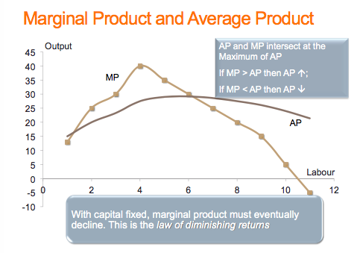

Average fixed cost is the total fixed cost per unit of output.
- AFC = FC/Q

Average variable cost is the total variable cost per unit of output.
- AVC = VC/Q

Average total cost is the sum of all costs per unit of output.
- ATC = TC/Q
- When drawing TC and TVC, don’t make them parallel, they are close together towards the end of curve
- For TC curve: take TP curve, turn it to the right and hold it up to the light

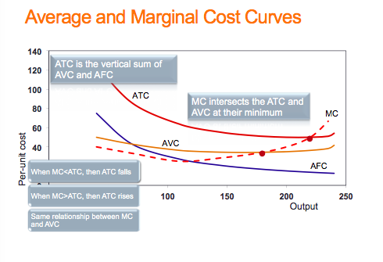
Marginal cost of production is the cost of producing each additional unit of output.
- MC = ΔTC/ΔQ
- MC = ΔTVC/ΔQ

Sunk cost is a fixed cost that has already been incurred and cannot be recovered, even by producing a zero output.

Increasing returns to scale implies that, when all inputs are increased by a given proportion, output increases more than proportionately.

Constant returns to scale implies that output increases in direct proportion to an equal proportionate increase in all inputs.

Decreasing returns to scale implies that an equal proportionate increase in all inputs leads to a less than proportionate increase in output.

Long-run average total cost is the lower envelope of all the short-run ATC curves.
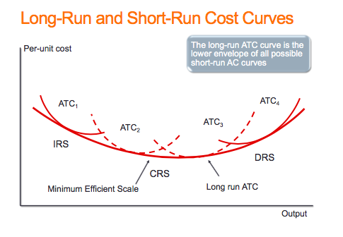
Returns to Scale: Increasing if proportionate change in all inputs yields more than proportionate increase in output

Minimum efficient scale defines a threshold size of operation such that scale economies are almost exhausted.

Long-run marginal cost is the increment in cost associated with producing one more unit of output when all inputs are adjusted in a cost minimizing manner.

Technological change represents innovation that can reduce the cost of production or bring new products on line.

Globalization is the tendency for international markets to be ever more integrated.

Cluster: a group of firms producing similar products, or engaged in similar research.

Learning by doing can reduce costs. A longer history of production enables firms to accumulate knowledge and thereby implement more efficient production processes.

Economies of scope occur if the unit cost of producing particular products is less when combined with the production of other products than when produced alone.

Chapter 9

Perfect competition: an industry in which many suppliers, producing an identical product, face many buyers, and no one participant can influence the market.
- Firms maximize profits
- Free entry/exit
- Price takers
- Homogeneous product
- Information is perfect
- P=MC

Advantages of perfectly competitive market:
- Productively efficient (allocates resources well)
- Allocatably efficient (P=MC)

Disadvantages of perfectly competitive market:
- Prone to market failures
- Tend to not be innovative because they all copy eachother

Profit maximization is the goal of competitive suppliers – they seek to maximize the difference between revenues and costs.
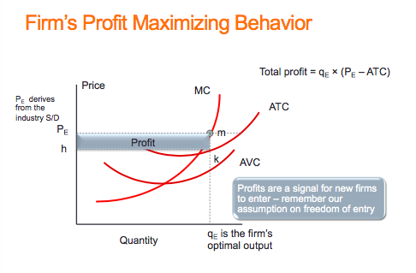
Marginal revenue is the additional revenue accruing to the firm resulting from the sale of one more unit of output.
- MR=ΔTR/ΔQ

Shut-down price corresponds to the minimum value of the AVC curve.
- MR,MC<AVC

Break-even price corresponds to the minimum of the ATC curve.

Short-run supply curve for perfect competitor: the portion of the MC curve above the minimum of the AVC

Industry supply (short run) in perfect competition is the horizontal sum of all firms' supply curves.

Short-run equilibrium in perfect competition occurs when each firm maximizes profit by producing a quantity where P=MC
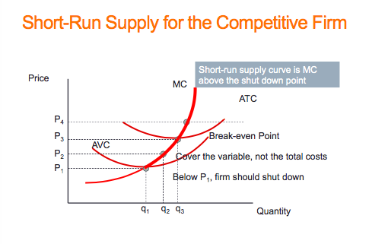
Economic (supernormal) profits are those profits above normal profits that induce firms to enter an industry. Economic profits are based on the opportunity cost of the resources used in production.

Long-run equilibrium in a competitive industry requires a price equal to the minimum point of a firm's ATC. At this point, only normal profits exist, and there is no incentive for firms to enter or exit.
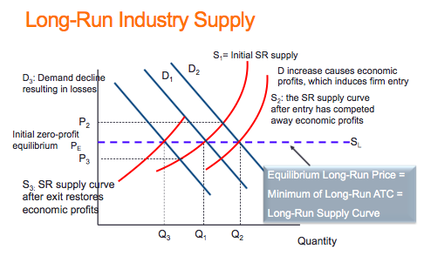
Industry supply in the long run in perfect competition is horizontal at a price corresponding to the minimum of the representative firm's long-run ATC curve.

Increasing (decreasing) cost industry is one where costs rise (fall) for each firm because of the scale of industry operation.

Chapter 10

Graph:
- MR curve is 2X as steep as D (same y-int, half x-int)
- Max. profit when MR=MC

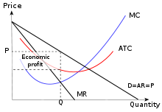
Monopolist: is the sole supplier of an industry's output, and therefore the industry and the firm are one and the same.
- 1 player
- Infinite barriers to entry

Natural monopoly: one where the ATC of producing any output declines with the scale of operation.

National Policy: a deliberate government policy to protect a domestic monopoly

Maintaining barriers to entry
- Patents, granted by government
- Predatory pricing, intended to drive out potential competition
- Lobbying government for subsidies as a means of preventing entry
- Excess production capacity
- Network goods that are utilized almost universally
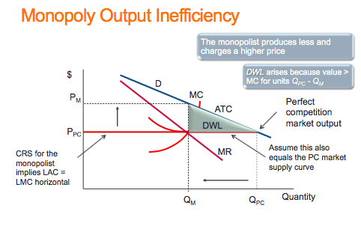
Allocative inefficiency arises when resources are not appropriately allocated and result in deadweight losses.

Price discrimination involves charging different prices to different consumers in order to increase profit.

A cartel is a group of suppliers that colludes to operate like a monopolist.

Rent seeking is an activity that uses productive resources to redistribute rather than create output and value.

Invention is the discovery of a new product or process through research.

Product innovation refers to new or better products or services.

Process innovation refers to new or better production or supply.

Patent laws grant inventors a legal monopoly on use for a fixed period of time.

Chapter 11
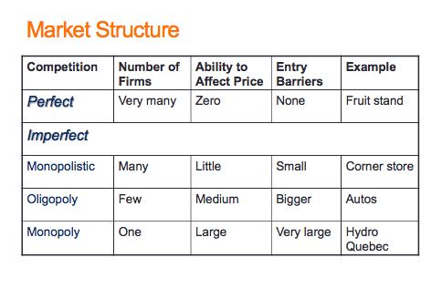
Imperfectly competitive firms face a downward-sloping demand curve, and their output price reflects the quantity sold.

Oligopoly defines an industry with a small number of suppliers.
- Price makers
- Heterogeneous products
- Many buyers/Few sellers (strategic interdependence)
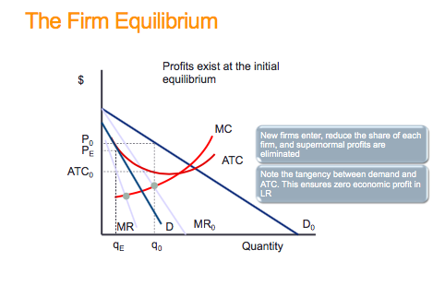
- Barriers to entry/exit
- Imperfect info
- Similar to monopoly

Monopolistic competition defines a market with many sellers of products that have similar characteristics. Monopolistically competitive firms can exert only a small influence on the whole market.
- Price makers
- Product is heterogeneous
- Many buyers/sellers
- No barriers to entry/exit
- Imperfect information
- LR profit=0
- MR=MC and P=ATC
- Every entry shifts D curve left
- Similar to perfect comp.

Duopoly defines a market or sector with just two firms. (ex: coke/pepsi)

Concentration ratio:N-firm concentration ratio is the sales share of the largest N firms in that sector of the economy.
- High ratio=imperfect comp.
- Low ration=higher comp.

Differentiated product is one that differs slightly from other products in the same market.

The monopolistically competitive equilibrium in the long run requires the firm's demand curve to be tangent to the ATC curve at the output where MR=MC.

Collusion is an explicit or implicit agreement to avoid competition with a view to increasing profit.

Conjecture: a belief that one firm forms about the strategic reaction of another competing firm.

Game: a situation in which contestants plan strategically to maximize their profits, taking account of rivals' behaviour.

Strategy: a game plan describing how a player acts, or moves, in each possible situation.

Nash equilibrium: one in which each player chooses the best strategy, given the strategies chosen by the other player, and there is no incentive for any player to move. (Both will confess)

Dominant strategy: a player's best strategy, whatever the strategies adopted by rivals.

Payoff matrix: defines the rewards to each player resulting from particular choices.

Credible threat: one that, after the fact, is still optimal to implement.

Cournot behaviour involves each firm reacting optimally in their choice of output to their competitors' decisions.
- TR₁=P₁Q₁
- P₁=a₁-b₁q
- P₂=a₂-b₂q
- q=Q₁-Q₂
- C₁=a₁-b₁Q₁-2b₂Q₂
- C₂=a₂-b₂Q₂-2b₁Q₁
- Q₁=(a₁-b₁Q₂-C₁)/2b₁
- Q₂=(a₂-b₂Q₁-C₂)/2b₂

Reaction functions define the optimal choice of output conditional upon a rival's output choice.

Chapter 15

Autarky denotes the no-trade situation.

Principle of comparative advantage states that even if one country has an absolute advantage in producing both goods, gains to specialization and trade still materialize, provided the opportunity cost of producing the goods differs between economies.

Terms of trade define the rate at which goods trade internationally.

Consumption possibility frontier defines what an economy can consume after production specialization and trade.

Intra-industry trade is two-way international trade in products produced within the same industry.

Intra-firm trade is two-way trade in international products produced within the same firm.

Dynamic gains: the potential for domestic producers to increase productivity by competing with, and learning from, foreign producers.

Total factor productivity: how efficiently the factors of production are combined.

Tariff is a tax on an imported product that is designed to limit trade in addition to generating tax revenue. It is a barrier to trade.
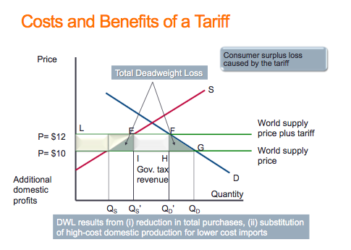
Quota is a quantitative limit on an imported product.
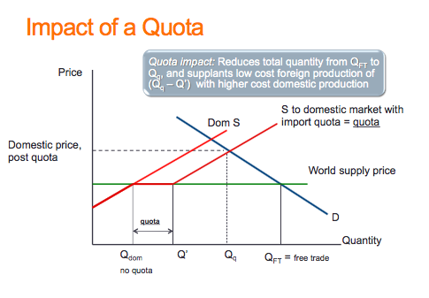
Trade subsidy to a domestic manufacturer reduces the domestic cost and limits imports.
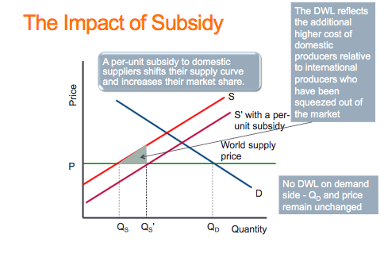
Non-tariff barriers, such as product content requirements, limits the gains from trade.

Dumping is a predatory practice, based on artificial costs aimed at driving out domestic producers.

