Experiment 1; Thin Layer Chromatography

By Claudia Nathalie Prieto
8721546

Partner: Emma Roy 8619079

CHM1321 D
Lab day: Tuesday afternoon
Lab week: 3

Demonstrator:
Camilo Viasus

2016-17-01

University of Ottawa

Student’s Initials: C.N.P.

Protocol:

For explanation and procedure refer to lab manual page 17 to 19

Observations:

During the experiment, multiple substances have been used. Most of them are very similar to each other in what corresponds to color, and smell. Initially, 2:8 mixture of EtOAc and hexane was used. This mixture of ethyl acetate: hexane is transparent and has a very strong smell resembling to polish remover (due to the acetate). Later, benzophenone, biphenyl, and 3 reference solutions were used. Reference solution A, ortho-bromonitrobenzene, reference solution B, meta-bromonitrobenzene, and reference solution C, para-bromonitrobenzene. All of this solution were transparent in exception of reference solution A which had a green tinge. Likewise, an unknown substance was also used. This one was identified as substance #12. This substance was a white, thick, crystal powder with a bitter smell. Lastly, another unknown substance named XX was used. This last one was a yellow, translucent liquid SMELL
The TLC plate was prepared by using the polar material called silica gel coated onto a piece of glass or rigid plastic. Being a white layer, when the base line and the solvent line were easily drawn with a pencil and were clearly seen. Likewise, when the drops of the used substances are applied on the TLC plate, it was visible that the substances were easily and rapidly adsorbed as well as the solvent evaporated in a couple of seconds after the TLC plate was taken out from the developing jar.
Once the TLC plate was placed under the UV light it was visible that most of the dots were of the same average size but not at the same level of height from the base line. However, in between the 2 TLC plates containing the same type of drops of a certain substance do have a very similar height from the base line. Finally, some of these dots were not perfectly shaped like ovals, but they were smudged.

Chart 1: Reagents table

Substance | Part A | Part B | Part C
2:8 EtOAc and Hexane (mL) | 9.95 | 9.8 | 9.9
Unknown solution #12 (mg) | 10 | Not used | Not used
Dichloro-methane (mL/# drops) | 1.60/ 1 | 1.60/ 1 | Not used
Benzophenone (mL/# drops) | 1.90/ 1 | 1.90/ 1 | Not used
Biphenyl (mL/# drops) | 1.80/ 1 | 1.80/ 1 | Not used
Reference solution A (# drops) | Not used | Not used | 1
Reference solution B (# drops) | Not used | Not used | 1
Reference solution C (# drops) | Not used | Not used | 1
9:1 Hexane EtOAc (mL) | Not used | Not used | 9.8
XX solution (mL/ # drops) | Not used | Not used | 2 / 1

TLC:

#1
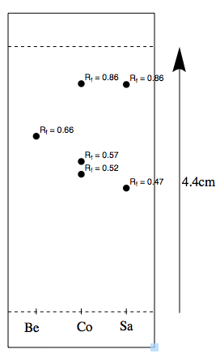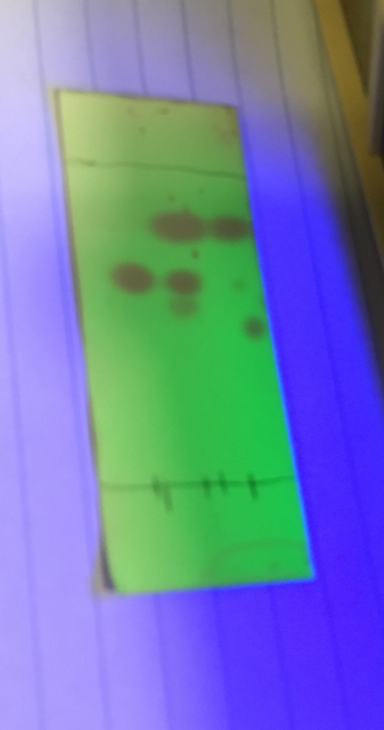
Compound | Label | D1 value (distance from compound’s dot baseline) | D2 value (distance from Baseline to Solvent line) | Rf value (correspondingly) | Liquid in jar
Benzophenone (reference) | Be | 2.9 cm | 4.4cm | 0.66 | 2:8 EtOAc and hexane
Sample (unknown solution  #12 + dichloromethane) | Sa | 2.1 cm & 3.8 cm | 4.4cm | 0.47 & 0.86 | 2:8 EtOAc and hexane
Co-spot (Sample + reference) | Co | 2.3 cm, 2.5 cm & 3.8 cm | 4.4cm | 0.52, 0.57 & 0.86 | 2:8 EtOAc and hexane

#2
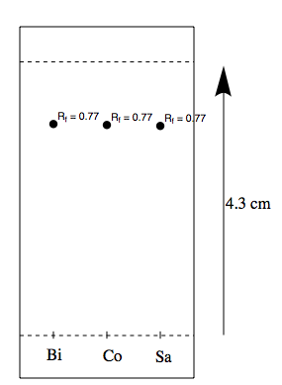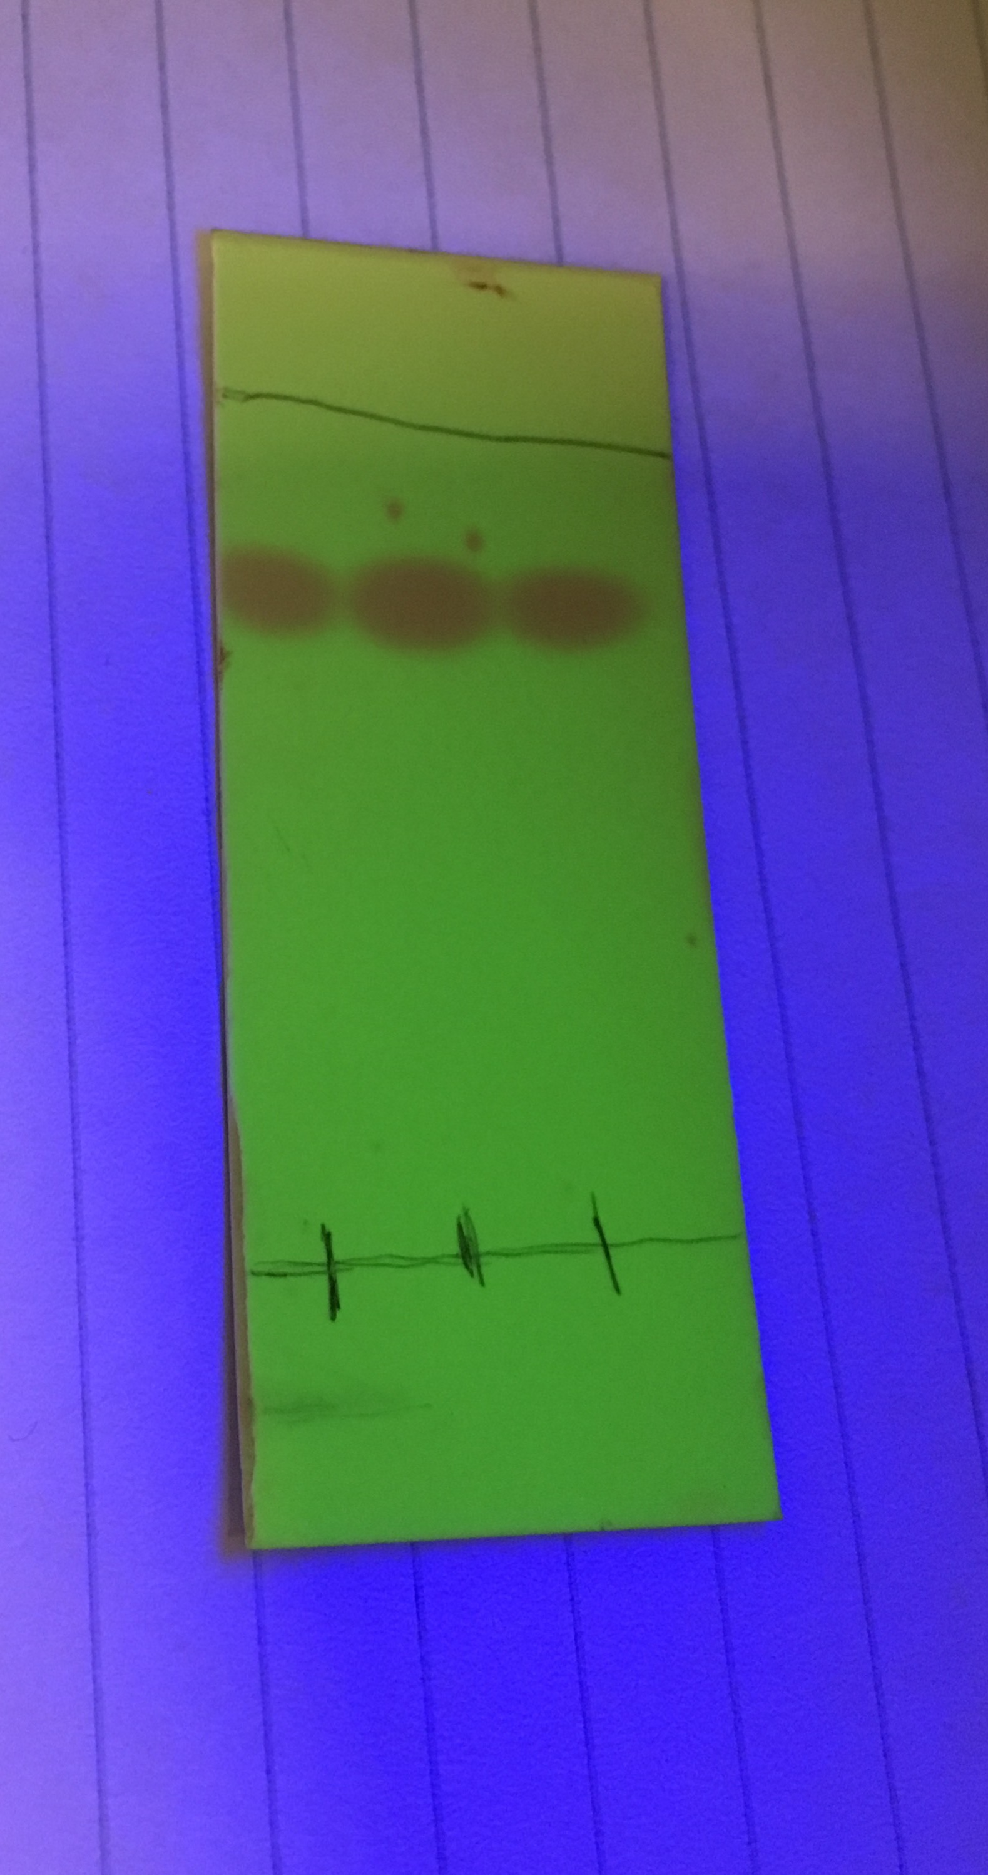

Compound | Label | D1 value (distance from compound’s dot baseline) | D2 value (distance from Baseline to Solvent line) | Rf value (correspondingly) | Liquid in Jar
Biphenyl(reference) | Bi | 3.3 cm | 4.3cm | 0.77 | 2:8 EtOAc and hexane
Sample (unknown solution  #12 + dichloromethane) | Sa | 3.3 cm | 4.3cm | 0.77 | 2:8 EtOAc and hexane
Co-spot (Sample + reference) | Co | 3.3 cm | 4.3cm | 0.77 | 2:8 EtOAc and hexane

#3
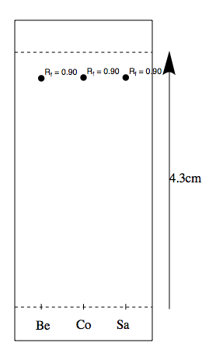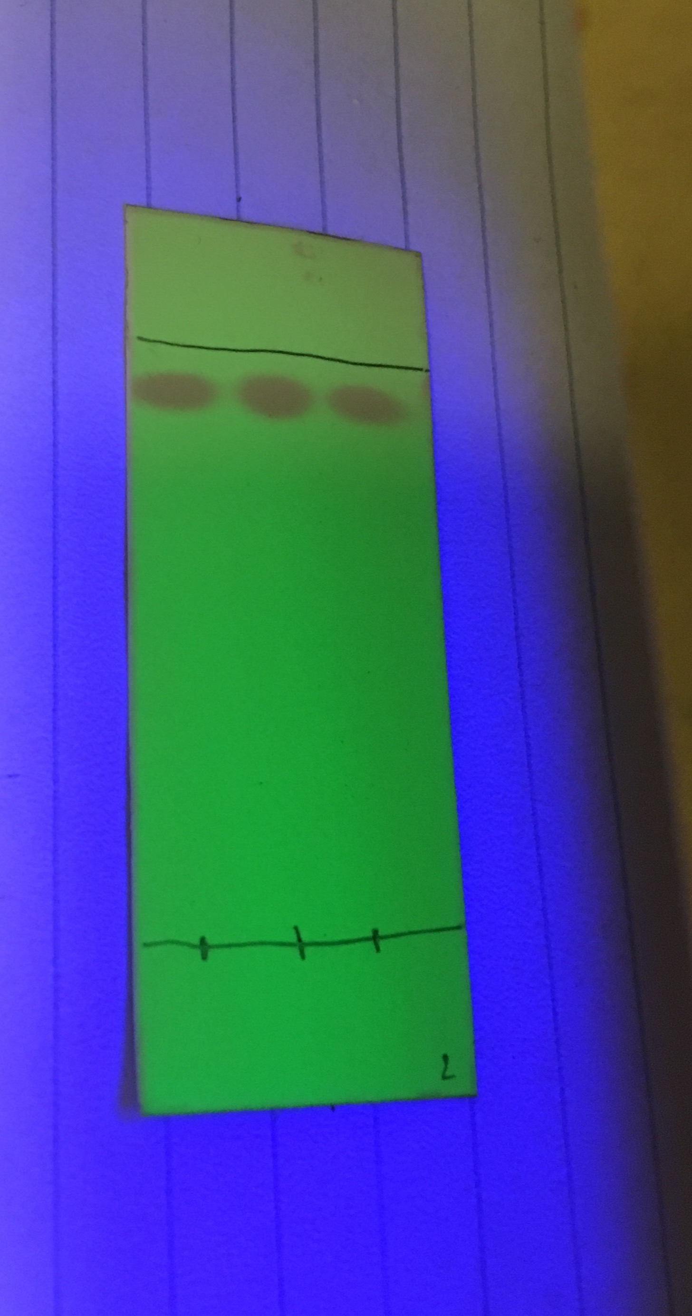
Compound | Label | D1 value (distance from compound’s dot baseline) | D2 value (distance from Baseline to Solvent line) | Rf value (correspondingly) | Liquid in Jar
Benzophenone (reference) | Be | 3.9 cm | 4.3cm | 0.90 | EtOAc (Ethyl acetate)
Sample (unknown solution  #12 + dichloromethane) | Sa | 3.9 cm | 4.3cm | 0.90 | EtOAc (Ethyl acetate)
Co-spot (Sample + reference) | Co | 3.9 cm | 4.3cm | 0.90 | EtOAc (Ethyl acetate)

#4

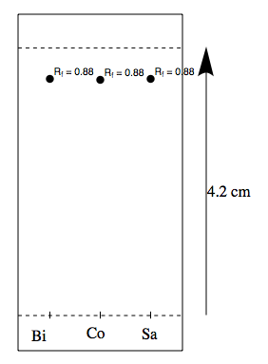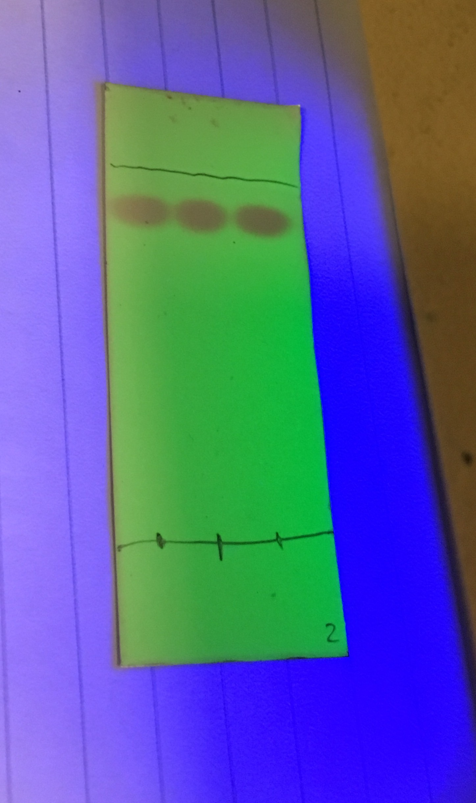

Compound | Label | D1 value (distance from compound’s dot baseline) | D2 value (distance from Baseline to Solvent line) | Rf value (correspondingly) | Liquid in jar
Biphenyl (reference) | Bi | 3.7 cm | 4.2cm | 0.88 | EtOAc (Ethyl acetate)
Sample (unknown solution  #12 + dichloromethane) | Sa | 3.7 cm | 4.2cm | 0.88 | EtOAc (Ethyl acetate)
Co-spot (Sample + reference) | Co | 3.7 cm | 4.2cm | 0.88 | EtOAc (Ethyl acetate)

#5

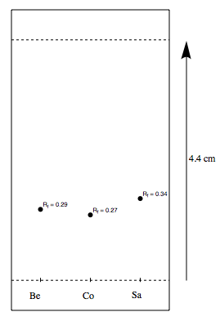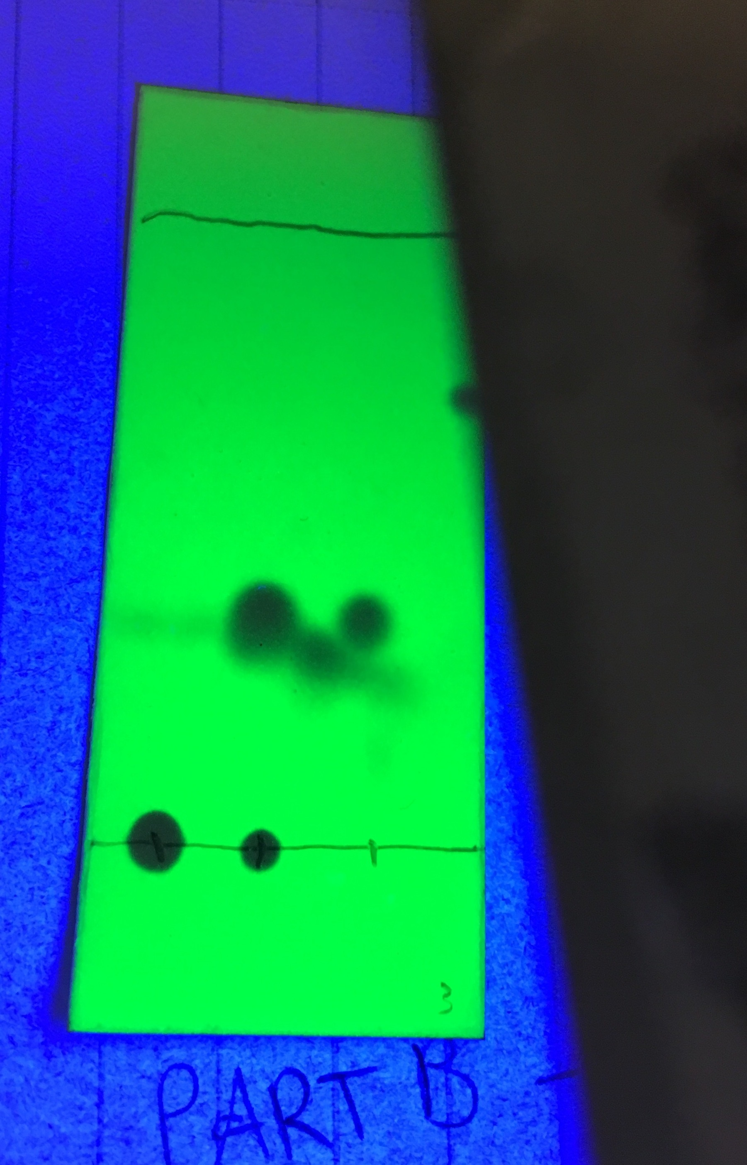

Compound | Label | D1 value (distance from compound’s dot baseline) | D2 value (distance from Baseline to Solvent line) | Rf value (correspondingly) | Liquid in jar
Benzophenone (reference) | Be | 1.3 cm cm | 4.4cm | 0.29 | hexanes
Sample (unknown solution  #12 + dichloromethane) | Sa | 1.2 cm | 4.4cm | 0.27 | hexanes
Co-spot (Sample + reference) | Co | 1.5 cm | 4.4cm | 0.34 | hexanes

#6

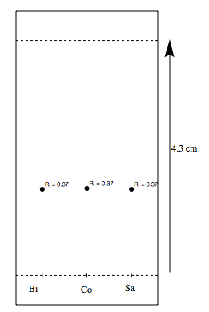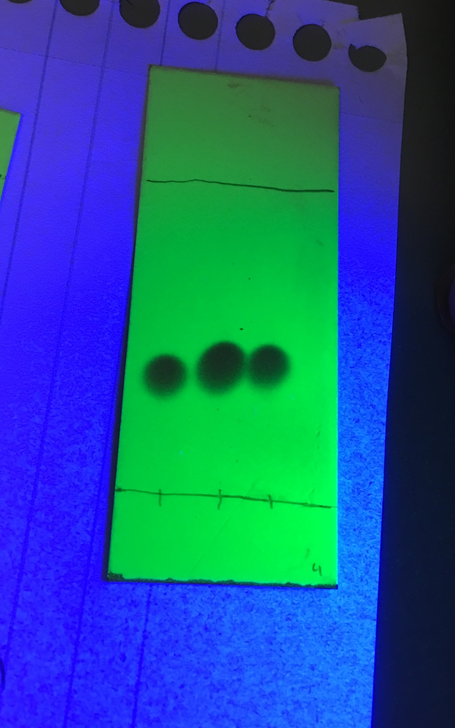

Compound | Label | D1 value (distance from compound’s dot baseline) | D2 value (distance from Baseline to Solvent line) | Rf value (correspondingly) | Liquid in jar
Biphenyl(reference) | Be | 1.6 cm | 4.3cm | 0.37 | hexanes
Sample (unknown solution  #12 + dichloromethane) | Sa | 1.6 cm | 4.3cm | 0.37 | hexanes
Co-spot (Sample + reference) | Co | 1.6 cm | 4.3cm | 0.37 | hexanes

#7
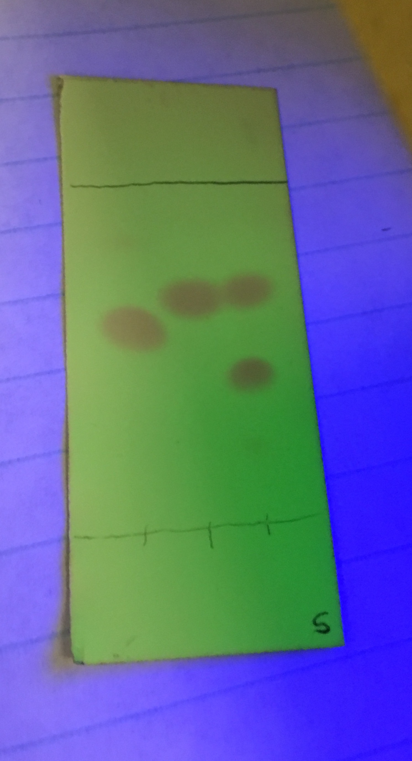

#8
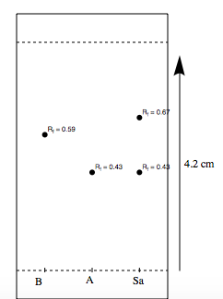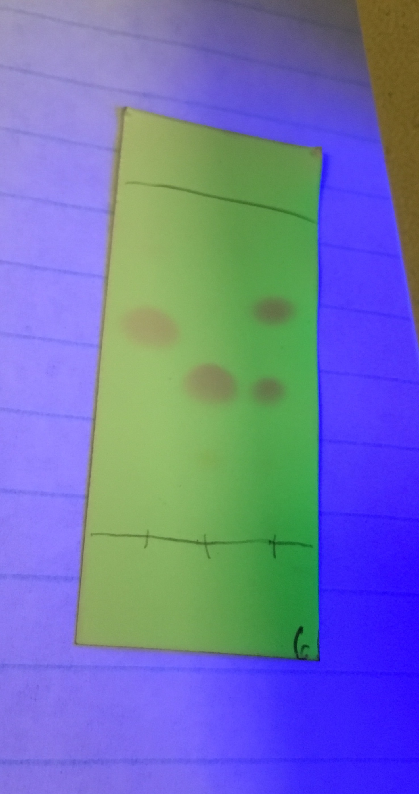

Calculations:

Rf: Data used from the results of Part B Benzophenone TLC plate

- Rf1 = compound to baseline/ baseline to solvent
Rf1 = 1.3cm/4.4 cm
Rf1 = 0.30 cm

- Rf2 = compound to baseline/ baseline to solvent
Rf2 = 1.2cm/4.4 cm
Rf2 = 0.27 cm

- Rf3 = compound to baseline/ baseline to solvent
Rf3 = 3.1cm/4.4cm
Rf3 = 0.72 cm

% Peak intensity (percentage of absorbance) for TLC lane 3

Data used from Part C TLC plate containing 1 sample and 2 reference solutions (B and A)

Figure 1: TLC lane 1 containing first peak

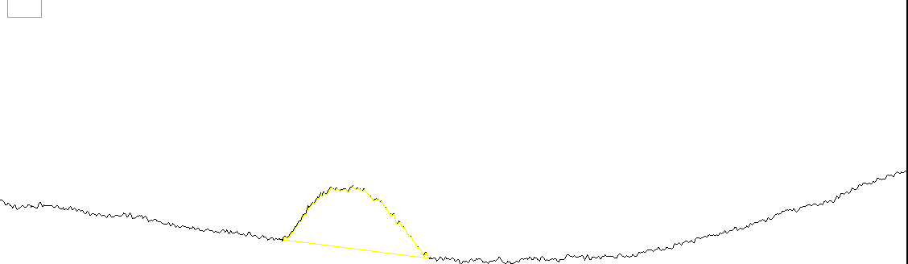

Figure2: TLC lane 2 containing second peak

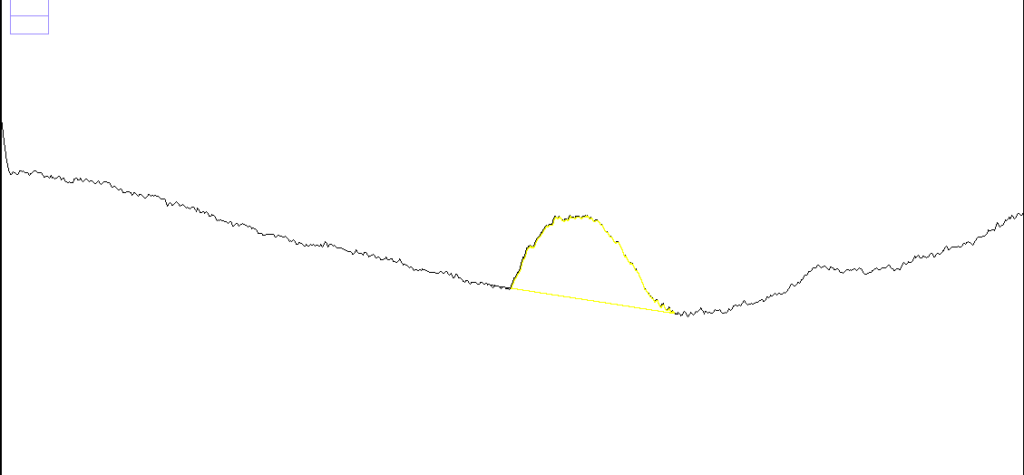

Figure 3: TLC lane 3 showing the third peak highlighted as the first peak of this lane

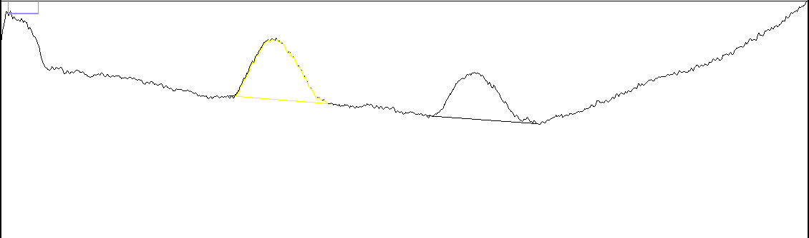
Figure 4: TLC lane 3 showing the fourth peak highlighted as the second peak of this lane

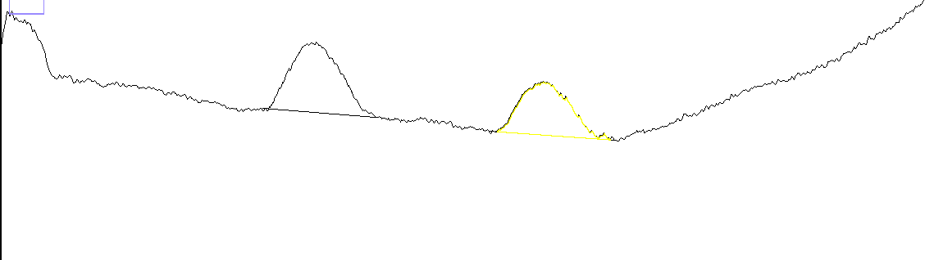

Figure 5: relative intensities of each peak in order of selection

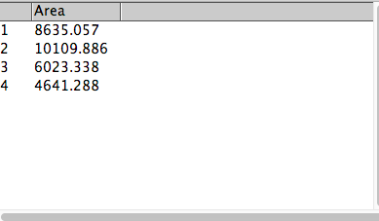

Absorbance of meta = 6023.338
Absorbance of ortho = 4641.288

% Absorbance of meta = [(area of peak 3) / (area of peak 3 + area of peak 4) ] x 100%
= (6023.338) / (6023.338 + 4641.288) x 100%
= (0.56479) x 100%
= 56.479% ≅ 56.5%

% Absorbance of ortho = [(area of peak 4) / (area of peak 3 + area of peak 4) ] x 100%
= (4641.288) / (6023.338 + 4641.288) x 100%
= (0.43520) x 100%
= 43.520% ≅ 43.5%

Discussion:

Introduction:

In processes including Organic substances, and in which the final goal is to recognize and differentiate the diverse components of a certain mixture, Chromatography is considered as the most efficient process to achieve this purpose. Being the base of the separation science, Chromatography was first invented by Mikhail Tswett in the early 1900s. In Chromatography, mixtures are separated according to differences in their solubilities. Two phases are seen during this process. The first phase is called the stationary in which usually a solid, thick liquid, or bonded coating that stays in the same place while during the second phase, the mobile phase, usually a liquid or a solid move through it or across it. The mobile phase moves/flows along the stationary phase carrying the solution components with it. Each component moves at a different rate as their affinity is different and this will cause them to become magnified.
In this case, a Thin Layer Chromatography (TLC) is done by making use of a thin, uniformly arranged layer of an adsorbent and polar material called silica gel coated onto a piece of glass or rigid plastic.

