CONCORDIA UNIVERSITY
Department of Economics

MIDTERM EXAMINATION
Version A

MULTIPLE CHOICE QUESTIONS

1) What is meant by the term "market failure"?
A) that allocative efficiency has not been achieved
B) that one or more markets are not in equilibrium
C) that the free market has failed to achieve desirable social goals
D) that the market economy is a failure
E) that a small group in society is affected

2) Consider the market for iPhones with inverse demand given by P=60-2*Q_{D} and inverse supply given by
P=10+3*Q_{S}. Find the Equilibrium price and Quantity.
A) Q* =10, P*=40
B) Q* =40, P*=10
C) Q* =10, P*=35
D) Q* =20, P*=20

3) The positive slope of a supply curve indicates that
A) as price goes up, quantity supplied will decrease.
B) as price goes up, quantity supplied will increase.
C) consumers will want to buy less at higher prices.
D) as price goes up, quantity supplied will remain constant.
E) if the costs of production increase, the quantity supplied will increase.

4) Given a typical downward-sloping demand curve in a market that has reached its equilibrium, the consumer
surplus
A) is measured by the area above the market price and under the demand curve.
B) is measured by the area immediately above the demand curve.
C) is calculated as the product of market price and quantity consumed.
D) is measured by the area below the market price and under the demand curve.
E) cannot be measured given the information.

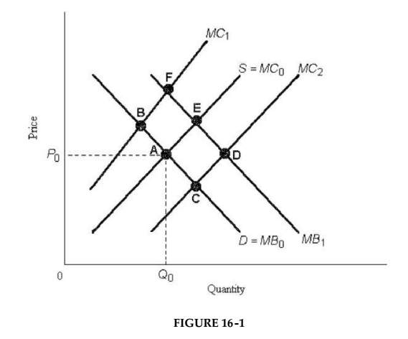
5) Refer to Figure 16-1. Suppose that the perfectly competitive market with no government intervention achieves equilibrium at point A. If the social marginal costs and social marginal benefits are represented by MC₂ and MB₀, respectively, then the competitive equilibrium quantity is
A) too high for allocative efficiency.
B) not enough information to determine allocative efficiency.
C) too low for allocative efficiency.
D) consistent with allocative efficiency.

6) Consider two firms, A and B, that must engage in pollution abatement. If Firm A has a lower marginal cost of
pollution abatement than Firm B, then
A) reallocating some of Firm B's abatement activity to Firm A can keep total abatement constant
but reduce the total cost of abatement.
B) regardless of costs, it is equitable for both firms to face the same direct controls on their pollution.
C) Firm B should lower its costs.
D) reallocating all abatement activity to Firm A will reduce pollution and reduce the total cost of abatement.
E) reallocating some of Firm A's abatement activity to Firm B will keep total abatement constant
but will reduce the total cost of abatement.

7) Which of the following would be considered as time series data?
A) Inflation rates between 1990 and 2010
B) The mortgage payments of Madonna, Sting and Marilyn Manson between 2005 and 2010
C) The effectiveness of a new cholesterol drug across two groups of clinical participants
D) The income and gasoline consumption of 1,000 residents in Montreal in 2012

8) The imposition of an excise tax usually causes the price paid by consumers to ________, while the price received by sellers ________.
A) fall; remains unchanged
B) rise; remains unchanged
C) rise; falls
D) rise; rises
E) fall; falls

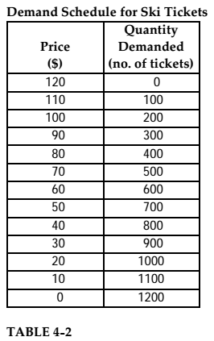

9

9) Refer to Table 4-2. Price elasticity over the interval of the demand curve between prices of $90 and $70 is
A) 2.0
B) 0.5
C) 0.5
D) 4.0
E) 1.0

10) A homeowner who keeps his sidewalk neatly shoveled creates a ____ externality to his neighbours. Without
any government policies, the number of homeowners who would keep a clean sidewalk will be too ___ compared to the efficient equilibrium. To correct this problem, the government can use a corrective _____.
A) Positive; low; subsidy
B) Positive; high; tax
C) Negative; high; tax
D) Negative; low; subsidy

11) During the 1970s, OPEC's output restrictions caused gasoline prices to increase sharply. Coincidentally,
demand for gas-guzzling cars fell. A likely explanation for these observations is that gasoline and cars had a
_______ elasticity of demand that was ________.
A) price; negative
B) cross; negative
C) income; positive
D) cross; positive
E) income; negative

12) Which of the following statements about government price controls is most accurate. They
A) usually set upper or lower limits on prices.
B) act as a guideline to producers as to what is a fair price.
C) ensure that the actual price is at its free-market equilibrium.
D) ensure that transactions take place at a fair price.
E) inform consumers what is the maximum price they should pay.

13) Madonna's income has just risen from $950 per week to $1050 per week. As a result, she decides to double the
number of movies she attends each week. Madonna's demand for movies is
A) income inelastic.
B) income elastic.
C) price elastic.
D) price inelastic.
E) positively cross inelastic.

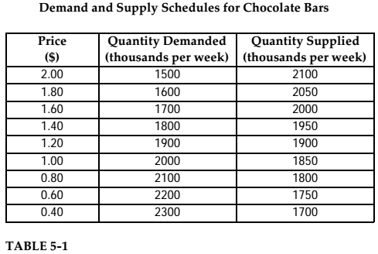

14) Refer to Table 5-1. Suppose that as a public health measure the government wants to reduce the number of chocolate bars consumed by children. If the government imposes a price of $1.60 per chocolate bar, how many fewer chocolate bars will be consumed each week, relative to the competitive equilibrium?
A) 300
B) 1800
C) 1700
D) 2000
E) 200

15) The Canadian government operates a progressive personal income-tax system. What broader social goal is
being met in this case?
A) income distribution
B) preference for public provision
C) protecting individuals from others or themselves
D) social responsibility
E) policies for economic growth

16) As the price of a good increases, the change in the quantity demanded can be shown by
A) shifting the demand curve leftward.
B) shifting the demand curve rightward.
C) moving down along the same demand curve.
D) moving up along the same demand curve.

17) Government price controls are policies that attempt to maintain the
A) quantity bought at less than the quantity sold.
B) quantity sold at less than the quantity bought.
C) price requested by the seller.
D) the price at some disequilibrium value.
E) market price at equilibrium.

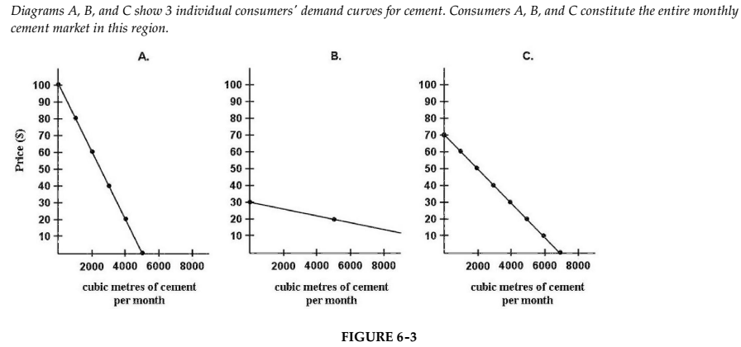

18) Refer to Figure 6-3. What is the market demand (in cubic metres per month) for cement at a price
of $20 per cubic metre?
A) 4000
B) 10 000
C) 5000
D) 0
E) 14 000

19) Consider a coal-fired electric-power plant that is operating under a cap-and trade-system. If its marginal cost
of pollution abatement (reduction) is $5 per unit and the price of the permit is $3 per unit, this firm will
A) sell permits and abate (reduce) more pollution.
B) not buy any permits, since that would push up its costs.
C) buy permits and abate (reduce) less pollution.
D) buy permits and abate (reduce) more pollution.
E) not abate (reduce) at all.

20) If the price of tea falls and as a consequence the demand for sugar rises, then tea and sugar are
A) complementary goods.
B) luxury goods.
C) substitute goods.
D) neutral goods.
E) independent goods.

21) A "decrease in supply" refers to which of the following?
A) a drop in the quantity actually exchanged
B) a downward movement along a supply curve
C) the likely result from a decrease in the price of a factor of production
D) a leftward shift in the supply curve
E) a decrease in quantity supplied

22) Weekend train travel costs less than weekday train travel. If the supply of train service remains the same
between weekdays and weekends, then the most likely explanation for this difference in price is that the weekend
A) supply curve is to the left of the weekday supply curve.
B) demand curve is to the right of the weekday demand curve.
C) demand curve is to the left of the weekday demand curve.
D) demand curve is random.
E) supply curve is to the right of the weekday supply curve.

23) Consider the global market for some mineral, X. In 2015, the equilibrium price and quantity were P = $27
and Q = 140. In 2016, the equilibrium price and quantity were P = $27 and Q = 175. Which of the following is
the best possible explanation for this change in market equilibrium?
A) There has been an increase in supply of mineral X.
B) There has been an increase in demand for mineral X.
C) There has been a simultaneous increase in demand for, and increase in supply of, mineral X.
D) There has been an increase in quantity demanded for mineral X.
E) There has been an increase in quantity supplied of mineral X.

24) Canada has a mixed economy because
A) The production and consumption of all goods and services are determined by the government
B) We have immigrants who come from different countries
C) Goods and services are provided by private firms and also by the government
D) Many Canadians speak more than one language
E) There is a mixed production and consumption of different goods and services in the economy

25) A vertical supply curve exhibits
A) a constant elasticity of supply.
B) a perfectly inelastic supply curve.
C) Both A and B are true.
D) None of the above.

26) Consider the market for iPhones with inverse demand given by P=60-2*Q_{D} and inverse supply given by P=10+3*Q_{S}. Suppose the Price floor is $50. Find the Deadweight Loss.
A) DWL=62.5
B) DWL=50
C) DWL=72.5
D) DWL=52.5

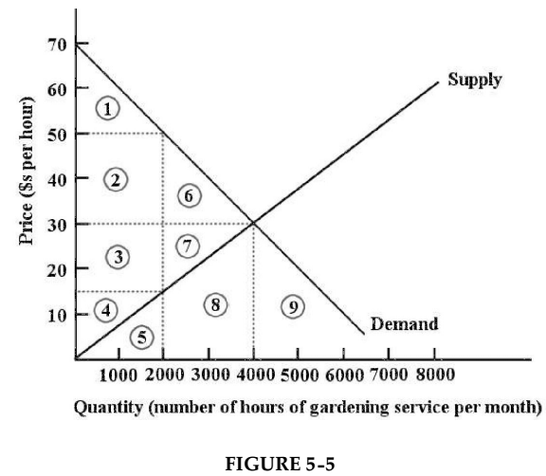

27) Refer to Figure 5-5. Suppose this market for gardening services is in a free-market equilibrium. If the
government then imposes a price floor of $50 per hour for gardening services, the result would be
A) a loss of economic surplus of the areas 6 and 7.
B) a loss of economic surplus of the area 1.
C) a loss of economic surplus of the areas 2, 3, 4, 6, and 7.
D) a loss of economic surplus of the areas 2 and 6.
E) a loss of economic surplus of the areas 1, 2, 3, and 4.

28) If the supply curve is vertical, then
A) The slope of the supply is equal to one
B) Quantity supplied is a bit responsive to price
C) The slope of the supply is equal to zero
D) Quantity supplied is not responsive to price

29) If a change in tastes has raised the price of tomatoes by 5% when the general price level increased by 2%, the
price of tomatoes
A) is not of interest anymore because it is rendered meaningless by the inflation.
B) ultimately increased by 7%.
C) is not affected by inflation as much.
D) increased by 3% relative to the average of all prices.
E) in fact increased by 3%.

30) Suppose the demand is given by P=10-2Q, and the equilibrium price is $4. What is the value of the consumer
surplus?
A) $5
B) $9
C) $7
D) $0
E) Cannot be determined without more information

31) In the 2008 recession, data revealed that manufacturers of chocolate bars, such as Nestle and Cadbury,
enjoyed substantial increase in sale. This suggests that chocolate bars are
A) Luxury goods
B) Necessity goods
C) Normal goods
D) Inferior goods

32) The opportunity cost of attending college is likely to be highest for a high school graduate:
A) who has access to student loans.
B) whose family is extremely wealthy.
C) who will attend a more expensive college.
D) who started a successful business in high school.

33) Economists frequently use economic models. These models:
A) are tools used in the analysis of economic relationships.
B) may be graphs expressing the relationship between two economic variables.
C) may be equations expressing a relationship between two or more variables.
D) all of the above.

34) Suppose the government imposes a $3 tax on each pack of cigarettes. Because the demand for cigarettes is likely to be _____, we expect the drop in equilibrium quantity to be ____, and the deadweight loss created to be ____.
A) Elastic; large; small
B) Inelastic; small; small
C) Inelastic; small; large
D) Elastic; large; large

35) If the demand curve is vertical a rightward shift of the supply curve will lead to
A) an increase in quantity supplied.
B) an increase in quantity demanded.
C) a decrease in quantity demanded.
D) a decrease in price.

36) The _______ measures the cost of a basket of goods bought by the average urban consumer.
A) Wage Rate index
B) Consumer Price Index
C) Gross Domestic Product
D) Purchasing Power Parity
E) Consumption bundle

37) An example of a public good is
A) apples on a tree in a public park
B) insurance
C) air travel
D) municipal transit service
E) street lighting

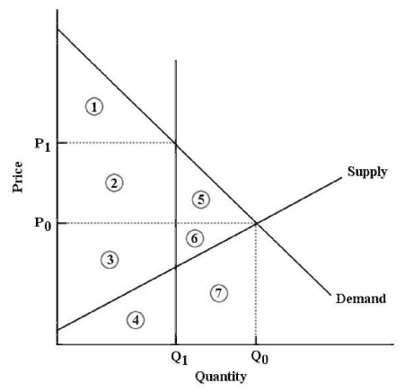
The diagram above shows the market for litres of milk.

38) Refer to Figure 5-8. After the imposition of a milk quota at quantity Q₁, economic surplus is represented by
A) areas 1, 2 and 5.
B) areas 3 and 4.
C) areas 2, 3, 5 and 6.
D) areas 1, 2 and 3.
E) areas 1, 2, 3, 4, 5, 6 and 7.

39) Cookie Monster consumes 2 goods - cookies and milk. If the price of cookies falls and as a consequence the
demand for milk rises, then cookies and milk are
A) complementary goods.
B) luxury goods.
C) substitute goods.
D) neutral goods.
E) independent goods.

40) Consider a tax imposed on daily parking charges in the downtown of a small city. Before the tax, equilibrium
price and quantity P = $15 and Q = 100. The government imposes a tax of $3 per car parked/day. Market
equilibrium adjusts to P = $16 and Q = 95. Which of the following statements about the burden of the tax is
correct?
A) Supply is less elastic relative to demand and therefore more of the burden falls on the consumer.
B) Supply is more elastic relative to demand and therefore more of the burden falls on the consumer.
C) Supply is less elastic relative to demand and therefore more of the burden falls on the seller.
D) Supply is more elastic relative to demand and therefore more of the burden falls on the
seller.

41) If the price elasticity of demand for a good is less than one in absolute terms, we say consumers of this good
A) are not very sensitive to the quantity they demand.
B) are not very sensitive to price.
C) are very sensitive to price.
D) are elastic.

42) It is assumed in standard economic theory that a firm makes decisions in an effort to
A) maximize its revenue.
B) be favoured politically.
C) maximize its profits.
D) have a highly diversified product.
E) become as large as possible.

43) A basket of goods in 2005 costs $625, while the value of the same basket in 2010 costs $800. If the base year
is 2005, what is the value of this price index in 2005?
A) 155
B) 78.125
C) 100
D) 128

44) Consider again the market for iPhones with inverse demand given by P=60-2*Q_{D} and inverse supply given by
P=10+3*Q_{S}. Find the consumer surplus and producer’s surplus.
A) CS =110, PS=150
B) CS =100, PS=150
C) CS =90, PS=150
D) CS =100, PS=120

45) Consider once more the market for iPhones with inverse demand given by P=60-2*Q_{D} and inverse supply
given by P=10+3*Q_{S}. Suppose the government provide subsidy of $2 per unit. Find the Deadweight Loss.
A) DWL=0.4
B) DWL=2.4
C) DWL=5
D) DWL=5.4

46) Which of the following is an example of a normative statement?
A) A higher price for a good causes people to want to buy less of that good.
B) A lower price for a good causes people to want to buy more of that good.
C) To make the good available to more people, a lower price should be set.
D) If you consume this good, you will be better off.

47) The term "quantity supplied" is the amount of a commodity that
A) is exchanged between firms and consumers during a given period of time at a given price.
B) is supplied at a fair market price.
C) firms actually sell during a given period of time at a given price.
D) firms wish to sell at a given price during a given period of time.
E) households wish firms would sell during a given period of time at a given price.

48) A rightward shift in the supply curve can be caused by
A) An increased in demand by the consumers of this product
B) An increase in business taxes the government charges the firms
C) A decrease in the prices of inputs used by the firms
D) A decrease in the consumers' income

49) Minimum wage is an example of a price ____, which is set _____ the equilibrium price.
A) Floor; below
B) Ceiling; above
C) Ceiling; below
D) Floor; above

50) In competitive markets, binding (or effective) price floors and price ceilings lead to
A) a reduction in deadweight loss.
B) a maximization of economic surplus.
C) an overall reduction in economic surplus, and therefore to market inefficiency.
D) fairer prices for consumers and producers, and therefore are better for society as a whole.
E) an overall increase in economic surplus, and therefore to market efficiency.

