Research Methods APA2180 Review

Lecture 1: Introduction to Research

We know what we know based on
- Authority
- Tradition
- Common Sense
- Media myths
- Personal Experience
- Science

Science = Empirical
- Empirical: Based on observation and experiment
- Use empirical approach to avoid misleading results and poor interpretation
- Data: Empirical evidence or information that someone gathers carefully according to rules or procedure.
  - Can be qualitative, quantitative or mixed methods

Scientific Method
- Body of techniques for investigating phenomena, acquiring new knowledge, or correcting/integrating previous knowledge
- Steps:
- Select topic
- Develop a research question
- Plan the study
- Collect data
- Analyze data
- Interpret data
- Share results
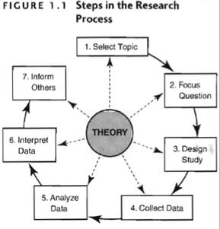
Purposes of Research
- Exploration
  - Starting place
- Descriptive
  - Uses lots of different types of data collection
- Explanation
  - Builds on exploratory and descriptive

Wings of Research
- Basic Research
  - Fundamental knowledge
  - Source of new ideas – breakthrough
  - Often has limited practical application
  - Consumer = scientific community
- Applied Research
  - Bridges fundamental research with real world
  - Addresses specific concerns
  - Very practical
  - Consumer – practitioners, public, government

Practice Questions
- What are the different ways in which we gain knowledge?
- What separates science from other ways of knowing?
- What are the 7 steps of the scientific method?
- Describe the three main purposes of research?
- What are the main differences between basic and applied research?

Lecture 2: General Research Orientations

Theory: An explanation of observed regularities or patterns
- 3 main components
- Definitions
- Descriptions of Phenomena
- Relational Statements
  - Deterministic
  - Probabilistic

PAM Theory
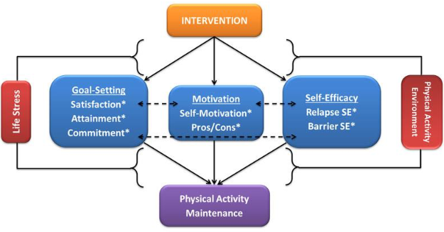

Types of Theories:
- Theories of the middle range
  - Limited in scope and can be tested directly
  - Enable further theorizing
- Grand Theories
  - General and abstract, and cannot be tested directly

Role of Theory in Research
- Does theory or research come first?
- Do we examine a problem and try to work out how it is caused/might be solved (Inductive reasoning)
- Or do we take an accepted theory of how things work and find evidence to support the problem (Deductive reasoning)

- Deriving theories/explanations from qualitative data is sometimes called grounded theory

  - Grounded because data has primacy over theory because the theme/concepts emerge from looking at data after it is collected
  - Created concepts and themes are applied to new data and refined

Inductive: Theory is the outcome of research  - Can be iterative  - Researcher goes back & fourth from data to theory or explanation  - Problem: Sometimes leads only to empirical generalization | Deductive: Theory directs the research
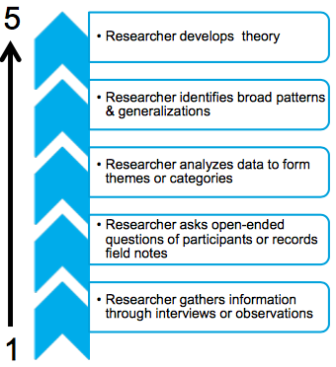 | 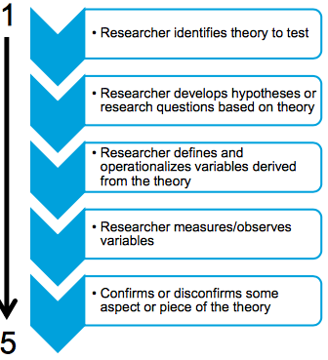

Epistemological Considerations
- Epistemology: Theory of knowledge
- What is regarded as acceptable knowledge?
- Two contrasting positions:
  - Positivism
  - Interpretivism

Positivism
- Social scientists use the same methods of inquiry that are used in natural sciences
- Empiricism: Knowledge must be based on information gathered through the senses
- Takes a deductive approach to gaining knowledge
- Purpose is to uncover social laws governing social reality
- Relies on scientific statements not normative statements
  - Scientific statements can be tested empirically and not subjected/rejected
  - Normative statements are a question of belief and not testable

Interpretivism
- Methods of natural sciences are very limited in producing knowledge of social world
- Goal of social science should not be to uncover social laws, but to grasp the subjective meanings of people’s actions
- Actions should be viewed from POV of social actors
- Researchers should develop an empathetic understanding of the people studied, sometimes called Verstehen (weber)

Ontological Considerations
- Ontology: Theory of reality
- Social Ontology: the nature of social entities
- Two ontological debates:
  - Objectivist perspective: Do social phenomena have an objective reality, independent of our perceptions?
  - Constructionist perspective: Is what passes for reality merely a set of mental constructions?

Quantitative Vs. Qualitative
- Different but complimentary
- Strategies differ in terms of their:
  - General orientation of social research
  - Epistemological foundations
  - Ontological basis
- Researchers will conduct:
  - Systematically collect and analyze empirical data
  - Examine patters to understand and explain the phenomena of interest

Quantitative
- Positivist approach
- Language of variable and hypotheses (IV, DV, Control)
- Tests a hypothesis
- Precise measurement and testing
- Generalizations and casual explanations
- Linear research path
- Usually deductive

Qualitative
- Interpretivisit approach
- Language of cases and contexts
- Authentic interpretation sensitive to the context
- Focuses on meaning rather than precision
- Context is critical
  - Past and present circumstances
- Same behaviors/events can have different meanings, and lead to different consequences
- Non-linear research path
- Usually inductive


Influences on the Conduct of Social Research
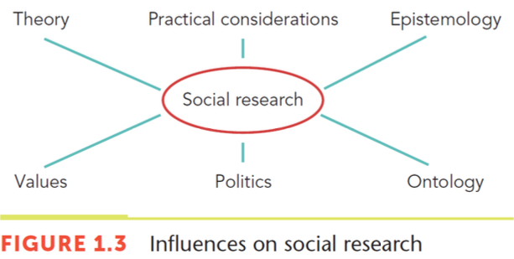
Values: A researcher’s values can contribute to bias in research
- Choice of topic
- Formulation of the research questions
- Choice of method
- Formulation of research design/data collection methods
- Actual data collection/analysis of data
- Interpretation of data
- Conclusions

Dealing with Value-bias
- Reflexivity: Researchers awareness that their values and decisions have an impact on the research
  - Researchers should be value-free
  - Research cannot be value-free, but researcher should be open and explicit about their values
  - Researchers should use their values to direct and interpret their investigation; value commitment is a good thing for researchers to have

Influences on Conduct of Social Research
- Politics
  - Researches may take sides
  - Funding
  - Research subjects/participants
  - Research findings
- Practical Considerations
  - Time
  - Cost/funding available
  - How much prior literature exists
  - Topic
  - All social research is a comprise between ideal and feasible

Research Questions
- Good research questions should be;
  - Clear
  - Researchable
  - Relate to established theory and research
  - Linked or closely related
  - Allow the researcher to make a contribution to existing knowledge
  - Neither too broad or too narrow

Summary
- A theory serves to explain observed regularities or patterns.
- Theory can either preceded research and data gathering
(deductive method) or emerge out of it (induction).
- Qualitative and quantitative research are two different approaches to social investigation and assume different epistemological (positivism vs interpretivism) and ontological (objectivism vs constructionism) considerations.
- Social research is also influenced by the values of the research, politics and practical considerations.
- The research question guide the research design and method, collection and analysis of data and the write up of the findings.

Lecture 3: Research Design

Research Design: Provides a framework for the collection and analysis of data.
- Choice of research design reflects decisions about priorities given o the dimension of the research process

Research Method: A technique for collecting data.
- Choice of research method reflects decisions about the type of instruments or techniques to be used

Quantitative | Qualitative
- Explains in laws and principles  - Cause and effect  - Nomothetic Explanation  - 3 criterial of causation  - Correlation  - Time order  - Non-spuriousness  - Reliability, reproducibility and validity apply | - Produce a rich description of the person/group studied  - Not applicable to other groups  - Idiographic explanation that’s based on empathetic understanding  - Select method of collection: Questionnaire, interview, participant observation  - Lincoln and Guba (1985) maintain that this work should be judged to different standards  - Trustworthiness is a major criteria and includes:  - Credibility: parallels internal validity  - Transferability: Parallels external validity  - Dependability: Parallels reliability  - Confirmability: Parallels objectivity

Evaluating Social Research
- Causality supports different types of research designs in social research, both qualitative and quantitative
- Often expressed in the language of variables
- 3 most prominent criteria:
  - Reliability – are measures consistent?
  - Replication/replicability – is study repeatable?
  - Validity – Are conclusions well founded?

Types of Validity
- Measurement validity
  - Do measures reflect concepts?
- Internal validity
  - Are casual relations between variables real?
- External validity
  - Can results be generalized beyond the research setting?
- Naturalistic studies: tend the satisfy the criteria that the findings are applicable to situations outside the research environment
- Representative samples: tend to satisfy the criteria that the findings can be generalized beyond the people or cases that are studied

Types of Research Design
- Experimental
- Cross-sectional
- Longitudinal
- Case study

Experiments
- 2 kinds:
  - Field experiments are conducted in real-life surroundings
  - Laboratory experiments take place in artificial environments
    - Controls research environment
    - Easier to randomly assign subjects
    - Easier to replicate
    - Weak external validity

- Key concepts:
  - Experimental or treatment group: receives a treatment or manipulation
  - Control group: does not get the treatment or manipulation
  - Random assignment: participants are placed in the experimental or control group
  - Pre-test: measurement of the dependent variable before the experiment
  - Post-test: measurement of the dependent variable after the experiment
  - Computation/analysis of group differences

Threats to Internal Validity
- Non-experimental events may have caused the changes observed
- Subjects may become sensitized to ‘testing’
- Changes in the way the pre and post-test was administered (Instrumentation)
- Participants leave the experiment before it is over (mortality)
- People change over time in any event (maturation)
- Non-random selection
- Ambiguity about the direction of casual influence because sometimes the temporal sequence is unclear

Threats to External Validity
- Interaction of selection and treatment
- Interaction of setting and treatment
- Interaction of history and treatment
- Interaction effects of pre-testing
- Reactive effects of experiment arrangements

Quasi-Experiments
- Differ from true experiments in that internal validity is harder to establish
- Many different types but an interesting type is “natural experiments”
  - Experiment-like conditions are produced by naturally occurring phenomena or changes brought about by people not doing research
- Often used in evaluation research

Cross-Sectional Design
- Taking observations at one point in time (no before and after)
- Do NOT include a manipulation of the independent variable (no treatment is given)
- Two or more variables are measured in order to detect patterns of association
- One strength of the design is that it can examine the effect of variables that cannot be manipulated
- Reliability and Measurement Validity are not connected to the design
- Replicability will be high as long as researcher specifies all procedures
- Internal Validity is weak due to co-relations being more likely to be found
- External Validity will be strong if the sample is truly random

Longitudinal Design
- Cases are examined at a particular time and again at later times
- Designs provide information about the time-order of changes in certain variables
- Helps establish the direction of cause
- 2 Types:
  - Panel study: same people, households, etc. are studied at different times
  - Cohort study: People sharing the same experience are studied at different times, but different people may be studied each time
- Problems can arise because this method is similar to cross-sectional research design
- Special problems include:
  - Attrition: people die or move home without withdrawing from study
  - Knowing when is the right time for the next wave of data collection
  - First round may have been badly though out, which leaves later rounds a mess
  - Panel conditioning effect may creep into research

Case Study Design
- Basic case study involves and in-depth study of a single case
- Can involve qualitative/quantitative research.
- Can be inductive or deductive
- Weakness:
  - External validity is questionable
- Strength
  - Provide in-depth descriptions of the characteristics of a particular case that cannot be achieved otherwise
Evaluating Case Study Research
- Biggest issue concerns external validity, because it is impossible to generalize the findings
- The point of the research is to examine particulars, rather than attempt to generalize
- Cases may be extended longitudinally or through a comparative design

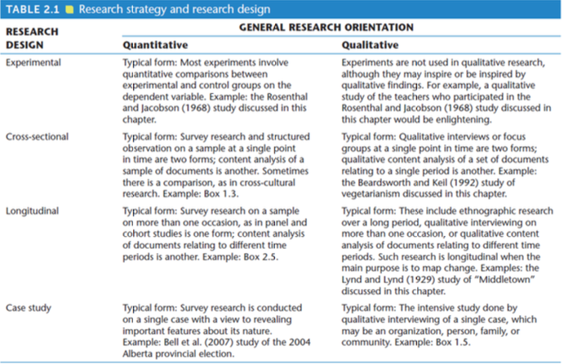

Summary Questions
• What are the two major types of research design?
• What are the characteristics of qualitative and quantitative
research?
• What are the criteria for evaluating quantitative and qualitative research?
• What are the characteristics of the different types of research design?

Lecture 4: Being a critical consumer

Authority Figures and the Media
- A study was done to determine the quality of health recommendations made on popular medical talk shows
- Looked at Dr. Oz and The Doctors
- Primary outcome: % of recommendations/claims supported by evidence
- Recorded both shows from Jan-May 2013 and randomly chose 80 recommendations from each show
- Looked for evidence for each recommendation and the evidence was evaluated for
  - Consistency (within study or across study)
  - Believability (quality, quantity and type of evidence)

Ways Research Findings can be Manipulated
- Examine figures closely
- Pay attention to wording
- Can always find something in your data if you do multiple analysis
- Be careful how you interpret wording of analysis
** Think about graphs showing the car crashes based on age... depending on the information you’re given, it can change the way the results look**

Industry Funded Research
- Creates conflicts of interest
- Greater potential to only tell one side of the story when results go missing
- Problem with using just a placebo in clinical trials

Summary Questions
- For what reasons may it be important to be wary of authority figures in the media.
- What is an example of how a visual chart can be designed to make you believe a certain point?
- What is an example of how wording of results can make you believe something?
- Why should we be critical of industry funded research?

Lecture 5: Research Ethics

Scientific Misconduct
- This happens when researchers falsify/distort data, the methods of data collection or plagiarize

Research Ethics
- Needs to be addressed in the initial stages of a study & should be kept in mind every phase of the study
- First priority of a social researcher is Do Not Harm
- Second priority is knowledge
- Risk assessment is a key feature for all researchers
- Constant balance between potential gin and risk of harm
- Research design is always weighted in favor of research subjects

Policies in Canada
- Canadian research is subject to Canadian Law: Canadian Charter of Rights and Freedoms
- Tri-council policy statement: Ethical Conduct for Research involving humans
  - Social Scientists and Humanities Research Council
  - Canadian Institutes of Health Research
  - Natural Sciences and Engineering Research Council
  - Approval process and administered through Research Ethics board
- Policy is due to inadvertent harm caused to participants
  - Researcher may not recognize all the risks

History and Ethics
- Nasi Research
- Tuskegee Syphilis Study (1932-1972)
- Milgram Obedience Study (1962)
- Zimbardo Prison Experiment (1971)
  - These led to the creation of IRB’s

Research Ethics Board (REB’s)
- All Canadian research requires REB approval
  - Must be obtained before people are approached to be participants
  - An appeal process
- REBs are internal to the affiliated institution
  - Universities, colleges, government, private companies
  - Members from different disciplines
  - Must have an external representative

- Conflict of interests rules
  - Funding relationships, work with the applicant

Tri-Council Policy Statement (TCPS2)
- Provides for variation in research methods
- Three core overlapping principles
- Respect for persons
  - Subjects are not objects/resources to be used for some end
  - Individuals have basic human rights that include dignified treatment by the researchers (MOST FUNDAMENTAL)
  - Informed consent, which is free & ongoing, is necessary for the researchers/participants
  - Participants must be advised of the risks/potential benefits

- Informed Consent: Potential participants are given an information sheet and/or consent form outlining what the research is about
  - Information sheet outlines the research project, methods, potential risks & benefits, names of those in charge, how data will be stored, etc
  - A consent form is important because it mentions the ability of the participant to leave study at any time
  - Prospective participant must have the ability to understand
  - Prospective participant must have ability to actually consent
  - A person with limited ability must have a guardian provide consent

- Use of Deception
  - Deception is the last resort and should be used sparingly
  - Subjects should be debriefed about the deception
  - Convert observation

- Concern for Welfare
  - Welfare in this context is concerned with the well-being of person, group, community affected by the research (avoid harm, embarrassment, inadvertent identification)
  - Privacy (ensure right to privacy)
  - Confidentiality (Not a concern with publicly available info, must be maintained when there is contact between researcher and subject)

- Privacy and Confidentiality in Qualitative research
  - In qualitative research, dealing with privacy and confidentiality issues is quite different;
  - Pseudonyms may not be enough
  - In depth research, analysis, + reporting may provide enough detail that people/locations can be identified
  - Make sure to change any identifiable info about participant

- Privacy and Confidentiality in Covert Research
  - Another issue surrounding privacy & confidentiality in qualitative studies pertains to covert research: Very intrusive, no consent, benefits must outweigh harms, little to no concern, permission from participant to use data may be sought after

- Secondary Participant
  - People who enter into a research setting whose social role is not at the heart of the research
  - Historically they have often missed in privacy, confidentiality, and consent concerns

- Criminal Activity, Sponsoring, etc
  - Researcher may have a duty to report on certain activities observed or disclosed
  - Sponsor may place conditions on the methodology used or the publication of the results, including warning patient about harmful drug
  - Any conflict of interest must be reported to REB (including relationship with sponsor)

- Justice
  - Covers all dimensions of fairness in the treatment of research subjects & researchers themselves
  - No person or group should be exploited for research
  - No person/group should be systemically excluded from the benefits
  - Principle of no harm should be followed

- Potential Harm vs Benefits
  - In practice, potential harm should not outweigh the potential benefits
  - Avoid research that is likely to cause or distribute harm
  - Life should not get worse because of participation in a research project
  - If potential harm & risks are greater than risks of everyday life, then informed consent is a minimum requirement
  - Right to withdraw from the study at any time

- Paid Participation
  - May include risks beyond participants normal behavior
  - May be viewed as pressure to participate or remain in a study beyond participants usual stopping point
  - Don’t make the research a payment for higher than usual level of risk

Summary
- The TCPS2 outlines three core principles for ethical conduct of research
- Respect for persons
  - Providing information (avoid use of deception)
  - Informed consent
- Welfare: the well-being of the persons involved
  - Privacy
  - Confidentiality
- Justice: fairness in treatment
  - Inclusivity
  - Risks vs benefits

Lecture 6: Structured Interviews and Questionnaires

Quantitative Research:
- Collection of numerical data
- Deductive relationship between theory and research
- Preference for the natural science approach to research (Positivism)
- Objectivist conception of social reality
Process of Quantitative Research:
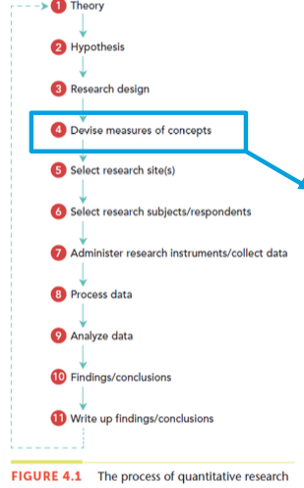
- Concepts: - Independent or Dependent. – Nominal and operational
- Operational: Process of converting concepts into indicators or into specific questions in a questionnaire/interview
- Indicators: Multiple for finer distinction: Likert. Multiple for different dimension
- Coding: Transforming a measure into numbers

Main Goals:
- Measurement: Data is used to quantify social phenomena & their interrelations
- Establishing Causality: What causes this phenomena?
- Generalization of finding to those not studied: Apply to large numbers of people and have a representative sample
- Replication: Provides a check for biases/routine errors and increases confidence in the original findings

Reliability:
- Stability: Is the measure stable over time?
- Internal reliability or consistency: Are the indicators consistent
- Inter-observer consistency: Is the measure consistent between observers

Validity: The indicator measures the concept is it has;
- Face validity
- Concurrent validity
- Construct validity
- Convergent validity

Criticisms of Quantitative Research:
- Failure to distinguish between objects in the natural/social phenomena
- Artificial and spurious sense of precision/accuracy
- Lack of ecological validity
- Static view of social life

The Structured Interview
- Interviews where both the questions and answers are structured.
- Respondents are asked to answer the same question in the same order
- Follow the interview schedule (Formal list of questions that the interviewer follows and questions must be asked in order)
- Surveys of public opinion involve conducting structured interviews

Standardized Structured Interview
- Used because they are standardized in asking the questions and recording answers
- Variation is expected in interviews
  - Respondents answer differently
  - Should be measured based on concept not interview process
  - Errors are unwanted. Can come from;
    - Intra-interviewer variability: Interviewer is not consistent in asking questions/recording answers (same or different respondent)
    - Inter-interviewer variability: Lack of consistency in asking questions/recording answers between different interviewers

Advantages:
- Reduce the chance of variation due to error on the part of the interviewer or emerging in the interview process
- Enhance the accuracy and ease of data processing because of the use of “Closed” or “Fixed End choices”

Disadvantages:
- Closed answers may not adequately cover the appropriate range of possibilities
- Structured interviews have to deal with the interviewer effects:
  - Reactions of respondents about the fact they are being studied
  - Characteristics of the interviewer may influence responses given
  - Sex, social class, and race of interviewer are key reactive issues

Interview Contexts
- Ratio interviewer – interviewee (Focus groups)
- Face to Face:
  - In person
  - Preferred method of academic research
  - Data considered to be of superior quality compared to phone
- Telephone interviews
  - Strengths: Cheaper & quicker for people who are geographically spread out. Easier to supervise and reduce interviewer errors. Reduced bias arising from interviewer effect
  - Weaknesses: May exclude people without telephones. Hard to sustain for a long period. Can’t collect info about interviewee’s social conditions. Difficult to be sure that the targeted respondent is the person answering questionnaire. Visual aids can’t be used to assist the interview
- Computer Assisted Interviewing
  - Programs are used to conduct interview and answers are immediately recorded in electronic form
  - Done in person (CAPI) and over phone (CATI)
  - Program relies on answers to filter out further questions that are unnecessary
  - Used less in academic survey research than in commercial survey research
- Online Personal Interviews
  - Advantages: Quality face to face with efficiency and economy of internet. Opportunity for more considered and fuller responses. Ease of contact for follow up. No need to transcribe
  - Disadvantages: High dropout rate, but may be overcome by developing mutual trust. Answers may be short on detail

Conducting Interviews
- Know the schedule: Less chance to make mistakes
- Introducing the research: Provide rationale for time
- Establish rapport: Balance
- Introductory statement: Disclosure, confidentiality
- Asking questions: Standardized
- Recording answers: Standardized
- Questions order: Standardized
- Probing: Simply repeat of probe in standardized way (can you expand on that?)
- Recording answers: Use cards for answer lists
- Training and supervision: Develop skill, quality control

Lecture 7: Questionnaires and Asking Questions

Questionnaires
- Structured interviews without an interviewer
  - Involve filling out a form and then it is returned to the researcher (usually by mail)
- Compared to interviewers, questionnaires tend to;
  - Have fewer “open” questions because closed ends are easier to answer
  - Have simple designs
  - Are short since people will discard if they are difficult

Advantages:
- Cheaper, quicker and more convenient to administer
- Possible to administer many questionnaires at the same time
- No interviewer effects
- Less social desirability bias (Respondents are more likely to give genuine answers to sensitive questions)

Disadvantages:
- No explanation of questions
- Greater risk of missing data (No probing/supervision)
- Needs to be short
- Not appropriate for certain respondents
- Order effects may occur
- Designated respondent

Online Social Surveys
- Email Surveys:
  - Tend to be aimed at smaller, homogenous groups
  - Embedded in the email
  - Embedded in attachments

- Web surveys:
  - Respondents go to a website to complete questionnaire
  - Have an attractive appearance and can include features such as filter questions, drop down menus, etc.
  - Responses can be automatically downloaded

- Diary Methods:
  - Form of questionnaire
  - Participants record their feelings, perceptions, actions, etc. on a form
  - Participants should be given explicit instructions on how to complete diary, time periods for recording, and types of experiences that should be recorded
  - Advantages: Fairly accurate data about frequency/time spent on behaviors of interest and about sequencing of behaviors
  - Disadvantages: More expensive than personal interviews. People may get tired of filling out. Details may not be recorded fully enough.

Respondent Problems
- Response set occurs when someone responds to a series of items in the same way, which suggests the responses are motivated by something other than the actual feelings
- Acquiescence: Trying to please the researcher
- Social desirability: Avoiding appearance of being bad/unlikeable
- Laziness or Boredom: Answers just to end the process

Summary
- Structured interview is a research instrument used to standardize the wording and order of questions and the recording of answers
- Structured interviews can be done in person, over the phone or online
- Questionnaires are easier to administer, less time, less costs but may have a lower response rate.
- Online surveys are questionnaires online that have the advantage of direct recording and an automatic use of filter questions but it limited to people using the internet
- Research-driven diary is a special type of questionnaire than is good to use in time-based issues and behaviours
- Response sets are a potential problem and questions should be build in to detect these types of errors.

Asking Questions

Closed Questions: Present the respondent with a set of answers from which to choose
- Advantages:
  - Easy to process answers
  - Standardization allows comparison of answers
  - Fixed responses may help clarify what the question means
  - Easier/quicker for the respondent to complete
  - Reduced bias in recording answers (no interpretation required by researcher)

- Disadvantages:
  - Loss of spontaneity and authenticity because relevant answers may be excluded from choices provided (use open questions to generate categories. “Other” category open for elaboration)
  - Categories can’t overlap (pre-test to establish appropriate and distinct categories)
  - Difficult to make forced choice answers exhaustive (pre-test to identify appropriate categories. “Other” can be used as a solution)

Open Questions: Response decisions are left completely to the respondent
- Difficult to convert answers to numerical data; tend to be used in qualitative research
- Advantages:
  - Respondents can answer in their own terms
  - Allow for unusual, unanticipated responses
  - No suggestions, so responses may expose knowledge and be more genuine
  - Good for exploring new or changing areas of research
  - Answers may lead to fixed choice responses
- Disadvantages:
  - Time consuming to record answers
  - Answers have to be coded – it is a long and tedious process
  - If used in questionnaires, respondent may balk at the request to write long answers
  - Recording inaccuracies for verbal answers
- Coding:
  - Post-coding:
    - Data is gathered and then themes/categories of behavior are determined
    - Each code will be assigned a number and then will be recorded into a file each time category is encountered
  - Pre-coding
    - Themes/categories are decided upon before data is gathered
    - Usually done with fixed-response items
    - Data is gathered through open responses and sorted into pre-set categories afterwards
    - Each code is assigned a number and is then recorded in a data file

Basic Principles for coding
- Categories must not overlap
- List of categories must be exhaustive (cover all possibilities and “other” category is usually required)
- Coders should be provided with a “coding frame” or “coding manual” that establishes clear rules about how codes are applied

General Rules for Designing Questions
- Keep research questions in mind
- Focus on exactly what you want to know
  - Be specific
- Put yourself in position of respondent
  - How would you answer the question?

Specific Rules
- Avoid ambiguous terms
- Avoid long questions
- Avoid double barreled questions
- Avoid very general questions
- Avoid leading questions
- Avoid questions that are 2 in 1
- Avoid questions that include double negatives
- Minimize technical terms
- Be sure respondents have knowledge to answer question
- Ensure symmetry between closed questions and answers
- Ensure answers are balanced
- Memory problems
- “Don’t know” option

Question Order
- Early questions should be related directly to research topic
- Questions of interest should be asked early
- “Sensitive” questions in the middle
- Questions grouped logically and into related sections
- General questions before specific
- Opinion/attitude questions before behavior/knowledge questions
- Ask questions in order, even if answer was given earlier

Designing Questionnaire
- Layer and Clarity
  - Provide clear layout/presentation
  - Choose vertical or horizontal answers
  - Clear instructions on how to respond
  - Keep questions and answers together on same page

- Response Sets
  - Identify response sets in a Likert Scale:
    - Pre-code answers to allow immediate scoring
    - Apply reverse coding to some questions (Identify response sets... same answer is repeated)
    - May create a scale in which agreement with some items goes in one direction of the concept but agreement with others indicates other directions
    - Coding will expose the response set so data can be excluded if necessary

Vignette Questions
- Presenting people with one or more scenarios & asking how they would respond
- Anchor choices in realistic situation
- Create distance between question and respondent (weakness: How they say they would react may be different from how they actually would react)
- Can provide usual information or a starting point for further research

Pilot Studies
- Generate closed questions out of open questions
- Test out questionnaire are instrument (reliability, validity)
- Gives practice opportunity to interviewers
- Can identify embarrassing, uninteresting and hard questions

Using Existing Questions
- If certain questions worked well, you may be able to use them for your study
- Original source must be cited
- Allow results from different studies to be compared
- Questions may be modified to suit purposes better
Summary
- Open questions allow for spontaneous answers but coding afterwards is tedious and difficult.
- Closed questions are quicker, easier in use and analysis but there may be a loss of spontaneity and authenticity
- A lot of thought has to go into the type of questions and the order and presentation of the questions.
- Pilot studies can increase reliability and validity.
- In some cases an existing set of questions may be beneficial.

Lecture 8: Structured Observation
Nonreactive Research
- Characteristics include:
  - Evidence is naturally occurring
  - Researchers use unobtrusive measures
  - Deductive but can also be inductive
  - Precise measurement
Types:
- Naturalistic Observation
- Participant observation
- Non-participant or ‘unobtrusive’
- Unstructured observation
- Structured observation:
- Entails direct observation of behavior
- Rules for observation and for recording the data are contained in the observation schedule
- Advantages: Direct view, specific time slot
- Disadvantages: May not be how they act at home
- Observation schedule
  - Clear statement of the research problem
  - Specifies who needs to be observed and which behaviors should be recorded
  - Categories for recording behavior should be mutually exclusive and exhaustive (Pilot study may help develop categories)
  - Classification scheme must be clear and easy to use
  - Minimal interpretation of behavior
- Strategies for observing behavior
  - Recording incidents (Wait until behavior is finest)
  - Time period (Processes are observed & recorded at a designated period of time) [e.g every day at lunch for 2 weeks]
  - Time sampling (Observe interactions that take place during designated intervals of time)[e.g every 15 mins for 3 hours]
- Reliability
  - Compared to survey research, structured observation offers:
- More reliable info about events
- Greater precision regarding duration & frequency of events
- Greater accuracy in time-ordering events
- More accurate reconstruction of large scale social episodes
  - Concerns:
- Inter-observer consistency is a concern (Cohen’s Kappa)
- Intra-observer consistency is also an issue
- Training is usually implemented to counter issues
- Validity
  - Measurement validity can be an issue
  - Structured observation must be administered properly
  - Researcher should try to determine whether there are any reactive effects
- People usually behave differently because they know they’re being watched
- Some research suggests this lesson as the researcher spends more time with the participants
  - Reactive effects:
- Reactive measurement effects occur when subjects awareness of the study leads to changes in behavior
- Response sets, social desirability bias, political correctness
  - Guinea pig or “Hawthorne effect” (subjects alter their behavior because they’re aware they’re being observed)
  - Role selection
  - Researcher presence as a change agent
  - Trying to be helpful to the researcher
  - Varied reaction according to who the researcher is (Need for double-blind experiments)
- Field experiments
  - Researcher engages in social interaction in its natural environment and watches what happens
  - Participants are not aware they’re being studied
  - In extreme cases, researchers have adopted a social role in the experiment and used deception to enter social spaces that would not otherwise be allowed (Like show Undercover Boss)
- Limited opportunity for collecting data
- At best a limited coding system can be implemented
- Criticisms of Structured Observation
  - Using an inappropriate observation schedule for a particular setting
- Unstructured observation done in advance of structured observation can help eliminate this problem and help develop a better schedule
  - Intentions and meanings of the acts observed may be missed
  - Effect of context on the behavior may not get sufficient attention
  - Structured observation produces small amounts of data which may be hard to piece together
- Content Analysis
- Secondary data analysis

Summary
- Structured observation is an alternative to survey-based measures of behaviour.
- It is based on explicit rules for observing, categorizing and recording behaviour.
- It is often applied to a narrow range of behaviours.
- Reliability depends on inter- and intra-observer consistency.
- Validity consists of measurement validity and reactive effects.
- Problems with structured observation include determining the meaning of and intensions behind a behaviour, and ensuring that the framework for recording the observation is valid.

Lecture 9: Other Sources of Data
Nonreactive Research
- Other unobtrusive measures
Documents (personal, governmental, official documents)
- Any data source that can be read
- Was not produced specifically for the purpose of research
- Personal Documents
  - Can be letters, diaries, autobiographies, newspapers, TV programs, websites & photographs
  - Photographs can be used to illustrate points, as sources of data or prompts to get people to talk
  - Always have to look at social context of photo
  - Always look at the representatives (what is not photographed? Selection bias/filtering)
- Government Documents
  - Produces more quantitative stats information
  - Include census info, voting records, official reports
  - Credibility, representativeness and meaning are sometimes an issue
- Official Documents
  - Include documents produced by companies and other private organizations
  - Credibility: Biases based on organizational structure may lead to data distortion
  - Representativeness: Access to info requires permission

- Four Criteria for Quality of Documents
  - Authenticity
- Genuine and unquestionable
  - Credibility
- Free from error/distortion and factually accurate
  - Representativeness
- Typical of what it is supposed to represent
  - Meaning
- Clear and comprehensible

Mass media outputs
- Newspapers, magazines, TV and films
- Authenticity
  - Authorship may be hard to ascertain
- Credibility
  - Often the actual focus of the media research
- Representativeness
  - Publications represent particular interest groups and must do so to keep and audience
  - Context is important
Virtual Outputs
- Include websites, email, listservs, discussion groups, chat rooms, etc
- Authenticity
  - Anyone can setup a website so the knowledge may not be valid
- Credibility
  - The posted information may not be correct
- Representativeness
  - Posted information is always changing
  - Search engines like google
- Meanings
  - What is the context of the website?
  - Often a webspeak or language barrier

Secondary data analysis
Advantages | Disadvantages
- Reduced cost and time efficient  - High quality data  - Opportunity for longitudinal analysis  - Subgroup analysis  - Opportunity for cross-sectional analysis  - More time for data analysis  - Reanalysis can offer new interpretations  - Wider obligations of the social researcher | - Lack of familiarity with the data  - Complexity of the data  - Ecological fallacy  - No control over the data  - Absence of key variables

Official Statistics
- Includes government data
- Advantages:
  - Often based on populations, not samples
  - Reactivity may be less pronounced because participants are not part of a study
  - Chance for longitudinal and cross-cultural studies
- Disadvantages
  - Only those processed by a government agency
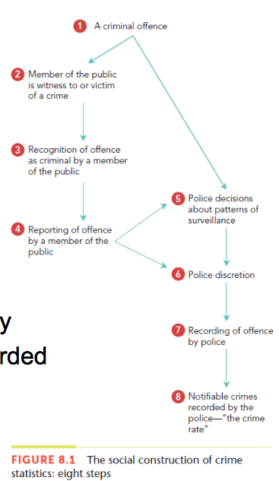
Reliability and Validity of Official Statistics
- Reliability can be affected by agency policies
  - How strictly police enforce the law and how much money is spent on certain police activities
- Reliability of official statistics can be affected by crime variables such as:
  - Variations in reporting the crime
  - Increased police surveillance of areas
  - Change in definition of crime

Changing Attitudes to official Statistics
- Change:
  - Official statistics, especially crime statistics, were viewed with suspicion in the 1960’s
  - In the 1980’s a shift to recognizing the value of official statistics started
  - Currently official statistics are each evaluated on their own merit

Summary
- Documents are data sources that can be read and was not produced specifically for the purpose of the research
- It is important to access the quality of documents using the four criteria set out by Scott (1990)
  - Authenticity, credibility, representativeness and meaning
- There are advantages and disadvantages of used other
sources for research.
- Even for official documents you have to assess the bias, reliability and validity.

