Date performed: 17/10/2016
Date submitted: 24/10/2016

Experiment # Hand-out
The Synthesis of 7,7-Dichloronorcarane Using a Phase-Transfer Catalyst

Introduction
In this experiment the objective was to prove that 7,7 –dichloronorcarane can be synthesized from chloroform and cyclohexene using a phase transfer catalyst. The reaction proceeded as the reaction scheme below:
[1] 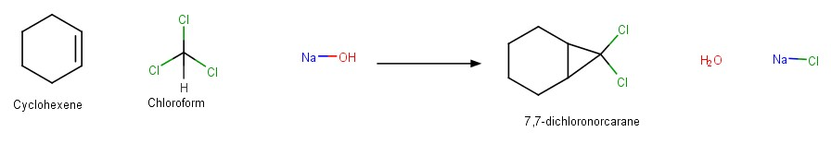
This synthesis is dependent on one thing only and that is the phase transfer catalyst. When the mixing of the reactants happens there will be two phases the organic phase and the aqueous phase. The organic will contain chloroform and cyclohexane whereas the aqueous will have the NaOH. These two phases separated from each other will lead to no reaction at all ^{[1]}. That is where the phase transfer catalyst (PTC) comes in. PTC can be an aqueous solution, an organic solution or both. The phase transfer catalyst’s job is to transfer the molecules across the phase boundary for a reaction to occur^{[3]}. PTC is used when there is an ionic reactant such as in this experiment the NaOH. Ionic reactants can either be anions or cations and the PTC used depends on that. When the reactant is an anion the PTC usually used is a quaternary ammonium salt, whereas for cations crown ethers are usually used ^{[3]}.
In this experiment the most important lab technique used is liquid-liquid extraction. In which there were two layers and the layer that is being extracted in this case is the organic layer. The theory behind liquid-liquid extraction is that if a substance is soluble in different degrees in two liquids then by mixing the two liquids it can be transferred from one to another. An extraction solvent is needed to perform this process^{[2]}. The properties of a good organic extraction solvent are that it should dissolve most organic substances and have a lower boiling point than the substances in order to be easily removed by evaporation after the extraction. In addition, an extraction solvent can also be water or an aqueous solvent in which it is able to extract polar substances from the organic solution^{[2]}.

Experimental
Table.1: Observations seen during the experiment
The step performed | Observation
Addition of cyclohexene + chloroform + 20 drops of tricaprymethylammonium chloride | Color becomes white
Addition of sodium hydroxide | Color turns to yellowish/gold color
After vigorous stirring | Foam starts forming

Changes in procedure:
- For extraction 2× 10 mL of Et₂O and not 25 mL
- Filter dry agent (Cacl₂) directly into round bottom flask for rotavop.
- No purification was done.
- Crude mass was recorded.
Results

Table 2: Table of reactants and products for this experiment
Reaction scheme
Compounds | Cyclohexene | Chloroform | 7,7-dichloronorcarane
MW (g/mol) | 82.15 | 119.4 | 165.1
Quantity (volume or mass) | 10.14 mL | 9.0 mL | 10.078g
Mole (mol) | 100 mmol | 110 mmol | 61 mmol
Stoichiometry | 1 | 1 | 1
Limiting reagent | Is a limiting reagent | - | -

Sample calculation for the number of moles for 7,7-dichloronorcarane:
10.078g$×\frac{1 mol}{165.1 g}$ of 7,7-dichloronorcarane = 0.0610mol $×$ 1000mmol = 61 mmol
Table 3: Yield obtained for the product 7,7-dichloronorcarane
Theoretical yield | Measured yield | % yield
16.51 g | 10.078g | 61.04%
Sample calculation:
Theoretical yield = $\frac{8.215g cyclohexene ×\frac{165.1g}{mol} 7,7-dichloronorcarane}{82.15 g/mol}$ = 16.51 g of 7,7-dichloronorcarane

% yield= $\frac{Experimental yield}{Theoretcal yield}×100=\frac{10.078g}{16.51g}×100=$ 61.04%
Table 4: Analysis of IR spectrum obtained from manual for product
Wavenumber (cm⁻¹) | Strength of band | Assignment of band | Expected wavenumber for band (cm⁻¹)
2940.04 | s | υ( C-H) | 3000-2840
793.54 | s | υ( C-Cl) | 739

Discussion
The objective of this experiment was to synthesis 7,7 –dichloronorcarane from cyclohexane, chloroform and sodium hydroxide. The mechanism for this reaction was determined to be:

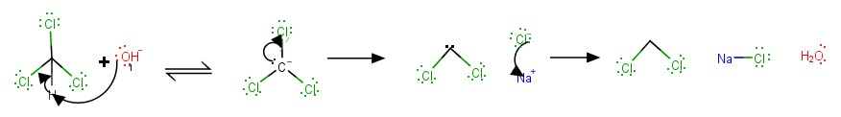
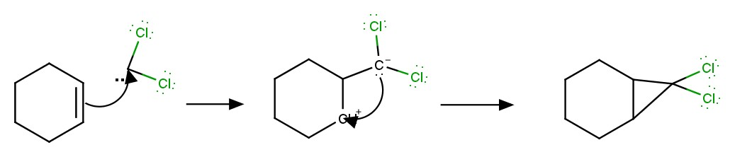

This mechanism is a two-step mechanism. The first step is an SN₁ reaction where chloroform reacts with the sodium hydroxide base and the chloroform loses a proton then loses a chlorine to form the dichlorocarbene ^{[4]}. The second step is a simple addition reaction where the dichlorocarbenes adds to the cyclohexene. This addition reaction causes the cyclohexene ring to lose a double a hydrogen and become a cation. Whereas the dichlorocarbenes added gets a negative charge for only having three bonds this causes it to close the ring and form the 7,7 –dichloronorcarane.
The synthesis begins with adding the cyclohexene and the chloroform in addition to the phase transfer catalyst that was used the tricaprymethylammonium chloride. Then NaOH was added and cyclohexanol and the reaction flask was left stirring on a plate in which the temperature was monitored until it rose to 60$℃$. When it rose to that temperature the reaction flask was placed in an ice bath to bring the temperature down ^{[1]}. This is an important step because the reaction is an exothermic reaction and the boiling points of the reactants is 83$℃$ for cyclohexene and 62$℃$ for chloroform, so that they do not boil the reaction should be monitored to stay below 60$℃$. However, once the reaction is over the temperature will drop spontaneously or in this case the temperature dropped till 45$℃$ and stayed on that temperature for a couple minutes which indicated that the reaction was over.
The second part of the experiment was to use the liquid-liquid extraction to remove the organic solution which contained the product. The extraction solvent that was used was ethyl ether. The washing was done twice and in each time the organic solution was placed in a flask and then the ethyl ether was dried using calcium chloride ^{[1]}. This drying agent has a medium intensity in the degree of the dryness in addition it removes traces of water quickly^{[2]}. The purification step was not preformed therefore the crude product was weighed.
The crude product that was measured was found to be 10.078g whereas the theoretical yield was calculated to be 16.51 g. Therefore, the percentage yield was found to be 61.04%. This is a pretty good yield for the synthesis however; since it is the crude product and not completely purified one cannot be certain that the whole mass that was found was of pure 7,7 –dichloronorcarane. Whereas the analysis of the IR spectrum that was given shows provides with only two useful stretches that can help determine that it is the product desired. The first stretch is the υ( C-H) stretch, this is a strong intensity band that is at 2940.04 cm⁻¹. This is the expected band because it is an sp³ C-H^{[5]}. The second stretch that is seen is the υ( C-Cl) which is at 793.54 cm⁻¹. However, the expected wavelength for this particular stretch is at 739 cm⁻¹ the difference in wavelength is due to the fact there are two chlorines attached at a tertiary carbon^{[5]}.
The yield obtained is not that bad however more precise results can be obtained if distillation operation was performed. In addition, some errors may have occurred during the extraction process where after each wash the organic solution was placed into a flask whereas the aqueous solution was placed in a beaker. This separation was done by separating the two solutions by eye this incurs human errors in which some organic solution may go into the aqueous solution even though it was washed several times.
Conclusion
In this experiment 7,7 –dichloronorcarane was synthesized from chloroform and cyclohexene in addition to using the tricaprymethylammonium chloride as phase transfer catalyst. The formation of product was successful in which the yield was found to be 10.078g and the percentage was around 61.04%. The IR spectrum for the product was also analyzed where the two main stretches that differs the cyclopropane from the cyclohexene.
References:
[1] Bellefuille, David de et al, Lab manual; Organic III: Organic Reactions. Experiment 22: The Synthesis of 7,7-Dichloronorcarane Using a Phase-Transfer Catalyst. Concordia University.2016.

[2] Lehman, John W. Operational Organic Chemistry :A Problem Solving Approach to the Laboratory Course. New Jersey: Pearson Education, 2009.

[3] Mastracchio, Anthony ; Phase Transfer Catalysis . MacMillan Lab. https://www.princeton.edu/chemistry/macmillan/group-meetings/AM_phase%20transfer%20catalysis.pdf (last accessed Oct.22,2016)

[4] Srebnik, Morris and Laloe, Eric: Chloroform. University of Toledo, OH, USA. http://reag.paperplane.io/00000625.htm#6 (last accessed Oct.21,2016)
[5] Pavia, Donald L.; et al. Introduction to spectroscopy,5th ed;Cengage Learning: Belmont, CA Brooks/Cole ,2009; p29.

