Kin 190 – Physiology and Anatomy Finals Prep
Bone Physiology
3 Sections in a typical long bone: Diaphysis, Metaphysis, Epiphysis (Distal, Proximal)
In Diaphysis
- Periosteum, endosteum, lacunae – contains bone cells (4 types)
- In periosteum – osteoblasts, osteogenic cells
- In endosteum – osteoblasts, osteoclasts, osteogenic cells
- Lacunae – osteocytes
  - Osteoprogenitor cell (from bone cell lineage)
    - Pre-osteoblasts
  - Osteoblasts (from bone cell lineage)
    - Bone formation
  - Osteocytes (from bone cell lineage)
    - Maintains bone tissue
    - Have many arms which extends out to canaliculi (small canals that connect lacunae)
  - Osteoclasts (from white blood cell lineage)
    - Bone resorption
- Medullary Cavity – contains yellow bone marrow
- Compact Bone – made of osteons (Circumferential lamellae, interstitial lamellae)
  - Harversian canals
    - Concentric lamellae rings made of Extracellular Metrix (ECM)
  - Between these lamellae, there are lacunae made up of osteocytes
In Metaphysis
- Epiphyseal line (plate) – where either interstitial or appositional bone growth happen
  - Bone grows inwardly
- Division of chondrocytes (cartilage cells)
- 4 layers of cell
  - Zone of resting cartilage
    - Chondrocytes anchoring epiphyseal plate to epiphysis
  - Zone of proliferating cartilage
    - Chondrocytes undergo cell division
    - Stacked into columns
  - Zone of hypertrophic cartilage
    - Chondrocytes mature and grow bigger
    - Remain in stacks
  - Zone of calcified cartilage
    - Osteoblasts make ECM
    - Chondrocytes are surrounded by these ECMs and dies off as these ECMs block access from outside
    - Left with empty longitudinal space = Harversian canal
    - Osteon is formed
In Epiphysis
- Spongey Bone – contains red bone marrow
  - Made up of trabeculae (irregular lattice of lamellae)
Factors influencing bone remodeling
- Load (stress) on bone
- Diet
  - Calcium, Phosphorus
  - Vitamins
    - C – synthesis of collagen
    - A – stimulating osteoblasts
    - D – absorb calcium from digestive system (food)
      - A.k.a = calcitriol
      - Produced by exposure to UV light
      - 7-dehydrocholestrol – activates calcitriol
  - Caffeine could interfere Ca²⁺ absorption in gut
  - Alcohol is toxic to osteoblasts
    - Stimulates parathyroid hormone – increase in bone resorption
- Hormones
  - Estrogen
    - Stimulates osteoblasts activity
    - Support apoptosis (programmed cell death) of osteoclasts
      - To little estrogen means osteoclasts can live longer increase bone resorption
  - Calcium homeostasis
    - Parathyroid (activated when [Ca²⁺] decreases) <-> Calcitonin (activated when [Ca²⁺] is increased)
    - Parathyroid
      - Increases osteoclasts activity
      - Stimulates formation of calcitriol (active form of Vitamin D)
    - Calcitonin
      - Decreases osteoclasts activity

Muscle Physiology
Layers of connective tissue and muscle
- Superficial fascia – separates skin from muscles
- Deep fascia – holds similar muscles together
  - Epimysium
    - This surrounds the whole skeletal muscles
  - Perimysium
    - This surrounds the fascicles
  - Fascicles
    - 10-100 muscle fibres
  - Endomysium
    - This surrounds each muscle fibres
  - Muscle fibres (cell)
    - Composed of:
      - sarcolemma – cell membrane
      - sarcoplasm – cytoplasm
      - many mitochondria – for production of ATP
      - multiple nuclei – many individual pre-cells fuses as a muscle cell
      - sarcoplasmic reticulum – made of calsequetrin (binds up to 50 Ca²⁺ ions)
      - Myofibrils
  - Myofibrils
    - Only found in muscle cells
    - Contraction comes from here
    - Extend the length of muscles
    - Made up of units called sarcomeres
      - Thick (myosin) and thin (actin) filaments
      - M-line, H zone, A-band, ZOO, I-band Z-disk
      - Titin, dystrophin, myomesin (M), alpha actinin (Z)
Brain – Motor command – neuromuscular junction – excitation-contraction coupling – contraction cycle
Synapse
- Excitatory/inhibitory
  - Depends on specific neurotransmitters
- Glutamate – excitatory NT
  - Glutaminergic receptor open ligand-gated Ca²⁺ channels on post synaptic membrane causes depolarization
  - Removal by re-uptake
- Gamma-amino-butyrate-acid (GABA) – inhibitory NT
  - GABA-eric receptors open ligand-gated Cl⁻ channels entry of Cl⁻ into post-synaptic cell causes hyperpolarization
  - Removal by re-uptake
- Spatial summation = net effect from multiple synapses

Graded Potential (synaptic potentials)
- Local small change in the membrane potential of the neuron
  - Limited spread along the membrane because of leakage
  - Typically occurring on dendrite of neurons
- Mediated by ligand-gated ion channels or mechanically-gated ion channels
  - Regulated by binding of neurotransmitters to their receptor
- Two types
  - Excitatory post-synaptic potentials (EPSP)
  - Inhibitory post-synaptic potentials (IPSP)
Action Potential
- At rest, Vm = -70mV (neurons) (muscle fibre = -90mV, epithelial cells = -50mV)
  - This potential is maintained by Na⁺ -K⁺ pump and leak channels
    - For every 3 Na⁺ ions exported, 2 K⁺ ions imported
    - [Na⁺]_{o} > [Na⁺]_{i}
    - [K⁺]_{o} < [K⁺]_{i}
- 3 phases of action potential
  - Depolarization phase
    - All or none
      - If voltage reaches the threshold, A.P will fire
      - Critical threshold = -55mV
    - Begins with the opening of voltage-gated Na⁺ channels
      - Programmed to open for half a millisecond
      - Has two gates
        - Activation gate (starts off closed and opens) (middle)
          - Fast acting
        - Inactivation gate (starts off opened and closes) (bottom)
          - Slow acting
        - The time activation gate opened and inactivation gate slowly closing is when Na⁺ ions rush into the cell for half a millisecond. (takes another half a millisecond to reset)
    - Always peaks at +30mV
  - Repolarization phase
    - Voltage-gated K⁺ channels begins to work at the peak voltage
    - Brings the Vm down below resting, almost close to -90mV
    - The slow closing of voltage-gated K⁺ channels account for the hyperpolarization
  - Hyperpolarization phase
    - After all the voltage-gated channels are closed, the Vm will slowly be brought back to its resting potential.
  - Refractory period
    - Absolute refractory period
      - During depolarization period from critical threshold to repolarization period, A.P will not propagate
    - Relative refractory period
      - A.P can propagate at the hyperpolarization period. However, it wll require more stimulus.
  - Propagation of A.P only goes one direction (trigger zone to axon terminal)
    - Saltatory conduction
      - Myelinated sections – current flow quickly with minimal leak
      - Nodes of Ranvier – depolarization opens Na⁺ channels and A.P is replenished
      - A-fibres 5~20 microns (myelinated) – 12~130 m/s
      - B-fibres 2~3 microns (myelinated) – 0.5~15 m/s
      - C-fibres 0.5~1.5 microns (not myelinated) – 0.5~2 m/s

Neuromuscular junction (NMJ)
- Action Potential (A.P) arrives at the synaptic end-bulb
  - Change in voltage coming down the cell
- Trigger opening of the voltage-gated Ca²⁺ channel
  - Influx of Ca²⁺ into synaptic end-bulb
- Vesicles fuse with the membrane
  - Exocytosis of Acetylcholine (ACh) into the synaptic cleft
- ACh binds to its receptors activates and opens ion channels
  - Na⁺ enters muscle cell
- Influx of the Na⁺ into the muscle depolarization of the muscle
Excitation-Contraction Coupling (ECC)
- After NMJ, depolarization spreads:
  - Through passive current flow (opposites attract)
  - All over sarcolemma and Transverse tubules
  - Voltage inside cell becomes more positive
- Depolarization triggers the release of Ca²⁺ from Sarcoplasmic Reticulum (SR)
  - Triad-functional system
    - One T-tubule, 2 terminal cisternae on either side
      - T-tubule is the extension of cell membrane
      - Terminal cisternae holds Ca²⁺
  - Depolarizing the T-tubule triggers the release of Ca²⁺ from the terminal cisternae
Contraction Cycle
- ATP hydrolysis (on the myosin head)
  - ATP + H₂O <-(ATPase)-> ADP + P_{i} + energy
- Binding – myosin moves and binds to an actin molecule
  - Forms a cross-bridge
  - P_{i} is released from the myosin head
    - Which triggers the power stroke
- Power stroke
  - Myosin head pivots (pushes actin) towards M-line using energy
  - ADP is released
- Detachment
  - As a new ATP binds to the myosin head, myosin is detached from the actin molecule
  - Myosin returns to its original configuration
- Cycle continues
Contraction cycle relies on the electrical stimulation from NMJ, and ECC and the availability of ATP
- Muscle at rest or work
  - At rest, ATP + creatine ADP + phosphocreatine through Creatine kinase
  - At work, vice versa
- Sources of ATP
  - Phosphocreatine
  - Aerobic cellular respiration
  - Anaerobic cellular respiration
Types of muscle contraction
- Concentric contraction
- Eccentric contraction
- Isometric contraction
Muscle Twitch
- The contracting and relaxing mechanism of the muscles
  - 1 nerve impulse 1 muscle twitch
  - Varies in duration from 7~200 ms
    - Muscle fibre type + external load affects the speed of a muscle twitch
- 3 phases in muscle twitch
  - Latent period
    - start of ECC which lead to the release of calcium
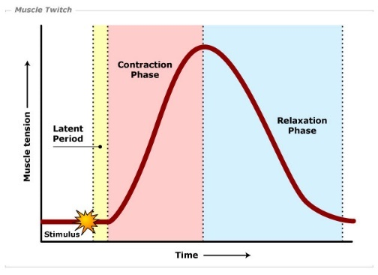
  - Contraction period
    - When you see rise in tension
    - Begins with the first release of Ca²⁺
  - Relaxation period
    - No new Ca²⁺ released
    - Ca²⁺ is pumped back into the S.R
- Faster the stimulation frequency, the more tension generated
  - This affects the peak force of a muscle twitch
Motor Unit = 1 motor neuron + all the muscle fibres it innervates
- Motor units have different sizes
  - Muscle for fine movement have small, and for powerful, big
- Motor unit recruitment (for increasing muscle tension)
  - Endurance movements
    - Very asynchronous
  - Powerful movements
    - Very synchronous
Muscle Fibre types
- Type I (SO – Slow oxidative fibre) (dark)
  - Smallest diameter – least powerful
  - Fatigue-resistant – high endurance
  - Slowest contraction speed
- Type IIb (FG – Fast Glycolysis fibre) (light)
  - Widest diameter – most powerful
  - Low endurance
  - Fastest contraction speed
- Type IIa (FOG – Fast Oxidative-Glycolytic fibre) (medium colour)
  - Medium diameter – medium strength
  - Medium endurance
  - Medium speed
- Humans have type I, IIa, but not IIb. In humans, it is called IIx
- Most people have 50-50 distribution of slow and fast muscle fibres
Neurophysiology
Peripheral Nervous System
3 subdivisions of PNS
- Somatic nervous system
  - Responsible for telling what is happening in our body
  - Conscious perception, sensory, motor neutrons
  - 5 senses
  - Only voluntarily controlled NS
- Autonomic nervous system
  - Automatic nervous system in our body
  - Heart rates, breath rates, etc
  - Fulfills basic needs of the body
    - Fight or flight response
      - Sympathetic and parasympathetic nervous system
- Enteric nervous system
  - Related to digestive system
    - Controls metabolism
Basic functions of the nervous system
- Sensory: afferent pathway
- Integrative: interneuron pathways
- Motor: efferent pathways
Cells of the nervous system
- Neurons
- Neuroglial cells
  - In CNS
    - Astrocytes
      - Secretes chemicals to surround capillaries and provide protection
    - Microglia
      - Responsible for clean up, removing all damaged neurons and etc
      - They eat them up
    - Ependymal cells
      - Hollow spots in the brain – along the cavities are ependymal cells
      - Reduce weight of the brain and provide protection from concussion
    - Oligodendrocytes
      - Make sure we have faster signal
      - Wraps around axons
  - In PNS
    - Satellite cells
      - Like astrocytes
    - Schwann cells
      - Like oligodendrocytes
      - These neuroglial cells form myelin sheaths
        - Made of lipids and proteins
        - Provide electrical insulation
        - Nodes of Ranvier
        - Much faster signal
      - Remak bundles
        - No nodes of Ranvier
        - Conduction is slower (usually for slow pain fibres)
Tactile Receptors
- Merkel discs
  - Superficial
    - Dendrites encapsuled in discs
  - Slow adapting (clothes on)
  - Responsive to light touch, receptive fields are small and well defined
- Meissner corpuscles
  - Superficial
    - Dendrites covered by capsules
  - Fast adapting (light fluttering)
  - Responsive to light touch, receptive fields are small and well defined (two point discrimination)
- Ruffini
  - Deep
    - Dendrites covered by capsules
  - Slow adapting (stereognosis)
  - Tactile must be bigger for them to respond, receptive fields are larger and more vague
- Pacinian
  - Deep
    - Dendrites covered by capsules
  - Fast adapting (repeated poking)
  - Tactile must be bigger for them to respond, receptive fields are larger and more vague
- Pain/temperature
  - Superficial
    - Free nerve endings (bare dendrites)
Proprioceptors
- Muscle spindle – muscle belly – spiral endings wrapping around instrafusal muscle fibre
- Golgi tendon organ – muscle tendon – free nerve endings embedded within tendon
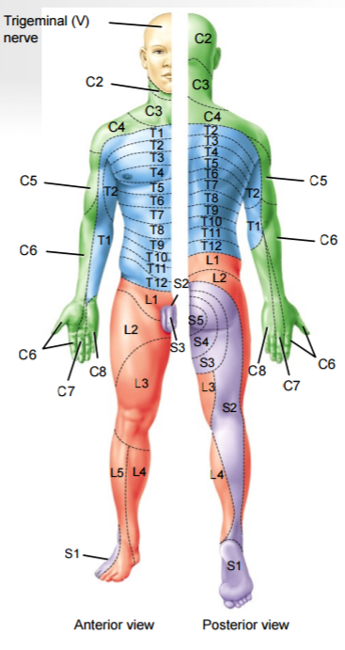Central Nervous System
Spinal Cord
- Each spinal cord segment is responsible for different parts of the body

- Cervical – upper limb and head
- Thoracic – body
- Lumbar – lower limb
- Sacral – posterior lower limb

- Dermatomes
  - Area of skin supplied by given spinal segment
- Myotomes
  - Group of muscles supplied by given spinal segment
Myotatic reflex
- Muscle stretch muscle spindles muscle contraction
Reverse myotatic reflex
- Muscle tension Golgi tendon organ muscle relaxation
Protections of the brain
- Bony structures
- Meninges
  - Dura mater (most superficial)
    - 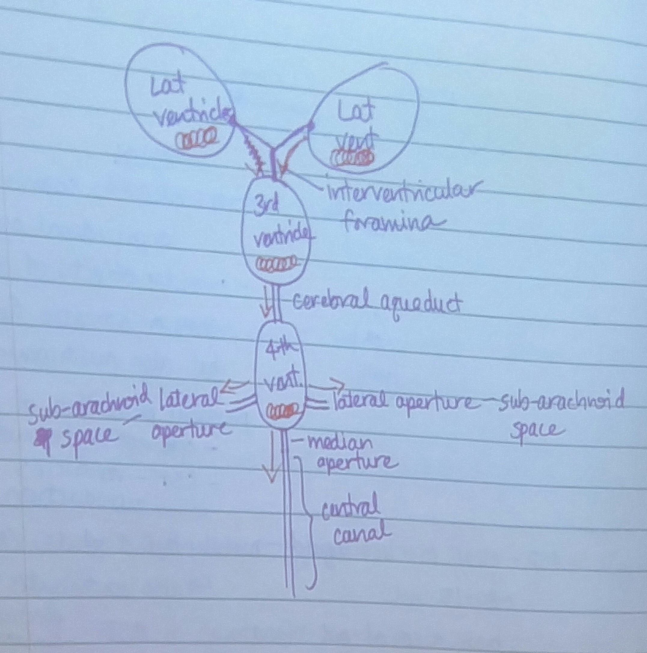Thick connective tissue
    - Extensions of this also separates parts of the brain
      - Falx cerebri
      - Falx cerebelli
  - Arachnoid mater
  - Sub aracnoid mater
  - Pia mater (deep)
    - Thin wrap material that follows the grooves of the brain
- Cerebrospinal fluid (CSF)
  - CSF is secreted and contained within the ventricles
    - 2 lateral ventricles, 3rd and 4th ventricles
    - Clear colourless fluid 80~150mL, mainly water and solute (lots of Na⁺ and little K⁺)
      - Also, contributes to healthy electro-chemical environment for neurons
  - CSF is produced by choroid plexus = capillaries, ependymal cells (neuroglial cell)
    - H₂O is drawn via osmotic gradient from blood plasma
  - Production of CSF = drainage of CSF
    - Reabsorption of CSF via venous system through the arachnoid villi
      - Bulk flow (exocytosis of fluid)
  - CSF Function
    - Mechanical protection of CNS (buoyancy, shock absorption)
    - Contributes to healthy extracellular environment for neurons
    - Exchange of nutrients and removal of waste productions in CNS
  - *hydrocephalus
    - Drainage of CSF is blocked by a tumor or etc
- Blood-Brain Barrier (BBB)
  - Blood supply to the brain is separated from blood supply to the rest of the body
    - Two internal carotid arteries
    - Two vertebral arteries (through the transverse foramen of cervical vertebrae)
    - Jugular vein
  - In other parts of the body, there are gaps in between the endothelial cells, however in the brain, there are no gaps between the endothelial cells
    - Astrocytes (constantly secrete paracrine that cause production of tight junctions) (these arms sit next to endothelial cells)
    - Only way for exchange of substances is to go through the plasma membrane
      - Selectively permeable
  - Function of BBB
    - Chemical protection of CNS
      - Protects the brain from fluctuations in hormonal, ionic, and neurotransmitter levels in the blood
    - Regulation of substances that can cross BBB

Brain anatomy and functions
- Cerebellum
  - Flocculonodular lobe (posture/balance and equilibrium)
    - Input: vestibular organs (inner ear)
    - Output: muscles of trunk (axial muscles) and also extensor muscles
  - Post lobes (motor coordination)
    - Input: somatic sensory receptors (muscle spindles, tactile receptors)
    - Output: communicate to other brain areas involved in motor control and control of keelhaul muscles
  - * Dysdiadochokinesia – impairment in ability to perform rapid, alternating movements
  - *Dysmetria – errors in the range of movements
- Cerebrum functions (cerebral cortex areas)
  - Frontal lobe
    - Muscle, purposeful movement control
    - *Broca’s area (frontal lobe)
      - Important for producing language (speech and writing)
  - Parietal lobe
    - Somatic sensory receptors, sensations
  - Occipital lobe
    - vision
  - Temporal lobe
    - Hearing, learning, memory
    - *Wernicke’s area (temporal lobe)
      - Important for understanding language (reading and hearing)
        - Wernicke’s aphasia – “word salad”
    - *anterograde amnesia – inability to make new memories (hippocampus)
    - *Retrograde amnesia – forget memories that have already been formed
  - Insula
    - Taste and smell
  - pre-frontal cortex
    - executive functions, judgement, the thinking part
  - cerebral cortex (layers)
    - superficial brim of grey matter
    - gyrus (most superficial)
      - pre-central gyrus
        - primary motor cortex through alpha motor neurons
      - post-central gyrus
        - primary somatosensory cortex (first area to receive sensations)
    - sulcus (shallow groove)
    - fissure (deep groove)
- Diencephalon
  - Epithalamus
    - Includes the pineal gland
      - Secretion of melatonin
      - Relates circadian rhythm
    - Habenular nuclei – processing smell
  - Thalamus
    - Grind central station
      - Major relay station of sensory information
  - Hypothalamus
    - Control centre for autonomic NS
    - Not tightly sealed by BBB (as well as the ‘vomiting centre)
    - Involved in regulation of endocrine
      - Pituitary glands
      - Thirst centre
      - Temperature regulation
- Tracts
  - Association tracts
    - axons that connect areas within the same hemisphere
  - Commissural tracts
    - axons that connect corresponding areas across opposite hemisphere
      - ex. Corpus callosium
  - Projection tracts
    - axons that connect cerebrum with other areas of the CNS
      - ex. Internal capsule
- brainstem (most of the cranial nerves comes out of the brainstem)
  - medulla
    - cardiovascular centre: controls heart rate, cardiac output, blood pressure
    - breathing centre: respiratory rate
    - vomiting, coughing, sneezing centre
      - *photic sneeze reflex (ACHOO autosomal dominant compelling helioophthalmic outburst syndrome)
    - Atlanto-axial dislocation fatal
    - Vagus nerve = cranial nerve X (10)
      - Parasympathetic innervation of the internal organs (digestion)
  - pons
    - pontine respiratory group: controls our intake
    - apneustic centre: longer breaths
      - apnea-cessation of breathing (during sleep)
    - facial nerve = cranial nerve VII (7)
      - alpha motor neurons to muscles of facial expressions
      - *bell’s palsy – temporary paralysis of facial nerve (usually half of the face)
    - trigeminal nerve = cranial nerve V (5)
      - sensory neurons from face
        - II 1 – ophthalmic branch
        - II 2 – maxillary branch
        - II 3 – mandibular branch
  - Midbrain
    - Red nucleus rubrospinal tract (longitudinal pathway)
      - Involved in limb movement
    - Substantia Nigra – releases dopamine
    - Superior and inferior colliculi
      - Superior – processes visual input
        - Eye movements and visual reflex (blink, pupillary light reflex, saccades)
      - Inferior – processes auditory input
    - Oculomotor nerve = cranial nerve III (3)
    - Trochlear nerve = cranial nerve IV (4)
    - Abducens nerve = cranial nerve VI (6)
    - *startle reflex (response to unexpected/loud noise)
      - Infants: Moro reflex
      - Sudden noise causes extension and abduction of limbs
  - reticular formation
    - mediates consciousness, sleep, and arousal
      - reticular activating system (from stimuli
    - ADHD too much alertness
    - Does not respond to olfactory stimuli (smell)
Neuron pathways
- Dedicated sensory pathways for different types of afferent input
  - Fine touch, proprioception
    - Posterior column-medial lemniscus pathway
      - 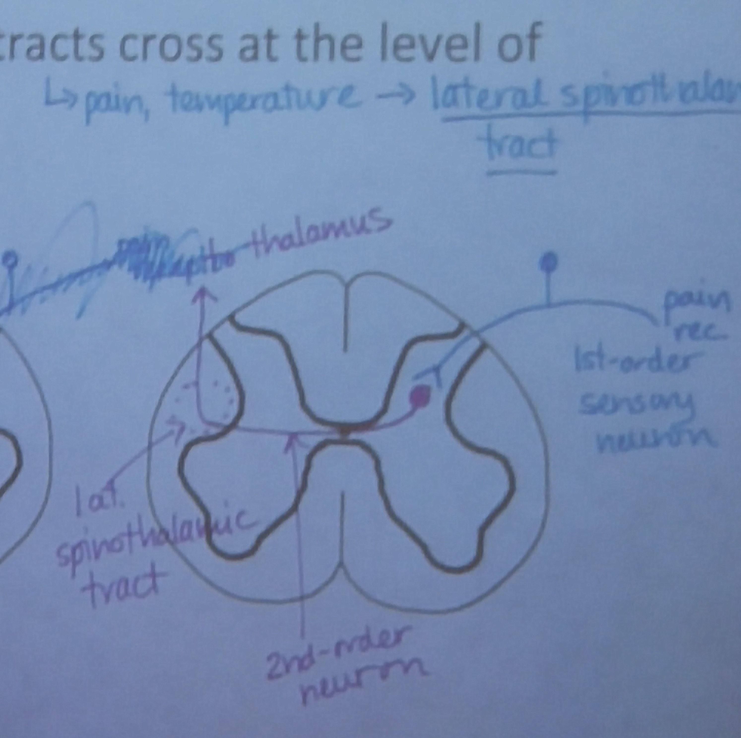Fibres cross at medulla
  - Pain and temperature
    - Lateral spinothalamic tract
      - Fibres cross at spinal cord
  - Crude touch and pressure
    - Anterior spinothalamic tract
      - Fibres cross at spinal cord
  - Proprioceptive info to cerebellum
    - Spinocerebellar tract
      - Fibres don’t cross
- Direct motor pathways
  - Lateral corticospinal tract
    - Decussate at medulla
    - Distal muscles
  - Anterior corticospinal tract
    - 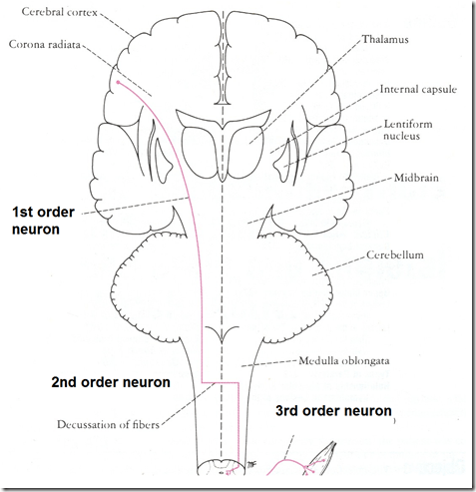Descend ipsilaterally
    - Muscles of axial skeleton
  - Corticobulbar tract
    - Descend bilaterally
    - Muscles in head
Basal ganglia
- Deep nuclei in grey matter
- Parkinson’s disease
  - Degeneration in substantial nigra
    - Leading to deficiency in NT (dopamine from substantial nigra)
  - Drug treatment – L-DOPA
    - Precursor to dopamine
- Huntington’s disease
  - Degeneration of basal ganglia neurons
  - Huntington’s chorea
    - Involuntary extra-movements
    - Lack of inhibition

