LESSON 2
What is Anthropology?
- A humanistic discipline that studies the diversity of human kind in its cultural manifestations (focuses on meanings rather than measurements, texture of everyday life rather than generalizations)  - Started with a focus on small-scale societies, uncovering details of peoples lives though sustained contact known as participant observation, which is conducted during fieldwork. | - Going to faraway places is linked to the discipline's history and intellectual premises as well as to the anthropologists' own history and interests.  - Many anthropologists now study closer to home or at home as the reasons for choosing a field site have changed and the site itself may feed into the topic and theoretical questions that one selects.

Anthropologists at Work
Let's listen to Dr. Deborah Gewertz, professor of Anthropology, Amherst College and Dr. Frederic Errington, professor of anthropology, Trinity College, Connecticut, tell us how they became anthropologists, and why they decided to carry out research in Papua New Guinea, a country located in the Southwest Pacific, north of Australia.

Verandah anthropologists traveled to colonized countries where they conducted research but did not live with the people they were studying. Armchair anthropologists studied cultures from afar.

The kula is: a trading network linking many islands of the Pacific.
Rapport is: a trusting relationship between the researcher and the study population.
Collaborative research: is an approach to learning about culture that involves the anthropologist working with members of the study population as partners and teammates rather than strictly as subjects.
The greatest distinction of anthropology is that it is global and comparative in its approach.

The most important anthropological paradigm used in 19th century Europe was: Evolutionary anthropology
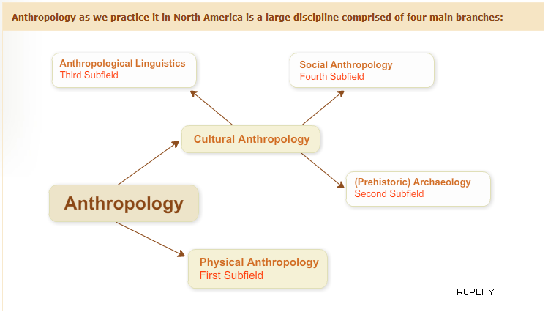

Physical Anthropology: First Subfield
Physical anthropologists (first subfield) study the physical dimension of human beings; divided into paleontologists and primatologists.
- Paleontologists study human evolution (paleontology) => how pre-human creatures became human beings, the ancestry of Homo Sapiens. A famous example is the discovery in Ethiopia in 1974 of Lucy,; a young female whose fossil remains date back 3.2 million years, classified as an Australopithecus Afarensis.
- Primatologists study the social life and behaviour of non-human primates, like chimpanzees (with whom we share 99% of our body chemistry) and gorillas, in the wild and captive, and experiment in animal psychology and ape language. An example of a well-known case is that of Jane Goodall and her studies of chimpanzees in east Africa.
Some physical anthropologists also study the genome of social groups in the hopes of providing clues on origins, migration and group identity of populations.

We will talk about animal communication later in the course, but in the meantime you can read more on big apes and language in this article " Great Ape Language" from Science Daily.

Archaeology: Second Subfield
Archaeologists (second subfield) are interested in finding objects (bones, fire) and artifacts (pottery, ornaments, etc.) because of what they can tell about the social life that once existed - revealing ways of life, presence of sacred rituals, etc., and not just housing layouts.

Pre-historic vs. Historic Archaeology:

Pre-historic archaeology studies societies that never left written records, whereas historic archaeology studies societies that did leave a written record.

Linguistic Anthropology: Third Subfield

Linguistic anthropologists (third subfield) are trained in linguistics and anthropology and study the relationship between language and the rest of culture => how speech and language are used to signal identity or status, express thoughts and knowledge, label the world around them, etc.

- Through comparative methods, this can provide information on migration and how people without writing systems were related in the past.
- Also interested in birth and death of languages, language and gender/nationalism/ethnicity/social class, ethnography of communication, how the context of communication affects the choice of language in any speech community => what is said to who, when it is said and how it is said.

Cultural or Social Anthropology: Fourth Subfield
Cultural and social anthropologists (called ethnology in Europe) (fourth subfield) often study contemporary societies anywhere in the world and the specialization in particular dimensions of social life (arts, economy, political life, religion) has caused fragmentation.
Topics vary greatly, even at Concordia University, and all can be studied from different theoretical perspectives, but all cultural anthropologists obtain their data firsthand through research in the field.

Anthropology is Holistic
Anthropology’s interest in the whole of the human condition lends to its four sub-disciplines, studying the diversity and transformations of human beings and their cultures. Each is an interpretive subfield aiming to understand human life from a holistic perspective and are thus taught in many anthropology departments in North America.
This is not however, standard in all anthropology traditions
– British anthropology is essentially social anthropology, while French anthropology is divided into three forms:
- physical anthropology (referred to as anthropology)
- archaeology
- ethnology (social and linguistic anthropology). They are taught autonomously.

Myth of Origin Story from the Solomon Islands

Here is an excerpt of the creole language of the Solomon Islands. It is called Pijin and is now spoken throughout the country. The grammar is very similar to that of the local languages, but 80% the vocabulary comes from English.
Listen to a local myth of origin told to me by Cecilia Saako, a 57-year-old woman from the Solomon Islands. Cecilia is from one of the Polynesian outliers in the Solomons. Pijin is a second language for her. She can neither read nor write.
Cecilia is a widow: those of us who know her culture can tell that she is a widow because her hair is short and her clothes are old and dirty, as is required by tradition. In brief, she is in mourning.
As you listen to Cecilia, read the text of the story and see if you can understand some of it before looking at the translation.

Part 2: History of the Discipline
- Chapter 1 in the textbook provides a brief summary of how anthropology appeared and evolved, founded in 19th-century Europe when evolutionary social theory was an important scientific paradigm.
- It was believed that societies developed in easily observed stages; this false assumption put Western societies ahead of all others– serving as justification for many acts of decimation or forced social transformations and the colonization of much of the world by European countries.
- Ethnocentrism: the belief that the moral standards, belief systems, arts, etc. of one's own society are superior to those of other societies.
- Common to some extent, a measure of ethnocentrism can be proof of successful socialization and enculturation of the individual and contentment. An extreme presence is rejected by anthropology and leads to intolerance.

Cultural Relativism
- Franz Boas's work best represents the beginning of American anthropology and the reaction to evolutionary anthropology at the beginning of the 20th century.
- Due to colonialism's destruction of many societies, Boas and students like Margaret Mead and Ruth Benedict thought to record human cultures before they disappeared. This became known as salvage anthropology.
- Cultural relativism understands societies in terms of their own logic rather than ranking or judging them by outside standards, but this idea must be examined carefully.

How does Anthropology Work?
- Participant observation: Living alongside your participants (the people you are studying) is a crucial part of your fieldwork as well as taking notes of all your observations.
- Interviews are also an important part of the research process, allowing further understanding through in-depth questions with individuals and are thus an important tool for eliciting information.
- Archives can also be helpful for finding information on the history and background of the area as well as demographics and statistics.
- Use of tools such as recorders, camcorders and cameras in the process of gathering audio and visual material allows interviews to be easily captured and transferred.

Participant Observation in Honiara
Because part of the research involves the transmission of linguistic knowledge in families, it is important that I live with families and see how this is done.
During my last two field trips in Honiara in 2007-2008, I lived with two different families: the Furau and the Wame. In the case of the Furau, three generations lived in the household, plus other members of the extended families.
All told we were 14 people. You can see pictures of some members of this family. While living with them, I shared their life, helping them with cooking, shopping, taking care of the children, cleaning, participating in family activities on the weekend and in the evenings, and attending church or other events.

Fieldwork
- Fieldwork is not an easy process and success depends on the acumen (insight/wisdom) and industriousness of the researcher, the soundness of the research project and on personal qualities.
- Fieldwork often takes anthropologists away from loved ones and/or in to cultural contexts that require adjustment to new ways of being, talking and etiquette and new timetables, forcing them out of their comfort zones.

- When researchers are brought into worlds so different from their own they can experience culture shock accompanied by frustration and difficulties adjusting. It is important to be able to recognize this as it can occur unexpectedly.
- Success in research depends on acceptance and on participants and their desire to help us (age, gender and class and can help or hinder the research).
- Chapter 2 explains that many anthropologists now work at home or in Western societies.

Ethics
- The relationship created with the people anthropologists work with (establishing rapport) is important. A relationship of mutual respect and trust aids in productive research.
- The relationship depends on the anthropologists’ people skills and traits (intellectual honesty, patience, tact, humour, independence, care).
- Anthropologists have moral obligations towards the people they study and these are detailed in a code of ethics; we have obligations as both fellow humans and as scientists.
- Intellectual honesty and quality publications are two very important obligations anthropologists have towards their participants.
- A third obligation (less mentioned) is the return of data and results of the research to people who have participated (by sending copies of interviews, transcriptions and pictures to individuals, groups, archives and museums or sending copies of the articles or books published).

LESSON 3
Definitions of Culture
What do anthropologists mean by culture?

A classic definition was proposed by Edward Tylor, a 19th-century British anthropologidy, who wrote in 1871 that: ‘Culture or civilization… is that complex whole which includes knowledge, belief, art, law, morals, customs, and any other capabilities and habits acquired by man as a member of a society.’

Let’s note that early definitions of culture focused on the aggregation of events, things and systems of thoughts that encompassed and guided human behaviour.
Needless to say, not all segments of Edward Tylor's definition have withstood the test of time. Anthropologists today are still considering cultures as complex wholes, but they would probably not refer to ‘man’ but to ‘humans’, they would probably not equate ‘culture’ with ‘civilization’ as this word connotes particular cultural traits (such as writing systems, centralized states, etc) that are not found in all societies.
It is fair to say that the dominant definition of culture has changed throughout the history of anthropology and that not all anthropologists agree on what it is. There are many ways of understanding this concept.
Various definitions of ‘culture’ by different scholars:
- ‘The learned behaviors and symbols that allow people to live in groups. The primary means by which humans adapt to their environments. The way of life characteristic of a particular human society.’ (Serena Nanda and Richard Warms, 2002: 412)
- ‘The learned system of beliefs, feelings, and rules for living around which a group of people organize their life.’ (Richley Crapo, 2002: 492)
- ‘Distinctively human; transmitted through learning; traditions and customs that govern behavior and belief. (Conrad Kottak, 2002: 501)
- ‘The system of knowledge more or less shared by members of a society.’ (Roger Keesing, 1981: 509)

Various Approaches
The range that exists in the definitions of culture is obviously large. But do not be mistaken. It is not that anthropologists disagree fundamentally on what culture is. Far from it. But their ‘take’ on it varies with the theoretical approaches they prefer. For instance, those anthropologists called ‘interpretive’ will focus on the symbols and thoughts of a cultural group. Others, such those called ‘materialists’ will focus on the learned behaviours and lifestyles of peoples. However different their approaches may be, all anthropologists agree that culture refers to learned (and somewhat shared) patterns of behaviour and thought.
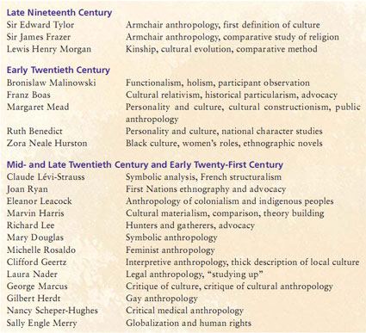

How did Culture Begin?
- Culture emerged through group formations and the development of language and the ability to use symbols.
- Culture as a means of addressing natural/social needs through a system of rules.
- Human needs are diverse and complex and accordingly, so is culture.

Conceptions about gender roles are symbolic, vary from society to society and they change over time.
Culture is Shared
- Sharing of culture reflected in the socialization of members in ways that contribute to understanding of common rules, meanings and behaviours.
- Culture shared allows for mutual interpretations, symbolic meanings, messages and intentions to flow.

Sir Edward Tylor, armchair anthropology
Bronislaw Malinowski, participant observation
Marvin Harris, cultural materialism
Claude Lévi-Strauss, structuralism
Franz Boas promoted the detailed study of individual cultures within their own historical contexts. This approach is called: d) historical particularism

One Society, Different Values
People in the same cultural group can have very different opinions and ways of understanding the world. People have different tastes, different expectations, different outlooks on things. Within the same cultural group, people will have different values, goals and systems of meanings.

For example:
For the longest time in Quebec, religion was taught in school and was mandatory in primary schools. When the government opted to make the course optional and to offer a course in ethics and morals for the children who did not want to take the religion course, many people were outraged, while others applauded.
In the wake of the ‘reasonable accommodation’ debate that took over the province in 2007-2008, the Quebec government opted to replace the course on ethics and religion with a course on comparative religious culture.
Some parents objected that the course gives the same importance to all religions and therefore undermines their own in the minds of the children.
Something to think about
How can you explain that this would happen in the same province with only 6 million people who share the same space, go through the same education system, have the same government, speak the same languages, and so on?

Social Cultural Diversity
Class, gender, race, ethnicity and indigenous peoples

In all societies, basic distinctions exist between individuals in terms of age and gender.
Often, what people can or cannot do, may or may not do, may or may not say, is linked to their memberships into social groups defined by their gender and their age.
In multicultural societies, other factors such as race, ethnicity and indigeneity have provided additional ways of ‘classifying’ people according to their skin colour, ethnic origin and native status.
We shall cover these issues in detail in a later lesson.

Subcultures
Clearly, when people are part of a cultural group they are not passive recipients of prepackaged systems of meanings, behaviour and thought.
As individuals, they develop their own opinions and ideas. Individuals in a culture engage the dominant culture according to gender, class, experience, age, etc. And this process is often what leads them to have different visions of what their culture is.

Some fully approve of the dominant model and embrace it while others reject it. It is the engagement with culture that leads to socio-cultural change.
When groups of people recognize themselves as having different ways of engaging the cultural world in which they live, we talk of subcultures.

Youth Culture
In some societies, young people have modes of expressions, behaviour and values that may be significantly different from those of their adult counterparts: they dress differently from their parents, they listen to different kinds of music, they use different words, and so on. This observation has led anthropologists such as Vered Amit to talk about youth culture. Yet however different some youth wish to be, they also engage with the rest of society.
This is true of many of the subcultures that comprise societies: subcultures organized around age, around leisure activities, around religions, around economic means, and so on.

A Subculture Example: Hip Hop Music
Stylistic origins | Funk, disco, soul, dub, toasting, performance poetry, spoken word, signifying, the dozens, scat singing, talking blues
Cultural origins | 1970s, the Bronx, New York City
Typical instruments | Turntable, synthesizer, vocals, drum machine, sampler, guitar, piano
Mainstream popularity | High worldwide since the late 1980s

Core Cultural Elements and Cultural Change
- Change in the mid-1940s: anthropologists studying cultural change, particularly from the point of view of acculturation studies, posited that not all areas of culture changed at the same pace.
- American scholars such as Herskovitz or Linton, for example, proposed that there were core elements in all cultures that were more resistant to change than others.

Case Study: Dancing in a Polynesian Settlement
On Easter Sunday 2007, your professor was invited to spend the day at the Lord Howe settlement in Honiara and witness/participate in the celebrations. There was to be music, food and a competition of dances. Your professor took her movie camera along.
On that day, a dance competition took place: groups of women and young boys belonging to different associations presented their dances. It was a long-drawn-out affair lasting many hours.
As you watch some segments of the video that your professor shot that day, pay attention to the dances of the women, their attire, the music they dance to, the use of perfume and the flower decorations they wear. Contrast that with the dances of the young boys and their attire.

The Lord Howe settlement is located at the mouth of the Mataniko River, by the seaside. It is inhabited exclusively by people from the Lord Howe Islands, a Polynesian outlier located north of the Solomon Islands, also known as Otong Java. In the settlement, people have running water but no sewage facilities, and housing runs from makeshift shelters to concrete houses.

Issues of Identity Amidst Change
- When external cultural markers are changed drastically, is the cultural group or individual identity any less authentic?
- Opposing concepts such as "traditional" and "modern" tend to oversimplify the complexities of cultural change.

Four Models of Cultural Interaction
- The most important forms of change are often associated with contact with outside groups.
- Anthropologists have identified four models of cultural interaction: clash of civilizations; McDonaldization; Hybridization; and Localization. You can read the description of each in the textbook.
- Amongst the various forms that contact has taken, colonialism (part of the clash of civilizations model), has brought about the biggest changes.

Four Models of Cultural Interaction
1 | Clash of civilizations | Conflict model
2 | McDonaldization | Takeover and homogenization model
3 | Hybridization | Blending model
4 | Localization | Local cultural remaking and transformation of global culture

Colonization
The word ‘colonization’ usually refers to European expansion into the non-Western world (from the 17th to 20th centuries), but has existed throughout history in various forms.
- European colonization has produced the most dramatic social changes in recent human history.
- Most empires had an agricultural mode of subsistence.

Egyptian Empire | Alexander's Empire | Mongol Empire | Aztec Empire
All of the empires above existed through colonization and subjugation of neighbours or of faraway lands for the benefit of the state that launched the expansion. Except for the Mongols, who were pastoralist nomads, all of these empires were established by populations whose main mode of subsistence was a strong agriculture.

Papua New Guinea is a country in the Western Pacific that comprises the eastern part of the large Island of New Guinea, the Bismark Archipelago, and the Island of Bougainville. Part of it was colonized by the Germans at the end of the 19th century, and subsequently by the Australians under a protectorate. It became independent in 1975.

Post-Colonial Politics
Colonization has not only affected individual groups located within former states, but it has also created new countries by amalgamating different ethnic groups and cultural groups into one geopolitical entity.
Think, for instance, of the countries of West Africa, such as Ivory Coast, Nigeria, the Congo, Rwanda, Ethiopia, the Sudan, etc., which were created by the Briitish, the Belgians and the French, and are now, after iIndependence, fraught with ethnic tensions. Again, the political crises that are shaking the Melanesian countries of Papua New Guinea, the Solomon Islands, Vanuatu and Fiji, are cases in point.

A general characteristic of post-colonial states is that they are politically and economically weak. Let's listen to Dr. Robert Foster, University of Rochester in the United States, explain why these weaknesses occur.

Colonialism and Modernity
For quite some time after they became independent, post-colonial states throughout the world have also been economically weak, and very often remained dependent on the economies of the former colonial powers. Even after independence, many former colonies had retained a form of economy that supplied raw commodities to the former colonial powers (coffee, sugar, cocoa, minerals, etc.) and served as a market for the sale of manufactured goods.
This observation led economists such as André Gunder-Frank to propose that under-development was maintained by the former colonial powers, and was in fact necessary for their own economic development. This thesis is questioned, particularly in light of the economic success stories of Brazil and South Korea, as well as other countries. Your professor asks Pierre Beaucage to clarify this point.

Globalization
Professor Beaucage’s view (from the previous slide) is very political and not all people will agree with it. Yet, as anthropologists have observed, dramatic types of change take place when, in the context of economic globalization, powerful international corporations, with the help of advertising campaigns, aim at changing people’s lifestyles and consumption patterns so as to market their ware.

But globalization involves more than the simple economic dimension of social relations.
Let’s listen to Dr. Jonathan Friedman from Lund University in Sweden and Dr. Robert Foster from the University of Rochester in the United States, who explain what they mean by globalization.

Final Thoughts
Food for Thought on this Lesson
"Technological progress is a conquering despot that does not stop. Any slowing down is seen as a retreat, and thus humanity is condemned to progress for life."
Alfred Sauvy, from Théorie générale de la population, 1952-1954
Right: Alfred Sauvy (Source: INED)
To Sum Up
- Culture is best understood as a way of life and a way of thinking about the world that is changing with the passage of time and through contact with other cultural groups.
- Cultures are the product of the interaction between individuals and social groups. In the process, they keep changing: through invention by individuals; through contact with other cultural groups; and through social transformations that cultural groups go through during their history.
- Some changes are incremental, while others are so dramatic that it is possible to think of them in terms of a revolution.

LESSON 4
Language and Communication
Part 1: The Origin of Language

What is Language?
Language is a code for communication consisting of a set of symbols and a set of rules for constructing messages => these symbols are arbitrary and conventional, used by peoples in societies and passed from generation to generation, and they can be oral, written or signed (like sign language).

It is through the study of speech that we can know language and the role it plays in social relationships. Let’s listen to Dr. Regna Darnell tell us what this relationship is.

Language as a Tool for Communication
Anthropologist Kevin Tuite (left), from Université de Montréal, in conversation with participants in his research project in Georgia, 2005 (Courtesy: Kevin Tuite)
- As a tool for communication, language is central to culture. Think of everyday activities that need language to be accomplished.
- The importance of language in anthropology was brought about by the works of Franz Boas and led to the creation of linguistics as a subfield (focusing on the relationship of language and culture.)
- Linguistic anthropologists look at social interactions and meanings through the study of discourse and speech.
- Speech is language in action (different from language), and by studying speech, we can know language and the role it plays in social relationships.

Displacement: refers to the ability to refer to events and issues beyond the immediate present.
Modern anthropologists think that language does not determines thought.

How did Language Begin?
Listen to your professor explain how language began.
Language began as:
(1) | The result of divine or supernatural intervention (God gave people language, i.e. Adam and Eve).
(2) | Language is part of the ontology of the world => language exists because humans exist. (particular conception/theory of the relationship of language to things in particular and to the world in general).
(3) | Language is an inherent part of the human species and is part of its evolution (language developed in relation to human evolution). This is the accepted belief.

(1)  The result of divine or supernatural intervention.  Biblical story of the Tower of Babel.  The Tower of Babel by Pieter Brueghel the Elder (1563) (Source: Kunsthistorisches Museum, Austria) |  | (2)  Language is part of the ontology of the world.  The relationship of language to particular things.  Mae’eadi and Anthropolgist Roger Keesing in Honiara, Solomon Islands, 1991 (Source: C. Jourdan)
(3)
Language is an inherent part of the human species and is part of its evolution.
The development of language in relation to human evolution.
All anthropologists believe that this third point is correct as it puts the development of language in relation to human evolution. Let’s see how in the next slide.

The Origin of Language
Physical anthropologists and paleontologists looking at evolution can help in uncovering the origin of language. The key to understanding how language appeared is to examine its functions: communication between people, store knowledge, think, and express emotions.

If language is linked to evolution, then:  - What point in the history of human evolution were physical (human physical traits like cognitive abilities and larynx) and social (communication through language advantageous) conditions favourable for the development of language?  - How important is the development of language for human evolution? Language was such an adaptive advantage that it put humans ahead on the evolution track, more distant than other humanoids like Neanderthalians. | 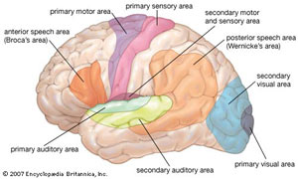  (Click on image to enlarge)
Paleontological records show that the combination appeared 1.6 million years ago at the time of the Homo Erectus. However, language took a long time to develop, and is believed to have only appeared in the last 100,000 years. It is associated with the physical and neurological characteristics of the modern Homo Sapiens.
The Development of Communications
The commucations diagram below explains the relationship between the development of language, needs for precise communication, development of the brain, and socialization (Source: S. Nanda)
- Language did not just appear with Homo Sapiens, although the how and why will never be known for certain. Nor is it known why vocal-based symbols were chosen over visual ones.
- Language was most likely the last step in human biological evolution, separating us from animals => Scupin remarked that human history began with cultural evolution (Scupin, 2000: 96).
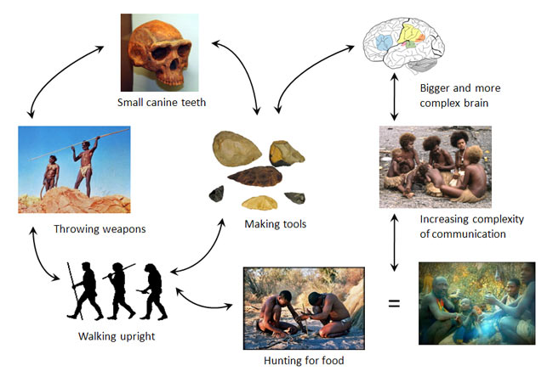

However simplistic this diagram is, it has the merit of proposing a theory of communication that seeks to integrate purely physical considerations with cognitive and social ones. It explains that language did not appear once Homo Sapiens appeared and physical evolution was over. We will never know how language began for sure, and we will never know the time at which it became more beneficial to communicate through a voice-based system of symbols rather than through a visual system of symbols and signs.
But one thing is certain: the capacity for language, which distinguishes humans from all other animals, was probably the last step in our biological evolution, and as Scupin remarks, since that time human history has been marked by cultural rather than biological evolution (Scupin, 2000: 96). In any case, explorations from several directions have greatly reduced the dimensions of our ignorance.

Part 2: What is Language?
Cuneiform script tablet from the Kirkor Minassian collection in the Library of Congress. From Year 6 in the reign from Amar-Suena/Amar-Sin between 2041 and 2040 BC. (Source: Library of Congress, Wikipedia)

Let's leave the topic of the origin of language and move on to the study of language itself. The easiest way to start this study is to ask ourselves the following question:
What do We Know When we Know a Language?
- We know the sounds that belong to our language and those that do not.
- We also know the place of some combinations of sounds.
- Finally, we know how to combine sounds in the right order in order to produce meaning.

What Do We Know about Language?
Building blocks of language:
- Phonology: sound systems
- Morphology: how words are put together
- Lexicon: the vocabulary
- Syntax: the grammar

We are socialized to use language efficiently by respecting social conventions – the most important aspect for linguistic anthropology.

The Main Characteristics of Human Language
Human language displays four main characteristics: arbitrariness, conventionality, productivity and displacement (the first two we share with non-human primates).
- Arbitrariness means that the relationship between sound and meaning is irrelevant (all languages would use the same words otherwise) => words are symbols: their meanings are defined by culture, not label.
- Conventionality and arbitrariness combined allow us to create new words, assign them meaning, change meaning as needed, and so on.
- Productivity allows us to communicate different messages by combining various elements of language. Thus we can modify and refine the meanings of sentences to fit the context (situation) in which they are spoken (tone, volume used to indicate urgency, etc.)
- Displacement allows us, through language, to talk about the past or future; permitting us to enter a world of abstraction since we cannot see the past or future.
Human language is thus a communication system that is open while those of animals are closed.

Language Socialization
- Language is the repository (bank) of meaning and is a tool used to communicate meaning. How it is used and what the use signals about human relationships is what is important to anthropologists.
- American linguist Noam Chomsky has shown that humans are predisposed for language learning. For example, children can understand and produce complex sentences without having been exposed to the data necessary for the production of such sentences.
- The key to language acquisition is in socialization (the social process associated with learning how to become a member of one’s own society), just like culture.
- Bambi Schieffelin and Elinor Ochs show in their research that language socialization involves two different activities: socialization to use language (language acquisition by children in the context of family life) and socialization through language (socialization of children into culture through language).
Why do languages change?
Schieffelin and Ochs (from the previous slide) make it clear that language socialization is the key to cultural socialization, and that language is central to culture and is fed by culture. In anthropology, the debate is whether language is the motor of culture or a mirror of it.
Languages change (like culture):
- Passage of time: each generation influences language in the ways they use it. Expressions change, along with grammar.
- Cultural contact and borrowing from other languages (sometimes this is forgotten through history).
- Migration and subsequent isolation and development of local culture (Quebec French Vs. France French).
- Identity creation.

Language Families
Dramatic changes can lead a language to be unrecognizable to its relatives over time. Historical linguists help us to understand how languages are related though lexicostatistics: comparing patterns of sound changes between languages. They compare words likely to be found in each language because they encode elements of everyday life shared by all societies.
- The initial list of 100 words (body parts, intimate family members, basic colours, basic physical environment elements) called the "Core Vocabulary" was compiled by linguist Morris Swadesh.
- Lexicostatistics has been criticized, but has allowed historical linguists to group languages into large families.

Language Families: Austronesian Languages
Austronesian Language Tree and Full Tree Figure of Austronesian Languages
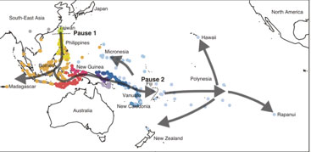 | 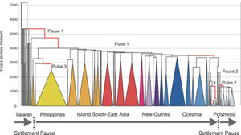

Common Words in Six Austronesian Languages
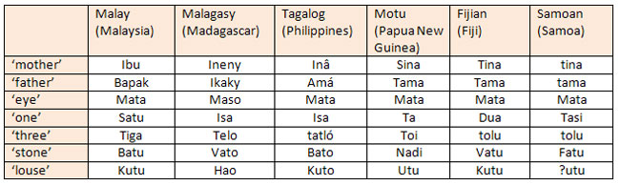

Why Do We Need to Know How Languages are Related?
Knowing how languages are related to each other is important to archaeologists or anthropologists who need to understand the geographical origins of a given group of people.

For instance, for a very long time the origin of Pacific Islanders was an object of conjecture and debate. A nagging question was: Given the cultural traits that are found on both sides of the Pacific Ocean, (pan pipes, tapas, stone or earth ovens, sweet potatoes) it was not clear whether Pacific Islanders had migrated into the Pacific from the Americas or from Asia.
So linguists started to do a comparative study of the languages of the Pacific using the lexicostatistics method. And what results did they get? Well, that that these languages could be grouped into two families: the Papuan languages and the Austronesian languages.

The subsequent comparison of the Austronesian languages of the Pacific with languages of Southeast Asia and South America was done to test the hypothesis of the origin of Pacific Islanders. The idea was that if scholars could find resemblances between the languages of the Pacific with languages found on either side of the Pacific Ocean, then we could determine the geographical origins of Pacific Islanders.

Origins of Pacific Islanders
Knowing how languages are related is important to anthropologists and archaeologists when attempting to understand the geographical origins of a given group => examining whether two groups with similar cultural traits may have originated from the same peoples.
For example: Pacific Islanders may or may not have migrated from the Americas or Asia. Using lexicostatistics, the languages could be grouped into two families: Papuan and Austronesian languages. Austronesian languages of the Pacific were then compared to those of Southeast Asia and South America in order to discover the existence of similarities or not.

How Language Changes
- Language changes reflect a healthy culture where new generations spout new ideas and ways of being appear and push language in different directions.
- Languages have disappeared when their speakers and cultures have come under attack throughout history (i.e. colonization of the world by Europe has left its mark; Tasmania, an island off Australia, had its last aboriginal speakers decimated by British settlers).
- Globalization of popular culture through English is having a similar effect elsewhere. TV programs, songs and print media give more prominence to one language. English has become a lingua franca (a language of universal communication used to overcome linguistic gaps that exist in multilingual encounters).
- Socioeconomic value is being associated with the dominant language and people give in to this and move away from their own language. It is when whole communities shift that ancestral languages become obsolete and disappear.
- National education systems that teach in one "national" language are responsible for many disappearances, for the government is giving social legitimacy to one language and forcing speakers of other languages to learn it.
- Language death is when a language disappears, which entails a process of endangerment stages.

There are 6000 languages present today and, while diversity is high, the forces of colonization, globalization and education threaten them. Linguist Richard Krauss estimates that in 100 years 90% of these languages will be gone or spoken only by the older generations.
However, new languages may appear when sociolinguistic situations allow them to develop, like the pidgin and creole languages of Jamaica or Haiti. They are created by the contacts between diverse populations speaking different languages and in social circumstances where learning the other languages is impossible. They are also linked to the early slave trade of the Atlantic between Africa and the Americas and in labour trade in the Pacific between Melanesian Islands and the Australian northern state Queensland.
Malayo-Polynesian Family of Languages
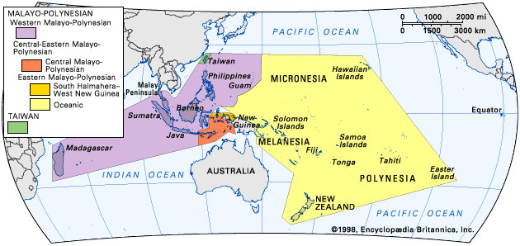
"Before European colonial expansion, Malayo-Polynesian had the widest territorial extent of any language family. A primary genetic division in the family separates the Austronesian languages of Taiwan from the remaining languages, which are divided into Western and Central-Eastern Malayo–Polynesian. Western Malayo-Polynesian includes Javanese, which is spoken by about 76 million people-more than a third of all Austronesian speakers."

The Genesis of Melanesian Pidgin

In the second part of the 19th century labourers, on sugar plantations who were recruited from their home islands in Melanesia had no access to learn the language of the plantation overseers, nor that of fellow diverse workers.
Thus, a new language developed that retained some grammatical features of the Melanesian languages and borrowed English vocabulary.
For a language with an unpromising start that did not exist 150 years ago, it is now spoken in Papua New Guinea, Solomon Islands and Vanuatu and serves as a national language.
Other New Languages
New languages also appear within particular social groups: Verlan, the language of young people in the housing projects of the suburbs of Paris, is a case in point.

What is Verlan?
Verlan is a form of French slang that plays with syllables and sounds and typically reverses the order of syllables as they are being heard (not written). Most famous examples are words such as Verlan (means: reverse) and ripou (a corrupt police officer).
Let’s see how they are built:
l'envers... l'en vers... vers l'en... versl'en... verslen... verlen... verlan pourri... pou rri... rri pou... rripou... ripou

Language and Identify
- Social jargons like Verlan or new languages are created not only as a means of communication but as a symbol of identity as well.
- Verlan was originally used to keep information away from those in authority, and it spread as a language of resistance to authority and identity (now used by disenfranchised youths).
- There is a strong association between language and identity and it is fraught with emotional considerations. Does your ability (or lack thereof) to speak Greek affect your identity as a Greek person?
- The association between language and identity has led governments to create language legislation.
  - For example: Bill 101 made French the official language of Quebec and made children not born to English-speaking parents attend French schools, thus implying that French is the language of Quebecers and to ensure the continuation of French as a strong cultural language on the North American continent. Some believed that Quebec culture could only survive in French.

The Sapir-Whorf Hypothesis
The debate revolves around two particular approaches:
- Is language such a powerful tool that it creates grooves of expression that predispose us to see the world in a particular way?
- Or, rather, is language a mirror of culture, reflecting cultural beliefs and preoccupations about the world?

Language as a Mirror
Anthropologists agree that there is a relationship between language and thought, but not one where language determines thought. Rather, they see it as an influence on the speaker's thinking and worldview (weak reading of the hypothesis).
Languages also develop vocabularies that reflect local cultural realities and preoccupations: military vocabulary is prominent in countries where the army is important and the whole vocabulary of cooking in English can be borrowed from French => sauté, julienne, etc.

Final Thoughts
- The languages of the world are fundamentally similar despite the superficial differences, as Chomsky has shown. They are all products of the same human capacity for language and all serve the same function in human societies.
- The differences between languages are due to the cultural imprint that each culture stamps onto them. Gender, class, age groups, power relationships, fashions and ideologies are inscribed on languages and how they are used.
- Languages are instruments to think with and to live with and thus are repositories (storehouses) of human cultural experience.

LESSON 5
Lesson 5: Religion: Ritual, Myth and the Cosmos

Edward B. Tylor: argued for a cultural evolutionary model whereby religions evolved from animism to monotheism
Bronislaw Malinowski provide a charter for society in that they express core beliefs and teach morality.
true about all rituals They are a patterned form of behaviour generally having to do with the supernatural realm.
Emile Durkheim’s theory: when people periodically congregate for the performance of religious rituals they are promoting social solidarity.
Animism
Animatism
An Anthropologist of Religion
One of the things I study is spirit possession in which people are temporarily taken over by spirits who seek them out in order to speak and act through them. Possession is a good metaphor to think about how we become the people we are.
I did not set out deliberately to become an anthropologist of religion. The factors that led me to anthropology were many, including dissatisfaction with the world as I found it, wanting to make sense of it by writing about it, seeking adventure in faraway places, and not wanted to specialize in a narrow undergraduate degree.

Spirit Possession in Mayotte
In 1975 I ended up on the island of Mayotte, in the Western Indian Ocean, to conduct my doctorial field world and discover the existence of spirit possession. It became deeply interesting to me;, it enabled forms of intimate communication as well as dramatic performances.
It led to puzzles about the nature of personhood, about the relations between the mind and the body, about illness and healing, about reality and performance and for forth. Spirit possession, and the topic of religion as a whole, raises fascinating questions about human rationality and imagination, about the ways we find ourselves, as a species in the world and the goals we set in order to prosper and live well.
Why Religion?
Why religion?" is a good question. Not considering the question of the divine or supernatural origin of the religions (which most anthropologists will claim are human creations), scholars have identified social and psychological reasons for religions:
- they explain
- they validate
- they comfort
- they define the way the world is
Taking the above into account, a definition of religion proposed in 1966 by Clifford Geertz, an American anthropologist, seems fitting:
Definition of religion: A religion is 1) a system of symbols which acts to establish powerful, pervasive and long-lasting moods and motivations in men by 2) formulating conceptions of a general order of existence and 3) clothing these conceptions with such an aura of factuality that 4) the moods and motivations seem uniquely realistic. (Source: Geertz 1966: Religion as a Cultural System).

Religion therefore defines and explains the world and establishes appropriate reactions towards it, (feeling, thinking, acting in it). Religions are belief systems that serve as models for living, and models of living. Other definitions of religion stress the belief in spiritual beings; yet others stress the quality of sacredness that demarcates the religious from the secular, that is, everyday life.

Distribution of Major World Religions
Population Distribution of Major World Religions  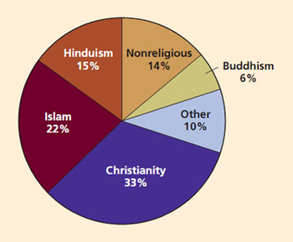
  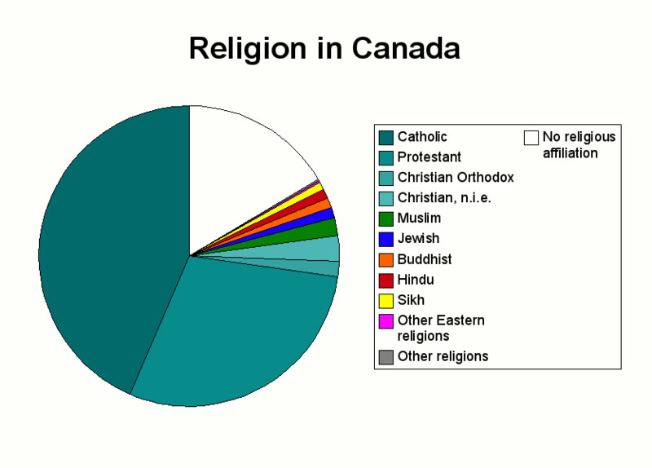
Different Deities or Agencies
- Religions vary with regards to the deities and agencies they posit, and with how people relate to them.
- Some religious systems, such as animism, believe in the presence of indwelling spirits (ghosts, tree spirits, and other spirit beings) while others, such as animatism, posit the presence of diffuse spiritual power such as Mana in Melanesia, or Orenda in North America.
Myths, Doctrines and Rituals
Religions are expressed through myths, doctrines and rituals.

- Myths are sacred texts (oral or written) that seek to explain the order of things and the state of the world. They usually explain how things came to be the way they are: myth of origin, myth of creation.
- Doctrines establish the rules (for human behaviour, and for behaviour vis-à-vis the supernatural beings and the spirits. They are formal statements.
- Rituals are often described as beliefs in action. Well-performed rituals are the ways to honour deities or spirits, to propitiate them, to appease them, and to communicate with them.
Rituals
- The early anthropological studies of rituals, such as those by French sociologist Durkheim and British anthropologist Radcliffe-Brown saw them as reinforcing collective sentiment and social integration. The nitty-gritty of the ritual itself, that is, the very steps and elements of the rituals, were not considered important. Contemporary anthropology, since the works of Victor Turner in particular, has recognized the structural importance of rituals and the symbolism they carry.

Rituals as Channels
- Rituals are the channels through which one communicates with the supernatural beings, with spirits or with ancestors. If the rituals are not performed perfectly, then the desired effect might not take place. Rituals include the performance of religious ceremonies, the sacrifice of animals during these ceremonies, the offering of food to spirits or deities, and various types of prayers, incantations and music that favour communication with deities or spirits. Hence the importance given in all religions to the performance of rituals.
- Some rituals are secret from the rest of society (such as the one Lianiamae is performing, left), others are communal events (such as religious services), and yet others are individual (individual prayers).
Life-Cycle Rituals
- These rituals are often also called rites of passage and they are often associated with or given salience through religion. Think of marriage blessed by priests, briss performed by the Rabbi or funeral rituals. We shall explore rites of passage in greater detail in the lesson on the Life Cycle.
Rituals as Communitas
- Anthropologist Victor Turner has shown that rituals help people achieve a sense of unity with each other. This is what he has called communitas. During rituals, people’s individuality can be subsumed to an overwhelming feeling of belonging. Note that communitas takes place as well in non-religious rituals or events.
- Turner noted that during the state of communitas, the 'normal' social order (including social hierarchy) is often forgotten and people feel as if they belong to a community of equals. During pilgrimages, people traveling together to a sacred site often share a feeling of belonging that erases social differences between pilgrims.
Pilgrimage to the Grand Pardon in Rocamadour, France
- Pilgrimages called Grand Pardons (Great forgiveness) take place once every hundred years since the 13th century on Saint John de Baptiste day (June 24), which coincides with the feast of Corpus Christi. This a Catholic pilgrimage that honours the Virgin Mary.
Liminality and Normal Life
Liminality | Normal Social Structure
Transition | State
Homogeneity | Heterogeneity
Communitas | Structure
Equality |Inequality
Anonymity | Names
Absence of property | Property
Absence of status | Status
Nakedness or uniform dress | Dress distinctions
Sexual continence or excess | Sexuality
Minimization of sex distinctions | Maximization of sex distinctions
Absence of rank | Rank
Humility | Pride
Disregard of personal appearance | Care for personal appearance
Unselfishness | Selfishness
Total obedience | Obedience only to superior rank
Sacredness | Secularity
Sacred instruction | Technical knowledge
Silence | Speech
Simplicity | Complexity
Acceptance of pain and suffering | Avoidance of pain and suffering

Religion in Daily Life
- Emile Durkheim has said that religion serves to reinforce social control by enforcing moral codes and setting rules for appropriate social behaviour.
- There are religions in which daily life and religious life are intertwined in such a way that social behaviour is often presented as having a divine origin. Think about what is happening currently in Afghanistan, where the Shiite leaders, to the uproar of the West, recently passed a law controlling the movement of married women outside of the home in the name of Islam.
- Think about the Catholic Church condemning the use of contraception methods or of the condom for its followers. In all cases known, religion is used by the powers that be to justify or reinforce social practices that seek to control the behaviour of all or some members of the society.
- Religions provide guidelines for social behaviour: rules necessary for the maintenance of social order are more powerful if they are attached to threats or rewards from a supernatural power.
Part 4: Religion and Change
- Even though religions tend to support the social order, they are also agents of change and sometimes revolution (think about the Islamic Revolution in Iran, for instance). During the phase of European colonization, the Catholic Church was instrumental in bringing about major social changes: converting people, condemning songs and dances, teaching literacy and Western religious music, emphasizing the nuclear family as the preferred model of residence, destroying shrines and old belief systems.
- While fundamentalist Christians or Muslims today still adhere to strict standards of beliefs, rules, customs and on the literal reading of texts sacred to their faith (the Bible, the Qur'an), they often seek to convert others.
- For example, Tele evangelists in the U.S. and fundamentalist Christian preachers are currently converting millions of people to fundamentalist Christianity in South America, Africa and the Pacific.

Case: Liberation theology (within the Catholic Church), as found in Latin America for instance, is a school of theology that claims that the poor have been oppressed by the rich: it claims that it is a moral duty to seek redress on behalf of the poor, and to bring about justice through political action. Liberation theologians act within the confines of democracy to bring about the end of poverty.

Cargo Cults: Chief Moro, the charismatic leader of the Moro movement, a cargo cult/revitalization movement/nativistic cult found in the Solomon Islands, 1997.

Syncretism
- Major crises, such as colonialism, for instance, lead to the adoption of sets of new symbols and rituals, while the meaning of life remains the same.
- For example, this is the case among the Maya of Mexico whose Catholicism is imbued with many of the meanings of their pre-Colombian religion. These religions have been called syncretic, meaning the synthesis of old and borrowed elements.
- Examples are voodoo in Haiti, Santeria in Cuba, Candomblé in Brazil. All involve some blend between Catholic, African, and native American beliefs and saints.

New Religions
- French philosopher André Malraux claimed that the 21st century would be ‘religious’ or it would not exist (‘Le 21ème siècle sera religieux ou ne sera pas’).
- Malraux seems to have been right. Not only has there been a reinforcement and radicalization of some established religions towards a more orthodox bend (Islam, Catholicism, some Christian denominations), but new religions have also developed. These attract people from other religions, but also people who were raised outside of religion.

Final Thoughts
- Religion is found in all cultures of the world, but in great diversity.
- Religion seems to contribute to social order, to answer general questions about one’s place in the world and the order of existence, to appease anxiety and provide solace.
- All religions of the world involve belief in supernatural beings and powers, rituals and expression of feelings.
- Variation in belief systems in societies is often related to social and environmental contexts.
- New religions often emerge in periods of social upheaval.

LESSON 6
Part 1: Food-Gathering Systems
Sorting out the various types of food-gathering systems
Anthropology has traditionally made a difference between the societies whose main ways of getting food is by collecting it or raising it, and those whose main way of getting food is by producing it.
pastoralists typically form trade links with foragers, horticulturalists or farmers to obtain food and other goods that they cannot produce themselves.
Family Farming: is an intensive strategy that involves growing crops on permanent plots with the use of plowing.
Using this criterion, we divide the various types of subsistence patterns in this way: | Subsistence Patterns
 | Food Collecting | - Foraging
 | Food Producing | - Pastoralism  - Horticulture  - Agriculture (small-scale and industrial farming)
This dichotomy reminds us that the relationship to nature changes when one simply partakes of the food that is available, and one tries to transform nature so as to obtain a bigger yield. But it is probably just as useful to divide these groups according to whether they are nomadic or sedentary.
Here are the five main ways of making a living according to whether a population is nomadic or sedentary: | Nomadism: | 1 - Foraging  2 - Pastoralism
 | Sedentarism: | 3 - Horticulture  4 - Agriculture  5 - Industry
In either case, these typologies are always reductionist, and we need to keep this in mind throughout this lesson.

Part 2: Foragers
The first mode of subsistence we will look at is what anthropologists have called hunters and gatherers, sometimes referred to as foragers.
Archaeologists estimate that humans have spent 90% of their existence on earth as foragers.

Bushmen in Africa | Punan in Malaysia
There are a variety of hunting and gathering societies, not only in terms of the presence or absence of horticulture, but also in terms of the reliance on (collecting) vegetable food or on hunting (animal food).
In fact, it would be appropriate to think of a continuum on which contemporary foraging groups could be located.
Netsilik Inuit + hunting | Australian Aborigines + collecting

Urban Foraging and Dumpster Diving
Most of you know that in many cities of the world, poor people make a living from foraging in the urban jungle, so to speak. I am referring to a mode of survival that requires people to depend on the refuse of others in order to eat or make a living.
To learn more:
- 'Hundreds' dead in Manila dump collapse
(Source: BBC News Online)
While some poor people, forced by economic necessities, clearly depend on what they find to supplement their diet and meet some of their needs, other forage in dumpster out of political convictions (anti waste movements, ecological considerations, etc.).
Pastoralism
People who raise animals and take care of herds are called pastoralists or herders. It is very rare to find groups of people who live exclusively off of herding.
- Historically, pastoralism represents an off- shoot of the early mixed agriculture and herding complexes, in association with dry grasslands.
- Pastoral economies, developing in marginal zones around those where settled agriculture predominated, have for several millenia been closely tied to those of sedentary peasants and of states on whose periphery they lay.
- Depending on the regions of the world, different types of animals are being herded and looked after.
Studying pastoralism requires that we look both at the internal organization of such groups, and the outside forces by which they are set. As we start our study of pastoralism, let’s keep in mind the following questions:
- What are the characteristics of pastoralist societies?
- How can we explain the differences?
- Why would pastoralists not want to kill the animals they herd?

Pastoral Nomadism: The Basseri of Iran
- In many areas of the world where grass becomes scarce during certain seasons of the year, or when the weather becomes bad, the animals have to be moved between various areas. This is the case of pastoralism practiced in high mountains such as the Alps or the Himalayas because the physical environment shapes people’s livelihoods. For instance, the Basseri, a pastoralist group living in Iran studied by anthropologist Fredrik Barth, live in the high Himalayas and almost in a symbiotic relationship with agriculturalists who are settled in the same areas and at live at about 5000 feet of elevation.
- Because they live on the products of their herds, the Basseri move their herds of sheep and goats towards the high mountain in the summer to let them take advantage of the fresh new grass, and move them back in the valley during the winter. The whole group is moving. They are nomadic and move their herds along traditional migration routes. They consume the products of their herds, such as meat and milk and use the wool and hides. These can be traded with neighboring villagers to meet other needs. During migration, all the properties of each family in the group must be moved: tents, bedding, cooking equipment, along with the herds. Transportation is provided by horses and donkeys across paths that are very steep. The crossing of rivers is always a dangerous affair. Social groups comprise about 5 to 6 families (conceived as 'tents'), led by a headman, with their own grazing areas and migratory routes. Such groups split away from the larger tribe of about 10-40 families at the time of migration. Membership in this larger tribe or 'oulad' is based on patrilineal descent.
- All those groups are ‘welded into a unit by their centralized political system, culminating in the single office of the chief… The chief... is the central, autocratic leader of the tribe’ (Barth 1961: 71). The Basseri, as with other nomadic societies today, have seen their traditional ways curtailed by the nation-states of which they are a part.

Transhumance in the Alps
- The seasonal movement of herds is called transhumance. It is typically found in the mountainous areas of the world where other forms of land exploitation would be difficult.
- In the Alps and other such mountainous areas, only the shepherds move with their flock (usually sheep and cows) and spend the summer season in the high pastures looking after their sheep. While watching over their herds, shepherds are busy making cheese with the milk of their animals. The rest of their families stay home in the valley and are busy with farming.
- Pastoralism with transhumance is associated with agriculture. The farmers supplement their income and food supply with vegetable gardens, orchards and small farm animals such as chicken, ducks and rabbits. They also grow hay and corn to be used as fodder by the animals during the winter season. At the end of the summer season, the shepherd takes the animals down in the valley and is ready to sell his cheese at local markets and shops: the European Community has imposed rules and quotas of production that are seriously affecting the livelihoods of shepherds.
- Transhumance was and still is practiced in many parts of the world as diverse as Scandinavia, Georgia, the Himalayas, Morocco, Italy and Lesotho.

Semi-Nomadic Pastoralism: The Samburu of Kenya
- The Samburu are an ethnic group living in Kenya, East Africa. They are closely related to the Maasai. Their livelihood depends on the tending of herds of zebus (local variety of cows), which are their most valuable possessions, but they also take care of goats and camels.
- More recently, and given the close contact they have with other non-pastoralist groups, some Samburu have started to be sedentary and to practice agriculture, thus supplementing their diet with grain products.

Pastoralism Today
- Pastoralism comes in many guises, but it is always a type of ecological adaptation. Pastoralists live in symbiosis with their animals.
- This obligatory relationship benefits both humans and animals: humans take care of the herds and ensure that they have access to grazing lands and that they reproduce; in return, they obtain food such as milk, blood, meat, wool and leather depending on the animal being herded.
- Although pastoralists rely on their herds for survival, it is not possible to survive exclusively on herding alone. Many pastoralists supplement their diet with hunting, gathering, and fishing. They also cultivate land and trade the by-products of their herds (cheese, for instance, or wool, or hide) with the neighbouring groups.
- One of the main difficulties faced by today's pastoralist societies is the encroachment of outside forces on the land that their herds need to have access to. States and governments everywhere have tried to sedentarize them for the purposes of tax collection, social control and control of population movements. This is done with the excuse of providing children with education and access to health services.

Horticulture
Horticulture |  | Agriculture
- No mechanization | - Mechanization
- No use of fertilizer | - Use of fertilizer
- No irrigation | - Irrigation
- No draught animals | - Use of draught animals
- Small yields per acre | - Larger yields per acre

- As a crop is harvested in one garden, a new garden is cleared and planted. The old garden is allowed to lie fallow, and secondary growth takes place. At some later optimum time (between 10 to 20 years), a new garden will be cleared from the secondary forest, and the logs will be burnt.
- The advantage is that the ashes will serve as nutrients and fertilizers for the soil. The garden is then planted and harvested a few months later. In some very arid areas, the optimal length of the fallow cycle is about 10 to 20 years, depending on the areas.
- Typically, a few gardens are exploited at the same time so as to ensure a regular supply of food. After a few cycles, the land is so depleted of nutrients that the secondary forest may not grow back.

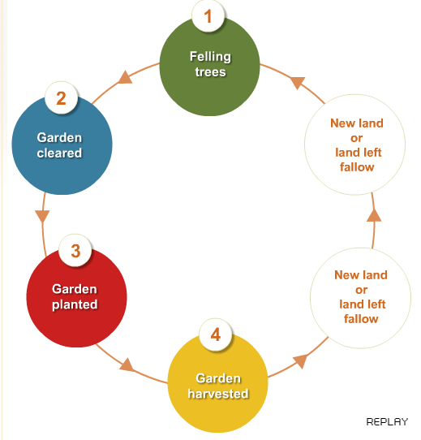

Successful Horticulture
Much of the success of extensive agriculture depends on the gardener’s abilities to take care of the land. This includes:
- letting the land lay fallow long enough so that the nutrients in the soils are replenished.
- practicing intercropping (i.e. an ingenious alternation of crops, or mixing of crops on the same plots of land).
- avoiding erosion.
Below both the gardens look a bit unkempt and disorganized compared to the kind of ‘gardens’ some people keep. But there is a logic to this way of gardening, and it has allowed people to live well off their land for many generations without facing famine.

A Kwaio garden, Solomon Islands, 1983 | Lily’s urban garden, Honiara, Solomon Islands , 2007
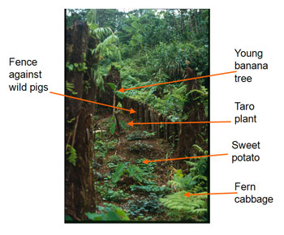 | 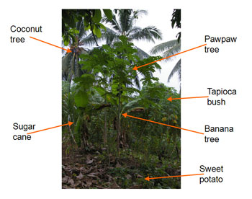

Intensive Agriculture: Non-Industrial Agriculture
We find two sorts of intensive agriculture: non-industrial and industrial agriculture.
- Peasants, who practice subsistence farming (non-industrial agriculture), do not rely to the same extent as industrial farmers on mechanization and fertilization. They make use of simpler tools such as hoes, shovels and animal-drawn plows and the land they tend is smaller. They grow crops and raise animals for their own consumption, and if surplus is produced it can be sold to the market. Farmers and peasants are part of the larger economy of the state in which they live but the production unit is the family unit.

- On the farm, the division of labour is usually by gender and age. Men perform the bulk of the manual labour while women take care of the house and small farm animals, process the food and take care of small children. In these societies, women’s status is lower than that of men.

Intensive Agriculture: Industrial Agriculture
- Industrial agriculture is a form of agriculture that relies most heavily on what mechanization and technology can offer and that is found in association with industrialism. It is characterized by large plots of land, use of heavy motorized equipment (tillers, harvesters), chemical fertilizers, herbicides, irrigation and efforts to modify the effects of weather conditions (shading textiles when the sun is too hot; green houses to grow food in off seasons or to speed the development of new crops). Industrial agriculture often rests on the production of one or two types of crops and is pegged to market prices and demands.
- It gives high yields but is rather inefficient in terms of the amount of work that is required to produce the products it needs to use in order to maintain the high yields (machines, pesticides, crops selections, textiles, tools, fertilizers) and make them available to the consumer (transportation, packaging food, delivering food, storing food, etc.). It requires only a small part of the labour force. For instance, in the United States, only 1.5% of the labour force is involved in food production. The same high yields ensure that large populations have access to food, particularly in urban centres. As a result, industrial agriculture is often ‘protected’ by governments.

The Food Crisis of Spring 2008
A combination of factors are at the root of this crisis: environmental, economic, social and demographic.
Environmental factors:
- A draught in Australia and monsoons in Asia affect production of rice and wheat.
Economic factors:
- Transformation of corn into biofuel creates shortage in corn as food.
- High price of petrol.
- International subsidies and competition.
Social factor:
- Changing food habits in various parts of the world.
Demographic factor:
- Increase in population.
Results of the Food Crisis
The Food and Agriculture Organization (FAO) of the United Nations announced that 30 countries in the world suffered a food crisis, 12 of them acute. Seventy-five million people were added to the ‘under the hunger threshold’ list in 2007. The number of undernourished people reached 923 million at the end of 2007 (Source: FAO website, 18/09/2008)

Modes of Production Summarized
The table on this slide summarizes the characteristics of the various modes of productions we have talked about in this lesson. Look at it carefully and pay attention to the socio-political characteristics associated with each mode of production. Keep them in mind as they will be explored further in the lessons that follow.
 | FOOD COLLECTORS | FOOD  PRODUCERS
 | Foragers | Horticulturalists | Pastoralists | Intensive Agriculturalists
Population density | Lowest | Low-moderate | Low | Highest
Maximum community size | Small | Small-moderate | Small | Large (towns & cities)
Nomadism/permanence of settlements | Generally nomadic or semi-nomadic | More sedentary: communities may move after several years | Generally nomadic or semi-nomadic | Permanent communities
Food shortages | Infrequent | Infrequent | Frequent | Frequent
Trade | Minimal | Minimal | Very important | Very important
Full-time craft specialists | None | None or few | Some | Many (high degree of craft specialization)
Individual differences in wealth | Generally none | Generally minimal | Moderate | Considerable
Political leadership | Informal | Some part-time political officials | Part- and full-time political officials | Many full-time political officials

