Econ Final Exam Review

Chapter 2: Labour Supply 1

Income-Leisure Trade-off
- Indifference curve can be used to explain an individual’s choice between the amount the amount of income they are receiving or the amount of leisure they are receiving
- Income is earned by devoting some of the leisure time to do some work.
- The greater the amount of sacrifice of leisure, that is, the greater the amount of work done, the greater income an individual earns

Consumption (c) | Leisure (L) | U(c,L)
10 | 7 | 8.37
10 | 8 | 8.94
9 | 8 | 8.49
9 | 9 | 9.00
8 | 9 | 8.49
8 | 10 | 8.94
7 | 10 | 8.37
7 | 11 | 8.77
6 | 11 | 8.12
Utility Function of Consumption and Leisure
- U=U(c,L)
- Example:

Indifference Curve
- Graphical representation of preferences over different bundles of (c,L)
- If bundles A and B are on the same indifference curve, person is indifferent with them
- If bundle A is on a higher indifference curve than B, then the person favours A Over B
- Gets flatter the more leisure you consume

Marginal Rate of Substitution (MRS)
- = Marginal U of L
Marginal U of c
- = MU(L)xP or MU(c)xP P= price of the product
- The amount of a good that a consumer is willing to give up for another good, as long as the new good is equally satisfying
- Slope of the indifference curve

Diminishing Marginal utility
- Marginal Utility: the change in utility as an additional unit is consumed
- As a person increases consumption of a product while keeping consumption of other products constant, there is a decline in the Marginal Utility that person derives from consuming each additional unit of that product
- Example: if an individual is hungry and buys three slices of pizza, they will get a greater amount of positive utility from the first slice than the third slice

Budget Line
- T- Maximum number of units of time a person can work
- W- Wage worker can earn
- YN- Non-Labour Income
- Graphing
- Maximum possible amount of consumption: WT + YN
- Maximum possible amount of Leisure: T
- Slope of the budget line: -W
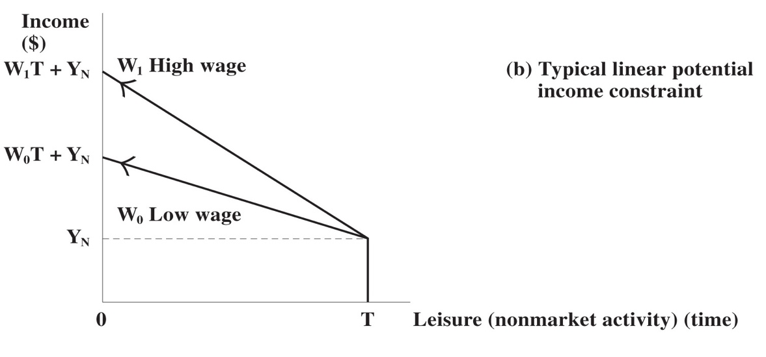

Workers Optimum
- Maximize ones’ utility subject to their budget constraint
- Gets to the indifference curve that is farthest away from 0, but is still on the budget line
- Utility maximizing choice: Bundle of (c,L) at which MRS=W
- MRS: Rate at which workers would like to substitute leisure for consumption
- W: Rate at which workers can substitute leisure for consumption

Reservation Wages
- Lowest wage at which the worker is willing to supply positive amount of labour
- Defined as the MRS at zero hours of work
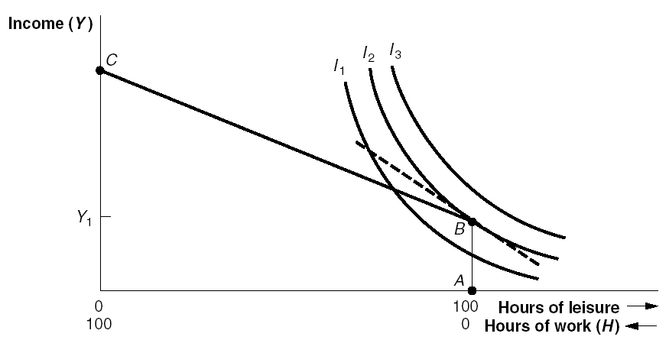
- The slope of the indifference curve is at B, which is the reservation wage

Income and Substitution Effect of Wage Changes
- Substitution Effect: Decreases the amount of leisure worker wants to consume
- Measures how much the higher price encourages consumers to use other goods, assuming a constant level of income
- When income increases, the price of leisure increases, causing you to work more
- Income Effect: Increases the amount of leisure worker wants to consume
- if the prices of wage rises, it effective
- When income increases, demand for leisure increases, suggesting you will work less

Individual Labour Supply Curves
- Labour Supply Curve: plot labour supply decision at each W against W
- Upward Sloping: Substitution effect dominates income effect
- Workers increase quantity of labour when wage increases

- Downward sloping: income effect dominates substitution effect
- Workers decrease quantity of labour when wage increases
- Backward Bending
- When wage is low Substitution effect dominates
- When wage increases Income effect dominates

Income effect
Substitution Effect

Chapter 3: Labour Supply and Public Policy

Income and Substitution Effects of Specific Policies

- Demogrant:
- Lump sum transfer to specific demographic group
- Shifts budget line outward
- Pure Income Effect
- increases consumption and leisure, decrease hours worked
- substitution effect increases labour supply because they recipients do not need to give money back
- Income Effect decrease labour supply because there is an increase in consumption and leisure
- Welfare
- Minimal level of well-being and social support for citizens to support basic needs.
- Welfare is largely provided by the government from tax income
- Increases reservation wage
- substitution effect increases labour supply because they recipients do not need to give money back
- Income Effect decrease labour supply because there is an increase in consumption and leisure
- Negative income Tax
- Have to have a minimum income
- Reduces employment
- Because recipients have to give back a portion of their welfare benefit when they earn income on the labour market, this policy effectively reduces the recipient’s wage (per unit of labour supplied). So, the policy makes leisure less expensive, which encourages recipients to consume more of it. The substitution effect of this policy tends to decrease labour supply.
- Wage Subsidy/EITC
- A transfer of s for every dollar earned
- Net Income: Y=(1+s)E E- earned income from working Y- total income
- Net Wage: (1+s)W
- Substitution effect encourages people to work more
- Income Effect Encourages people to work less
- Earned Income Tax Credit (EITC)- designed to reduce number of people on welfare
- Child Care Subsidy
- Benefit to working parents
- Fixed cost- price doesn't change

Case Study: EITC on Labour Supply of Single Mothers
- Predicted Effect: For women currently not participating in the labour force, EITC will increase wages, potentially above their reservation wages and it should increase labour force participation
- They decided to look at the differences between a controlled group and a treatment group and compare the differences before and after the program
- Findings: EITC increased LPF, no effect of hours worked maybe because of measurement and knowledge of the program

Differences in Differences = (change in X for treatment group) – (change in X for control group)

Chapter 4: Labour Supply Over the Life Cycle

Age-Labour Force Participation & Birth Cohort Effects
- Age Effects:
- Schooling, work, retirement
- Birth Cohort Effects:
- Changing retirement age, prevalence of higher education, married women in the workplace
- Example: women born in 1941-45 have different lifetime work patterns than women born in 1956-60

Responses to wage changes over the life cycle
- Responses to wage changes depend on whether or not wage change was excepted
- Permanent unanticipated wage change:
- Income & Substitution effect
- Small labour supply effect
- Evolutionary wage change
- Anticipated change in wages over life cycle, associated with aging
- Income/substitution effects spread out over life cycle, don not happen as wage changes occur
- Transitory unanticipated change
- Substitution effect larger than income effect

Home Protection
- Two types of goods:
- Time-intensive
- Produced meals in the home
- Meals, cleaning, childcare
- Goods-intensive
- Goods purchased with money
- Food, clothing, car
- Consumption goods and inputs into home production function
- Factors in decision about market work vs home production:
- Wages
- Higher wages implicitly raise the price of home-produced goods
- Higher wags raise price of leisure
- Price of inputs vs finished products
- Example: price of pre-packaged food vs raw ingredients
- Cost of preparing home-produced goods
- Household technologies
- Decreases time required in home production
Fertility and Childbearing
- Family Formation: important to understanding women’s labour supply decisions
- Children increase a woman’s time spent at home
- Omitted variable: unobserved preferences

Retirement Decisions
- People decide when to retire because of mandatory retirement age, wealth & earnings and the health & nature of work
- Public pensions
- Old Age Security (OAS)
- Demogrant to people over 65
- Income effect- early retirement

Case Study: Birth Control & Women’s Labour Supply
- Goldin and Katz (2002)
- Effect of birth control pills on women’s career and marriage decisions
- Theoretical effect of pill on human capital investment:
- Better control over timing of fertility
- Allows women to recover costs associated with career investment
- Encourages them to incur costs associated with skill acquisition
- Effects on marriage:
- Creates thicker marriage market for career women
- Lowers costs associated with delaying marriage
- Major findings:
- Access to birth control pills increased % of women not married by age 23 by 2.1%
- Women working in professional jobs increased by 1.7%

Chapter 5: Labour Demand

Production Function: amount that is produced with given input of labour and capital depends on production technology
- Labour- N
- Capital- K
- Capital: physical inputs, machines
- Q = F(K,N)
- Characteristics of a production function:
- More inputs produce more output
- Diminishing marginal product
- Marginal Product of K (MPk): increase in output when input of capital is increased by a small amount, holding labour constant
- Marginal product of N (MPn): increase in output when input of labour is increased by a small amount, holding capital constant
- The marginal product of K and N are diminishing because of crowding

Marginal Revenue Product of Labour: MRPn = P x MPn

Marginal Cost of Labour: MCn = W

Profit Maximizing Condition: P x MPn = W or MRPn

Long run
- All inputs variable (not consistent)
- Can sub capital for labour

Isoquants: Curve illustrating different combinations of K and N that create the same amount of output
- Possible to produce the same quantity of output with different combinations of capital and labour.
- Example: Q = K1/2 N1/2
- Same out put from K=4, N=16
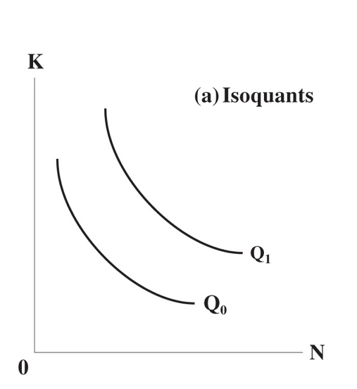

Marginal Rate of Technical Substitution: Rate at which K and N can be substituted for one another to hold output constant
- MRTS = MPn/MPk
- Is the slope of isoquant curve
- MRTS gets smaller/flatter the more labour is employed

- Isocost Curve: Represent different combinations of labour and capital that cost the same amount
- Example: Price of capital (r) is $5 per unit, Price of labour (w) is $10
- K=4, N=1 costs $30; K=2, N=2 costs $30
- Both points on same isocost curve
- Slope of isocost: -w/r
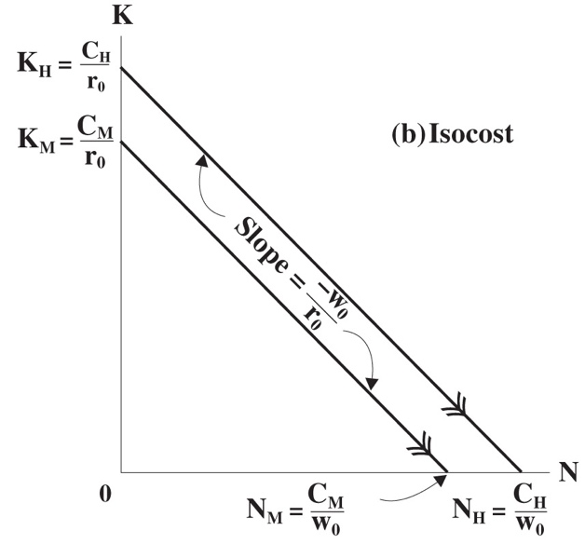

- At optimal choice of K, N:
- MRTS = w/r If MRTS > w/r → could raise profits by using more labour and less capital
- if MRTS < w/r → could raise profits by using more capital and less labour

Substitution Effect: Relative prices of inputs have changed, which makes the firm want to alter mix of inputs
Scale Effect: Overall costs have increased, which makes the firm want to change the level of production

Firms Labour Demand Curve
- Downward sloping: higher wages, which means that a company should substitute towards other inputs and scale back on production
- Short Run Labour demand:
- Capital is fixed
- Only scale effect
- Smaller response
- Long run Labour demand:
- Capital is constant (variable)
- Both substitution effect and scale effect
- Large response

- Elastic Demand: If wages increase, quantity of labour demanded decreases “a lot”
- Inelastic Demand: if wages increase, quantity of labour demanded decreases “a little”
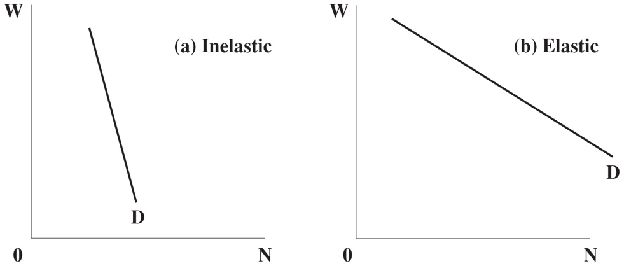

Chapter 6: Labour Market Equilibrium

Market Demand for Labour
- Market Labour Demand Curve: horizontal sums of individual firms labour demand curves
- Example: suppose market consists of 2 firms
- When w=2, firm 1 demands 2 units of labour and firm 2 demands 3 units of labour
- Market demand for labour when w=2 is 5 units of labour
- Relationship between wage paid by employers and labour demanded
Market Labour Demand Curve
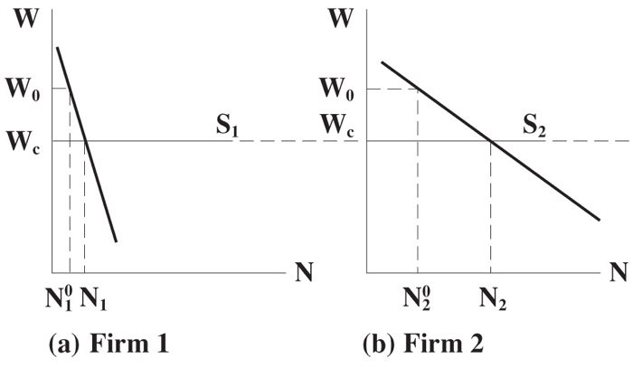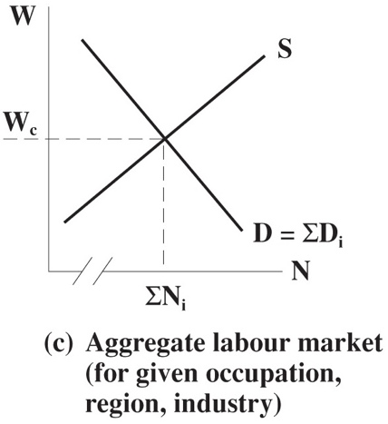

Market Supply of Labour
- Each individual worker has a labour supply curve
- Market labour supply curve is horizontal sum of individual supply curves
- Relationship between wage received by workers and labour supplied
- Example:
- Suppose market consists of two workers
- When w=2, worker 1 is willing to supply 10 units of labour and worker 2 is willing to supply 5 units of labour
- Market supply of labour when w=2 is 15 units

Working with Supply and Demand
- Equilibrium: Wage at which Labour demanded (N^D) = Labour Supplied (N^S)
- When N^S > N^D
- There are more people willing to work than jobs available
- Some workers will offer to work less than the going wage
- Market wage will fall
- When N^D > N^S
- There are more job openings than workers
- Some firms will offer to pay more than the going wage
- Market wage will rise
- In equilibrium, everyone willing to work at the going wage is working, and every firm willing to hire workers at the going wage is hiring workers
- Calculating equilibrium wages and employment:
- Linear supply and demand functions:
- Demand: N^D = a+bW
- Supply: N^S = c+dW
- In equilibrium, N^D = N^S
- a+bW = c+dW
- W= a-c/d-b
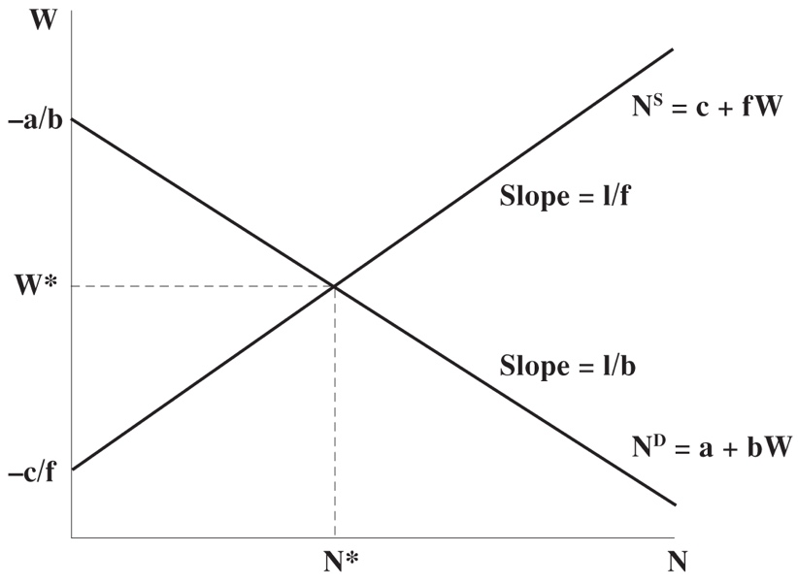

- Example:
- N^D = 25-3W
- N^S = 5+2W
- Equilibrium wage: 25-3W = 5+2W
- W =4 and N=13
Effect of Payroll taxes on Equilibrium Wages
- Payroll taxes alter relationship between wages and amount paid/received for a unit of labour
- Example: payroll tax paid by employers
- increases cost of hiring a unit of labour
- shifts demand curve down
- Example: wage subsidy given to workers
- Increases effective wage workers receive for every unit of labour supplied
- Shifts supply curve up

- Unit Payroll Tax: employers must pay a tax T to the government for every unit of labour hired
- Example: add unit payroll tax T to previous example:
- Labour demand before tax: N^D =25-3W
- Labour Supply =5+2W
- A payroll tax of T increases wages that firms have to pay by T per unit
- New labour demand: N^D =25-3(W+T)
- Then Equilibrium wages are: W1 =4-3/5T
- Decline in equilibrium wages caused by payroll tax

Monopsony: single employer in market
- Firm choses the wage it pays its workers
- Face upward-sloping labour supply curve
- If firm wants to hire more workers, it has to increase wages
- MC of labour is greater than the wage
- Implication:
- marginal cost of labour is greater than the wage because:
- If a firm wants to hire more labour, it must increase the wage
- This means it is paying higher wages to all of its workers
- Just like a competitive firm, monopolist will choose a wage at which marginal revenue product of labour equals marginal cost of labour
- This optimal wage will be lower than the equilibrium wage in competitive labour market
- Will hire fewer workers than competitive market

Effects of Minimum Wages
- Increases unemployment among low-wage workers
- Minimum wage below equilibrium wage:
- Non-binding
- No effect on wages or employment
- Minimum wage above equilibrium wage:
- Binding
- Labour supplied>Labour Demanded
- Creates unemployment
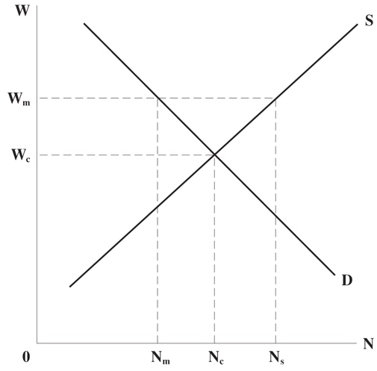
Nc = labour demanded/supplied without minimum wage
Nm = labour demanded under minimum wage
Ns = labour supplied under minimum wage

Chapter 7: Human Capital

Human capital can explain why different people earn different wages

Investment in Human Capital
- Individuals decide how much education to invest in by weighing the costs and benefits associated with each year of schooling
- Individuals do not receive any direct utility or disutility from the educational process
- Choose the income stream with the highest present value of lifetime earnings

Present Value
- PV1 =Y + Σt=1 Y/(1+r)^t =Y+Y/r
- Now you can increase your income by ΔY in every period if you spend one more year in school. The direct costs of this additional year of school at D
- The new income stream is:
- PV2= 0 +Σt=1 Y+ΔY/(1+r)^t- D= Y+ΔY/r- D
- Net gain from additional year of schooling: PV2-PV1
- = ΔY/r – (Y+D)

Optimal Schooling Choice
- Marginal benefit from extra year of schooling: ∆Y/ r
- Present value of additional earnings for the rest of your life
- Marginal cost of extra year of schooling: Y + D
- Foregone earnings plus direct costs
- End schooling when MB = MC

Internal Rate of Return (i): implicit rate of return on investment in education
- You are investing: Y + D
- The yearly return on this investment is: ∆Y
- The Rate of return on investment is: ∆Y/ Y+D

Signalling
- Basic features:
- Different workers are differently productive
- Imperfect information
- firms cannot tell if a worker is a high or low type
- however, firms do observe the quantity of schooling (s) that a worker has invested in
- firms use education as a signal of worker’s productivity
- Equilibrium: high productivity workers invest in education; low productivity workers do not
- Education is more costly for low workers
- Firms have beliefs about the productivity of a worker, given the quantity of schooling he or she has obtained.
- Firms believe that a worker is a “high type” if s ≥ 1.5; will pay this worker w = $2.
- Firms believe that a worker is a “low type” if s < 1.5; will pay this worker w = $1.
- A worker chooses a level of education that maximizes his utility.
- (Benefits) - (Costs), or (Earnings) - (Schooling costs)
- Low productivity workers:
- For any level of education s, a low type worker will incur s in costs.
- If he gets education s < 1.5, he will earn w = 1.
- If he gets education s ≥ 1.5, he will earn w = 2.
- High productivity workers:
- For any level of education s, a high type worker will incur s/2 in costs.
- If he gets education s < 1.5, he will earn w = 1.
- If he gets education s ≥ 1.5, he will earn w = 2.

Empirical Evidence
- people with more education earn more
- Returns to Schooling:
- OLS Regression:
- ln Y = α + rS + ε
- run this regression with data on income and schooling; expect to find r >0
- should include age and experience variable because they are correlated with schooling

Ability Bias
- high earning people deriving more utility from the educational process, or finding education less costly
- ability bias is a form of omitted variable bias
- the ε is an error term
- ε= A+u
- A is ability and u is random
- this bias estimates of the return to schooling upwards, in other words, it causes us to overestimate the return to schooling
- we don't have a great way to measure ability, so we cant perfectly control for its effect on earnings.

Chapter 8: Immigration

Consequences of Immigration on Native Labour Market
- immigration increases size of labour force
- may decrease wages for everyone
- if the wages can’t adjust such as the minimum wage laws then unemployment may increase
- but it also may increase demand for labour because there are more people in the economy, purchasing goods and services
Issues on measuring immigration
- immigration to a city is not random
- we do not observe counterfactual- we do not know what would have happened to any given city or country in the absence of immigration

The Mariel Boatlift
- Measure effect of immigration on local labour market using natural experiment
- Random shock to immigration from Cuba to Miami
- Increased Miami labour force by 7%; increased number of Cuban workers in Miami by 20%
- No effect of Mariel Boatlift on wages or unemployment in Miami because most of the Mariel workers were unskilled

Economic Outcomes of Immigrants
- Entry effect: immigrants may face period of lower wages or unemployment upon arrival
- Economic assimilation: migrants should improve relative to native-born workers

Migrant Selection & Migrant Cohort Effects
- Basic principle:
- Migration is an investment, much like education.
- Migrate if the return exceeds the costs.
- Higher wage inequality → lower wage inequality:
- “Return to skill” lower in destination
- More lucrative for unskilled workers – negative selection
- Lower wage inequality → higher wage inequality:
- “Return to skill” higher in destination
- More lucrative for highly skilled workers – positive selection
- Performance of immigrants depends on years since migration (YSM)

Brain Drain
- Tendency for highly educated Canadians to migrate to the US
- Reduces skill level in Canada, increases skill level in America
- Reduce tax base in Canada

Chapter 9: Discrimination in the Labour Market

Discrimination: individuals earn different wages to equally productive or qualified workers because of gender, race, ethnicity

Theories:
Taste-based Discrimination
- Created by Gary Becker (1957), Kenneth Arrow (1973)
- Demand theory of discrimination
- Employers explicitly discriminate against workers from a certain group
- Due to employer’s preference for one group over another

Equilibrium wages for different groups
- Two groups: A and B
- Both groups have the same value of marginal product: VMPn
- Groups A and B get paid different wages: Wa and Wb
- Marginal cost of hiring worker from group a: MCa = Wa
- Marginal cost of hiring worker from group B: MCb = Wb+d
- d is a discrimination parameter
- costlier for firm- they dislike
- Firms choose how many workers to hire from A and B by:
- set VMPn =MCn
- group A: VMPN =Wa
- group B: VMPN =Wb +d
- group B has lower wages, market labour demand is lower for group B
Demand for Group A


Demand for Group B

- Example:
- Market Demand for group A is: N^Da = 500-50Wa
- Market Demand for group B: N^Db =400-50Wb
- Labour supply is 100 for group A and B
- Equilibrium Wage for A: N^Da=N^Sa, 500-50Wa =100, Wa= 8
- Group B: 400-50Wb =100, Wb =6

Statistical Discrimination: discrimination that stems from imperfect information about workers’ productivity, not overt dislike for workers from different groups
- Firms cannot observe an individual worker’s productivity
- But firms know what the average productivity is
- Firms sometimes observe signal information of an individual’s productivity such as a university transcript
- Firms pay their workers what they believe to be their marginal product
- Worker productivity wage: W =pMP +(1-p) S
- p= weight placed on prior beliefs (between 0 and 1)
- MP= average productivity
- S = signal

Measuring Discrimination
- Gender wage gaps
- Decreasing over time
- Women tend to be paid lower
- Women less likely to be promoted
- Gender wage gap is sensitive to how wages are measured
- It drops significantly when using hourly wages instead of yearly earning
- Explanation:
- Women work fewer hours
- Have less continuous work experience
- Tend to work in lower-paying occupations and at smaller firms

Chapter 10: Unemployment

- Unemployment rate = #unemployed/ # in labour force
- Labour force participation rate =# in labour force/ population
- Employment rate =# Employed/ # in labour force
- Unemployment is prevalent because of discouraged workers this is common during recessions or it could be workers awaiting recall
- Stocks: a certain number of workers in each state which is either unemployed, employed and not in the labour force

